Software Architecture Document
CBIIT BDA

Last Revised: | December 21, 2010
Produced By: | CBIIT BDA Team
Version: | 1.0

Revision History
When you make a change to a document, you must add an entry to this Revision History table and you must manually type the Last Revised Date on the front cover.

Date | Version | Description | Revised by
12/21/2010 | 1.0 | Incorporated all work previously documented, and still being maintained, on the BDA Wiki. This is simply a summary of the design work performed by the BDA team of Paul Duvall, Steve Saksa, Mahi Nara, Tim Bassett, and Michael Nyika, over the course of designing and documenting the design via the BDA Wiki. | Rob Daly
Copyrights and Trademarks
© Copyright 2010 by CBIIT, caBIGTM. All rights reserved.
Table of Contents
1. Introduction 3
1.1. Purpose 3
1.2. Scope 3
2. Architectural Representation 3
3. Component View 3
3.1. BDA Framework 3
3.1.1. BDA Templates 4
3.1.2. BDA Utilities (API) 4
3.1.3. BDA Hudson Management scripts 4
3.1.4. Ivy Repository 5
3.1.5. Eclipse Tools 5
3.1.6. Binary Repository 5
3.1.7. Tools to download 5
3.1.8. Custom Ant Tasks 5
3.1.9. DbConfig - Database configuration custom Ant task 5
3.1.10. Subversion Utilities to Branch/Tag/Merge projects 6
3.1.11. BDA Versioning 6
4. Deployment View 7
4.1.1. Try this one 8

Introduction

Purpose
This document provides a comprehensive architectural overview of the CBIIT BDA system and software. It is intended to capture and convey the significant architectural decisions that have been made on the system. The team maintains a complete and detailed perspective of the design of the system and software on the BDA Wiki. Please refer to it for additional detail and hyperlinked content.

Scope
This document describes the aspects of the BDA system and software design that are considered to be architecturally significant; that is, those elements and behaviors that are most fundamental for guiding the construction by the team. Stakeholders who require a technical understanding of the BDA framework, dashboard, and other components are encouraged to start by reading this document, then moving on to the BDA Wiki.

Architectural Representation
The BDA suite is comprised of several support level tools and tool software. We employ component diagrams and descriptions as the primary means to represent the architecture.

Component View

BDA Framework

The BDA Framework is a collection of Ant utilities (macros), template scripts, custom Ant tasks, and other tools designed to make building software at CBIIT more consistent and reliable. Refer to Figure 1 for an overview of how each component fits into the whole.
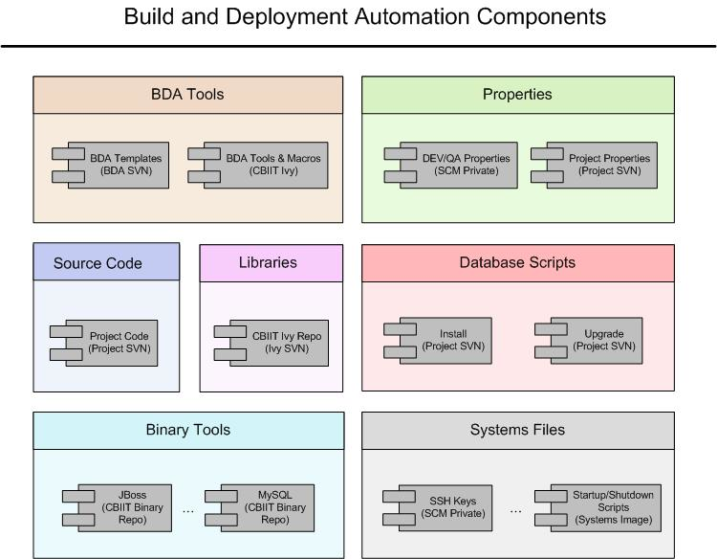
Figure 1 - Build and Deployment Automation Components

BDA Templates
The BDA Templates is a set of blueprints provided to development teams to help jump start their single-command builds. These templates include targets to perform most steps required to build, test, inspect and deploy an application. The BDA Templates rely on the BDA Utilities (Ant macros) to perform most of its tasks.
https://gforge.nci.nih.gov/svnroot/automation/trunk/software/bda-build-template

BDA Utilities (API)
The BDA Utilities is a set of macros created by the BDA team to simply build script management. Most common activities you might use ant to perform are already implemented can be called by passing a few attributes to the macros.
https://gforge.nci.nih.gov/svnroot/automation/trunk/software/utils

BDA Hudson Management scripts
The BDA Hudson Management scripts will do the following things
Download, install and configure Tomcat and Hudson servers
Write Hudson configuration from Hudson to SVN
Write Hudson configuration to Hudson from SVN
https://gforge.nci.nih.gov/svnroot/automation/trunk/software/hudson-manager

Ivy Repository
The BDA team worked with the Systems team to create a Subversion repository for storing an Ivy Repository. This has several benefits:
- The JARs only need to be stored once and shared across projects
- Every JAR file is checked into a structure and renamed to include the version in its name
- The projects have clear documentation of which versions are required
- Dependent projects can use Ivy dependency definitions generated and maintained by dependent projects.
https://gforge.nci.nih.gov/svnroot/commonlibrary/trunk/ivy-repo

Eclipse Tools
We've compiled best practices and tools into a bundle of scripts aimed to reduce learning curve and streamline development for Eclipse users. One such tool is a template plugins file which bundles the most widely used plugins for developing quality code in Eclipse. The following page outlines the steps to download the plugins file and import the definitions into Eclipse.

Binary Repository
All binary files (including the ivy-repo) are stored in this module, so that they do not need to be stored multiple times in each project repository. Build scripts can retrieve these files from the "Ant get" command. The files are stored in techstack/platform directory structure.
https://gforge.nci.nih.gov/svnroot/commonlibrary/trunk

Tools to download
The following tools may need to be downloaded to get deployments to work:
Tool | Version | Platform/Location
Java | 1.5.0_10 | Windows
Java | 1.5.0_10 | Linux
MySQL | 5.0.27 | Windows
MySQL | 5.0.27 | Other
PostgreSQL | 8.3.3-1 | Other
Globus | 4.0.3 | Other
SVN Client | 1.4.6 | Windows
SVN Client | 1.4.6 | Other

Custom Ant Tasks
There were certain tasks that could not be performed by Ant but were required by the build process, so custom ant tasks were written to meet this need.

DbConfig - Database configuration custom Ant task
Ant does not currently have a condition to test database connectivity, so this custom task checks connectivity with the provided credentials, verifies database vendor and version, etc. DbConfig is a custom Ant task for database verification during build or deployment. The task supports the following operations:
- Validate database connection
- Validate user credentials
- Validate database vendor and version
This Ant custom task is an open-source project hosted under SourceForge.

Subversion Utilities to Branch/Tag/Merge projects
This utility can branch/tag/merges any number of Subversion projects. The projects are specified as comma separated values for the property project.names in the project.properties. The repository details for the projects are specified in the project.properties. The property names should start with <project_name>. You will use the same project name as in the SVN repository. For example, for caGWAS, the name of the first project-specific property will be cagwas.tag.name (the name cagwas must match one of the comma-delimited values in project.names.
The Utility can be checked out (via SVN) from:
https://gforge.nci.nih.gov/svnroot/automation/trunk/software/svn-utilities
To create Branches/Tags
ant tag-branch:projects
To Merge use: (Ensure your Subversion client is in the System path (e.g. svn.exe))
ant merge:projects

BDA Versioning
The BDA 1.x Framework components are:
- BDA Utils (Common Ant macros) - https://wiki.nci.nih.gov/x/yqN8 and API Documentation: https://wiki.nci.nih.gov/x/rAWG
- BDA Templates (Ant scripts that work with latest BDA Utils) - https://wiki.nci.nih.gov/x/wqN8
- BDA Certification Dashboard (for monitoring projects on a daily basis) - https://wiki.nci.nih.gov/x/jojB
- CBIIT Binary Repository (for hosting tools that projects will download and use) - http://gforge.nci.nih.gov/svnroot/commonlibrary/trunk/
- SCM Private Subversion Repository (for hosting properties files) - http://gforge.nci.nih.gov/svnroot/scm-private/trunk/projects/
- Screencasts (for BDA'fication and Configuring Hudson CI server and VM) - https://wiki.nci.nih.gov/x/FAG5
- Wiki documentation - https://wiki.nci.nih.gov/x/fJd8
T Wiki documentation is being updated continually, but it'll be important to verify that the wiki doco matches whatever changes are being released.
As for versioning, we recommend the following:
- Major.Minor.Patch
  - Example: 1.2.1
  - Major: A new component (in additional to the list above)
  - Minor: A new feature in one of the components above (e.g. New Cert indicator, New Macro). Something that could require a change on the developer's part
  - Patch: Fixing an existing feature. Developers should not need to make any changes other than, perhaps, updating their properties file to the new version.

Deployment View
The Deployment View of the BDA system and software is conceptualized in Figure 2. Included among the notable components are the following:

- Ivy SVN Repository
  - Using Ivy
- SCM Private Properties
  - SCM Private SVN Repo
- Binary Repo (Tech Stack)
  - SVN Binary Repo
- Project SVN Repo
- BDA Utils
  - BDA Utils Main Page
  - BDA Utils Documentation
  - BDA Utils Files. Ant macros file is called bda-build-utils.xml.
- Master Build Template
  - {{build.xml}} template diagram (Grand)
  - {{install.xml}} template diagram (Grand)
  - Files
  - Documentation
- Master Build Script
  - Build and Install Templates
  - Example Scripts
- Compile/Package
  - build.xml template. Find the build:all target, This target eventually calls your sub-project build script to generate build artifacts.
- Tests
  - build.xml template. There is a wrapper target called test:all that will call your sub-project build's automated tests.
- Static Analysis
  - build.xml template. There is a wrapper target called static-analysis:all that will call your sub-project build's automated static analysis tools.
  - static-analysis-build.xml
    - There are custom targets for Simian (duplication), PMD and CheckStyle (coding standards), JavaNCSS (Cyclomatic Complexity), and FindBugs (Advanced Bug Finder). You will need modify for your project.
- Generate WSRF
- Command-Line Installer/Upgrader (Creation)
  - build.xml template. The dist target calls dist:installer, dist:upgrader, dist:src, dist:gui-installer targets.
- GUI Installer (Creation)
  - build.xml template. The dist target dist:gui-installer target.
- Installer
  - install.xml template. The default target is install. See all of the install: targets.
- Upgrade
  - install.xml template. See all of the upgrade: targets.
- GUI Installer
  - Customize the GUI Install templates
  - BDA GUI Installer
- Pre-Install Validation
  - install.xml template. Search for install:validation:pre-install target.
  - BDA Utils Ant macros. Search for validate-pre-install macro.
- Database Validation
  - install.xml template. Search for install:validation:pre-install target.
  - BDA Utils Ant macros. Search for validate-pre-install macro.
- Compare Properties Validation
  - BDA Utils API Doc - Search for Property Validation
  - BDA Utils file. Search for the compare-properties macro.
- Install/Configure App Server
  - install.xml template. See the install, install:jboss:, install:tomcat:
- Deploy/Configure Application
  - install.xml template. See the install, install:jboss:, install:tomcat: targets.
- Configure/Deploy Grid Services
  - install.xml template. See the install:jboss:grid:, install:tomcat:grid: targets. These targets will deploy and configure WSRF onto an existing server.
- Install (Database)
  - install.xml template. See the install:database.
- Upgrade (Database)
  - install.xml template. See the upgrade:database.
- Post-install Validation
- CI Server
  - How to Install and Configure Hudson
  - Hudson Installation Scripts
- AntHill Pro
  - AntHill Pro Configuration and Usage

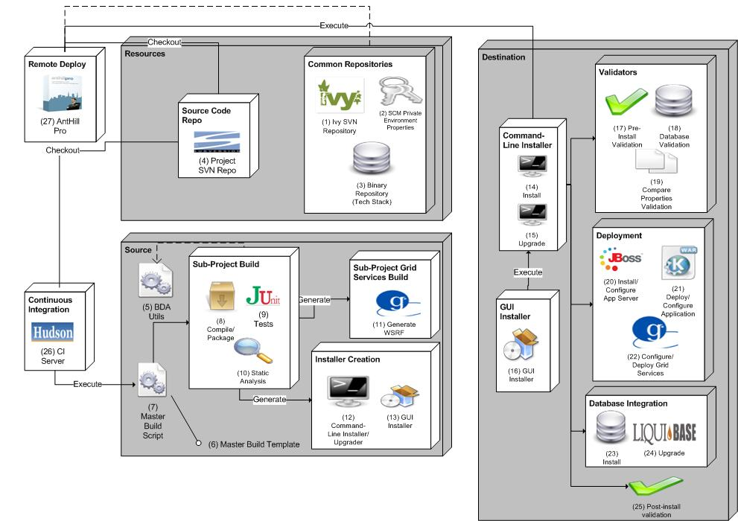
Figure 2 - Conceptual Deployment View of BDA Architecture

Complete and hyperlinked BDA Documentation is available at https://wiki.nci.nih.gov/display/BuildandDeploymentAutomation/BDA+Documentation

