Bioconductor Use Cases
Fred Hutchinson Cancer Research Center

DOCUMENT REVISION HISTORY
Version Number | Date | Description
1.0 | April 2006 | - Draft
1.1 | May 2006 | - Incorporating adopter, VCDE, Architecture comments

Background/Summary
This module exposes Bioconductor package functionality as web services available through caGRID. Use cases include Biocondcutor package development as a web service, semantic annotation, deployment management, and web service use.
Table of Content
1 Introduction 4
2 Actors and Goals 4
2.1 Bioconductor package developer 4
2.2 Semantic annotation team 4
2.3 Deployment manager 4
2.4 Web service user 4
3 Use Cases 5
3.1 Produce a Java–based web services interface to a Bioconductor package 5
3.1.1 Use Case Model 5
3.1.2 Brief Description 5
3.1.3 Primary Actor 6
3.1.4 Preconditions 6
3.1.4.1 Functioning R system 6
3.1.4.2 Primary Bioconductor package 6
3.1.4.3 Additional Bioconductor packages 6
3.1.5 Basic Flow of Events 6
3.1.6 Postconditions 7
3.1.6.1 Web services interface to Bioconductor package 7
3.1.7 Special Requirements 7
3.2 Apply semantic annotation to a web services enabled Bioconductor package 7
3.2.1 Use Case Model 7
3.2.2 Brief Description 8
3.2.3 Primary Actor 8
3.2.4 Secondary Actors 8
3.2.5 Preconditions 9
3.2.5.1 RWebServices enabled package 9
3.2.5.2 Semantic annotation tools in caCORE SDK 9
3.2.6 Basic Flow of Events 9
3.2.7 Postconditions 9
3.2.7.1 Semantically annotated RWebServices package 9
3.2.8 Special Requirements 9
3.3 Deploy an annotated and web services enabled Bioconductor package as a caGRID analytic service 10
3.3.1 Use Case Model 10
3.3.2 Brief Description 11
3.3.3 Primary Actor 11
3.3.4 Preconditions 11
3.3.4.1 Semantically annotated RWebServices enabled package 11
3.3.4.2 Established caGRID node 11
3.3.4.3 caGRID deployment tools and facilities 11
3.3.5 Basic Flow of Events 11
3.3.6 Postconditions 12
3.3.6.1 Biocondcutor package functionality available as caGRID analytic service 12
3.3.7 Special Requirements 12
3.4 Discover and invoke a Bioconductor function as a caGRID analytic service 13
3.4.1 Use Case Model 13
3.4.2 Brief Description 13
3.4.3 Primary Actor 14
3.4.4 Preconditions 14
3.4.4.1 caGRID data source and workflow tools. 14
3.4.4.2 caGRID-deployed RWebServices package 14
3.4.5 Basic Flow of Events 14
3.4.6 Postconditions 16
3.4.6.1 Semantically correct results 16
3.4.6.2 Exceptions 16
3.4.6.3 Side-effects 16
3.4.7 Special Requirements 16
3.4.7.1 caGRID workflow client 16
4 Overall Requirements 16
4.1 Requirements Prioritization 16
5 Data Definitions 17
6 Sign Off 18
6.1 Approval 18

Introduction
Bioconductor is a collection of open-source software components based on the R programming language. Bioconductor is used for gene expression and other high-throughput analysis in molecular biology. R packages are collections of algorithms grouped to facilitate particular analyses.
This module allows R package developers to expose the functionality of their package as analytic services on caGRID. Our primary concern, and the focus of our use cases, is the development of tools for converting existing Bioconductor packages to caGRID analytic services. This is in contrast to other modules, which may focus on providing specific functionality as analytic services.

Actors and Goals

Bioconductor package developer
Develop and expose Bioconductor functionality as a web service.

Semantic annotation team
Semantically annotate identified Bioconductor package web service functionality to facilitate use as a caGRID analytic service.

Deployment manager
Deploy semantically annotated Bioconductor packages as caGrid analytic services.

Web service user
Use Bioconductor analytic service in a caGrid workflow.

Use Cases

Produce a Java–based web services interface to a Bioconductor package

Use Case Model
In this diagram, the colored ‘Bioconductor package’ is the software component to be exposed as a web service. Uncolored components represent additional Bioconductor packages that facilitate the use case.
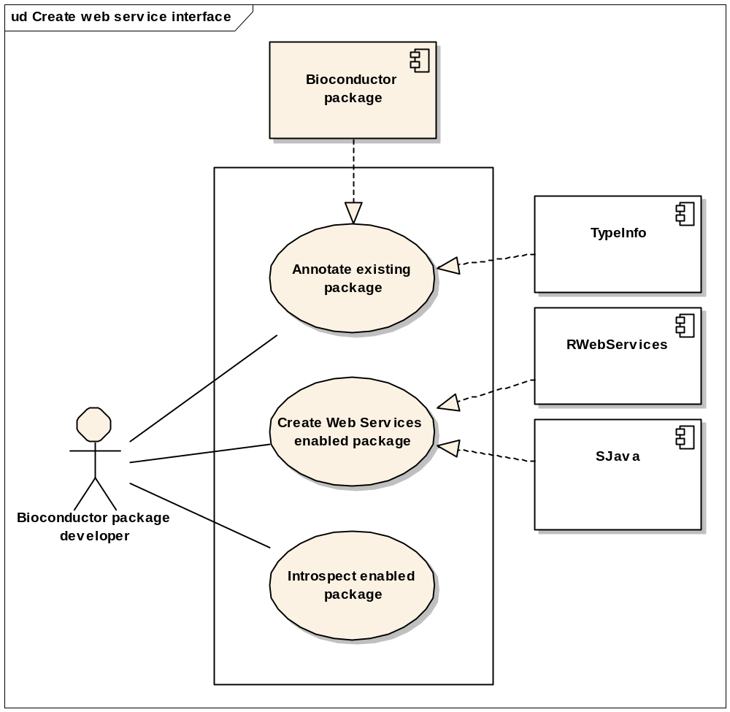

Brief Description
A Bioconductor package is a group of related functions, documentation, and data that perform specific statistical analyses. Bioconductor packages are usually authored by one or a few individuals, and address specialized or cutting-edge needs in statistical analysis.
This use case involves a Bioconductor package developer who desires to make all or a portion of the functionality of their package available as a web service within the caGrid environment.

Primary Actor
The primary actor in this use case is a computationally- and statistically capable individual wishing to produce or modify an R package to be deployed as a web service in caGRID. The individual is familiar with R, but has no special skills related to web services.

Preconditions

Functioning R system
The R package developer requires a functioning R system. This includes a development tool chain described in detail in documentation associated with the R project.

Primary Bioconductor package
The Bioconductor package developer has authored a package to perform statistical analysis. The Bioconductor package will contain R codeand documentation, and may contain C or Fortran code. Prior to adaptation to the web services environment, the package satisfies the normal conditions placed on R packages, compiling, linking, and installing into the developer’s standard R system without errors or warnings.

Additional Bioconductor packages
TypeInfo, a Bioconductor package to provide strongly typed access to R functions and methods.
RWebServices, a Bioconductor package to convert other R packages to web services. RWebServices translates R objects, methods, and functions to corresponding Java classes and methods.
SJava, a Bioconductor and Java package that provides infrastructure for the R/Java interface.

Basic Flow of Events
The R package developer initiates flow of events by identifying those aspects of their package that are most suitable for use in a web services context.
The Bioconductor package developer uses TypeInfo to apply type specification to the functions to be web-service enabled. This step is required because R is not a strongly typed language. Type specification is conducted in the R program, and integrated into R packages by including appropriate statements in the source code for the package. The steps required for this are very familiar to the R developer.
The developer initiates the next step in the workflow by providing a list of TypeInfo-enabled functions to the RWebServices package. RWebServices uses type specification in conjunction with method and function definitions contained in the TypeInfo-enabled package (and other packages the developer may have required) to generate a collection of Java classes corresponding to objects in the TypeInfo-enabled package. The Java classes can integrate into SJava for evaluation.
The developer then invokes Java introspection tools on the classes constructed by RWebServices to construct UML domain models expressed as XMI.

Postconditions

Web services interface to Bioconductor package
The postcondition of this use case is a Java interface to specific functionality of a Bioconductor package, coupled with UML domain models expressed as XMI.

Special Requirements
None.

Apply semantic annotation to a web services enabled Bioconductor package

Use Case Model
The VCDE SIG has extensive documentation on specific steps required to apply semantic annotation. We emphasize in this use case the major points of connection between the VCDE use cases and the steps required for semantic annotation of web services enabled Bioconductor packages.
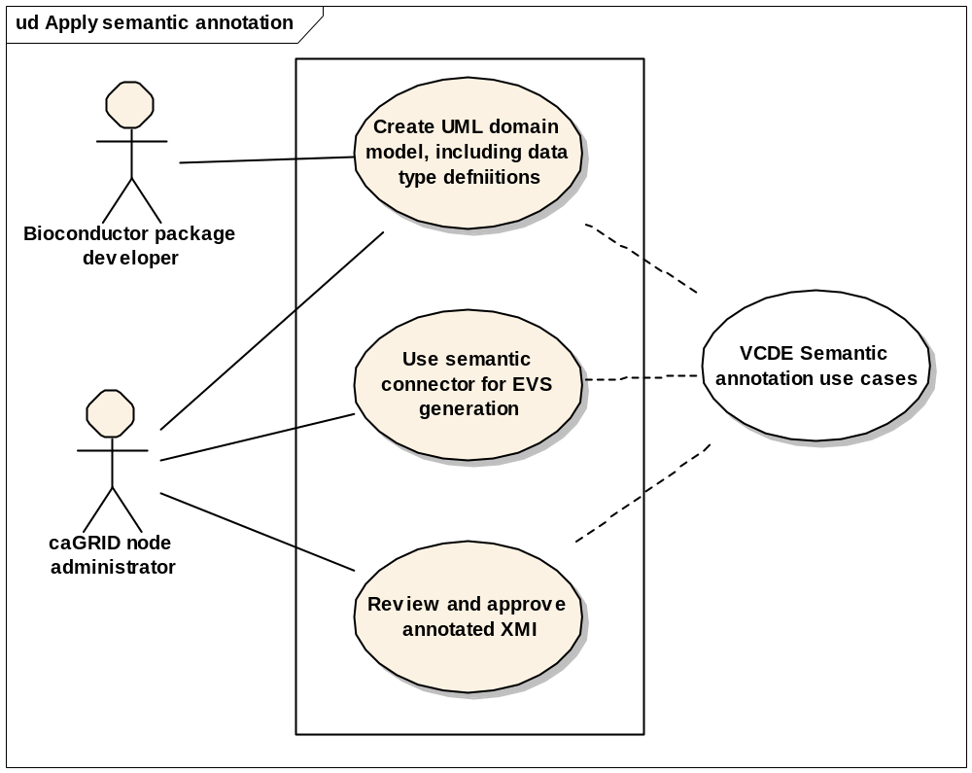

Brief Description
This use case adds semantic annotation to a web services enabled Bioconductor package, so that the package can be incorporated into caGrid. This use case is a collaboration between the Biocondcutor package developer (an expert in a narrowly defined statistical analysis) and a caGRID node administrator (familiar with semantic concepts important in caGRID). The semantic annotation team collaborates to associate argument and return types with terms from semantically controlled vocabularies.

Primary Actor
The primary actor is the individual responsible for exposing Bioconductor functionality on caGrid. This may be the package developer, or the caGrid node administrator.

Secondary Actors
Either the package developer or caGrid node administrator is a secondary actor, depending on the primary actor.

Preconditions

RWebServices enabled package
The RWebServices enabled package is the postcondition of use case 3.1.

Semantic annotation tools in caCORE SDK

Basic Flow of Events
The primary actor uses caCORE SDK tools and procedures to apply semantic annotation to the UML domain models. This step uses the caCORE Enterprise Vocabulary Services (EVS) APIs hosted at the NCI to search the NCI Thesaurus for the appropriate concepts. The major phases of this (detailed in VCDE documentation) include:
The primary actor uses a UML modeling tools such as enterprise architect to transform XMI from introspection of Java web services objects to UML domain models.
The primary actor identifies data types, requesting new data type create from NCICB if necessary.
The primary actor exports the XMI and fixes it for caGRID compatibility, e.g., using ant fix-xmi.
The primary actor uses Semantic Connector to generate an initial EVSReport CSV file. This is submitted for approval and verification through NCICB application support. The primary actor uses this to annotate the fixed XMI file.
Any new caDSR data types are added to caDSR, and the primary actor forwards the verified, annotated, and fixed XMI to NCICB Application Support.

Postconditions

Semantically annotated RWebServices package
The postcondition consists of the Bioconductor package(s), RWebServices Java wrappers, and a semantically annotated and approved UML domain model expressed as XMI.

Special Requirements
None.

Deploy an annotated and web services enabled Bioconductor package as a caGRID analytic service

Use Case Model
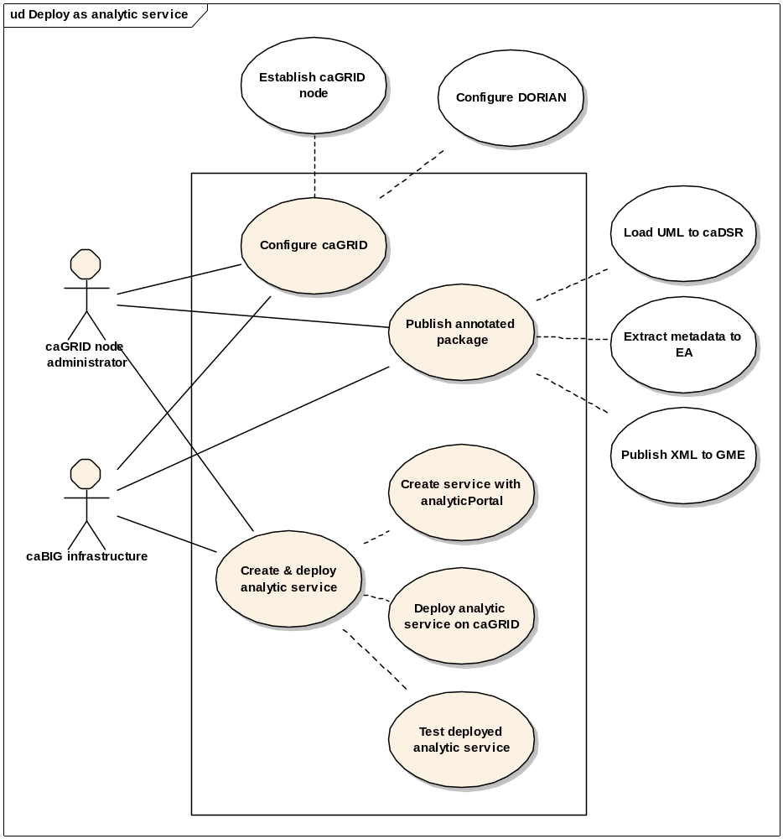

Brief Description
The deployment manger takes Java programs generated from RWebServices as input, and generates a valid caGRID analytical service. This may be done for local deployment or, with the assistance of NCICB application support personnel, for global deployment.

Primary Actor
The primary actor is the local deployment manager. The primary actor is responsible for deploying the analytic service locally, or coordinating deployment with NCICB Application Support personnel.

Preconditions

Semantically annotated RWebServices enabled package
This is the postcondtion of use case 3.2.

Established caGRID node
This use case presumes that a caGRID node is already established. The node likely includes existing data and analytic services.

caGRID deployment tools and facilities
Tools and facilities include Cancer Data Standards Repository (caDSR), UML Domain Model Loader (part of caCORE SDK), the Grid User Management Service (DORIAN; previously GUMS), Global Model Exchange (GME) and the GME Viewer GUI, analyticPortal, ant script for analytic service deployment (from caGRID).

Basic Flow of Events
The deployment manager configures DORIAN, running either locally or with a local proxy to the DORIAN service of NCI.
The deployment manager transforms and loads the semantically annotated UML domain models into caDSR. This step is facilitated by the UML Domain Model Loader. Deployment as a non-local caGRID service involves NCICB Application Support personnel.
The metadata resulting from the previous step is extracted to an XML schema using Enterprise Architect.
The deployment manager publishes the XML Schema into the GME using GME Viewer. The first step is to connect GME Viewer to a GME Service (at NCI or elsewhere). The second step is to publish the XML schemas to the GME service. This inserts the XML schemas into the XML database on GME server.
The deployment manager creates an analytic service using programmatically or using analyticPortal. The first step is to create an analytical service. The second step is to add methods to the analytical service (this can be done using a GUI, or more effectively through the command line). A method description includes the method name, name and type of input parameters and return data. All data types are selected from published XML Schemas on GME servers. analyticalPortal automatically generates Java skeletons for the methods, data types, and web service functionality. The final step is to insert code into the skeletons to provide implementation.
The deployment manager deploys the analytic service on a running web server. This is done with an ant script available in caGRID, and involves copying appropriate portions of the analytic services directory to certain server directories.
The deployment manager validates the analytic service using an established test suite and protocol.

Postconditions

Biocondcutor package functionality available as caGRID analytic service

Special Requirements
None.

Discover and invoke a Bioconductor function as a caGRID analytic service

Use Case Model
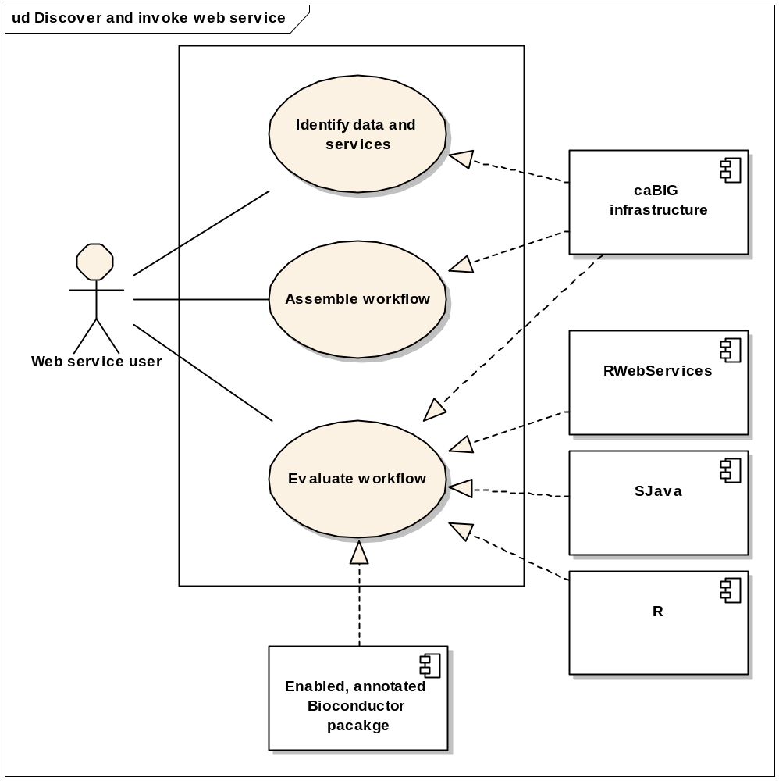

Brief Description
This use case involves caGRID-deployed RWebServices packages as analytic services in a caGRID workflow.
IMPORTANT NOTE: this use case represents a key component of the project, but the workflow and client tools (‘caBIG infrastructure’) are NOT part of the deliverables for this project.
This use case uses analysis of microarray data as a specific example.

Primary Actor
The web service user is a clinician, statistician, or other practitioner with access to caGRID workflow tools, data, and analytic services. The user may have no specialized programming or systems administration knowledge.

Preconditions

caGRID data source and workflow tools.
Discovery and invocation of analytic services requires a data source and integrated workflow tools. caArray is an archetypal data source. caGrid provides mechanisms for service invocation.

caGRID-deployed RWebServices package

Basic Flow of Events
The following diagram summarizes basic flow of events.
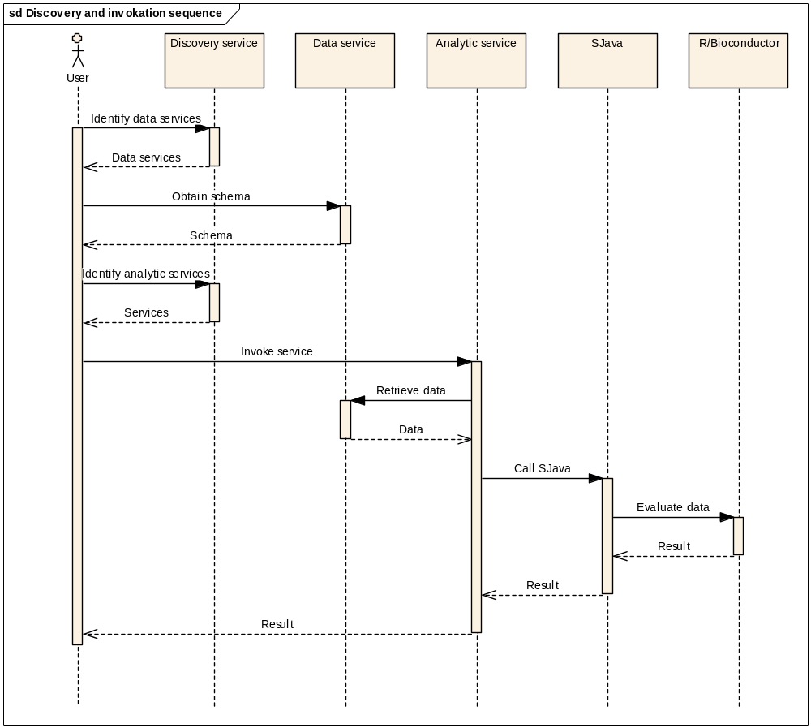 The web service user identifies data (e.g., caArray) and analytic services (e.g., provided by the affy package of Bioconductor) to be used, with the aid of caGRID discovery resources. Data and services are semantically interoperable and of defined type.
The web service user invokes a service (e.g., normalize.quantiles) on identified data. The analytic service retrieves the data from the specified data service (e.g., caArray).
The analytic service calls SJava to evaluate the data with the specified function.
SJava calls the appropriate function (normalize.quantiles) in R/Bioconductor, transmitting the data to the function. RWebServices mediates data transfer.
The Bioconductor function evaluates the data, accepting semantically correct arguments and returning results massaged to semantically correct values.
SJava returns the result to the analytic service.
The analytic service returns the result to the user.
Workflow can involve extended computation. The caGRID workflow provides mechanisms for session management, including retrieving workflow outcomes.

Postconditions

Semantically correct results
The usual postcondition of each step involving RWebServices will be a single semantically correct object, representing the result of the service.

Exceptions
Errors during RWebServices evaluation, due to malformed data, unanticipated computational problems, or limitations of the RWebServices algorithm, result in exceptions containing descriptive information about the nature of the difficulty.

Side-effects
RWebServices may generate side-effects. These include informational messages (R ‘warning’ and ‘message’) about special conditions encountered during evaluation, and secondary output (e.g., diagnostic graphical plots) produced during function evaluation. These are reported as WSDL attachments, and are made available to the web services user through the caGRID workflow.

Special Requirements

caGRID workflow client
The forgoing presumes a caGRID workflow client, with specific abilities that include division of tasks between available computational resources, session management, handling exception, and reporting side effects. No such caGRID workflow client is currently available.

Overall Requirements

Requirements Prioritization

Priority | Use Case Name | Supp Requirement Ref #
1 | Produce a Java–based web services interface to a Bioconductor package
3 | Apply semantic annotation to a web services enabled Bioconductor package
2 | Deploy an annotated and web services enabled Bioconductor package as a caGRID analytic service
4 | Discover and invoke a Bioconductor function as a caGRID analytic service

Data Definitions
Bioconductor package – a valid collection of statistical and other analytic tools written in the R programming language.
TypeInfo, SJava –existing Bioconductor packages providing infrastructure for this project.

Sign Off

Approval

Workspace General Contractor Rep Print Name Date
Architecture Workspace Rep Print Name Date
VCDE Workspace Rep Print Name Date
Workspace Working Group Rep Print Name Date
NCICB Rep Print Name Date

