Bioconductor Use Cases
Fred Hutchinson Cancer Research Center

DOCUMENT REVISION HISTORY
Version Number | Date | Description
1.0 | August 2008 | - Draft

Background/Summary
This module exposes Bioconductor package functionality as web services available through caGrid, and develops an R-based client for accessing caGrid index, data, and analytic services. Use cases describe how exposed Bioconductor packages will be accessed, and how the users will interact with the R-based client.
Table of Content
1 Introduction 4
2 Actors and Goals 4
2.1 Bioconductor Package Developer 4
2.2 Bioconductor caGrid Service 4
2.3 CaGrid Developer Client 4
2.4 R User 4
2.5 caGrid User 4
3 Use Cases 5
3.1 A stateless Bioconductor caGrid Service is discovered and invoked by a caGrid Developer Client 5
3.1.1 Use Case Model 5
3.1.2 Brief Description 5
3.1.3 Primary Actor 5
3.1.4 Preconditions 5
3.1.4.1 Primary Bioconductor package 5
3.1.4.2 CaGrid-enabled Biocondcutor package 5
3.1.4.3 Discoverable Bioconductor CaGrid service 5
3.1.5 Basic Flow of Events 6
3.1.6 Postconditions 7
3.1.7 Special Requirements 7
3.2 A stateful Bioconductor caGrid Service is discovered and invoked by a caGrid Develper Client 7
3.2.1 Use Case Model 7
3.2.2 Brief Description 7
3.2.3 Primary Actor 7
3.2.4 Preconditions 7
3.2.5 Basic Flow of Events 8
3.2.6 Postconditions 9
3.2.7 Special Requirements 9
3.3 A secure Bioconductor caGrid Service is discovered and invoked by a caGrid Develper Client 9
3.3.1 Use Case Model 9
3.3.2 Brief Description 9
3.3.3 Primary Actor 9
3.3.4 Preconditions 9
3.3.5 Basic Flow of Events 9
3.3.6 Postconditions 10
3.3.7 Special Requirements 10
3.4 A Bioconductor caGrid Client discovers data or analytic services 10
3.4.1 Use Case Model 10
3.4.2 Brief Description 10
3.4.3 Primary Actor 10
3.4.4 Preconditions 10
3.4.4.1 CaGrid Index Service 10
3.4.4.2 Bioconductor CaGrid Cilent 11
3.4.5 Basic Flow of Events 11
3.4.6 Postconditions 11
3.4.7 Special Requirements 11
3.5 A Bioconductor caGrid Client invokes a data service 11
3.5.1 Use Case Model 11
3.5.2 Brief Description 11
3.5.3 Primary Actor 12
3.5.4 Preconditions 12
3.5.4.1 CaGrid Data Service 12
3.5.4.2 Bioconductor CaGrid Cilent 12
3.5.5 Basic Flow of Events 12
3.5.6 Postconditions 12
3.5.7 Special Requirements 13
3.6 A Bioconductor caGrid Client invokes an analytic service 13
3.6.1 Use Case Model 13
3.6.2 Brief Description 13
3.6.3 Primary Actor 13
3.6.4 Preconditions 13
3.6.4.1 CaGrid Analytic Service 13
3.6.4.2 Bioconductor CaGrid Cilent 13
3.6.5 Basic Flow of Events 13
3.6.6 Postconditions 14
3.6.7 Special Requirements 14
4 Overall Requirements 14
4.1 Requirements Prioritization 14
5 Data Definitions 15
6 Sign Off 16
6.1 Approval 16

Introduction
Bioconductor is a collection of open-source software components based on the R programming language. Bioconductor is used for gene expression and other high-throughput analysis in molecular biology. R packages are collections of algorithms grouped to facilitate particular analyses.
This module exposes specific Bioconductor package functionality as caGrid analytic services, and develops an R-based caGrid client.

Actors and Goals

Bioconductor Package Developer
Develop and expose Bioconductor functionality as a web service.

Bioconductor caGrid Service
A Java-based caGrid analytic service and associated infrastructure, including a Bioconductor caGrid ‘worker’ with embedded R, for evaluation of valid Bioconductor caGrid Service requests.

CaGrid Developer Client
A client developed to invoke caGrid Bioconductor analytic services. In general, the caGrid Developer Client has a third party relationship to the current project, i.e., it is not developed as part of the current software effort.

R User
Access caGrid servics from within R.

caGrid User
Use Bioconductor analytic service with tools produced by a CaGrid Developer.

Use Cases

A stateless Bioconductor caGrid Service is discovered and invoked by a caGrid Developer Client

Use Case Model

Brief Description
A caGrid Developer uses standard caGrid service discovery tools to identify an appropriate Bioconductor caGrid Analytic Service, including service end point and input and output parameters. The caGrid Developer arranges to marshall input parameters into XML conforming to caGrid standards, invokes the Bioconductor caGrid Analytic Service using caGrid standard methods, and waits for the Bioconductor caGrid Analytic Service to complete. The service performs the requested operation, returning the appropriate data structures to the caGrid Developer as XML serialized in accordance with caGrid standards.

Primary Actor
The primary actor is the Bioconductor caGrid service.

Preconditions

Primary Bioconductor package
Bioconductor caGrid packages are based on pristine or modified existing Biconductor packages.

CaGrid-enabled Biocondcutor package
A Bioconductor package must be CaGrid enabled. This requires that the interface to the package (written in R) be translated (using the RwebService Bioconductor package) to a Java representation that can be invoked from within a running Java program. This also requires that the Java-enabled Bioconductor package be interfaced with caGrid using the introduce client and appropriate data registration.

Discoverable Bioconductor CaGrid service
The Bioconductor CaGrid service must be discoverably using CaGrid discovery tools such as the caGrid portal. This requires that the Bioconductor CaGrid module be deployed to a publically accessible server, and that the deployment successfully registers with the production instance of the caGrid Index Service.

Basic Flow of Events
The following diagram summarizes the basic flow of events.
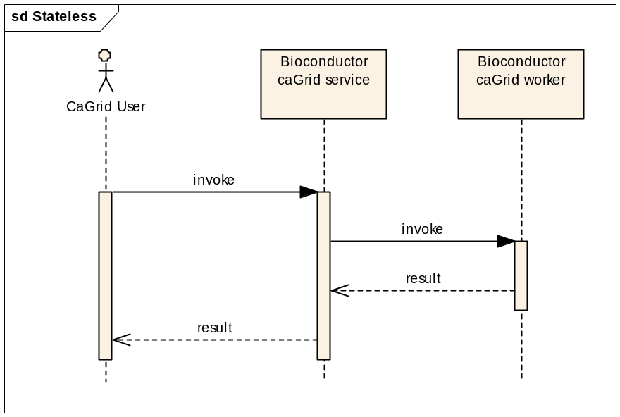
The caGrid Developer identifies the service and its input and return types. The caGrid Developer arranges to marshal data from an appropriate source (e.g., a caArray or other caGrid data service) into valid object formats for the service. The caGrid developer invokes the Bioconductor CaGrid service using caGrid-specified protocols, and maintains an active connection with the Bioconductor caGrid service until the service completes.
The Bioconductor caGrid service receives the service request as deserialized XML from caGrid tools. The Bioconductor caGrid service forwards the service request and data to an Bioconductor caGrid ‘worker’ to perform the requested service. The Bioconductor caGrid worker forward the service request to the embedded R instance, performing data type transformations between Java and R data type representations as necessary. The embedded R instance evaluates the service request, and returns the result to the Bioconductor caGrid worker. The Bioconductor caGrid worker transforms data between R and Java representations as necessary, and forwards the result to the Bioconductor caGrid service. The Bioconductor caGrid service returns the data to the caGrid Developer using caGrid protocols.
Error conditions during evaluation are propagatted from R through the Bioconductor caGrid worker to the Bioconductor caGrid service and to the caGrid Developer client.
The Bioconductor caGrid service returns to the caGrid Developer the data as in the format specified in the Index Service description.

Postconditions
The Bioconductor CaGrid worker and service are available for additional service requests. The caGrid Developer client posesses results of the Bioconductor CaGrid Service, or has been notified of error conditions precluding complete evaluation.
The Bioconductor caGrid Service remains available for additional service requests throughout.

Special Requirements
This scenario depends heavily on existing caGrid infrastructure, including the introduce toolkit to generate an appropriate interface between the caGrid service and Java layers, the caGrid GME to contain registered data types, and the caGrid Index Service to maintain a current registry of discoverable clients.

A stateful Bioconductor caGrid Service is discovered and invoked by a caGrid Develper Client

Use Case Model

Brief Description
This scenario differs from scenario 3.1 in that the caGrid Developer Client interacts with a stateful Bioconductor caGrid Service. The caGrid Developer client invokes a service as in scenario 3.1, but immediately retrieves an End Point Reference (EPR) containing information about where and how the client will retrieve the result. The caGrid Developer Client queries the EPR until the Bioconductor caGrid Service indicates completion. The caGrid Developer Client then retrieves the result.

Primary Actor
The primary actor is the Bioconductor caGrid Service.

Preconditions
Preconditions are those for scenario 3.1, with the additional requirement that the Bioconductor caGrid Service has used the End Point Reference facilities within caGrid introduce to generate a service capable of utiliizing EPRs.

Basic Flow of Events
The basic flow of events is summarized in the following diagram
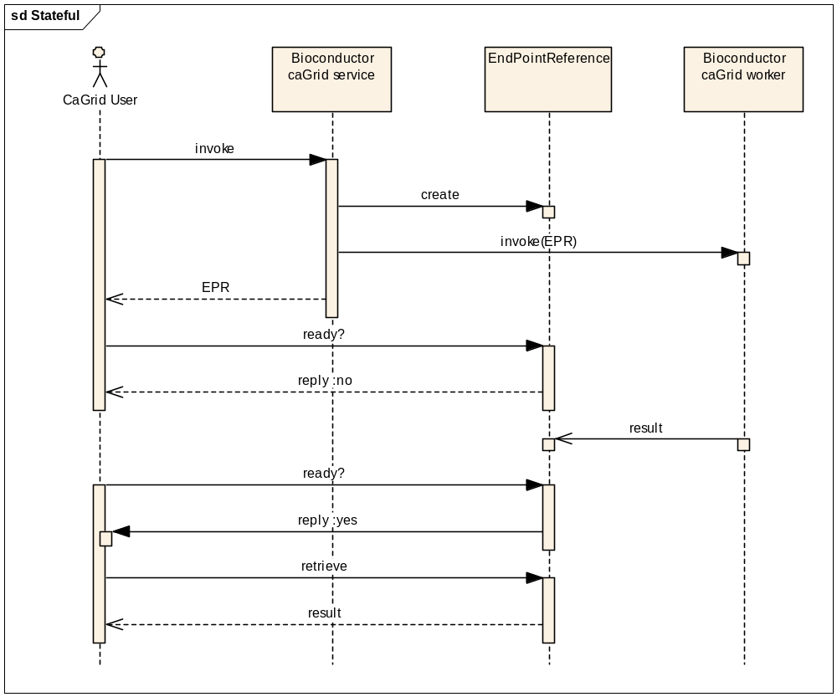
The caGrid Developer client marshals and invokes the Bioconductor caGrid Service as in scenario 3.1
The Bioconductor caGrid Service responds to the service request by immediately returning an EPR to the caGrid Developer Client. The EPR is initially configured to indicate that the service request is not yet complete. The Bioconductor caGrid Service forward the service request to the Bioconductor caGrid worker for fulfilment as in scenario 3.1, with the exception that the worker returns results or error conditions to the EPR rather than to the service.
The EPR is initialized to resond to queries (originating from the caGrid Developer Client) for results with a signal indicating that the computation is not yet complete. On notification of service completion (successfully or with error conditions) from the Bioconductor caGrid worker, the EPR changes state such that subsequent requests from the caGrid Developer Client are met with a resonse indicating service completion. The caGrid Developer Client then queries the EPR for the result or error condition. The EPR performs marshalling and data transfer of results to the client using caGrid protocols. Protocols may include use of caGrid Transfer, or standard XML-based transfer.

Postconditions
The Bioconductor caGrid worker becomes available for evaluation of subsequent service requests. The EPR is destroyed after a specified lifespan. The caGrid Developer Client proceeds with down-stream processing of the returned result.
The Bioconductor caGrid Service remains available for additional service requests throughout.

Special Requirements
There are no special requirements beyond those specified in scenario 3.1.

A secure Bioconductor caGrid Service is discovered and invoked by a caGrid Develper Client

Use Case Model

Brief Description
This scenario differs from scenario 3.1 and 3.2 in that the caGrid Developer Client presents caGrid security credentials to the service. The Bioconductor caGrid Service fulfils the service request, returning the result or error condition to an appropriately credentialed caGrid Devleoper Client.

Primary Actor
The primary actor is the Bioconductor caGrid Service.

Preconditions
Preconditions are those for scenario 3.1, with the additional requirement that the Bioconductor caGrid Service has used the End Point Reference facilities within caGrid introduce to generate a service capable of utiliizing EPRs.

Basic Flow of Events
The caGrid Developer client marshals and invokes the Bioconductor caGrid Service as in scenario 3.1
The flow of events for stateless Bioconductor caGrid Services are similar to that in scenario 3.1, with the exception that the credentials of the caGrid Developer Client are validated against the security requirements imposed on the deployed service.
The flow of events for stateful Bioconductor caGrid Services differ from scenario 3.2 in that the Bioconductor caGrid Service validates the credentials of the caGrid Developer Client. Further, the EPR created by the Bioconductor caGrid Service is informed of the caGrid Developer Client Credentials, and each service request directed toward the EPR is validated against the original credentials before any action is taken. A caGrid Developer Client querying the EPR with invalid credentials are informed of the inconsistency, and denied access to information on the status or actual results.

Postconditions
Postconditions are those of scenarios 3.1 or 3.2, respectively.

Special Requirements
This use case requires a correctly configured and functioning caGrid security infrastructure, in addition to the postconditions in scenario 3.1.

A Bioconductor caGrid Client discovers data or analytic services

Use Case Model

Brief Description
An R user installs and loads the Bioconductor caGrid Client package. The user queries an Index Service for available data and analytic services. The Index Service responds with service descriptions including necessary information for input and output data types and service location.

Primary Actor
The primary actor is Bioconductor caGrid Client.

Preconditions

CaGrid Index Service
This use case requires that one or more instances of the caGrid Index Service is available for query.

Bioconductor CaGrid Cilent
This use case requires that the Bioconductor CaGrid Client has internet access unobstructed by firewalls or other unnavigable obstacles. The Bioconductor caGrid Client requires a Java virtual machine compatible with caGrid infrastructure. The Bioconductor caGrid client also requires additional R packages. The R package installation mechanism ensures that the Java and additional package requirements are satisfied when the Bioconductor caGrid Client package is installed.

Basic Flow of Events
In response to R user actions (commands typed at the R command prompt), the Bioconductor CaGrid Client queries the caGrid Index Service for available services. It performs this operation by transforming the R user request into an appropriately formatted query for a Java-based caGrid Discovery Cient. The discovery client uses caGrid protocols to marshal the discovery request and convey the request to the caGrid Index Service. The caGrid Index Service replies with available data and analytic services, their end points, and references to input and output parameter types. The Java-based caGrid Discovery Client transmits information about service availability to the R layer of the Biconductor caGrid Client. The Bioconductor caGrid client presents available services and data requirements to the R user in a manner consistent R user expectation, e.g., as a S4 classes with appropriate display and navigation facilities.
Error conditions, e.g., lack of Index Service availability, are reported to the R user through standard R mechanisms.

Postconditions
The Bioconductor CaGrid Client has retained information about service end points and required data types for service invocation, and about the index service

Special Requirements
None.

A Bioconductor caGrid Client invokes a data service

Use Case Model

Brief Description
An R user employs information discovered in scenario 3.4 to marshal apropriate input arguments and invoke a caGrid data service. The R user employs R commands to invoke the service. The service responds with results or error conditions, and the Bioconductor caGrid Client returns these to the R user. The R user navigates the results using standard R idioms.
Error conditions, e.g., malformed data service requests or lack of service availability, are transmitted to the user with standard R methods.

Primary Actor
The primary actor is Bioconductor caGrid Client.

Preconditions

CaGrid Data Service
This use case requires that the caGrid Data Service advertised by the Index Service remains active, and responds to service requests.

Bioconductor CaGrid Cilent
The requirements on the Bioconductor caGrid Client are the same as those in scenario 3.4.

Basic Flow of Events
In response to R user actions (commands typed at the R command prompt), the R layer of the Bioconductor CaGrid Client formulates the request in an appropriate fashion for queries on caGrid Data Services. The request is tranfered to the Java layer of the Bioconductor caGrid client, which transmits the request, using established caGrid protocols, to the caGrid data service. The caGrid data service responds with an appropriate result set. The Java layer of the Bioconductor caGrid Client marshals the results into an appropriate R representation, and forwards the results to the R layer. The R layer displays results to the user in a form that allows navigation and extraction of data using familiiar R idioms.
Error conditions, e.g., lack of Data Service availability or malformed service requests, are reported to the R user through standard R mechanisms.

Postconditions
The Bioconductor CaGrid Client retains information retrieved from the Data Service in a way that allows the R user to navigate and extract return values.

Special Requirements
None.

A Bioconductor caGrid Client invokes an analytic service

Use Case Model

Brief Description
An R user employs information discovered in scenario 3.4 and 3.5 to marshal apropriate input arguments and invoke a caGrid analytic service. The R user employs R commands to invoke the service. The service responds with results or error conditions, and the Bioconductor caGrid Client returns these to the R user. The R user navigates the results using standard R idioms.
Error conditions, e.g., malformed service requests or lack of service availability, are transmitted to the user with standard R methods.

Primary Actor
The primary actor is the Bioconductor caGrid Client.

Preconditions

CaGrid Analytic Service
This use case requires that the caGrid Analytic Service advertised by the Index Service remains active, and responds to service requests. The CaGrid Analytic Service must be stateless so that the Bioconductor caGrid Client can invoke and retrieve results in a single step. The caGrid Analytic Service interface must adhere to caGrid standards, so that data input and return types can be determined unambiguously from service descriptions.

Bioconductor CaGrid Cilent
The requirements on the Bioconductor caGrid Client are the same as those in scenario 3.4.

Basic Flow of Events
In response to R user actions (commands typed at the R command prompt), the R layer of the Bioconductor CaGrid Client formulates the request in an appropriate fashion for queries on caGrid Analytic Services. The primary difference from scenario 3.5 is that the input data types of analytic services are registered in the caGrid GME and available via the caGrid Analytic Service description, rather than being CQL-based queries. The request is tranfered to the Java layer of the Bioconductor caGrid client, which transmits the request, using established caGrid protocols, to the caGrid Analytic Service. The caGrid Analytic Service responds with an appropriate result. The Java layer of the Bioconductor caGrid Client marshals the results into an appropriate R representation, and forwards the results to the R layer. The R layer displays results to the user in a form that allows navigation and extraction of data using familiiar R idioms.
Error conditions, e.g., lack of Data Service availability or malformed service requests, are reported to the R user through standard R mechanisms.

Postconditions
The Bioconductor CaGrid Client retains information retrieved from the Analytic Service in a way that allows the R user to navigate and extract return values.

Special Requirements
None.

Overall Requirements

Requirements Prioritization
Requirement priorities are in the order of use cases, as presented above, i.e., develop stateful and then stateless services, and then develop a client capable of first discovery, then data service invocation, then analytic service invocation, and finally managing user credentials.

Data Definitions
Bioconductor package – a valid collection of statistical and other analytic tools written in the R programming language.
TypeInfo, SJava –existing Bioconductor packages providing infrastructure for this project.

Sign Off

Approval

Workspace General Contractor Rep Print Name Date
Patrick McConnell 9 June
Architecture Workspace Rep Print Name Date
Salvatore Mungal 16 June
VCDE Workspace Rep Print Name Date
Warren Kibbe (Adopter rep) 19 May
Workspace Working Group Rep Print Name Date
NCICB Rep Print Name Date

