FHCRC Genomics Resource caBIG Adopter Review
Introduction

Throughout the duration of this contract, we have undertaken the role of adopter to develop and integrate clients for caGrid enabled Bioconductor modules into our workflow.

About the FHCRC Genomics Shared Resource

The Genomics Shared Resources comprised of three technology-driven laboratories: the DNA Array Lab, the Genetic Analysis Lab, and the RNA Interference (RNAi) Lab. These laboratories offer FHCRC researchers access to the latest cutting-edge microarray, sequencing, genotyping, and RNAi screening technologies and expertise.

The DNA Array Laboratory was developed in 1998 and currently offers researchers access to five different microarray platforms: Affymetrix GeneChips, Illumina BeadArrays, NimbleGen, and Agilent Technologies commercial microarrays, as well as mechanically spotted custom cDNA/BAC/oligo microarrays. Resource personnel perform all functions pertaining to microarray technology; provide consultation on experimental design, approaches to troubleshooting, and assistance with data quality and analysis issues.

The facility routinely performs a variety of microarray assays designed to study global-scale transcript expression, expression of microRNAs, protein-DNA interactions (chromatin immunoprecipitation assay, ChIP-on-chip and DNA adenine methyltransferase identification assay (DamID)), DNA methylation profiling, gene copy number (comparative genomic hybridization assay, array-CGH), and DNA replication timing. Three of these assays (DamID, DNA methylation profiling, and DNA replication timing) were developed by FHCRC researchers in collaboration with the DNA Array Laboratory.
Data Management and Analysis Support in the Resource
Microarray data management and analysis support is provided by Resource personnel. Microarray data is stored and accessed via HutchBASE, a customized version of BASE v2.6 (BioArray Software Environment) (1) that was originally developed at Lund University in Sweden. BASE is an open-source MIAME compliant web-based data storage and management tool with additional LIMS capabilities. It is used for sample submission, order processing, and as a data repository. HutchBASE has several integrated analysis tools in the form of 'plugins,' though data can also be exported for use with external analysis applications, including direct data import into and launching of MultiExperiment Viewer (MeV)(2) from within HutchBASE.
Data analysis and annotation tools provided by the Resource include commercial software (Illumina BeadStudio, Partek Genomics Suite, and Ingenuity Pathway Analysis), as well as open-source software such as MeV, SAM, Cluster/TreeView, CyberT, FatiGo, BioConductor packages, UCSC Genome Browser, etc. Data management and analysis tools are available to researchers through an internal website, which includes software downloads/connectivity instructions, instructional and training documents, and supporting files relevant to each application.
Adopter Roles
As adopters, we have been involved in providing input pertaining to the specification of module functionality, client development and testing, as well as deployment of each client into our workflow. Throughout the contract, we have met with the module developers every other week to go over progress, resolve issues, and chart out the road ahead.
For each module, a pattern has been followed in which the module developers have given us documentation for the API and example code for a simple client, which typically read serialized files as input. In our hands, each client was modified to read relevant input files and return appropriate user readable results files.
To test each module, results generated by the client via the webservice were validated against results that we generated in R. Throughout the process, we worked closely with the module developers in testing and troubleshooting. Typically, each module would undergo several rounds of testing until the results were deemed satisfactory. Each round of testing was carefully documented and provided to the module developers. Test logs and client source code for the modules has been made available in two separate SVN repositories, details of which can be found under References.
To make the modules available to our end users, we have deployed them locally using several different methods: a servlet, an applet, a HutchBASE plugin, and direct incorporation into MeV. Initially the servlet and applet routes were taken for the first and second modules that we worked with, respectively. The initial clients were treated in this standalone manner for the benefits of simplicity and rapid deployment. Once we became more familiar with working with the modules and thought about them in the context of our existing tools, it became apparent that this wasn't an entirely satisfactory solution if we were to better integrate them into our workflow. Our focus for deployment is currently to integrate the modules as either HutchBASE plugins or features in MeV.
The Modules
Throughout the contract we worked with six different caGrid enabled Bioconductor modules, with the status of each outlined below.
caDNAcopy
caDNAcopy is based on the Bioconductor package DNAcopy (3), which includes functions to identify regions of copy number variation. caDNAcopy was the first caBIG module that we worked with. A locally hosted servlet was developed, used for testing, and made available to our end users via the Center's intranet (Fig 1.).
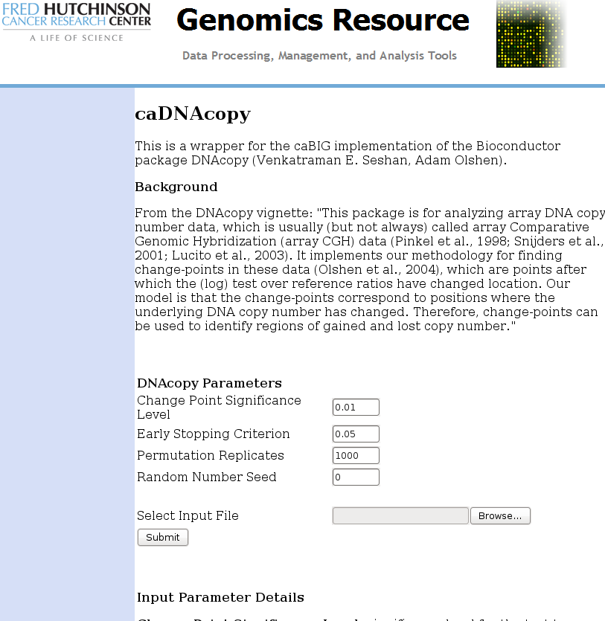Figure 1: caDNAcopy Web Interface

caArrayQualityMetrics
Based on the Bioconductor package arrayQualityMetrics (4), caArrayQualityMetrics generates quality metrics reports from microarray experiment data. Initially, a web applet was developed for testing and rapid deployment to our end users and made available on the Center's intranet. To more seamlessly integrate the service into our workflow, caArrayQualityMetrics has also been made available as a HutchBASE plugin. The resulting caArrayQualityMetrics report that is generated is stored in the database and associated with the experiment from which it was generated. Figures 2 through 5 display a few snapshots of the module's implementation in HutchBASE.
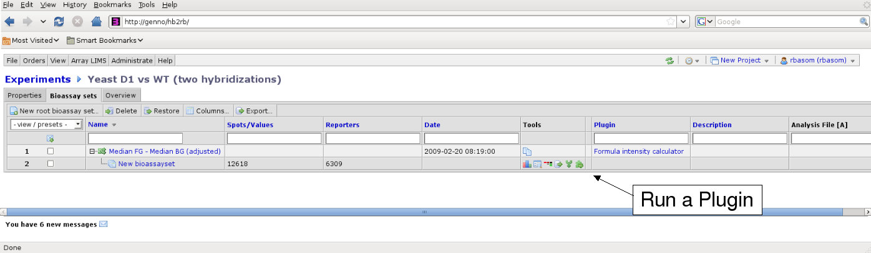Figure 2: Experiment View within HutchBASE, Press the Plugin Button to Begin

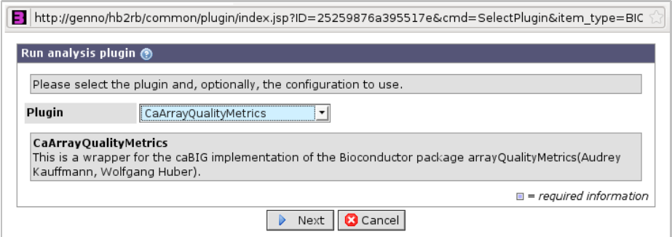Figure 3: Plugin Selection
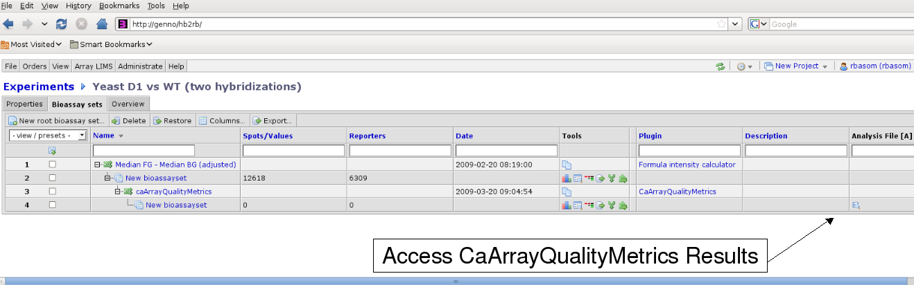Figure 4: Plugin has Executed, Results are Available

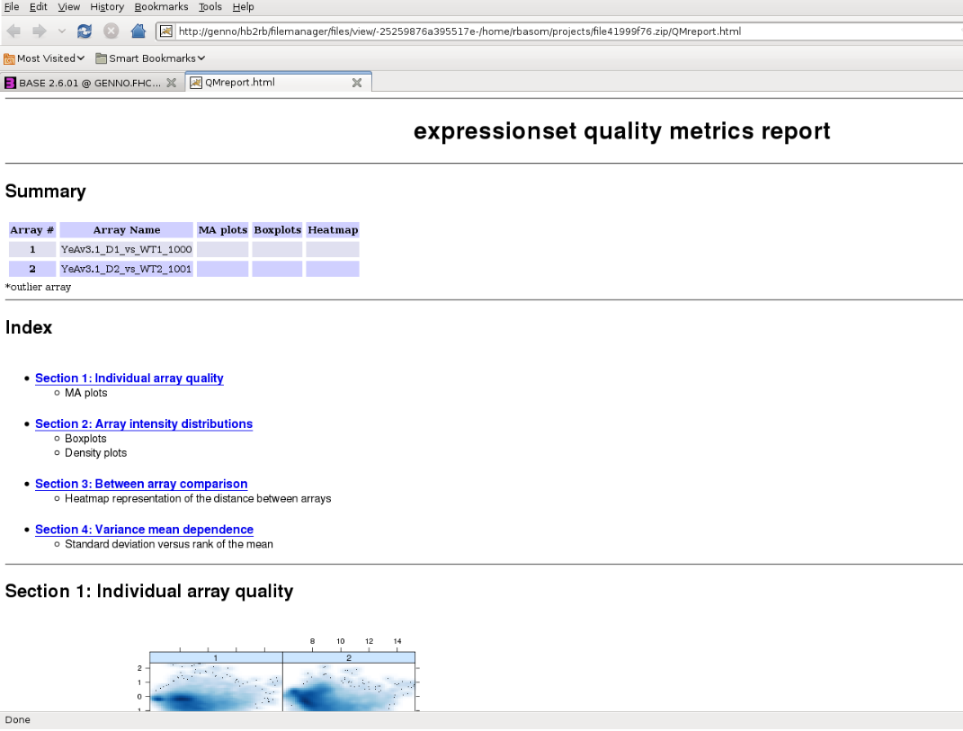Figure 5: caArrayQualityMetrics Report Displayed within HuchBASE
caGeneFilter
caGeneFilter is based on the Bioconductor package genefilter (5), which contains various methods for filtering genes from microarray experiments.
To integrate the service into our workflow, the filters from caGeneFilter that we didn't otherwise have available (specifically, the annotation and KoverA filters) were incorporated into the open source application MeV, which can be launched and populated with data from within 'HutchBASE.' Figures 6 and 7 show a set of data before and after undergoing the annotation filter.
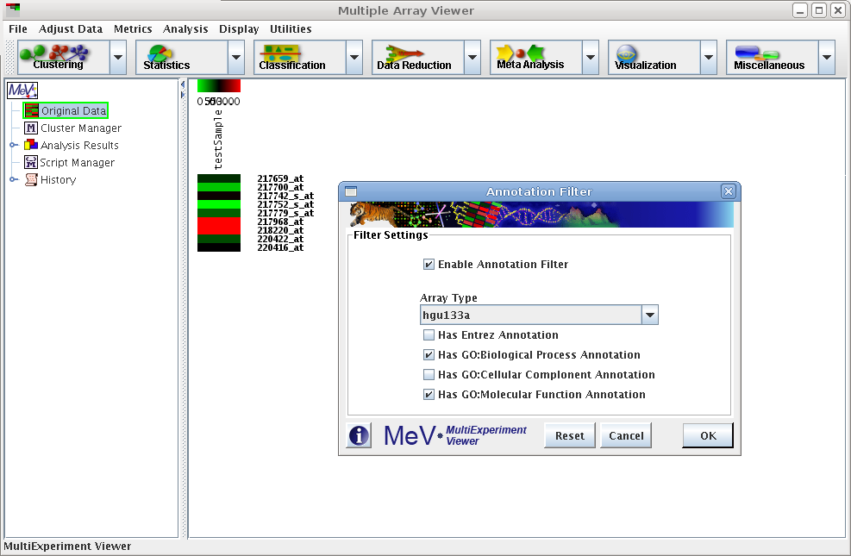Figure 6: Annotation Filter Settings in MeV
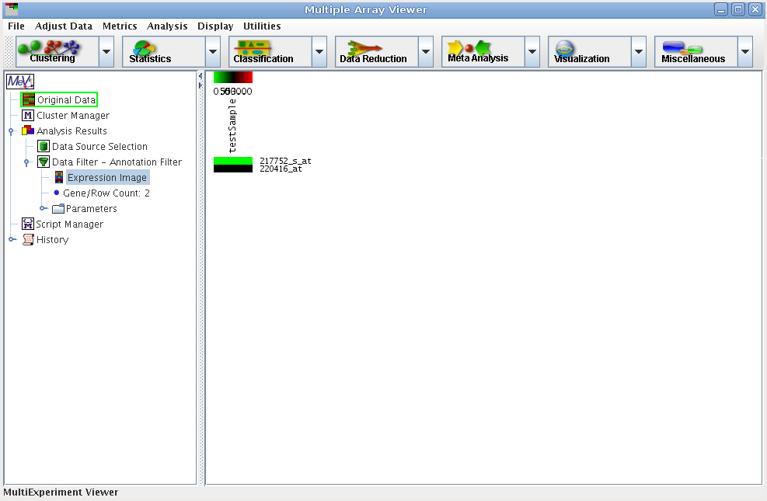Figure 7: Data Post-Filtering

caLinearModel
caLinearModel is based on the Bioconductor package limma (6), which contains tools for working with linear models in the context of differential expression for microarray data. Testing has been completed for the caLinearModel module with plans to integrate it into MeV.
caGeneSetAnalysis
Based on the Bioconductor package GSEABase (7), caGeneSetAnalysis contains classes and methods to support Gene Set Enrichment Analysis. We're currently developing a client and testing caGeneSetAnalysis, with plans to integrate it into MeV.
caMachineLearning
caMachineLearning is based on the Bioconductor package MLInterfaces (8), which provides interfaces to supervised and unsupervised machine learning procedures. We're currently developing a client and testing caGeneSetAnalysis, with plans to integrate it into MeV.
Reflections on the Process
The clients that have been developed during this contract will serve to give our users access to several Bioconductor tools that have been or will be seamlessly integrated into our existing workflow. Having Bioconductor packages available within a user friendly graphical environment is of tremendous benefit as most of our users lack sufficient proficiency in R to otherwise use these tools.
As adopters, we brought to the table some knowledge of basic Java programming as well as bioinformatic needs, which were necessary to utilize the services. Given our experience with adopting each of the modules, we feel that users with similar expertise at other sites should be able to develop their own clients in a straight forward manner. As long as the webservices are hosted in a location that we can access, we plan on keeping these newly developed clients in our workflow.

References
1. Lao H. Saal, Carl Troein, Johan Vallon-Christersson, Sofia Gruvberger, Åke Borg and Carsten Peterson BioArray Software Environment: A Platform for Comprehensive Management and Analysis of Microarray Data Genome Biology 2002 3(8): software0003.1-0003.6
http://base.thep.lu.se
2. Saeed AI, Sharov V, White J, Li J, Liang W, Bhagabati N, Braisted J, Klapa M, Currier T, Thiagarajan M, Sturn A, Snuffin M, Rezantsev A, Popov D, Ryltsov A, Kostukovich E, Borisovsky I, Liu Z, Vinsavich A, Trush V, Quackenbush J. TM4: a free, open-source system for microarray data management and analysis Biotechniques 2003 Feb;34(2):374-8
http://www.tm4.org/mev.html
3. DNAcopy
http://bioconductor.org/packages/2.4/bioc/html/DNAcopy.html
4. arrayQualityMetrics
http://bioconductor.org/packages/2.4/bioc/html/arrayQualityMetrics.html
5. genefilter
http://bioconductor.org/packages/2.4/bioc/html/genefilter.html
6. limma
http://bioconductor.org/packages/2.4/bioc/html/limma.html
7. GSEABase
http://bioconductor.org/packages/2.4/bioc/html/GSEABase.html
8. MLInterfaces
http://bioconductor.org/packages/2.4/bioc/html/MLInterfaces.html
Relevant test logs and client source code can be found at the following URLs:
Test Logs
https://gforge.nci.nih.gov/svnroot/bioconductor/trunk/admin/TestLogs
Adopter Clients
https://hedgehog/compbio/cabig/caGrid/adopterClients/

