Project Management Plan: Bioconductor caGrid analytic service and client development

Project summary
Project name; Bioconductor caGrid analytic service and client development
Start date: August 1, 2008
Cancer Center: Fred Hutchinson Cancer Research Center
Date Awarded:
Current Stage of Project: Development Life Cycle
Points of Contact:
Position | Name | Phone | Email
Project Manager | Dr. Martin Morgan | 206 667 2793 | mtmorgan@fhcrc.org
Project Coordinator | May Alipao | 206 667 6463 | malipao@fhcrc.org

Statement of Work -- Overview
Project management recognizes three broad aspects to the statement of work.
- Tasks 1, 2 and 6 correspond to overall project coordination, and include activities and deliverables that draw from the entire project. These tasks are collectively referred to as ‘oversight’ tasks.
- Tasks 3, 4, and 5 represent iterative software development activities with deliverables representing updating and hosting existing services (Task 3), developing a Bioconductor client (Task 4), and developing additional analytic services (Task 5). These tasks are collectively referred to as ‘developer’ tasks.
- Tasks 7 assess software from the adopter perspective. These tasks are collectively referred to as ‘adopter’ tasks, and their management is presented in a separate document.

Success factors
Factors indicating project success include:
- Successful update of existing Bioconductor / caBIG services
- Deployment of 5 additional Bioconductor / caBIG services
- Development of R / Bioconductor-base caGrid client
- Contribution of reference and benchmark data sets

Work product identification
Table 1 provided a detailed list of deliverables and due dates. The primary point of contact for all deliverables is the project manager.
Table 1: Task deliverables and due dates
REFERENCE | DELIVERABLE | DUE DATE | POINT OF CONTACT
Task 1.1 | Project Management Plan | Initial draft due at project kick off meeting; Final due 20 days following contract award. | Project manager
Task 1.2 | Monthly Status and Financial Report | 10th of each month | Project manager / project coordinator
Task 1.3 | Project Summary Report | Due at project completion | Project manager
Task 2.1 | Use Case Document and Requirements Specification Document | Draft due 60 days after project start, iterative modification throughout the project | Project manager
Task 2.2.1 | UML Static Class Diagram Model | Draft due 90 days after project start; iterative development through the project | Project manager
Task 2.2.2 | Master Design Document | Draft due 90 days after project start; iterative development throughout the project | Project manager
Task 2.3 | Initial or Updated Test Plan | Initial test plan due 60 days after project start, iterative development throughout the project | Project manager
Task 2.4 | API Documents, API Code | One month prior to project completion | Project manager
Task 2.5 | Source Code and Executables, and Test Activity Logs and Bug Reports | Iterative development throughout project; deliverable due 2 weeks prior to project completion | Project manager
Task 2.6 | Updated User Manual and Administration Guide | 2 weeks prior to completion of project performance period | Project manager
Task 2.7 | Installation Guide and Release Notes | 2 weeks prior to completion of project performance period | Project manager
Task 3.1 | Upgrade Existing Bioconductor Analytic Services to caGrid 1.x | Six weeks after project start | Project manager
Task 3.2 | Register Bioconductor caGrid Analytic Services and Hosting on caGrid | Twelve weeks after project start | Project manager
Task 4.1 | Additional Development, Testing and “Hardening” of RWebServices | Iterative throughout the project. | Project manager
Task 4.2 | Develop a Bioconductor Client Interface to caGrid 1.x | 7/22/2009 | Project manager
Tasks 5.1-5.5 | Additional Bioconductor Analytical Service Modules (Propose Timeline for Implementation) | 7/22/2009 | Project manager
Task 6.1.1 | Semantically Annotated XMIs | 6 weeks prior to project completion | Project manager
Task 6.1.2 | CDE Use Report, and Annotated XML Files | 6 weeks prior to project completion | Project manager
Task 6.2 | Compatibility Review Submission Package | 2 weeks prior to completion of project performance period | Project manager

Schedule
Task scheduling is outlined in Figure 1 (overall project planning, tracking, and execution) with additional detail on developer tasks in Figure 2. Tasks 5 (development of new analytic modules) are dependent on ongoing enhancements associated with Task 4.1 (‘hardening’ of RWebServices). Each subtask of Task 4.2 (Bioconductor client) depends on successful copletionof the preceeding subtask task.
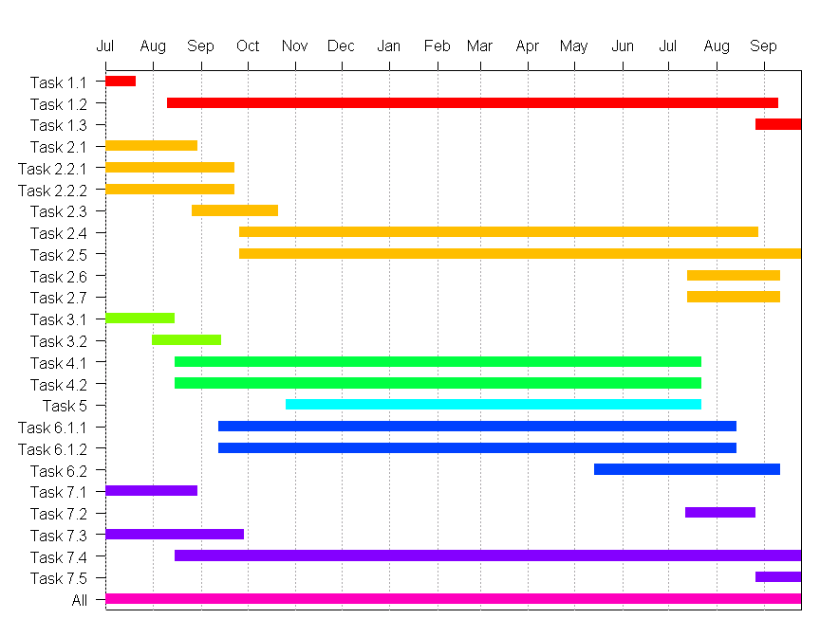
Figure 1: Overall project planning, tracking, and execution schedule
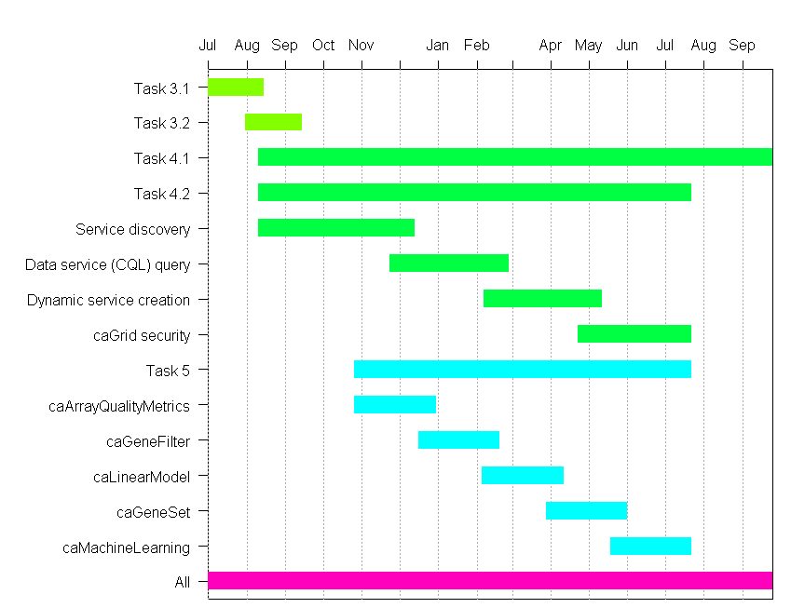 Figure 2: Developer task planning, tracking, and execution schedule

Staff allocation
Staffing falls into two layers, project oversight and project realization. Key personnel, their role, and time commitment are summarized in Table 2
Table 2 Staffing commitments and roles
Individual | Role | Commitment (% FTE)
Dr. Martin Morgan | Project management | 40%
Dr. Robert Gentleman | Technical and domain expertise | 10%
Programmer | Software development; tasks 3 and 4 | 100%
Programmer | Software development; task 5 | 100%
May Alipao | Project coordinator | 20%

Risk identification and mitigation
The project proposal includes development of a risk management plan. The plan includes an incrementally updated log of significant risk issues, possible solutions, and solutions adopted. Risk management will be at the project level, encompassing administrative, development, and adoption risk. Risk management is the primary responsibility of the project manager.
Several risks are apparent at the start of the project; these are outlined in Table 3 and discussed further below.

Table 3 Risk identification and mitigation
Risk | Probability | Preventative measures | Contingency measures
Staffing | Moderate | Active identification of suitable personnel; leverage existing knowledge base; graded increase in task complexity | Increased commitment from senior project team
Technology change | Moderate | Track leading-edge development issues; interact with essential parties; participate in caBIG workspace and other activities | Track currently-released product versions

Staffing risks
The software engineer positions represent significant staffing risks: mainstream engineers with significant Java and web services experience do not usually have extensive experience with R, and vice-versa. We take several approaches to managing this risk.
Drs. Gentleman and Morgan are experts in all aspects of R, from user experience through internal implementation details to inter-(programming) language communication. Both have experience with caGrid technologies, including both the grid service technology stack and the implementation layers required to interface R to Java and grid services.
The lead software engineer is expected to have Java and web services experience in a bioinformatics environment. This represents a large pool of potential candidates, and we anticipate access to a strong pool of possible candidates. We anticipate that creative engineers will be drawn to the opportunity for grid-related development of tools targeted to the established Bioconductor end-user community.
Tasks are scheduled so that the lead software engineer develops skills from their existing strength. The lead software engineer works first on tasks with a large web services and Java component (updating and deploying existing analytic services). This provides the lead software engineer with the opportunity to understand Bioconductor and the underlying R language. This exposure will occur in an environment uniquely rich in Bioconductor expertise (professional development of Bioconductor occurs in Dr. Gentleman’s group). It is anticipated that the lead software engineer will gain expertise through formal interaction with Dr. Morgan, formal internal training opportunities, and informal interaction with the post-doctoral and professional programmers in Dr. Gentleman’s group.
The hire of the second software engineer is delayed until several months into the project. One objective driving this management decision is to establish an effective mentoring relationship between the lead and second software engineer, particularly with respect to Bioconductor training.
Time allocated to tasks is structured so that the duration of initial iterations is longer than subsequent iterations. This allows opportunity for learning during the early iterations, and for efficient execution of tasks as software engineers gain experience.

Risk of technology change
The project relies on a diverse suite of dynamic software components, including R and Bioconductor (new releases every 6 months), caGrid, caArray, and underlying technologies.
We will manage risk of technology change in R and Bioconductor by closely tracking the ‘development’ version of these software products. These products are sufficiently mature that the development version represents incremental changes in underlying technology. Changes often offer improvements in performance or internal representation. Developments are usually introduced in the context of a very large set of functioning packages, and are seldom disruptive on a large scale. Tracking the development version extends the useful life of modules by ensuring that the final product is consistent with the most current release of R and Bioconductor.
Our approach to risk management with caArray and caGrid is to focus on currently released software versions, and to incorporate necessary updates to match new releases in a timely manner. We pursue this approach, since version changes in caArray and caGrid have in the recent past represented substantial changes in exposed interfaces and available functionality. These novel features have not been documented, during development, to the extent required to make productive use of them during development of products such as those in the present proposal.

