CaArray / Bioconductor interoperability
Martin Morgan – May 18, 2009

Pre-requisites
caArray ‘external’ model v. 1.0

Complete model reuse
An ideal situation would knit the outputs of caArray with the inputs of Bioconductor, with complete model reuse. For example, querying caArray to ‘Download data set’ returns a DataSet object summarized below.

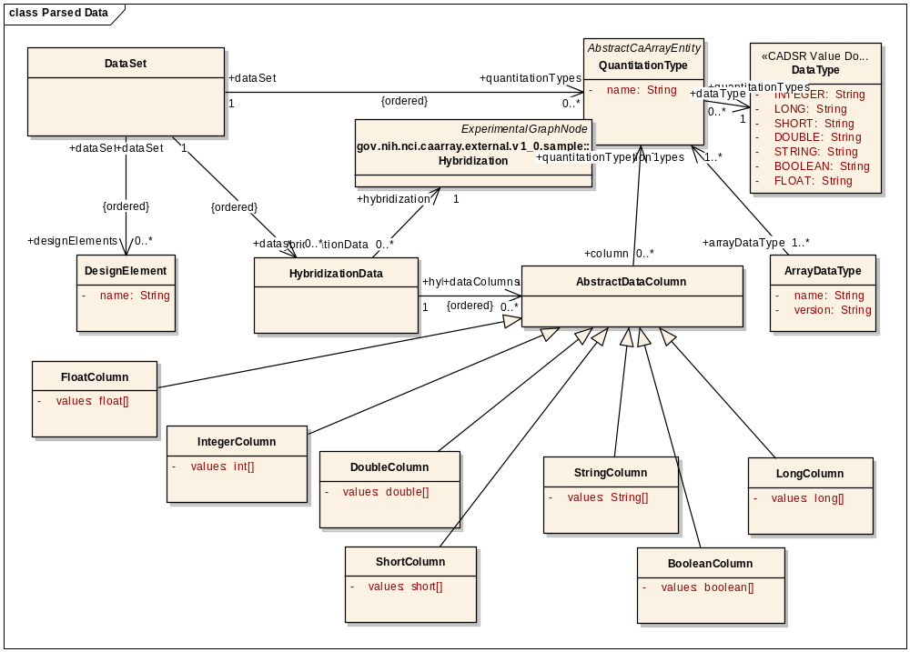

A typical Bioconductor service that might operate on this object is caLinearModel. The main obstacle to complete model reuse is multiplicity of association. There are two examples from the model above.

- Our module expects each HybridizationData to be associated with a single AbstractDataColumn, and for the subclass of that to be DoubleColumn; we would not know how to ‘choose’ between multiple data columns (or would have to provide the user with a way of specifying columns), and would have no use for, say, BooleanColumn or StringColumn.
- (Not illustrated above, but clarified by Rashmi) Hybridization contains multiple associations to FactorValue. Our module requires either one (e.g., a grouping factor for a t-test) or two (e.g., for a two-way ANOVA) FactorValues for each Hybridization. If presented with the model above, we have no way to choose the appropriate FactorValue for the user.

Another obstacle is that certain orderings are implicit in the caArray model (this is probably necessary for the complex data being modeled), whereas we would rather they were explicit. As an example

- In a two-factor ANOVA, the input data must have exactly two FactorValues for each Hybridization. Because of this strong requirement, we would rather model the association explicitly – ‘factorOne’, and ‘factorTwo’ – rather than relying on an implicit association, ordering, and presence of particular FactorValues across Hybridizations.

Partial model reuse
Our current solution reuses ‘leaf’ components of the caArray model. Thus we represent our expression data as a DoubleColumn, our factor values as FactorValue, and our gene / probe set identifiers as DesignElement. These are incorporated into our own objects for ‘data’ input into our services. We also introduce novel model components that represent parameters of the statistical tests we perform, and that have no comparable elements in caArray.

caGrid Transfer
CaArray can be queried for raw (‘manufacturer’) files, and these can be retrieved using caGrid Transfer. We do not currently, but could, accept the return type from an appropriately formulated caArray request, and use this to invoke caGrid transfer on the caArray instance to perform the transfer directly into our service. This could be very straight-forward, or quite complicated (delegating security credentials, satisfying semantic requirements, and standardizing transfer protocols are all areas of uncertainty, and all depend on the implementation details of CaArray). We have delayed implementing anything so far because of the dependence on these CaArray implementation details.

