C3PR – Core &Web
Technical Specification

Copyright Notice. Copyright 2006 Duke Comprehensive Cancer Center (“caBIG™ Participant”). caTRIP was created with NCI funding and is part of the caBIG™ initiative. The software subject to this notice and license includes both human readable source code form and machine readable, binary, object code form (the “caBIG™ Software”).
This caBIG™ Software License (the “License”) is between caBIG™ Participant and You. “You (or “Your”) shall mean a person or an entity, and all other entities that control, are controlled by, or are under common control with the entity. “Control” for purposes of this definition means (i) the direct or indirect power to cause the direction or management of such entity, whether by contract or otherwise, or (ii) ownership of fifty percent (50%) or more of the outstanding shares, or (iii) beneficial ownership of such entity.
License. Provided that You agree to the conditions described below, caBIG™ Participant grants You a non-exclusive, worldwide, perpetual, fully-paid-up, no-charge, irrevocable, transferable and royalty-free right and license in its rights in the caBIG™ Software, including any copyright or patent rights therein that may be infringed by the making, using, selling, offering for sale, or importing of caBIG™ Software, to (i) use, install, access, operate, execute, reproduce, copy, modify, translate, market, publicly display, publicly perform, and prepare derivative works of the caBIG™ Software; (ii) make, have made, use, practice, sell, and offer for sale, and/or otherwise dispose of caBIG™ Software (or portions thereof); (iii) distribute and have distributed to and by third parties the caBIG™ Software and any modifications and derivative works thereof; and (iv) sublicense the foregoing rights set out in (i), (ii) and (iii) to third parties, including the right to license such rights to further third parties. For sake of clarity, and not by way of limitation, caBIG™ Participant shall have no right of accounting or right of payment from You or Your sublicensees for the rights granted under this License. This License is granted at no charge to You. Your downloading, copying, modifying, displaying, distributing or use of caBIG™ Software constitutes acceptance of all of the terms and conditions of this Agreement. If you do not agree to such terms and conditions, you have no right to download, copy, modify, display, distribute or use the caBIG™ Software.
Your redistributions of the source code for the caBIG™ Software must retain the above copyright notice, this list of conditions and the disclaimer and limitation of liability of Article 6 below. Your redistributions in object code form must reproduce the above copyright notice, this list of conditions and the disclaimer of Article 6 in the documentation and/or other materials provided with the distribution, if any.
Your end-user documentation included with the redistribution, if any, must include the following acknowledgment: “This product includes software developed by Duke Comprehensive Cancer Center.” If You do not include such end-user documentation, You shall include this acknowledgment in the caBIG™ Software itself, wherever such third-party acknowledgments normally appear.
You may not use the names “Duke Comprehensive Cancer Center”, “The National Cancer Institute”, “NCI”, “Cancer Bioinformatics Grid” or “caBIG™” to endorse or promote products derived from this caBIG™ Software. This License does not authorize You to use any trademarks, service marks, trade names, logos or product names of either caBIG™ Participant, NCI or caBIG™, except as required to comply with the terms of this License.
For sake of clarity, and not by way of limitation, You may incorporate this caBIG™ Software into Your proprietary programs and into any third party proprietary programs. However, if You incorporate the caBIG™ Software into third party proprietary programs, You agree that You are solely responsible for obtaining any permission from such third parties required to incorporate the caBIG™ Software into such third party proprietary programs and for informing Your sublicenses, including without limitation Your end-users, of their obligation to secure any required permissions from such third parties before incorporating the caBIG™ Software into such third party proprietary software programs. In the event that You fail to obtain such permissions, You agree to indemnify caBIG™ Participant for any claims against caBIG™ Participant by such third parties, except to the extent prohibited by law, resulting from Your failure to obtain such permissions.
For sake of clarity, and not by way of limitation, You may add Your own copyright statement to Your modifications and to the derivative works, and You may provide additional or different license terms and conditions in Your sublicenses of modifications of the caBIG™ Software, or any derivative works of the caBIG™ Software as a whole, provided Your use, reproduction, and distribution of the Work otherwise complies with the conditions stated in this License.
THIS caBIG™ SOFTWARE IS PROVIDED "AS IS" AND ANY EXPRESSED OR IMPLIED WARRANTIES (INCLUDING, BUT NOT LIMITED TO, THE IMPLIED WARRANTIES OF MERCHANTABILITY, NON-INFRINGEMENT AND FITNESS FOR A PARTICULAR PURPOSE) ARE DISCLAIMED. IN NO EVENT SHALL THE DUKE COMPREHENSIVE CANCER CENTER OR ITS AFFILIATES BE LIABLE FOR ANY DIRECT, INDIRECT, INCIDENTAL, SPECIAL, EXEMPLARY, OR CONSEQUENTIAL DAMAGES (INCLUDING, BUT NOT LIMITED TO, PROCUREMENT OF SUBSTITUTE GOODS OR SERVICES; LOSS OF USE, DATA, OR PROFITS; OR BUSINESS INTERRUPTION) HOWEVER CAUSED AND ON ANY THEORY OF LIABILITY, WHETHER IN CONTRACT, STRICT LIABILITY, OR TORT (INCLUDING NEGLIGENCE OR OTHERWISE) ARISING IN ANY WAY OUT OF THE USE OF THIS caBIG™ SOFTWARE, EVEN IF ADVISED OF THE POSSIBILITY OF SUCH DAMAGE.

Development Team(s)
Development | Technical Documentation | Program Management
Kruttik Aggarwal² | Manav Kher² | Bob Annechiarico¹
Manav Kher² | Priyatam Mudivarti² | Jamie Cuticchia¹
Priyatam Mudivarti² |  | Patrick McConnell¹
Ram Chilukuri² |  | Ram Chilukuri²
Ramakrishna Gundala²
¹Duke Comprehensive Cancer Center | ²SemanticBits

Contacts and Support
Enter training contact | Patrick McConnell (patrick.mcconnell@duke.edu)
Enter customer support contact | NA

LISTSERV Facilities Pertinent to software teams
LISTSERV | URL | Name
c3prv2-elaborator | c3prv2-elaborators@gforge.nci.nih.gov | C3PR Elaborators Forum
C3prv2-general | c3prv3-general@gforge.nci.nih.gov | C3PR General Forum
C3prv2-developers | c3prv2-developers@gforge.nci.nih.gov | C3PR Developers Forum

1. Scope and Purpose 6
2. Overview 6
2.1. Technology Stack 6
2.2. Core Modules 7
2.2.1. Domain Object Layer 7
2.2.2. Views 7
2.2.3. Controllers 7
2.2.4. Commands 7
2.2.5. Service Layer 7
2.2.6. Persistence Layer 7
2.2.7. Utilities 7
3. Domain Analysis Model 9
4. Implementation Model 10
5. Data Model 11
6. Use Case Realization 12
6.1. Create Study 12
6.1.1. Activity Diagram 12
6.1.2. Sequence Diagram 13
6.2. Search Study 13
6.2.1. Activity Diagram 14
6.2.2. Sequence Diagram 14
6.3. Create Subject 15
6.3.1. Activity Diagram 15
6.3.2. Sequence Diagram 16
6.4. Search a Subject 17
6.4.1. Activity Diagram 17
6.4.2. Sequence Diagram 18
6.5. Register Subject to a Study 18
6.5.1. Activity Diagram 18
6.5.2. Sequence Diagram 19
7. Integration with External Systems 19
7.1. ESB Client 19
8. Unit Testing 19
8.1. JUnit 19
8.2. Spring Mock Objects 19
8.3. Generic Test Classes 19
9. Integration Testing 20
10. Configuration/Build/Deployment 20

Scope and Purpose
The scope of this document is to provide technical design / specification, for the Core & Web project modules within C3PR v2. The specification will include the use case realizations within each iteration with accompanying UML models and documentation wherever appropriate.
The purpose of this document is to facilitate development with an initial phase of analysis and design and support as a documentation of the overall design in the Core project for other developers.

Overview
C3PR Core project consists of the core modules for overall project like domain objects, service layer classes, Data Access Objects (DAOs), db scripts, utility classes and shared libraries servicing the entire project. The sub-project is built independently from the others and is included as a dependency for other projects. Although the Core project cannot be deployed as an application itself, it can packaged in a separate jar to include in your project’s classpath.

Technology Stack

Operating System | Windows XP/Linux
Java Version | JDK 1.5.2
MVC framework | Spring MVC 2.0
View Technology | JSP, JSP Tag libraries, AJAX
AJAX Framework | Direct Web Remoting (DWR), Scriptaculus
ORM | Hibernate 3.2.1
Transactions, IOC, dependency injection | Spring 2.0
Web Server | Tomcat 5.5.20
Database | Oracle 10x / PostgreSQL 8x
Development Tools | Eclipse 3.2/JBoss IDE 2.0, Enterprise Architect 4.5
Build | Ant
Source Control | CVS (gForge)

Core Modules

Domain Object Layer
C3PRv2 has a domain driven design with analysis starting from a BRIDG (Biomedical Research Integrated Domain Group) Harmonized model. A set of domain objects will be created in edu.duke.cabig.c3pr.domain. Once domain model is finalized, an immediate Implementation Model is based out of the domain model which identifies the Java classes, associations. The SAMe domain objects are persisted using Hibernate and Hibernate 3 annotations will be used for mapping to database elements instead of separate hbm files. These annotations can in turn be configured via Spring’s bean configuration files.

Views
The view technology incorporated in C3PRv2 consists of JSP pages, css, AJAX and tag libraries included from Spring.

Controllers
Spring’s MVC is being used as the defacto MVC architecture for C3PRv2. All the Controller classes for the respective use case will be located in the package edu.duke.cabig.c3pr.web

Commands
A set of command objects (Form objects) as per the Spring MVC which acts as a command for each controller. It is recommended to use domain objects as command wherever applicable to reduce the unnecessary creation of extra value objects.

Service Layer
The service layer will expose a set of interfaces for the client to call in (currently the interface decided is a Web Interface). The Controller classes typically delegate the functionality to Service classes. Spring adds the dependency injection for the implemented classes as Controller need not be coupled with the SAM.

Persistence Layer
DAO implementations will be created to facilitate database access. The application will only access the database via a DAO interface object. Each implementation of the dao interface would a specific implementation (in this case, hibernate) which extend the org.Springframework.orm.hibernate3.support.HibernateDaoSupport class that provides a good template for quickly building data access methods without the risk of database leaks and poor error handling.

Utilities
Several Utility classes for supporting Springmvc framework like propertyEditors, tag libraries, email, xml marshalling, string etc are included in this package, etc

Open Session In View filter

A filter which implements the Open Session In View pattern. Different from the one built into Spring because this one delegates to an instance of OpenSessionInViewInterceptor configured in the application context. This permits the use of the same interceptor for deployed code & unit tests.
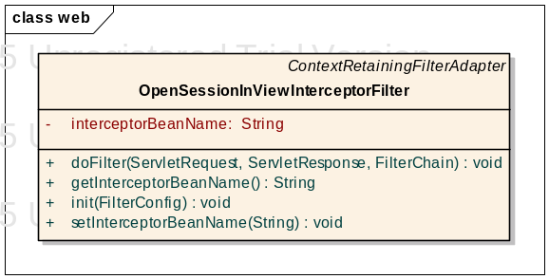

XmlMarshaller

A handy utility to Marshall/unmarshall xml files

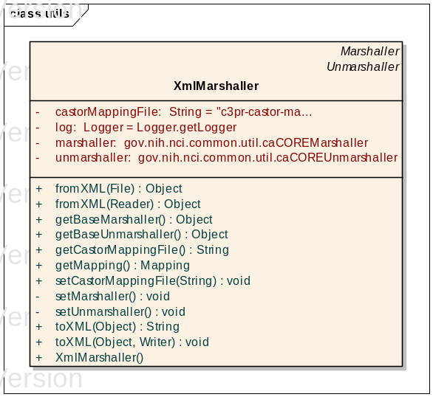

Domain Analysis Model
The domain analysis model for C3PR is based on a BRIDG.

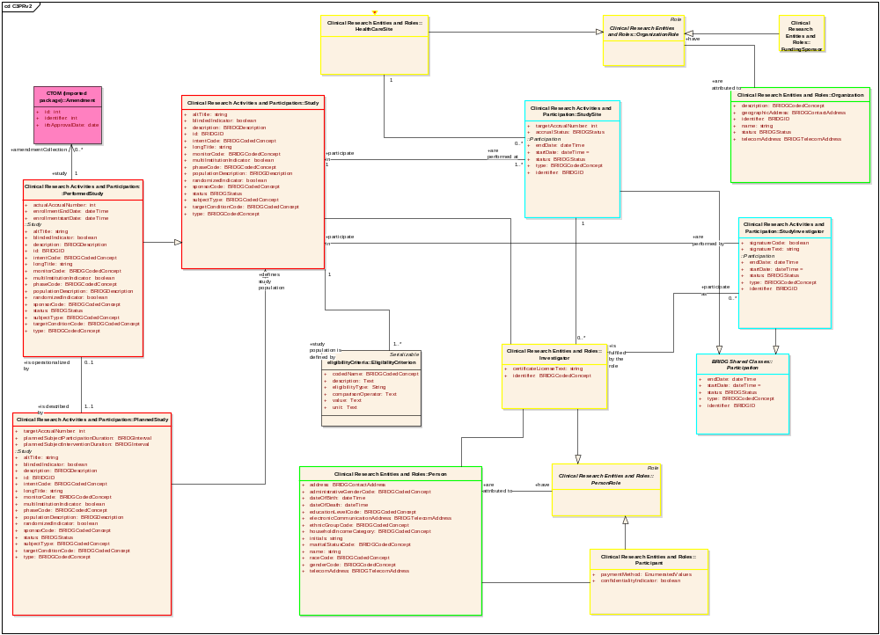

Implementation Model
Derived from Domain Analysis model, the implementation model is a model realized for a Java implementation with classes, associations. For a complete UML model, refer the Domain model section in c3pr-uml design in appendix

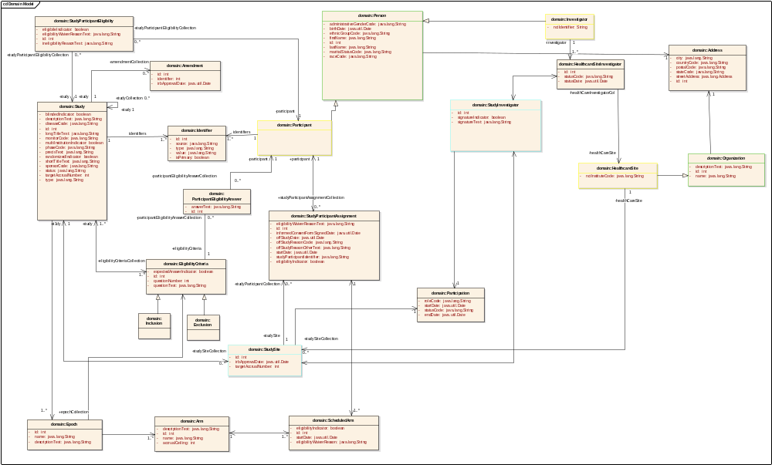

Data Model
C3PR is currently tested for Oracle 10x/Postgres 8x databases

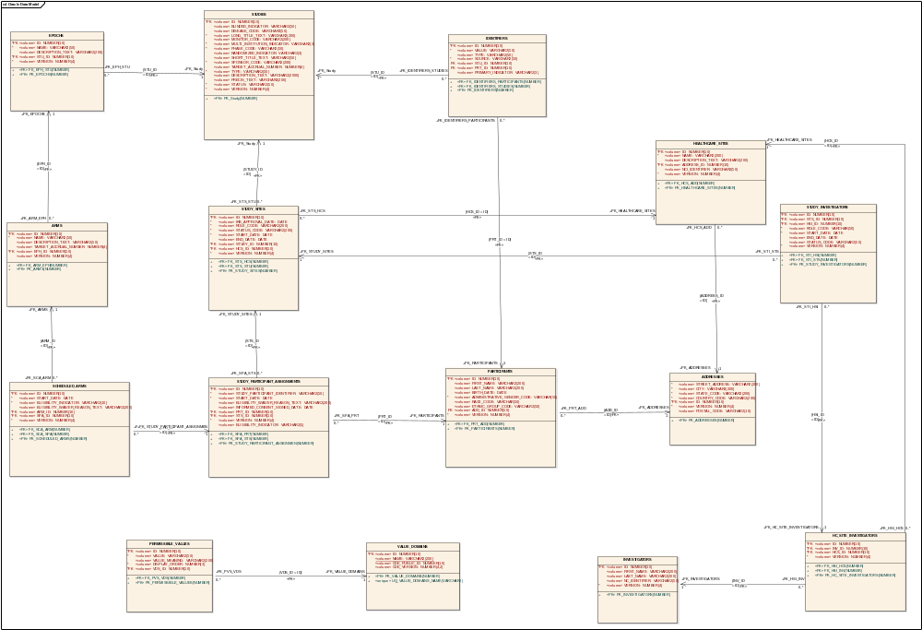

Use Case Realization

Create Study
This use-case deals with the manual creation of a study by entering each data element of the study.

Activity Diagram
The workflow is split into multiple pages in a Wizard style for capturing individual pieces of information for simplifying the workflow of Study creation

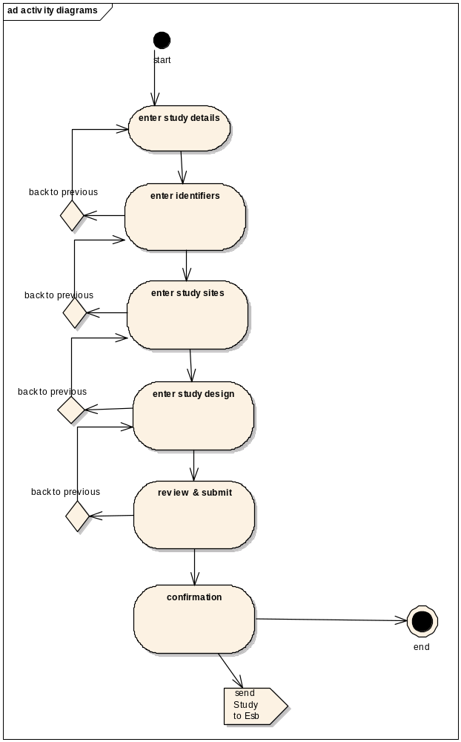

Sequence Diagram
Core controller of Create Study is based on Spring’s AbstractWizardFormController. This eliminates the session/form handling by the developer and provides fine extension points for generating a workflow between a well defined set of pages with the notion of back/next buttons. The validations used on the page are two level – client side javascript and server side Spring Validator validations (to be done only on the last page).

The command object used for the controller is the domain object itself. The advantages of this design is that there are no unnecessary value objects/DTOs used in the whole process and the emphasis is on reusing rich domain objects across all layers in the appropriate context. The View saves individual elements of Study object within each page of the workflow (wizard) dynamically and on the last page the entire graph of Study object along with it’s associations of StudySite, Identifiers, Epochs, Arms are saved.
Spring’s HibernateTemplate is used to saveOrUpdate the populated domain object

This also involves in integration with ESB client interface to add an asynchronous message. ServiceMix and GridServices are used to propagate the newly created Study. The Activity diagram is omitted in lieu of the sequence diagram (which is more useful).

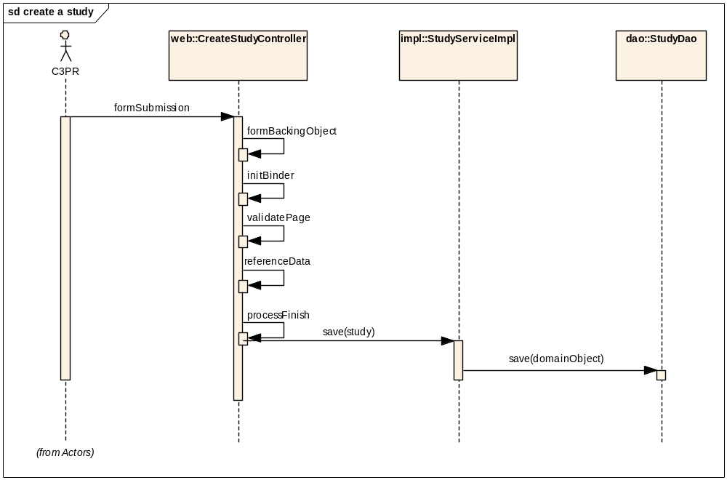

Search Study
This use-case deals with searching an existing Study either by status, long title or by one of the Identifiers

Activity Diagram
User is provided a simple Form where search criteria can be entered (includes wildcards), search results are displayed in separate search results page with an option of searching from the same page via an intuitive search bar on the top of search results page

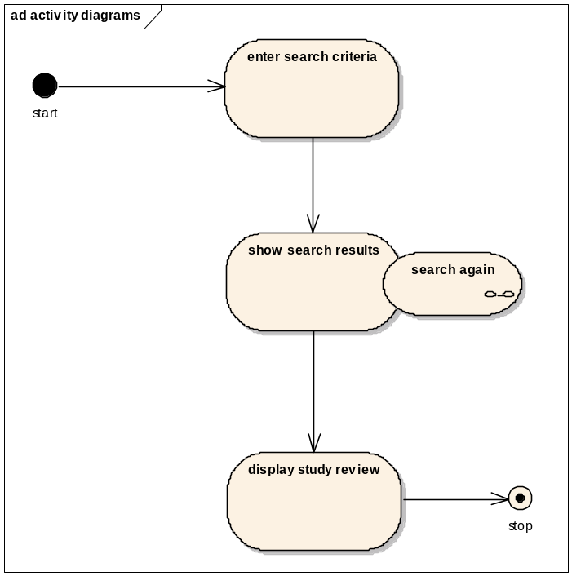

Sequence Diagram
As it’s a simple search, a SimpleFormController is being used for implementing the behavior of
Search->SearchRestults page. Hibernate’s SearchByExample is being used to search using an example object populated with the user’s dynamic criteria.

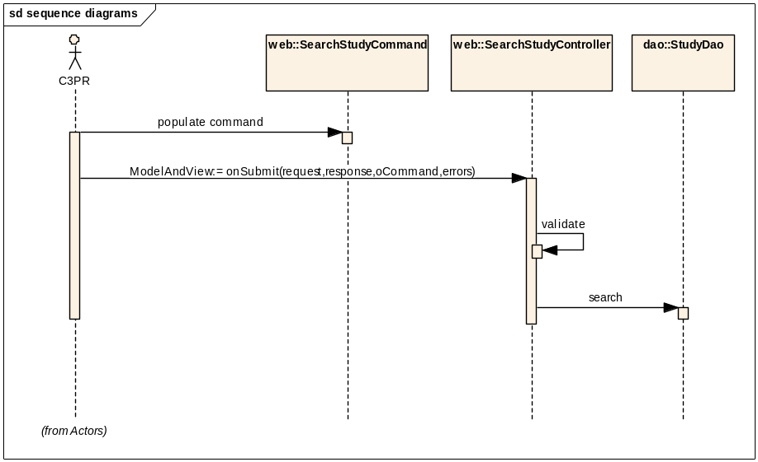

Create Subject
This use-case deals with the creation of a subject by entering each data element of the subject

Activity Diagram
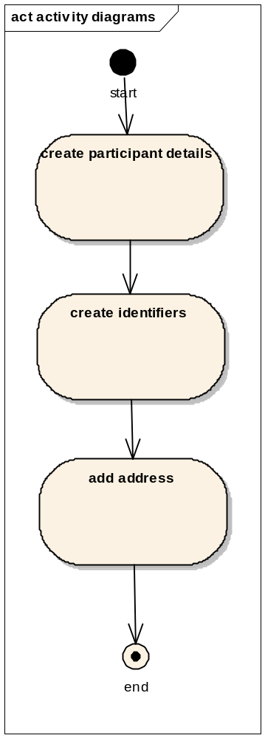

Sequence Diagram
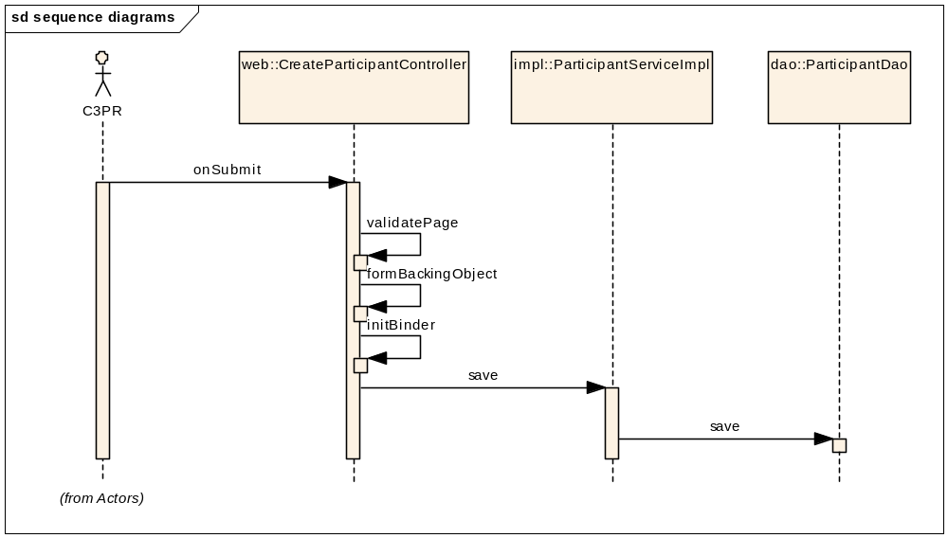

Search a Subject

Activity Diagram
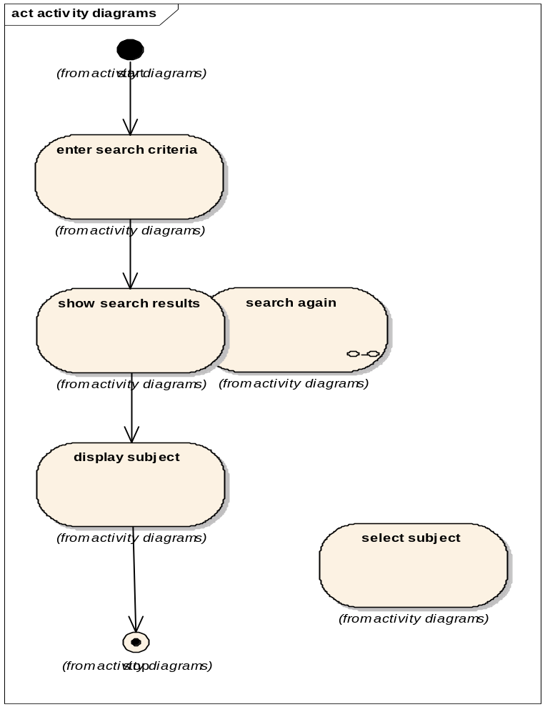

Sequence Diagram
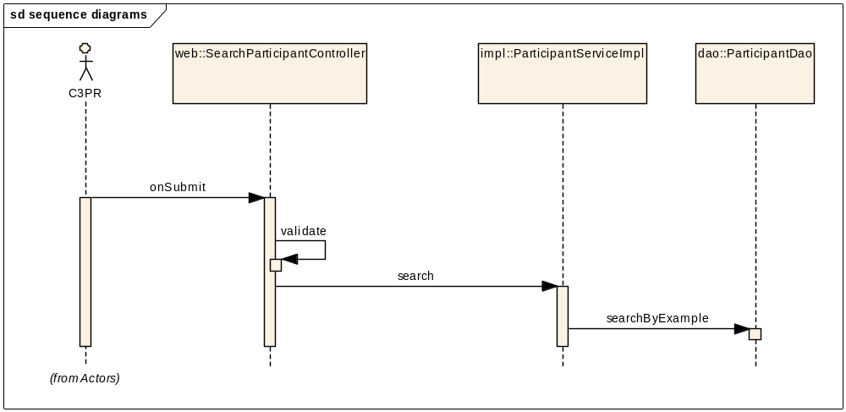

Register Subject to a Study
This use case deals with registering a participant with a study at a study site. The following are the various scenarios possible:
- Patient not currently in C3PR.
- Patient already existing in C3PR but not registered to any protocol.

Activity Diagram
The workflow is split into multiple pages in a Wizard style for capturing individual pieces of information for simplifying the workflow of Registration.
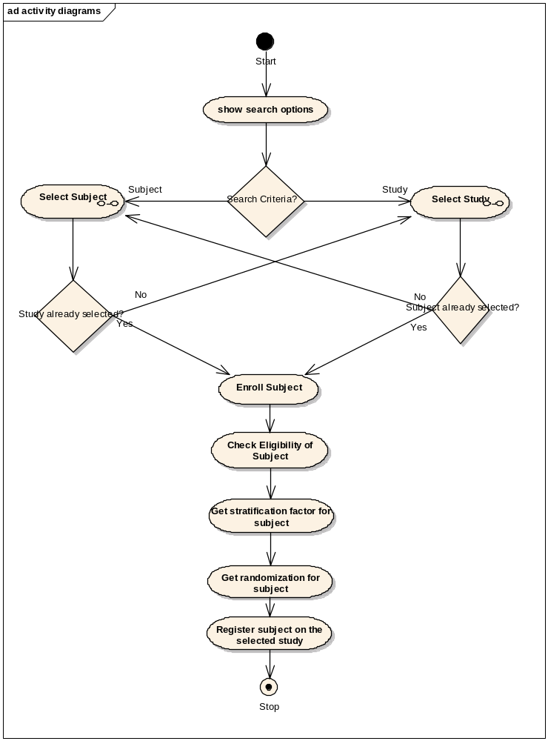
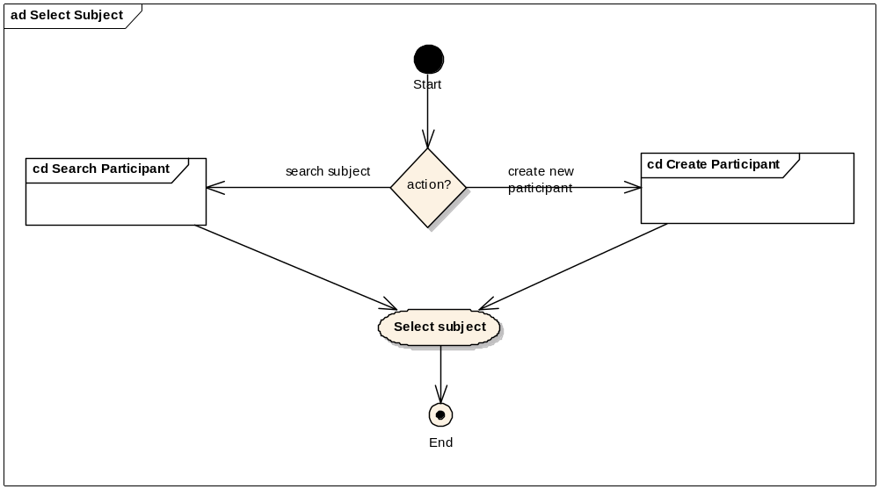
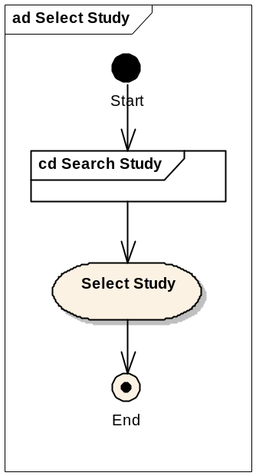

Sequence Diagram
Core controller of Registration is based on Spring’s AbstractWizardFormController. This eliminates the session/form handling by the developer and provides fine extension points for generating a workflow between a well defined set of pages with the notion of back/next buttons. The validations used on the page are two level – client side javascript and server side Spring Validator validations (to be done only on the last page).

The command object used for the controller is the domain object itself. The advantages of this design is that there are no unnecessary value objects/DTOs used in the whole process and the emphasis is on reusing rich domain objects across all layers in the appropriate context. The View saves individual elements of StudyParticipantAssignment object within each page of the workflow (wizard) dynamically and on the last page the entire graph of StudyParticipantAssignment object along with it’s associations of StudySite, Participant and ScheduledArms are saved.
Spring’s HibernateTemplate is used to saveOrUpdate the populated domain object

This also involves in integration with ESB client interface to add an asynchronous message. ServiceMix and GridServices are used to propagate the newly created Registration. The Activity diagram is omitted in lieu of the sequence diagram (which is more useful).

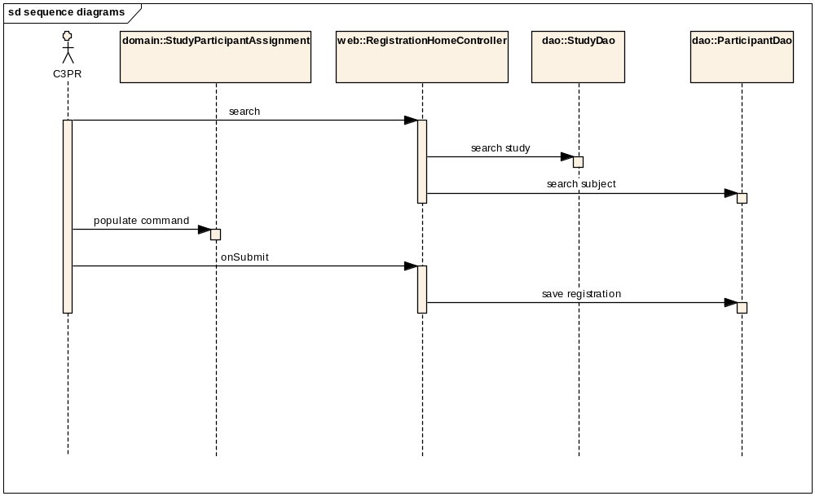

Integration with External Systems

ESB Client
C3PR Service interacts with an ESB client for messaging in order to pass on the data created (new Study, registration etc) to other instances of C3PR, as well as other external applications. More information about the design of ESB can be found in the technical design of ESB

Unit Testing

JUnit
JUnit framework will be used for unit testing.

Spring Mock Objects
Use of Spring mock objects for mocking the dependent layers

Generic Test Classes
A set of generic JUnit Test cases will be written for each layer to expedite the unit testing across each layer.

Integration Testing
Integration Testing will be achieved via JUnit/Haste frameworks. This is integrated with the main build file.

Configuration/Build/Deployment
The files in the Core/Web projects will be build through the main build file (build-core & build-web individually). For all other builds like build-tests, the individual build files of these projects have corresponding ant tasks
- References
No | Artifact | Type | Link
1 | GForge CVS Repository | CVS Repository | gforge.nci.nih.gov
2 | c3pr_uml.eap | UML Design
3 | C3PRv2-BRIDG.EAP | Domain Model | gforge.nci.nih.gov
4 | C3prv2_use_cases.doc | Use Cases | gforge.nci.nih.gov
5 | c3prv2_technical_architecture.doc | Architecture | gforge.nci.nih.gov
6 | C3prv2_srs.doc | SRS | gforge.nci.nih.gov
7 | c3prv2_technical_spec_servicemix.doc | design | gforge.nci.nih.gov

- Glossary
Term | Definition
C3PR | Cancer Central Clinical Participant Registry
API | Application Programming Interface
GUI | Graphical User Interface
UML | Unified Modeling Language

