caBIG® Platform Independent Model and Service Specification

Subject Registration

1.1

12th August 2010

Authors | Kunal Modi
Editor | Kunal Modi, Santosh Joshi, Kruttik Aggarwal, Denis Krylov
Reviewers | Kunal Modi, Kalpesh Patel, Santosh Joshi, Brian McIndoe, Kruttik Aggarwal, Denis Krylov
Architecture Inception Team | Kalpesh Patel, John Koisch, Paul BoyesChristo Andonyadis

Version Number | Date | Contributor | Description
0.0.1 | 11/30/2009 | Kunal Modi | Initial Draft
0.0.2 | 12/15/2009 | Kunal Modi | Incorporated ESST team’s review comments
1.0 | 08/10/2010 | Kruttik Aggarwal | Reflecting changes from CFSS
1.1 | 08/10/2010 | Kruttik Aggarwal | Updated the information model

TABLE OF CONTENTS

1 Introduction 4
1.1 Overview 4
1.2 Relationship to Standards 4
1.3 Relation to the Subject Registration Conceptual Functional Service Specification 4
1.3.1 Conformance and Compliance 5
2 Platform Independent Model and Service Specification 7
2.1 Overview and Architecture 7
2.2 Implementation Considerations 7
2.2.1 Assumptions 8
2.2.2 Deployment Considerations 8
2.2.3 Jurisdictional Domains 8
2.3 Information Model 9
2.3.1 StudySubject Type 9
2.3.2 StudySubject State Model 12
2.3.3 Subject Registration Implementation model 13
2.3.4 Error Implementation Model 14
2.4 Control Data Type Definitions 15
2.4.1 Status/Return Values/Exceptions 15
2.4.2 Error Codes 15
2.4.3 Query Parameters and Result Sets 17
3 Interfaces 18
3.1 UML Model of Interfaces 18
3.2 Operations (Enumeration) 18
3.3 Operation Behavior Descriptions 21
3.3.1 SR-INF 1: SRManagementBase Interface 21
3.3.2 SR-INF2: SRQuery Interface 22
3.3.3 SR-INF3: SRManagementCoordinatingCenter Interface 23
3.3.4 SR-INF4: SRManagementSite Interface 28
3.3.5 SR-INF5: SRReporting Interface 30
4 Dynamic Model 33
5 Profiles 34
5.1 Functional Profiles 34
5.2 Semantic Profiles 37
6 Relationship with other services 38
7 Conformance Statements 39
8 Appendix A - References 40
9 Appendix B - Glossary 41
10 Appendix C - Cross Reference Tables 42
10.1 Interface to Profile Mapping 42
10.2 Interface Operations to Profile Operations 42

Subject Registration Platform Independent Model and Service Specification

Introduction

Overview
The purpose of the Subject Registration service is to provide a set of interfaces to manage the clinical subject registration process, including multi-site studies. In addition, this service is intended to provide authoritative information on a subject’s registration.

This service is part of NCI’s Enterprise Services (NES) and has to adhere to all the service specifications and guidelines set by the NCI’s Enterprise Conformance and Compliance Framework (ECCF). This service also has to adhere to the underlying NCI’s version of BRIDG v2.1 and use the NCI’s restricted list of ISO 21090 data types.

The following document provides the Platform Independent Model and Service Specification (PIMSS) for Subject Registration which is compliant with all the standards and guidelines mentioned above and at the same time are compliant to all the functionality described by the conformance profiles in the Subject Registration Conceptual Functional Service Specification (CFSS)

Relationship to Standards

Standards | Description
NCI’s BRIDG v3.0.1 | The Subject Registration Service will use NCI’s version of BRIDG Model
NCI’s ISO 21090 | The Subject Registration Service will use the NCI’s implementation of ISO 21090

Relation to the Subject Registration Conceptual Functional Service Specification

Conceptual Functional Service Specification Name | Conceptual Functional Service Specification Version | Description & Link to the Conceptual Functional Service Specification
Subject Registration Conceptual Functional Service Specification | 1.2 | The Subject Registration Platform Independent Model and Service Specification follows the Subject Registration Conceptual Model and Service Specification located at the following location:  https://ncisvn.nci.nih.gov/svn/c3pr/trunk/c3prv2/documentation/design/essn/SubjectRegistration/CFSS_Subject_Registration_Service_08-01-2010.doc

Deviation from the Conceptual Functional Service Specification | Reason for Deviation
None | Not Applicable

Conformance and Compliance
This service is conformant and compliant to the following conformance profiles described in the Subject Registration Conceptual Functional Service Specification

Conformance Profile No. | SR-CP1
Conformance Profile Name | SR Query BRIDG V3.0.1
Functional Profiles
  Functional Profile No. | Functional Profile Name
  SR-FP1 | SR Query
Semantic Profiles
  Semantic Profile No. | Semantic Profile Name
  SR-SP1 | SR BRIDG V3.0.1

Conformance Profile No. | SR-CP2
Conformance Profile Name | SR Site BRIDG V2.1
Functional Profiles
  Functional Profile No. | Functional Profile Name
  SR-FP2 | SR Site
Semantic Profiles
  Semantic Profile No. | Semantic Profile Name
  SR-SP1 | SR BRIDG V2.1

Conformance Profile No. | SR-CP3
Conformance Profile Name | SR CCenter BRIDG V2.1
Functional Profiles
  Functional Profile No. | Functional Profile Name
  SR-FP3 | SR CCenter
Semantic Profiles
  Semantic Profile No. | Semantic Profile Name
  SR-SP1 | SR BRIDG V2.1

Conformance Profile No. | SR-CP4
Conformance Profile Name | SR Reports BRIDG V2.1
Functional Profiles
  Functional Profile No. | Functional Profile Name
  SR-FP4 | SR Reports
Semantic Profiles
  Semantic Profile No. | Semantic Profile Name
  SR-SP1 | SR BRIDG V2.1

Platform Independent Model and Service Specification

Overview and Architecture
The sections below fully describe the overall architecture of the Subject Registration Service Interface. It provides details about the operations and behavior of the interfaces exposed by the service. These interfaces are designed for the end consumer and are designed based on the functionality which is accessed cohesively by each of the consumers. Based on this grouping of functionality the overall service is spilt into 5 interfaces.

Subject Registration Management Base: This interface contains all the operations which are accessed both by consumers at each trial site as well as the coordinating center. These operations are generally related to updating an existing subject registration.
Subject Registration Management Site: This interface contains only those operations which are accessed by the consumers at each trial sites. These operations are generally pertaining to initiating a registration request or slot reservations.
Subject Registration Management Coordinating Center: This interface contains only those operations which are accessed by the consumers at the coordinating center. These operations are generally pertaining to approving a registration request as well as slot reservations
Subject Registration Query: This interface contains operations which are accessed both by the consumers at each trial site as well as the coordinating center to retrieve an existing subject registration.
Subject Registration Reporting: This interface contains operations which are used by the CCRB, IRBs, Administrators, Sponsors to produce various reports to track the accrual, screening as well as demographic information for a particular study.

This grouping is done in order to be compliant with the functional profiles described in the CFSS. All operations accept NCI’s BRIDG v2.1 based object for input and output and use the ISO 21090 data types for data transfer. There are certain classes which have been added to facilitate return of report data.

Implementation Considerations

Implementation Consideration | Impact
Service to use the constrained ISO datatypes | The service developed might not be fully compliant with other ISO 21090 systems
Service to use NCI’s version of BRIDG v3.0.1 | The service developed might not be fully compliant with other BRIDG v3.0.1 systems

Assumptions

Assumptions | Affects
Audit & Logging is assumed to be handled by supporting infrastructure | As a result it is not explicitly referenced in individual operations and assumed to be done automatically
Authorization checks are enforced | Only authorized users will be allowed access
Demographics CRF Requirements not considered | The demographics CRF requirements will be considered in future
Single Demographic Information per subject is stored | Support for storage of multiple demographics data for a subject per study will be considered in future

Deployment Considerations

Deployment Consideration | Impact
Remote Deployment Mode | Service should run remotely and be able to support remote client
Multiple Jurisdiction | Service should be able to be deployed across various institutions and be compliant with local jurisdictions
External Access | The coordinating center would need to be able to access the SR Query & SR CCenter profiles at each of the participating sites within the given study

Jurisdictional Domains

Jurisdictional Domains | Boundary
Trial Co-ordinating Center & Trial Sites | The Subject Registration will be deployed at various institutions where trials would be conducted. They would be under jurisdiction of these individual centers

Information Model

Analysis Model

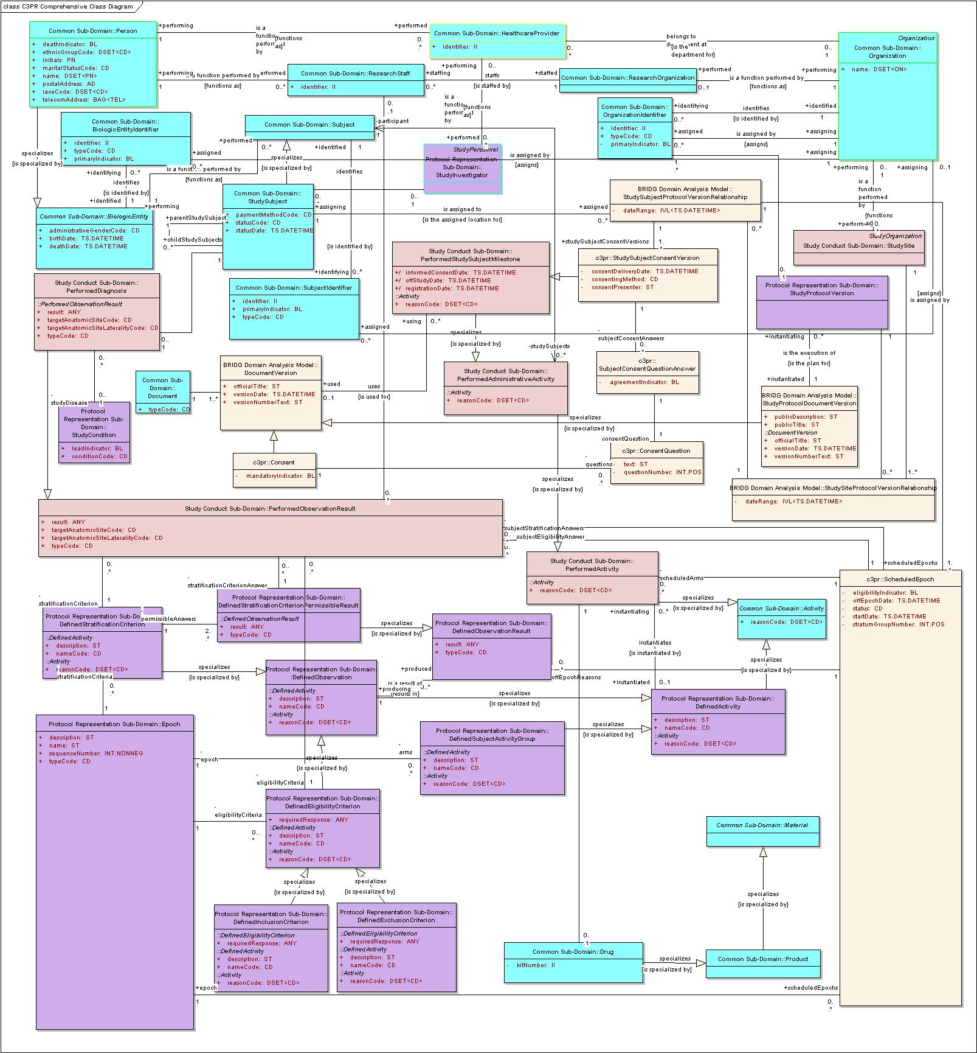

StudySubject State Model
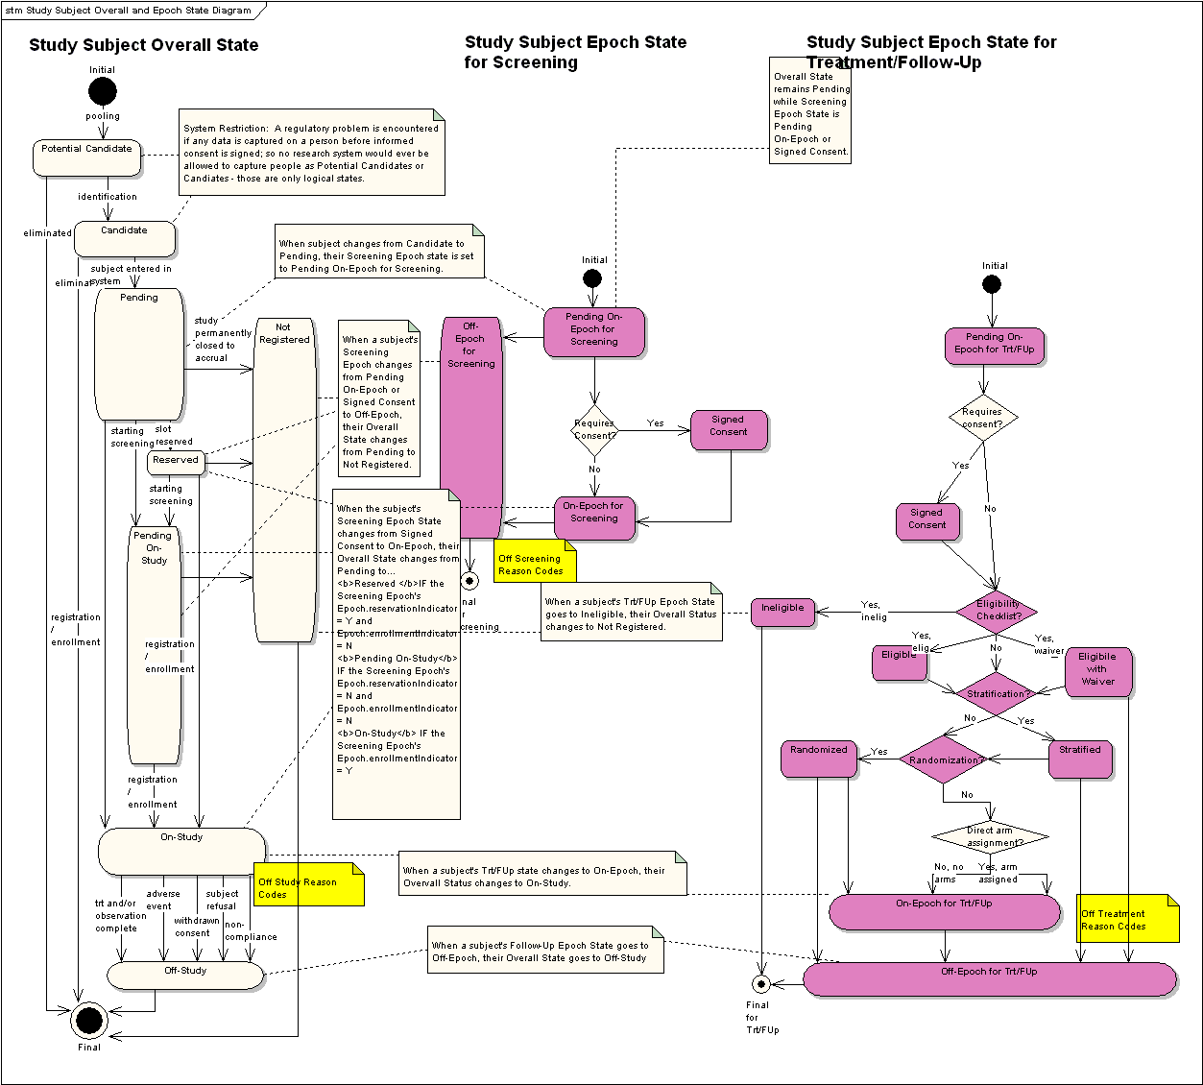
State Transition Diagram for StudySubject object during the entire registration process

Subject Registration Implementation model

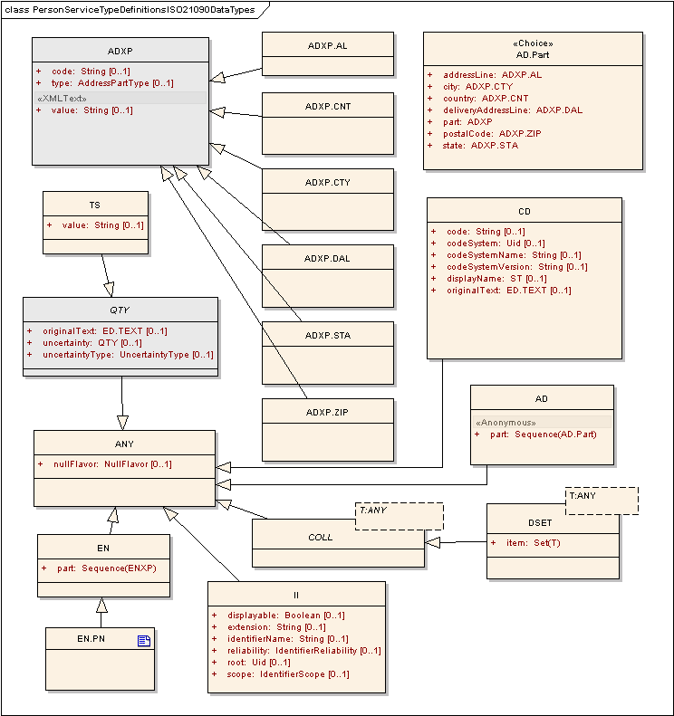
ISO 21090 data types used in the Subject Registration Model

Error Implementation Model
This service returns only one exception class named SRException. The structure and details of SRException class are given below

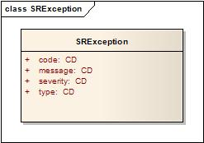

Attribute Name | Type | Attribute Description
code | CD | The actual error code which the Exception class represents
message | CD | The detailed error message
severity | CD | The severity of this error. It can be “FATAL”, “HIGH”, “MEDIUM” or “LOW”
type | CD | Indicates what type of error has occurred. Eg. Business, System etc.

Control Data Type Definitions

Status/Return Values/Exceptions

Data Type | Type (Status / Return Value / Exception) | Data Type Description
SRException | Exception | The return object in case there is any exception during the execution of any of the operations listed below

Error Codes

Error Code | Error Type | Error Severity | Error/Exception Message
SR1001 | Business | HIGH | Invalid data type or code value for an attribute
SR1002 | Business | HIGH | Invalid StudySubject class representation
SR1003 | Business | HIGH | Invalid StudyProtocol class representation
SR2001 | Business | MEDIUM | Subject already registered to the study
SR2002 | Business | MEDIUM | Subject registration is rejected (with appropriate details in error message details from the underlying systems if any)
SR2003 | Business | MEDIUM | Site not assigned to the Study Protocol
SR2004 | Business | MEDIUM | Study Protocol is not approved
SR2005 | Business | MEDIUM | Study Protocol is not open for enrollment
SR5001 | Business | LOW | Study Subject doesn’t exist for the given identifier
SR5002 | Business | LOW | Site doesn’t exist for the given identifier
SR5003 | Business | LOW | Study doesn’t exist for the given identifier
SR5004 | Business | LOW | No subjects found for the given search criteria
SR5005 | Business | LOW | No accruals data found for the input criteria

Query Parameters

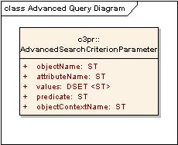

Attribute Name | Type | Attribute Description
attributeName | ST
dependentObjectName | ST
objectName | ST
value | ST

Summary3 Report

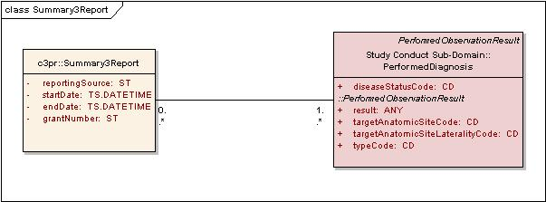

Attribute Name | Type | Attribute Description
reportingSource | ST | Reporting organization/site name.
startDate | TS.DATETIME | Report start date
endDate | TS.DATETIME | Report end date
grantNumber | ST | Grant Number

Interfaces

UML Model of Interfaces

Interface No | Interface Name | Interface Description
SR-INF1 | SRManagementBase | Provides the functionality common to both the registering site as well as coordinating center.
SR-INF2 | SRQuery | Provides the functionality to query subject registration
SR-INF3 | SRManagementCoordinatingCenter | Provides the functionality available to the Study Registrar at the coordinating center.
SR-INF4 | SRManagementSite | Provides the functionality available to the Site Registrar at the registering site
SR-INF5 | SRReporting | Provides the functionality available to the Study Registrar (as well as other approved personnel) at the Study Coordinating center.

Operations (Enumeration)

Operation No. | Operation Name | Interface Name | Operation Description
SR-INF1-OP1 | updateSubjectRegistration | SRManagementBase | To do limited updates a subject registration record.
SR-INF1-OP1 | importRegistrations | SRManagementBase | To import legacy subject registrations
SR-INF2-OP1 | querySubjectRegistration | SRQuery | To query / retrieve a Subject Registration
SR-INF2-OP2 | retrieveSubjectDemographyHistory | SRQuery | To query / retrieve a Subject’s Demography History
SR-INF3-OP1 | transferRegisteredSubject | SRManagementCoordinatingCenter | To transfer a subject from one study site to another within the given study
SR-INF4-OP1 | initiateSubjectEnrollment | SRSite | To initiate subject registration on a study (it could be pre-registration as well)
SR-INF4-OP2 | changeStudySubjectEpochAssignment | SRSite | To change/assign subject to a new epoch in the study (from Screening to Treatment, Treatment to Followup etc.
SR-INF4-OP3 | reconsentSubject | SRSite | To reconsent subject.
SR-INF4-OP4 | takeSubjectOffStudy | SRSite | To take/put subject off-study.
SR-INF4-OP5 | failSubjectScreening | SRSite | To fail subject screening.
SR-INF4-OP6 | discontinueSubjectEnrollment | SRSite | To discontinue subject from study enrollment process.
SR-INF5-OP1 | retrieveAccuralData | SRReporting | To retrieve the accrual data
SR-INF5-OP2 | generateSummary3Report | SRReporting | To generate summary3 report.

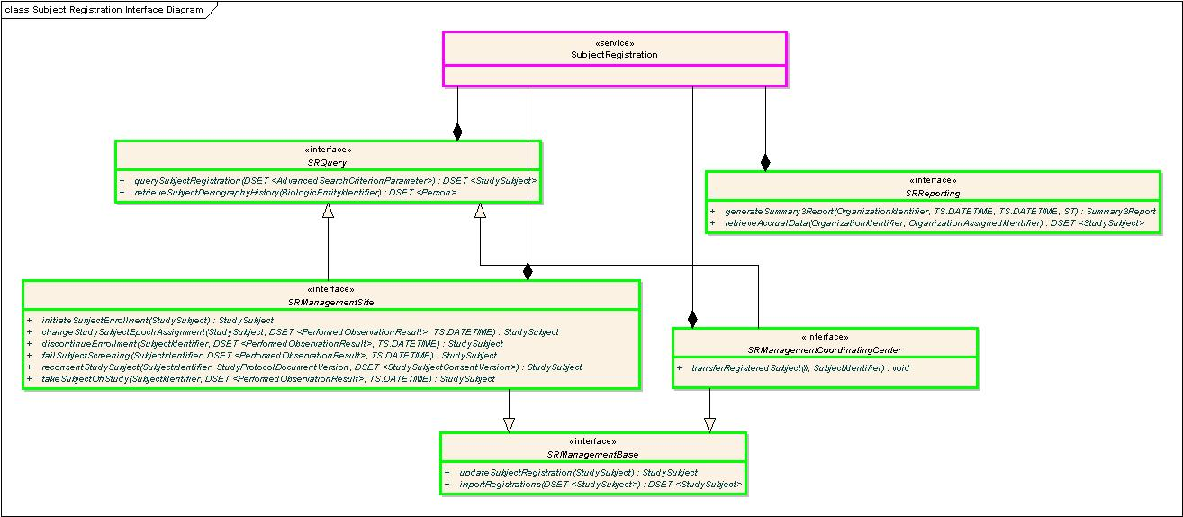
Interface Diagram for Subject Registration Service

Operation Behavior Descriptions

SR-INF 1: SRManagementBase Interface

SR-INF1-OP1: updateSubjectRegistrationState operation

Behavior Description | Allows the client to change a limited subset of information associated with a study subject.
Pre-Conditions | The subject must be registered to the study.
Security Conditions | The requestors:  - Must be Registration QA Manager for the registering study site.
Inputs | BRIDG : StudySubject (object populated with updated values):  - SubjectIdentifier : Unique identifier for study subject [M]  - Person Object [O]  - ScheduledEpoch.Epoch.ScheduledArm.Arm.nameCode [O]  - ScheduledEpoch.Epoch.ScheduledArm.Drug.kitNumber [O]  - DSET <StudySubjectConsentVersion> [O]
Outputs | BRIDG : StudySubject (updated)
Post-Conditions | The StudySubject’s details are updated.
Exception Conditions | - Invalid data type or code value for an attribute  - Invalid update request  - Study Subject doesn’t exist for the given identifier
Additional Implementation Details | When updating the subject’s signed consent information, the operation will add new signed consents if not present or update existing ones with new values.
Notes

SR-INF1-OP2: importRegistrations operation

Behavior Description | Allows the client to import legacy registration records.
Pre-Conditions | The studies must exist in the system.
Security Conditions | The requestors:  - Must be Data Importer for the registering study site.
Inputs | DSET <BRIDG: StudySubject> [M]
Outputs | void
Post-Conditions | The registration records are created.
Exception Conditions | - Invalid registration record.
Additional Implementation Details | When importing registrations this operation will save the registrations in the raw form i.e only basic structure of the registration records will be validated. No registration level business rules will be executed.  However, once the registration is imported, other capabilities can be used to manage the registration record. The onus of validating the registration record lies with the consumer/client.
Notes

SR-INF2: SRQuery Interface

SR-INF2-OP1: querySubjectRegistration operation

Behavior Description | Allows retrieving subject registrations for the given criteria. This operation provides a complete query solution with variesty of query options. It will retrieve all the StudySubject objects which match the input search criteria.
Pre-Conditions | None
Security Conditions | The requestors:  - Must be a member of Study Registrar group for the given study  OR  - Must be a member of Registration QA Manager group at the given site  OR  - Must be a member of Data Reader group for the given study  OR  - Must be a member of Data Analyst group for the given study  OR  - Must be a member of Business Administrator group.
Inputs | DSET <C3PR : AdvanceSearchCriteriaParameter>
Outputs | DSET <BRIDG : StudySubject>
Post-Conditions | None
Exception Conditions | - Invalid data type or code value for an attribute  - No subjects found for the given search criteria
Additional Implementation Details | AdvanceSearchCrietriaParameter is a generic class that allows complex search criteria to be modeled for the operation. Please refer to 2.4.3.
Notes

SR-INF2-OP1: retrieveSubjectDemographyHistory operation

Behavior Description | Allows retrieving subject’s demography across registrations. When a subject participates in multiple trials, a demography footprint is created which can potentially have different values across different registrations of the subject. This operation would consolidate the subject’s demography details and present the demography history.
Pre-Conditions | None
Security Conditions | The requestors:  - Must be a member of Subject Manager group at the given site
Inputs | BRIDG : BiologicEntityIdentifier
Outputs | DSET <BRIDG : StudySubject>
Post-Conditions | None
Exception Conditions | - Invalid data type or code value for an attribute  - No subject found for the given search criteria  - More than once subject found with the given identifier
Additional Implementation Details | Different demography information for the same subject can only be consolidated if all the different snapshots of the same subject have the same identifier.
Notes

SR-INF3: SRManagementCoordinatingCenter Interface

SR-INF3-OP1: transferRegisteredSubject operation

Behavior Description | Enables transferring a subject from one study site to another within the given study.
Pre-Conditions | None
Security Conditions | The requestors:  - Must be a member of Registration QA Manager group at the given site
Inputs | BRIDG: II (SiteIdentifier)  BRIDG: OrganizationAssignedIdentifier (Coordinating center assigned identifier for the study)
Outputs | void
Post-Conditions | None
Exception Conditions | - Invalid data type or code value for any attribute  - Site doesn’t exist for the given identifier
Additional Implementation Details
Notes

SR-INF3

SR-INF4: SRManagementSite Interface

SR-INF4-OP1: initiateSubjectEnrollment operation

Behavior Description | This functionality is invoked by the client to request  - Either a pre-registration  - Or a full registration.  If the epoch is enrolling and the study has mandatory companion studies, then the subject will be registered on the given companions.
Pre-Conditions | - Study must exist and is in “OPEN” state  - StudySite must exist and is in ‘ACTIVE’ state  - Any hard limits on accrual must not have been reached  - Subject must have signed consent  - Subject has met all the eligibility criteria defined in the enrolling epoch (for full registration)
Security Conditions | The requestors:  - Must be a member of Site Registrar group at the given site  - Must be a member of Site Registrar group for the given study
Inputs | BRIDG : StudySubject (object populated) with following details:  - Person [M]  - ScheduledEpoch [M]  - DSET <StudySubjectConsentVersion> [M]  - StudySubjectProtocolVersionRelationship. StudySiteProtocolVersionRelationship.StudyProtocolVersion.OrganizationAssignedIdentifier [M]  - StudySubjectProtocolVersionRelationship. StudySiteProtocolVersionRelationship.StudySite.Organization.DSET<identifier>[M]  - DSET <StudySubject> (Companion registration details) [O]
Outputs | BRIDG: StudySubject (Containing a temporary identifier in field Identifier of II type in case the epoch is non enrolling, or StudySubjectIdentifier assigned by the CoordinatingCenter)
Post-Conditions | Subject is Pending On-Study if the epoch is non-enrolling, or On-Study if the epoch is enrolling.
Exception Conditions | - Invalid StudySubject class representation  - Subject already registered to the study.  - Invalid StudyProtocol identifier  - Study Site is not active  - Study Protocol is not open for enrollment  - Invalid data type or code value for an attribute
Additional Implementation Details | The operation will refer to the subject management service to pull the subject. The following are the cases:  - If subject exists – Take a snapshot of the subject and freeze it against the registration. Discard subject demography details from the input of the operation. Use the demography data fetched from the subject management.  - If subject does not exist – Create the subject using the subject management service and then do as above.
Notes

SR-INF4-OP2: changeStudySubjectEpochAssignment operation
Behavior Description | This functionality is invoked by the client to request to assign the subject to a new epoch in the study, e.g. from screening to treatment, from treatment to follow-up.  If the new epoch is enrolling and the study has mandatory companion studies, then the subject will be registered on the given companions.
Pre-Conditions | - StudySite must exist and is in ‘ACTIVE’ state  - Any hard limits on accrual must not have been reached  - Subject must have signed consent  - Subject has met all the eligibility criteria defined in the enrolling epoch (for enrolling epoh)
Security Conditions | The requestors:  - Must be a member of Site Registrar group at the given site  - Must be a member of Site Registrar group for the given study  OR  - Must be a member of Registration QA Manager group at the given site.
Inputs | BRIDG : StudySubject (object populated) with following details:  - SubjectIdentifier (Unique study subject identifier) [M]  - ScheduledEpoch [M]  - DSET <StudySubjectConsentVersion> [O]  - DSET <StudySubject> (Companion registration details) [O]  DSET <C3PR: OffEpochReason> (Reason codes for taking the subject off previous epoch) [M]  ISO-TS.DATETIME: OffEpochDate (Date the subject was taken off previous epoch) [M]
Outputs | BRIDG: StudySubject (Containing a temporary identifier in field Identifier of II type in case the epoch is non enrolling, or StudySubjectIdentifier assigned by the CoordinatingCenter)
Post-Conditions | Subject is Pending On-Study if the epoch is non-enrolling, or On-Study if the epoch is enrolling.
Exception Conditions | - Invalid StudySubject class representation  - Invalid Epoch  - Invalid OffEpochReason code
Additional Implementation Details
Notes

SR-INF4-OP3: reconsentSubject operation
Behavior Description | This functionality is invoked by the client to reconsent subject on a specific study protocol version.
Pre-Conditions | - New study protocol version is available for the site.  - Subject must have signed new consent forms.
Security Conditions | The requestors:  - Must be a member of Site Registrar group at the given site  - Must be a member of Site Registrar group for the given study  OR  - Must be a member of Registration QA Manager group at the given site.
Inputs | - BRIDG: SubjectIdentifier (Unique study subject identifier) [M]  - BRIDG: StudyProtocolDocumentVersion [M]  - DSET <StudySubjectConsentVersion> [M]
Outputs | void
Post-Conditions | Subject is reconsented on the new study protocol version
Exception Conditions | - No study subject found with the given identifier  - No study protocol version found with the given identifier  - Invalid consent form version(s).
Additional Implementation Details
Notes

SR-INF4-OP4: takeSubjectOffStudy operation

Behavior Description | This functionality is invoked by the client to take subject off-study
Pre-Conditions | - StudySubject must be in ‘On-Study’ state.
Security Conditions | The requestors:  - Must be a member of Site Registrar group at the given site  - Must be a member of Site Registrar group for the given study  OR  - Must be a member of Registration QA Manager group at the given site.
Inputs | - BRIDG: SubjectIdentifier (Unique study subject identifier) [M]  - DSET < C3PR: OffEpochReason> (Off study reason codes) [M]  - ISO-TS.DATETIME: OffStudyDate (Date the subject was taken off study)[M]
Outputs | void
Post-Conditions | Subject is taken off study. StudySubject state is ‘Off-Study’.
Exception Conditions | - No study subject found with the given identifier  - Invalid OffStudyReason code
Additional Implementation Details | Off study reason code list is derived from CDE-2003606.
Notes

SR-INF4-OP5: failSubjectScreening operation

Behavior Description | This functionality is invoked by the client to fail subject’s screening
Pre-Conditions | - StudySubject must be in ‘Pending On-Study’ state.  - Study subject must be assigned to ‘Screening Epoch’.
Security Conditions | The requestors:  - Must be a member of Site Registrar group at the given site  - Must be a member of Site Registrar group for the given study  OR  - Must be a member of Registration QA Manager group at the given site.
Inputs | - BRIDG: SubjectIdentifier (Unique study subject identifier) [M]  - DSET < C3PR: OffEpochReason> (Off screening reason codes) [M]  - ISO-TS.DATETIME: OffScreeningDate (Date the subject failed screening)[M]
Outputs | void
Post-Conditions | Subject is recorded as failed screening. StudySubject state is ‘Not Registered’.
Exception Conditions | - No study subject found with the given identifier  - Invalid OffScreeningReason code
Additional Implementation Details | Off screening reason code list is currently being prepared for CDE.
Notes

SR-INF4-OP6: discontinueSubjectEnrollment operation

Behavior Description | This functionality is invoked by the client to discontinue subject from the enrollment process of a study. This generally happens when the subject withdraws its consent.
Pre-Conditions | - StudySubject must be in ‘Pending On-Study’ or ‘Pending’ state.
Security Conditions | The requestors:  - Must be a member of Site Registrar group at the given site  - Must be a member of Site Registrar group for the given study  OR  - Must be a member of Registration QA Manager group at the given site.
Inputs | - BRIDG: SubjectIdentifier (Unique study subject identifier) [M]  - DSET < C3PR: OffEpochReason> (Discontinuing reason codes) [M]  - ISO-TS.DATETIME: DiscontinuationDate (Date the subject was discontinued from study)[M]
Outputs | void
Post-Conditions | Subject is discontinued from study. StudySubject state is ‘Not Registered’.
Exception Conditions | - No study subject found with the given identifier  - Invalid DiscontnuationReason code
Additional Implementation Details | Discontinuation reason code is a combination of OffStudyReasons, OffTreatmentReasons & OffScreeningReasons code.
Notes

SR-INF5: SRReporting Interface

SR-INF5-OP1: retrieveAccuralData operation

Behavior Description | Study Accrual data is required to be reported to a number of agencies and bodies. The method returns the accrual data in a standard Accrual data format from which information can be retrieved for individual applications reporting
Pre-Conditions | None
Security Conditions | The requestors:  - Must be a member of Site Registrar group at the given site  - Must be a member of Site Registrar group for the given study  OR  Must be a member of Registration QA Manager group at the given site.
Inputs | - BRIDG: StudyProtocolVersion.OrganizationAssignedIdentifier [O]  - BRIDG: Organization.DSET<identifier>[O]  At least one of the two inputs should be provided.
Outputs | DSET<BRIDG: StudySubject>
Post-Conditions | None
Exception Conditions | - Study doesn’t exist for the given identifier  - No accruals data found for the input criteria  - Site doesn’t exist for the given identifier
Additional Implementation Details
Notes

SR-INF5-OP2: generateSummary3Report operation

Behavior Description | Summary3 report is required by many cancer centers to submit to NCI. This operation will generate Summary3 report.
Pre-Conditions | None
Security Conditions | The requestors:  - Must be a member of Site Registrar group at the given site  - Must be a member of Site Registrar group for the given study  OR  Must be a member of Registration QA Manager group at the given site.
Inputs | - ISO-II: SiteIdentifier (Unique site identifier) [M]  - ISO-TS.DATETIME: StartDate (Summary3 report start date)  - ISO-TS.DATETIME: EndDate (Summary3 report end date) [O]  - ISO-ST: GrantNumber (to be included as part of the report) [O]
Outputs | Summary3Report
Post-Conditions | None
Exception Conditions | - Site doesn’t exist for the given identifier  - Invalid start date, end date combination
Additional Implementation Details | Summary3 report is generated with Summary3 disease site codes.
Notes

Dynamic Model

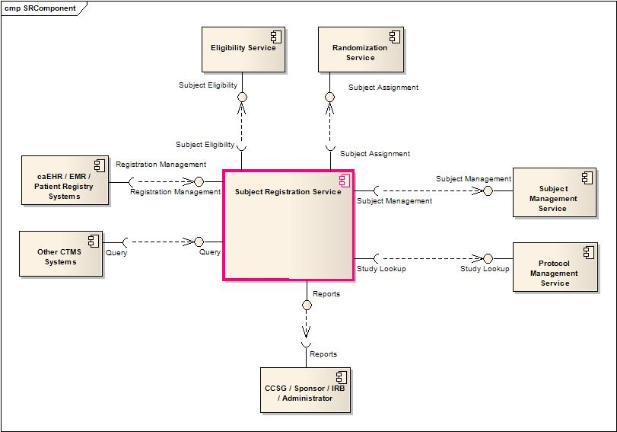
Component View depicting major Interactions of Subject Registration Service

Profiles

Functional Profiles

Profile No. | Profile Name | Profile Description
SR-FP1 | SR Query | This profile provides query functionality
SR-FP2 | SR Site | This profile contains all registration request capabilities used by a study site.
SR-FP3 | SR CCenter | This profile contains all registration approval capabilities used by a coordinating center.
SR-FP4 | SR Reports | This profile provides the ability to retrieve data for use in submission reports.

Interface Operation No. | Interface Operation Name | Profile No. | Profile Name
SR-INF1-OP1 | updateSubjectRegistration | SR-FP2  SR-FP3 | SR Site  SR CCenter
SR-INF1-OP1 | importRegistrations | SR-FP2  SR-FP3 | SR Site  SR CCenter
SR-INF2-OP1 | querySubjectRegistration | SR-FP1  SR-FP2  SR-FP3 | SR Query  SR Site  SR CCenter
SR-INF2-OP2 | retrieveSubjectDemographyHistory | SR-FP1  SR-FP2  SR-FP3 | SR Query  SR Site  SR CCenter
SR-INF3-OP1 | transferRegisteredSubject | SR-FP3 | SR CCenter
SR-INF4-OP1 | initiateSubjectEnrollment | SR-FP2 | SR Site
SR-INF4-OP2 | changeStudySubjectEpochAssignment | SR-FP2 | SR Site
SR-INF4-OP3 | reconsentSubject | SR-FP2 | SR Site
SR-INF4-OP4 | takeSubjectOffStudy | SR-FP2 | SR Site
SR-INF4-OP5 | failSubjectScreening | SR-FP2 | SR Site
SR-INF4-OP6 | discontinueSubjectEnrollment | SR-FP2 | SR Site
SR-INF5-OP1 | retrieveAccuralData | SR-FP4 | SR Reports
SR-INF5-OP2 | generateSummary3Report | SR-FP4 | SR Reports

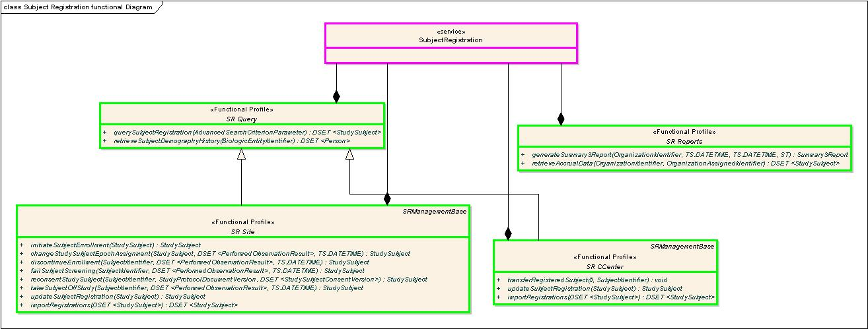
Profile view of the Operations of Subject Registration Service

Semantic Profiles

Semantic Profile No. | Semantic Profile Name | Semantic Profile Description
SR-SP1 | BRIDG V3.0.1 Subject Registration | BRIDG V3.0.1 based Subject Registration Semantic Profile

Relationship with other services

Service Name | Dependant / Depends | Data | Description
Subject Management Service | Dependant | Subject Demographic Data | Subject Registration Service uses the Subject Management service to persist the Subject’s Demographic data
Protocol Management Service | Dependant | Study Protocol Data | Subject Registration Services uses the Protocol Management service to determine if the protocol is active or not and also is open for enrollment and any hard limits have not be reached
Eligibility Service | Dependant | Study Subject Information  Study Protocol Data | Subject Registration Services uses the Eligibility Service to determine if the Subject is eligible for enrollment into the given study or not
Randomization Service | Dependant | Study Subject Information  Study Protocol data | Based on the randomization requirements for the Study, this service returns the arm to which the subject should be assigned.
Other CTMS Services | Depends | Subject Registration Data | All the other services use the Subject Registration Service to verify subject’s registration information

Conformance Statements

Name | Type | Viewpoint | Description | Test method
Multiple Jurisdictions | Obligation | Enterprise | Implementers must provide an implementation that supports multiple jurisdictional domains (i.e. support different Coordinating Center and Sites as well as multi-site trials ) | Test cases include multiple domain scenarios
Query Performance | Obligation | Enterprise | The performance of the SRQuery interface should be within 0.2 second to return a single record from the underlying database | Test cases to include performance testing.
Conformance Profiles | Obligation | Computational / Information | In order to claim a minimal level of conformance to the Subject Registration specification, designers/implementers are obligated to support the following mandatory Conformance Profiles (i.e. their contained functional and semantic profiles): SR Query BRIDG V2.1 & SR Site BRIDG V2.1 or SR CCenter BRIDG V2.1 | Test cases to be defined to test each specified profile.
Optional Functional Profiles | Permission | Computational | Implementers may implement the additional functional profiles not included in the mandatory conformance profiles. | Test cases to be defined to test each specified profile.
ISO Datatypes | Obligation | Information | Implementers are obliged to support ISO 21090 datatypes in all operations | Test cases to include processing of each relevant data type
Auditing | Obligation | Engineering | Designers/implementers are obligated to decide on and document the approach for logging or auditing of operation calls. | Design Review

Appendix A - References

Name | Description | Location
NCI’s BRIDG v2.1 | NCI’s BRIDG model used for modeling the SR Service | https://gforge.nci.nih.gov/frs/download.php/5009/BRIDG_Release_2.1_Package.zip
Use Case Document | Document containing use cases for the C3PR application | https://cabig-kc.nci.nih.gov/CTMS/KC/index.php/C3PR_Use_Cases
Subject Registration CFSS | Conceptual Functional Service Specification for Subject Registration | https://gforge.nci.nih.gov/plugins/scmsvn/viewcvs.php/trunk/specifications/CFSS_Subject_Registration_Service.doc?root=ent-services&view=log

Appendix B - Glossary

Term | Description
BRIDG | The Biomedical Research Integrated Domain Group (BRIDG) has developed a comprehensive domain analysis model representing biomedical/clinical research.
C3PR | Cancer Central Clinical Patient Registry is the existing application developed by CTMS workspace which handles subject registration

Appendix C - Cross Reference Tables

Interface to Profile Mapping

Interface No. | Interface | Profile No. | Profile
SR-INF1 | SRManagementBase | SR–FP2  SR–FP3 | SR Site  SR CCenter
SR-INF2 | SRQuery | SR-FP1  SR–FP2  SR–FP3 | SR Query  SR Site (Partial)  SR CCenter (Partial)
SR-INF3 | SRManagementCoordinatingCenter | SR-FP3 | SR CCenter
SR-INF4 | SRManagementSite | SR–FP2 | SR Site
SR-INF5 | SRReporting | SR-FP4 | SR Reports

Interface Operations to Profile Operations

Interface Operation No. | Interface Operation Name | Profile No. | Profile Name
SR-INF1-OP1 | updateSubjectRegistration | SR-CPB4 | Update Subject Registration
SR-INF1-OP1 | importRegistrations | SR-CPB14 | This capability is used to import legacy registrations.
SR-INF2-OP1 | querySubjectRegistration | SR-CPB9 | Query Subject Registration
SR-INF2-OP2 | retrieveSubjectDemographyHistory | SR-CPB11 | Retrieve Subject Demography History
SR-INF3-OP1 | transferRegisteredSubject | SR-CPB8 | Transfer a Registered Subject
SR-INF4-OP1 | initiateSubjectEnrollment | SR-CPB1 | Initiate Subject Enrollment
SR-INF4-OP2 | changeStudySubjectEpochAssignment | SR-CPB2 | Change Study Subject Epoch Assignment
SR-INF4-OP3 | reconsentSubject | SR-CPB3 | Reconsent Subject
SR-INF4-OP4 | takeSubjectOffStudy | SR-CPB5 | Take Subject Off Study
SR-INF4-OP5 | failSubjectScreening | SR-CPB6 | Fail Subject Screening
SR-INF4-OP6 | discontinueSubjectEnrollment | SR-CPB7 | Discontinue Subject Enrollment
SR-INF5-OP1 | retrieveAccuralData | SR-CPB10 | Retrieve Accrual Data
SR-INF5-OP2 | generateSummary3Report | SR-CPB13 | Generate Summary3 Report

