Use Case Document

Cancer Central Clinical Participant Registry (C3PR)
Version 2
Duke Comprehensive Cancer Center

Table of Contents

1 Introduction 5
1.1 Overview 5
1.2 Document Conventions 5
1.3 Related Documents 6
2 Actors and Roles 6
2.1 Roles 6
3 Manage Subjects and Study Personnel 8
3.1 Create Subject 8
3.2 Create Investigator 10
3.3 Create Research Staff 12
3.4 Create Organization 13
3.5 Associate Investigator to Study 15
3.6 Associate Study Personnel to Study 17
3.7 Add Stratification 18
3.8 Add Diseases 19
3.9 Update Subject 21
3.10 Update Study Personnel 21
3.11 Verify Subject 21
3.12 Verify Study Personnel 21
3.13 Delete Subject 21
3.14 Delete Study Personnel 21
3.15 Manage Subject Address 21
3.16 Manage Subject Contact 21
3.17 Manage Study Personnel Contact 21
3.18 Search for a Subject 22
3.19 Search for a Study Personnel 22
3.20 View a Subject 22
3.21 View a Study Personnel 22
3.22 Associate Disease to Subject 22
4 Manage Study 23
4.1 High Level Manage Study Use Case Diagram 23
4.2 High Level Study Data Capture Use Case Diagram 24
4.3 Create Study Definition Manually 24
4.4 Load Study Definition from a File 28
4.5 Get Study Definition via Study Message from External Source 29
4.6 Search for Studies 31
4.7 View Study 32
4.8 Update Study 34
4.9 Approve Study Definition 35
4.10 Amend Study Definition 37
4.11 Abstract Study Data 38
4.12 Register Subject to a Study Arm 38
4.13 Synchronize Creation of Study Definition with Study Calendar 38
4.14 Synchronize Registration of a Subject on a Study Arm with Study Calendar 40
5 Manage Registration 42
5.1 Register a New Subject to a Study 42
5.2 Register an Existing Unregistered Subject to a Study 43
5.3 Register an Existing Registered Subject to a Study 44
5.4 Save a registeration in a incomplete status 44
5.5 Register Subject to Local Study Study 44
5.6 Register Subject to External Study Study 44
5.7 Register Subject to a Reservation-enabled Study 44
5.8 Search for Registrations 45
5.9 View Subject Registration History 47
5.10 Update Eligibility Status on a Pre-Registration/Registration 50
5.11 Assign Subject to a Randomization Arm 51
5.12 Update Registration Status of a Subject on a given Study 52
5.13 Reserve Registration 53
5.14 Store Subject Screening Data 53
5.15 Submit Pending Registration Information 54
5.16 Confirm Submitted Registration Information 54
5.17 Replicate Registration to Companion Study 54
5.18 Replicate Registration to Local Site 54
6 Manage Randomization 54
6.1 Email Notify Registrar 54
6.2 Display Notification 54
6.3 Randomize Using Study Block 54
6.4 Randomize Using Call-out 54
7 Manage Eligibility Criteria 55
7.1 Approve Eligibility Criteria 55
7.2 Exempt Eligibility Criteria 55
7.3 Import Eligibility Criteria 55
8 Access Clinical Data 55
9 Manage Stratification 55
10 Manage Relationship 55
10.1 Create Relationship 55
11 Login 55
12 Reporting 56
13 From C3PR Release 1 (Not Yet Analyzed) 56
13.1 Maintain Study Strata Randomized List 56
13.2 Synchronize Subject with External Subject Registry 56
13.3 Assign Study Part to Subject 56
13.4 Generate Referral Letter 56
14 Integration 56
15 Overall Requirements 56
15.1 Requirements Prioritization 56
16 Sign Off 57
16.1 Approval 57

Introduction

Overview
Researchers, who conduct clinical trials themselves and often require comparative data for dosing, measurable clinical trial end-points, model validation, encounter difficulty accessing aggregate clinical trials data. This, in turn, limits their ability to advance the science. The development and deployment of a central registry, containing requisite information on clinical trials, will provide all groups (subjects and their families indirectly, community physicians and cancer researchers directly) to meet their diverse set of informational and data needs.
C3PR Release 1 provides a highly configurable participant registry for managing clinical study registration at a single site. However, it cannot easily manage cross-site studies, and it can be very difficult to install, configure, and manage. The primary goal of C3PR Release 2 is to build upon Release 1 to make it more generally useful to the cancer research community. A scoping goal will be for C3PR to manage participant registration to multi-site studies. This involves the integration of C3PR instances at different centers. Additionally, integration beyond C3PR will be needed to perform institution-level and PI-level eligibility checks. The current registration model is somewhat limited, allowing for simplistic randomization based upon manual assignment of participants to arms. Furthermore, study management in C3PR will be greatly enhanced. Though C3PR is not intended as a central study repository, study information is critical to the registration process. Study information will be expanded to meet the use cases of multiple eligibility check-points, multi-institutional studies, and differing randomization schemes. C3PR Release 1 provided registration from a participant-centric standpoint. This workflow will be enhanced to provide registration from a study-centric view, and reporting will be extended to provide this information to external systems to generate complex reports.

Document Conventions
The C3PR Release 2 project follows the iterative development of the Unified Framework Process. Thus, each document is a snapshot of a work-in-progress. The following conventions will be used throughout the document:

- Red highlighting will indicate new items that need to be addressed immediately in the next iteration by the developers.
- Green highlighting will indicate new items that need to be addressed in the next iteration by the elaborators.

Related Documents

- Vision and scope document
https://gforge.nci.nih.gov/plugins/scmcvs/cvsweb.php/c3prv2/documentation/communication/c3prv2_vision_scope.doc?cvsroot=c3prv2
- Communication Plan
https://gforge.nci.nih.gov/plugins/scmcvs/cvsweb.php/c3prv2/documentation/communication/c3prv2_communication_plan.doc?cvsroot=c3prv2
- Use case document
https://gforge.nci.nih.gov/plugins/scmcvs/cvsweb.php/c3prv2/documentation/use_cases/c3prv2_use_cases.doc?cvsroot=c3prv2

- Project plan
https://gforge.nci.nih.gov/plugins/scmcvs/cvsweb.php/c3prv2/documentation/planning/c3prv2_project_plan.doc?cvsroot=c3prv2
- Risk matrix
https://gforge.nci.nih.gov/plugins/scmcvs/cvsweb.php/c3prv2/documentation/risks/?cvsroot=c3prv2

Actors and Roles
The actors are the actual users of the system. They can have one or more roles in the system. These roles can be assigned and revoked based upon specific studies. Roles will define the privileges that an actor has to perform functions within C3PR.

Roles
C3PR Role | C3PR Definition | caDSR Role | caDSR Concepts | caDSR Definition | BRIDG Role
Subject | Does not participate in C3PR | Participant | C29867 | Someone who takes part in an activity. | Participant
Study Chair | Has overall responsibility for scientific conduct of study. Has read permission for all aspects of his studies. | Study Chair | C51878 | A person who is responsible for providing overall management for the operation of the study, and for reporting to the Data and Safety Monitoring Board. The continual review of the data by an independent individual or DSMB assures the investigator(s) that the trial can continue without jeopardizing patient safety. | MISSING
Site Principle Investigator | Conducts studies at a single institution. Has read permission for all aspects of his studies. | Principal Investigator | MISSING | An investigator who is responsible for all aspects of the conduct of a study. | Investigator
Enrolling Physician | Performs treatment and follow-up for subjects. Has read permissions to study reports. | Physician | C25741 | Physician; a licensed medical practitioner. | MISSING
Data Manager | Collects and reviews data. Has read permissions to study reports. | Data Manager | C51820 | A person primarily responsible for database creation, data collection, validation, integration, coding, review, quality evaluation, and archiving, as well as for preparation of reports and data displays. | Clinical Data Management
Study Coordinator | Defines and conducts the study at a particular site. Has create, read, and update of study definitions. Can stop enrollment on a study. Has read permissions for aggregate reports. | Study Coordinator | C51880 | A person who handles most of the administrative responsibilities of a clinical study, acts as liaison between investigative site and sponsor, and reviews all data and records before a monitor's visit. | Study Designer
Registrar | Enrolls subjects on studies. Has create, read, and update permissions on subjects, enrollments, and treatment assignments. Has read permission on the study and reports. | Registrar | C25357 | Registrar; someone responsible for keeping records. | MISSING
IRB Manager for C3PR | Manages the IRB aspects of a study. Has update permission on the study record. | Protocol Chair at an Organization | C51855 | A person at a business or administrative group that retains the responsibility for regulation compliance and ensures the proper administration of the objectives, study design, and methodology of study. | MISSING
Site Coordinator | Manages administrative aspects of study conduct. Has delete and read permissions across all aspects of C3PR. Has update permission on the study record. | Site Coordinator | C51872 | The staff member at the organization who is responsible for program management of the study and functions as the primary contact at the organization. | Site Coordinator
Security Manager | Assigns access privileges to C3PR system. Has permissions to assign roles. | MISSING | MISSING | MISSING | MISSING
Technical System Administrator | Administers C3PR from a technical standpoint. Has permissions to create new roles. | MISSING | MISSING | MISSING | MISSING
Site Software Developer | Writes modules to interact with C3PR, such as new reports. Has permissions to create and update reports. | Software Developer | C67226 | A person or organization that designs software and writes the programs. Software development includes the design of the user interface and the program architecture as well as programming the source code. A somewhat broader scope of computer programming or a specialty of project managing. | Programmer
Data Analyst | Analyzes data. Has permissions to read all data in C3PR. | Statistician | C51877 | A person responsible for the compilation, organization, and analysis of mathematical data. | Statistician
More roles related to BRIDG may be added in future iterations.
Note that there are differences in terminology regarding roles among the various institutions and organizations, as well as variations in combinations of roles. This document will not attempt to capture all the variations and situation specific differences, but describes roles to a sufficient level of detail needed for system functionality.

Manage Subjects and Study Personnel
To be filled in later.

Create Subject

Use Case Model
Add model here

Brief Description
This use-case deals with the manual creation of a subject by entering each data element of the subject.

Primary Actor
Registrar or any other designated user of C3PR with role authority to create a Subject.

Secondary Actors
None

Preconditions
- The user is logged in to the system with a user account that has role authority to create a Study.
- The Subject doesn’t already exist.

Basic Flow of Events
- The user indicates to the system that he/she wants to create a new Subject by clicking the Create Subject link
- The system displays the screen that gives the user option of entering the Subject information manually. The user clicks on the enter Subject manually link.
- The user enters the Subject data elements in the fields.
- The user indicates to the system that the required Subject information has been entered for creation of a new Subject.
- The system displays Subjects with matching fields to ensure that the subject is not a duplicate.

Postconditions
- If the user is logged in to the system with a user account that has role authority to create a Subject (for example, a Registrar), the created Subject is approved.
- If the user was logged in to the system with a role authority to only enter the Subject information, the created Subject awaits for further validation check before it becomes approved.

Alternate flow
1. The system shows an error for Subjects with a duplicate identifier.

Alternate flow
1. The system displays Subjects with matching fields to ensure that the subject is not a duplicate.

Data Items
Data Element | Validation/Notes
(1) First name | Required, configurable
(2) Maiden Name | Not Required, configurable
(3) Last name | Required, configurable
(4) SSN | Not Required, configurable
(5) First visit date | Not Required, configurable
(6) Race | Required, multi-select
(7) Method of payment | Not Required, configurable (also attached to a study, or just to a study?)
(8) Annotation | Note: these are questions that must be captured for the subject when the subject is created or registred
8.1 Name | Required (not an input field)
8.2 Value | Required, configurable (input field)
8.3 Allowable values | Not Required (not an input field)
8.4 isOptional | Required (not an input field)
8.4 atSubject | Required (not an input field)
8.5 atStudy | Required (not an input field)
(9) Participant identifiers | Required
9.1 Value | Required
9.2 Type | Required
9.3 Source | Not Required
9.4 isPrimary | Not Required (defaults to false)
(10) Ethnicity | Required
(11) Contact Information | (E-mail, Phone, Fax) – Not required

Special Requirements
None

Create Investigator

Use Case Model
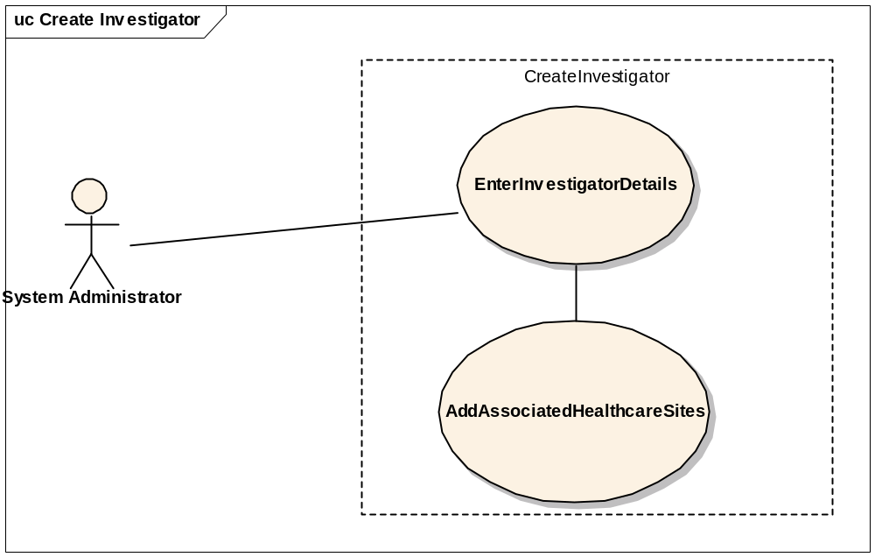

Brief Description
This use-case deals with the manual creation of an Investigator at the specified healthcare sites by entering each data element of the investigator.

Primary Actor
System administrator or any other designated user of C3PR with administrative privilege to create an investigator.

Secondary Actors
Site Coordinator

Preconditions
- The user is logged in to the system with an administrative account that has role authority to create an investigator.
- The investigator doesn’t already exist.

Basic Flow of Events
- The user indicates to the system that he/she wants to do administrative tasks by clicking on the Administration link
- The user indicates to the system that he/she wants to create an investigator by clicking on the create Investigator link.
- The system displays the screen that gives the user option of entering the investigator information manually.
- The user enters the Investigator data elements in the fields.
- The user indicates to the system that the required investigator information has been entered for creation of a new investigator by clicking on save link.

Postconditions
- If the ser is logged in to the system with a user account that has administrative privileges to create an Investigator (for example, a System Administrator), the created Investigator is approved.

Data Items
  - First Name (required)
  - Last Name (required)
  - Maiden Name
  - Contact Information (e-mail, phone, fax)
  - NCI Identifier
  - Healthcare Site(s) (required)

Special Requirements
None

Create Research Staff

Use Case Model
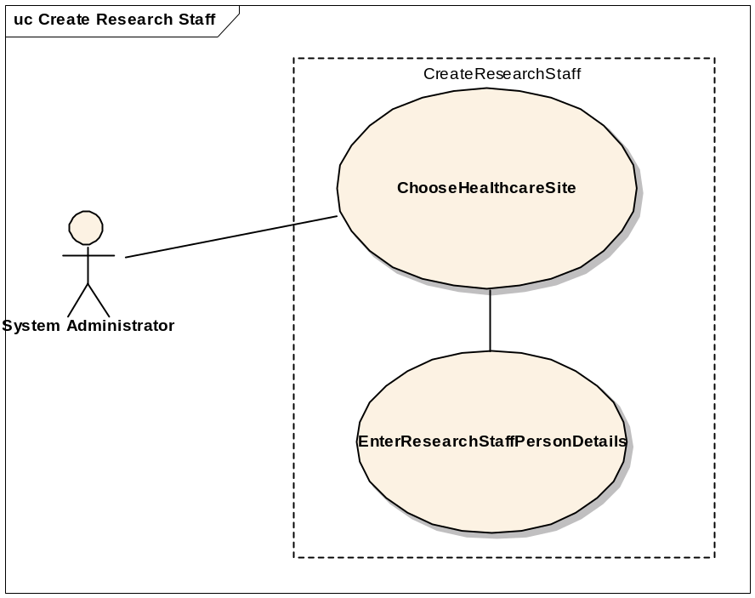

Brief Description
This use-case deals with the manual creation of research staff by entering each data element of the research staff.

Primary Actor
System administrator or any other designated user of C3PR with administrative privilege to create research staff.

Secondary Actors
None

Preconditions
- The user is logged in to the system with an administrative account that has role authority to create research staff.
- The research staff doesn’t already exist.

Basic Flow of Events
- The user indicates to the system that he/she wants to do administrative tasks by clicking on the Administration link
- The user indicates to the system that he/she wants to create a research staff member by clicking on the create research staff link.
- The system displays the screen that gives the user option of entering the research staff member information manually.
- The user enters the research staff member’s data elements in the fields.
- The user indicates to the system that the required research staff member information has been entered for creation of a new research staff member by clicking on save link.

Postconditions
- If the user is logged in to the system with a user account that has administrative privileges to create a research staff (for example, a System Administrator), the created research staff member is approved.

Data Items
  - First Name (required)
  - Last Name (required)
  - Contact Information (e-mail, phone, fax)
  - Healthcare Site (required)

Special Requirements
None

Create Organization

Use Case Model
ADD MODEL HERE.

Brief Description
This use-case deals with the manual creation of Organization by entering organization related data. The user can enter information and select save or select reset tab to clear the entered data.

Primary Actor
System administrator or any other designated user of C3PR with administrative privilege to create Organization.

Secondary Actors
None

Preconditions
- The user is logged in to the system with an administrative account that has role authority to create Organization.
- The Organization doesn’t already exist.

Basic Flow of Events
- The user indicates to the system that he/she wants to do administrative tasks by clicking on the Administration link
- The user indicates to the system that he/she wants to create an Organization by clicking on the Create Organization link.
- The system displays the screen that lets the user enter the Organization information manually.
- The user enters Organization’s data elements in the fields.
- The user indicates to the system that the required Organization information has been entered for creation of a new Organization by clicking on save link.

Postconditions
- If the user is logged in to the system with a user account that has administrative privileges to create a research staff (for example, a System Administrator), the created research staff member is approved.

Data Items
  - Name (required)
  - Description
  - NCI Institute Code
  - Street Address
  - City
  - State
  - Zip
  - Country

Special Requirements
None

Associate Investigator to Study

Use Case Model
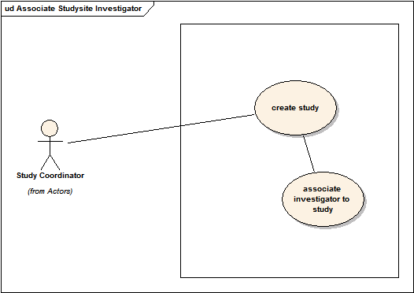

Brief Description
This use case allows the user to associate a investigator to a study.

Primary Actor
Study Coordinator

Secondary Actors
Research Nurse

Preconditions
Study is created with at least one site. This process takes place during the creation or after the creation of study.

Basic Flow of Events
1. The user indicates that he/she wants to associate a study investigator.
2. The user selects the desired site for which the association should take place.
3. The user chooses the list of investigators associated for this site to be assigned as study investigator, which is commonly referred to as the enrolling physician.
4. The user chooses other relevant info for the association
5. The user may select more site investigators repeating the steps 1-4

Post Conditions
None

Alternate Flow
1. Instead of selecting a single Study Investigator, the user selects a group of Investigators

Data Items
Signature Indicator, Signature, Start Date, End Date, Healthcare Site, Status, Role

Associate Study Personnel to Study

Use Case Model
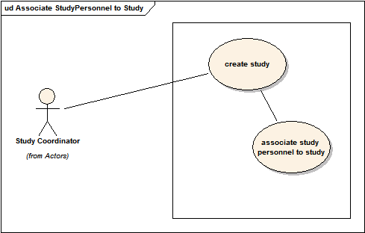

Brief Description
A study, depending on whether it is multi-site study or not can have multiple sites associated with it. Each site can have one or more personnel (Research Staff) involved in conducting the study. This use case deals with associating such staff with a Study. Study Coordinator, during the creation of a study definition, will be able to select one or many of the study personnel for the study.

Primary Actor
Study Coordinator

Secondary Actors
Research Nurse

Preconditions
Study is created with at least one site. This process takes place during the creation or after the creation of study.

Basic Flow of Events
1. The user indicates that he/she wants to associate study personnel.
2. The user selects the desired site for which the association should take place.
3. The user chooses the list of research staff associated for this site to be assigned as study personnel
4. The user chooses other relevant info for the association
5. The user may select more research staff repeating the steps 1-4

Post Conditions
None

Data Items
Start Date, End Date, Healthcare Site, Research Staff

Special Requirements
None.

Add Stratification

Use Case Model
TBD

Brief Description
Studies can have one or more stratification factors. Each stratification factor consist of a question and one or more discreet answers. The answers for a particular Subject on a Study determine the stratum group for the Study Subject. The stratum group can be used to help determine the arm during randomization.

Primary Actor
Study Coordinator: defines the stratification when defining the study
Registrar: registers a subject to a study and, in doing so, defines the stratum group for the subject.

Secondary Actors
None

Preconditions
None.

Basic Flow of Events: Study Definition
1. The user enters the stratification portion of the study definition workflow
2. The user adds one more stratification factors
3. The user defines the question text for each stratification factor
4. The user defines one or more discreet answers for each stratification factor
5. The system saves the stratification factors

Basic Flow of Events: Subject Registration
1. The user enters the registration workflow
2. The user navigates to the stratification tab
3. The user answers each stratification factor question via drop-down menus
4. The stratum group is displayed when then final stratification factor is answered
5. The system saves the stratum group

Post Conditions
None

Data Items
1. Stratification factor question
2. Stratification factor answers
3. Stratum group

Special Requirements
None.

Add Diseases

Use Case Model
TBD

Brief Description
Studies can have one or more disease sites associated with them. These disease sites are used during Registration to allow the user to select a disease site for a Study Subject. There are a number of different disease site nomenclatures used in the community. C3PR will initially provide the CTEP disease sites.

Primary Actor
Study Coordinator: defines the disease sites when defining the study
Registrar: registers a subject to a study and, in doing so, defines the disease sites for the subject.

Secondary Actors
None

Preconditions
None

Basic Flow of Events: Study Definition
1. The user enters the disease site portion of the study definition workflow
2. The user adds one more more disease sites
3. The user can select a category to add, a subcategory, or a disease site

Basic Flow of Events: Subject Registration
1. The user enters the registration workflow
2. The user navigates to the disease site tab
3. The user selects a disease site or enters a free-text disease site

Post Conditions
None

Data Items
1. Study disease sites
2. Study Subject disease site

Special Requirements
None.

Update Subject
This use case allows the user to update the Subject’s record.
In progress

Update Study Personnel
This use case allows the user to update the Study Personnel’s record.
In progress

Verify Subject
This use case allows the user to approve a Subject.
In progress

Verify Study Personnel
This use case allows the user to approve a Study Personnel.
In progress

Delete Subject
This use case provides the sole mechanism for a user to delete a Subject’s record that was erroneously entered in C3PR
In progress

Delete Study Personnel
This use case provides the sole mechanism for a user to delete a Study Personnel’s record that was erroneously entered in C3PR
In progress

Manage Subject Address
This use case allows the user to add/update Subject’s address information.
In progress

Manage Subject Contact
This use case allows the user to add/update Subject’s contact information.
In progress

Manage Study Personnel Contact
This use case allows the user to add/update Study Personnel’s contact information.
In progress

Search for a Subject
This use case allows the user to search a Subject depending upon the search criteria (FN, LN, D.O.B, PID#, etc).
In progress

Search for a Study Personnel
This use case allows the user to search a Study Personnel depending upon the search criteria (FN, LN, D.O.B, PID#, etc).

View a Subject
This use case allows the user to view Subject’s record.
In progress

View a Study Personnel
This use case allows the user to view Study Personnel’s record.
In progress

Associate Disease to Subject
This use case allows the user to associate one or more diseases/disease sites to a subject. This is part of the registration process.
In progress

Manage Study

Study Management is not the primary function of C3PR. However, Study Management is critical for the independent functioning of C3PR because registration is driven by the structure of the study. Therefore, it is included as a primary use case.

High Level Manage Study Use Case Diagram
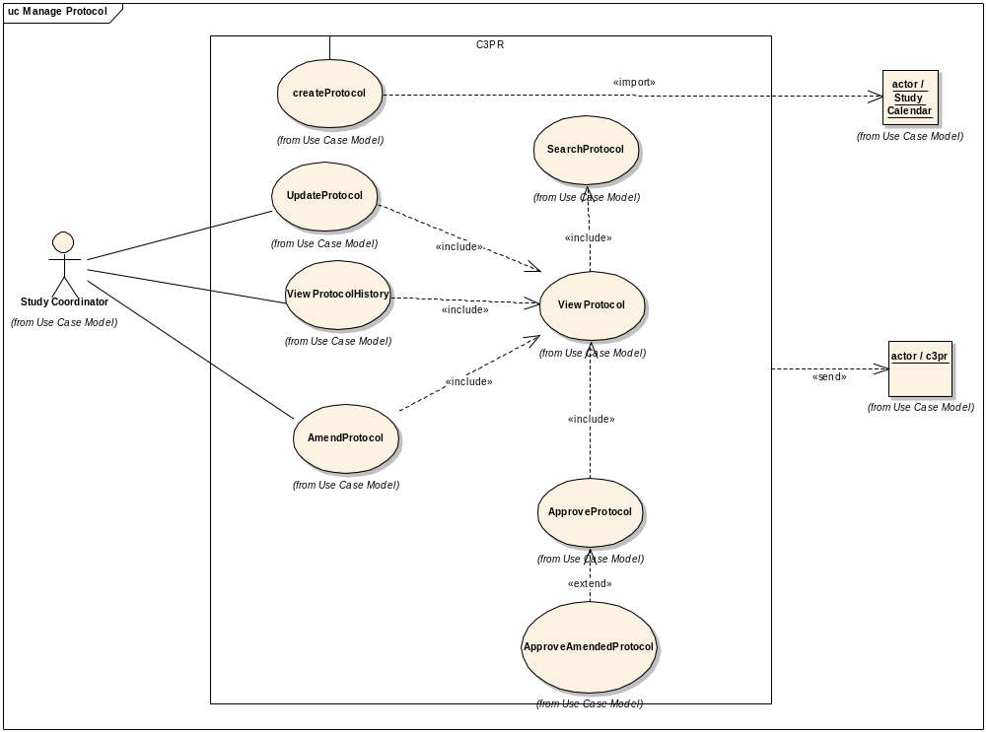

High Level Study Data Capture Use Case Diagram
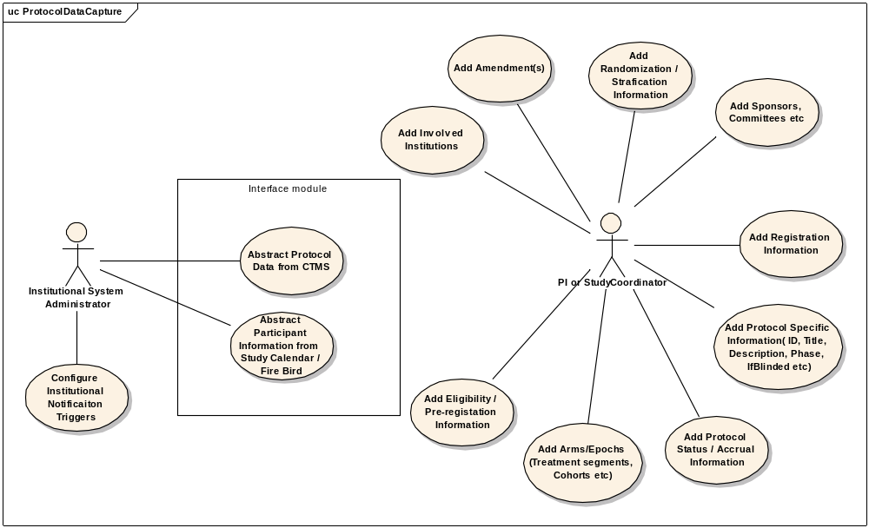

Create Study Definition Manually

Use Case Model
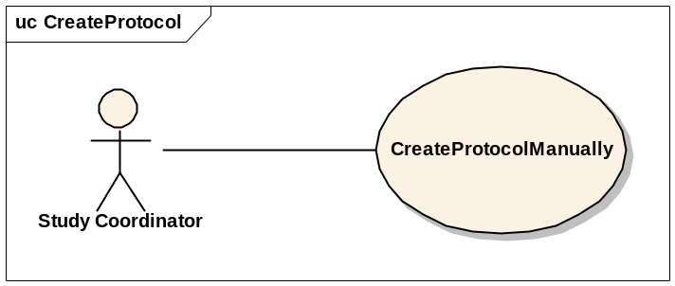

Brief Description
This use-case deals with the manual creation of a study by entering each data element of the study.

Primary Actor
Study Coordinator or any other designated user of C3PR with role authority to create a study.

Secondary Actors
None

Preconditions
- The user is logged in to the system with a user account that has role authority to create a study.

Basic Flow of Events
- The user indicates to the system that he/she wants to create a new study definition by clicking the Create Study link
- The system displays the screen that gives the user option of entering the study information manually. The user clicks on the enter study manually link.
- The user enters the study data elements in the fields.
- The user indicates to the system that the required study information has been entered for creation of a new study through a confirmation window with all of the study data items.

Post conditions
- If the user is logged in to the system with a user account that has role authority to create a Study (for example, a Study Manager), the created study is verified.
- If the user was logged in to the system with a role authority to only enter the study information, the created study awaits for further validation check from a Study Coordinator/Study Manager before it becomes approved.

Alternate flow
- The system displays studies with matching fields to ensure that the study is not a duplicate.

Data Items

Data Element | Validation/Notes
(1) Study ID | Required (at least 1)
1.1 Value | Required
1.2 Type | Required
1.3 Source | Not Required
1.4 Is primary | Not Required (defaults to No)
(2) Study Amendment | Not Required
(3) Study Amendment Date | Required
(4) Study Phase | Required
(5) PI Name | Required (There is only 1 designated PI, the others are AIs)
(6) Branch | Not Required
(7) Study Long Title | Required
(8) Study Short Title | Not required
(9) Study Description | Required
(10) Precis | Not Required
(11) NCI NCIN Number | Not Required (may not be there)
(12) Registration Tracked | Yes/No (default: Yes)
(13) Multi-Institutional Study | Yes/No (default: No)
(14) Involved Institutions
14.1 Name | Required
14.2 Role | One of:  Data Coordinating Center?  Study Authority  Funding Sponsor  Participant Site (Health Care Site)  Affiliate Site  Study Site  Registration Center
14.3 Site Investigator | Required (multiple allowed)
14.4. IRB Start Date | Required
14.4. IRB End Date | Required
14.5 IRB approved accrual ceiling | Not Required
14.6 CTEP ID | Not Required
14.7 IRB Name | Not Required
14.8 Site ceiling | Not Required (this is when coordinating=No and is a multisite study)
14.9 Accrual ceiling | Not Required (can have any number)
14.9.1 Name | Required
14.9.2 isHard | Not Required (default: No)
14.9.3 Count | Required
14.9.4 Notification | Not Required (can have any number)
14.9.4.1 Percentage | Required (e.g. 80%)
14.9.4.2 Number | Required (e.g. 13 out of 15)
14.9.4.3 Description | Required
14.9.4.4 Roles | Required (who to notify)
(15) Study Accrual Ceiling | Required this ceiling should not be enforcing, or it will cause problems
(16) Study Accrual to Date | Default: 0
(17) Sponsor | Organization leading the research (for example, CTEP, NCI, Pfizer)
(19) Study Monitor | For example, CDUS, CTMS, Quintiles
(21) Study Type | Not Required
(22) Study Design | Not Required
(23) Study History | At least 1 required
23.1 Status | Required
23.2 Date of change | Required
(24) Study Open Date | Required – For future opening
(25) Study Close Date for Accrual | Required – For future closing
(26) Study Close Date Final | Required – For future closing
(27) Randomization
27.1 IsRandomized | Required (yes/no) (default: No)
27.2 Method | Method (Required if IsRandomized=Yes) ( a.Book, b. Built-in, c.Call-out)
(28) Arms
28.1 Name | Required
28.2 Description | Required
28.3 Number | Not Required
28.4 Status | Not Required
28.5 Accrual Ceiling | Not Required
28.6 Epoch | Not Required
28.6.1 Name | Not Required
28.6.2 Date | Start/End
28.7 Treatment Segments | Not Required
28.7.1 Name | Not Required
28.7.2 Epoch Name | Not Required
28.7.3 Eligibility at Segment | Not Required
28.8 Eligibility at Arm | Not Required
28.9 Cohort | Required
28.9.1 Yes/No | TBD
28.9.2 Name | TBD
28.9.3 Expiration Time | TBD
(29) Epoch | Not Required
29.1 Name | Not Required
(30) Blinded | Required (yes/no) (default: no)
(31) Blinded Type | Required (If Blinded=Yes)
(32) Eligibility | Not Required
(33) Other Identifiers | Multiple Allowed
33.1 Source | Not Required
33.2 Name | Required
33.3 Value | Required
(34) Pre-Registration
34.1 IfRequired | Yes/No (default: no)
34.2 Eligiblity | Not Required
(35) Disease site | Not Required - Can have multiple
35.1 Name | Required
35.2 CTEP code | Not Required
(36) Status | Required: Active, Closed, etc.
(37) Study form | Not Required (could have more than one)
37.1 Name | Required
37.2 Description | Required
37.3 Format | Required (pdf, word doc, etc.)
37.4 File | Required (binary file uploaded)
(38) IRB consent date | Not Required (this is the date that the IRB approved the consent)
(39) Allows reservation | Not Required (defaults to No)
(40) Drug Agent | Not Required - Can have multiple
40.1 Name | Required
40.2 CTEP code | Not Required

Special Requirements
None

Load Study Definition from a File

Use Case Model
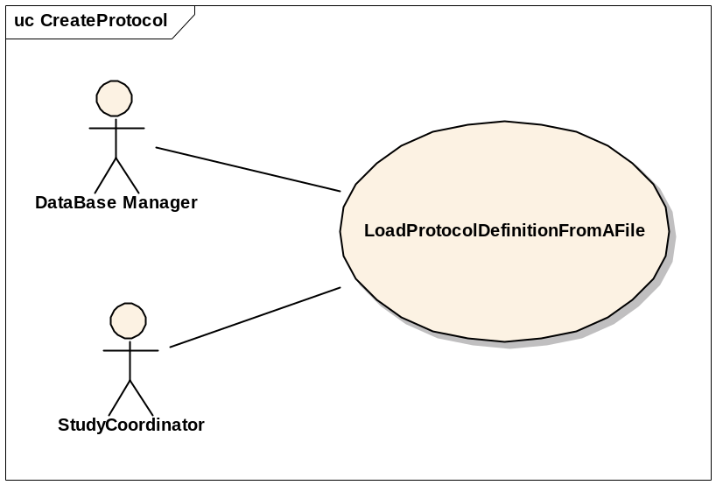

Brief Description
This use-case deals with loading a Study from a file that is on the user’s local system.

Primary Actor
Study Administrator or any other designated user of C3PR with role authority to create a Study.

Secondary Actors
None

Preconditions
- The user is logged in to the system with a user account that has role authority to create a Study.

Basic Flow of Events
- The user indicates to the system that he/she wants to create a new study definition from a file by clicking the Import Study link
- The system displays a screen that allows the user to browse their local file system.
- The user selects the appropriate file which contains the information about the study to be loaded into the system.
- After selecting the file, the user indicates to the system to create a new study definition based on the information in the file.
- The system reads the file and validates the file.
- If the file is valid, a new study definition entry is created.

Post conditions
- If the user is logged in to the system with a user account that has role authority to create a Study (for example, a Study manager), the created study is approved.
- If the user was logged in to the system with a role authority to only enter the study information, the created study awaits for further validation check from a study coordinator/study manager before it becomes approved.

Special Requirements

Get Study Definition via Study Message from External Source

Use Case Model
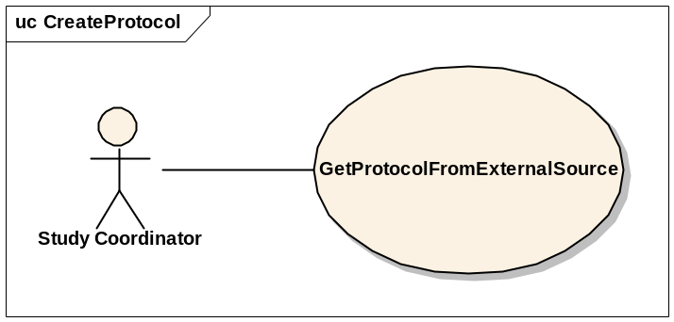

Brief Description
This use-case deals with creation of a Study at the local system after getting/importing it from an external source via a Study Message.

Primary Actor
Study Administrator, Study Coordinator or any other designated user of C3PR with role authority to create a Study.

Secondary Actors
None

Preconditions
- The user is logged in to the system with a user account that has role authority to create a Study.
- C3PR is configured to receive messages from the external source.

Basic Flow of Events
- The user indicates to the system that he/she wants to create a new study definition by clicking the Import Study link
- The system displays a screen that displays the import methods. This screen allows the user to import a new study.
- The user clicks on a link, and the study is imported
- If errors occur during the import, they are displayed to the user
- If the study is imported successfully, the user views the study.
- The user checks the study for correctness and updates the study entries to correspond to the local site requirements (IRB approval, accrual ceiling, etc).
- After importing the study, the user confirms the study creation.

Postconditions
The imported study waits for further changes/validation with respect to the local site conditions (IRB approval, accrual ceiling, etc) before it is available for use at the local site.

Alternate path
- If the study already exists, an error is returned

Data Items
See 4.3.8

Special Requirements

Search for Studies

Use Case Model
TBD

Brief Description
This use-case deals with searching for a study. Reasons for searching for a study include:
  - Looking for duplicate studies
  - Begin subject registration
  - Check for eligibility requirements
  - Check study status
  - Modify a study

Primary Actor
Database Manager, Study Coordinator, Principal Investigator or any other user of C3PR with role authority to search for a study.

Secondary Actors
None

Preconditions
The user is logged in to the system with a user account that has role authority to search for a study.

Basic Flow of Events
- The user indicates to the system that he/she wants to search for a given study definition by clicking the Search Study link.
- The user enters the search criteria for the study and submits the information to the system.
- The system displays 0, 1 or multiple study definitions depending on the search criteria.

Post conditions
The resulting study list is in a state that the user can transition to any of the manage study or register subject use cases. This means sufficient detail is presented to the user in order to determine which study to transition to. These details will be determined in later iterations.

Data Items
Search criteria: keyword, disease site, phase or PI, unique study ID.

Special Requirements

View Study

Use Case Model
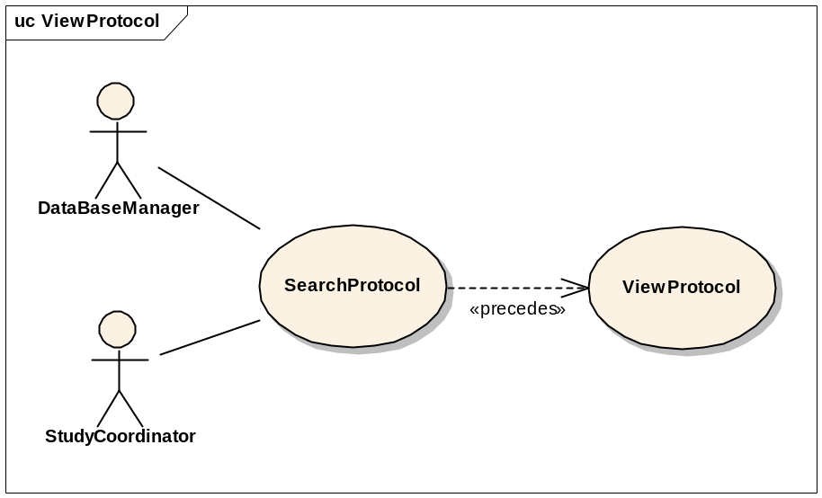

Brief Description
This use-case deals with viewing a study.

Primary Actor
Database Manager, Study Coordinator, Principal Investigator or any other user of C3PR with role authority to view a study.

Secondary Actors
None

Preconditions
The user is logged in to the system with a user account that has a role authority to view a study definition.

Basic Flow of Events
- The user indicates to the system that he/she wants to search for a given study definition by clicking the Search Study link.
- The user enters the search criteria for the study and submits the information to the system.
- The system displays 0, 1 or multiple study definitions depending on the search criteria.
- The user selects a study and clicks on the link to view that study.
- All data items from the study are displayed

Post conditions

Data Items
See section 4.3.

Special Requirements

Update Study

Use Case Model
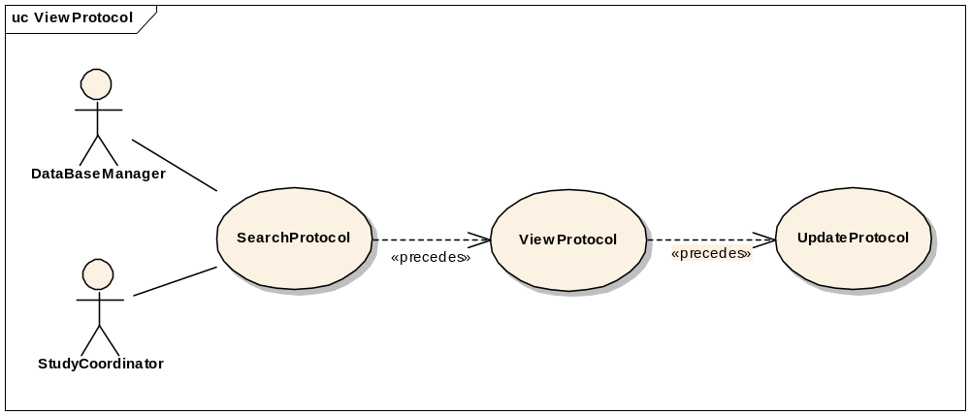

Brief Description
This use-case deals with updating a study entry through the user interface. Note that this is different from a study amendment, which is a metadata item about an official change to a study.

Primary Actor
Database Manager, Study Coordinator or any other user of C3PR with role authority to update a study definition. This includes changing the status of the study (i.e. open versus closed).

Secondary Actors
None

Preconditions
The user is logged in to the system with a user account that has role authority to update a study definition.

Basic Flow of Events
- The user indicates to the system that he/she wants to search for a given study definition by clicking the Search Study link.
- The user enters the search criteria for the study and submits the information to the system.
- The system displays 0, 1 or multiple study definitions depending on the search criteria.
- The user selects a study and clicks on the link to view that study.
- The user clicks on the Update Study link and updates the necessary fields.
- The user saves the updated study information to the system.

Post conditions
- If the user is logged in to the system with a user account that has role authority to update a study, the study stands updated
- If the user is logged in to the system with a user account that doesn’t have a role authority to update a study, the study awaits for further validation check from a study manager.

Data Items

Special Requirements

Approve Study Definition

Use Case Model
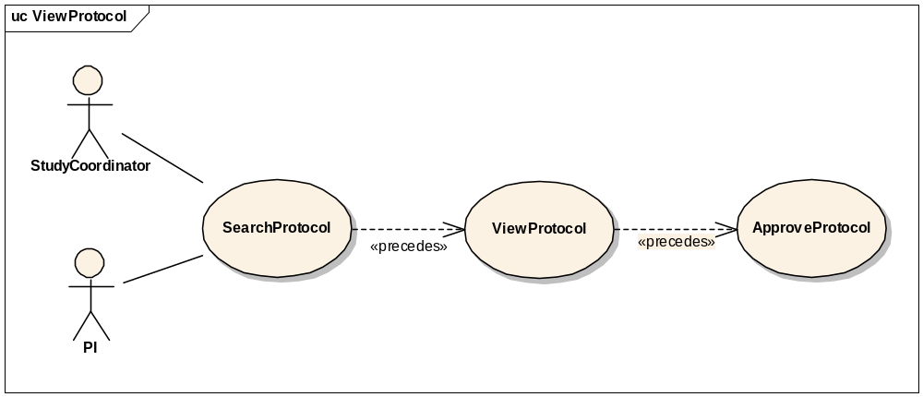

Brief Description
This use-case deals with approval or validation of a study definition entry.

Primary Actor
Study Coordinator, PI or any other designated user of C3PR with role authority to approve a Study.

Secondary Actors
None

Preconditions
- The user is logged in to the system with a user account that has role authority to approve a Study.
- The Study definition has already been created but not validated.

Basic Flow of Events
- The user indicates to the system that he/she wants to search for a given study definition by clicking the Search Study link.
- The user enters the search criteria for the study and submits the information to the system.
- The system displays 0, 1 or multiple study definitions depending on the search criteria.
- The user indicates to the system that he/she wants to approve a newly created study definition by clicking the Approve Study link
- The user selects a study from a list of newly created studies.
- The user views the newly created study.
- He/She checks for the correctness of the data elements of the study against the coordinating site/local site parameters.
- The user approves the newly created study by clicking on Approve button or link.

Postconditions

The created study has been approved.

Data Items

Special Requirements

Amend Study Definition

Use Case Model
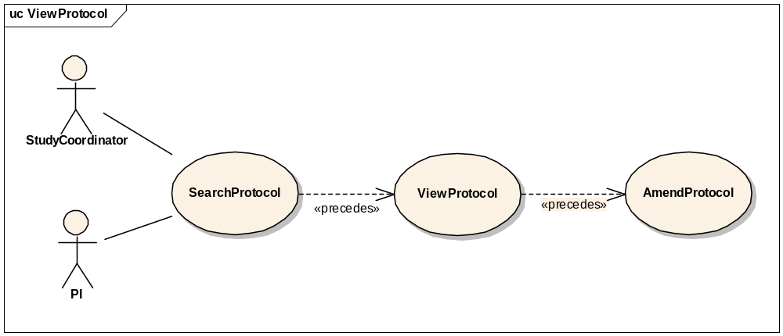

Brief Description
This use-case deals with amending a current study definition.

Primary Actor
Study Coordinator, Principal Investigator or any other designated user of C3PR with role authority to amend a study definition.

Secondary Actors
None

Preconditions
The user is logged in to the system with a user account that has role authority to amend a study definition.

Basic Flow of Events
- The user indicates to the system that he/she wants to search for a given study definition by clicking the Search Study link.
- The user enters the search criteria for the study and submits the information to the system.
- The system displays 0, 1 or multiple study definitions depending on the search criteria.
- The user selects the study definition for which he/she wants to amend.
- The user indicates to the system that he/she wants to make an amendment by clicking on the Amend Study link.
- The user enters the amendment data items
  - A history of the original study will be kept.

Postconditions
The study definition has been amended.

Data Items
The study amendment data items are still being defined

Special Requirements

Abstract Study Data

Register Subject to a Study Arm
This will have a similar flow to edit study because a user may want to select a study from a search.

Synchronize Creation of Study Definition with Study Calendar

Brief Description
This use case propagates the Study definition created in the C3PR system to Study Calendar system via CTMS Hub. The use case assumes that C3PR is the authoritative source for study information as far as the PSC is concerned.

Primary Actor
Study Administrator or any other designated user of C3PR with role authority to create a Study.

Secondary Actors
- CTMS Hub (caExchange or some other messaging infrastructure)
- Subject Study Calendar (PSC)
- Study Coordinator

Preconditions

Successful Creation of Study in C3PR system
The Study definition has been successfully created in the C3PR system (refer to use cases 3.1 and 3.2) by a user with a user account that has role authority to create a Study.

Basic Flow of Events
- The system generates a message in a predetermined format containing the new study information.
- The system then submits the new study message to the CTMS Hub.
- The CTMS Hub determines where the message needs to be delivered to, which is Study Calendar system in this case.
- The CTMS Hub transforms the new study message into a message format that the Study Calendar system can process.
- The Study Calendar system processes the study message and creates the Study Definition.
- After successfully processing the new study definition message, the Study Calendar system sends an acknowledgment to the CTMS Hub indicating the successful creation of a Study Definition in the Study Calendar system.
- The CTMS Hub sends an email notification indicating the creation of a new Study Definition to relevant actors including the Study Coordinator.

Postconditions

Creation of Study Definition in C3PR and PSC
A Study Definition created in the C3PR is replicated in the PSC.

Email Notifications
Email notifications are sent to relevant actors indicating the creation of a new study.

Data Items

Special Requirements

Synchronize Registration of a Subject on a Study Arm with Study Calendar

Brief Description
This use case essentially deals with propagating the registration information of a subject on a Study Arm created in the C3PR system to Study Calendar system via CTMS Hub.

Primary Actor
Registrar or any other designated user of C3PR with role authority to register a subject on a Study Arm.

Secondary Actors
- CTMS Hub
- Subject Study Calendar (PSC)
- Participant Coordinator

Preconditions

Successful Creation of Study in the Study Calendar system
  - The Study definition has been successfully created in the Study Calendar system either manually thru the Study Calendar web interface or thru a message from the C3PR system (refer to use case 3.5).

Basic Flow of Events
- The system generates a message in a predetermined format containing the new registration information.
- The system then submits the new registration message to the CTMS Hub.
- The CTMS Hub determines where the message needs to be delivered to, which is Study Calendar system in this case.
- The CTMS Hub transforms the new registration message into a message format that the Study Calendar system can process.
- The Study Calendar system processes the new registration message by creating the Subject record, if the Subject does not already exist in the Study Calendar system, and then creates the calendar for the Arm to which the Subject is being registered to.
- After successfully processing the new subject registration message, the Study Calendar system sends an acknowledgment to the CTMS Hub indicating the successful creation of the calendar corresponding to the Arm that the subject is registered on in the Study Calendar system.
- The CTMS Hub sends an email notification indicating the creation of a new calendar for the Arm that the subject is registered on to relevant actors including the Participant Coordinator.

Post conditions

Creation of Subject record in PSC
A new Subject record is created in the Study Calendar system if the Subject does not already exist in it.

Creation of Calendar for the Arm related to the Subject
The calendar for the Arm that the Subject is registered on is created in the study calendar system.

Email Notification
Email notifications are sent to relevant actors indicating the creation of the Subject (optional) and calendar.

Exception flow
Errors during the normal flow of events will through the messaging system will trickle back to the user. This could include a misconfigured messaging system or errors generated by the target system.

Data Items
These items will be enumerated in a future iteration.

Special Requirements

Manage Registration

The following use cases describe the management of subject registration in C3PR. Different registration scenarios are captured as distinct use cases because they follow different flows and potentially have different actors and pre-requisites.

Register a New Subject to a Study

Use Case Model
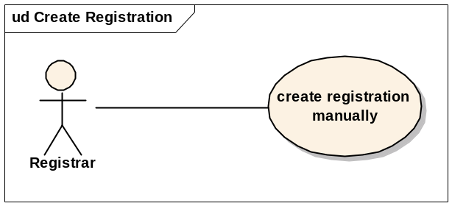

Brief Description
This use case will allow the user to register a subject not currently in the C3PR system to a study. The user will be required to enter subject information before completing the registration.

Primary Actor
Registrar or any other designated user of C3PR with role authority to register a Subject.

Secondary Actors
None

Preconditions
- The user is logged in to the system with a user account that has role authority to create a Study.
- The Study already exists.
- Any hard accrual limits are not exceeded
- The Study has a status of Active

Basic Flow of Events
Add the flow
Include notification of accrual if meets configured percentages
Include check for accrual for all hard limits
Include check for Study status

Postconditions
- If the user is logged in to the system with a user account that has role authority to register a Subject (for example, a Registrar), the registration is approved.
- If the user was logged in to the system with a role authority to only enter the registration information, the registration awaits for further validation check before it becomes approved.

Data Items
Data Element | Validation/Notes
(1) Method of Payment | Not Required, configurable
(2) Enrollment date | Required
(3) Study subject identifier | Not Required, configurable (not generated by c3pr)
3.1 Value | Required
3.2 Type | Required
3.3 Source | Not Required
3.4 isPrimary | Not Required (default is false)
(4) Treating MD | Not Required
(5) Diagnosis | Not Required, configurable
5.1 Name | Required
5.2 Date | Required
(6) Adult/Pediatric flag | Not Required, configurable (determining this from the birthday is problematic)
(7) Randomization | Not Required (could have nay number)
7.1 Arm | Required
7.2 Date | Required
(8) Registration status | Required, history tracked
8.1 Date | Required
8.2 Value | Required (Enrolled, Screening, Screening failure, Compassionate care, Ineligible after enrollment, etc.)

Special Requirements
None

Register an Existing Unregistered Subject to a Study
This use case will allow the user to register a subject that is currently in the C3PR system but not registered on a study. The user will have to identify an existing subject such that subject information is not duplicated.

Register an Existing Registered Subject to a Study
This use case will allow the user to register a subject that is currently in the C3PR system and registered on a study. The user will have to identify a study that the subject is not already registered to such that registration information is not duplicated.

Save a registration in an incomplete status
This use case allows the user to select a study and select a subject and without entering other details, save the information in an incomplete status. Users can then search for the registration and complete the information and the registration will either go on pending status if it requires some approval, if it’s a multi site study or it can be accepted as a complete registration.

Register Subject to Local Study
This use case allows the user to register a subject to a study originated at the local site.

Register Subject to External Study
This use case allows the user to register a subject to a study originated at an external site (coordinating site, CALGB, etc).
Include registration at local site, with propagation to coordinating site, and vice versa.

Register Subject to a Reservation-enabled Study
In some Phase I studies, there are very small number of accrual slots
It is important that someone can be registered to the study, get worked up, and then potentially be removed from the study
This type of “reservation” allows the next candidate to take the originally registered slot
This differs from most studies, where the de-registered slot is “lost” – the next subject is registered to the next slot

Search for Registrations

Use Case Model
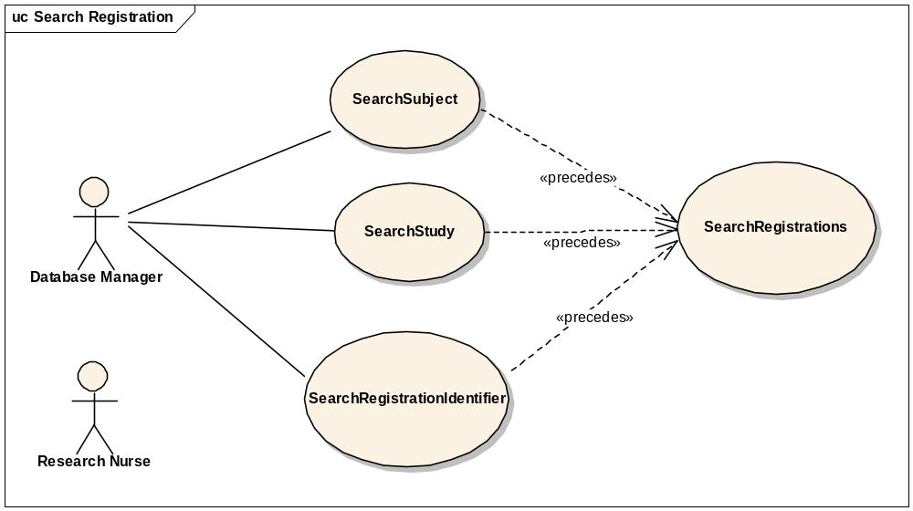

Brief Description
This use-case deals with searching for registrations. Reasons for searching for registrations include:
  - Looking for duplicate registrations
  - View registration history
  - Check for eligibility requirements
  - Check registration status
  - Modify a registration
  - To assign a subject to a randomized arm

Primary Actor
Database Manager, Study Coordinator, Principal Investigator or any other user of C3PR with role authority to search for a registration.

Secondary Actors
Research Nurse

Preconditions
The user is logged in to the system with a user account that has role authority to search for a registration.

Basic Flow of Events
- The user indicates to the system that he/she wants to search for registrations by clicking on the Search Registration link.
- The system displays a 2-step search process. The user first searches for a subject, study or a registration identifier based on subject search criteria, study search criteria or the registration identifier value respectively.
- The user then searches for the registrations based on the selected subject, study or registration identifier
- The system displays 0, 1 or multiple registrations depending on the search criteria.

Post conditions
The resulting registration list is in a state that the user can transition to any of the manage registration use cases like completing, updating eligibility, assigning to a randomized arm, updating registration status etc. This means sufficient detail is presented to the user in order to determine which registration to transition to.

Data Items
Search criteria: (1) Subject (last name, identifier value), (2) Study (short title, long title, identifier value, status), (3) Registration Identifier value.

Special Requirements

View Subject Registration History

Use Case Model
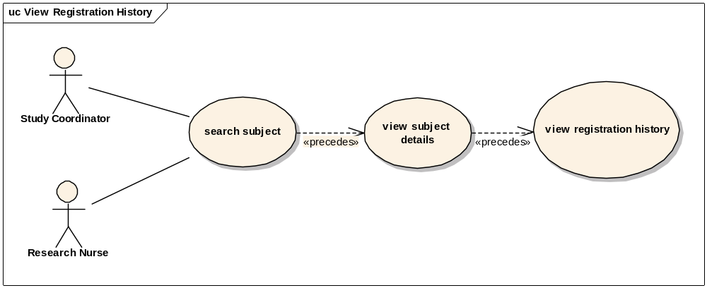

Brief Description
This use case allows the user to view registration details of a subject.

Primary Actor
Site Coordinator, CRA or any other designated user of C3PR with role authority to view a registration.

Secondary Actors
Research Nurse

Preconditions
1 The subject is already registered to a study at a particular healthcare site.
2 The user is logged into the system with a user account that has role authority to view registration details.

Basic Flow of Events
1 The user searches for a given subject.
2 The user selects desired subject to view the subject details.
3 The user indicates that he/she wants to view the desired registration from a list of registrations the subject is on.
4 The user can choose to view registration details, eligibility status, registration status, stratification factors, randomization arm, and registration identifiers by clicking on appropriate tab.

Postconditions
1 The user viewed the details of a desired registration.

Data Elements
The following details can be viewed. TBD: revise into a table
1. Subject summary
(a) Subject name
(b) Subject gender
(c) Subject birthdate
(d) Subject ethnicity
(e) Primary Identifier Source
(f) Primary Identifier
2. Study summary
(a) Study short title
(b) Study version
(c) Study Identifier Source
(d) Study Identifier
(e) Study status
(f) Study phase
(g) Study type
(h) Study sponsor
(i) Study disease
3. Registration Status
(a) Pending (The registration is not complete or/and the consent is not signed or/and waiting for approval)
(b) Registered (A treatment date and treating physician)
(c) Closed-Not Counted (Not counted towards registration accrual)
4. Eligibility
(a) Eligibility Status
(i) Incomplete
(ii) Ineligible
(iii) Eligible
(II) If eligible
(i) Met
(ii)Waived (eligibility waiver reason)
(iii)Compassionate care
5. Registration Details
(a) If registration is complete
(i) Treating physician
(ii) Registration Identifier
(iii) Treatment date
(iv) Informed Consent form signed date
(v) Informed Consent version
(vi) Healthcare Site
6 Stratification/Randomization
(a) Stratification Criteria
(b) Randomization type (book, call-out, hub)
(c) Randomization result (Arm A, Arm B, Arm C of the treatment Epoch)
7 Registration Identifiers
(a)
(i) Identifier Type
(ii) Identifier Source
(iii) Identifier Value
(iv) Primary Indicator

Update Eligibility Status on a Pre-Registration/Registration

Use Case Model
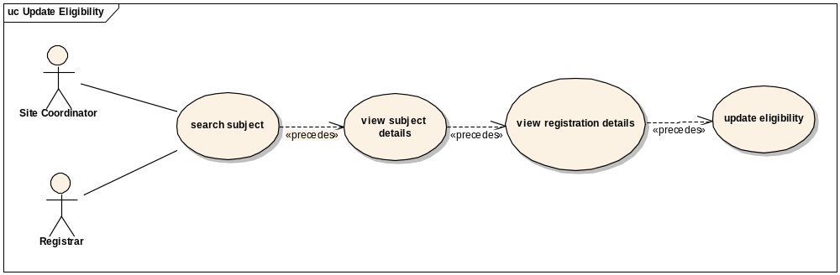

Brief Description
This use case allows the user to update eligibility status of a subject on a given registration.

Primary Actor
Site Coordinator, CRA or any other designated user of C3PR with role authority to update eligibility on a given registration.

Secondary Actors
Research Nurse

Preconditions
1 The subject is already pre-registered to a study at a particular healthcare site.
2 The user is logged into the system with a user account that has role authority to update eligibility status of a subject on a given study.

Basic Flow of Events
1 The user searches for a given subject.
2 The user selects desired subject to view the subject details.
3 The user indicates that he/she wants to view the desired registration details from a list of registrations the subject is on.
4 The user indicates that he/she wants to view the eligibility of the subject on the given study by selecting the eligibility tab.
5 The user can change the eligibility of the subject and indicates to the system that he/she wants to save the new eligibility status.

Postconditions
- If the user had the role authority to update eligibility of the subject on the given study, the eligibility status would be updated.
- If the user didn’t have the role authority to update eligibility of the subject, the status would await for further approval.

Assign Subject to a Randomization Arm

Use Case Model
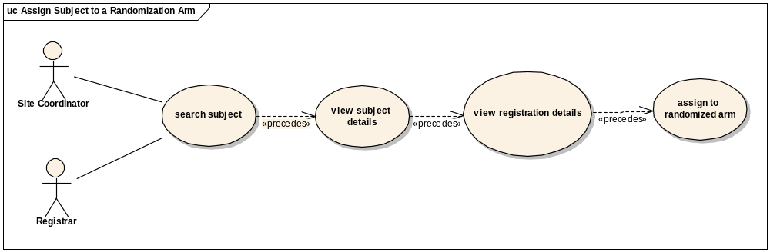

Brief Description
This use case allows the user to assign a subject to an arm.

Primary Actor
Site Coordinator, CRA, designated Statistician or any other user of C3PR with role authority to assign a subject to a randomized arm on a given registration.

Secondary Actors
Research Nurse

Preconditions
1 The subject is already registered to a study at a particular healthcare site.
2 The user is logged into the system with a user account that has role authority to assign a subject to a randomized arm on a given study.

Basic Flow of Events
1 The user searches for a given subject.
2 The user selects desired subject to view the subject details.
3 The user indicates that he/she wants to view the desired registration details from a list of registrations the subject is on.
4 The user indicates that he/she wants to view the randomization information of the subject on the given study by selecting the randomization tab.
5 The user selects the desired arm to which the subject is to be assigned indicates to the system that he/she wants to save the arm.

Postconditions
- If the user has the role authority to assign the subject to a randomized arm on the given study, the subject is assigned to a randomized arm.

Update Registration Status of a Subject on a given Study

Use Case Model
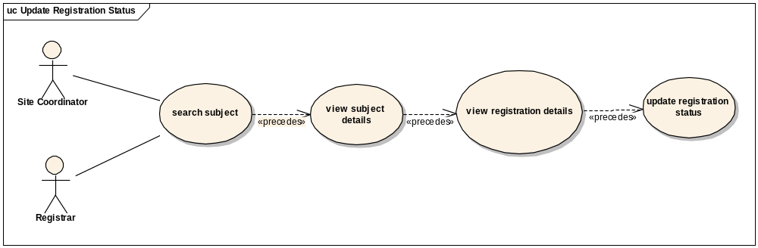

Brief Description
This use case allows the user to update the registration status of a subject on a given study.

Primary Actor
Site Coordinator, CRA, or any other designated user of C3PR with role authority to update the registration status on a given study.

Secondary Actors
Research Nurse

Preconditions
1 The subject is pre-registered to a study at a particular healthcare site.
2 The user is logged into the system with a user account that has role authority to update registration status for a subject on a given study.

Basic Flow of Events
1 The user searches for a given subject.
2 The user selects desired subject to view the subject details.
3 The user indicates that he/she wants to view the desired registration details from a list of registrations the subject is on.
4 The user indicates that he/she wants to view the registration status of the subject on the given study by selecting the registration tab.
5 The user selects the desired registration status and indicates to the system that he/she wants to save the status.

Postconditions
1 If the user has the role authority to change registration status of the subject on the given study, the registration status of the subject stands changed.

Reserve Registration
This use case allows the user to reserve a slot/position for a subject on a study so that whenever accrual starts, the subject can be registered.

Store Subject Screening Data
This use case allows the user to store screening data of the subject. This use case is primarily required for reporting purposes; however, this data may be reused during the registration.

Submit Pending Registration Information
This use case allows the user to submit a pending registration.

Confirm Submitted Registration Information
This use case provides for a confirmation message to be sent once a pending registration is submitted. This will be a synchronous message (by email?) such that treatment can immediately begin.

Replicate Registration to Companion Study
This use case allows the user to replicate the subject registration information to selected companion studies.

Replicate Registration to Local Site
This use case allows the user to replicate the subject registration information to the local site.

Manage Randomization

Email Notify Registrar
This use case allows the user to notify the randomization registrar for randomization.

Display Notification
This use provides for a notification to be displayed to the randomization registrar on the website after the user logs in.

Randomize Using Study Block
This use case allows the user to fetch randomization from a study block stored in C3PR.

Randomize Using Call-out
This use case allows the user to fetch randomization arm via a call-out to an external randomization routine (e.g. the Randomization Hub).

Manage Eligibility Criteria

Approve Eligibility Criteria
This use case allows the user to approve eligibility criteria of a subject.

Exempt Eligibility Criteria
This use case allows the user to exempt the eligibility criteria for a subject (for example, “compassionate treatment exemption”).

Import Eligibility Criteria
This use case allows the user to import eligibility criteria from external sources like caDSR.

Access Clinical Data
This use case allows the user to access clinical data from external systems like C3D.

Manage Stratification
TBD

Manage Relationship

Create Relationship
This use case allows the user to associate a Study Personnel or Subject to other Study Personnel(s) or Subject(s).
More use cases TBD.

Login
This use case allows the user to login into C3PR.

Reporting

Advanced Registration Search

Use Case Model
ADD MODEL HERE

Brief Description
This use case allows the user to enter information in 4 different kinds of criteria and run a registrations search. The search results table also allows the user to download the results in .xls format at the click of a button.

Primary Actor
Administrator or any other designated user of C3PR with role authority to generate reports.

Secondary Actors
None

Preconditions
1 The user is logged in to the system with an administrative account.

Basic Flow of Events
1 The user enters the desired search criteria. The four criteria are: Study, Site, Registration and Subject.
2 The user clicks the search button to retrieve the corresponding registrations.
3 The user clicks on the export as excel icon to download the table in the .xls format.

Postconditions
- The search results are displayed in a table on the same page.
- This table provides a export as excel button which lets the user download the table contents in excel format.

From C3PR Release 1 (Not Yet Analyzed)

Maintain Study Strata Randomized List

Synchronize Subject with External Subject Registry

Assign Study Part to Subject

Generate Referral Letter

Integration
These use cases will allow user to integrate with external systems like caMATCH, CDW, Study Calendar etc.

Overall Requirements

Requirements Prioritization

Priority | Use Case Name | Supp Requirement Ref #
1 | Manage Study

Sign Off

Approval

Workspace General Contractor Rep Print Name Date
Architecture Workspace Rep Print Name Date
VCDE Workspace Rep Print Name Date
Workspace Working Group Rep Print Name Date
NCICB Rep Print Name Date

