Characteristics/Fields  (i.e., variables, criteria) | Descriptors  (e.g., Options within fields, levels)
Screenshot | 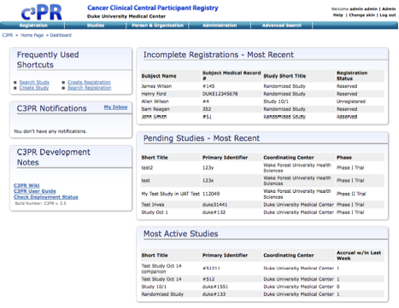
Product Description (3-4 sentence text field) | The Cancer Center Participant Registry (C3PR) is a web-based application used for end-to-end registration of patients to clinical trials. This includes capturing the consent signed date, eligibility criteria, stratification, randomization, and screening. Clinical workflows are enabled by both subject- and study-centric views into the registration process. C3PR can be run in a standalone mode where study definitions, investigators, study personnel, and sites are entered into the system, or C3PR can be run in an integrated mode with the caBIG Clinical Trials Suite (CCTS). C3PR also enables multi-site clinical trials where registration information is entered locally at affiliate sites and the registration is completed by call-out to the coordinating site.
Intended Audience(s) (Text Field) | Clinical trials staff (CRAs, registrars, study coordinators, site coordinators, system administrators)
Current Version Number | 2.5
Release Date of Current Version | October, 2008
Tool Download Files  (Text field with links) | https://gforge.nci.nih.gov/frs/download.php/5095/c3prv2-installer-offline-2.5.3.jar
Demo Files and Exercises  (Text field with links) | https://demo.semanticbits.com/c3pr/
Documentation and Training  (Text field with links) | https://gforge.nci.nih.gov/docman/index.php?group_id=214&selected_doc_group_id=4005&language_id=1
Are Training Modules Available in LMS? (Select one) | NO
End User Support (Text field with links) | http://cabig-kc.nci.nih.gov/CTMS/forums
Developer & Adopter Institutions (Text field with links) | Developers:  - Duke Comprehensive Cancer Center  - SemanticBits  Adopters:  - Duke Cancer Center  - Wake Forest Cancer Center  - Lombardi Cancer Center  Elaborators:  - Mayo Clinic  - CALGB  - Westat

