Test Script Number: | register_participant |  |  |  | Module: |  |  | Tester Name: |  | Steven Cheng | Pass/Fail:  Fail
Use Case #: |  |  |  |  | Username: | c3pr_admin |  | Test Date: |  | 08/03/2007 | Pass/Fail:  Fail
Estimated Execution Time: |  |  |  |  |  |  | Actual Execution Time: |  | 10 min
Test Objective: register a participant.

Test Setup: log in as an administrator.

Related Requirements
or Configuration Change Requests (Number/Description):

 | Test Action | Expected Results | Pass / Fail | Actual Results/Comments | gForge Tracker Bug ID
 | Click Registration tab, click Create Registration link, run Study Search to find the study, then click Search button. See figure 1. |  | Pass | Study Search results displayed.  Tested features:  - Search study by Identifier, Short Title and Status works fine. In addition, input one blank space and run search, get all studies displayed.  - Search subject by Last Name and Identifier works fine. Blank space search not work on the subject search.
 | Click the right one to select it. See figure 2 |  | Pass | The study is selected, go to next step to select subject.  Comments:  - Hyperlinks on Select Study tab and Select Subject tab do nothing. It’s better remove the hyperlinks on them. In iteration 4, all tabs have hyperlinks, but do nothing.  - Mouse icon is not changed on hyperlinks of study or subject. | 6892  8128
 | Run Search Subject to find the participant, then click Search button. See figure 3 |  | pass | Subject Search results displayed.
 | Click the right one to select it. See figure 4. |  | fail | The system is broken. | 8224

Tester Signature: Steven Cheng

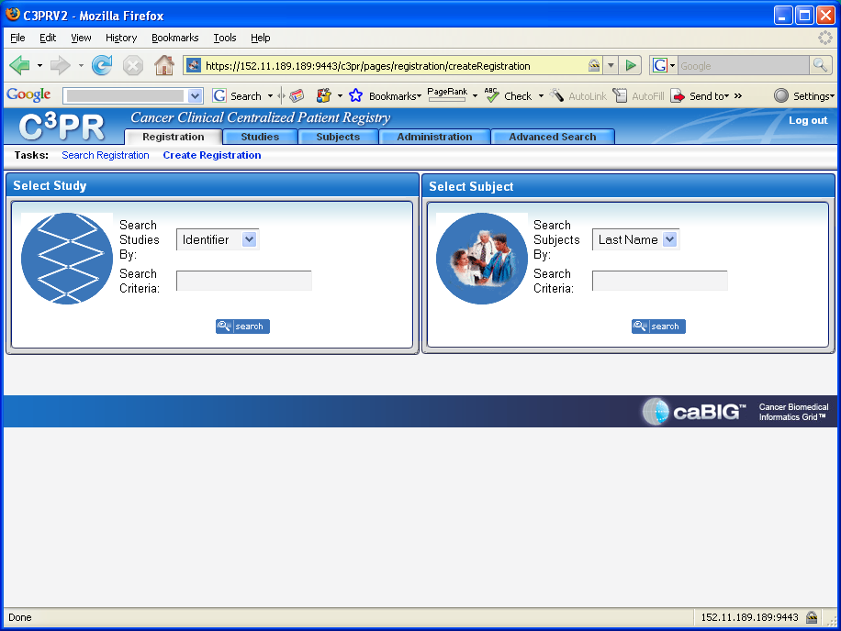
Figure 1
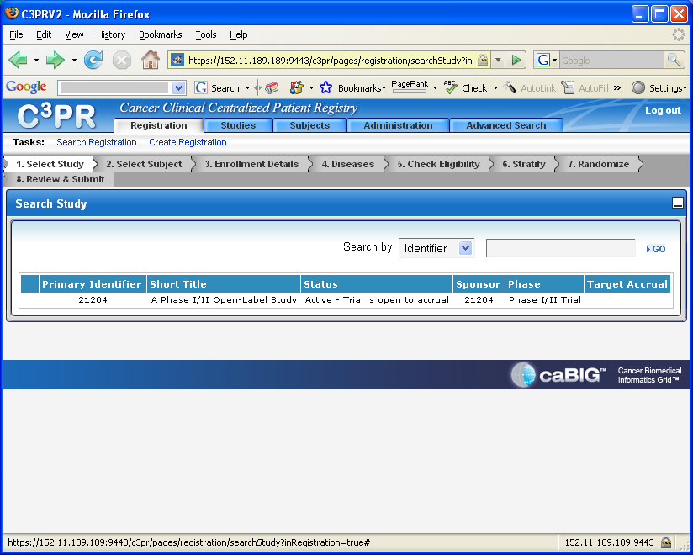
Figure 2
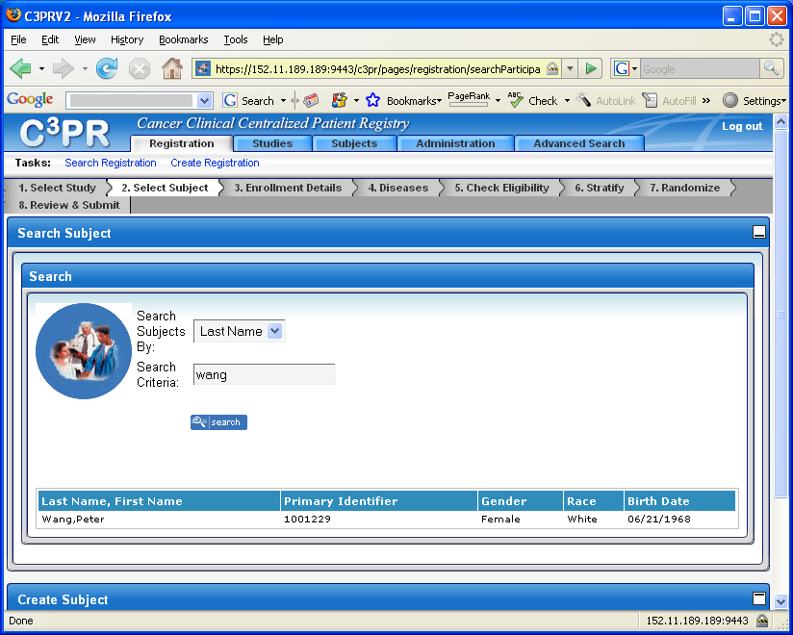
Figure 3
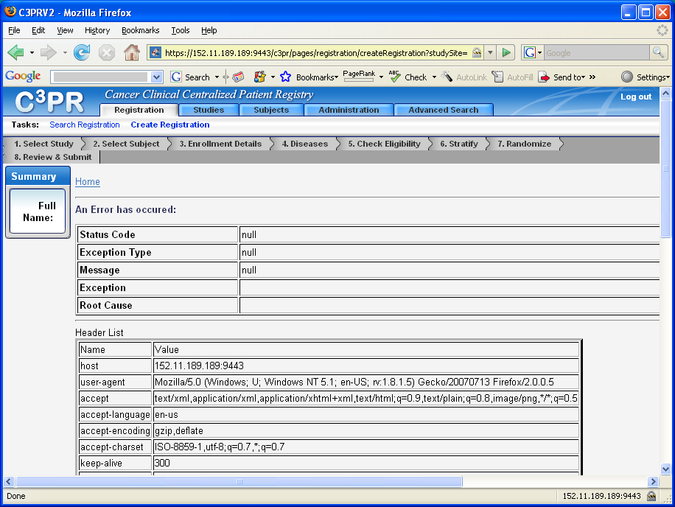
Figure 4

