C3PR v2
End User Manual

Duke Comprehensive Cancer Center CenterCenter

Document Change History
Version Number | Date | Contributor | Description
0.1 | 9/20/2007 | Patrick McConnell | Template
0.1.2 | 10/04/2007 | Peter Le | Draft
0.1.3 | 01/24/2008 | Peter Le | Draft
0.1.4 | 02/22/2008 | Peter Le | Draft


Updated February 22, 2008
Copyright and License page

Copyright Notice. Copyright 2007 Duke Comprehensive Cancer Center (“caBIG™ Participant”). C3PR was created with NCI funding and is part of the caBIG™ initiative. The software subject to this notice and license includes both human readable source code form and machine readable, binary, object code form (the “caBIG™ Software”).
This caBIG™ Software License (the “License”) is between caBIG™ Participant and You. “You (or “Your”) shall mean a person or an entity, and all other entities that control, are controlled by, or are under common control with the entity. “Control” for purposes of this definition means (i) the direct or indirect power to cause the direction or management of such entity, whether by contract or otherwise, or (ii) ownership of fifty percent (50%) or more of the outstanding shares, or (iii) beneficial ownership of such entity.
License. Provided that You agree to the conditions described below, caBIG™ Participant grants You a non-exclusive, worldwide, perpetual, fully-paid-up, no-charge, irrevocable, transferable and royalty-free right and license in its rights in the caBIG™ Software, including any copyright or patent rights therein that may be infringed by the making, using, selling, offering for sale, or importing of caBIG™ Software, to (i) use, install, access, operate, execute, reproduce, copy, modify, translate, market, publicly display, publicly perform, and prepare derivative works of the caBIG™ Software; (ii) make, have made, use, practice, sell, and offer for sale, and/or otherwise dispose of caBIG™ Software (or portions thereof); (iii) distribute and have distributed to and by third parties the caBIG™ Software and any modifications and derivative works thereof; and (iv) sublicense the foregoing rights set out in (i), (ii) and (iii) to third parties, including the right to license such rights to further third parties. For sake of clarity, and not by way of limitation, caBIG™ Participant shall have no right of accounting or right of payment from You or Your sublicensees for the rights granted under this License. This License is granted at no charge to You. Your downloading, copying, modifying, displaying, distributing or use of caBIG™ Software constitutes acceptance of all of the terms and conditions of this Agreement. If you do not agree to such terms and conditions, you have no right to download, copy, modify, display, distribute or use the caBIG™ Software.
- Your redistributions of the source code for the caBIG™ Software must retain the above copyright notice, this list of conditions and the disclaimer and limitation of liability of Article 6 below. Your redistributions in object code form must reproduce the above copyright notice, this list of conditions and the disclaimer of Article 6 in the documentation and/or other materials provided with the distribution, if any.
- Your end-user documentation included with the redistribution, if any, must include the following acknowledgment: “This product includes software developed by Duke Comprehensive Cancer Center.” If You do not include such end-user documentation, You shall include this acknowledgment in the caBIG™ Software itself, wherever such third-party acknowledgments normally appear.
- You may not use the names “Duke Comprehensive Cancer Center”, “The National Cancer Institute”, “NCI”, “Cancer Bioinformatics Grid” or “caBIG™” to endorse or promote products derived from this caBIG™ Software. This License does not authorize You to use any trademarks, service marks, trade names, logos or product names of either caBIG™ Participant, NCI or caBIG™, except as required to comply with the terms of this License.
- For sake of clarity, and not by way of limitation, You may incorporate this caBIG™ Software into Your proprietary programs and into any third party proprietary programs. However, if You incorporate the caBIG™ Software into third party proprietary programs, You agree that You are solely responsible for obtaining any permission from such third parties required to incorporate the caBIG™ Software into such third party proprietary programs and for informing Your sublicensees, including without limitation Your end-users, of their obligation to secure any required permissions from such third parties before incorporating the caBIG™ Software into such third party proprietary software programs. In the event that You fail to obtain such permissions, You agree to indemnify caBIG™ Participant for any claims against caBIG™ Participant by such third parties, except to the extent prohibited by law, resulting from Your failure to obtain such permissions.
- For sake of clarity, and not by way of limitation, You may add Your own copyright statement to Your modifications and to the derivative works, and You may provide additional or different license terms and conditions in Your sublicenses of modifications of the caBIG™ Software, or any derivative works of the caBIG™ Software as a whole, provided Your use, reproduction, and distribution of the Work otherwise complies with the conditions stated in this License.
- THIS caBIG™ SOFTWARE IS PROVIDED "AS IS" AND ANY EXPRESSED OR IMPLIED WARRANTIES (INCLUDING, BUT NOT LIMITED TO, THE IMPLIED WARRANTIES OF MERCHANTABILITY, NON-INFRINGEMENT AND FITNESS FOR A PARTICULAR PURPOSE) ARE DISCLAIMED. IN NO EVENT SHALL THE DUKE COMPREHENSIVE CANCER CENTER OR ITS AFFILIATES BE LIABLE FOR ANY DIRECT, INDIRECT, INCIDENTAL, SPECIAL, EXEMPLARY, OR CONSEQUENTIAL DAMAGES (INCLUDING, BUT NOT LIMITED TO, PROCUREMENT OF SUBSTITUTE GOODS OR SERVICES; LOSS OF USE, DATA, OR PROFITS; OR BUSINESS INTERRUPTION) HOWEVER CAUSED AND ON ANY THEORY OF LIABILITY, WHETHER IN CONTRACT, STRICT LIABILITY, OR TORT (INCLUDING NEGLIGENCE OR OTHERWISE) ARISING IN ANY WAY OUT OF THE USE OF THIS caBIG™ SOFTWARE, EVEN IF ADVISED OF THE POSSIBILITY OF SUCH DAMAGE.

Development Team
Development | End User Guide | Program Management
Patrick McConnell¹ | Patrick McConnell¹ | Jamie Cuticchia¹
Kruttik Aggarwal² | Bob Morrell³ | Bob Annechiarico¹
Manav Kher² | Stephen Cheng³ | Patrick McConnell¹
Ramakrishna Gundala² | William Banks¹ | Ram Chilukuri²
Ram Chilukuri² | Mohammad Farid¹
Vinay Gangoli² | Peter Le¹
 | Seth Fehrs¹
¹Duke Comprehensive Cancer Center
²Semantic Bits
³Wake Forest

Contacts and Support
Training contact | c3prv2-support@gforge.nci.nih.gov

LISTSERV Facilities Pertinent to software teams
LISTSERV | URL | Name
c3prv2-elaborators | c3prv2-elaborators@gforge.nci.nih.gov | C3PR Elaborators Forum
c3prv2-support | c3prv2-support@gforge.nci.nih.gov | C3PR Support Forum

Table of Contents
Chapter 1 Introduction to the Manual 7
Overview of C3PR Functionality 7
Users of C3PR 8
Organization of the User Guide 9
Document Text Conventions 10
Chapter 2 Overview of the Software 13
Layout of the User Interface 13
Look and Feel 13
Chapter 3 Logging In 16
Security 16
Accessing C3PR 16
Logging into C3PR 16
Chapter 4 Managing Studies 17
Adding Studies 17
Searching for Studies 29
Chapter 5 Managing Subjects 29
Adding Subjects 32
Searching for Subjects 32
Chapter 6 Managing Registrations 35
Registering Subjects 35
Searching for Registrations 39
Chapter 7 Advanced Querying 41
Querying for Registrations 41
Querying for Studies 41
Chapter 8 Administration 43
Adding Investigators 45
Adding Research Staff 45
Adding Organizations 48
Importing Data (Study and Registration) 49
Appendix A References 50
Technical Manuals/Articles 50
caBIG Material 50
caCORE Material 50

Appendix B Glossary 51
Index 53

Chapter 1 - Introduction to the Manual
This End User Guide was created to provide users of the Cancer Central Clinical Participant Registry (C3PR) with information on how to use the application.
Topics in this chapter include:
Overview of C3PR Functionality
Users of C3PR
Organization of the User's Manual
Document Text Conventions

Overview of C3PR Functionality

The overarching vision of C3PR Release 2 is to extend the existing cancer Clinical Central Participant Registry (C3PR) system and underlying database to enable additional capability for the capture and management of:
- Clinical trials participant registration
- Protocol information
- Clinical trials registration information across different clinical studies
- Information on referring physicians, research sites, and organizations
- Timely access to information for clinical research staff and physicians.
The focus of version 2 is to:
- Integrate with other clinical systems, including C3PR-to-C3PR integration for multi-site studies
- Extend registration, including storing randomization information
- Enhance protocol management, including web-based management
- Improve the user interface from the perspective of the registrar
- Extend reporting
C3PR is a powerful tool for managing clinical trials and the registration of subjects. Users can create detailed abstracts of clinical trials and manage the treatment epochs, IRB approval, sites, and assigned roles for that study. Subject registrations include information about enrollment, eligiability, stratification and randomization. C3PR is also useful for Cancer Centers reporting to the NC as it collects the data necessary for the Summary 3 and 4 annual reports in terms of the clinical trial and subject registration details.

C3PR Release 1 provides a highly configurable participant registry for managing clinical study registration at a single site. However, it cannot easily manage cross-site studies, and it can be very difficult to install, configure, and manage. The primary goal of C3PR Release 2 is to build upon Release 1 to make it more generally useful to the cancer research community. A scoping goal will be for C3PR to manage participant registration to multi-site studies. This involves the integration of C3PR instances at different centers, as well as providing messaging interfaces to integrate with legacy (non-C3PR) registries. Additionally, integration beyond C3PR will be needed to perform institution-level and PI-level eligibility checks. The current registration model is somewhat limited, allowing for simplistic randomization based upon manual assignment of participants to arms. Furthermore, protocol management in C3PR will be greatly enhanced. Though C3PR is not intended as a central protocol repository, protocol information is critical to the registration process. Protocol information will be expanded to meet the use cases of multiple eligibility check-points, multi-institutional studies, and differing randomization schemes. C3PR Release 1 provided registration from a participant-centric standpoint. This workflow will be enhanced to provide registration from a protocol-centric view, and reporting will be extended to provide this information to external systems to generate complex reports.
More information about C3PR can be found at:
- The C3PR GForge site: http://gforge.nci.nih.gov/projects/c3prv2/
- The C3PR Wiki: http://ccis1716.duhs.duke.edu/wiki/index.php?title=C3PR
C3PR is aiming for caBIG silver-level compatibility, as well as caBIG grid compatibility. Currently, the guidelines and review process for gold-level compatibility are not defined well enough to claim gold-level compliance.

Users of C3PR
Users of C3PR encompass cancer center staff involved in the registration of subjects onto clinical trials. This includes system administrators (to configuere and manage the system), the centralized clinical trial management organization, study coordinators, registrars, data managers, and investigators. This document will focus on those users who are interacting with C3PR through the web interface, which primarily includes the clinical trial management organization, study coordinators, registrars, and data managers.

Organization of the User Guide
Chapter | Chapter Contents
Chapter 1 | Introduction to the User Manual: This chapter orients the first time user to what is contained within the manual as well as provides a brief background of the software.
Chapter 2 | Overview of the Software: This chapter gives a fairly high level overview of the application. It gives context for the problem that the application has been created to solve; components of the software, the features and functions of the application itself. Also a general orientation to the look and feel of the application's user interface (UI).
Chapter 3 | Logging In: This chapter gives an explanation of how to access and log into the application.
Chapter 4 | Managing Studies: This chapter gives a detailed description of how to add, search for, and manage studies.
Chapter 5 | Managing Subjects: This chapter gives a detailed description of how to add, search for, and manage subjects.
Chapter 6 | Managing Registrations: This chapter gives a detailed description of how to add, search for, and manage registrations.
Chapter 7 | Advanced Querying: This chapter gives a detailed description of how to add, search for, and manage studies.
Chapter 8 | Administration: This chapter describes how to query for registrations and studies.
Appendix A | References: This appendix lists documents that were referred to in order to create this manual.
Appendix B | Glossary: This appendix lists terms along with their definitions.
Index | Full Index

Document Text Conventions
The following table shows various typefaces to differentiate between regular text and menu commands, keyboard keys, and text that you type. This illustrates how conventions are represented in this guide.

Convention | Description | Example
Bold & Capitalized Command  Capitalized command > Capitalized command | Indicates a Menu command  Indicates Sequential Menu commands | Admin > Refresh
text in small caps | Keyboard key that you press | Press enter.
text in small caps + text in small caps | Keyboard keys that you press simultaneously | Press shift + ctrl and then release both.
Boldface type | Options that you select in dialog boxes or drop-down menus. Buttons or icons that you click. | In the Open dialog box, select the file and click the Open button.
Italics | Used to reference other documents, sections, figures, and tables. | caCORE Software Development Kit 1.0 Programmer’s Guide
Italic boldface type | Text that you type | In the New Subset text box, enter Proprietary Proteins.
Courier typestyle | Used for filenames, directory names, commands, file listings, source code examples and anything that would appear in a Java program, such as methods, variables, and classes. | URL_definition ::= url_string
Note: | Highlights a concept of particular interest | Note: This concept is used throughout the installation manual.
Table 1. 1 Document Conventions
Warning! | Highlights information of which you should be particularly aware. | Warning! Deleting an object will permanently delete it from the database.
{} | Curly brackets are used for replaceable items. | Replace {root directory} with its proper value such as c:\cabio

Chapter 2 - Overview of the Software
Topics in this chapter include:
Layout of the User Interface
Look and Feel

Layout of the User Interface
C3PR allows participant registry to track subject registrations to clinical trials by screening, registration, re-randomization, protocol amendments, re-consent, etc.
It also ensures that all registration criteria are met. Participants can also perform the randomizes the subject to the trial, registers the subject on the trial.
C3PR can also handles reporting that meets federal regulatory. At the same time, it supports local reporting needs. Thus, C3PR supports a multi-site integration.

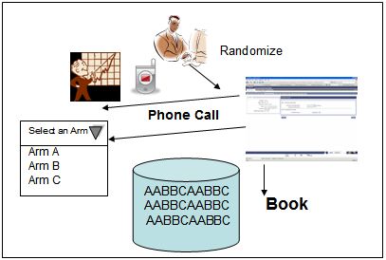
Figure 1: Randomization process

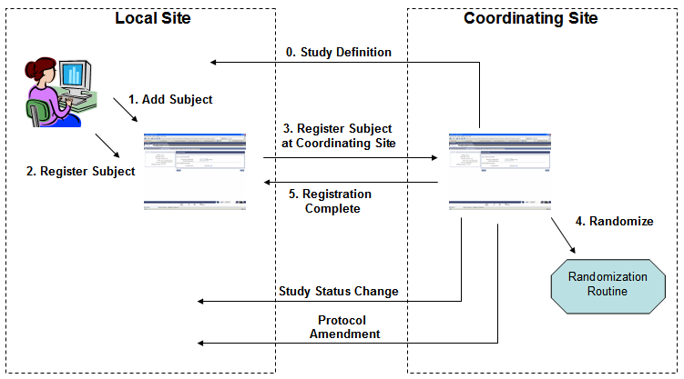
Figure 2: Multi-site integration
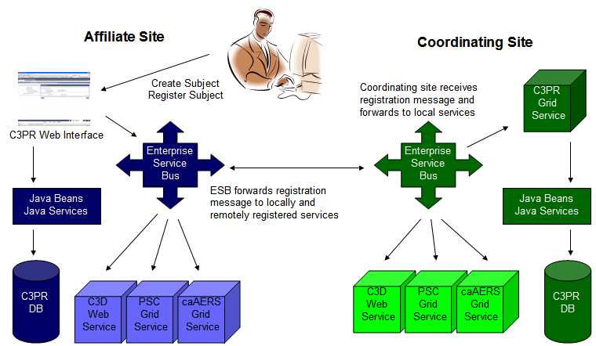

Figure 3: Multi-site trials

To better understand how C3PR interact, the architecture uses its latest technology.

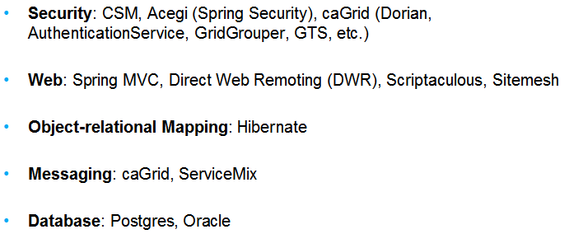

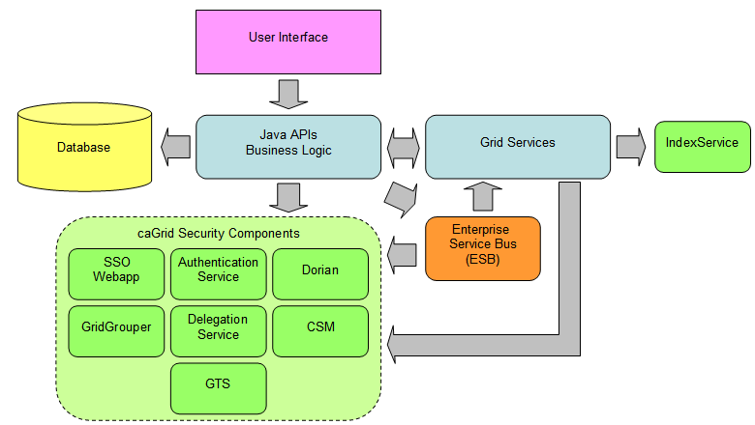
Figure 3: C3PR Architecture

Look and Feel

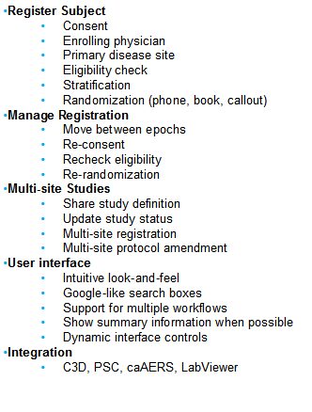
Here are some of the use cases and features of C3PR:
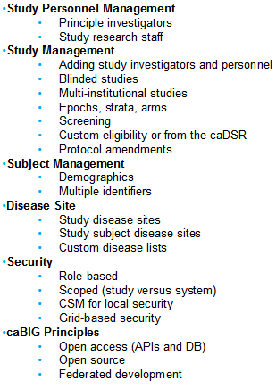

Chapter 3 - Logging In
Topics in this chapter include:
Security
Accessing C3PR
Logging into C3PR

Security
Users are added to the system through the administration tab (see chapter 8). At that time, they are provided a user name and password.

Accessing C3PR
Once C3PR is installed, it can be accessed through a standard web browser, such as Firefox 2.0 or Internet Explorer 6.0. A demonstration site is hosted at Duke and can be reached at:

https://c3pr1.duhs.duke.edu:8443/c3pr/public/login

Once you have copied the link, paste it into a browser and press return to see the C3PR webpage.

Logging into C3PR
Enter your user name and password into the appropriate fields on the login page, which is the first page you will see when accessing C3PR.
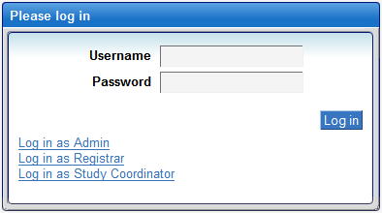

To log in to C3PR:

From the C3PR web page, type in the username and password
- Click Log in button
- Once the users have login successfully, they can manage a Study (see Chapter 4 Managing Studies).

Chapter 4 - Managing Studies
Topics in this chapter include:
Adding Studies
Searching for Studies
Export Studies
Edit Studies
Amend Studies

Adding Studies
Before adding a new Study, please read the following warning and notes messages. The user will not be able to complete adding a new Study and all data entries will be lost.
Warning! Before adding a new study, please check with the system administrator that someone has done the following:
- Pre-defined the Disease Category
- Pre-defined the Study Organization
- Pre-defined the Assigning Authority
- Pre-defined the Principal Investigator
- Pre-defined the Personnel Research Staff
- Pre-defined the Name of the Coordinating Center
If one of these steps has not been completed, Study cannot be created. C3PR does not have a “save as draft” mode.
The definition of “Pre-defined” is that the data currently exists, having already being entered into C3PR.
To see if any of the above data has already being pre-defined, go to the Administration tab - see Chapter 8: Administration. For the Disease Category, this is the list that has been preloaded with C3PR. As a result, C3PR does not have a tool to allow the system administrator to modify or add new disease category.

NOTES:
1. Bold word(s) contain in this instruction document indicated the name of the field.
2. In order to complete to create a new study, the twelve sub-tasks must be filled out.
3. These twelve sub-tasks relate and depend on one another. Thus, the behavior or action on each sub-task will be difference upon its previous answer. Please consult with the Study Coordinator on how each of these twelve sub-tasks relate or interact with one another.
4. In each of these sub-tasks, there are required fields that must have a value. Value can be either (1) type in by the users or (2) select from the list. A required field has a red asterisk mark (*) in front of the field name. A field without a red asterisk mark (*) indicates that it does not require a user to enter a value.
5. At anytime throughout the process, by clicking on the Back or Continue button, and/or sub-task tab, C3PR will validate the field entries. If there are errors, C3PR will notify the user and display the error message on the screen. All errors must be corrected in order to continue to proceed to the next sub-task. If there are no errors, then C3PR will save all the entries and proceed to the next sub-task.
6. Save: Click on the Back or Continue buttons will save the data only if the fields contain no errors. In order to create a new Study, the user must complete and save all the sub-tasks and receive a confirmation page that the Study was created successfully. Otherwise, when C3PR saves the data from each of the sub-task, the Study has not necessarily been created. Even when the Study has been created, it may still need to be actived.

To begin to add a new Study, please complete these following procedures:
- From the main menu, select the Studies tab
- From the Tasks bar, click on Create Study
- Fill out the Create Study: Details page
  - Type in the Short Title for the study. This field limited to 30 characters
in length.
  - Type in the Long Title for the study. This is the descriptive text used to
represent the long title name or name of a protocol.
  - Type in the Description for the study. This is the free text field of the
type of study being conducted by the Cancer Therapy Evaluation Program (CTEP).
  - Type in the Precis for the study. This is the structure summary
description of a protocol document.
  - Type in the Target Accrual for the study. This is the total number of
patients/subjects/participants needed for protocol enrollment (accrual).
  - Select a Type of the study. The Study has six types to select.
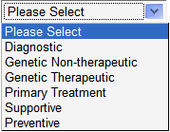
  - Select a Phase of the study. The Study has six phases to select.
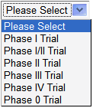
  - Select whether or not if the Study is Blinded. Select Yes or No. Note: if
the selection is Yes, then the Randomized field will default to Yes, and the type is a Phone Call randomization.
  - Select whether or not if the study is a Multi-Institutional.
Select Yes or No
  - Type in or select a date for the Consent Version/Date. The field can
accept any value – text and/or numeric and/or date.
  - Select whether or not if the study is being randomized. If the selection
is Yes, then select the Type of the randomization. The Type can be either a Book or Phone Call. Please note: if the type of the randomization is Book, then prepare to locate and upload the Book randomization later on.
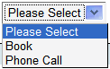
  - Select the Name of the Coordinating Center by typing its first letter that
would identify the Name. At this point, the Name of the Coordinating Center should appear from the list. Please select the Name from the list.
Warning: If the Name is not on the list (pre-defined), you must notify your system administrator before you can continue. Please log out C3PR.
  - Select the Principle Investigator by typing its first letter of the Principle
Investigator. At this point, the name of the Principle Investigator should appear from the list. Please select the Principle Investigator from the list.
Warning: If the Principle Investigator is not on the list (pre-defined), you must notify your system administrator before you can continue. Please log out of C3PR.
  - Type in the Coordinating Center Identifier. This is the identifier assigned
by the main site hosting the trial, which may be different from the indentifier your site is using if you are not the coordinating center. The value can be text and/or numeric.
  - Type in the Funding Sponsor Name. It is the name of the organization or
an institution conducting the trial [DCP]. The value can be text and/or
numeric.
  - Type in the Funding Sponsor Identifier. The value can be text
and/or numeric.

Click Continue button to proceed to the next task

- Fill out the Epochs and Arms. There are two types of Epochs – 1. Treatment epoch and 2. Non-Treatment epoch. An epoch is a vertical segmentation of one or more arms which are parallel in time.
4.1.0 Click on Add Treatment Epoch to add a treatment epoch
4.1.1 Type in the Name. This is a coded value which indicates the
general scope of the activities that occur in the various arms of the Epoch. For example, screening, treatment, follow-up, etc.
4.1.2 Type in the Description of the epoch.
4.1.3 Type in the Order of the epoch. The field accepts only an integer value. It uses to describe a period of time that cuts across the arms of a Study assuming time is depicted horizontally.
    - Select the Randomized for the epoch. Select this field in order to
determine whether the cross-cutting period of time in the Study requires that Subjects be randomized onto the Study.
This selection available only if the randomization in a previous section 3.11 has selected a Yes value. Also, if the study is blinded (section 3.8) then the Randomization defaults to Yes and the type defaults to Phone call. At this point, it does not matter what type (book or phone call) of the randomization is being used.
    - Click Add Arm to add an Arm to the treatment epoch.
      - Type in the name of the Arm.
An active Study requires having two or more Arms for each of the treatment epochs. If there is one Arm, then the Study is in a pending status. A treatment epoch can exist without adding an arm but only if it has no randomization.
      - Type in the Description of the arm. This is the full description
of the details of the protocol treatment arm or group.
      - Type in the Accrual Ceiling. This field indicates the total
number of patients targeted for accrual to an arm of a treatment epoch.
Click on the red X mark if you wish to remove the Arm information.

    - Upon completed the treatment epoch, the user has two options (1) to
continue by clicking on the Continue button, or (2) create a non-treatment epoch. To create a non-treatment epoch, continue with the following steps:
4.2 Click on Add Non-Treatment Epoch to add a non-treatment epoch
4.2.1 Type in the Name of the non-treatment epoch.
4.2.2 Type in the Description that would describe the non-treatment
epoch
4.2.3 Select the Accrual Indicator. Note: this is a required field and it uses as an indicator whether the entry into the epoch counts as an accrual (applies only to pre-treatment, epochs where participation on this trial is not certain).
4.2.3.1 If the selected value is Yes, then type in the Accrual Ceiling. This is the maximum number of participants allowed or expected to participate in the non-treatment epoch.
4.2.4 Type in the Enrollment Indicator. Note: This is a required field and an indicator whether entry into the epoch requires enrollment.
Click on the red X mark if you wish to remove the non-treatment epoch information.
    - Upon completed the non-treatment epoch, the user has two options (1) to continue by clicking on the Continue button, or (2) to go back to the previous page by clicking the Back button.

Click Back to go back to the previous page
Click Continue button to proceed to the next task

- Fill out the Eligibility by adding an Inclusion Criteria and/or Exclusion Criteria
    - If the Study has a treatment epoch, then select the Treatment Epoch
    - Select the caDSR File to Import by clicking on the Browse… button, and located the file to upload. Once the file has been identified and ready to upload, click on the Upload button. Note: The caDSR file (available at the NCI formbuilder website) contains inclusion/exclusion criteria.


5.2.1 Click on Add Inclusion Criterion to add an Inclusion Criteria.
5.2.2 Type in a Question that would describe a complete set of text for an individual question/criterion on the eligibility checklist of a protocol. Note: NA - Allow Not Applicable answer, Yes, and No are permissible answers. Click on the red X mark to remove the Question.
5.2.1 Click on Add Exclusion Criterion to add an Exclusion Criteria
5.2.2 Type in a Question that would describe a complete set of text for an individual question/criterion on the eligibility checklist of a protocol. Note: NA - Allow Not Applicable answer, Yes and No are permissible answers. Click on the red X to remove the Question.

Click Back to go back to the previous page
Click Continue button to proceed to the next task

- Fill out the Study Stratification
6.1.1 Click on Add Stratification Factor
6.1.2 Type in the Stratification Question and Answer. The specific Question to be answered in order to identify the stratum group for the Study subject. The Answers from which the subject can choose. Note: these are required fields.
Click on the red X mark to remove both the question and answer.
6.2 Click on the Generate Stratum Groups to generate the stratum groups

Click Back to go back to the previous page
Click Continue button to proceed to the next task

- Fill out the Study Randomization
Randomization procedure:
- The selection for the randomization in section 3.11 must be Yes, in order to fill out this section.
- This section of the Study Randomization depends on the treatment epoch (section 4.1.4). In other words, this section of the Randomization is for the treatment epoch. As a result, the Randomization in section 4.1.4 must be Yes, in order to fill out this section.
- This section of the Study Randomization also depends on a Stratum Groups Number in section 6.2. However, in order to generate the Stratum Groups Number, the Study must contain a stratification factor in section 6.1.1.
- C3PR will accept either the Randomization Book or File.
The Book allows the participants to manually enter the values in this sequence. It must be in this following order: Stratum Group Number, Position, and Arm Name. The position always begins with zero (0) for every Stratum Groups Number. For example, if a stratum group numbers 0 and 1 and Arms named A and B, then the entries could look like this:
0,0,A
0,1,A
0,2,A
1,0,B
1,1,B
Note that every Randomization entry starts on a new line.
The File allows the participants to upload a file instead of manually entering its value. Regardless of whether the Randomization is a Book or File, the sequence must be the same. That is must be in this order - Stratum Group Number, Position, and Arm Name. C3PR accepts either a .txt, .csv, or .doc file
* C3PR will accept only either the Randomization Book or File. C3PR will accept
whatever the last action (Book or File) was. For example, a Book Randomization is entered first and later a File Randomization is uploaded, C3PR accepts the File Randomization as it was the last action made to the Randomization procedure.
  - To upload the randomization Book, type in the Randomization Book (text containing the Book Randomization Entries), then click on the Upload the Randomization Book button
7.2 To upload the randomization file, Select file to Import by clicking on the Browse… button, and located the file to upload. Once the file has been identified and ready to upload, click on the Upload Randomization File button. The upload file contains the Book Randomization Entries.

Click Back to go back to the previous page
Click Continue button to proceed to the next task

- Fill out the Study Diseases
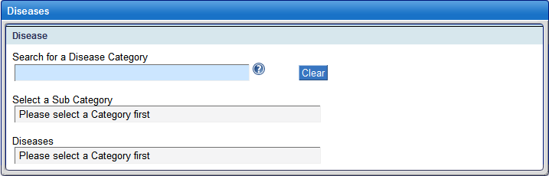
8.1 Select the Disease Category.
The disease category must be already pre-defined within the C3PR. To determine if the category has already been pre-defined, type the first few letters of the name, and C3PR will search for the item. If it finds the category, you can simply select the name from the list instead of typing the whole name.
Warning: if the Disease Category has not been pre-defined, you must notify your system administrator before you can continue. Please log out C3PR.
8.2 Select a Sub Category
8.3 Select the Diseases
8.4 Click on Add Study Disease
When clicking on Add Study Disease, the name of the study disease should appears in the “Select Disease” screen. This screen has two sections - Disease Term and Primary. Under the Disease Term, next to the disease’s name, there is a red X mark. Clicking on the red X mark to remove the study disease, or placing a check mark in the box to indicate whether if the disease is a primary.

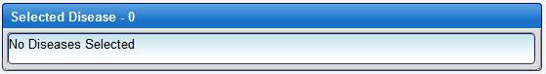
Click Back to go back to the previous page
Click Continue button to proceed to the next task

- Fill out the Study Sites
  - Click on the Add Study Site
  - Fill out the Organization. This is the name of the organization or an
institution conducting the trial [DCP].
Warning: if the Organization has not being pre-defined, you must notify your system administrator before you can continue. Please log out C3PR.
  - Fill out the Activation Date in this format (mm/dd/yyyy). This is the date
that when a site begins participation in a Study. Upon clicking on the icon, the system will load the calendar for the user to select a date.
  - Fill out the IRB Approval Date in the format (mm/dd/yyyy). This is the
date that the institutional review board or research ethics board authorized approval or most recent reapproval of the Study protocol for that site.
  - Fill out the Target Accrual Number. This is the total number of
patients/subjects/participants needed for protocol enrollment at this site.

Click Back to go back to the previous page
Click Continue button to proceed to the next task

- Fill out the Study Identifiers
10.1 To add on another Organization Assigned Identifiers, click on Add Another Identifier
10.1.1 Select the Assigning Authority from the list.
Warning: if the Assigning Authority has not been pre-defined, you must notify your system administrator before you can continue. Please log out C3PR.
10.1.2 Select the Identifier Type from the list.
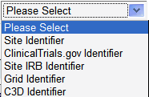

10.1.3 Type in the Identifier. This is the actual identifier number or text.
10.1.4 Check whether or not if the identifier is a Primary Indicator.
10.2 Click on Add Another Identifier for the System Assigned Identifiers
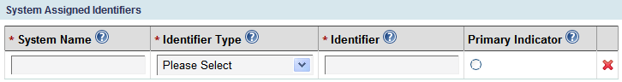
10.2.1 Type in the System Name
10.2.2 Select the Identifier Type from the list below
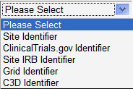
10.2.3 Type in the Identifier.
10.2.4 Check whether or not if the identifier is a Primary Indicator

Click Back to go back to the previous page
Click Continue button to proceed to the next task

- Fill out the Study Investigators.
11.1 Select an Organization
11.2 Select a Group
11.3 Select Investigator
11.4 Click on Add Investigators >> button

Click Back to go back to the previous page
Click Continue button to proceed to the next task

- Fill out the Study Personnel
12.1 Click on Add Research Staff Person
12.2 Select a Name from the list. A name that would indicating a person’s first (personal or given) name; the name that precedes the surname. Synonym = Given Name [DCP]
Warning: if the Name has not being pre-defined, you must notify your system administrator before you can continue. Please log out C3PR.
12.4 Select a Role from the list. The role a study personnel plays on a Study (e.g. registrar or Study coordinator)
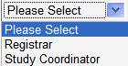
  - Select the Status from the list. An indication of whether Study personnel are currently participating in a Study.
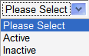
Note: The Personnel Summary shows the personnel assigned to the Study.

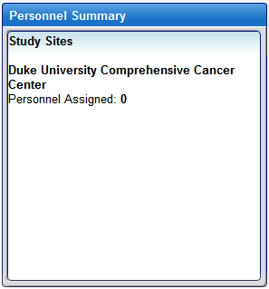
Click Back to go back to the previous page
Click Continue button to proceed to the next task

- Fill out the Study Notifications for people to receive email upon specified accrual lanmarks.
13.1 Click on Add Notification
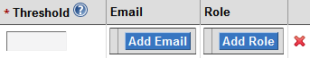
13.2 Type in Threshold. It is the portion of accrual to be met for notification of accrual to a Study.
13.3 Click on Add Email to add email
  - Click on Add Role to select a Role

Click Back to go back to the previous page
Click Continue button to proceed to the next task

- Overview of the study
14.1 Review the Study Overview
14.1.1 Review the Basic Details
14.1.2 Review the Site
14.1.3 Review the Identifiers
14.1.4 Review the Investigator
14.1.5 Review the Personnel
14.1.6 Review the Stratification Factor
14.1.7 Review the Stratum Groups
14.1.8 Review the Diseases
14.1.9 Review the Epochs & Arms
14.1.10 Review the Notifications

Upon its completion of the Study Overview, there are three options.
- Click on Save to save the Study information. A confirmation page will display that the Study successfully created. Note: C3PR will save the data entries but the Study will not be active.
- Click on Save and Activate to save and active the Study. A confirmation page will display that the Study successfully created. Note: A Study can only be active if all requirements are met.
- Click on Print to print the Study Overview

Searching for Studies
To search for a study:
- From the main menu, select the Studies tab
- From the Tasks bar, click on Search Study
- Select Search By
- 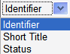
- Type in Search Criteria. You can use a % as a wild card to search on partial text.
- Click Search
- Select the Short Title from the Search Results to view the Study
- Once viewing the Study, the users can Export, Edit, Amend or Print the Study.

Exporting Studies
The following procedures allow the user to export a Study:
From the main menu, select the Studies tab
- From the Tasks bar, click on Search Study
- Select Search By
- Type in Search Criteria. You can use a % as a wild card to search on partial text.
- Click Search
- Select the Short Title from the Search Results to view the Study
- Click on Export Study button
- Select either to Open with or Save to Disk
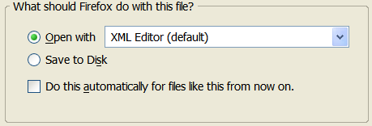

Editing Studies
The following procedures allow the user to export a Study:
From the main menu, select the Studies tab
- From the Tasks bar, click on Search Study
- Select Search By
- Type in Search Criteria. You can use a % as a wild card to search on partial text.
- Click Search
- Select the Short Title from the Search Results to view the Study
- Click on Edit Study button

Amending Studies
The following procedures allow the user to amend a Study:
From the main menu, select the Studies tab
- From the Tasks bar, click on Search Study
- Select Search By
- Type in Search Criteria. You can use a % as a wild card to search on partial text.
- Click Search
- Select the Short Title from the Search Results to view the Study
- Click on Amend Study button
- Type in Version #
- Type in Amendment Date
- Type in Comments
- Check the Reason for Amendment (minimum of one)
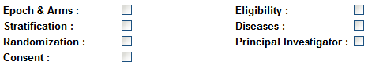
- Click on Save or Save & Continue
- Continue with Amend Study: Details, Epochs & Arms, Eligibility, Stratification, Randomization, Diseases, Sites, Identifiers, Investigators, Personnel, Notifications, and Summary.

Printing Studies
The following procedures allow the user to print a Study:
From the main menu, select the Studies tab
- From the Tasks bar, click on Search Study
- Select Search By
- Type in Search Criteria. You can use a % as a wild card to search on partial text.
- Click Search
- Select the Short Title from the Search Results to view the Study
- Click on Print button

Chapter 5 - Managing Subjects
Topics in this chapter include:
Adding Subjects
Searching for Subjects

Adding Subjects
To add a Subject to a Study, log in to C3PR. See Chapter 3 for the instruction on how to log in to C3PR.
To add a new subject:
1. From the main menu, select the Subjects tab
2. From the Tasks bar, click on Create Subject
To begin to register a new subject, fill out the Create Subject: Details page
2.1 Type in the First Name for the subject
2.2 Type in the Last Name for the subject
2.3 Type in the Middle Name for the subject
2.4 Type in the Maiden Name for the subject
2.5 Select the Gender for the subject
2.6 Type in the Birth Date for the subject
2.7 Select the Ethnicity for the subject
2.8 Select the Race(s) for the subject
2.9 Select the Organization
Warning: if the Organization has not being pre-defined, you must notify your system administrator before you can continue.
2.10 Type in an Identifier
2.11 Click Add Another Identifier for the Organization Assigned Identifiers
2.11.1 Type in the Assigning Authority
2.11.2 Select the Identifier Type
2.11.3 Type in the Identifier
2.11.4 Indicate whether or not if the subject is a Primary Indicator
2.12 Click Add Another Identifier for the System Assigned Identifiers
2.10.1 Type in System Name.
2.10.2 Select the Identifier Type.
2.10.3 Type in the Identifier.
2.10.4 Indicate whether or not if the subject is a Primary Indicator

Upon its completion of the Subject Details, click Continue

3. Fill out the Address & Contact Info
3.1 Type in the Street Address
3.2 Type in the City
3.3 Type in the State
3.3 Type in the Zip
3.3 Type in the Country
3.3 Type in the Email
3.3 Type in the Phone
3.3 Type in the Fax

Click Continue

4. Review and Submit
4.1 Review the Basic Details
4.2 Review the Address
4.3 Review the Contact Information
4.4 Review the Identifier

Click Save. If there is no error, then C3PR displays that the Subject successfully created.

Searching for Subjects
To search for a Subject, log in to C3PR. See Chapter 3 for the instruction on how to log in to C3PR.
To search for a subject:
1. From the main menu, select the Subjects tab
2. From the Tasks bar, click on Search Subject
3. Select Search By
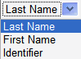
4. Type in Search Criteria. You can use a % as a wild card to search on partial text
5. Click Search

Chapter 6 - Managing Registrations
Topics in this chapter include:
Creating Registrations
Searching for Registrations

Creating Registrations
To create a new registration, log in to C3PR. See Chapter 3 on how to log in to C3PR.
To create a new registration:
1. From the main menu, select the Registration tab
2. From the Tasks bar, click on Create Registration
There are six sub-tasks for the Registration.
  - Select Subject & Study
  - Enrollment Details
  - Check Eligibility
  - Stratification
  - Select Arm
  - Review & Submit
3. First task: Create Registration: Select Subject & Study
3.1 Select a Subject. There are two ways for a subject to be selected. It can be either (1) select an existing subject using the search subject feature, or (2) simply create a new subject.
3.1.1.0 Select an existing subject, using Search Subject
3.1.1.1 Select one of the options - Search Subject By
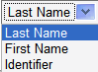
3.1.1.2 Type in Search Criteria. You can use a % as a wild card to search all the available subjects
3.1.1.3 Click on Search
Upon click on Search, C3PR displays the results. Select the subject from the results by moving the cursor to the name and click the mouse. Immediately, the Select a Subject screem gets highlighted and C3PR displays the selected subject. Next, the “Select a Subject” screen gets minimize. To restore to a full screen, click on the icon under the “Select a Subject” screen.
If the result comes back with data, then click on the name of the subject that you want to select.
If the result comes back with no data, and/or you want to create a new subject, then click on Create Subject. (see 3.1.1.0 on how to Create Subject).
3.1.2.0 Create New Subject
3.1.2.1 Click on Create Subject tab
3.1.2.2 Type in the First Name for the subject
3.1.2.3 Type in the Last Name for the subject
3.1.2.4 Type in the Middle Name for the subject
3.1.2.5 Type in the Maiden Name for the subject
3.1.2.6 Select the Gender for the subject
3.1.2.7 Type in the Birth Date for the subject. Date format should be mm/dd/yyyy
3.1.2.8 Select the Ethnicity for the subject. This field indicates the person’s self declared ethnic origination, independent of racial origination.
3.1.2.9 Select the Race(s) for the subject
3.1.2.10 Type in the Organization
3.1.2.11 Type in the Identifier
3.1.2.12 Click add the Organization Assigned Identifiers then click on Add Another Identifier
3.1.2.12.1 Type in the Assigning Authority
3.1.2.12.2 Select the Identifier Type
3.1.2.12.3 Type in the Identifier
3.1.2.12.4 Indicate whether or not if the subject is a Primary Indicator
3.1.2.13 To add the Address and Contact info, click on Address & Contact Info
3.1.2.13.1 Type in Street Address
3.1.2.13.2 Type in the City
3.1.2.13.3 Type in the State
3.1.2.13.4 Type in the Zip
3.1.2.13.5 Type in the Country
3.1.2.13.6 Type in the Email
3.1.2.13.7 Type in the Phone
3.1.2.13.8 Type in the Fax
3.1.2.14 Click Save
Upon click on Save, C3PR saves the subject, and the new subject has been selected. Thus, the Select a Subject screen gets highlighted and C3PR displays the selected subject. The “Select a Subject” screen gets minimize. To restore to a full screen, click on the icon under the “Select a Subject” screen.
3.2 Once the Subject has been selected, the next step is to select a study
3.2.1 Select one of the Search Studies By options:
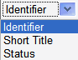
3.2.2 Type in Search Criteria. You can use a % as a wild card to search all the available studies
3.2.3 Click Search
3.2.4 Select the Study from the list. If the Study has more than one site, then select the Site, along with the Study.
Waring: If the study is not on the list, then please contact the system administrator or create the Study (see chapter 4 on how to create a new Study).
3.3 If the selected Study has an epoch treatment, then C3PR displays all the available epoch treatments. Select an epoch treatment from the list.
3.4 Click Continue to proceed to the next task (Enrollment Details)

4. Second task: Create Registration: Enrollment Details
Warning: If the participant is already registered on this epoch. If you want to move this subject to another epoch of this study, please use Manage Registration module.You can navigate to Manage Registration by searching the registration and then clicking on the registration record. See “Search for Registrations” section on how to change its current epoch.
  - Fill out the Enrollment Details
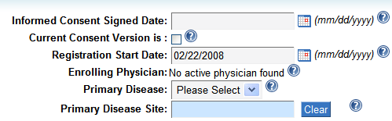
4.1.1 Type in Information Consent Signed Date
4.1.2 Indicate whether if the Current Consent Version is. This is the version of the consent document that the subject signed.
4.1.3 Type in the Registration Start Date
4.1.4 Select the Primary Disease. If the selection is Other, then C3PR provides the user with an addition text field to which it represents a type of disease other than the primary disease for which the patient is being treated could be typed in.
4.1.5 Select the Primary Disease Site
4.1.6 Click Continue to proceed to the next task (Check Eligibility).
5. Third task: Create Registration: Check Eligibility
If the selected epoch does not involved checking eligibility, then click Continue to proceed to the next task (Strafification).
6. Fourth task: Create Registration: Stratify
If the selected epoch does not involved strafication, then click Continue to proceed to the next task (Select Arm).
7. Fifth task: Create Registration: Select Arm
7.1 Select Arm from the list
7.2 Click Continue to proceed to the next task (Review & Submit).
8. Fifth task: Create Registration: Review & Submit
8.1 Review the Registration data
8.2 Click on Save to save the Registration data
8.3 Read the Confirmation Message

Searching for Registrations
To search for a registration, log in to C3PR. See Chapter 3 on how to log in to C3PR.
To search for a registration:
1. From the main menu, select the Registration tab
2. From the Tasks bar, click on Search Registration
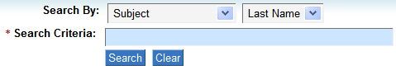
3. Select one of the options for Search By
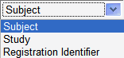
If the above “Search By” option is a Subject, then select one of the below options
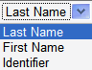
If the above “Search By” option is a Study, then select one of the below options
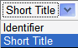
4. Type in Search Criteria (case sensitive & cannot use % as wild card)
5. Click on Search
6. Based on the above search criteria, if C3PR finds its match, then it displays the result for the user to select. Select a Study from the result.
6.1 Once the Study has been selected from the result, the user can (1) view the registration, (2) edit the enrollment details, (3)print the Study, (4) export the Study, or (5) change its current epoch.
6.1.1 To view the registration, simply select a study from the search result. C3PR displays the Overview page for the user to view the registration.
6.1.2 To edit the enrollment details (Only if the registration status is Registered), click on the Edit button under the Enrollment Details section from the Overview page. If the registration status is “Take subject off study”, then edited the registration won’t be able to performed.
6.1.2.1 To “Take subject off study”, click on the button
6.1.2.2 Fill out the Reason
6.1.2.3 Fill out the Date
6.1.2.4 Click OK
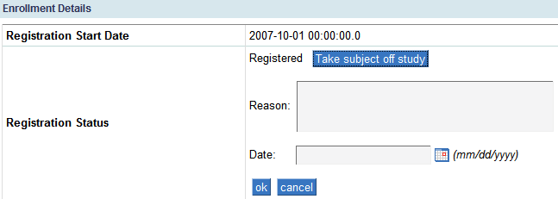
6.1.3 To print the registration, click the Print button from the Overview
6.1.4 To export the registration, click the Export button from the Overview
6.1.5 To change its current epoch, click on Change Current Epoch tab.
6.1.5.1 At this point, C3PR displays all the epoch treatments that related to this registration. To change its current epoch, simply drag and drop the subject to the appropriate epoch.

Chapter 7 - Advanced Querying
Topics in this chapter include:
Querying for Registrations
Querying for Studies

Querying for Registrations
To search for a registration, please complete these following procedures:
From the main menu, select the Administration tab
From the Tasks bar, click on Search Registration
1. To search for a registration, C3PR allows participant to query any of the below four criteria:

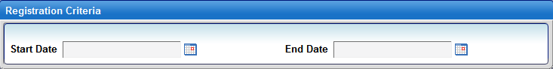
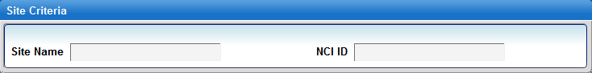
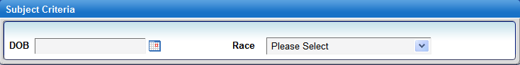
Click on Search to begin to Search for a registration

Querying for Studies
To search for a Study, please complete these following procedures:
From the main menu, select the Administration tab
From the Tasks bar, click on Search Study
2. To search for a Study, C3PR allows participant to query any of the below two criteria:

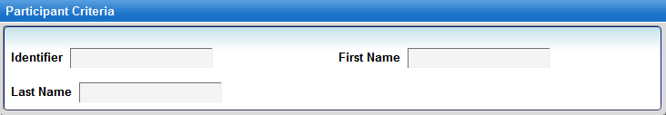
Click on Search to begin to Search for a Study

Chapter 8 - Administration
Topics in this chapter include:
Configure C3PR
Adding Investigators
Adding Research Staff
Adding Organizations
Importing Studies
Importing Registration

Configure C3PR
C3PR has the following configurations that would allow participants to have more control in their research environment.
To begin to configure C3PR, from the main menu, select the Administration tab
Click on Tasks: Configure C3PR

Here are the configurations for C3PR:
Authentication Mode
This defines the strategy C3PR uses to authenticate. Possible values are 'local' and 'webSSO' (Default: local)

Authorization enable switch
Switch to turn on/off authorization. The value may not be applied until the application is restarted (Default: false)

C3D hotlink URL
The base URL for the C3D deployment to which this C3PR instance can link (Default: https://octrials-train.nci.nih.gov/opa45/rdclaunch.htm)

C3PR URL
This is the URL of this C3PR instance.

caAERS hotlink URL. The base URL for the caAERS deployment to which this C3PR instance can link (Default: https://cbvapp-d1017.nci.nih.gov:28443/caaers/pages/ae/list)

WebSSO base URL
(Default: https://cbvapp-d1017.nci.nih.gov:48443/cas)

WebSSO certificate file
websso certificate file path
(Default: /System/Library/Frameworks/JavaVM.framework/Versions/1.5.0/Home/lib/security/cacerts)

ESB enable switch
Switch to turn on/off esb (Default: false)

ESB URL
URL for the enterprise service bus -- the value may not be applied until the application is restarted (Default: https://cbvapp-d1017.nci.nih.gov:28445/wsrf/cagrid/CaXchangeRequestProcessor)

Host certificate file host certificate file path
(Default: /Users/kherm/certs/manav.local-cert.pem)

Host key
Host key path (Default: /Users/kherm/certs/manav.local-key.pem)

Hosted Mode
If the value is false, C3PR will not send a registration request to Co-ordinating center for approval for Multi-Site trials (Default: true)

Local site NCI institute code
The NCI institute code of the site where this C3PR instance is running

SMTP authentication
(Default: true)

From address
The "from" address for all mail sent by C3PR. This address need not be a real e-mail address. The value may not be applied until the application is restarted
(Default: admin@semanticbits.com)

SMTP password
Mail server password (only necessary if the mail server requires authentication). The value may not be applied until the application is restarted (Default: biju1234)

SMTP server
The address of the outgoing mail server (e.g.: smtp.gmail.com). The value may not be applied until the application is restarted (Default: smtp.comcast.net)

SMTP port
The port number of the outgoing mail server. The value may not be applied until the application is restarted (Default: 25)

SMTP user name
Mail server username (only necessary if the mail server requires authentication). The value may not be applied until the application is restarted
(Default: biju.joseph@semanticbits.com)

Study Calendar hotlink URL. The base URL for the Study Calendar deployment to which this C3PR instance can link
(Default: https://cbvapp-d1017.nci.nih.gov:28443/psc/pages/schedule)

Once the participants completed the C3PR configuration, click the Save button to save the configuration.

Adding Investigators
To add a new Investigator, please complete these following procedures:
From the main menu, select the Administration tab
From the Tasks bar, click on Investigator
The Investigator task has three options 1. Search 2. Create and 3. Group
  - To search for an Investigator, enter one or all of the three fields, First Name, Last Name, and NCI Identifier.
Note: Use the NCI Identifier that assigned in the NCI investigator registry to a physician approved for conducting a clinical trial [CTEP].
Also, use % as wildcard for any of the three fields.
8.1.1 Click on Search to search for an Investigator
  - To create a new investigator, click on Create Investigator tab
8.2.1 Select the Organization or the study site at which the investigator exists.
Warning: The name of the Organization must be selected from the list. If the Organization is not on the list, then DO NOT create Investigator. Please create the Organization first, then a new investigator could be added to the Study. (See Adding Organization section). DO NOT use the Add Organization button while under Create Investigator).
If the investigator has a multiple organization, then click on Add Organization button
    - Select the Investigator Status. Select Active or inactive. This is the code value that represents the activity status of the Study site investigator that will grant that investigator activity capability within that site context.
    - Type in the First Name of the investigator
    - Type in the Last Name of the investigator
    - Type in the Middle Name of the investigator
    - Type in the Maiden Name of the investigator
    - Type in the NCI Identifier of the investigator
    - Type in the Email or Username of the investigator
    - Type in the Phone number of the investigator
    - Type in the Fax number of the investigator
    - Click on Save to create a new investigator
  - Select the Organization
8.3.1 Select a Group. If a group does not exist, and the participants want to add a group for the investigator, then click on Add Group.
8.3.2 To add an investigator group, click on Add Group
8.3.3 Type in the Name of the group
8.3.4 Type in the Start Date
8.3.5 Type in the End Date
8.3.6 Type in the Description of the group investigator
8.3.7 To add a new Investigator to the group investigator, click on Add Investigator
8.3.7.1 Select the Investigator from the list by typing a first or few letter of the investigator first or last name.
8.3.7.2 Type in the Start Date
8.3.7.3 Type in the End Date

8.3.8 Click on Save to create a new Investigator Groups

Adding Research Staff
To add a new Research Staff, please complete these following procedures:
From the main menu, select the Administration tab
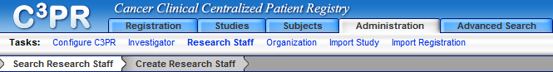
From the Tasks bar, click on Research Staff
The Research Staff task has two options 1. Search 2. Create New
    - To search for a Research Staff, enter one or all of the four fields, First Name, Last Name, NCI Identifier, and Organization
Use the NCI Identifier that the identifier assigned in the NCI research statff registry to a research staff person. The Organization is the site at which the research staff exists. If the Organization does not exit, then DO NOT continue. The Organization needs to be created first before C3PR can create new research staff.
Also, use % as wildcard for any of the fields, except the Organization
8.4.2 Click on Search to search for an Investigator
8.5.1 To create new Research Staff, select the Organization at which the research staff exists.
8.5.2 Type in the First Name of the research staff
8.5.3 Type in the Last Name of the research staff
8.5.4 Type in the Middle Name of the research staff
8.5.5 Type in the Maiden Name of the research staff
8.5.6 Type in the NCI Identifier of the research staff
8.5.7 Type in the Email or Username of the research staff
8.5.8 Type in the Phone number of the research staff
8.5.9 Type in the Fax number of the research staff
8.5.10 Check the user role for the research staff. Check at least one or check all the roles that apply.
◻C3pr admin ◻Study coordinator
◻Registrar ◻Site coordinator

Adding Organizations
To add a new Organization, please complete these following procedures:
From the main menu, select the Administration tab
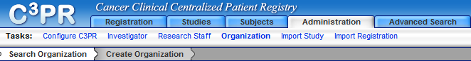
From the Tasks bar, click on Organization
The Organization task has two options 1. Search 2. Create New
8.6.1 To search for a Organization, enter Name and/or NCI Identifier
Note: the NCI Identifier is the assigned code that uniquely identifies an organization. Also, you can use % as a wildcard for any of the fields
    - Click on Search to search for an Organization
    - To create new Organization, enter the following fields:
        - Type in the Name of the oganization
        - Type in the Description of the organization
        - Type in the NCI Institue Code of the organization
        - Type in the Street Address of the organization
        - Type in the City of the organization
        - Type in the State of the organization
        - Type in the Zip code of the organization
        - Type in the Country that the organization located

Click on the Save button, to create a new organization

Importing Study
To import a Study, please complete these following procedures:
From the main menu, select the Administration tab
From the Tasks bar, click on Import Study
    - Select XML file to import by clicking on the Browse … button
    - Click on Import to import Study
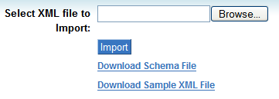
    - Click on the Study that was just imported and change the status of the Study Sites
In order to upload the registration.

Importing Registrations
Warning: The Study site must be actived in order to import registrations.
To import a Registration, please complete these following procedures:
From the main menu, select the Administration tab
From the Tasks bar, click on Import Registration
    - Select XML file to import by clicking on the Browse … button
    - Click on Import to import Registration
References

Technical Manuals/Articles
- National Cancer Institute. "caCORE 2.0 Technical Guide", ftp://ftp1.nci.nih.gov/pub/cacore/caCORE2.0_Tech_Guide.pdf
- Java Bean Specification: http://java.sun.com/products/javabeans/docs/spec.html
- Foundations of Object-Relational Mapping: http://www.chimu.com/publications/objectRelational/
- Object-Relational Mapping articles and products: http://www.service-architecture.com/object-relational-mapping/
- Hibernate Reference Documentation: http://www.hibernate.org/hib_docs/reference/en/html/
- Basic O/R Mapping: http://www.hibernate.org/hib_docs/reference/en/html/mapping.html
- Java Programming: http://java.sun.com/learning/new2java/index.html
- Javadoc tool: http://java.sun.com/j2se/javadoc/
- JUnit: http://junit.sourceforge.net/
- Extensible Markup Language: http://www.w3.org/TR/REC-xml/
- XML Metadata Interchange: http://www.omg.org/technology/documents/formal/xmi.htm

caBIG Material
- caBIG: http://cabig.nci.nih.gov/
- caBIG Compatibility Guidelines: http://cabig.nci.nih.gov/guidelines_documentation

caCORE Material
- caCORE: http://ncicb.nci.nih.gov/core
- caBIO: http://ncicb.nci.nih.gov/core/caBIO
- caDSR: http://ncicb.nci.nih.gov/core/caDSR
- EVS: http://ncicb.nci.nih.gov/core/EVS
- CSM: http://ncicb.nci.nih.gov/core/CSM
Glossary
Term | Definition
API | Application Programming Interface
caArray | cancer Array Informatics
caBIG | cancer Biomedical Informatics Grid
caBIO | Cancer Bioinformatics Infrastructure Objects
caCORE | cancer Common Ontologic Representation Environment
caDSR | Cancer Data Standards Repository
C3PR | Cancer Translational Research Informatics Platform
CDE | Common Data Element
CSM | Common Security Module
CSV | Comma Delimited
DCQL, | Distributed Common Query Language
EA | Enterprise Architect
EVS | Enterprise Vocabulary Services
GUI | Graphical User Interface
HTTP | Hypertext Transfer Protocol
JAR | Java Archive
Javadoc | Tool for generating API documentation in HTML format from doc comments in source code (http://java.sun.com/j2se/javadoc/)
JDBC | Java Database Connectivity
JUnit | A simple framework to write repeatable tests (http://junit.sourceforge.net/)
metadata | Definitional data that provides information about or documentation of other data.
NCI | National Cancer Institute
NCICB | National Cancer Institute Center for Bioinformatics
ORM | Object Relational Mapping
RDBMS | Relational Database Management System
SDK | Software Development Kit
Semantic connector | A development kit to link model elements to NCICB EVS concepts.
SQL | Structured Query Language
UI | User Interface
UML | Unified Modeling Language
URL | Uniform Resource Locators
VD | Value Domain
WAR | Web Application Archive
WSDL | Web Services Description Language
XMI | XML Metadata Interchange (http://www.omg.org/technology/documents/formal/xmi.htm) - The main purpose of XMI is to enable easy interchange of metadata between modeling tools (based on the OMG-UML) and metadata repositories (OMG-MOF) in distributed heterogeneous environments

Index

Adminstration
Configuration, 40
Investigators, 42
Organizations, 45
Research Staffs, 44
C3PR
Definition, 7
Overview & Functionality, 7
Users, 8
Wiki, 8
Common Security Module, 14
Exporting to Excel, 29
Importing Study, 46
Importing Registrations, 46
Login
Accessing , 16
Advanced Query Builder, 19
Basic Query Builder, 10
Organization of the User's Manual, 9
Overview
Architecture, 15
List of Features, 15
Multi-site Intergartion, 13
Randomization Process, 13
User Interface, 13
Query Search
Filters, 38
Finding, 38
References
caBIG materials, 47
caCORE material, 47
Scientific publications, 47
Technical manuals, guides, 47
Registrations
Create, 35
Search, 37
Studies
Amend, 30
Create, 29
Details, 18
Diseases , 24
Edit, 30
Eligibility, 22
Epochs and Arms, 20
Export, 29
Identifiers, 26
Non-Treatment Epoch, 21
Notifications , 28
Overview, 29
Personnel, 27
Print, 31
Randomization, 23
Requirements, 17
Sites, 25
Search , 29
Treatment Epoch, 20
Subjects
Create, 32
Search, 33
Text Conventions
keyboard keys, 10
menu commands, 10
The C3PR GForge site, 8

