Test Script Number: | create_new_study |  |  |  | Module: |  |  | Tester Name: |  | Steven Cheng | Pass/Fail:  Fail
Use Case #: |  |  |  |  | Username: |  |  | Test Date: |  | 04/24/2007 | Pass/Fail:  Fail
Estimated Execution Time: |  |  |  |  |  |  | Actual Execution Time: |  | 60 min
Test Objective: create a new study.

Test Setup:

Related Requirements
or Configuration Change Requests (Number/Description):

 | Test Action | Expected Results | Pass / Fail | Actual Results/Comments | gForge Tracker Bug ID
 | Click Studies tab, click Create Study link, fill the required information for Details, then click Save &Continue button. See figure 1. |  | Pass | Identifiers tab is active.  Required field validation works correctly.
 | Fill the required information for Identifiers, then click Save & Continue button. See figure 2 |  | Pass | Sites tab is active.  Comments: Identifier is optional, remove red *  Add/Remove identifier function work correctly, but need to put description text next to icons.  Required field validation does NOT work on this page.  Radio button can’t be unchecked.
 | Fill the required information for Sites, then click Save & Continue button. See figure 3 |  | pass | Investigators tab is active  Comments: Start Date, End date and IRB Approval Date are optional? The system still take without any input. | 4227
 | Fill the required information for Investigators, then click Save & Continue button. See figure 4 |  | pass | Personnel tab is active  Comments: when input investigator’s name, error message really bother users. After click Save & Continue button, the system automatically clears the investigator’s name and stop going to next step.  By delete the investigator, can go through next step | 6112
 | Fill the required information for Personnel, then click Save & Continue button. See figure 5 |  | pass | Eligibility Checklist tab is active.  Comments: the same error as in step 4
 | Fill the required information for Eligibility Checklist, then click Save & Continue button. See figure 6 |  | pass | Epochs & Arms tab is active.
 | Fill the required information for Epochs & Arms, then click Save & Continue button. See figure 7 |  | pass | Overview tab is active.
 | Review the study’s information, then click Save & Continue button. See figure 8, 9 |  | fail | Comments: the study created couldn’t be saved in the system. | 6113

Tester Signature: Steven Cheng

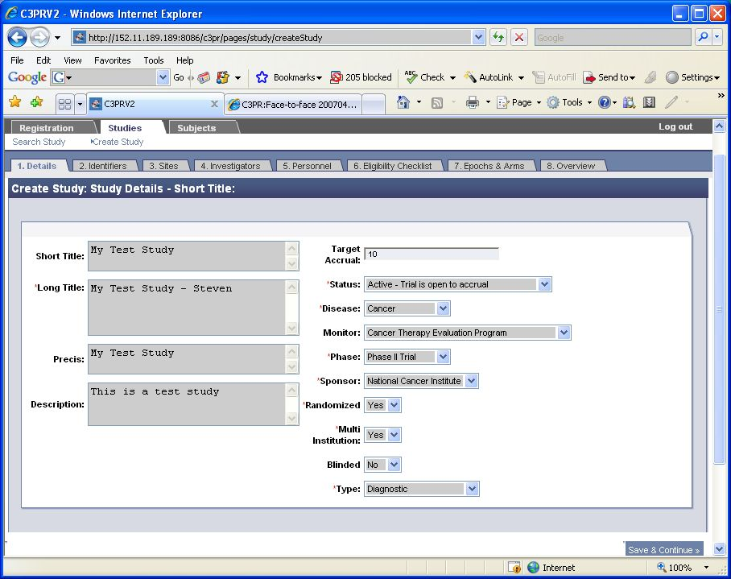

Figure 1

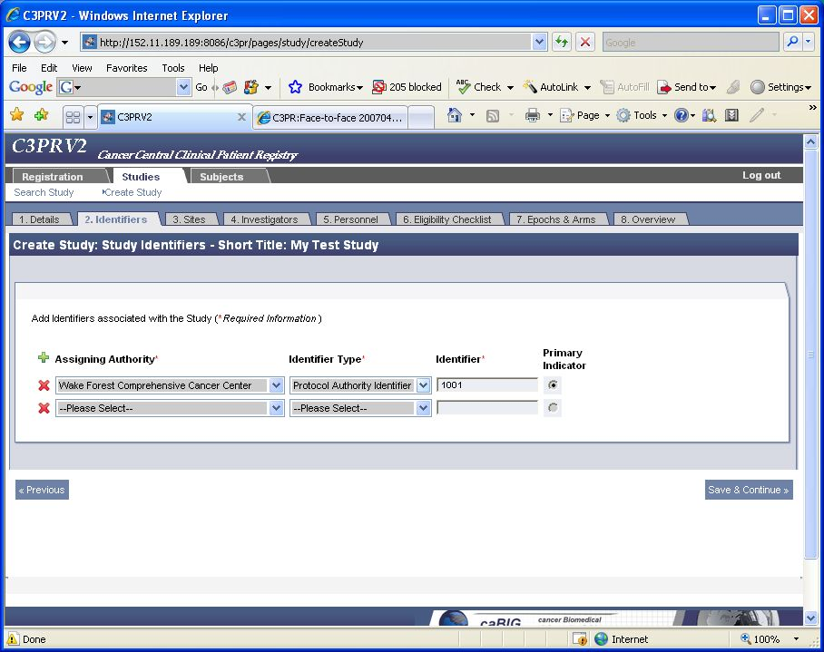

Figure 2
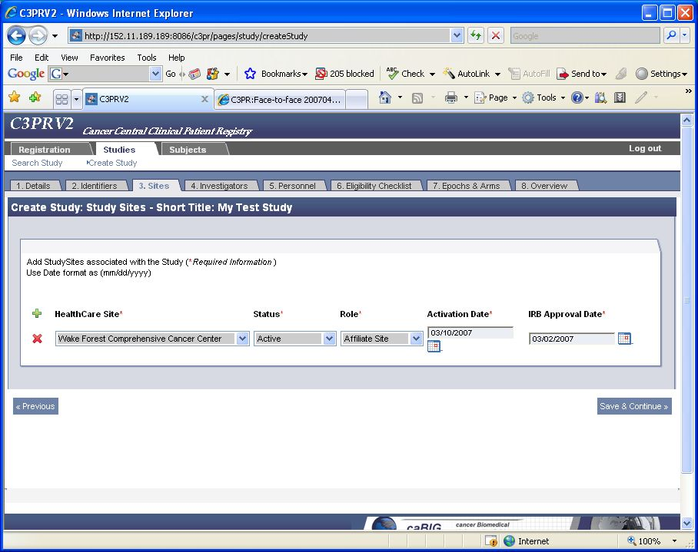
Figure 3
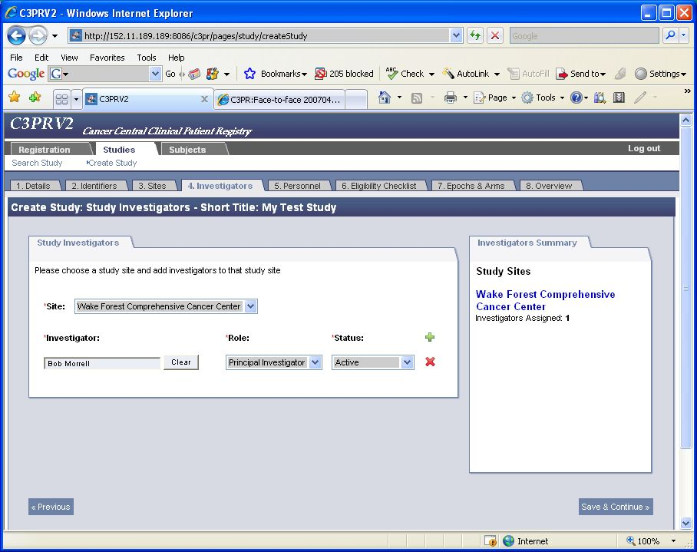
Figure 4
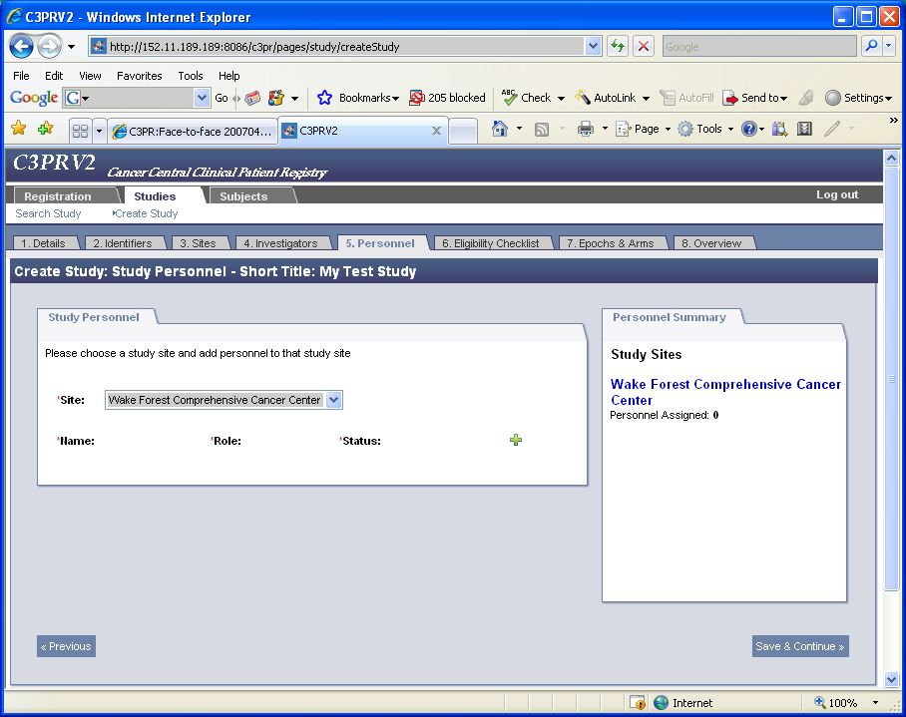
Figure 5
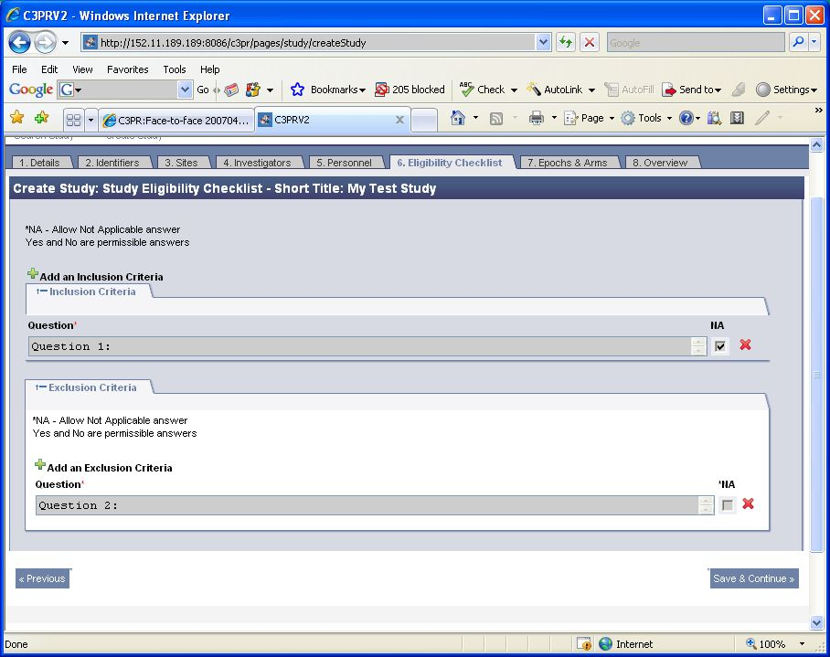
Figure 6
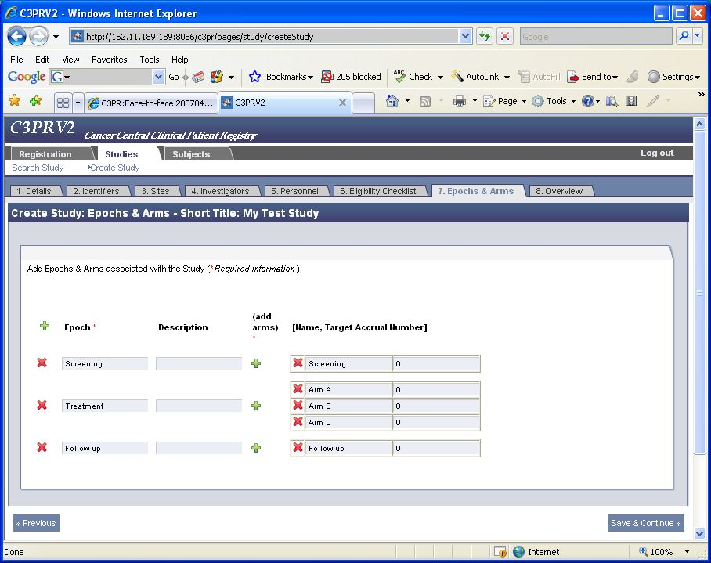
Figure 7
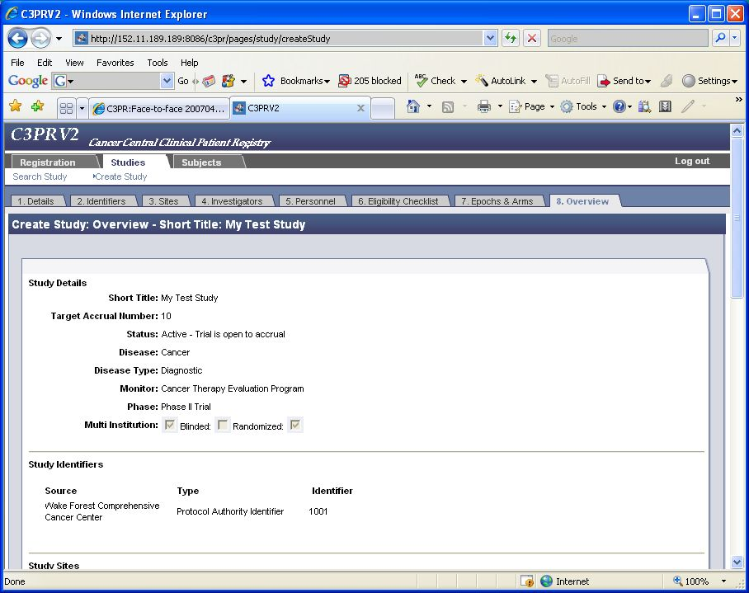
Figure 8
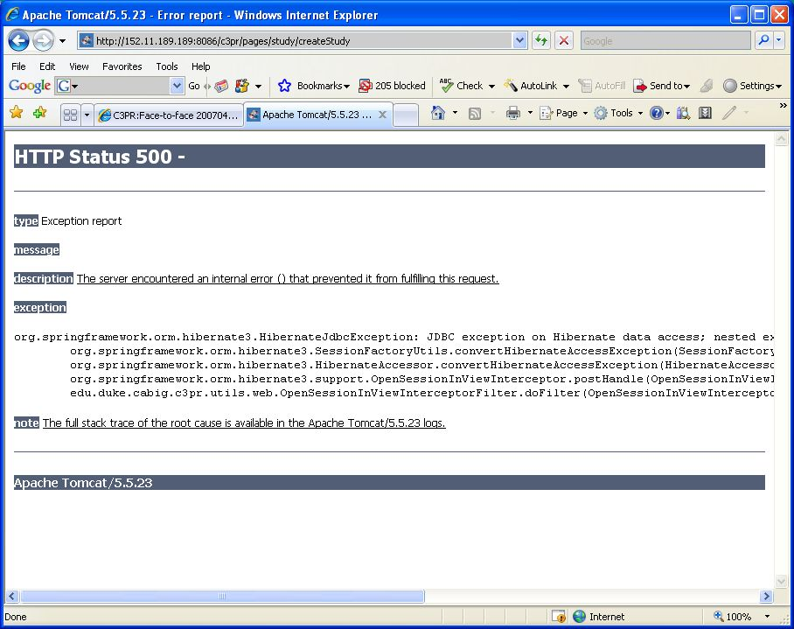
Figure 9

