Test Script Number: | register_participant |  |  |  | Module: |  |  | Tester Name: |  | Steven Cheng | Pass/Fail:  pass
Use Case #: |  |  |  |  | Username: |  |  | Test Date: |  | 05/04/2007 | Pass/Fail:  pass
Estimated Execution Time: |  |  |  |  |  |  | Actual Execution Time: |  | 1 hr
Test Objective: register a participant.

Test Setup:

Related Requirements
or Configuration Change Requests (Number/Description):

 | Test Action | Expected Results | Pass / Fail | Actual Results/Comments | gForge Tracker Bug ID
 | Click Registration tab, run Study Search to find the study, then click Search button. See figure 1. |  | Pass | Study Search results displayed.
 | Click the right one to select it. See figure 2 |  | Pass | The study is selected, go to next step to select subject.
 | Run Search Subject to find the participant, then click Search button. See figure 3 |  | pass | Subject Search results displayed.
 | Click the right one to select it. |  | pass | The subject is selected, go to next step to enter Enrollment Details.
 | Fill the date by using calendar function, then click Save & Continue button. See figure 4 |  | pass | Go to next step to Check Eligibility  Comments:  Previous button does not work on this page, it will clear out the selected date once click. | 6322
 | Check the box for Eligibility Indicator, then click Save & Continue button. See figure 5. |  | pass | Go to next step to Stratify
 | Click Save & Continue button. See figure 6. |  | pass | Go to next step to Review and Submit  Comments: Tab ‘6. Review & Submit’ should not be highlighted in this page, only tat ‘5. Stratify’ | 6323
 | Click Save button. See figure 7, 8. |  | Pass | Subject Registration has been successfully completed.  Comments:  1) Tab ‘6. Review & Submit’ should be highlighted in this page.  2) Print link in confirmation page does not work.  3) Edit button for Subject does not work either.  4) The system does NOT check duplicate registration at all, you can register the same subject to the same study twice. | 4428  4441  6321

Tester Signature: Steven Cheng

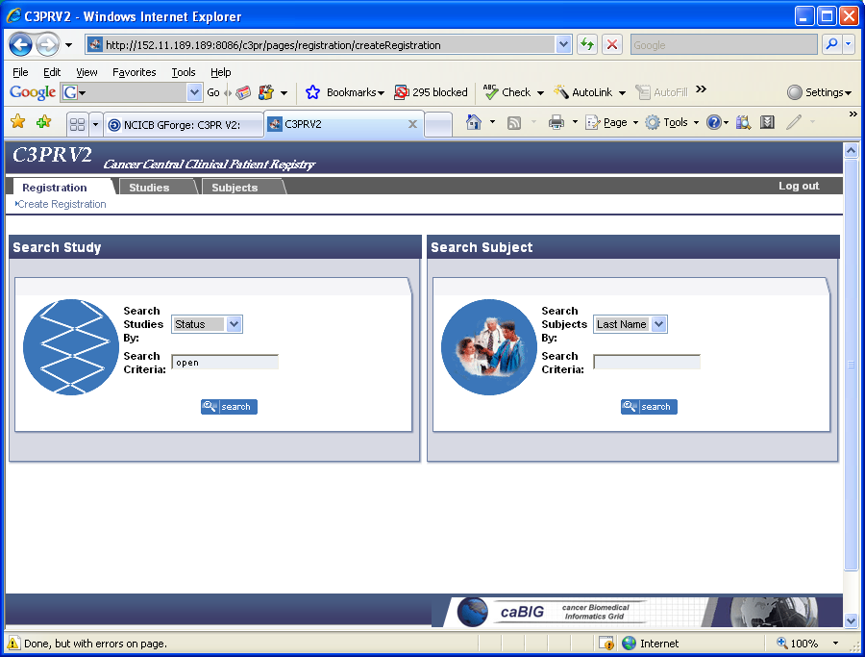

Figure 1

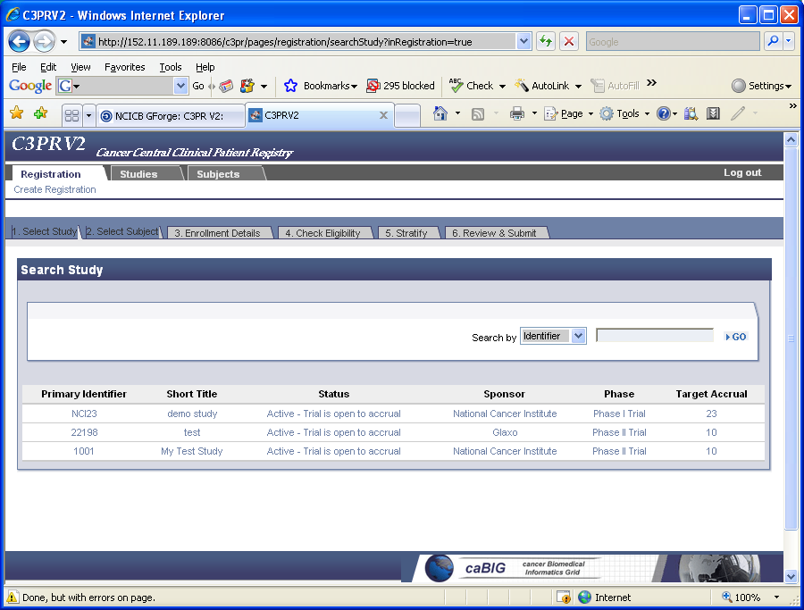

Figure 2
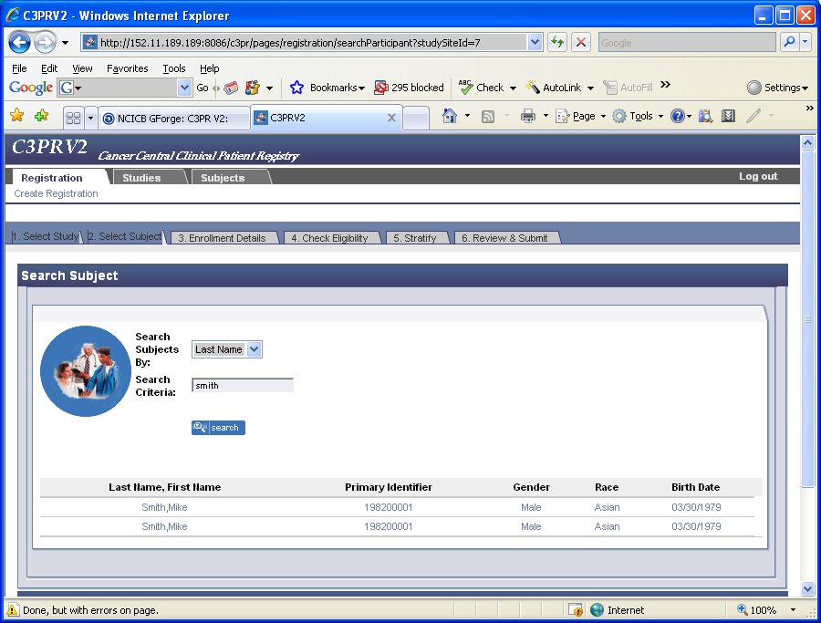
Figure 3
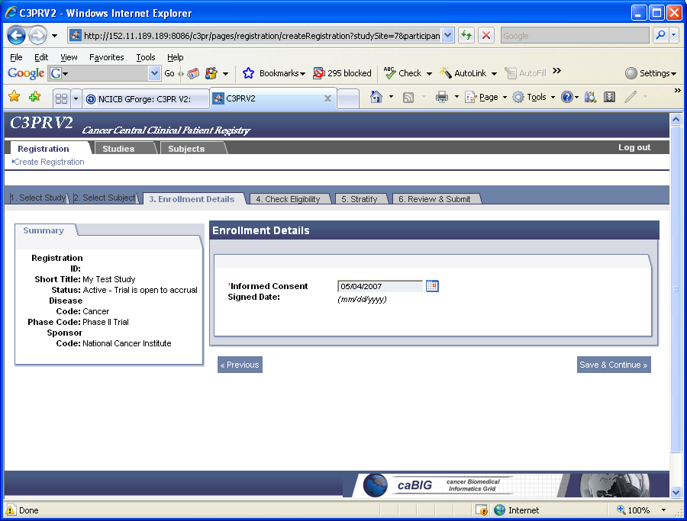
Figure 4
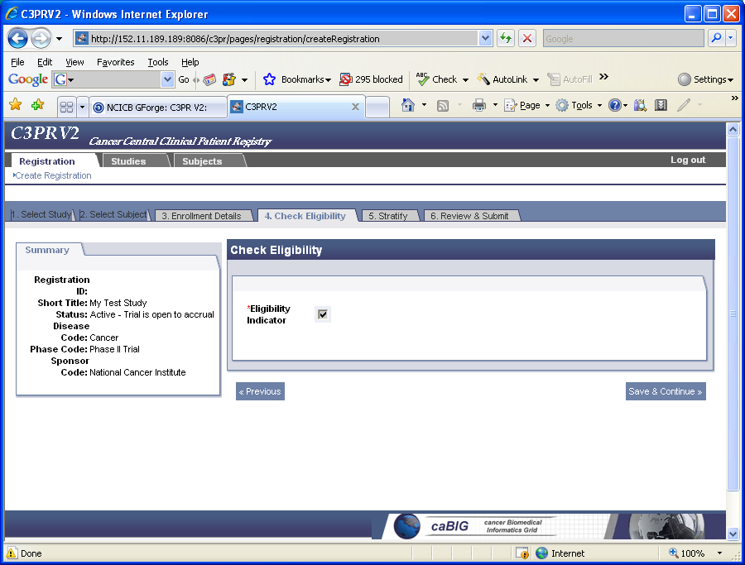
Figure 5
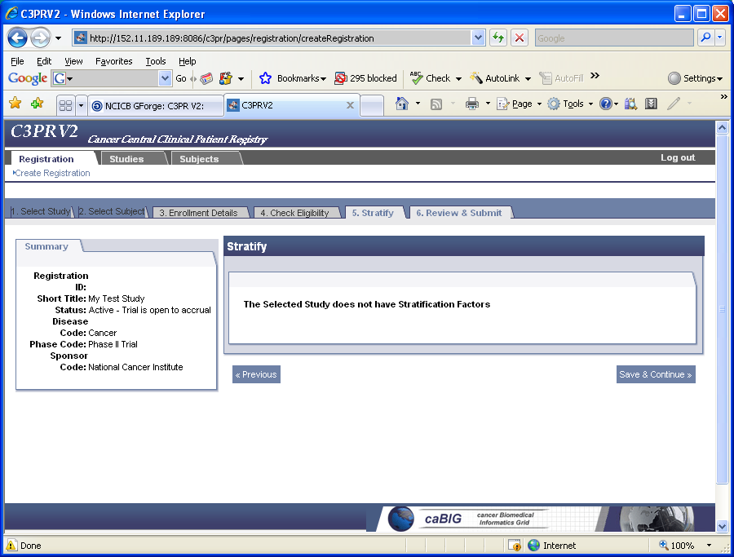
Figure 6
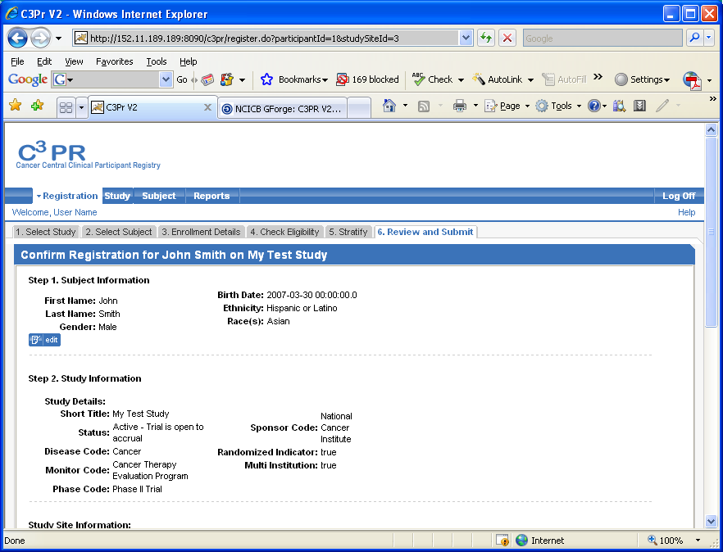
Figure 7
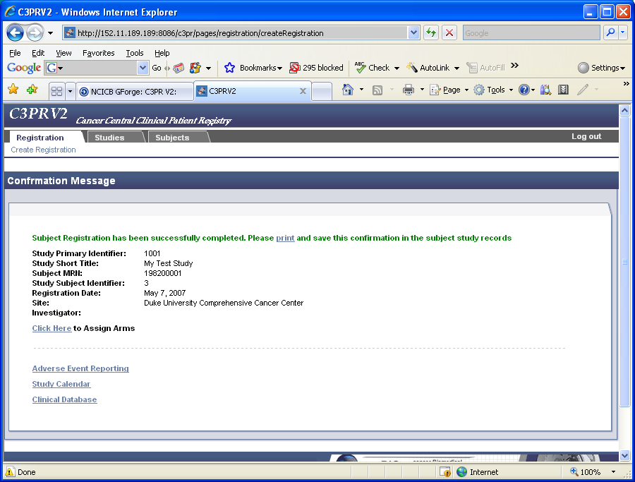
Figure 8

