8

Test Script Number: | create_new_research_staff |  |  |  | Module: |  |  | Tester Name: |  | Steven Cheng | Pass/Fail:  pass
Use Case #: |  |  |  |  | Username: | c3pr_admin |  | Test Date: |  | 08/31/2007 | Pass/Fail:  pass
Estimated Execution Time: |  |  |  |  |  |  | Actual Execution Time: |  | 10 min
Test Objective: create a new research staff.

Test Setup:

Related Requirements
or Configuration Change Requests (Number/Description):

 | Test Action | Expected Results | Pass / Fail |  | Actual Results/Comments |  | gForge Tracker Bug ID
 | Click Administration tab, then click Create Research Staff link, fill the required information for new research staff, then click Save button. See figure 1. |  | Pass |  | Tested features:  1) Required field validation is active.  2) Save button works  3) Reset tab works
 | Confirmation message displayed. See figure 2 |  | Pass |  | New research staff successfully created.  Tested features:  - the link to create another research staff person work properly  Comments:  - remove Save button on the confirmation page. |  | 7539 - fixed

Tester Signature: Steven Cheng

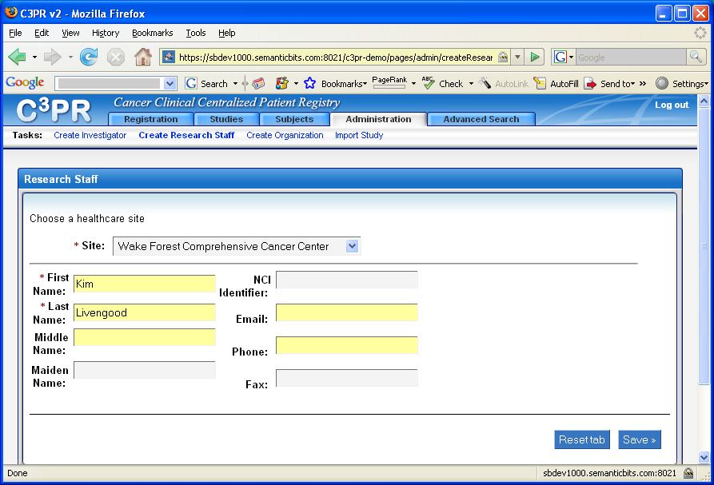

Figure 1

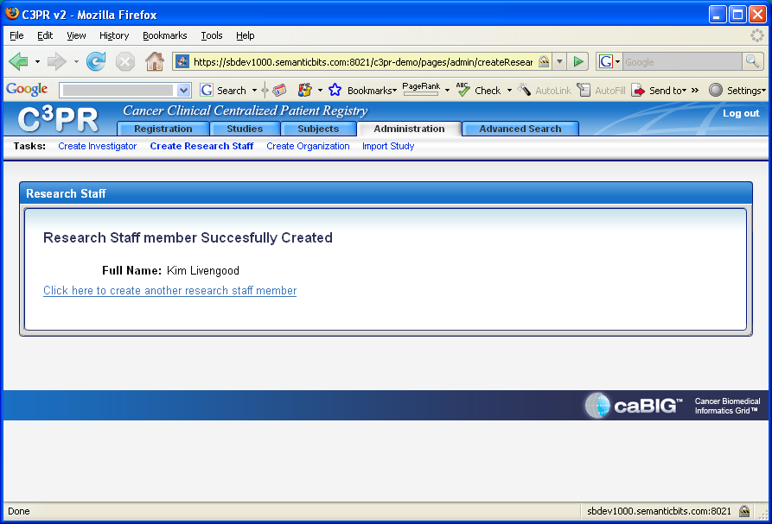

Figure 2

