Test Script Number: | register_participant |  |  |  | Module: |  |  | Tester Name: |  | Steven Cheng | Pass/Fail:  pass
Use Case #: |  |  |  |  | Username: |  |  | Test Date: |  | 03/07/2007 | Pass/Fail:  pass
Estimated Execution Time: |  |  |  |  |  |  | Actual Execution Time: |  | 1 hr
Test Objective: register a participant.

Test Setup:

Related Requirements
or Configuration Change Requests (Number/Description):

 | Test Action | Expected Results | Pass / Fail | Actual Results/Comments | gForge Tracker Bug ID
 | Click Registration tab, run Study Search to find the study, then click Search button. See figure 1. |  | Pass | Study Search results displayed.
 | Click the right one to select it. See figure 2 |  | Pass | The study is selected, go to next step to select subject.
 | Run Search Subject to find the participant, then click Go button. See figure 3 |  | pass | Subject Search results displayed.
 | Click the right one to select it. |  | pass | The subject is selected, go to next step to enter Enrollment Details.
 | Fill the date by using calendar function, then click Continue button. See figure 4 |  | pass | Go to next step to Check Eligibility
 | Check the box for Eligibility Indicator, then click Continue button. See figure 5. |  | pass | Go to next step to Stratify
 | Click continue button. See figure 6. |  | pass | Go to next step to Review and Submit
 | Click Submit button. See figure 7, 8. |  | Pass | Subject Registration has been successfully completed.  Comments: print link in confirmation page does not work.  Edit button for Subject does not work either. | 4428  4441

Tester Signature: Steven Cheng
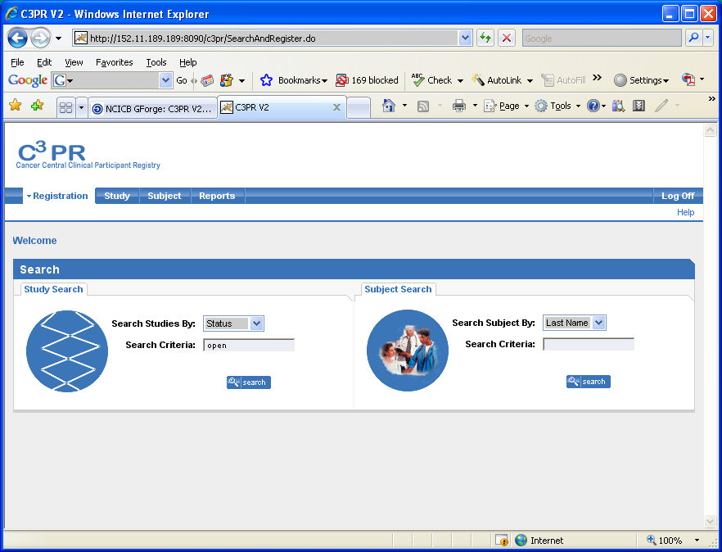
Figure 1
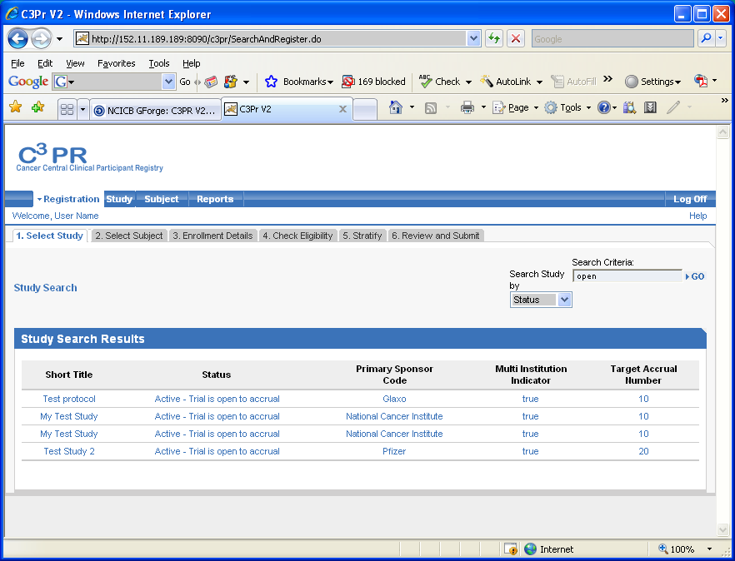
Figure 2
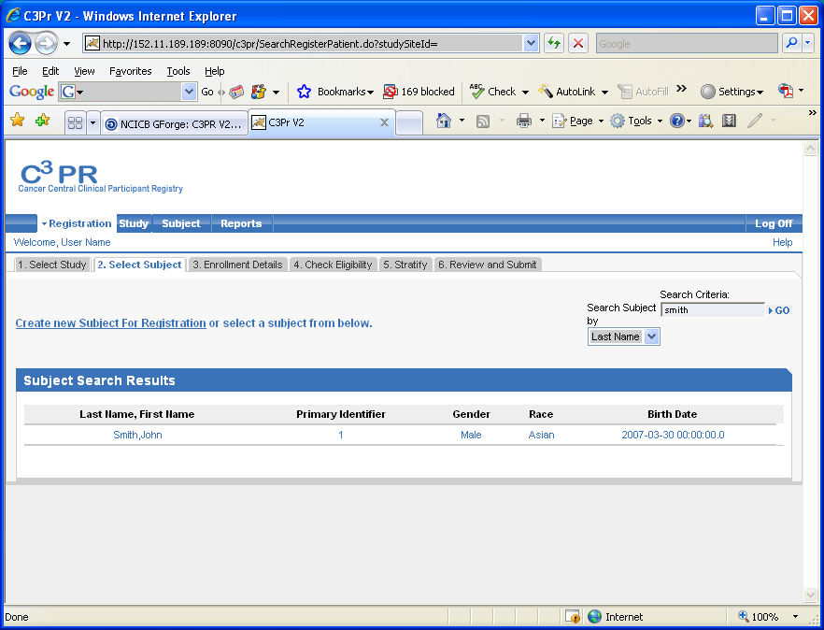
Figure 3
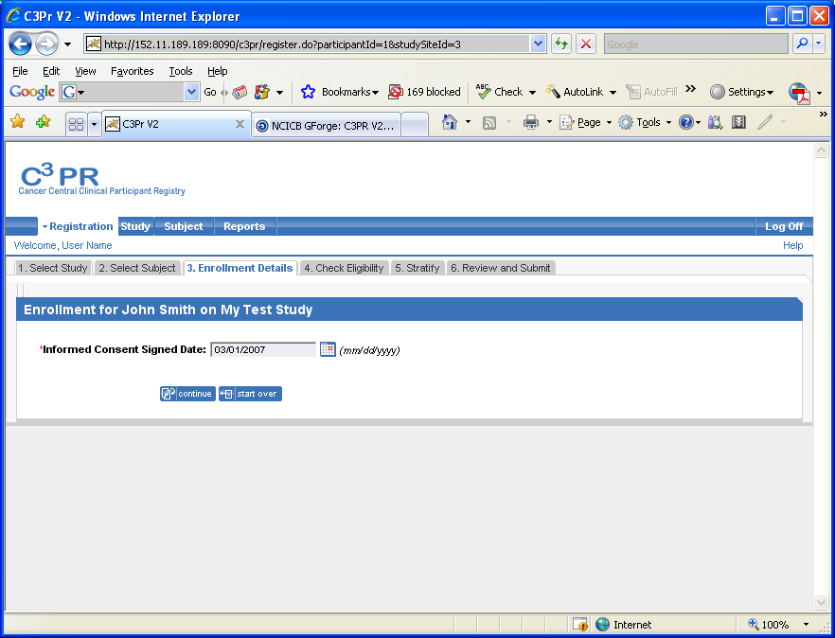
Figure 4
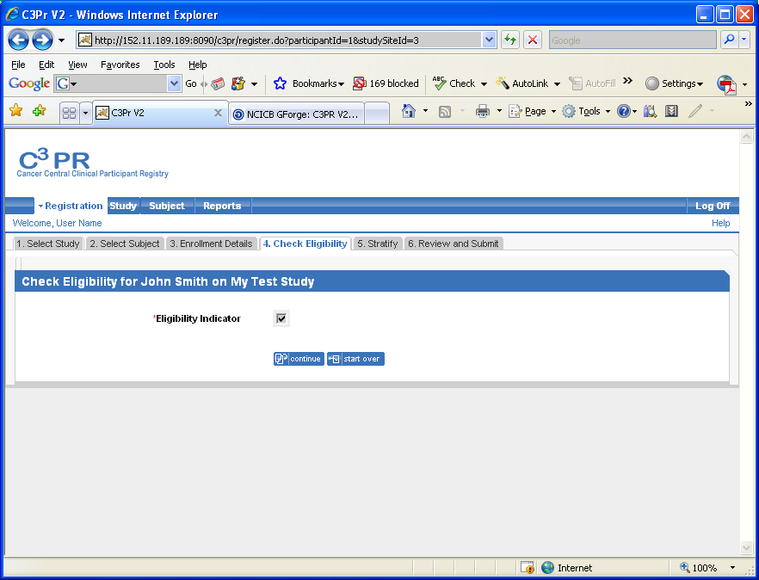
Figure 5
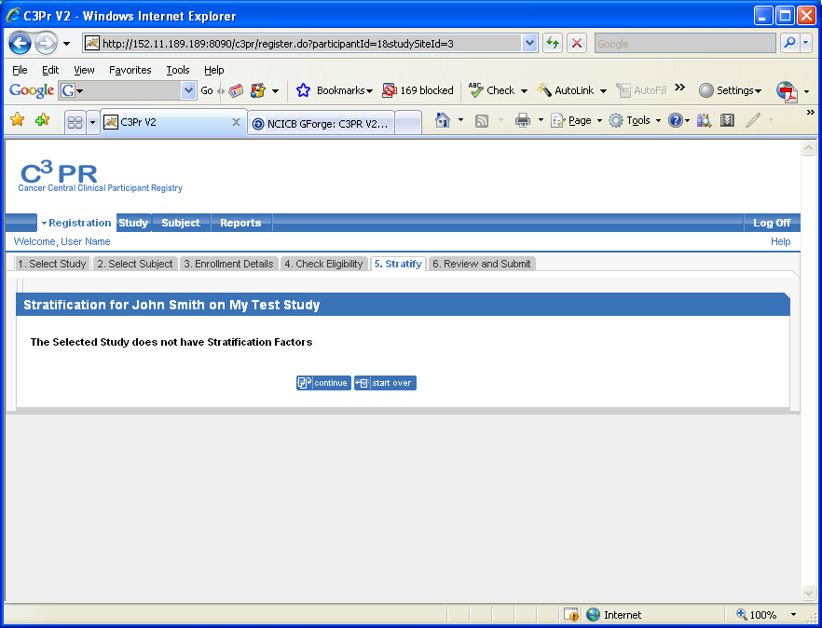
Figure 6
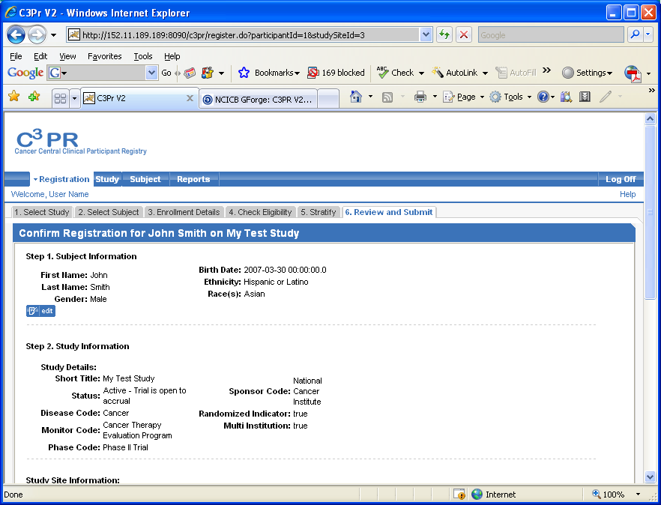
Figure 7
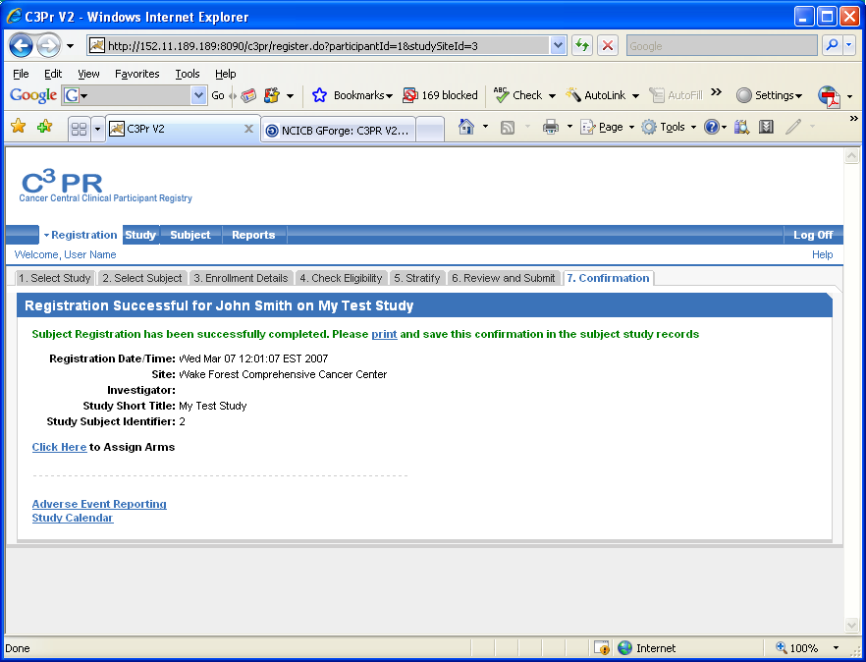
Figure 8

