Test Script Number: | create_new_participant |  |  |  | Module: |  |  | Tester Name: |  | Steven Cheng | Pass/Fail:  pass
Use Case #: |  |  |  |  | Username: |  |  | Test Date: |  | 05/22/2007 | Pass/Fail:  pass
Estimated Execution Time: |  |  |  |  |  |  | Actual Execution Time: |  | 40 min
Test Objective: create a new participant.

Test Setup:

Related Requirements
or Configuration Change Requests (Number/Description):

 | Test Action | Expected Results | Pass / Fail | Actual Results/Comments | gForge Tracker Bug ID
 | Click Subjects tab, and click Create Subject link, fill the required information for new participant, then click Continue button. See figure 1. |  | Pass | Tested features:  - Required field validation is active for all related fields.  - Data format for birth date checked.  Comments:  - Future date should not be accepted as a birth date.  - Valid date should be checked.  - Assigning Authority, Identifier Type and Identifier are ALL required? Otherwise remove red * at front of each.  - Add ‘add/remove button’ to control Assigning Authority, not always come with 5 at default.  - Radio button for Primary Indicator can not be unchecked. | 4433  6904  4435  6312  6313
 | Fill the required information in Address page, then click Continue button. See figure 2 |  | Pass | Tested features:  - Required field validation is active for all related fields.  Comments:
 | Review Participant Details, click Save button. See figure 3, 4 |  | pass | Subject successfully created with confirmation message.  Tested features:  - Edit buttons works fine.  Comments:  - The system does not check duplicates for participants at all. You can add the same person twice to the system. See figure 5. | 6905

Tester Signature: Steven Cheng

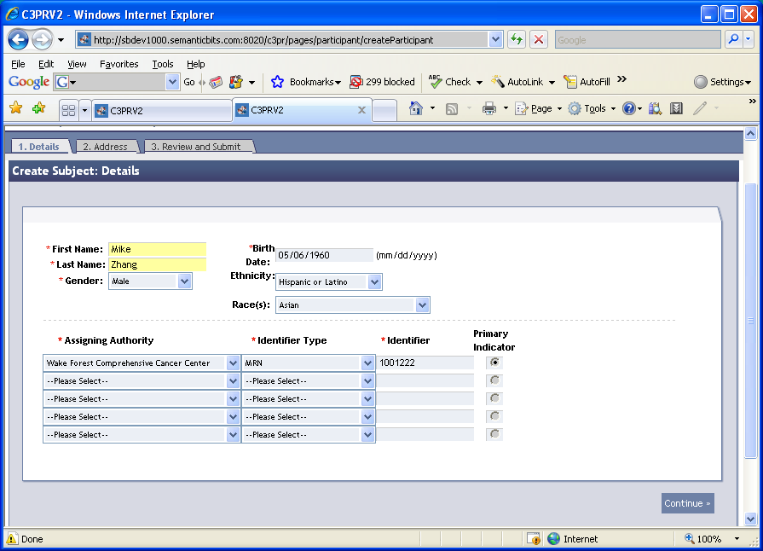

Figure 1

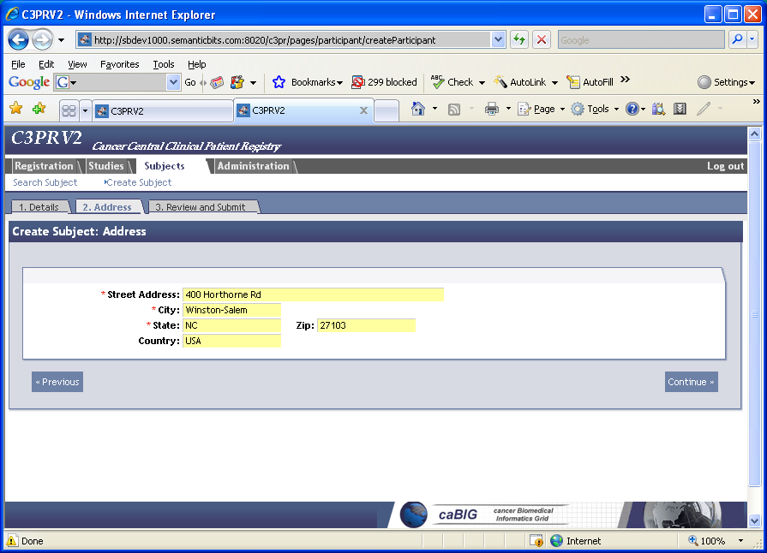

Figure 2
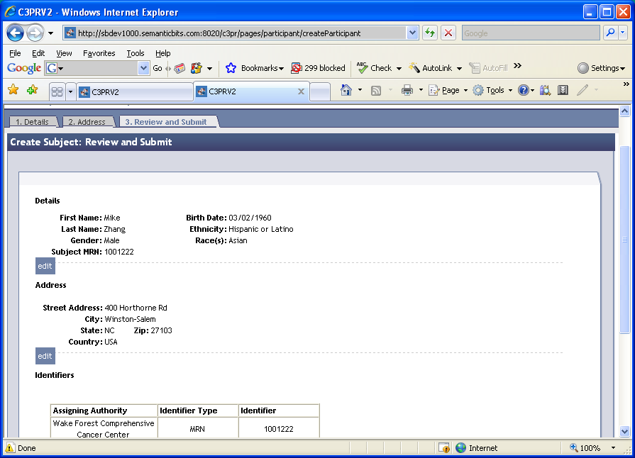
Figure 3

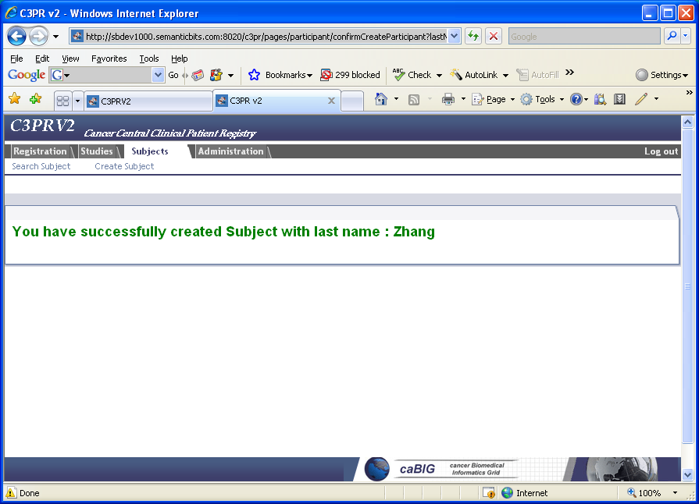
Figure 4

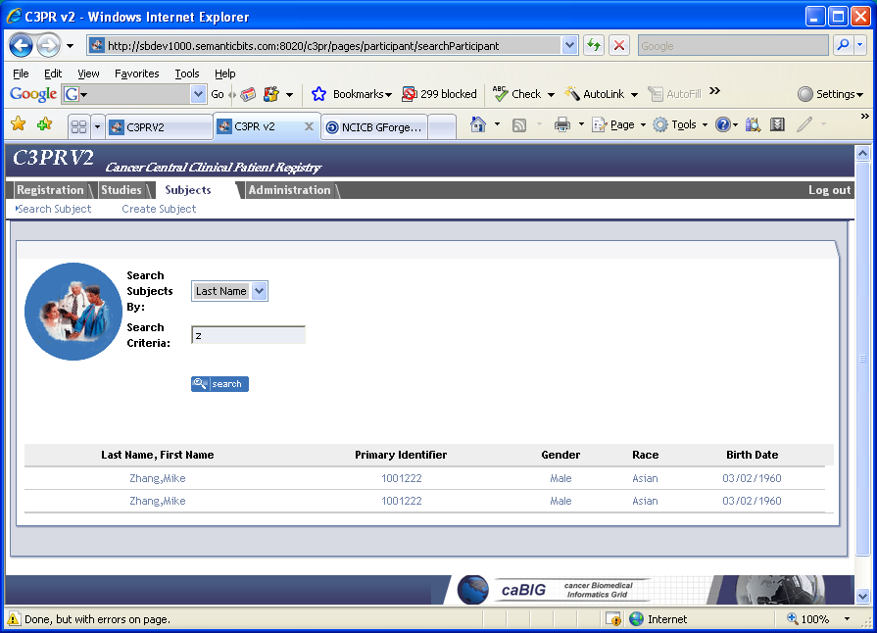
Figure 5

