Test Script Number: | create_new_study |  |  |  | Module: |  |  | Tester Name: |  | Steven Cheng | Pass/Fail:  Pass
Use Case #: |  |  |  |  | Username: |  |  | Test Date: |  | 05/22/2007 | Pass/Fail:  Pass
Estimated Execution Time: |  |  |  |  |  |  | Actual Execution Time: |  | 60 min
Test Objective: create a new study.

Test Setup:

Related Requirements
or Configuration Change Requests (Number/Description):

 | Test Action | Expected Results | Pass / Fail | Actual Results/Comments | gForge Tracker Bug ID
 | Click Studies tab, click Create Study link, fill the required information for Details, then click Continue button. See figure 1. |  | Pass | Tested features:  - Required field validation is active for all related fields except Type field.  Comments:  1) Required field validation for Type field is inactive. | 6930
 | Fill the required information for Identifiers, then click Continue button. See figure 2 |  | Pass | Tested features:  - Required field validation is active even when ‘--Please Select--‘ is selected by default.  - +/X buttons work fine on most time except some special cases.  Comments:  - Need to put description text next to +/X button icons.  - Once click X button to delete the only existing one, + button will not work  - Radio button can’t be unchecked. | 6931  6932  6933
 | Fill the required information for Sites, then click Continue button. See figure 3 |  | pass | Tested features:  - Required field validation is active even when ‘--Please Select--‘ is selected by default.  Comments:  - Activation date and IRB Approval Date are optional? The system still takes without any input.  - +/X buttons don’t work in IE7  - Once click X button to delete the only existing one, + button will not work | 4227  6932
 | Fill the required information for Investigators, then click Save & Continue button. See figure 4 |  | pass | Tested features:  - Required field validation is active even when ‘--Please Select--‘ is selected by default.  - +/X buttons work fine on most time  Comments:  - Currently the system will only accept investigators added by administrator. User’s input will be cleared automatically.  - Click X button should not fire an event to check the required fields for the one to be deleted. | ? 6112  6934
 | Fill the required information for Personnel, then click Continue button. See figure 5 |  | pass | Tested features:  - Required field validation is active even when ‘--Please Select--‘ is selected by default.  - +/X buttons work fine on most time  Comments:  - Currently the system will only accept investigators added by administrator. User’s input will be cleared automatically.  - Click X button should not fire an event to check the required fields for the one to be deleted. The same as in step 4. | 6934
 | Fill the required information for Eligibility Checklist, then click Continue button. See figure 6 |  | pass | Tested features:  - Required field validation is active  - +/X buttons work fine on most time  Comments:  - Wrong label for Exclusion Criteria, replace Inclusion with Exclusion | 6935
 | Fill the required information for Stratification Factors, then click Continue button. See figure 7 |  | pass | Tested features:  - Required field validation is active  Comments:  - +/X buttons don’t work | 6940
 | Fill the required information for Diseases, then click Continue button. See figure 8 |  | pass | Tested features:  - Clear button works  - Sub Category/Diseases list auto populated.  - +/X buttons work fine.  - Selected Disease count works fine  Comments:
 | Fill the required information for Epochs & Arms, then click Save & Continue button. See figure 9 |  | pass | Tested features:  - +/X buttons work fine on most time  Comments:  - Click X button should not fire an event to check the required fields for the one to be deleted. The same as in step 4. | 6934
 | Review the study’s information, then click Save button. See figure 10, 11 |  | pass | The study successfully created  Comment:  - Save button on figure 11 for what? Should be removed?  - Confirmation message should be displayed once the study successfully created. | 6944  6945

Tester Signature: Steven Cheng

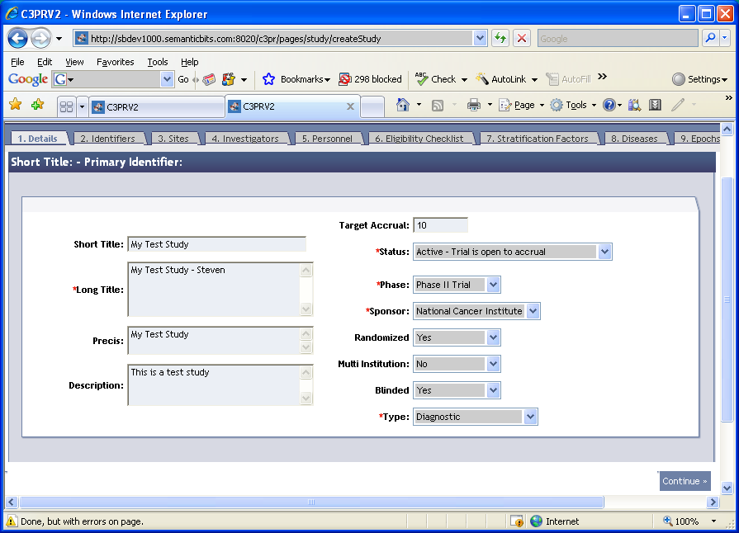

Figure 1

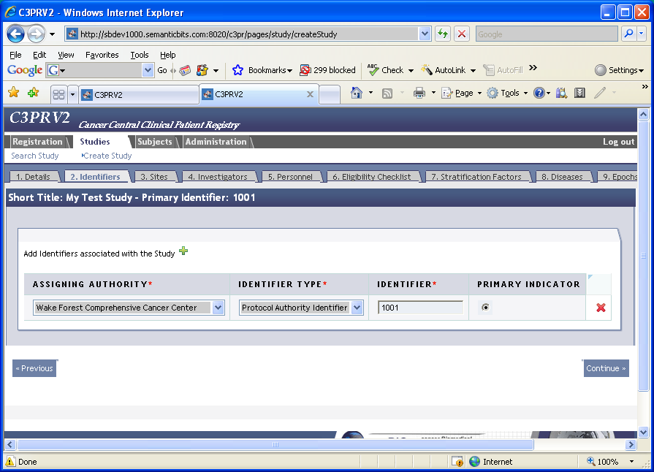

Figure 2
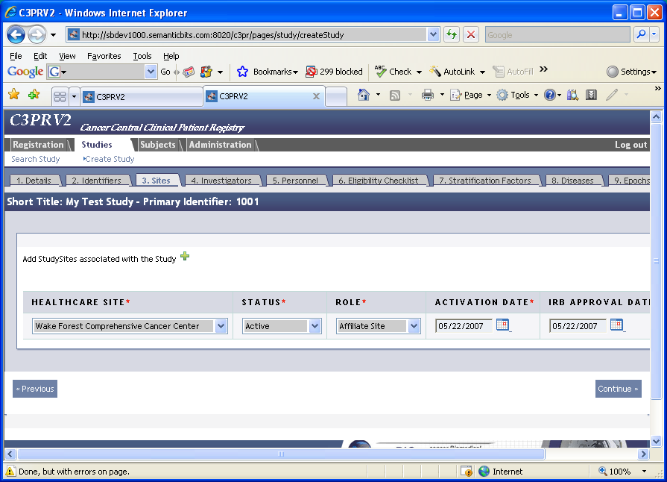
Figure 3
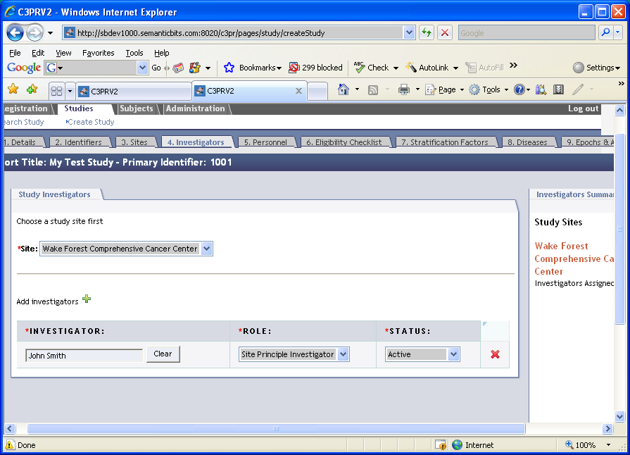
Figure 4
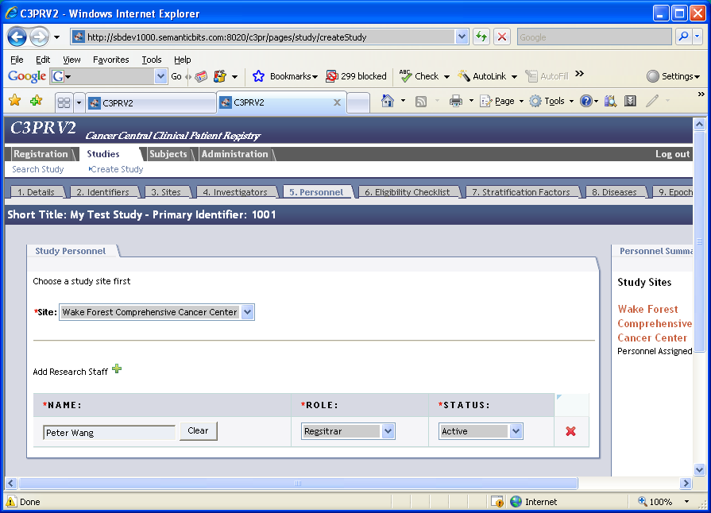
Figure 5
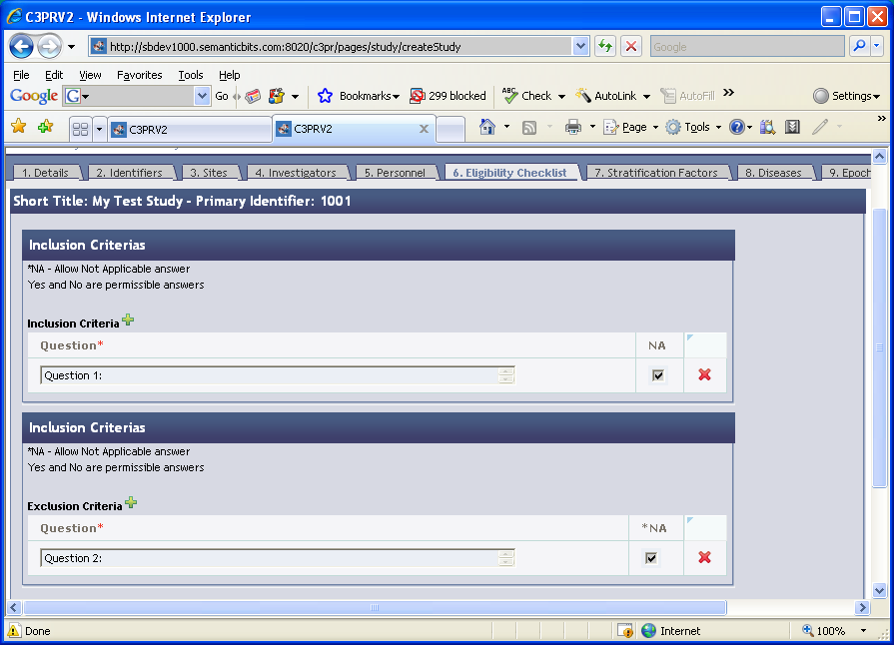
Figure 6
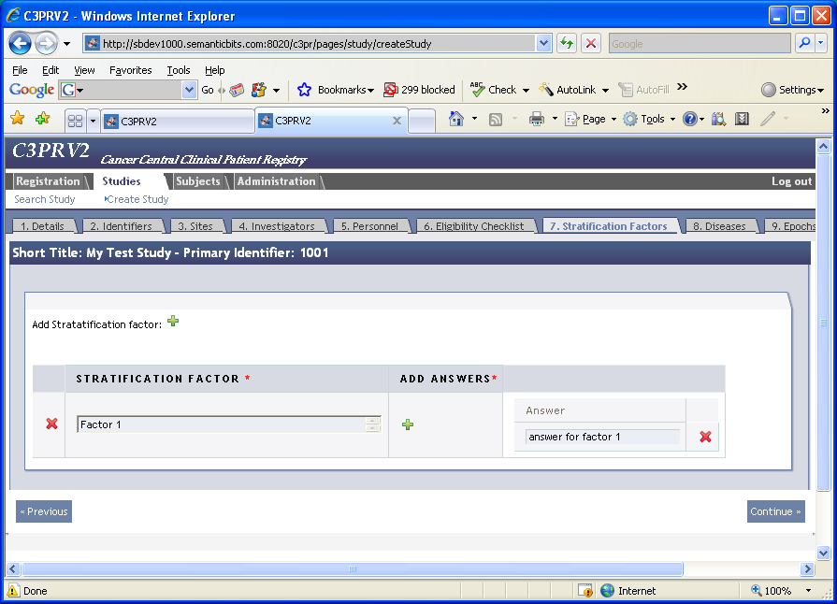
Figure 7
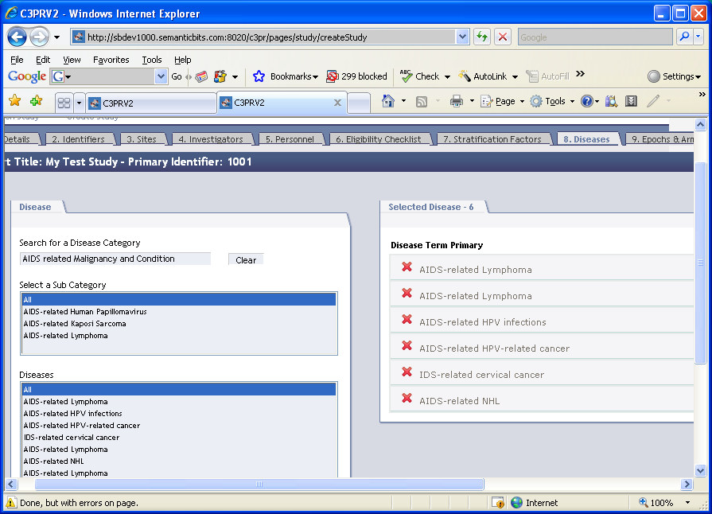
Figure 8
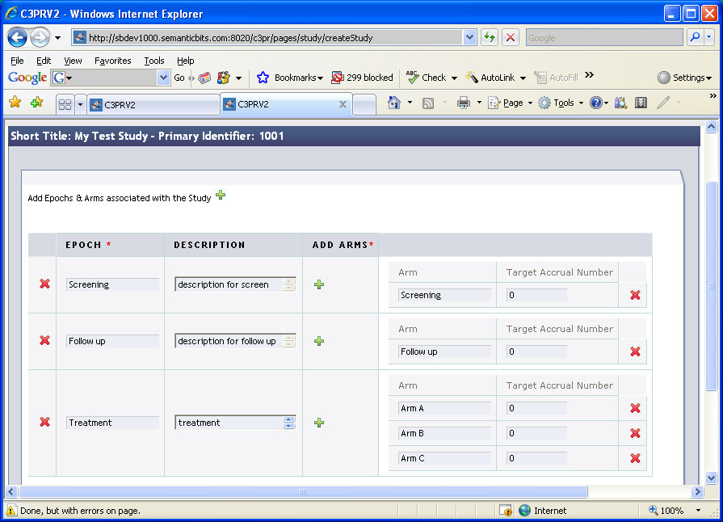
Figure 9
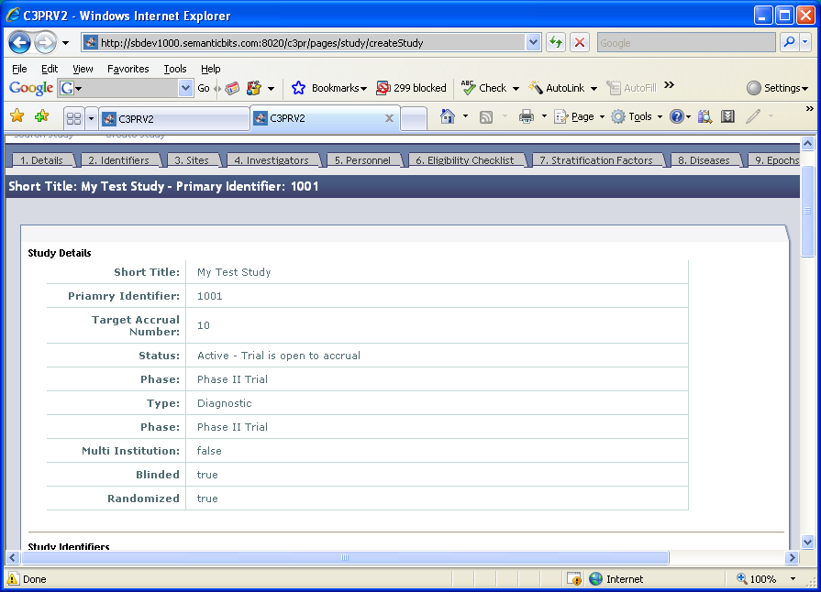
Figure 10

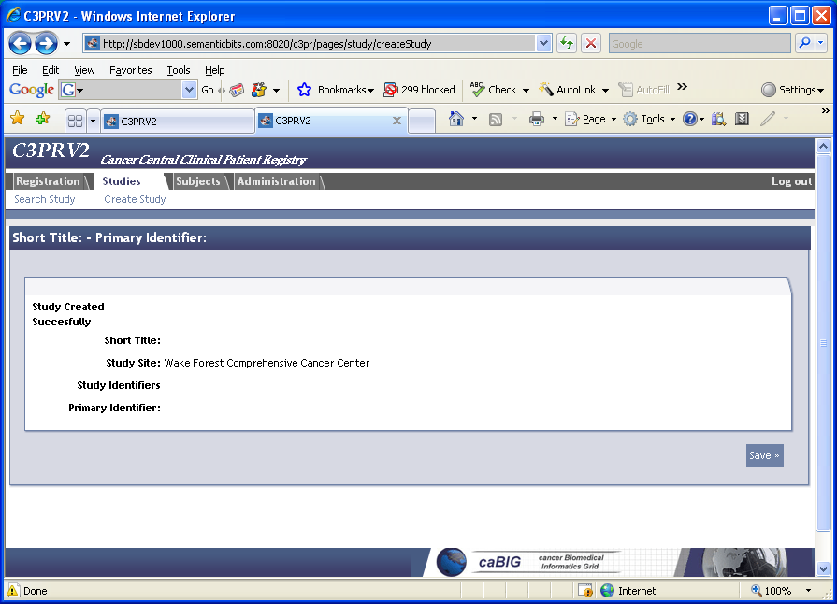
Figure 11

