Test Script Number: | register_participant |  |  |  | Module: |  |  | Tester Name: |  | Steven Cheng | Pass/Fail:  failed
Use Case #: |  |  |  |  | Username: |  |  | Test Date: |  | 05/22/2007 | Pass/Fail:  failed
Estimated Execution Time: |  |  |  |  |  |  | Actual Execution Time: |  | 1 hr
Test Objective: register a participant.

Test Setup:

Related Requirements
or Configuration Change Requests (Number/Description):

 | Test Action | Expected Results | Pass / Fail | Actual Results/Comments | gForge Tracker Bug ID
 | Click Registration tab, click Create Registration link, run Study Search to find the study, then click Search button. See figure 1. |  | Pass | Study Search results displayed.  Tested features:  - Search study by Identifier, Short Title, Long Title and Status works fine. In addition, input one blank space and run search, get all studies displayed except by Identifier.  - Search subject by Last Name and Identifier works fine. Blank space search not work on the subject search.
 | Click the right one to select it. See figure 2 |  | Pass | The study is selected, go to next step to select subject.  Comments:  - Select Study tab and Select Subject tab do nothing. It’s better remove the hyperlinks on them. | 6892
 | Run Search Subject to find the participant, then click Search button. See figure 3 |  | pass | Subject Search results displayed.
 | Click the right one to select it. |  | pass | The subject is selected, go to next step to enter Enrollment Details.
 | Fill the date by using calendar function, then click Continue button. See figure 4 |  | pass | Go to next step to Check Eligibility  Tested features:  - Required field validation is active for all related fields.  - Data format for consent signed date checked.  - Date calendar works fine.  - Enrolling Physician list auto populated from the study’s investigators.  Comments:  - Previous button does not work on this page, it will clear out the selected date once click.  - Red * is put in the front of Informed Consent Signed Date, but the system check the required field for Informed Consent Version. Which one is right?  - The system automatically ignores date with invalid format or an invalid date without any error displayed when pass the required field validation. | 6322  6893  6895
 | Select Disease and Disease Site, then click Continue button. See figure 5. |  | pass | Go to next step to Stratify  Tested features:  - Primary Disease list auto populated from the study disease list  Comments:  - Clear button does nothing.  - One text box on there without anything displayed, remove that.  - Tab ‘5. Check Eligibility’ should NOT be highlighted in this page. | 6898  6897  6896
 | Still in Check Eligibility tab, answer the questions, Click Continue button. See figure 6. |  | fail | The system stopped to continue.  Tested features:  - Required field validation is active for all related answer fields.  - Answer lists auto populated from the study  Comments:  - Tab ‘4. Disease’ should NOT be highlighted in this page.  - Once click Previous button twice, got error message. See figure 7 | 6896  6891

Tester Signature: Steven Cheng

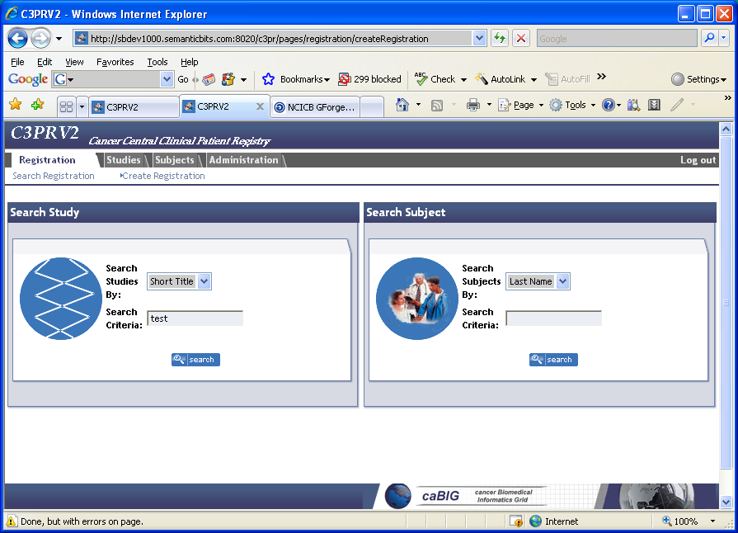

Figure 1

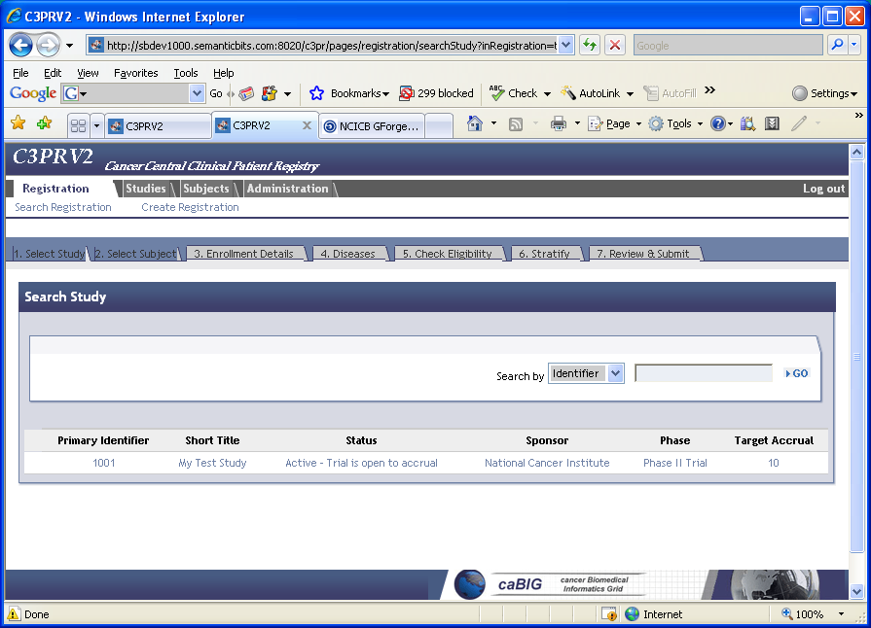

Figure 2
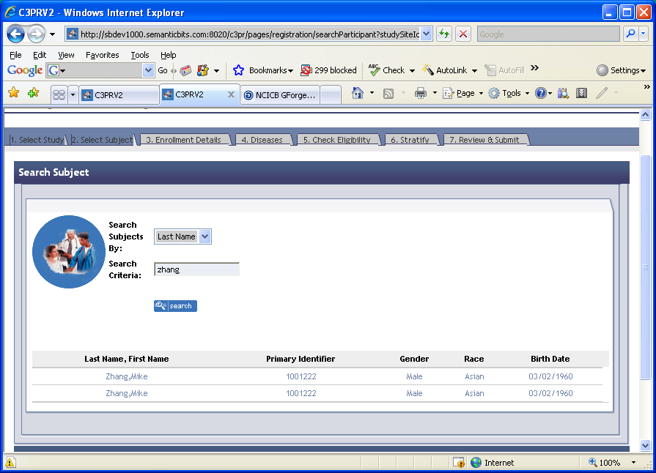
Figure 3
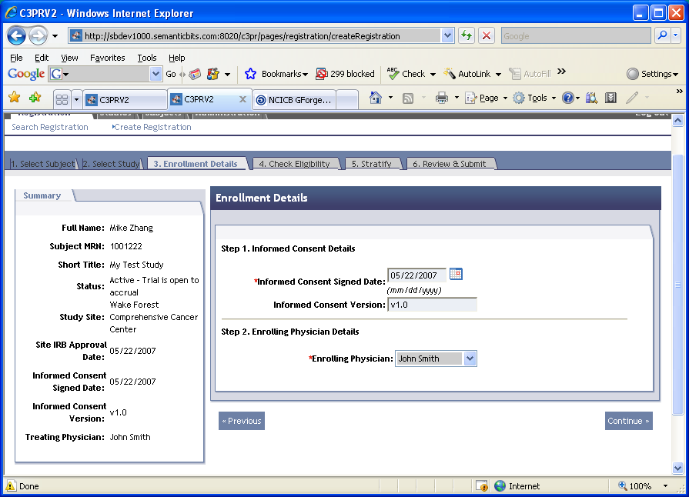
Figure 4
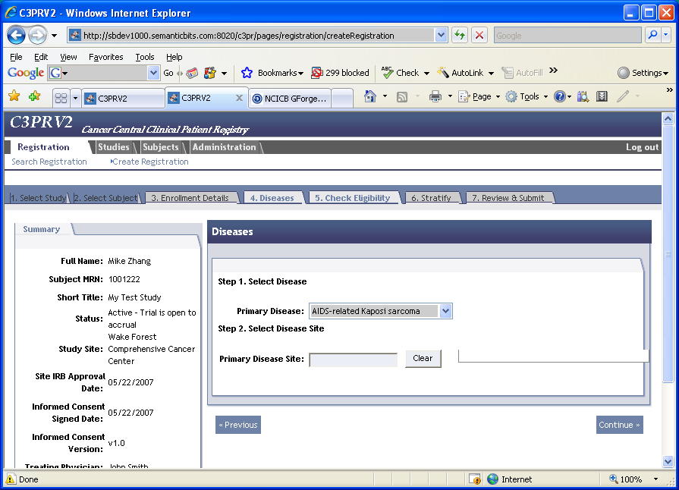
Figure 5
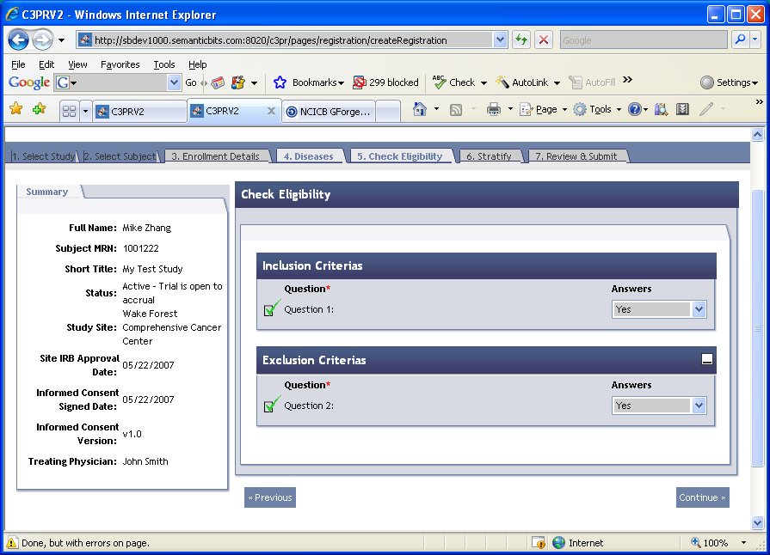
Figure 6
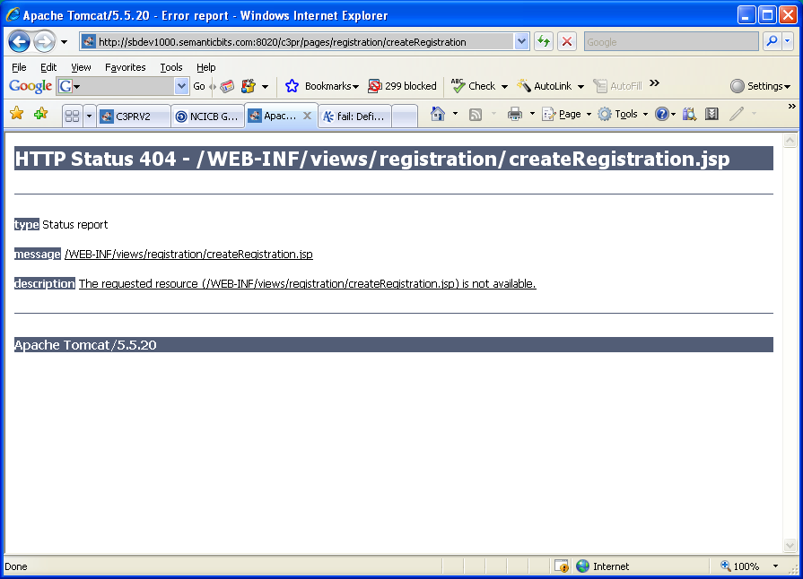
Figure 7

