C3PR V2
Technical Architecture Guide

Duke Comprehensive Cancer Center


Copyright and License page

Copyright Notice. Copyright 2006 Duke Comprehensive Cancer Center (“caBIG™ Participant”). C3PR was created with NCI funding and is part of the caBIG™ initiative. The software subject to this notice and license includes both human readable source code form and machine readable, binary, object code form (the “caBIG™ Software”).
This caBIG™ Software License (the “License”) is between caBIG™ Participant and You. “You (or “Your”) shall mean a person or an entity, and all other entities that control, are controlled by, or are under common control with the entity. “Control” for purposes of this definition means (i) the direct or indirect power to cause the direction or management of such entity, whether by contract or otherwise, or (ii) ownership of fifty percent (50%) or more of the outstanding shares, or (iii) beneficial ownership of such entity.
License. Provided that You agree to the conditions described below, caBIG™ Participant grants You a non-exclusive, worldwide, perpetual, fully-paid-up, no-charge, irrevocable, transferable and royalty-free right and license in its rights in the caBIG™ Software, including any copyright or patent rights therein that may be infringed by the making, using, selling, offering for sale, or importing of caBIG™ Software, to (i) use, install, access, operate, execute, reproduce, copy, modify, translate, market, publicly display, publicly perform, and prepare derivative works of the caBIG™ Software; (ii) make, have made, use, practice, sell, and offer for sale, and/or otherwise dispose of caBIG™ Software (or portions thereof); (iii) distribute and have distributed to and by third parties the caBIG™ Software and any modifications and derivative works thereof; and (iv) sublicense the foregoing rights set out in (i), (ii) and (iii) to third parties, including the right to license such rights to further third parties. For sake of clarity, and not by way of limitation, caBIG™ Participant shall have no right of accounting or right of payment from You or Your sublicensees for the rights granted under this License. This License is granted at no charge to You. Your downloading, copying, modifying, displaying, distributing or use of caBIG™ Software constitutes acceptance of all of the terms and conditions of this Agreement. If you do not agree to such terms and conditions, you have no right to download, copy, modify, display, distribute or use the caBIG™ Software.
- Your redistributions of the source code for the caBIG™ Software must retain the above copyright notice, this list of conditions and the disclaimer and limitation of liability of Article 6 below. Your redistributions in object code form must reproduce the above copyright notice, this list of conditions and the disclaimer of Article 6 in the documentation and/or other materials provided with the distribution, if any.
- Your end-user documentation included with the redistribution, if any, must include the following acknowledgment: “This product includes software developed by Duke Comprehensive Cancer Center.” If You do not include such end-user documentation, You shall include this acknowledgment in the caBIG™ Software itself, wherever such third-party acknowledgments normally appear.
- You may not use the names “Duke Comprehensive Cancer Center”, “The National Cancer Institute”, “NCI”, “Cancer Bioinformatics Grid” or “caBIG™” to endorse or promote products derived from this caBIG™ Software. This License does not authorize You to use any trademarks, service marks, trade names, logos or product names of either caBIG™ Participant, NCI or caBIG™, except as required to comply with the terms of this License.
- For sake of clarity, and not by way of limitation, You may incorporate this caBIG™ Software into Your proprietary programs and into any third party proprietary programs. However, if You incorporate the caBIG™ Software into third party proprietary programs, You agree that You are solely responsible for obtaining any permission from such third parties required to incorporate the caBIG™ Software into such third party proprietary programs and for informing Your sublicensees, including without limitation Your end-users, of their obligation to secure any required permissions from such third parties before incorporating the caBIG™ Software into such third party proprietary software programs. In the event that You fail to obtain such permissions, You agree to indemnify caBIG™ Participant for any claims against caBIG™ Participant by such third parties, except to the extent prohibited by law, resulting from Your failure to obtain such permissions.
- For sake of clarity, and not by way of limitation, You may add Your own copyright statement to Your modifications and to the derivative works, and You may provide additional or different license terms and conditions in Your sublicenses of modifications of the caBIG™ Software, or any derivative works of the caBIG™ Software as a whole, provided Your use, reproduction, and distribution of the Work otherwise complies with the conditions stated in this License.
- THIS caBIG™ SOFTWARE IS PROVIDED "AS IS" AND ANY EXPRESSED OR IMPLIED WARRANTIES (INCLUDING, BUT NOT LIMITED TO, THE IMPLIED WARRANTIES OF MERCHANTABILITY, NON-INFRINGEMENT AND FITNESS FOR A PARTICULAR PURPOSE) ARE DISCLAIMED. IN NO EVENT SHALL THE DUKE COMPREHENSIVE CANCER CENTER OR ITS AFFILIATES BE LIABLE FOR ANY DIRECT, INDIRECT, INCIDENTAL, SPECIAL, EXEMPLARY, OR CONSEQUENTIAL DAMAGES (INCLUDING, BUT NOT LIMITED TO, PROCUREMENT OF SUBSTITUTE GOODS OR SERVICES; LOSS OF USE, DATA, OR PROFITS; OR BUSINESS INTERRUPTION) HOWEVER CAUSED AND ON ANY THEORY OF LIABILITY, WHETHER IN CONTRACT, STRICT LIABILITY, OR TORT (INCLUDING NEGLIGENCE OR OTHERWISE) ARISING IN ANY WAY OUT OF THE USE OF THIS caBIG™ SOFTWARE, EVEN IF ADVISED OF THE POSSIBILITY OF SUCH DAMAGE.

Insert Names of Development Team(s) here
Development | Architecture guide | Program Management
Patrick McConnell¹ | Manav Kher² | Jamie Cuticchia¹
Ram Chilukuri² | Ram Chilukuri² | Bob Annechiarico¹
Ramakrishna Gundala² | Patrick McConnell¹ | Patrick McConnell¹
Kruttik Aggarwal² |  | Ram Chilukuri²
Priyatam Mudivarti²
Manav Kher²
¹Duke Comprehensive Cancer Center
²Semantic Bits

Contacts and Support
Enter training contact | Patrick McConnell  (patrick.mcconnell@duke.edu)
Enter customer support contact | NA

LISTSERV Facilities Pertinent to software teams
LISTSERV | URL | Name
c3prv2-elaborator | c3prv2-elaborators@gforge.nci.nih.gov | C3PR Elaborators Forum
C3prv2-general | c3prv2-general@gforge.nci.nih.gov | C3PR General Forum
C3prv2-developers | c3prv2-developers@gforge.nci.nih.gov | C3PR Developers Forum

Table of Contents

1 Introduction 2
1.1 About C3PRV2 2
1.2 Overview of the guide 2
1.3 Additional Documentation 2
1.4 Document Text Conventions 3
2 Overview of the Software 4
2.1 Software Overview 4
2.2 System Requirements 4
2.3 Database Requirements 5
2.4 Design and Architecture 5
2.5 C3PRV2 Components 6
3 C3PRV2 Requirements 7
4 C3PR Design and Architecture 9
4.1 Architecture 9
4.2 Architectural Layers (Logical View) 9
4.2.1 Domain 9
4.2.2 Business Service 9
4.2.3 Data Access 10
4.2.4 Presentation 10
4.2.5 ESB 13
4.3 Process View 15
4.4 Deployment View 16
4.5 Dependency injection (Architectural Pattern) 16
4.6 Open Session In View Filter (Architectural Pattern) 18
4.7 Grid Identifiers (Architectural Pattern) 18
5 Security and Security Management 19
5.1 TLS 19
5.2 Dorian 20
5.3 Authentication 20
5.4 Authorization 21
5.5 Single Sign On (Web SSO) 22
6 C3PRV2 API 23
7 Information Model 23
8 Customized Tools 23
9 Appendix I: References 24
Appendix B: Glossary 25

Introduction

About C3PRV2
Cancer Central Clinical Participant Registry version 2.0 (C3PRV2) aims to extend the existing C3PR system to enhance the capture and management of protocol/trials information, clinical trials registration, information on physicians, research sites, and organizations, and to enhance access to information.

Overview of the guide
This document covers the technical and design aspects of the implementation of C3PRV2 with an overview of the requirements for context.

Not covered here, but available in other project documents are:
- Detailed requirements
- Use cases
- Domain UML model
- Installation
- Administration

This final architecture guide is pending final approval from cross-cutting workspaces (Architecture and/or Training). Feedback from review will be incorporated.

Additional Documentation
The architecture guide gives and overview of the C3PRV2 system. Additional details on use cases, design, installation can be found in the following documents.

Document | Type | Link
c3pr_uml.eap | UML Design | gforge.nci.gov
C3PRv2-BRIDG.EAP | Domain Model | gforge.nci.nih.gov
C3prv2_use_cases.doc | Use Cases | gforge.nci.nih.gov
c3prv2_technical_specification_Integration | Architecture | gforge.nci.nih.gov
C3prv2_srs.doc | SRS | gforge.nci.nih.gov
c3prv2_technical_spec_servicemix.doc | design | gforge.nci.nih.gov
C3PRv2 Installation Guide.doc | Installation | gforge.nci.nih.gov

Document Text Conventions

The following table shows various typefaces to differentiate between regular text and menu commands, keyboard keys, and text that you type. This illustrates how conventions are represented in this guide.

Convention | Description | Example
Bold & Capitalized Command  Capitalized command > Capitalized command | Indicates a Menu command  Indicates Sequential Menu commands | Admin > Refresh
text in small caps | Keyboard key that you press | Press enter
text in small caps + text in small caps | Keyboard keys that you press simultaneously | Press shift + ctrl and then release both.
Special typestyle | Used for filenames, directory names, commands, file listings, source code examples and anything that would appear in a Java program, such as methods, variables, and classes. | URL_definition ::= url_string
Boldface type | Options that you select in dialog boxes or drop-down menus. Buttons or icons that you click. | In the Open dialog box, select the file and click the Open button.
Italics | Used to reference other documents, sections, figures, and tables. | caCORE Software Development Kit 1.0 Programmer’s Guide
Italic boldface type | Text that you type | In the New Subset text box, enter Proprietary Proteins.
Note: | Highlights a concept of particular interest | Note: This concept is used throughout the installation manual.
Warning! | Highlights information of which you should be particularly aware. | Warning! Deleting an object will permanently delete it from the database.
{} | Curly brackets are used for replaceable items. | Replace {root directory} with its proper value such as c:\cabio

Overview of the Software

Software Overview
C3PRV2 consists of a Java web application that based on the J2EE Servlets infrastructure, WSRF-compliant web services that are built on top of caGrid infrastructure, and JBI components that are hosted by Apache ServiceMix JBI container.

For details on the implementing libraries, see Chapter 4.

More information about C3PRV2 can be found at:
- The C3PR GForge site
- The C3PR Wiki
- CTMS Gforge site
Example Image, for my comment. This provides an end-user with a larger view of architectural benefits (external links etc.).

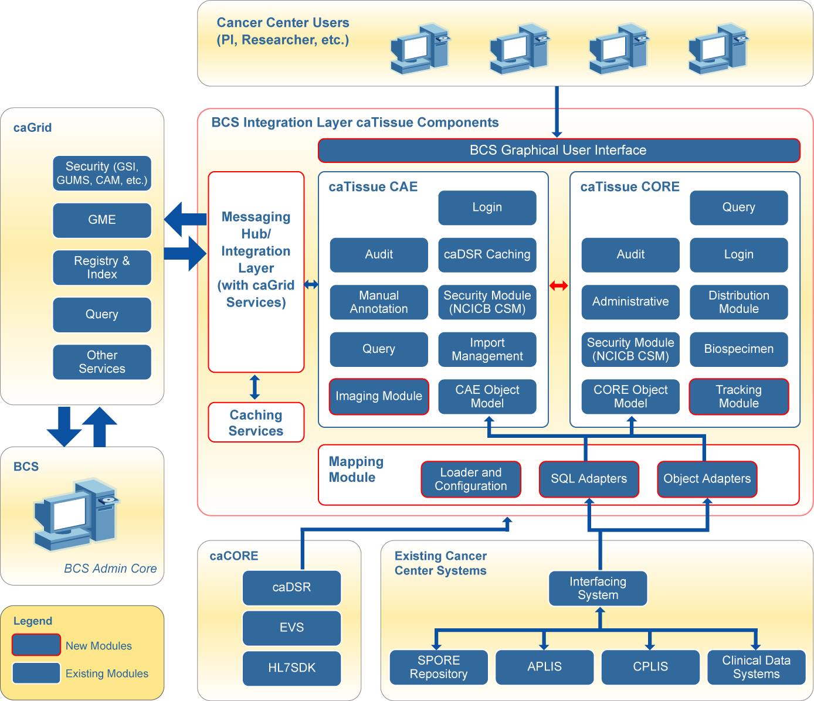.

System Requirements

Software Name | Version | Description | URL
Java SE Development Kit | JDK 5.0 | The Java SE development kit with JRE, compilers and debuggers | http://java.sun.com/javase/downloads/index.jsp
Apache Tomcat | 5.5.17 or higher | Servlet container for JSP | http://tomcat.apache.org/download-55.cgi
Apache Ant | 1.6 or higher | Java-based build tool | http://ant.apache.org/bindownload.cgi
Apache ServiceMix | 3.1 | JBI (JSR 208) container | http://incubator.apache.org/servicemix/home.html
Globus Toolkit | 4.0.x | Grid Toolkit for caGrid services | http://www.globus.org/toolkit
Apache Maven | 2.x | Software build tool | http://maven.apache.org/download.html
Table 1 Required software and technology

Database Requirements

C3PRV2 requires access to a properly-configured database. The application is built with database-independence in mind and has been tested on the following:

Database Name | Version | Description | URL
PostgreSQL | 8 | PostgreSQL is a powerful, open source relational database system. | http://www.postgresql.org/download/
Oracle | 9i | Industry-leading, commercial database product. | http://www.oracle.com/technology/software/products/oracle9i/index.html
Table 2 Supported relational database systems.

For more details, please see the Installation Guide

Design and Architecture
C3PRV2 is based on the J2EE n-tier architecture where business logic is partitioned in its own distinct re-usable layer. Each layer communicates with its adjacent layer only. This architecture promotes reusability, scalability and ease of implementation (See Figure 1)

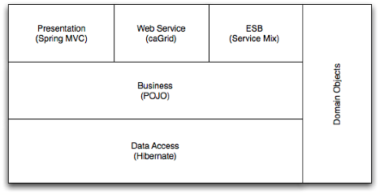
Figure 1 High-level overview of the C3PR system

C3PRV2 Components
The C3PR system is divided into specific components that each has specific responsibility in the overall system. The components currently are defined as follows:
- Core
Contains all code that has cross-component dependency. This includes XML serialization and implementation models.
- Web
The web application that is the end-user front-end to the C3PR system.
- Enterprise Service Bus
The enterprise messaging service for the C3PR system. A reference implementation ESB client will also be developed for the C3PR system, and will be available as an independent module that can be used outside of the C3PR project.
- Business layer
A Java business tier that exposed the business logic of the system.
- Grid services
A WSRF standards-based interface to the business logic of C3PR. This will be used as the consumer interface to the ESB.

The above list of components will change and grow as the C3PR application is developed.

C3PRV2 Requirements
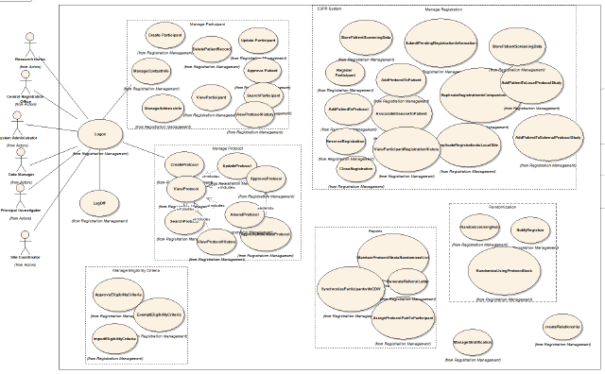
Figure 2 Use case view

The requirements (Figure 2) fall into the following broad categories:

System Requirements
caBIG Silver level compliance, APIs, environment (web browser, databases, etc.), security, and grid enablement

Application Requirements
GUI, querying, metadata, query sharing

Non-functional requirements
Logging, auditing, exceptional flow, reliability, portability, version control

Functional Requirements
  - Protocol Management: C3PR Release 2 will allow for the loading, management, and searching of protocols. Eligibility criteria and randomization will be accessible and managed through the web interface. C3PR does not aim to be the primary protocol management system; however, we envision C3PR to contain enough basic protocol information to register participants and track them on the protocol.
  - Participant Management: This component will manage all aspects of the participant data including address, contact information, searching, synchronization with external systems and relations management.
  - Registration Management: Complete registration management will be provided within the C3PR system including stratification, assignment to protocol arms with and without randomization. Registration status and notification will be a central goal of integration with external systems.
  - Reports: C3PR will allow for reports generation by providing data dumps to be incorporated with external data, as well as an internally managed reporting module to provided through the web interface.
  - Eligibility Criteria Management: C3PR will continue to support the optional import, review and approval process of the eligibility criteria. In Release 2 this support will include distinct eligibility checklists for different phases (or epochs) of the same protocol. The definition of all the eligibility checklists will optionally be maintained in the caDSR within the FormBuilder application and the C3PR system will provide support to import the eligibility checklist to be displayed dynamically within C3PR. Reuse of eligibility criteria through the caDSR will be explored.
  - Auditing/Logging: The Release 2 system aims to provide complete auditing features including tracking changes and record data as a snapshot prior to any data modifications.
  - Login: will component will leverage the current CSM based security model. Furthermore, the caGrid 1.0 security infrastructure will be leveraged for authentication, authorization, and trust fabrics.
  - Data Loading: Release 2 of the system will allow participant, registration, and protocol data to be loaded from external sources. The approach of the C3PR application is to provide data loading, API-based (web service), and web interface based methods to manage all aspects of the C3PR system.
  - Clinical Data Access: C3PR will continue to provide direct access to clinical data in C3D (and other clinical data management systems) for the selected participant on the selected protocol.

More detailed about the system and scientific requirements can be found in the C3PR SRS found at: C3PRV2 SRS Document
In addition, readers may find useful the C3PR Use Case Document, which can be found at: C3PRV2 Use Case Document

C3PR Design and Architecture
This chapter will include the following topics:
- Design is how the requirements of the software are implemented in the product
- Include links to developer design documents such as use case documents and to the latest UML models for the software

Architecture
Details of the C3PRV2 architecture can be found in this Enterprise Architect Project

Architectural Layers (Logical View)

It has 6 fundamental layers – domain, data access, business service, presentation, web service, and ESB – and several ancillary packages, all glued together using dependency injection.

Domain
All layers in the n-tier architecture communicate with their adjoining layers using domain objects. The domain objects are pure JavaBeans. There is no need for separate concerns on view layer, for instance, there is no need for separate view objects or separate persistence objects and mapping between all the objects. All of C3PR domain objects reside in the package edu.duke.cabig.c3pr.domain; the Design & Analysis starting from a BRIDG (Biomedical Research Integrated Domain Group) Harmonized model
The Domain objects not only encapsulates the state but have basic behavior (like adding/removing collections) incorporated. Each domain object knows how to persist itself via Hibernate annotations. (Instead of separate hbm files to map persistent objects to database).
More details on the domain model can be found in the design document

Business Service
The business service layer will expose a set of interfaces for the client to call in. The Controller classes typically delegate the functionality to Service classes. Spring adds the dependency injection for the implemented classes as Controller need not be coupled with the Service implementations.

Data Access
The data access layer in C3PRV2 is implemented using the Data Access Object (DAO) J2EE design pattern. The domain objects are created, updated and queried exclusively via DAOs. A DAO essentially encapsulates the logic necessary to create, retrieve update, and delete a domain object from the database. Implementation of DAO pattern promotes database portability. The DAOs in C3PRV2 are based on the Spring Framework’s Hibernate abstraction layer. Use of this abstraction layer greatly simplifies the data access by eliminating the need to write low level and repetitive plumbing code using the API provided by Hibernate framework.

Presentation
The presentation layer can further be sub divided into control and view layers, which are described below.

Control
The control layer is made up of two closely-collaborating types of classes: commands and controllers. Commands encapsulate the data and behavior associated with a user operation, generally including one or more domain objects. Controllers handle mapping incoming requests onto command instances and providing the command output back to the view layer.

C3PRV2 uses Spring MVC (which is itself based on Servlets) to dispatch web requests to the appropriate controllers.

View
The view technology consists of JSP pages with standard stylesheets (css), JSP Tag libraries including Spring tag libraries, AJAX, DWR and Scriptaculous (See Figure 3)


Figure 3 Ajax model vs. Classic web model (reference)

Design templating is handled using SiteMesh (Figure 4), which takes the full HTML pages generated from the JSPs and decorates it with the common site elements

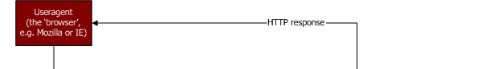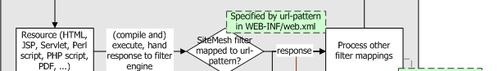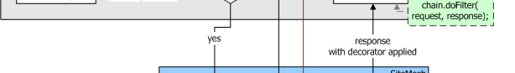
Figure 4 Sitemesh flow diagram (reference)

ESB
C3PR Integration subproject is aimed at providing a reference implementation, for integrating different clinical systems within the caBIG CTMS workspace.

We are using the Apache ServiceMix ESB , which is open source implementation of the the Java Business Integration (JBI) standard (JSR 208). The goal of JBI is to allow components and services to be integrated in a vendor independent way, allowing users and vendors to plug and play.

The main components of a JBI-compliant ESB include binding components (BCs), service engines (SEs), and the normalized message router (NMR). BCs are responsible for translating between protocol- or transport-specific messages to “normalized” messages. The structure of a normalized message defined by the abstract service definition in the WSDL of the target service provider that is exposed by the binding component. SEs provide services such as content-based routing, translation among message exchange patterns (MEPs), or message format translation. The NMR routes messages among BCs and SEs based service type and the operation being executed. It is also responsible for fulfilling the requested quality of service (QoS).

Figure 5 shows typical interactions among C3PR and other systems in the CTMS suite of applications. In one scenario, the C3PR application invokes a Java Messaging service (JMS) endpoint that is exposed by the JMS BC. The JMS BC normalizes the message and places in on the NMR which routes it to the EIP (Enterprise Integration Pattern) SE. The incoming message will in some cases have a grid proxy as part of the message. The grid proxy is obtained from the caGrid GAARDS infrastructure, by the application producing the message. The proxy is either a property of the message or part of the content of the message itself. The EIP SE populates the normalized message’s JAAS subject with the principal and credentials obtained from the proxy. The EIP then places the message onto the NMR, which routes it to the Grid Service BC. The Grid Service BC then invokes the caAERS RegistrationConsumer grid service.

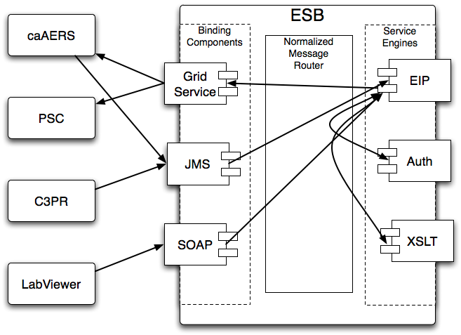
Figure 5 ESB flow diagram

Process View
Figure 6 shows a sequence diagram of how a new Protocol is created in the C3PRV2 system and propagated to other applications through the ESB

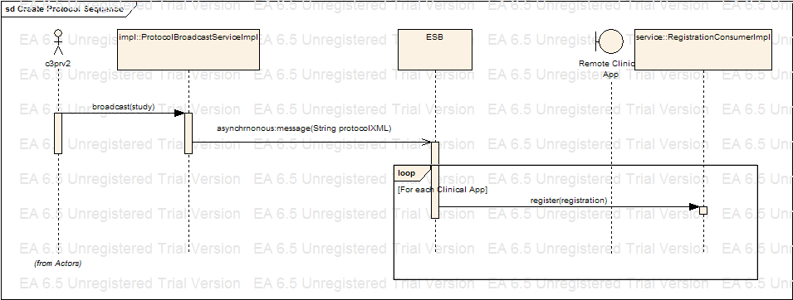
Figure 6 C3PRV2 Sequence diagram

Figure 7 shows the above sequence of events while leveraging caGrid Security for user authentication and authorization

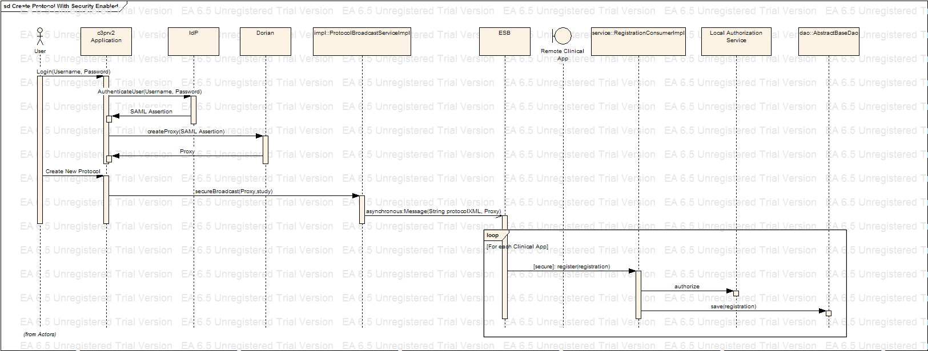
Figure 7 C3PRV2 Sequence diagram with grid Security

Deployment View
Figure 8 shows how C3PRV2 application will be deployed in a production environment.

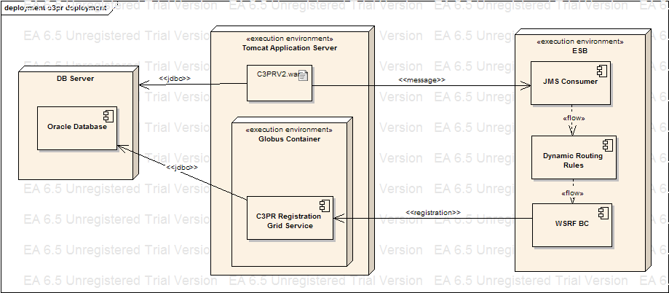
Figure 8 C3PRV2 deployment diagram

Dependency injection (Architectural Pattern)

The objects in different layers are connected or wired together using an architectural pattern called dependency injection/inversion of control. This means that, instead of a DAO object acquiring a data source from JNDI, or a controller finding a DAO using some sort of service locator, each object declares the objects (commonly referred to as collaborators) it depends on based on its own requirements. All the collaborators are instantiated by an external configuration tool; all their dependencies are satisfied by that tool when they are created.

Inter-layer dependencies are oriented such that higher levels depend on lower levels, but never vice versa. For instance, a service may depend on a DAO, but a DAO will never depend on a service.

C3PRV2 uses the Spring Framework (version 2.0), specifically Spring IOC container for dependency injection, with the dependencies declared in a series of XML files included alongside the deployed classes. For more information about the Spring Framework, please see this documentation.

Figure 9 illustrates the wiring of various objects that belong to different layers in C3PRV2:

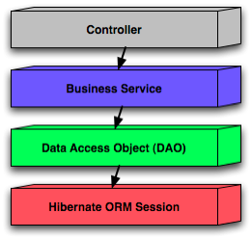
Figure 9: Spring wiring of C3PRV2 web app components

Open Session In View Filter (Architectural Pattern)

A filter which implements the Open Session In View pattern. Different from the one built into Spring because this one delegates to an instance of OpenSessionInViewInterceptor configured in the application context. This permits the use of the same interceptor for deployed code & unit tests.

Grid Identifiers (Architectural Pattern)

Grid Identifier servers as a unique identifier for persistent entities across different C3PR instances. For example, to be able to uniquely identify a Study in C3PR instance ‘A’ in Duke and another Study object (with the same semantics) in C3PR instance ‘B’ at Mayo, the only way to uniquely identify is via a Grid Identifier.
In C3PR an interface is included to achieve this functionality – GridIndentifierCreator. Two different implementations exist for generating Grid Ids, one based on UUID (LocalGridIdentifier) and another based on caBIG grid ID handler.
Currently we are using LocalGridIdentifiers

Security and Security Management
The requirements of the C3PR security architecture are to ensure the privacy and integrity of all network communication, and to enforce authentication and authorization before granting access to operations and data. This architecture is also required to enforce authentication and authorization of users and services that may be outside of the security authority of the host organization.
Privacy and integrity of data in transit through the network are ensured by using Transport Level Security (TLS). Access to data at rest in a database is protected using basic (username/password) authentication mechanisms. Authentication is enforce using a combination of Public Key Infrastructure (PKI) and basic authentication. Authorization policy is constructed and maintained using NCICB’s Common Security Module (CSM). Authorization policy is enforced using custom components in the web application layer and the caGrid Authz module, which enables local and external (grid-wide) policy to be enforced in parallel.
PKI-based authentication works as follows. Users and services are provisioned with X509v3 certificates that have been signed by widely-trusted certificate authorities. During negotiation of security communication between parties, party A authenticates party B by verifying that the certificate of party B has been signed by a certificate authority that party A trusts. Both uni- and bi-directional (mutual) authentication can be required.
Basic authentication involves looking up the requesting parties credentials (username and password) in some credential provider. Grid users have a proxy certificate (short-lived X509 certificate) and are authenticated using PKI authentication.
The following sections describe how security issues are addressed at each layer of the C3PR architecture.(Web Application)

TLS

The C3PR web application runs in a servlet container. Web browser clients make requests to the container, and code running in the container sends and receives messages from a JMS broker. To secure communication between the web browser and the web application, the servlet container is configured to accept connections over HTTPS, and the web application is configured to require that pages containing sensitive data can only be accessed over HTTPS. In this way, all data communicated between the browser and the application are encrypted. To secure communication between the web application and the JMS broker, the broker is configured to accept SSL connections and the client is configured to use a SSL connection to the broker.

Dorian

Dorian is the Grid User Account Management system provided by caGrid 1.0 . Dorian acts is a bridge between external security domains and the grid. Dorian allows users to use their existing credentials (external to the grid) to authenticate to the grid.
Dorian comes with a default identity provider. This allows users to register for an account and obtain grid credentials through Dorian. We leverage the Dorian default IdP for requesting grid credentials for users in c3pr v2. This grid credentials can then be used to authenticate to other CTMS systems, thus providing a Single Sign On (SSO) between these systems.

- Proxy Creation Workflow
- Client authenticates with Local IdP
- Client creates public/private key pair to use for grid proxy.
- Client requests Dorian to create a grid proxy.
- Dorian verifies that the SAML assertion provided by the user is signed by a Trusted IdP and that the user has a valid account.
- Dorian locates the user’s grid credentials, private key and certificate
- Dorian uses the public key provided to create a proxy certificate and signs it with the user’s private key
- Dorian returns the proxy certificate to the user.
- The user may now use the proxy to authenticate to grid services

Authentication

The first step in the security workflow is authentication, which is the process by which a trusted organization claims a user is who they claim to be. This is implemented using the caGrid AuthenticationService (see Figure 10). The goal is for the user to get a grid user certificate to be used in authorization. The user submits their credentials (user name and password) to the AuthenticationService, which has an institutional IdP plugged in. This component performs the necessary steps to determine that the user credentials are valid. In the case of the Duke IdP plugin, the user name and password are validated against the Duke Domain Controller, which uses NT Security. Once validated, the AuthenticationService returns a SAML Assertion to the user, which asserts that the user is who they claim to be. The SAML Assertion can then be passed off to a Dorian Service to generate a grid user certificate.
Grid users must provide a proxy certificate which is validated using PKI. Authentication of grid users is enforced by the WEBSSO module. See the WEBSSO section for details.

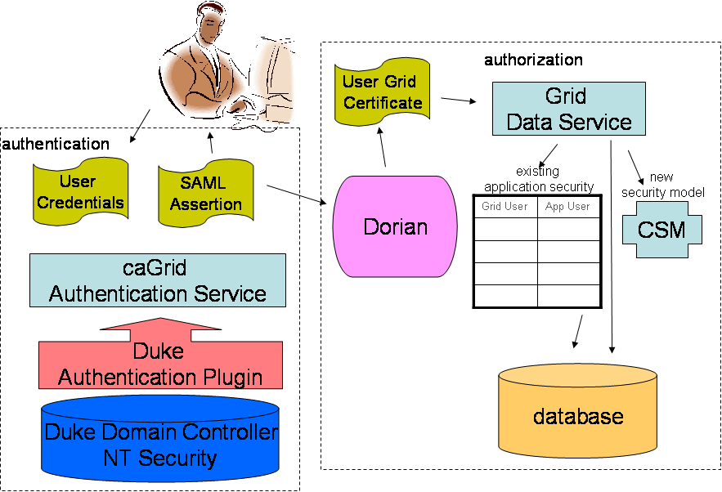
Figure 10 High-level overview of the caTRIP security architecture

Authorization

The second step in the security workflow is authorization, which is the process by which a system grants the user access to specific resources. This is implemented using the CSM plug-in to the grid data service. The grid user is mapped to an application user. When a data field is accessed on behalf of the user, an authorization structure is queried to determine if the user has permission to access it. If not, then a security exception is returned to the client. Authorization is made possible because a trust fabric exists between the service serving the data resource and the AuthenticationService.
Both role-based and identity-based authorization. Role-based authorization policy applies in two ways. First is access to URLs – roles are assigned access permissions to the pages they need to function. Second is attribute-based – some pages mutate based on the roles granted to the logged-in user. Certain links or forms will only appear if a user has a role that grants him or her access to the target page.

C3PR also uses identity-based authorization for specific resources. For example, it is possible to limit access an individual item to one or more users. Authorization is enforced through a combination of a Spring interceptor, custom JSP tags, and the caGrid Authz component.
As described previously, the Spring DispatcherServlet passes an incoming request to the chain of interceptors before delegating to the Controller. One of these interceptors is the URLAccessCheckInterceptor, which verifies if the logged in user is authorized to access the page that he is requesting, based on his role. If the user does not have privileges to access a page then the access denied page is displayed. The URLAccessCheckInterceptor uses the CSM API to determine the roles of the logged in user.
Similarly, custom JSP tags control the rendering of a page based on the user’s role, so that only sections which expose functionality and data to which the user is authorized are displayed. This works fine for local users because they can be provisioned with roles using the organization’s CSM. However, it is impractical to provision all possible grid users. Instead, the Authz component is plugged into CSM to enable grid-based authorization policy to be enforced in parallel with local policy. See the caGrid User’s Guide for more information about the Authz component.

Single Sign On (Web SSO)

The WebSSO component of C3PR is used by web applications in the CTMS suite to implement SSO at the web application layer. It is designed to be easily integrated into an existing web application. The following describes how this component works.
First, some background. In caGrid, authentication is achieved through the use of X.509 certificates. Therefore, each user needs a certificate in order to access a secure resource on the grid. The caGrid components that enable each user to obtain a certificate are the Dorian service and the AuthenticationService service. AuthenticationService plays the role of an Identity Provider (IdP). Dorian plays the role of an Identity Federation Service (IFS).
A user obtains a certificate by following these steps:
- User provides IdP username and password
- IdP returns a singed SAML assertion attesting to the user's identity
- User provides SAML assertion to IFS
- IFS returns a certificate

The certificate returned by the IFS is a proxy certificate, which we commonly refer to as a grid proxy. It is basically just a short-lived certificate (usually valid for only 12 hours).

C3PRV2 API
Details to be added

Information Model
Details to be added

Customized Tools
Details to be added

Appendix I: References

- Java Bean Specification
- Hibernate Reference Documentation:
- Java Programming
- Javadoc tool
- JUnit
- Spring Framework
- Sitemesh
- DWR
- JAAS
- caGrid Homepage
- JMS
- Servicemix

- Appendix B: Glossary
Term | Definition
CSM | Common Security Module
IdP | Identity Provider
API | Application Programming Interface
CDE | Common Data Element
GUI | Graphical User Interface
UML | Unified Modeling Language
JMS | Java Message Service
API | Application Programming Interface
caBIG | cancer Biomedical Informatics Grid
DAO | Data Access Objects
HTTP | Hypertext Transfer Protocol
JDBC | Java Database Connectivity
JSP | JavaServer Pages
ORM | Object Relational Mapping
RDBMS | Relational Database Management System
SDK | Software Development Kit
HASTE | High-level Automated System Test Environment
WSRF | Web service resource framework
ESB | Enterprise Service Bus
AJAX | Asynchronous JavaScript a
BC | Binding Component
SE | Service Engine
NMR | Normalized Message Router
JAAS | Java Authentication and Authorization Service
GAARDS | Grid authentication and authorization with Reliably Distributed Services
DWR | Direct Web Remoting

