Stakeholder Involvement and Communication Plan
Cancer Central Clinical Patient Registry (C3PR) V2

The C3PR development effort requires the involvement of multiple organizations and varying levels of interaction to ensure a successful product is produced. The purpose of this document is to outline who the Stakeholders are, their involvement in the project, and the plan for successful communication with the primacy Stakeholders involved in development of the Module.

Stakeholders
There are a number of groups that can currently be identified as Stakeholders in this project. Stakeholders who have a direct role in elaboration, module development, and testing are the Primary Stakeholders and will be described in more detail in later sections. The Secondary Stakeholders will not be regularly involved in the development or testing of the Study Calendar Module, however they have potential to impact the project. In particular, documents will be sent to the entire CTMS Workspace for review prior to finalization. This listserv includes representatives from all those groups listed as Secondary Stakeholders. The Stakeholders are:

Primary Stakeholders
- Duke
- Semantic Bits
- Wake Forest
- Mayo
- CALGB
- Cooperative Groups
- Westat
- CCR

Secondary Stakeholders
- caBIG Clinical Trial Management System (CTMS) Workspace members
- caBIG Clinical Trials Working Group (CTWG)
- Cancer Centers
- Other NCI Funded Programs
- National Cancer Institute (NCI)
- NCI Center for Bioinformatics (NCICB)
- Clinical Data Interchange Standards Consortium (CDISC) and Trial Design Model (TDM)
- Booz Allen Hamilton staff

Primary Stakeholder Interest
The Primary Stakeholders will be involved in project elaboration, development, and testing. Their interests in the project are described below:

- Duke
Duke is the primary institution on the contract, and will be involved in planning, managing, developing, testing, and adopting C3PR. The Duke team is made up of:
- Jamie Cuticchia: principle investigator
- Bob Annechiarico: project manager, lead elaborator, lead adopter
- Patrick McConnell: lead architect
- Vijaya Chadaram: domain expert
- Seth Fehrs: domain expert
- Michael Leonard: domain expert
- William Banks: database manager
- Mohammad Farid: database administrator
- Emily Allred: financial specialist

- Semantic Bits
Semantic Bits is the primary developer on the project and will be involved in all aspects of the project. The team is made up of:
  - Ram Chilukuri: lead developer
  - Vinay Kumar: technical expert
  - Manav Kher: developer
  - Ramakrishna Gundala: developer
  - Kruttik Aggarwal: developer
  - Priyatam Mudivarti: developer

- Wake Forest
Wake Forest is a primary adopter of C3PR V2, representing a site with a variety of legacy applications that will interface with C3PR. They will be involved in elaboration, testing, and adoption. The team is made up of:
  - Bob Morrel: lead elaborator, lead adopter
  - List other members

- Mayo
Mayo is an elaborator site and will be involved in elaboration and testing, though they may become an adopter at a future time. The team is made up of:
- Sharon Elcombe: lead elaborator
- Diane Parkin: domain expert
- Rammohan Deeduvanu: technical expert

- CALGB
The Cancer Leukemia Group B (CALGB) represents an important set of investigators and studies. They will be involved in elaboration and testing. The team is made up of:
  - Kimberly Johnson: lead elaborator
  - Marin Shanley: domain expert
  - Josh Yoder: technical expert
  - Charles Keen: technical expert
  - Amish Shah: technical expert

- Coalition Cooperative Groups
The Coalition of Cooperative Groups represents a large collection of investigators and institutions that enroll patients on studies. They will act as elaborators, and are comprised of:
- Prasid Dasgupta: lead elaborator

- Westat
Westat is the developer of the Randomization Hub, which will plug into C3PR. In addition, they develop patient registry software for the Cooperative Groups, placing them as important elaborators. The team is made up of:
  - Steve Riordan: lead elaborator
  - Charles Keen: domain expert

- CCR
The NCI Center for Cancer Research (CCR) represent C3PR V1 adopters. They will act as elaborators and adopters. The team includes:
- Jeffrey Shilling: lead elaborator, lead adopter

- Patient Advocates
Patient Advocates represent the interests of cancer patients. This group will be involved as an elaborator, providing important feedback in the scope and functionality of C3PR. The group includes:
- Patty Spears: lead elaborator

Primary Stakeholder Communication Plan
The Elaboration Phase of C3PR V2 has a short timeline of 4 months, which is designed to prepare the project for an 8 month construction phase. The goal of the Elaboration Phase is to elaborate all uses use cases at a high level, select a handful of high priority, risky use cases to enumerate in details, and develop these use cases. This means that communication with the stakeholders must be quick and efficient. Testing, likewise, will need to be done rapidly. The C3PR development team will take a four-tiered approach to engaging the stakeholders: communication with developers, elaborators, BAH/NCI, and the caBIG community.

The first tier of communication is with the project developers. The lead architect and lead developer will hold weekly teleconferences with developers to ensure that project goals are being met in a timely fashion.

The second tier will be communication is with the elaborators, which will be handled in a hierarchical way. The lead elaborators of each primary stakeholder team will be the first point of contact for any requests for document review, use case elaboration, or requirements analysis. Requests from project management will filter down through the hierarchy to domain experts through the lead elaborators (see Figure 1). A biweekly teleconference will be held between project management, the lead architect, the lead developer, and the lead elaborators. It is expected that each lead elaborator will pass requests to the domain experts in their team, collect feedback, and present it back to the group (either verbally or in documentation form).
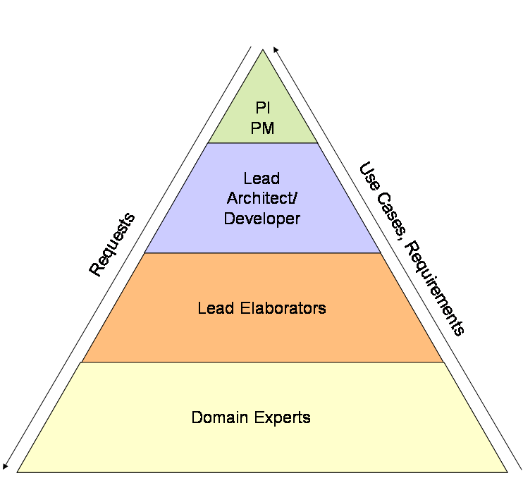
Figure 1 Communication plan

The third tier of communication is with BAH and NCI management. The goal of this communication is to present the progress of the project and discuss high-level scope, feature, and design decisions. This will also provide a forum to discuss issues around specific deliverables, including risks to the project. A biweekly teleconference will be set up to enable this communication.

The fourth and final tier of communication is with secondary stakeholders. This communication will occur in a variety of forums depending on the stakeholder. Some examples of this include communicating with the appropriate special interest groups in the caBIG CTMS Workspace. This will occur on a monthly basis.

Communication Matrix

Event | Group(s) | When | Method
Developer Meeting | Developers | Tuesday at 10:00, Weekly | Add tcon info here
Developer Communication | Developers | Ad Hoc | Email listserv:  c3prv2-developers@gforge.nci.nih.gov
Face-to-face | Developers, Adopters (NU), End Users (CRO Staff) | 11/6/2006-11/8/2006 and twice in construction phase | Multi-day onsite meeting at Duke
Elaborator Meeting | Elaborators | Tuesday at 11:00, Biweekly | Add tcon info here
Elaborator Communication | Elaborators | Ad Hoc | Email listserv:  c3prv2-elaborators@gforge.nci.nih.gov
CTMS SIG? | Project Management, End Users | 1st & 3RD Monday of each month | Teleconference
BAH/NCI Update | Project Management, BAH, NCI | 1st & 3RD Monday of each month | Teleconference

