Software Requirements Specification

Cancer Central Clinical Participant Registry (C3PR)
Version 2
Duke Comprehensive Cancer Center

DOCUMENT REVISION HISTORY
Version Number | Date | Description
1.0 | 11/12/2006 | - Draft template
2.0 | 11/30/2006 | - Enhanced use cases for Protocol Management

Background/Summary
This document describes the use cases for the C3PR V2 software. These communicate to developers and end users the requirements of the system at a functional level. Each use case provides one or more scenarios that convey how the system should interact with the users called actors to achieve a specific business goal or function

Table of Content

1 Introduction 5
1.1 Overview 5
1.2 Related Documents 5
2 Actors and Goals 6
2.1 Study-Coordinator/Protocol Manager 6
3 Manage Participant 6
3.1 Create Participant 6
3.2 Update Participant 6
3.3 Verify Participant 6
3.4 Delete Participant 7
3.5 Manage Participant Address 7
3.6 Manage Participant Contact 7
3.7 Search for Participant 7
3.8 View Participant 7
4 Manage Protocol 8
4.1 High Level Manage Protocol Use Case Diagram: 8
4.2 High Level Protocol Data Capture Use Case Diagram: 9
4.3 Create Study/Protocol Definition Manually. 9
4.4 Load Protocol Definition from a File 12
4.5 Get Protocol/Study Definition via Protocol Message from external Source. 13
4.6 Search Protocol. 15
4.7 View Protocol. 16
4.8 Update Protocol. 17
4.9 Approve Study/Protocol Definition. 19
4.10 Amend Study/Protocol Definition. 20
4.11 Abstract Protocol Data 22
4.12 Register Patient to a Protocol Arm 22
4.13 Synchronize Creation of Protocol Definition with Study Calendar 22
4.14 Synchronize Registration of a Patient on a Protocol Arm with Study Calendar 23
5 Manage Registration 25
5.1 Add Patient to Local Protocol Study 25
5.2 Add Patient to External Protocol Study 25
5.3 Add Protocol to Patient 25
5.4 Associate Disease to Patient 25
5.5 View Participant Registration History 25
5.6 Register Participant 25
5.7 Reserve Registration 25
5.8 Close Registration 25
5.9 Store Patient Screening Data 26
5.10 Submit Pending Registration Information 26
5.11 Replicate Registration to Companion Protocol 26
5.12 Replicate Registration to Local Site 26
6 Manage Randomization 26
6.1 Email Notify Registrar 26
6.2 Randomize Using Protocol Block 26
6.3 Randomize Using Call-out 26
7 Manage Eligibility Criteria 26
7.1 Approve Eligibility Criteria 26
7.2 Exempt Eligibility Criteria 27
7.3 Import Eligibility Criteria 27
8 Access Clinical Data 27
9 Manage Stratification 27
10 Manage Relationship 27
10.1 Create Relationship 27
11 Login 27
12 Reporting 27
13 From C3PR Release 1 (Not Yet Analyzed) 28
13.1 MaintainProtocolStrataRandomizedList 28
13.2 SynchronizeParticipantwithCDW 28
13.3 AssignProtocolPartToParticipant 28
13.4 GenerateReferralLetter 28
14 Integration 28
15 Overall Requirements 28
15.1 Requirements Prioritization 28
16 Sign Off 29
16.1 Approval 29

Introduction

Overview
Researchers, who conduct clinical trials themselves and often require comparative data for dosing, measurable clinical trial end-points, model validation, encounter difficulty accessing aggregate clinical trials data. This, in turn, limits their ability to advance the science. The development and deployment of a central registry, containing requisite information on clinical trials, will provide all groups (patients and their families indirectly, community physicians and cancer researchers directly) to meet their diverse set of informational and data needs.
C3PR Release 1 provides a highly configurable participant registry for managing clinical study registration at a single site. However, it cannot easily manage cross-site studies, and it can be very difficult to install, configure, and manage. The primary goal of C3PR Release 2 is to build upon Release 1 to make it more generally useful to the cancer research community. A scoping goal will be for C3PR to manage participant registration to multi-site studies. This involves the integration of C3PR instances at different centers. Additionally, integration beyond C3PR will be needed to perform institution-level and PI-level eligibility checks. The current registration model is somewhat limited, allowing for simplistic randomization based upon manual assignment of participants to arms. Furthermore, protocol management in C3PR will be greatly enhanced. Though C3PR is not intended as a central protocol repository, protocol information is critical to the registration process. Protocol information will be expanded to meet the use cases of multiple eligibility check-points, multi-institutional studies, and differing randomization schemes. C3PR Release 1 provided registration from a participant-centric standpoint. This workflow will be enhanced to provide registration from a protocol-centric view, and reporting will be extended to provide this information to external systems to generate complex reports.

Related Documents

- Vision and scope document
https://gforge.nci.nih.gov/plugins/scmcvs/cvsweb.php/c3prv2/documentation/communication/c3prv2_vision_scope.doc?cvsroot=c3prv2
- Communication Plan
https://gforge.nci.nih.gov/plugins/scmcvs/cvsweb.php/c3prv2/documentation/communication/c3prv2_communication_plan.doc?cvsroot=c3prv2
- Use case document
https://gforge.nci.nih.gov/plugins/scmcvs/cvsweb.php/c3prv2/documentation/use_cases/c3prv2_use_cases.doc?cvsroot=c3prv2

- Project plan
https://gforge.nci.nih.gov/plugins/scmcvs/cvsweb.php/c3prv2/documentation/planning/c3prv2_project_plan.doc?cvsroot=c3prv2
- Risk matrix
https://gforge.nci.nih.gov/plugins/scmcvs/cvsweb.php/c3prv2/documentation/risks/?cvsroot=c3prv2

Actors and Goals
The likely users of the C3PR system are people with the job responsibilities listed below.

Study-Coordinator/Protocol Manager
A study-coordinator or protocol manager is the primary user of the C3PR system. He/She registers the patients to a protocol and essentially manages the protocol study at a given site.

Manage Participant

Create Participant
This use case allows the user to create a participant in C3PR.

Update Participant
This use case allows the user to update participant’s record.

Verify Participant
This use case allows the user to approve a participant.

Delete Participant
This use case allows the user to delete a participant record, which was erroneously entered in C3PR and never otherwise.

Manage Participant Address
This use case allows the user to add/update participant’s address information.

Manage Participant Contact
This use case allows the user to add/update participant’s contact information.

Search for Participant
This use case allows the user to search a participant depending upon the search criteria (FN, LN, D.O.B, PID#, etc).

View Participant
This use case allows the user to view participant’s record.

Manage Protocol

High Level Manage Protocol Use Case Diagram:
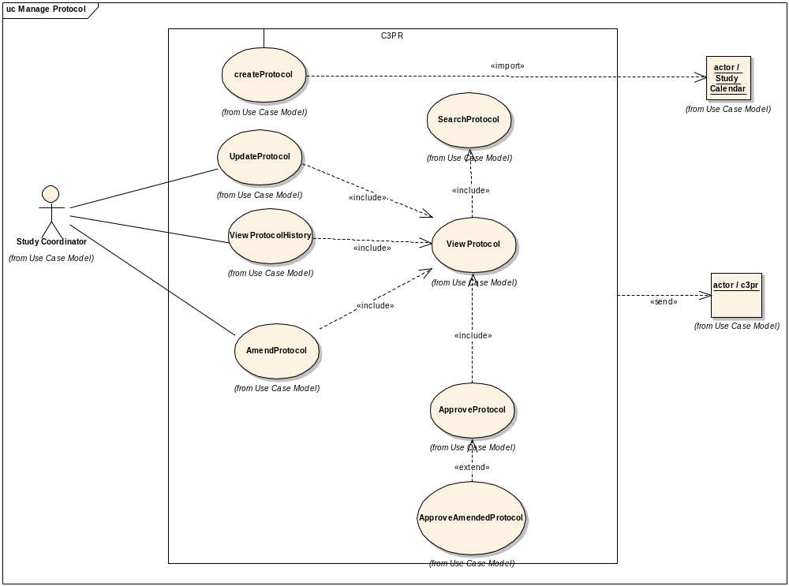

High Level Protocol Data Capture Use Case Diagram:
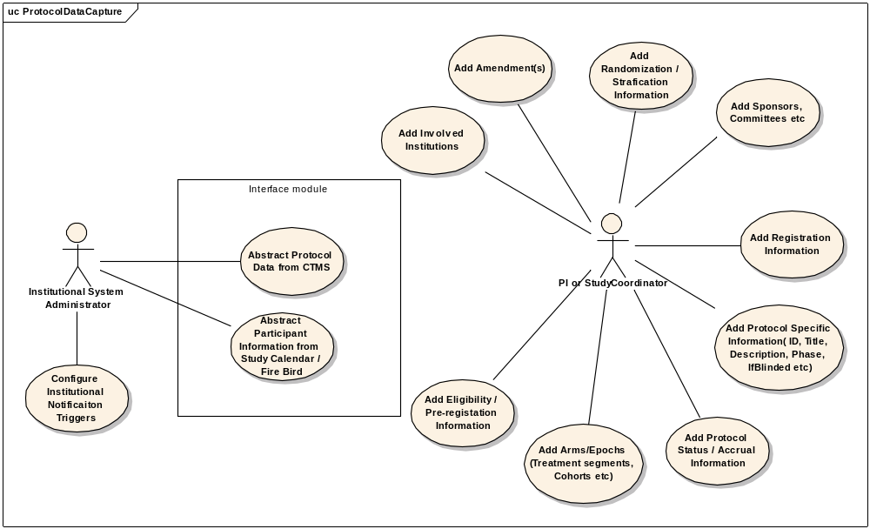

Create Study/Protocol Definition Manually.

Use Case Model
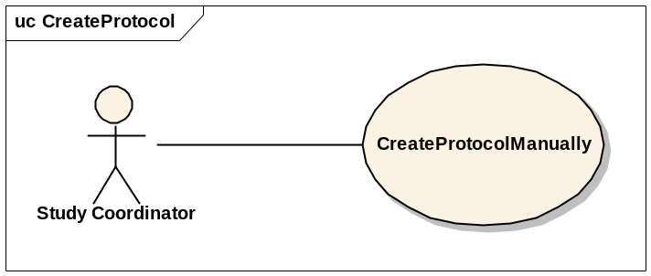

Brief Description
This use-case deals with the manual creation of a protocol by entering each data element of the protocol.

Primary Actor
Study Coordinator or any other designated user of C3PR with role authority to create a Protocol.

Secondary Actors
None

Preconditions
- The user is logged in to the system with a user account that has role authority to create a Protocol.
- The Protocol doesn’t already exist.

Basic Flow of Events
- The user indicates to the system that he/she wants to create a new protocol definition by clicking the Create Protocol link
- The system displays the screen that gives the user option of entering the protocol information manually. The user clicks on the enter protocol manually link.
- The user enters the protocol data elements in the fields.
- The user indicates to the system that the required protocol information has been entered for creation of a new protocol.

Postconditions
- If the user is logged in to the system with a user account that has role authority to create a Protocol (for example, a Protocol manager), the created protocol is approved.
- If the user was logged in to the system with a role authority to only enter the protocol information, the created protocol awaits for further validation check from a study coordinator/protocol manager before it becomes approved.

Data Items

Data Element | Validation/Notes
(1) Protocol ID | Required
(2) Protocol Amendment | Current
(3) Protocol Amendment Date | Required
(4) Protocol Phase | Required
(5) PI Name | Required (There is only 1 designated PI, the others are AIs)
(6) Branch | Required
(7) Protocol Long Title | Required
(8) Protocol Short Title | No/ but would be good
(9) Protocol Description | Required
(10) Precis | Not Required
(11) NCI NCIN Number | Not Required (may not be there)
(12) Registration Tracked | Yes/No (default: Yes)
(13) Multi-Institutional Protocol | Yes/No
(14) Involved Institutions
14.1 Name | Required
14.2 Coordinating | Yes/No
14.3 Site Investigator | Required (multiple allowed)
14.4. IRB Dates | Required (Start and End Dates )
14.5 IRB approved accrual ceiling | Not Required
(15) Protocol Accrual Ceiling | Required this ceiling should not be enforcing, or it will cause problems
(16) Protocol Accrual to Date | Default: 0
(17) Sponsor | Organization leading the research (for example, CTEP, NCI, Pfizer)
(18) Sponsor's Protocol ID | Required
(19) Protocol Monitor | For example, CDUS, CTMS, Quintiles
(20) Protocol Monitor's Protocol ID | Not Required
(21) Protocol Type | Not Required
(22) Protocol Design | Not Required
(23) Protocol History | At least 1 required
23.1 Status | Required
23.2 Date | Required
(24) Protocol Open Date | For future opening
(25) Protocol Close Date for Accrual | For future closing
(26) Protocol Close Date Final | For future closing
(27) Randomization
27.1 IsRandomized | Required (yes/no)
27.2 Method | Method( a.Book, b. Built-in, c.Call-out)
(28) Arms
28.1 Name | Required
28.2 Description | Required
28.3 Number | Not Required
28.4 Status | Not Required
28.5 Accrual Ceiling | Not Required
28.6 Epoch | Not Required
28.6.1 Name | Not Required
28.6.2 Date | Start/End
28.7 Treatment Segments | Not Required
28.7.1 Name | Not Required
28.7.2 Epoch Name | Not Required
28.7.3 Eligibility | Not Required
28.8 Eligibility | Not Required
28.9 Cohort | Required
28.9.1 Yes/No | ??
28.9.2 Name | ??
28.9.3 Expiration Time | ??
(29) Epoch | Not Required
29.1 Name | Not Required
(30) Blinded | Required (yes/no)
(31) Blinded Type | Required
(32) Eligibility | Not Required
(33) Local Identifiers | Multiple Allowed
33.1 Name | Required
33.2 Value | Required
(34) Pre-Registration
34.1 IfRequired | Yes/No
34.2 Eligiblity | Not Required

Special Requirements

< First Special Requirement >

Load Protocol Definition from a File

Use Case Model
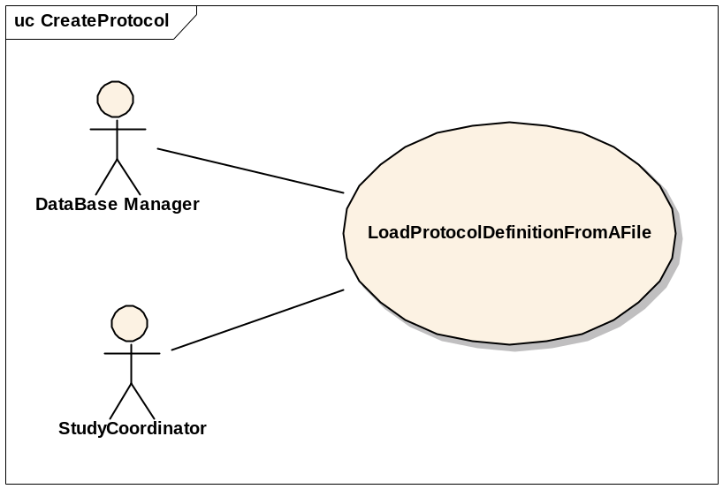

Brief Description
This use-case deals with loading a Protocol from a file that is on the user’s local system.

Primary Actor
Study Administrator or any other designated user of C3PR with role authority to create a Protocol.

Secondary Actors
None

Preconditions
- The user is logged in to the system with a user account that has role authority to create a Protocol.
- The Protocol doesn’t already exist.

Basic Flow of Events
- The user indicates to the system that he/she wants to create a new protocol definition from a file by clicking the Import Protocol link
- The system displays a screen that allows the user to browse their local file system.
- The user selects the appropriate file which contains the information about the protocol to be loaded into the system.
- After selecting the file, the user indicates to the system to create a new protocol definition based on the information in the file.
- The system reads the file and creates a new protocol definition entry.

Postconditions
- If the user is logged in to the system with a user account that has role authority to create a Protocol (for example, a Protocol manager), the created protocol is approved.
- If the user was logged in to the system with a role authority to only enter the protocol information, the created protocol awaits for further validation check from a study coordinator/protocol manager before it becomes approved.

Special Requirements

Get Protocol/Study Definition via Protocol Message from external Source.

Use Case Model
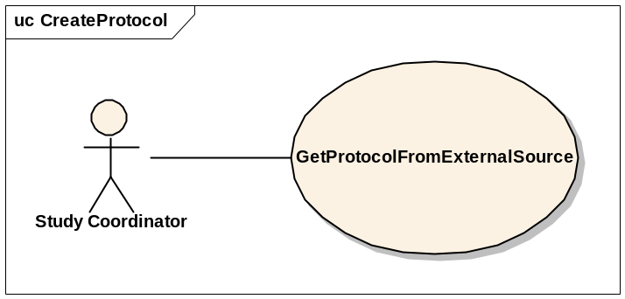

Brief Description
This use-case deals with creation of a Protocol at the local system after getting/importing it from an external source.

Primary Actor
Study Administrator, Study Coordinator or any other designated user of C3PR with role authority to create a Protocol.

Secondary Actors
None

Preconditions
- The user is logged in to the system with a user account that has role authority to create a Protocol.
- The Protocol doesn’t already exist.

Basic Flow of Events
- The user indicates to the system that he/she wants to create a new protocol definition by clicking the Create Protocol link
- The system displays a screen that allows the user to import a new protocol.
- The user clicks on the link and views the protocol.
- The user checks the protocol for correctness and updates the protocol entries to correspond to the local site requirements (IRB approval, accrual ceiling, etc).
- After updating the protocol, the user indicates to the system to create the protocol and the system creates the protocol definition entry.

Postconditions
The imported protocol awaits for further changes/validation with respect to the local site conditions (IRB approval, accrual ceiling, etc) before it is available for use at the local site.

Data Items

Special Requirements

Search Protocol.

Use Case Model
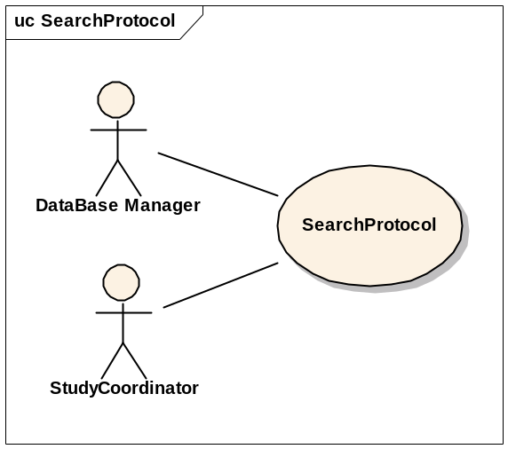

Brief Description
This use-case deals with searching for a protocol.

Primary Actor
Database Manager, Study Coordinator, Principal Investigator or any other user of C3PR with role authority search for a protocol definition.

Secondary Actors
None

Preconditions
The user is logged in to the system with a user account that has role authority to search for a protocol definition.

Basic Flow of Events
- The user indicates to the system that he/she wants to search for a given protocol definition by clicking the Search Protocol link.
- The user enters the search criteria for the protocol and submits the information to the system.
- The system displays 0, 1 or multiple protocol definitions depending on the search criteria.

Postconditions

Data Items

Special Requirements

View Protocol.

Use Case Model
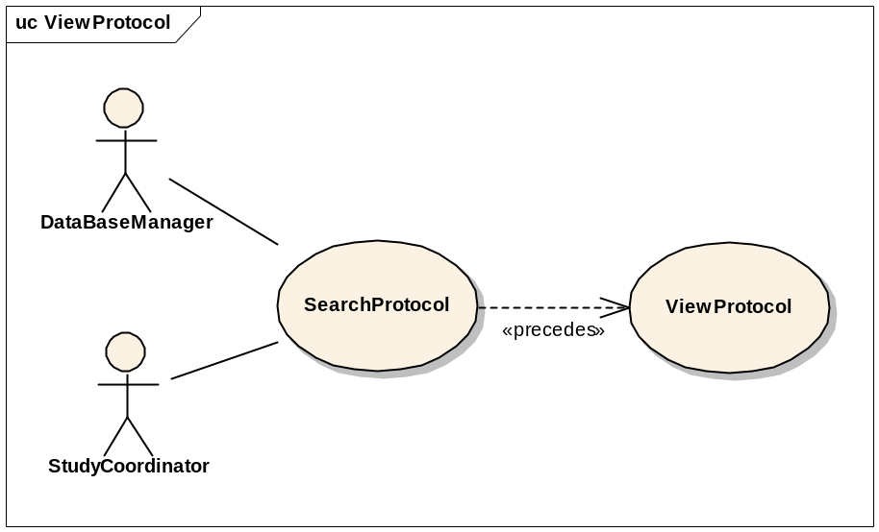

Brief Description
This use-case deals with viewing a protocol.

Primary Actor
Database Manager, Study Coordinator, Principal Investigator or any other user of C3PR with role authority to view a protocol.

Secondary Actors
None

Preconditions
The user is logged in to the system with a user account that has role authority to search for a protocol definition.

Basic Flow of Events
- The user indicates to the system that he/she wants to search for a given protocol definition by clicking the Search Protocol link.
- The user enters the search criteria for the protocol and submits the information to the system.
- The system displays 0, 1 or multiple protocol definitions depending on the search criteria.
- The user selects a protocol and clicks on the link to view that protocol.

Postconditions

Data Items

Special Requirements

Update Protocol.

Use Case Model
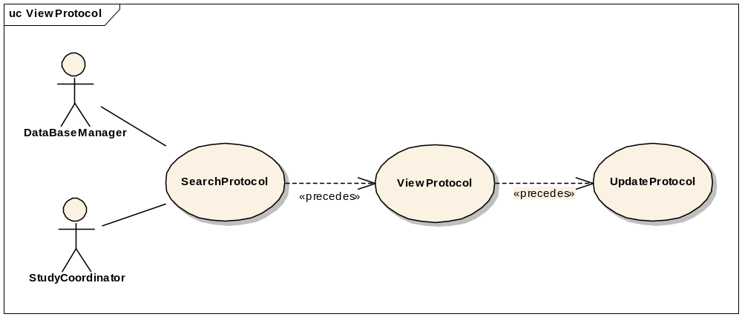

Brief Description
This use-case deals with updating a protocol entry.

Primary Actor
Database Manager, Study Coordinator or any other user of C3PR with role authority to update a protocol definition.

Secondary Actors
None

Preconditions
The user is logged in to the system with a user account that has role authority to update a protocol definition.

Basic Flow of Events
- The user indicates to the system that he/she wants to search for a given protocol definition by clicking the Search Protocol link.
- The user enters the search criteria for the protocol and submits the information to the system.
- The system displays 0, 1 or multiple protocol definitions depending on the search criteria.
- The user selects a protocol and clicks on the link to view that protocol.
- The user clicks on the Update Protocol link and updates the necessary fields.
- The user submits the updated protocol information to the system.

Postconditions
- If the user is logged in to the system with a user account that has role authority to update a protocol, the protocol stands updated
- If the user is logged in to the system with a user account that doesn’t have a role authority to update a protocol, the protocol awaits for further validation check from a protocol manager.

Data Items

Special Requirements

Approve Study/Protocol Definition.

Use Case Model
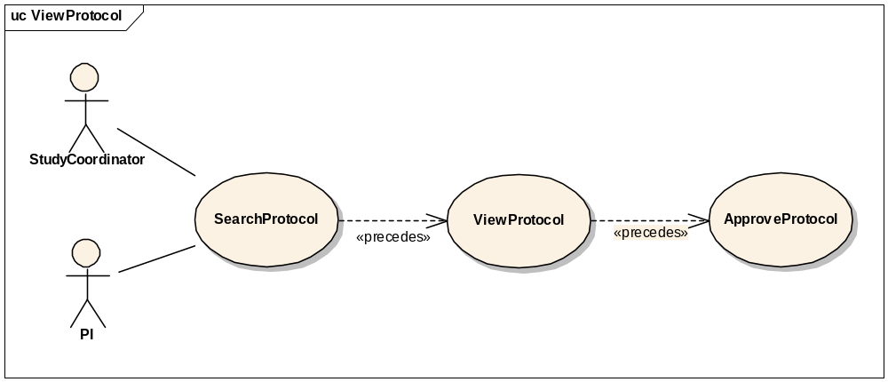

Brief Description
This use-case deals with approval or validation of a protocol definition entry.

Primary Actor
Study Coordinator, PI or any other designated user of C3PR with role authority to approve or create a Protocol.

Secondary Actors
None

Preconditions
- The user is logged in to the system with a user account that has role authority to create a Protocol.
- The Protocol definition has already been created but not validated.

Basic Flow of Events
- The user indicates to the system that he/she wants to search for a given protocol definition by clicking the Search Protocol link.
- The user enters the search criteria for the protocol and submits the information to the system.
- The system displays 0, 1 or multiple protocol definitions depending on the search criteria.
- The user indicates to the system that he/she wants to approve a newly created protocol definition by clicking the Approve Protocol link
- The user selects a protocol from a list of newly created protocols.
- The user views the newly created protocol.
- He/She checks for the correctness of the data elements of the protocol against the coordinating site/local site parameters.
- The user approves the newly created protocol.

Postconditions

The created protocol has been approved.

Data Items

Special Requirements

Amend Study/Protocol Definition.

Use Case Model
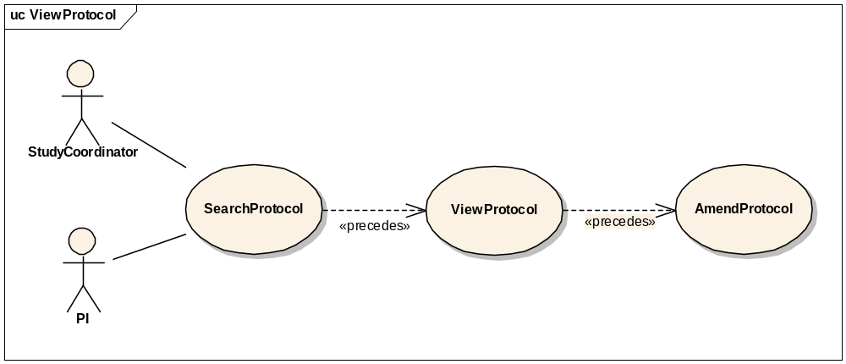

Brief Description
This use-case deals with amending a current protocol definition.

Primary Actor
Study Coordinator, Principal Investigator or any other designated user of C3PR with role authority to amend a protocol definition.

Secondary Actors
None

Preconditions
The user is logged in to the system with a user account that has role authority to amend a protocol definition.

Basic Flow of Events
- The user indicates to the system that he/she wants to search for a given protocol definition by clicking the Search Protocol link.
- The user enters the search criteria for the protocol and submits the information to the system.
- The system displays 0, 1 or multiple protocol definitions depending on the search criteria.
- The user selects the protocol definition for which he/she wants to amend.
- The user indicated to the system that he/she wants to make an amendment by clicking on the Amend Protocol link.
- The user makes the necessary changes to the protocol definition and submits the information to the system.

Postconditions
The protocol definition has been amended.

Data Items

Special Requirements

Abstract Protocol Data

Register Patient to a Protocol Arm

Synchronize Creation of Protocol Definition with Study Calendar

Use Case Model

Brief Description
This use case essentially deals with propagating the Protocol definition created in the C3PR system to Study Calendar system via CTMS Hub.

Primary Actor
Study Administrator or any other designated user of C3PR with role authority to create a Protocol.

Secondary Actors
- CTMS Hub
- Patient Study Calendar (PSC)
- Study Coordinator

Preconditions

Successful Creation of Protocol in C3PR system
The Protocol definition has been successfully created in the C3PR system (refer to use cases 3.1 and 3.2) by a user with a user account that has role authority to create a Protocol.

Basic Flow of Events
- The system generates a message in a predetermined format containing the new protocol information.
- The system then submits the new protocol message to the CTMS Hub.
- The CTMS Hub determines where the message needs to be delivered to, which is Study Calendar system in this case.
- The CTMS Hub transforms the new protocol message into a message format that the Study Calendar system can process.
- The Study Calendar system processes the protocol message and creates the Protocol Definition.
- After successfully processing the new protocol definition message, the Study Calendar system sends an acknowledgment to the CTMS Hub indicating the successful creation of a Protocol Definition in the Study Calendar system.
- The CTMS Hub sends an email notification indicating the creation of a new Protocol Definition to relevant actors including the Study Coordinator.

Postconditions

Creation of Protocol Definition in C3PR and PSC
A Protocol Definition created in the C3PR is replicated in the PSC.

Email Notifications
Email notifications are sent to relevant actors indicating the creation of a new protocol.

Data Items

Special Requirements

Synchronize Registration of a Patient on a Protocol Arm with Study Calendar

Use Case Model

Brief Description
This use case essentially deals with propagating the registration information of a patient on a Protocol Arm created in the C3PR system to Study Calendar system via CTMS Hub.

Primary Actor
Registrar or any other designated user of C3PR with role authority to register a patient on a Protocol Arm.

Secondary Actors
- CTMS Hub
- Patient Study Calendar (PSC)
- Participant Coordinator

Preconditions

Successful Creation of Protocol in the Study Calendar system
  - The Protocol definition has been successfully created in the Study Calendar system either manually thru the Study Calendar web interface or thru a message from the C3PR system (refer to use case 3.5).

Basic Flow of Events
- The system generates a message in a predetermined format containing the new registration information.
- The system then submits the new registration message to the CTMS Hub.
- The CTMS Hub determines where the message needs to be delivered to, which is Study Calendar system in this case.
- The CTMS Hub transforms the new registration message into a message format that the Study Calendar system can process.
- The Study Calendar system processes the new registration message by creating the Patient record, if the Patient does not already exist in the Study Calendar system, and then creates the calendar for the Arm to which the Patient is being registered to.
- After successfully processing the new patient registration message, the Study Calendar system sends an acknowledgment to the CTMS Hub indicating the successful creation of the calendar corresponding to the Arm that the patient is registered on in the Study Calendar system.
- The CTMS Hub sends an email notification indicating the creation of a new calendar for the Arm that the patient is registered on to relevant actors including the Participant Coordinator.

Postconditions

Creation of Patient record in PSC
A new Patient record is created in the Study Calendar system if the Patient does not already exist in it.

Creation of calendar for the Arm for the Patient
The calendar for the Arm that the Patient is registered on is created in the study calendar system.

Email Notification
Email notifications are sent to relevant actors indicating the creation of the Patient (optional) and calendar.

Data Items

Special Requirements

Manage Registration

Add Patient to Local Protocol Study
This use case allows the user to add a patient to a protocol originated at the local site.

Add Patient to External Protocol Study
This use case allows the user to add a patient to a protocol originated at an external site (coordinating site, CALGB, etc).

Add Protocol to Patient
This use case allows the user to add a protocol to a patient.

Associate Disease to Patient
This use case allows the user to associate a disease/disease site to a patient.

View Participant Registration History
This use case allows the user to view the registration history of a patient.

Register Participant
This use case allows the user to register a patient to a protocol.

Reserve Registration
This use case allows the user to reserve a patient on a protocol so that whenever accrual starts, the patient can be registered.

Close Registration
This use case allows the user to close a registration.

Store Patient Screening Data
This use case allows the user to store screening data of the patient. This use case is primarily required for reporting purposes.

Submit Pending Registration Information
This use case allows the user to submit a pending registration.

Replicate Registration to Companion Protocol
This use case allows the user to replicate the patient registration information to all the companion protocols.

Replicate Registration to Local Site
This use case allows the user to replicate the patient registration information to the local site.

Manage Randomization

Email Notify Registrar
This use case allows the user to notify the randomization registrar for randomization.

Randomize Using Protocol Block
This use case allows the user to fetch randomization from a protocol block stored in C3PR.

Randomize Using Call-out
This use case allows the user to fetch randomization arm via a call-out to an external randomization routine (e.g. the Randomization Hub).

Manage Eligibility Criteria

Approve Eligibility Criteria
This use case allows the user to approve eligibility criteria of a patient.

Exempt Eligibility Criteria
This use case allows the user to exempt the eligibility criteria for a patient (for example, “passionate treatment exemption”).

Import Eligibility Criteria
This use case allows the user to import eligibility criteria from external sources like CaDSR.

Access Clinical Data
This use case allows the user to access clinical data from external systems like C3D.

Manage Stratification
TBD

Manage Relationship

Create Relationship
This use case allows the user to associate a participant to other participant(s).
More use cases TBD.

Login
This use case allows the user to login into C3PR.

Reporting
TBD

From C3PR Release 1 (Not Yet Analyzed)

MaintainProtocolStrataRandomizedList

SynchronizeParticipantwithCDW

AssignProtocolPartToParticipant

GenerateReferralLetter

Integration
These use cases will allow user to integrate with external systems like caMATCH, CDW, Study Calendar etc.

Overall Requirements

Requirements Prioritization

Priority | Use Case Name | Supp Requirement Ref #
1 | Manage Protocol

Sign Off

Approval

Workspace General Contractor Rep Print Name Date
Architecture Workspace Rep Print Name Date
VCDE Workspace Rep Print Name Date
Workspace Working Group Rep Print Name Date
NCICB Rep Print Name Date

