Test Script Number: | create_new_administrator |  |  |  | Module: |  |  | Tester Name: |  | Steven Cheng | Pass/Fail:  pass
Use Case #: |  |  |  |  | Username: | c3pr_admin |  | Test Date: |  | 11/20/2007 | Pass/Fail:  pass
Estimated Execution Time: |  |  |  |  |  |  | Actual Execution Time: |  | 20 min
Test Objective: create a new administrator.

Test Setup:

Related Requirements
or Configuration Change Requests (Number/Description):

 | Test Action | Expected Results | Pass / Fail | Actual Results/Comments | gForge Tracker Bug ID
 | Click Administration tab, then click Create Research Staff link, fill the required information for new administrator, then click Save button. See figure 1. |  | Pass | Tested features:  1) Required field validation is active.  2) Save button works  3) Reset tab works  4) Email format checked – good feature
 | Confirmation message displayed. See figure 2 |  | Pass | New research staff successfully created.  Comments:  - remove Save button on the confirmation page. | 7539 - fixed
 | Log out and re-log in with the username created above |  | Pass | Successfully log in  Comments:  - pass word is case sensitive – good feature.  - User role should be displayed for each user in both search result and detail page. See figure 3. | 9619

Tester Signature: Steven Cheng
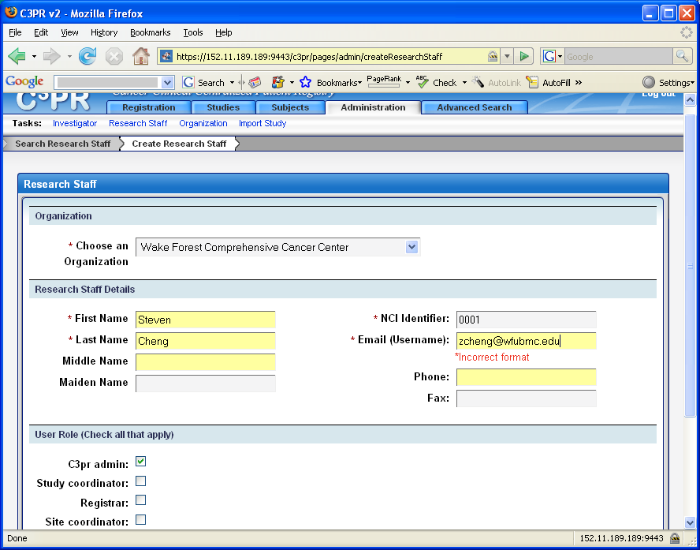
Figure 1
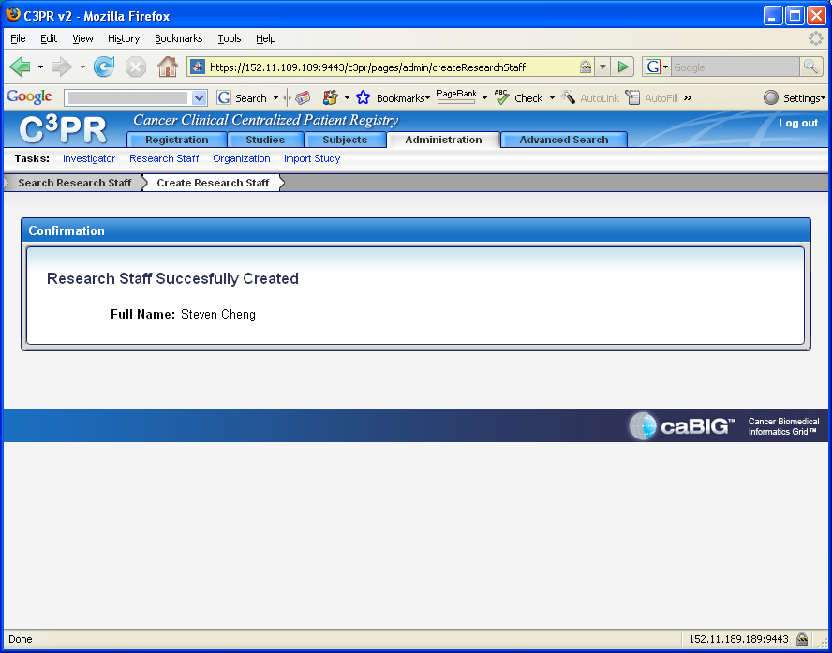
Figure 2
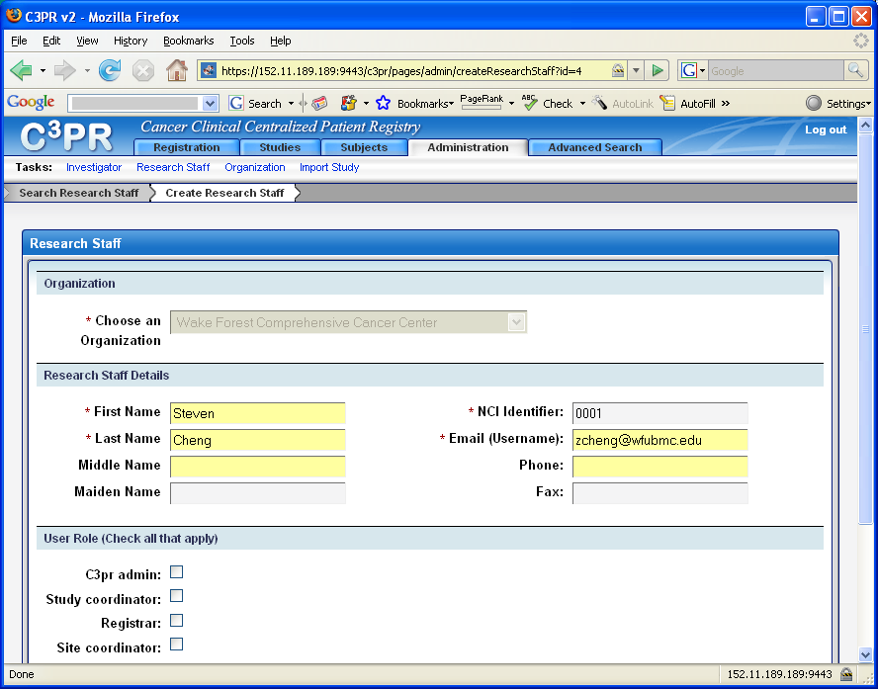
Figure 3

