Test Script Number: | create_new_investigator |  |  |  | Module: |  |  | Tester Name: |  | Steven Cheng | Pass/Fail:  pass
Use Case #: |  |  |  |  | Username: | c3pr_admin |  | Test Date: |  | 11/27/2007 | Pass/Fail:  pass
Estimated Execution Time: |  |  |  |  |  |  | Actual Execution Time: |  | 30 min
Test Objective: create a new investigator.

Test Setup: log in as an administrator.

Related Requirements
or Configuration Change Requests (Number/Description):

 | Test Action | Expected Results | Pass / Fail | Actual Results/Comments | gForge Tracker Bug ID
 | Click Administration tab, click Create Investigator, then fill the required information for new investigator, then click Save button. See figure 1. |  | Pass | Tested features:  1) Required field validation is active.  2) Add/Remove buttons work  3) Save button works  4) Reset tab works  5) Email format checked - good  Comments:  - Clicking +/X button should not fire an validation for First/Last Name required control. In this case, both buttons are inactive when First/Last Name are not filled.  - Clicking X button can NOT delete the only existing one. It is better to inactive X button when only one exists.  - Clicking X button should not fire a validation for Site/Status required control either.  - Investigator can be created without site and status assigned.  - Wrong label for Create Investigator page. | 6899 - fixed  6900 - fixed  6899 – fixed  8111  10605
 | Confirmation message displayed. See figure 2 |  | Pass | New investigator successfully created.  Comments:  - Remove ‘Save’ button in confirmation page.  - Remove ‘Enter Investigator Details’ label in confirmation page.  - Type error on the confirmation page: “successfully” | 7154 - fixed  7155 – fixed  9626

Tester Signature: Steven Cheng
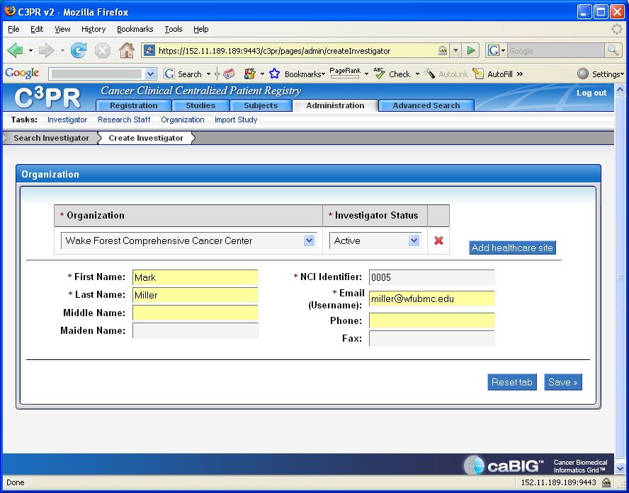
Figure 1
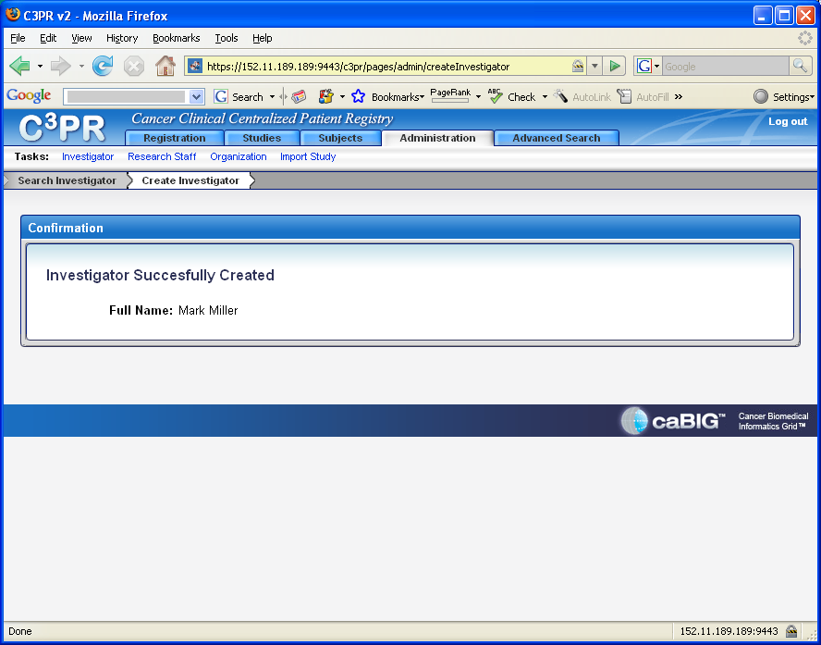
Figure 2

