Test Script Number: | create_new_registrar |  |  |  | Module: |  |  | Tester Name: |  | Steven Cheng | Pass/Fail:  pass
Use Case #: |  |  |  |  | Username: | c3pr_admin |  | Test Date: |  | 11/20/2007 | Pass/Fail:  pass
Estimated Execution Time: |  |  |  |  |  |  | Actual Execution Time: |  | 10 min
Test Objective: create a new registrar.

Test Setup:

Related Requirements
or Configuration Change Requests (Number/Description):

 | Test Action | Expected Results | Pass / Fail | Actual Results/Comments | gForge Tracker Bug ID
 | Click Administration tab, then click Create Research Staff link, fill the required information for a new registrar, then click Save button. See figure 1. |  | Pass | Tested features:  1) Required field validation is active.  2) Save button works  3) Reset tab works  4) Email format checked – good feature
 | Confirmation message displayed. See figure 2 |  | Pass | New research staff successfully created.
 | Log out and re-log in with the username created above |  | Pass | Successfully log in

Tester Signature: Steven Cheng
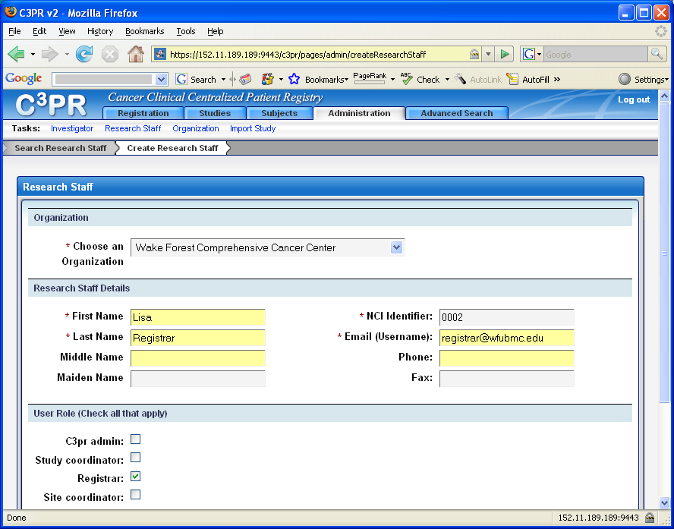
Figure 1
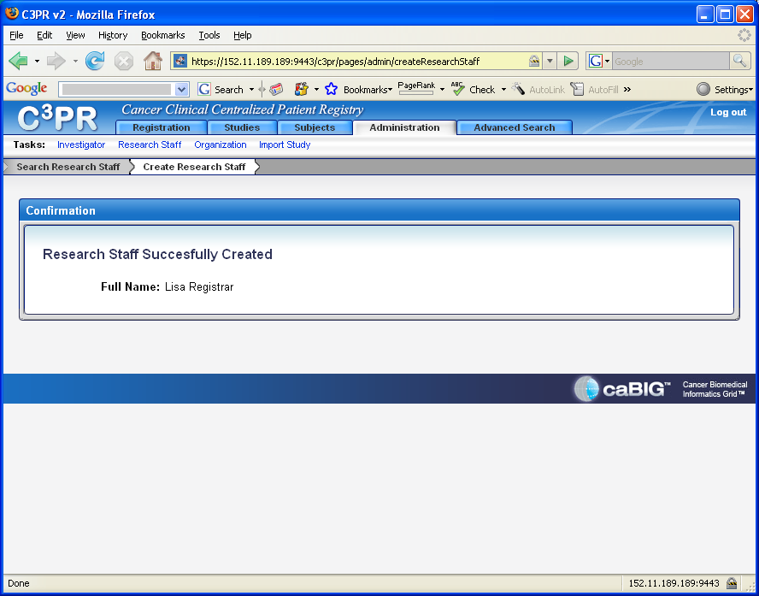
Figure 2

