caBIG® Subject Management Platform Specific Service Specification

Subject Management Service
Web Service

Version 0.0.9
11/30/2010

Authors | Denis G. Krylov, SemanticBits LLC
Editor | Kunal Modi
Reviewers | Kunal Modi, Kruttik Aggarwal
Architecture Inception Team | Kalpesh Patel, John Koisch, Paul Boyes

DOCUMENT CHANGE HISTORY

Version Number | Date | Contributor | Description
0.0.1 | 05/19/10 | Denis G Krylov | Initial draft
0.0.2 | 05/27/10 | Denis G Krylov | Removed actualIndicator
0.0.3 | 06/16/10 | Denis G Krylov | WSDL updates.
0.0.4 | 07/21/2010 | Denis G Krylov | Updated to conform to the updated PIM.
0.0.5 | 08/09/2010 | Denis G Krylov | Provided clarifications on SAML use; sample SOAP request.
0.0.6 | 09/15/2010 | Denis G Krylov | Added description of “Advanced Query Subject” operation.
0.0.7 | 09/27/2010 | Denis G Krylov | Clarified use of SAML and WS-* spec versions.
0.0.8 | 11/16/2010 | Denis G Krylov | Clarified security conditions for operations.
0.0.9 | 11/30/2010 | Denis G Krylov | Addressed ESST feedback.
Table of Contents
1 Executive Summary 5
1.1 Service Description and Purpose 5
1.2 Scope 5
1.3 Platform Details 5
1.4 Relationship to Standards 5
1.4.1 Domain Standards 5
1.4.2 Technology Standards 6
2 Conformance to Platform Independent Model 7
2.1 Conformance Profile 7
2.2 Functional Profiles 7
2.3 Semantics 7
2.3.1 Domain Object Semantics 7
2.3.2 Return Value Semantics 7
2.3.3 Error Handling Semantics 7
3 Platform Specific Model 9
3.1 Overview 9
3.2 Domain Model 9
3.3 Technology Stack 9
3.4 Assumptions and Dependencies 10
3.5 Service Interface 10
3.5.1 Interface Model 10
3.5.2 WSDL Messages and Port Types 10
3.5.3 Operations Details 11
3.6 Message Information Model 15
3.6.1 Information Model 16
3.6.2 Information Model Description 17
3.7 Implementation Considerations 18
3.7.1 Security 18
3.7.2 Auditing 18
3.7.3 Privacy 18
3.7.4 Error Handling 19
3.8 Deployment Considerations 19
3.8.1 Deployment Modes 19
3.8.2 Performance 19
3.8.3 Scalability 19
3.8.4 Discovery 20
3.8.5 Uptime 20
3.8.6 Failover 20
3.9 Constraints 20
3.10 Known Issues 20
4 Recommendations for Conformance and Compliance 20
4.1 Conformance Assertions 20
5 Appendix A – References 22
6 Appendix B – Relevant Standards 22
7 Appendix C – Glossary 22
8 Appendix D – Sample SOAP Envelope 22
9 Appendix E – WSDL 25

Executive Summary

Service Description and Purpose
The purpose of this service is to provide a set of interfaces to enable the creation, updating, deactivation and querying of a Subject. It is intended to provide authoritative information on a Subject to those applications and services that require it.

A Subject in the context of this service is a person who may be either a candidate of interest for a study or an actual registered participant on one or more studies.

The main consumer of this service will be the Subject Registration service, which requires that a Subject exists before the registration process can begin. Other services, such as the Adverse Event service or the Scheduled Calendar service, may also be consumers of Subject information.

This service is part of NCI’s Enterprise Services (NES) and adheres to all the service specifications and guidelines set by the NCI’s Enterprise Conformance and Compliance Framework (ECCF). This service also adheres to the underlying NCI’s version of C3PR-harmonized BRIDG v3.0.2 and uses the NCI’s restricted list of ISO 21090 data types.

Scope
The scope of this document is limited to the specification of the Subject Management service as a web service using the WSDL 1.1 and XML Schema 1.0 standards. The service will initially focus on the Subject Management Query and Subject Management Full Management functional profiles providing operations to create and update a subject, to update a subject’s state, and to query for subject’s information.

Platform Details
The implementation platform selected for the service is a Web Service described by means of WSDL and restricted to SOAP/HTTP protocols.

Relationship to Standards

Domain Standards
Standards | Description
NCI’s BRIDG v3.0.2 | The Subject Management Service will use NCI’s version of BRIDG Model harmonized with C3PR.
NCI’s ISO 21090 | The Subject Management Service will use the NCI’s implementation of ISO 21090

Technology Standards
Standards | Description
HTTP 1.1 | Hyper Text Transfer Protocol version 1.1 without Extension Framework (RFC2774) will be used as a transport mechanism.
TLS/SSL | Transport Layer Security and Secure Socket Layer are cryptographic protocols that will be used to secure information transmitted to and from the Web service.
SOAP 1.1 | Simple Object Access Protocol version 1.1 will be used to interact with the Web service endpoint.
XML Schema 1.0 | XML Schema version 1.0 will be used to define types used to interact with the Web service.
WSDL 1.1 | Web Services Description Language 1.1 will be used to describe the Web service.
WS-Policy/WS-SecurityPolicy 1.2 | Web Services Policy Framework 1.2 will be used to describe security-related policies of the Web service in the WSDL document.
WS-Trust 1.3 | Web Services Trust will be used to describe details of issuance of SAML security tokens.
SAML 1.0 | Security Assertion Markup Language 1.0 will be used to implement authentication of the Web service’s clients.
WS-I Basic Profile 1.1 | A set of non-proprietary Web services specifications, along with clarifications, refinements, interpretations and amplifications of those specifications. Will be used to promote Web service interoperability.

Conformance to Platform Independent Model

Conformance Profile
This service implements the SM Query BRIDG V3.0.2 and SM Full Management BRIDG V3.0.2 conformance profiles.

Functional Profiles
This service implements both SM Query and SM Full Management profiles described in the platform independent model (PIM).

Semantics
This service implements the SM BRIDG V3.0.2 semantic profile from the Platform Independent Model (PIM). The referenced “ISO” package contains NCI’s version of ISO 21090 data types. The element and type names in the XML directly correspond to the types in the Platform Independent Model (PIM). The complete WSDL can be located in the Appendix E – WSDL

Platform-specific representation of the classes contained in the PIM is detailed in the following sections.

Domain Object Semantics

via the following XSD fragment. The referenced “ISO” package contains ISO 21090 data types and is omitted for brevity. The element and type names in the XML directly correspond to the types in PIMSS.

via the following XSD fragment. The referenced “ISO” package contains ISO 21090 data types and is omitted for brevity. The element and type names in the XML directly correspond to the types in PIMSS.

via the following XSD fragment. The referenced “ISO” package contains ISO 21090 data types and is omitted for brevity. The element and type names in the XML directly correspond to the types in PIMSS.

This service directly implements the semantics of Organization via the following XSD fragment. The referenced “ISO” package contains ISO 21090 data types and is omitted for brevity. The element and type names in the XML directly correspond to the types in PIMSS.

This service directly implements the semantics of Organization Identifier via the following XSD fragment. The referenced “ISO” package contains ISO 21090 data types and is omitted for brevity. The element and type names in the XML directly correspond to the types in PIMSS.

Return Value Semantics
Any SOAP reply that does not contain a fault and contains HTTP 200 OK code is to be considered a successful acknowledgement of the service operation. Any service operation that does not return a SOAP reply is to be considered successfully executed if it returns HTTP 200 OK or 202 Accepted status code.

Error Handling Semantics
At the logical level described in PIM, the Subject Management Service throws a single exception with attributes for severity, type, and code. In this platform-specific model, each exception is typed independently as shown on the diagram below. Error code, severity, and type attributes thus are eliminated, and service clients are encouraged to rely on exception type hierarchy to derive this information.
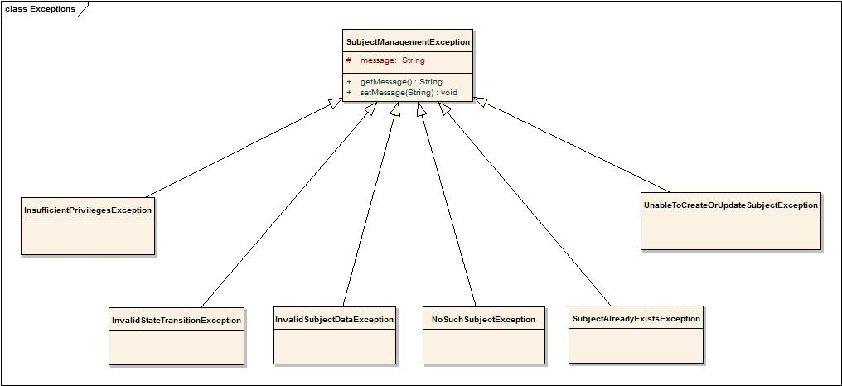

InvalidSubjectDataException
This exception is thrown when an XML message contains invalid or malformed data for a subject.

InvalidStateTransitionException
This exception is thrown when an invalid state transition is requested for a subject. The following diagram depicts allowable state transitions for a subject:
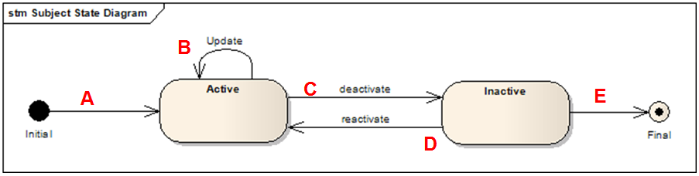

NoSuchSubjectException
This exception is thrown when an update or a state transition is attempted on an inexistent subject.

SubjectAlreadyExistsException
This exception is thrown when a subject being created already exists in the system.

UnableToCreateOrUpdateSubjectException
This exception is thrown when updating or creating a subject fails for a reason that is not covered by other exception types.

InsufficientPrivilegesException
This exception is thrown when a caller of the service does not have sufficient privileges to perform the requested operation.

Platform Specific Model

Overview
This section describes the service payload model and the service interface contract in detail. Links to the schemas for the service message payloads are included. The service interface is described using WSDL snippets and the complete WSDL is in the Appendix E – WSDL. This section also provides guidelines for implementing this service.

Domain Model

Standards | Description
NCI’s BRIDG v3.0.2 | The service specifications will be based on NCI’s version of BRIDG Model.
NCI’s Implementation of ISO 21090 Data types | The service specifications will be based on NCI’s restricted implementation of ISO 21090 data types.

Technology Stack
Please refer to the 1.4.2 Technology Standards section above for details on what technology stack is used to access the service.

Assumptions and Dependencies

Assumption | Affects
HTTP is the only transport protocol choice used to transmit SOAP messages to and from the service. | Clients of the service will not be able to use other protocols to consume the service.

Service Interface

Interface Model
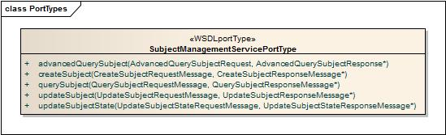
This service interface consists of four operations, and corresponds to both SM Query and SM Full Management profiles. The service interface details are provided in the following sections.

WSDL Messages and Port Types
The service shall conform to the messages and port types defined in the WSDL located at the following URL:
Description | URL
Subject Management WSDL | https://ncisvn.nci.nih.gov/svn/c3pr/tags/c3pr_v2.9.3_PRE1_M2/projects/web/web/WEB-INF/wsdl/SubjectManagement.wsdl
Subject Management XML Schema | https://ncisvn.nci.nih.gov/svn/c3pr/tags/c3pr_v2.9.3_PRE1_M2/projects/web/web/WEB-INF/wsdl/SubjectManagement.xsd
Business exception types thrown by interface operations. | https://ncisvn.nci.nih.gov/svn/c3pr/tags/c3pr_v2.9.3_PRE1_M2/projects/web/web/WEB-INF/wsdl/SubjectManagement.wsdl
ISO 21090 Healthcare Datatypes. | https://ncisvn.nci.nih.gov/svn/c3pr/tags/c3pr_v2.9.3_PRE1_M2/projects/web/web/WEB-INF/wsdl/ISO_datatypes_Narrative.xsd

Operations Details
The following sections describe service operations in detail.

Query Subject
Behavior Description | Query by example model of querying and will retrieve all the Subject objects that match the input search criteria.
Pre-Conditions | Users need to obtain and present a valid SAML assertion confirming their identity.
Security Conditions | The requestor must be a member of Subject Manager group.
Inputs | BRIDG : Subject (as defined in the XSD specified in section 3.5.2). Partially or fully populated instance of subject.
Outputs | <DSET> BRIDG : Subject (as defined in the XSD specified in section 3.5.2). A collection of subjects, which match the specified criteria and are registered to the site.
Post-Conditions | None
Exception Conditions | - InvalidSubjectDataException  - InsufficientPrivilegesException
Additional Implementation Details | If there are no subjects found, which match the specified criteria, an empty collection is returned.
Notes | By default, this method will return only the subjects which are in “ACTIVE” state. In order to retrieve “INACTIVE” subjects it must be explicitly specified in the input query criteria

Advanced Query Subject
Behavior Description | Query by advanced criteria model of querying and will retrieve all the Subject objects which match the input search criteria.
Pre-Conditions | Users need to obtain and present a valid SAML assertion confirming their identity.
Security Conditions | The requestor must be a member of Subject Manager group.
Inputs | DSET <SM : AdvanceSearchCriteriaParameter> (as defined in the XSD specified in section 3.5.2). One or more search criteria parameters.
Outputs | <DSET> BRIDG : Subject (as defined in the XSD specified in section 3.5.2). A collection of subjects, which match the specified criteria and are registered to the site.
Post-Conditions | None
Exception Conditions | - InvalidSubjectDataException  - InsufficientPrivilegesException
Additional Implementation Details | If there are no subjects found, which match the specified criteria, an empty collection is returned.
Notes | By default, this method will return only the subjects which are in “ACTIVE” state. In order to retrieve “INACTIVE” subjects it must be explicitly specified in the input query criteria

Create Subject
Behavior Description | Allows creation of a Subject object, which can then be registered into a clinical trial.
Pre-Conditions | Users need to obtain and present a valid SAML assertion confirming their identity.
Security Conditions | The requestor must be a member of Subject Manager group.
Inputs | BRIDG : Subject (as defined in the XSD specified in section 3.5.2)
Outputs | BRIDG : Subject (as defined in the XSD specified in section 3.5.2)
Post-Conditions | A new Subject object is created with state as “ACTIVE”
Exception Conditions | - InvalidSubjectDataException  - SubjectAlreadyExistsException  - UnableToCreateOrUpdateSubjectException  - InsufficientPrivilegesException
Additional Implementation Details | None
Notes

Update Subject
Behavior Description | Allows updating a Subject’s attribute values except the state
Pre-Conditions | The Subject must be already created and is in “ACTIVE” state. Users need to obtain and present a valid SAML assertion confirming their identity.
Security Conditions | The requestor must be a member of Subject Manager group.
Inputs | BRIDG : Subject (as defined in the XSD specified in section 3.5.2)
Outputs | BRIDG : Subject (as defined in the XSD specified in section 3.5.2) with the updated values.
Post-Conditions | None
Exception Conditions | - InvalidSubjectDataException  - NoSuchSubjectException  - UnableToCreateOrUpdateSubjectException  - InsufficientPrivilegesException
Additional Implementation Details | None
Notes | A notification should be sent to registration service.

Update Subject State
Behavior Description | Allows the updating of Subject’s State. A subject can be in either of the two states “ACTIVE” or “INACTIVE”. This operation allows toggling between them. Once it has become “INACTIVE”, a subject object cannot be assigned to a study and is not available for querying.
Pre-Conditions | The Subject must be already created and is in either “ACTIVE” or “INACTIVE” state. Users need to obtain and present a valid SAML assertion confirming their identity.
Security Conditions | The requestor must be a member of Subject Manager group.
Inputs | BiologicEntityIdentifier (as defined in the XSD specified in section 3.5.2)  ST : NewState (as defined in the XSD specified in section 3.5.2)
Outputs | BRIDG : Subject (as defined in the XSD specified in section 3.5.2)
Post-Conditions | The Subject object is either “ACTIVE” or “INACTIVE” based on the new state passed
Exception Conditions | - NoSuchSubjectException  - InvalidStateTransitionException  - InsufficientPrivilegesException
Additional Implementation Details | None
Notes | A notification should be sent to registration service.

Message Information Model
Communication protocol of the Referral Service is chosen to be SOAP 1.1, so all messages of the service will contain appropriate SOAP envelope and will conform to this protocol standard.

Information Model
The platform for this PSM is chosen to be Web Service, thus Platform Independent Model presented in the PIM specification document is transformed into Web Service Specific Model represented by an XML Schema in section 3.5.2. The model’s class diagram is shown below:

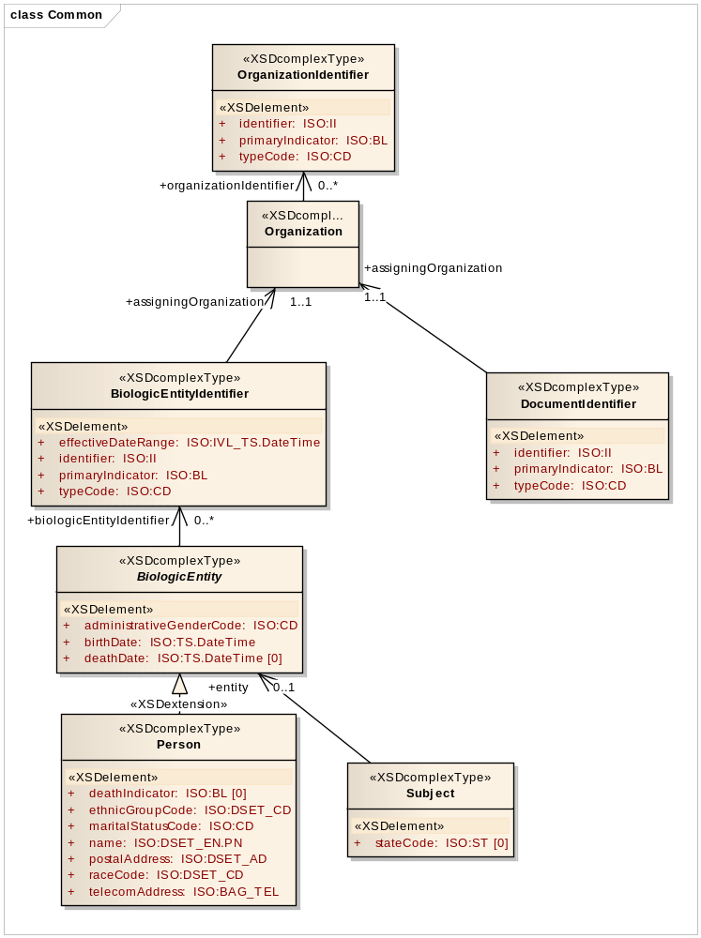

The Information Model that is shown above uses ISO 21090 data types, in accordance with the PIM specification. PSM class diagram for the given ISO data types is provided below.
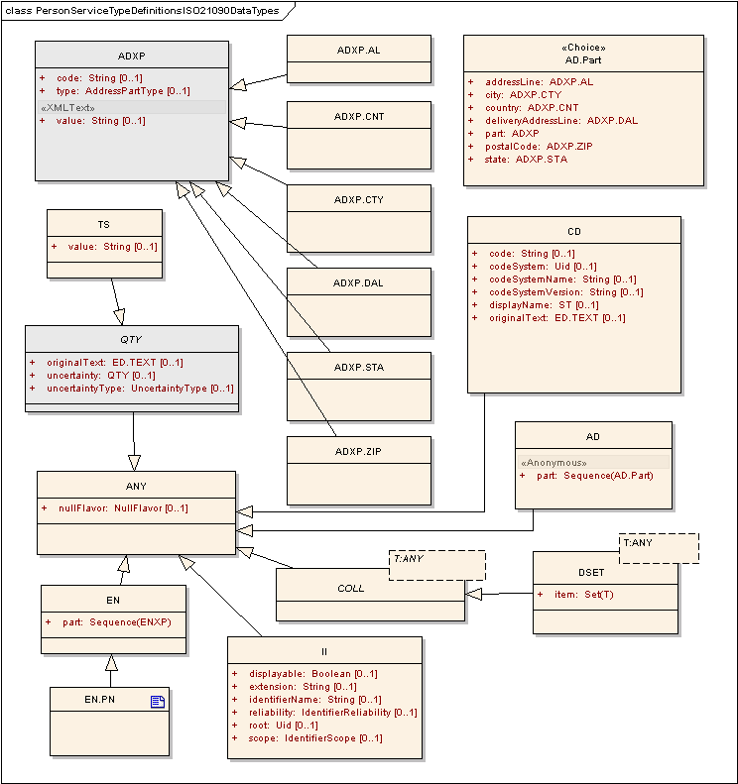

Information Model Description
Please refer to the XSD mentioned above in section 3.5.2 and comments contained within.

Implementation Considerations

Security

Encryption
The service will utilize transport-level security using HTTPS/SSL that will ensure confidentiality and integrity of the data being transmitted. Security policy specified in the WSDL file will require clients of the service to support secured connections.

Authentication
- Authentication Required: Yes
- Anonymous Access Allowed: No
- Type of Credential: SAML v1.0 Token obtained from an Identity Provider
  - For details on token format and token attributes please refer to the caBIG Subject Management Service Integration Guide document specified in Appendix A – References.

Authorization
- Authorization Required: Yes
- Authorization Type: Local policy enforcement
- Authorization Product: Local CSM Based
- Authorization Policy: Provisioning required

Auditing
The service implementation will record details of all invocations in the database. Records will include identity of the caller, timestamp, subject’s data, and other invocation parameters.

Privacy
.
Data Element | Privacy Regulation | Access Requirement | Public Information
Subject | HIPAA | User needs to be member of Subject Manager group to have access to the complete subject record. | No public access.

Error Handling
The WSDL document specified in 3.5.2 defines a number of different fault types that represent different error conditions and can be returned in a SOAP response.

Deployment Considerations

Deployment Modes
The service will be deployed as a JAX-WS 2.1 Java Web service using SOAP 1.1 binding over HTTPS in a WS-I Basic Profile v1.1-compliant container.

Performance
The table below lists, per operation, the maximum average performance conformant implementations must meet, under the load given in the next section. Times are expressed in seconds, and should be measured using clients on networks local to the deployed services. Roundtrip times are for full message delivery, but do not include network latency or client serialization/de-serialization overhead.

Operation | Maximum Average Roundtrip
createSubject | < 2.0s
updateSubject | < 2.0s
updateSubjectState | < 2.0s
querySubject | < 2.0s

Scalability
Conformant services will support the performance metrics described in the previous section under a sustained maximum load of 2 requests per second. The requests should be a random mix of the available operations.

Discovery
The service posts all specifications in a WSDL and is accessible via web service endpoints. The specification does not cover how interested parties discover available web service endpoints. It is conceivable that there will be global and local registries, such as UDDI, that list available service providers in the context of further metadata aiding the discovery of relevant services. Clients can invoke the web service via any SOAP-based service client applications.

Uptime
The expected uptime for this service is to be 99.9% during business hours.

Failover
Failover should be provided for endpoints in the case of failing server software (servlet container, database) or hardware. Recommended is a second server (hardware) that can either be switched in when the primary hardware fails or concurrently deployed in a load balancing setup.

Constraints
No known constraints at this time.

Known Issues
No known issues at this time.

Recommendations for Conformance and Compliance

Conformance Assertions
Name | Type | Viewpoint | Description | Test method
NCI’s version of BRIDG 3.0.2 conformant | Obligation | Informational | The semantics of the Subject representation are directly conformant to BRIDG 3.0.2. | 1. Design Review  2. Inspection of WSDL and XSD
ISO 21090 Data Type conformant | Obligation | Informational | The attributes of the Subject class use ISO 21090 data types as defined in the referenced PIM_21090 document, as represented by the ISO 21090 XSD. | 1. Design Review  2. Inspection of WSDL and XSD
Observable behavior | Prohibition | Computational | Service clients are prohibited from making any assumptions based on the internal implementation details of the Service. As a corollary, all observable behavior must be made explicit in the Service specification. | 1. Design Review  2. Change of implementation not affect clients
Functional Profile | Obligation | Computational | All functional profiles must be implemented. | 1. Design review  2. Inspection of WSDL and XSD
Operations required | Obligation | Computational | Designers/implementers are obligated to implement all of the operations of both identified functional profiles. | 1. Test cases include all identified operations
Information Model Conformance | Obligation | Information | The Information Model representation will conform to the Information model provided in Section 3.6.1. | 1. Design Review  2. Test cases to be defined to test specified information model conformance
Multiple Jurisdictions | Obligation | Enterprise | Implementers will provide an implementation that supports multiple jurisdictional domains to support different Coordinating Center and Sites as well as multi-site trials | 1. Test cases include multiple domain scenarios
Query Performance | Obligation | Enterprise | The performance of the “querySubject” operation should be within 0.2 second to return a single record from the underlying database | 1. Test cases to include performance testing.
Auditing | Obligation | Engineering | Designers/implementers are obligated to decide on and document the approach for logging or auditing of operation calls | 1. Design Review

Appendix A – References
Name | Description | Location
NCI’s BRIDG v3.0.2 | NCI’s BRIDG model used for modeling the SM Service | https://gforge.nci.nih.gov/frs/download.php/8131/BRIDG_Release_3.0.2_Package.zip
Use Case Document | Document containing use cases for the C3PR application | https://cabig-kc.nci.nih.gov/CTMS/KC/index.php/C3PR_Use_Cases
Subject Management Service PIM | Platform Independent Model and Service Specification for Subject Management Service | https://ncisvn.nci.nih.gov/svn/c3pr/trunk/c3prv2/documentation/design/essn/SubjectManagement/PIM_Subject_Management_Service.doc
PIM_21090.doc | ISO 21090 data types | https://gforge.nci.nih.gov/svnroot/coppa/trunk/documents/analysis_and_design/PIM_21090.doc
Subject Management Service Integration Guide | Subject Management Service Integration Guide | https://ncisvn.nci.nih.gov/svn/c3pr/trunk/c3prv2/documentation/design/essn/SubjectManagement/caBIG_Subject_Management_Service_Integration_Guide.doc

Appendix B – Relevant Standards
Please refer to the Section 1.4 of this document.

Appendix C – Glossary
Please refer to the caBIG shared glossary located at https://wiki.nci.nih.gov/display/Suite/10+-+Glossary+v2.2.

Appendix D – Sample SOAP Envelope
<soap:Envelope xmlns:soap="http://schemas.xmlsoap.org/soap/envelope/">
<soap:Header>
<wsse:Security
xmlns:wsse="http://docs.oasis-open.org/wss/2004/01/oasis-200401-wss-wssecurity-secext-1.0.xsd"
soap:mustUnderstand="1">
<Assertion xmlns="urn:oasis:names:tc:SAML:1.0:assertion"
xmlns:saml="urn:oasis:names:tc:SAML:1.0:assertion" xmlns:samlp="urn:oasis:names:tc:SAML:1.0:protocol"
xmlns:xsd="http://www.w3.org/2001/XMLSchema" xmlns:xsi="http://www.w3.org/2001/XMLSchema-instance"
AssertionID="_84a2dba9583195eb43fab0d3abf3f356" IssueInstant="2010-08-09T19:36:59.319Z"
Issuer="dkrylov" MajorVersion="1" MinorVersion="1">
<AuthenticationStatement
AuthenticationInstant="2010-08-09T19:36:59.319Z"
AuthenticationMethod="urn:oasis:names:tc:SAML:1.0:am:password">
<Subject>
<NameIdentifier NameQualifier="c3pr">jdoe01
</NameIdentifier>
<SubjectConfirmation>
<ConfirmationMethod>urn:oasis:names:tc:SAML:1.0:cm:holder-of-key
</ConfirmationMethod>
<ds:KeyInfo xmlns:ds="http://www.w3.org/2000/09/xmldsig#">
<ds:X509Data>
<ds:X509Certificate>
MIIDBjCCAsMCBExgWAQwCwYHKoZIzjgEAwUAMGgxDDAKBgNVBAYTA1VTQTELMAkGA1UECBMCVkEx
EDAOBgNVBAcTB0hlcm5kb24xETAPBgNVBAoTCHNlbWFudGljMQ8wDQYDVQQLEwZDb2RpbmcxFTAT
BgNVBAMTDERlbmlzIEtyeWxvdjAeFw0xMDA4MDkxOTMzMjRaFw0xMDExMDcxOTMzMjRaMGgxDDAK
BgNVBAYTA1VTQTELMAkGA1UECBMCVkExEDAOBgNVBAcTB0hlcm5kb24xETAPBgNVBAoTCHNlbWFu
dGljMQ8wDQYDVQQLEwZDb2RpbmcxFTATBgNVBAMTDERlbmlzIEtyeWxvdjCCAbgwggEsBgcqhkjO
OAQBMIIBHwKBgQD9f1OBHXUSKVLfSpwu7OTn9hG3UjzvRADDHj+AtlEmaUVdQCJR+1k9jVj6v8X1
ujD2y5tVbNeBO4AdNG/yZmC3a5lQpaSfn+gEexAiwk+7qdf+t8Yb+DtX58aophUPBPuD9tPFHsMC
NVQTWhaRMvZ1864rYdcq7/IiAxmd0UgBxwIVAJdgUI8VIwvMspK5gqLrhAvwWBz1AoGBAPfhoIXW
mz3ey7yrXDa4V7l5lK+7+jrqgvlXTAs9B4JnUVlXjrrUWU/mcQcQgYC0SRZxI+hMKBYTt88JMozI
puE8FnqLVHyNKOCjrh4rs6Z1kW6jfwv6ITVi8ftiegEkO8yk8b6oUZCJqIPf4VrlnwaSi2ZegHtV
JWQBTDv+z0kqA4GFAAKBgQDHeWl2X3DU7++f2MUfUKKSd6IAfkMd8/3r4tg5n12BhnqmnIiBX0rE
p47Nsn6bFK4kEEhXggb62Tm+XamuoTocvXRFwFKzJxVDi3O7Qgy1a8gutLSkPtwnoVos2gnoJULX
isk/G8q0fkLHnfrcmPKRh4MHvKQwSGxlMXGJzgW9tDALBgcqhkjOOAQDBQADMAAwLQIUF83BLhDU
gjRXybQuhiDEp9baBjMCFQCBuvPoXWRi3wgYshBzxI0ebaLMiQ==
</ds:X509Certificate>
</ds:X509Data>
</ds:KeyInfo>
</SubjectConfirmation>
</Subject>
</AuthenticationStatement>
<ds:Signature xmlns:ds="http://www.w3.org/2000/09/xmldsig#">
<ds:SignedInfo>
<ds:CanonicalizationMethod
Algorithm="http://www.w3.org/2001/10/xml-exc-c14n#" />
<ds:SignatureMethod Algorithm="http://www.w3.org/2000/09/xmldsig#dsa-sha1" />
<ds:Reference URI="#_84a2dba9583195eb43fab0d3abf3f356">
<ds:Transforms>
<ds:Transform
Algorithm="http://www.w3.org/2000/09/xmldsig#enveloped-signature" />
<ds:Transform Algorithm="http://www.w3.org/2001/10/xml-exc-c14n#">
<ec:InclusiveNamespaces
xmlns:ec="http://www.w3.org/2001/10/xml-exc-c14n#" PrefixList="code ds kind rw saml samlp typens #default xsd xsi" />
</ds:Transform>
</ds:Transforms>
<ds:DigestMethod Algorithm="http://www.w3.org/2000/09/xmldsig#sha1" />
<ds:DigestValue>nyKQmWEfKc+aQnOVfcMeJQOFfI8=</ds:DigestValue>
</ds:Reference>
</ds:SignedInfo>
<ds:SignatureValue>W5MR1Ia4NUFS1nibEgruQPrDQYRpQlAv7sU+R/a0kR79157nGb1L9Q==
</ds:SignatureValue>
<ds:KeyInfo>
<ds:X509Data>
<ds:X509Certificate>
MIIDBjCCAsMCBExgWAQwCwYHKoZIzjgEAwUAMGgxDDAKBgNVBAYTA1VTQTELMAkGA1UECBMCVkEx
EDAOBgNVBAcTB0hlcm5kb24xETAPBgNVBAoTCHNlbWFudGljMQ8wDQYDVQQLEwZDb2RpbmcxFTAT
BgNVBAMTDERlbmlzIEtyeWxvdjAeFw0xMDA4MDkxOTMzMjRaFw0xMDExMDcxOTMzMjRaMGgxDDAK
BgNVBAYTA1VTQTELMAkGA1UECBMCVkExEDAOBgNVBAcTB0hlcm5kb24xETAPBgNVBAoTCHNlbWFu
dGljMQ8wDQYDVQQLEwZDb2RpbmcxFTATBgNVBAMTDERlbmlzIEtyeWxvdjCCAbgwggEsBgcqhkjO
OAQBMIIBHwKBgQD9f1OBHXUSKVLfSpwu7OTn9hG3UjzvRADDHj+AtlEmaUVdQCJR+1k9jVj6v8X1
ujD2y5tVbNeBO4AdNG/yZmC3a5lQpaSfn+gEexAiwk+7qdf+t8Yb+DtX58aophUPBPuD9tPFHsMC
NVQTWhaRMvZ1864rYdcq7/IiAxmd0UgBxwIVAJdgUI8VIwvMspK5gqLrhAvwWBz1AoGBAPfhoIXW
mz3ey7yrXDa4V7l5lK+7+jrqgvlXTAs9B4JnUVlXjrrUWU/mcQcQgYC0SRZxI+hMKBYTt88JMozI
puE8FnqLVHyNKOCjrh4rs6Z1kW6jfwv6ITVi8ftiegEkO8yk8b6oUZCJqIPf4VrlnwaSi2ZegHtV
JWQBTDv+z0kqA4GFAAKBgQDHeWl2X3DU7++f2MUfUKKSd6IAfkMd8/3r4tg5n12BhnqmnIiBX0rE
p47Nsn6bFK4kEEhXggb62Tm+XamuoTocvXRFwFKzJxVDi3O7Qgy1a8gutLSkPtwnoVos2gnoJULX
isk/G8q0fkLHnfrcmPKRh4MHvKQwSGxlMXGJzgW9tDALBgcqhkjOOAQDBQADMAAwLQIUF83BLhDU
gjRXybQuhiDEp9baBjMCFQCBuvPoXWRi3wgYshBzxI0ebaLMiQ==
</ds:X509Certificate>
</ds:X509Data>
</ds:KeyInfo>
</ds:Signature>
</Assertion>
</wsse:Security>
</soap:Header>
<soap:Body>
<ns4:QuerySubjectRequest xmlns:ns2="http://enterpriseservices.nci.nih.gov"
xmlns:ns3="uri:iso.org:21090"
xmlns:ns4="http://enterpriseservices.nci.nih.gov/SubjectManagementService">
<subject>
<ns2:entity xmlns:xsi="http://www.w3.org/2001/XMLSchema-instance"
xsi:type="ns2:Person">
<ns2:administrativeGenderCode code="Male" />
</ns2:entity>
</subject>
</ns4:QuerySubjectRequest>
</soap:Body>
</soap:Envelope>

Appendix E – WSDL
<?xml version="1.0" encoding="UTF-8" standalone="no"?>
<wsdl:definitions xmlns:soap="http://schemas.xmlsoap.org/wsdl/soap/"
xmlns:jaxws="http://java.sun.com/xml/ns/jaxws"
xmlns:tns="http://enterpriseservices.nci.nih.gov/SubjectManagementService"
xmlns:xsi="http://www.w3.org/2001/XMLSchema-instance" xmlns:sm="http://enterpriseservices.nci.nih.gov"
xmlns:ISO="uri:iso.org:21090" xmlns:wsdl="http://schemas.xmlsoap.org/wsdl/"
xmlns:common="http://enterpriseservices.nci.nih.gov/Common"
xmlns:a="http://www.w3.org/2005/08/addressing"
xmlns:t="http://docs.oasis-open.org/ws-sx/ws-trust/200512" xmlns:xsd="http://www.w3.org/2001/XMLSchema"
name="SubjectManagementService"
xsi:schemaLocation="http://java.sun.com/xml/ns/jaxws http://java.sun.com/xml/ns/jaxws/wsdl_customizationschema_2_0.xsd uri:iso.org:21090 ISO_datatypes_Narrative.xsd http://enterpriseservices.nci.nih.gov SubjectManagement.xsd http://schemas.xmlsoap.org/ws/2005/07/securitypolicy http://schemas.xmlsoap.org/ws/2005/07/securitypolicy/ws-securitypolicy.xsd"
targetNamespace="http://enterpriseservices.nci.nih.gov/SubjectManagementService">
<jaxws:bindings>
<jaxws:package name="edu.duke.cabig.c3pr.webservice.subjectmanagement"></jaxws:package>
</jaxws:bindings>
<wsdl:types>
<xsd:schema xmlns:jaxb="http://java.sun.com/xml/ns/jaxb"
jaxb:version="2.1"
targetNamespace="http://enterpriseservices.nci.nih.gov/SubjectManagementService">
<xsd:annotation>
<xsd:appinfo>
<jaxb:schemaBindings>
<jaxb:package name="edu.duke.cabig.c3pr.webservice.subjectmanagement" />
</jaxb:schemaBindings>
</xsd:appinfo>
</xsd:annotation>
<xsd:import namespace="http://enterpriseservices.nci.nih.gov"
schemaLocation="SubjectManagement.xsd" />
<xsd:import namespace="uri:iso.org:21090" schemaLocation="ISO_datatypes_Narrative.xsd" />
<xsd:import namespace="http://enterpriseservices.nci.nih.gov/Common" schemaLocation="Common.xsd"/>
<xsd:element name="CreateSubjectRequest">
<xsd:complexType>
<xsd:sequence>
<xsd:element name="subject" type="common:Subject"
minOccurs="1" maxOccurs="1"></xsd:element>
</xsd:sequence>
</xsd:complexType>
</xsd:element>
<xsd:element name="CreateSubjectResponse">
<xsd:complexType>
<xsd:sequence>
<xsd:element name="subject" type="common:Subject"
minOccurs="1" maxOccurs="1"></xsd:element>
</xsd:sequence>
</xsd:complexType>
</xsd:element>
<xsd:element name="QuerySubjectRequest">
<xsd:complexType>
<xsd:sequence>
<xsd:element name="subject" type="common:Subject"
minOccurs="1" maxOccurs="1"></xsd:element>
</xsd:sequence>
</xsd:complexType>
</xsd:element>
<xsd:element name="QuerySubjectResponse">
<xsd:complexType>
<xsd:sequence>
<xsd:element name="subjects" type="sm:DSET_SUBJECT"
minOccurs="1" maxOccurs="1"></xsd:element>
</xsd:sequence>
</xsd:complexType>
</xsd:element>
<xsd:element name="AdvancedQuerySubjectRequest">
<xsd:complexType>
<xsd:sequence>
<xsd:element name="parameters"
type="common:DSET_AdvanceSearchCriterionParameter" />
</xsd:sequence>
</xsd:complexType>
</xsd:element>
<xsd:element name="AdvancedQuerySubjectResponse">
<xsd:complexType>
<xsd:sequence>
<xsd:element name="subjects" type="sm:DSET_SUBJECT"
minOccurs="1" maxOccurs="1"></xsd:element>
</xsd:sequence>
</xsd:complexType>
</xsd:element>
<xsd:element name="UpdateSubjectRequest">
<xsd:complexType>
<xsd:sequence>
<xsd:element name="subject" type="common:Subject"
minOccurs="1" maxOccurs="1"></xsd:element>
</xsd:sequence>
</xsd:complexType>
</xsd:element>
<xsd:element name="UpdateSubjectResponse">
<xsd:complexType>
<xsd:sequence>
<xsd:element name="subject" type="common:Subject"
minOccurs="1" maxOccurs="1"></xsd:element>
</xsd:sequence>
</xsd:complexType>
</xsd:element>
<xsd:element name="UpdateSubjectStateRequest">
<xsd:complexType>
<xsd:sequence>
<xsd:element name="biologicEntityIdentifier" type="common:BiologicEntityIdentifier"
maxOccurs="1" minOccurs="1"></xsd:element>
<xsd:element name="newState" type="ISO:ST" maxOccurs="1"
minOccurs="1"></xsd:element>
</xsd:sequence>
</xsd:complexType>
</xsd:element>
<xsd:element name="UpdateSubjectStateResponse">
<xsd:complexType>
<xsd:sequence>
<xsd:element name="subject" type="common:Subject"
minOccurs="1" maxOccurs="1"></xsd:element>
</xsd:sequence>
</xsd:complexType>
</xsd:element>

<xsd:element name="InvalidSubjectDataExceptionFault" type="tns:InvalidSubjectDataExceptionFault"></xsd:element>
<xsd:element name="InvalidStateTransitionExceptionFault" type="tns:InvalidStateTransitionExceptionFault"></xsd:element>
<xsd:element name="NoSuchSubjectExceptionFault" type="tns:NoSuchSubjectExceptionFault"></xsd:element>
<xsd:element name="SubjectAlreadyExistsExceptionFault" type="tns:SubjectAlreadyExistsExceptionFault"></xsd:element>
<xsd:element name="UnableToCreateOrUpdateSubjectExceptionFault" type="tns:UnableToCreateOrUpdateSubjectExceptionFault"></xsd:element>

<xsd:complexType name="InvalidSubjectDataExceptionFault">
<xsd:complexContent>
<xsd:extension base="common:BaseFault"></xsd:extension>
</xsd:complexContent>
</xsd:complexType>
<xsd:complexType name="InvalidStateTransitionExceptionFault">
<xsd:complexContent>
<xsd:extension base="common:BaseFault"></xsd:extension>
</xsd:complexContent>
</xsd:complexType>
<xsd:complexType name="NoSuchSubjectExceptionFault">
<xsd:complexContent>
<xsd:extension base="common:BaseFault"></xsd:extension>
</xsd:complexContent>
</xsd:complexType>
<xsd:complexType name="SubjectAlreadyExistsExceptionFault">
<xsd:complexContent>
<xsd:extension base="common:BaseFault"></xsd:extension>
</xsd:complexContent>
</xsd:complexType>
<xsd:complexType name="UnableToCreateOrUpdateSubjectExceptionFault">
<xsd:complexContent>
<xsd:extension base="common:BaseFault"></xsd:extension>
</xsd:complexContent>
</xsd:complexType>
</xsd:schema>
</wsdl:types>

<wsdl:message name="CreateSubjectRequestMessage">
<wsdl:part name="parameters" element="tns:CreateSubjectRequest" />
</wsdl:message>
<wsdl:message name="CreateSubjectResponseMessage">
<wsdl:part name="parameters" element="tns:CreateSubjectResponse" />
</wsdl:message>
<wsdl:message name="QuerySubjectRequestMessage">
<wsdl:part name="parameters" element="tns:QuerySubjectRequest" />
</wsdl:message>
<wsdl:message name="QuerySubjectResponseMessage">
<wsdl:part name="parameters" element="tns:QuerySubjectResponse" />
</wsdl:message>
<wsdl:message name="AdvancedQuerySubjectRequestMessage">
<wsdl:part name="parameters" element="tns:AdvancedQuerySubjectRequest" />
</wsdl:message>
<wsdl:message name="AdvancedQuerySubjectResponseMessage">
<wsdl:part name="parameters" element="tns:AdvancedQuerySubjectResponse" />
</wsdl:message>
<wsdl:message name="UpdateSubjectRequestMessage">
<wsdl:part name="parameters" element="tns:UpdateSubjectRequest" />
</wsdl:message>
<wsdl:message name="UpdateSubjectResponseMessage">
<wsdl:part name="parameters" element="tns:UpdateSubjectResponse" />
</wsdl:message>
<wsdl:message name="UpdateSubjectStateRequestMessage">
<wsdl:part name="parameters" element="tns:UpdateSubjectStateRequest" />
</wsdl:message>
<wsdl:message name="UpdateSubjectStateResponseMessage">
<wsdl:part name="parameters" element="tns:UpdateSubjectStateResponse" />
</wsdl:message>

<!-- Fault Messages -->
<wsdl:message name="InvalidSubjectDataExceptionFaultMessage">
<wsdl:part name="fault" element="tns:InvalidSubjectDataExceptionFault"></wsdl:part>
</wsdl:message>
<wsdl:message name="InvalidStateTransitionExceptionFaultMessage">
<wsdl:part name="fault" element="tns:InvalidStateTransitionExceptionFault"></wsdl:part>
</wsdl:message>
<wsdl:message name="NoSuchSubjectExceptionFaultMessage">
<wsdl:part name="fault" element="tns:NoSuchSubjectExceptionFault"></wsdl:part>
</wsdl:message>
<wsdl:message name="SubjectAlreadyExistsExceptionFaultMessage">
<wsdl:part name="fault" element="tns:SubjectAlreadyExistsExceptionFault"></wsdl:part>
</wsdl:message>
<wsdl:message name="UnableToCreateOrUpdateSubjectExceptionFaultMessage">
<wsdl:part name="fault"
element="tns:UnableToCreateOrUpdateSubjectExceptionFault"></wsdl:part>
</wsdl:message>
<wsdl:message name="SecurityExceptionFaultMessage">
<wsdl:part name="fault" element="common:SecurityExceptionFault"></wsdl:part>
</wsdl:message>

<wsdl:portType name="SubjectManagement">
<wsdl:operation name="createSubject">
<wsdl:input message="tns:CreateSubjectRequestMessage" />
<wsdl:output message="tns:CreateSubjectResponseMessage" />
<wsdl:fault message="tns:SecurityExceptionFaultMessage"
name="SecurityException" />
<wsdl:fault message="tns:InvalidSubjectDataExceptionFaultMessage"
name="InvalidSubjectDataException" />
<wsdl:fault message="tns:SubjectAlreadyExistsExceptionFaultMessage"
name="SubjectAlreadyExistsException" />
<wsdl:fault message="tns:UnableToCreateOrUpdateSubjectExceptionFaultMessage"
name="UnableToCreateOrUpdateSubjectException" />
</wsdl:operation>
<wsdl:operation name="querySubject">
<wsdl:input message="tns:QuerySubjectRequestMessage" />
<wsdl:output message="tns:QuerySubjectResponseMessage" />
<wsdl:fault message="tns:SecurityExceptionFaultMessage"
name="SecurityException" />
<wsdl:fault message="tns:InvalidSubjectDataExceptionFaultMessage"
name="InvalidSubjectDataException" />
</wsdl:operation>
<wsdl:operation name="advancedQuerySubject">
<wsdl:input message="tns:AdvancedQuerySubjectRequestMessage" />
<wsdl:output message="tns:AdvancedQuerySubjectResponseMessage" />
<wsdl:fault message="tns:SecurityExceptionFaultMessage"
name="SecurityException" />
<wsdl:fault message="tns:InvalidSubjectDataExceptionFaultMessage"
name="InvalidSubjectDataException" />
</wsdl:operation>
<wsdl:operation name="updateSubject">
<wsdl:input message="tns:UpdateSubjectRequestMessage" />
<wsdl:output message="tns:UpdateSubjectResponseMessage" />
<wsdl:fault message="tns:SecurityExceptionFaultMessage"
name="SecurityException" />
<wsdl:fault message="tns:NoSuchSubjectExceptionFaultMessage"
name="NoSuchSubjectException" />
<wsdl:fault message="tns:UnableToCreateOrUpdateSubjectExceptionFaultMessage"
name="UnableToCreateOrUpdateSubjectException" />
<wsdl:fault message="tns:InvalidSubjectDataExceptionFaultMessage"
name="InvalidSubjectDataException" />
</wsdl:operation>
<wsdl:operation name="updateSubjectState">
<wsdl:input message="tns:UpdateSubjectStateRequestMessage" />
<wsdl:output message="tns:UpdateSubjectStateResponseMessage" />
<wsdl:fault message="tns:SecurityExceptionFaultMessage"
name="SecurityException" />
<wsdl:fault message="tns:InvalidStateTransitionExceptionFaultMessage"
name="InvalidStateTransitionException" />
<wsdl:fault message="tns:NoSuchSubjectExceptionFaultMessage"
name="NoSuchSubjectException" />
</wsdl:operation>
</wsdl:portType>

<wsdl:binding name="SubjectManagementSOAP" type="tns:SubjectManagement">
<wsp:Policy xmlns:sp="http://docs.oasis-open.org/ws-sx/ws-securitypolicy/200702"
xmlns:wsp="http://schemas.xmlsoap.org/ws/2004/09/policy">
<wsp:ExactlyOne>
<wsp:All>
<sp:TransportBinding>
<wsp:Policy>
<sp:TransportToken>
<wsp:Policy>
<sp:HttpsToken RequireClientCertificate="false" />
</wsp:Policy>
</sp:TransportToken>
<sp:AlgorithmSuite>
<wsp:Policy>
<sp:Basic256Rsa15 />
</wsp:Policy>
</sp:AlgorithmSuite>
</wsp:Policy>
</sp:TransportBinding>

<sp:SupportingTokens>
<wsp:Policy>
<sp:IssuedToken sp:IncludeToken="http://docs.oasis-open.org/ws-sx/ws-securitypolicy/200702/IncludeToken/AlwaysToRecipient">
<sp:RequestSecurityTokenTemplate>
<t:TokenType>urn:oasis:names:tc:SAML:1.0:assertion</t:TokenType>
<t:KeyType>http://docs.oasis-open.org/ws-sx/ws-trust/200512/Bearer</t:KeyType>
</sp:RequestSecurityTokenTemplate>
</sp:IssuedToken>
</wsp:Policy>
</sp:SupportingTokens>

<sp:Trust13>
<wsp:Policy>
<wsp:ExactlyOne>
<wsp:All>
<sp:MustSupportIssuedTokens />
</wsp:All>
</wsp:ExactlyOne>
</wsp:Policy>
</sp:Trust13>
</wsp:All>
</wsp:ExactlyOne>
</wsp:Policy>
<soap:binding style="document"
transport="http://schemas.xmlsoap.org/soap/http" />
<wsdl:operation name="createSubject">
<soap:operation style="document" />
<wsdl:input>
<soap:body use="literal" />
</wsdl:input>
<wsdl:output>
<soap:body use="literal" />
</wsdl:output>
<wsdl:fault name="SecurityException">
<soap:fault name="SecurityException" />
</wsdl:fault>
<wsdl:fault name="InvalidSubjectDataException">
<soap:fault name="InvalidSubjectDataException" />
</wsdl:fault>
<wsdl:fault name="SubjectAlreadyExistsException">
<soap:fault name="SubjectAlreadyExistsException" />
</wsdl:fault>
<wsdl:fault name="UnableToCreateOrUpdateSubjectException">
<soap:fault name="UnableToCreateOrUpdateSubjectException" />
</wsdl:fault>
</wsdl:operation>
<wsdl:operation name="querySubject">
<soap:operation style="document" />
<wsdl:input>
<soap:body use="literal" />
</wsdl:input>
<wsdl:output>
<soap:body use="literal" />
</wsdl:output>
<wsdl:fault name="SecurityException">
<soap:fault name="SecurityException" />
</wsdl:fault>
<wsdl:fault name="InvalidSubjectDataException">
<soap:fault name="InvalidSubjectDataException" />
</wsdl:fault>
</wsdl:operation>
<wsdl:operation name="advancedQuerySubject">
<soap:operation style="document" />
<wsdl:input>
<soap:body use="literal" />
</wsdl:input>
<wsdl:output>
<soap:body use="literal" />
</wsdl:output>
<wsdl:fault name="SecurityException">
<soap:fault name="SecurityException" />
</wsdl:fault>
<wsdl:fault name="InvalidSubjectDataException">
<soap:fault name="InvalidSubjectDataException" />
</wsdl:fault>
</wsdl:operation>
<wsdl:operation name="updateSubject">
<soap:operation style="document" />
<wsdl:input>
<soap:body use="literal" />
</wsdl:input>
<wsdl:output>
<soap:body use="literal" />
</wsdl:output>
<wsdl:fault name="SecurityException">
<soap:fault name="SecurityException" />
</wsdl:fault>
<wsdl:fault name="InvalidSubjectDataException">
<soap:fault name="InvalidSubjectDataException" />
</wsdl:fault>
<wsdl:fault name="NoSuchSubjectException">
<soap:fault name="NoSuchSubjectException" />
</wsdl:fault>
<wsdl:fault name="UnableToCreateOrUpdateSubjectException">
<soap:fault name="UnableToCreateOrUpdateSubjectException" />
</wsdl:fault>
</wsdl:operation>
<wsdl:operation name="updateSubjectState">
<soap:operation style="document" />
<wsdl:input>
<soap:body use="literal" />
</wsdl:input>
<wsdl:output>
<soap:body use="literal" />
</wsdl:output>
<wsdl:fault name="SecurityException">
<soap:fault name="SecurityException" />
</wsdl:fault>
<wsdl:fault name="InvalidStateTransitionException">
<soap:fault name="InvalidStateTransitionException" />
</wsdl:fault>
<wsdl:fault name="NoSuchSubjectException">
<soap:fault name="NoSuchSubjectException" />
</wsdl:fault>
</wsdl:operation>
</wsdl:binding>
<wsdl:service name="SubjectManagementService">
<wsdl:port name="SubjectManagement" binding="tns:SubjectManagementSOAP">
<soap:address location="REPLACE_WITH_ACTUAL_URL" />
</wsdl:port>
</wsdl:service>
</wsdl:definitions>

