Cancer Central Clinical Participant Registry v2.5

Installation Guide

Updated September 16, 2008
caBIG™ is an initiative of the National Cancer Institute, NIH, DHHS

Copyright and License page

Copyright Notice. Copyright 2006 Duke Comprehensive Cancer Center (“caBIG™ Participant”). C3PR was created with NCI funding and is part of the caBIG™ initiative. The software subject to this notice and license includes both human readable source code form and machine readable, binary, object code form (the “caBIG™ Software”).
This caBIG™ Software License (the “License”) is between caBIG™ Participant and You. “You (or “Your”) shall mean a person or an entity, and all other entities that control, are controlled by, or are under common control with the entity. “Control” for purposes of this definition means (i) the direct or indirect power to cause the direction or management of such entity, whether by contract or otherwise, or (ii) ownership of fifty percent (50%) or more of the outstanding shares, or (iii) beneficial ownership of such entity.
License. Provided that You agree to the conditions described below, caBIG™ Participant grants You a non-exclusive, worldwide, perpetual, fully-paid-up, no-charge, irrevocable, transferable and royalty-free right and license in its rights in the caBIG™ Software, including any copyright or patent rights therein that may be infringed by the making, using, selling, offering for sale, or importing of caBIG™ Software, to (i) use, install, access, operate, execute, reproduce, copy, modify, translate, market, publicly display, publicly perform, and prepare derivative works of the caBIG™ Software; (ii) make, have made, use, practice, sell, and offer for sale, and/or otherwise dispose of caBIG™ Software (or portions thereof); (iii) distribute and have distributed to and by third parties the caBIG™ Software and any modifications and derivative works thereof; and (iv) sublicense the foregoing rights set out in (i), (ii) and (iii) to third parties, including the right to license such rights to further third parties. For sake of clarity, and not by way of limitation, caBIG™ Participant shall have no right of accounting or right of payment from You or Your sublicensees for the rights granted under this License. This License is granted at no charge to You. Your downloading, copying, modifying, displaying, distributing or use of caBIG™ Software constitutes acceptance of all of the terms and conditions of this Agreement. If you do not agree to such terms and conditions, you have no right to download, copy, modify, display, distribute or use the caBIG™ Software.
- Your redistributions of the source code for the caBIG™ Software must retain the above copyright notice, this list of conditions and the disclaimer and limitation of liability of Article 6 below. Your redistributions in object code form must reproduce the above copyright notice, this list of conditions and the disclaimer of Article 6 in the documentation and/or other materials provided with the distribution, if any.
- Your end-user documentation included with the redistribution, if any, must include the following acknowledgment: “This product includes software developed by Duke Comprehensive Cancer Center.” If You do not include such end-user documentation, You shall include this acknowledgment in the caBIG™ Software itself, wherever such third-party acknowledgments normally appear.
- You may not use the names “Duke Comprehensive Cancer Center”, “The National Cancer Institute”, “NCI”, “Cancer Bioinformatics Grid” or “caBIG™” to endorse or promote products derived from this caBIG™ Software. This License does not authorize You to use any trademarks, service marks, trade names, logos or product names of either caBIG™ Participant, NCI or caBIG™, except as required to comply with the terms of this License.
- For sake of clarity, and not by way of limitation, You may incorporate this caBIG™ Software into Your proprietary programs and into any third party proprietary programs. However, if You incorporate the caBIG™ Software into third party proprietary programs, You agree that You are solely responsible for obtaining any permission from such third parties required to incorporate the caBIG™ Software into such third party proprietary programs and for informing Your sublicensees, including without limitation Your end-users, of their obligation to secure any required permissions from such third parties before incorporating the caBIG™ Software into such third party proprietary software programs. In the event that You fail to obtain such permissions, You agree to indemnify caBIG™ Participant for any claims against caBIG™ Participant by such third parties, except to the extent prohibited by law, resulting from Your failure to obtain such permissions.
- For sake of clarity, and not by way of limitation, You may add Your own copyright statement to Your modifications and to the derivative works, and You may provide additional or different license terms and conditions in Your sublicenses of modifications of the caBIG™ Software, or any derivative works of the caBIG™ Software as a whole, provided Your use, reproduction, and distribution of the Work otherwise complies with the conditions stated in this License.
- THIS caBIG™ SOFTWARE IS PROVIDED "AS IS" AND ANY EXPRESSED OR IMPLIED WARRANTIES (INCLUDING, BUT NOT LIMITED TO, THE IMPLIED WARRANTIES OF MERCHANTABILITY, NON-INFRINGEMENT AND FITNESS FOR A PARTICULAR PURPOSE) ARE DISCLAIMED. IN NO EVENT SHALL THE DUKE COMPREHENSIVE CANCER CENTER OR ITS AFFILIATES BE LIABLE FOR ANY DIRECT, INDIRECT, INCIDENTAL, SPECIAL, EXEMPLARY, OR CONSEQUENTIAL DAMAGES (INCLUDING, BUT NOT LIMITED TO, PROCUREMENT OF SUBSTITUTE GOODS OR SERVICES; LOSS OF USE, DATA, OR PROFITS; OR BUSINESS INTERRUPTION) HOWEVER CAUSED AND ON ANY THEORY OF LIABILITY, WHETHER IN CONTRACT, STRICT LIABILITY, OR TORT (INCLUDING NEGLIGENCE OR OTHERWISE) ARISING IN ANY WAY OUT OF THE USE OF THIS caBIG™ SOFTWARE, EVEN IF ADVISED OF THE POSSIBILITY OF SUCH DAMAGE.

Table of Contents

1. Introduction……... …1
Background 1
Audience 1
Resources………...…………………………………………………………………………………2
Related Documents……...………………………………………………………………………….3
2. C3PR Software and Technology Requirements 4
Hardware Requirements 4
Software Requirements 5

3. Installing C3PR 7
4. Common Problems with Installer (FAQ) 24
5. Securing Tomcat 25
6. Contacting Technical Support 26
Appendix A – Configuring Multiple Tomcat Servers 27

Introduction
This installation guide outlines the supported configurations and installing, setting up and configuring the application and databases for the Cancer Central Clinical Participant Registry version 2.5 (C3PRv2.5).

Background | The Cancer Central Participant Registry (C3PR) is a web-based application used for end-to-end registration of patients to clinical trials. This includes capturing the consent signed date, eligibility criteria, stratification, randomization, and screening. Clinical workflows are enabled by both subject- and study-centric views into the registration process. C3PR can be run in a standalone mode where study definitions, investigators, study personnel, and sites are entered into the system, or C3PR can be run in an integrated mode with the caBIG Clinical Trials Suite (CCTS). C3PR also enables multi-site clinical trials where registration information is entered locally at affiliate sites and the registration is completed by call-out to the coordinating site.  Throughout the development of C3PR, a number of elaborator and adopter sites are actively being engaged to help define requirements and test the application. Our primary elaborators include Duke, Wake Forest, Mayo, Westat, CALGB, CCR, and the Coalition of Cooperative Groups. Our primary adopters include Duke and Wake Forest with engagement of Georgetown and CCR.  C3PR release 1 was developed by Nortel Solutions and released in 2006. Release 2 and was developed by Duke Cancer Center in collaboration with SemanticBits, LLC and was released in March, 2008. We are currently in the next phase of development with releases slated for the end of September, 2008 and March, 2009.

Audience | This document is designed to meet the needs of administrators who will be performing deploying C3PR. To perform the tasks outlined in this document, you should be familiar/knowledgeable with running command-line utilities, running web applications in application containers, and configuring databases. Ideally, the person performing these functions should be someone who is an experienced system administrator.

CCTS | C3PRv2.5 is a component of the caBIG Clinical Trials Suite (CCTS). Installation instructions and other documentation can be found at:  https://wiki.nci.nih.gov/display/CTMS/CCTS+Installation+Guide
Security | Configuring security is not part of the installation guide. See the C3PRv2.5 administration guide for instructions on this:  http://gforge.nci.nih.gov/plugins/scmcvs/cvsweb.php/c3prv2/documentation/design/c3prv2_administration_guide.doc?cvsroot=c3prv2

Support for C3PRv1 | Although C3PRv2 is based on the underlying functionality of C3PRv2, much of C3PRv2 has been redesigned with more accepted open source technologies to meet the current standards for interoperability and web application development in alignment with caBIG initiative. Hence we are not supporting C3PRv1 as a part of C3PRv2 development. However, critical functionality and use cases would be reused/refactored into C3PRv2, wherever possible.

Resources:

Development Team(s)
Development | Installation Documentation | Program Management
Patrick McConnell | Manav Kher | Bob Annechiarico¹
Ram Chilukuri | Ram Chilukuri | Jamie Cuticchia¹
Kruttik Aggarwal | Patrick McConnell | Patrick McConnell¹
Ramakrishna Gundala |  | Ram Chilukuri²
Priyatam Mudivarti
Manav Kher

Contacts and Support
Enter training contact | Patrick McConnell  (patrick.mcconnell@duke.edu)
Enter customer support contact | NA

LISTSERV Facilities Pertinent to software teams
LISTSERV | URL | Name
c3prv2-elaborator | c3prv2-elaborators@gforge.nci.nih.gov | C3PR Elaborators Forum
C3prv2-general | c3prv2-general@gforge.nci.nih.gov | C3PR General Forum

Related Documents:

Management | End User | Analysis | Technical
Project Plan | End User Guide | C3PR Use Cases | Architecture Guide
Scrum Artifacts | Training Module | Requirements Specification | Domain Analysis Model
Adoption Plan | Installation Guide | Activity Diagrams | Domain Implementation Model
Communications Plan | Initial Configuration Guide |  | Deployment Diagrams
Test Plan |  |  | User Acceptance Tests
C3PR Arc Requests

C3PR Software and Technology Requirements

Hardware Requirements
There aren’t any stringent hardware requirements because C3PR is a lightweight web application not intended to have a very large code base. See Table 1 for guidance on hardware requirements.
Processor | Pentium PIII, above 1.5 GHz
RAM | Minimum 512MB. (testing)  2 GB recommended
Operating System | Windows 2000,XP, Linux Mac OS X 10.4.x
Hard Disk Space | Minimum 500MB free space
Table 1 Guidance on hardware requirements

Software Requirements
Required Software | You must download and install the required software that is not included with the C3PRv2.5 (listed in Table 2 ) The software name, version, description, and URL hyperlinks (for download) are indicated in the table

Software Name | Version | Description | URL
Java Software Development Kit (SDK) | JDK 5.0 Update 11 or higher | The J2SE Software Development Kit (SDK) supports creating J2SE applications | http://java.sun.com/javase/downloads/index_jdk5.jsp
Oracle 9i/10g Database ** | 9i/10g only | Oracle is a commercially-available relational database management system (RDBMS) that can be used on all major operating systems | http://www.oracle.com/technology/software/products/database/oracle10g/index.html
PostGreSQL** | 8.2 only | PostgreSQL is a powerful, open source relational database system. It runs on all major operating systems | http://www.postgresql.org/ftp/source/
Globus Toolkit | 4.0.3 only | Globus toolkit is an open source WSRF-compliant web services java container. Only the Java ws-core source version is needed | http://www.globus.org/toolkit/downloads/4.0.3/#wscore_bin
Tomcat Web Server* | 5.0.28 or later | Open source servlet container | http://archive.apache.org/dist/tomcat/tomcat-5/v5.0.28/bin/jakarta-tomcat-5.0.28.zip
Ant* | 1.6.5 or later | Ant is used for Building the C3PR application | http://archive.apache.org/dist/ant/binaries/
Table 2 Required software and technology for C3PRV2 .5
**Either Oracle OR PostGreSQL (not both) is required as an RDBMS for C3PR application. Note that C3PRv2 doesn’t support SQL Server (which had been supported by C3PRv1)
* Included with the Graphical installer

Note - Drivers for Oracle 9i/10g and PostGreSQL are included with the C3PR. If you are using a different version of Oracle, you must obtain the appropriate drivers. JDBC drivers can be downloaded from the Sun Developer Network at http://developers.sun.com/product/jdbc/drivers/index.html, or from the individual vendors’ sites (for example, the Oracle 9i driver classes12.zip can be downloaded from http://www.oracle.com/technology/software/tech/java/sqlj_jdbc/htdocs/ jdbc817.html). These drivers should be placed in the {project_home}/lib directory and the {CATALINA_HOME}/common/lib directory to enable connection to the appropriate database. In addition, some manual modification of the Hibernate configuration files may be necessary. Hibernate is a set of libraries included with C3PR.

Installing C3PR
C3PRV2.5 has been tested with the operating systems and hardware specified in Table 2 of this guide. We cannot guarantee C3PRV2.5 will work if you are using variations of these operating systems and/or hardware.
C3PRV2.5 has a graphical installer to ease the installation process. The following are the steps to install C3PRV2.5 using the graphical installer.

Note: for CCTS installation, ensure all pre-requisite software has been installed in accordance with the CCTS Installation Guide. As per the CCTS Installation Guide, the following environment variables should already be established on the application server where C3PR will be installed:

- CATALINA_HOME
- ANT_HOME
- JAVA_HOME
- GLOBUS_LOCATION

If the installation is being performed on a Linux server, a GUI Emulator tool must be installed to allow GUI windows to be presented for the Graphical Installer. See the CCTS Installation Guide for instructions on setting up a GUI Emulator.

1 | Download the latest version of the installer from Gforge (located under the heading “Graphical Installer”)  Note: There are two versions of the GUI installer – Online and Offline  The Online version is very compact in size (<2MB) but requires that you be connected to the Internet during the installation. The online installer downloads required software during the install process. The online installer will also download the latest release of C3PRv2.5  The offline installer packages all the required software and is fairly large download, but can be used in situations where Internet connection is not available or is severely limited (firewall). The offline installer will have to be downloaded for each new release of C3PRv2.5  The online GUI installer is recommended.  Example download for a Linux system:  %> cd $HOME  %> mkdir C3PRv2.5  %> cd C3PRv2.5  %> wget http://gforge.nci.nih.gov/frs/download.php/3096/c3prv2.5-installer-offline-1.0.jar
2 | OPTIONAL. If a previous version of C3PR was installed, delete your existing c3prv25 web application. This will usually mean deleting $CATALINA_HOME/webapps/c3prv2.5 directory
3 | Download the Globus (version and download URL provided in Table 2) and do the following  Unzip the downloaded archive into a local folder (henceforth referred to as <globus_root_folder>
- 3  4 | Note for CCTS installation: this step is handled once before any installations are performed and can be skipped.  Verify that the following environment variables are set:  - JAVA_HOME (pointing to the root directory of the Java installation)  - GLOBUS_LOCATION (pointing <globus_root_folder>)  Also, ensure that your PATH statement includes the locations of the Java binaries. Optionally, set CATALINA_HOME if you wish to use an existing tomcat installation. Otherwise, the installer will install one for you.  To set environment variables in Windows:  - Right-click My Computer > Properties (from the shortcut menu) > Advanced tab.  - Click the Environment_Variables button.  - In the New System Variable dialog box, add the Variable and Variable Value.  Examples:  Variable = JAVA_HOME  Value = C:\j2sdk1.5.0_11  Variable=GLOBUS_LOCATION;  Value=C:\ws-core-4.0.3;  To do this in Unix/Mac:  $ export JAVA_HOME=/usr/java..1.5  $ export GLOBUS_LOCATION=/usr/local/ws-core-4.0.3  $ export CATALINA_HOME =/usr/apache-tomcat-5.0.28
5 | Launch the C3PR installer by double clicking on the installer jar file (in windows and Mac) or by running the following command (applies to any OS)  java –jar c3prv2.5-installer-1.0.jar  This will launch the graphical installation wizard.  Note: Do not launch the jar using Java Jar Launcher tool (double clicking on the file). This does not use the environment variables you set in Step 4 (see FAQ 1 in chapter 4)
6 | Follow the installation wizard to configure and install C3PRV2.5. Most screens during the installation process are self explanatory.
7 | Welcome to the C3PRV2.5 Installer Program  On the welcome page, Click Next  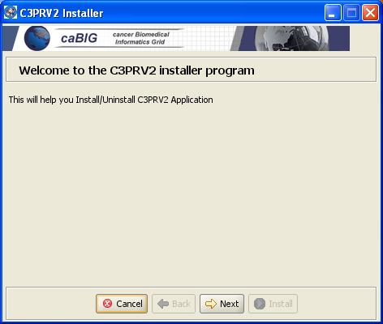
8 | License Agreement  You can either accept or reject the license. The license needs to be accepted to proceed with installation, if the license is rejected the installation will be aborted. Click Next to continue.  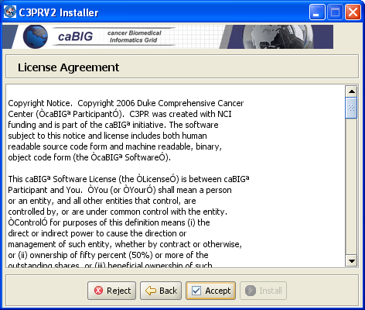
9 | Installation directory  You can let the installer select the installation directory(C:\Program Files\c3prv2.5) or can select a different directory of your choice using the “Select Folder”.This is where the application will be installed. Click Next to continue and it will confirm for the creation of the selected directory click yes to accept.  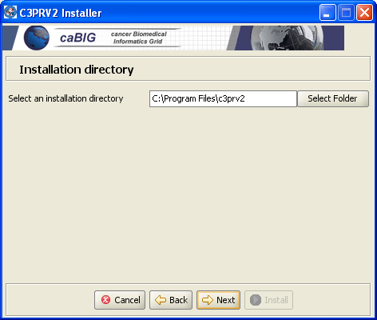
10 | Install Tomcat  You can let the installer deploy and configure tomcat or choose an existing installation of tomcat on your system. If you choose to use an existing tomcat, see Tomcat SSL How To web page for information on configuring the tomcat server for the HTTPS protocol (C3PRV2.5 uses SSL to secure client server interaction). Click Next to continue.  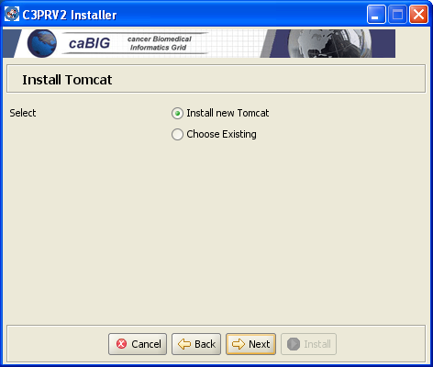
11 | Select Directory to install Tomcat  You can let the installer select the directory(C C:\Program Files\c3prv2.5\apache-tomcat-5.5.23) or can select a different directory of your choice using the “Select Folder”.This is where the Tomcat will be installed. Click Next to continue and it will confirm for the creation of the selected directory click yes to accept.  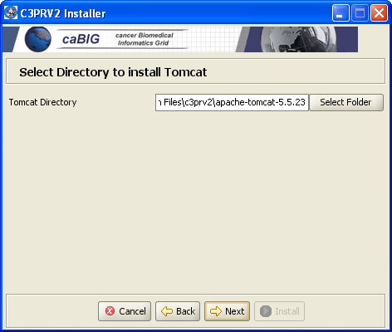
12 | Components to Install  Choose the components that you want to install and click Next  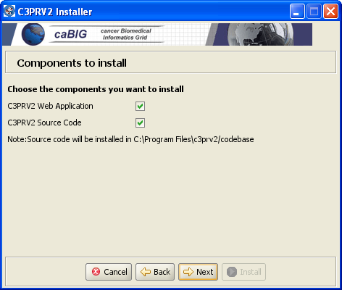
13 | Configure Tomcat  If you chose “Choose Existing” in the Install Tomcat Section follow the instructions to configure the Tomcat..  Note:Ignore these instructions if you are using the installer to install a new tomcat.  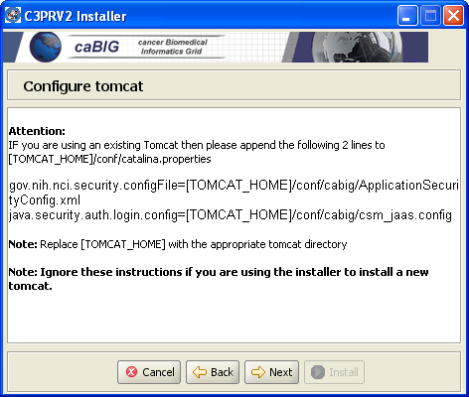
14 | Select Log File name  You can let the installer deploy and configure tomcat  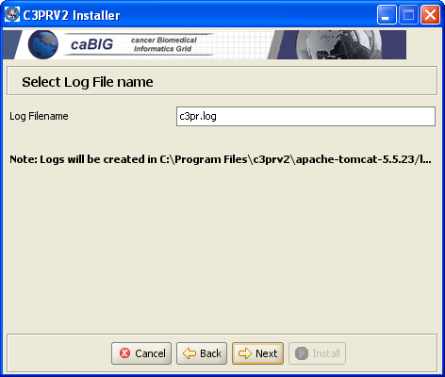
15 | Configure CSM  Select to configure CSM and click Next.  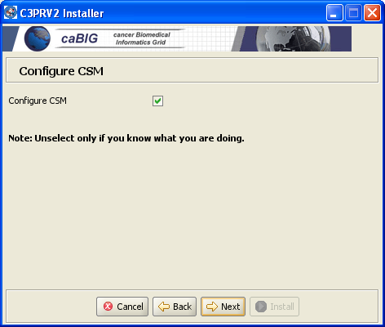
16 | Select to Enable/Disable Authorization  Select to enable or disable Authorization and click Next  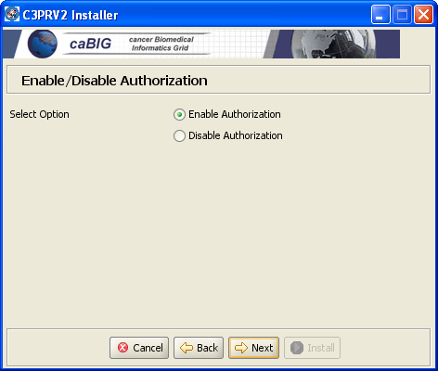
17 | Select Database  Select the Database you want to use and click Next  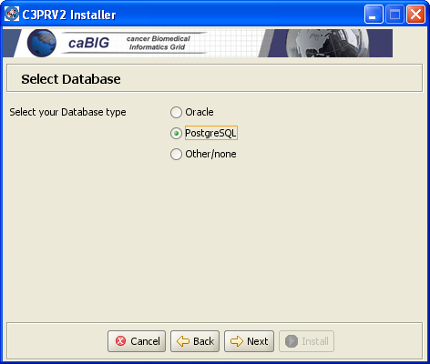
18 | Database Properties  Note: An empty database is exists.  Specify the Database URL ,Username and Password  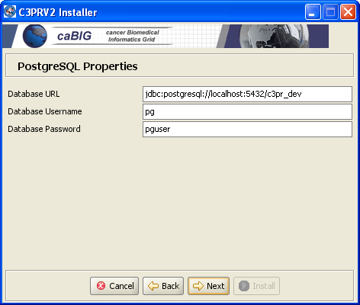
19 | C3PRV2.5 Installation Process  Click Install to start the installation process. This will initiate the installation and display the installation's status.  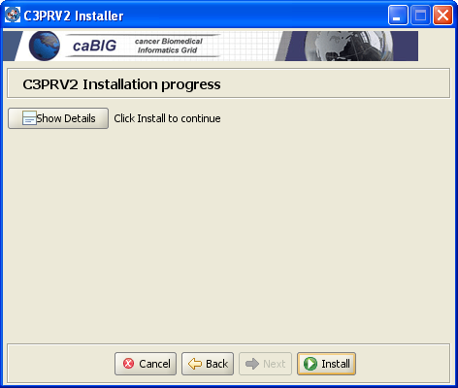
9 | After navigating through the GUI screens, the install process will run through to completion. C3PRv2.5 install is complete.
10 | If you selected to install a new tomcat then set your CATALINA_HOME environment variable .
12 | Open command prompt, change directory to <CATALINA_HOME>\bin
13 | Run the following command to start tomcat server  startup.bat (windows)  startup.sh (unix)
13 | After your web application server has completely finished starting, open the browser with the following URL  http://localhost:9080/c3pr  C3PR Login page should be displayed with successful installation:  Add the screen shot  NOTE: The installer’s version of tomcat runs on port 9080. Your existing tomcat might be on a different URL/Port. Replace localhost:port with the correct hostname/port assignment. The port assignment will be the Tomcat container that has been configured for the application server.  Example:  - http://cbvapp-q1009.nci.nih.gov:8080/c3pr  - To login, use the default userid: cctsdemo1@nci.nih.gov  - Password: cctsdemo1

At this point your installation should be complete. See the C3PR Administration Guide for configuring C3PR:

http://gforge.nci.nih.gov/docman/view.php/214/10331/c3prv2_administration_guide.doc

Note: for CCTS installation, you will have to configure WebSSO integration. See the administration guide for more details.

See Common Problems during Installation if you encounter problems during installation. You may also send email to c3prv2-support@gforge.nci.nih.gov for support.

Common Problems with Installer (FAQ)

Problem: My installation failed with the message “class sun.tools.javac.Main not on the classpath. Perhaps JAVA_HOME does not point to the JDK. Its currently set to c:/Program Files/Java/jre_1.5.0_11”

Solution: This can happen when installing in the Microsoft Windows Operating system. First, try running the installer from the command prompt (as described in step5).

If the above solution does not work then copy the tools.jar file from $JAVA_HOME/lib/ to c:/Program Files/Java/jre_1.5.0_11/lib/ext directory. If the $JAVA_HOME/jre/lib/ext does not exist then go ahead and create it. Re-run the installer after doing this.

NOTE: c:/Program Files/Java/jre_1.5.0_11 can be different on your system

Problem: My installation failed at the final step with the message “edu.northwestern.bioinformatics.bering.Migration’?

Solution: This means the database create/update scripts did not work. Please check the database URL you entered in the installer. Also, make sure that an empty database is available to the installer. The installer can created the tables etc. but not create a database.

Problem: My installation failed at the final step with the message
“FATAL ERROR: c3pr_dev datbase does no exist”

Solution: This implies that you do not have an empty database created as instructed in Step 8 of the Error: Reference source not found chapter.

Securing Tomcat
c3pr requires a secure tomcat container and uses https by default. To secure your Tomcat installation, do the following

Step | Action
1 | Open command prompt, change directory to codebase\antfiles
2 | Run the following command  ant tomcat.security  NOTE:There will be instructions after you run this target on how to edit your tomcat.properties
3 | Follow the online directions on configure SSL for your tomcat (if not done in a previous install)  Tomcat SSL How To

Contacting Technical Support
Please mail c3prv2-support@gforge.nci.nih.gov for support on Installation or general C3PR technical Support queries

Appendix A – Configuring Multiple Tomcat Servers
More often there is a requirement to configure multiple tomcat servers if a tomcat instance is already running another application. A few modifications need to be done to achieve this. It is recommended to install a separate tomcat instance for C3PR. Make a note of the installation directory.

- Setting Tomcat Home:
By default C3PR assumes a single instance of Tomcat installation and looks for a CATALINA_HOME environment variable. If there exists another tomcat instance already, there is a good chance that it is taking up this environment variable. To override this, you need to set your CATALINA_HOME environment variable to your desired Tomcat installation and run the installation process.

Furthermore, you can install a new Tomcat instance with the Graphical Installer. This Tomcat will run on a non default http/https ports – 9080 and 9443. Once your installation is complete reset your CATALINA_HOME to point to the new instance and start/stop the instance.

