CDE Standards Reuse

Mary Cooper and Patrick McConnell

Contents
1. Contents 1
2. Introduction 1
2.1. Scope 1
2.2. References 1
3. Identifying Standard CDEs 1
4. Reusing Standard CDEs 3

Introduction

Scope
This document is designed for caBIG modelers to help them identify and reuse CDEs designated as standards in their UML models.

References
The following documents may be of help:

- caCORE SDK manual: http://gforge.nci.nih.gov/docman/view.php/148/7346/caCORE_SDK_3.2.1_Programmers_Guide.pdf

Identifying Standard CDEs
Standard CDEs can be found in the caDSR in the Data Standards classification of the caBIG context. Open the caDSR CDE Browser in your web browser (http://cdebrowser.nci.nih.gov/CDEBrowser/). In the tree on the left, open the caBIG context under caDSR Contexts, Classifications, and then Data Standards. Click on Standard. The approved standard CDEs will appear on the right-hand side. Click Download Data Elements to Excel to get a spreadsheet of the standard CDEs (see Figure 1). Alternately, individual Standards can be accessed by opening the Standard folder in the CDE Browser tree and clicking on the individual Standard of interest (see Figure 2).
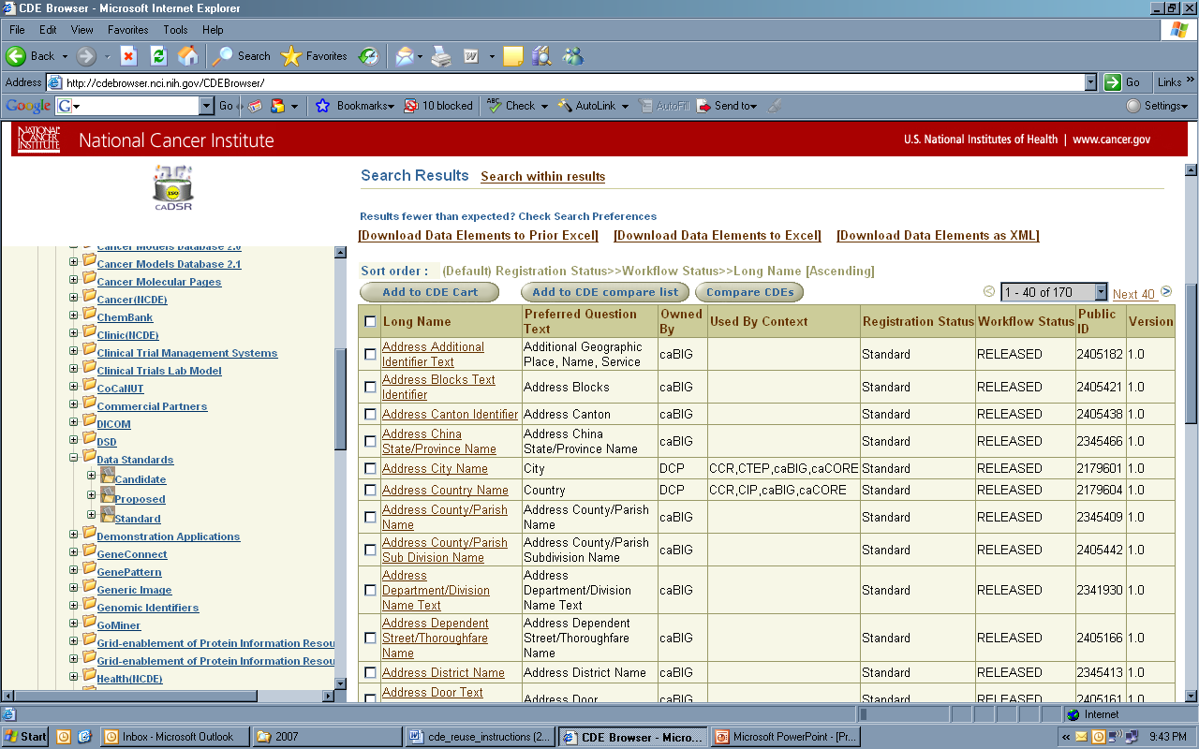
Figure 1 Screenshot of CDE standards in the CDE Browser.

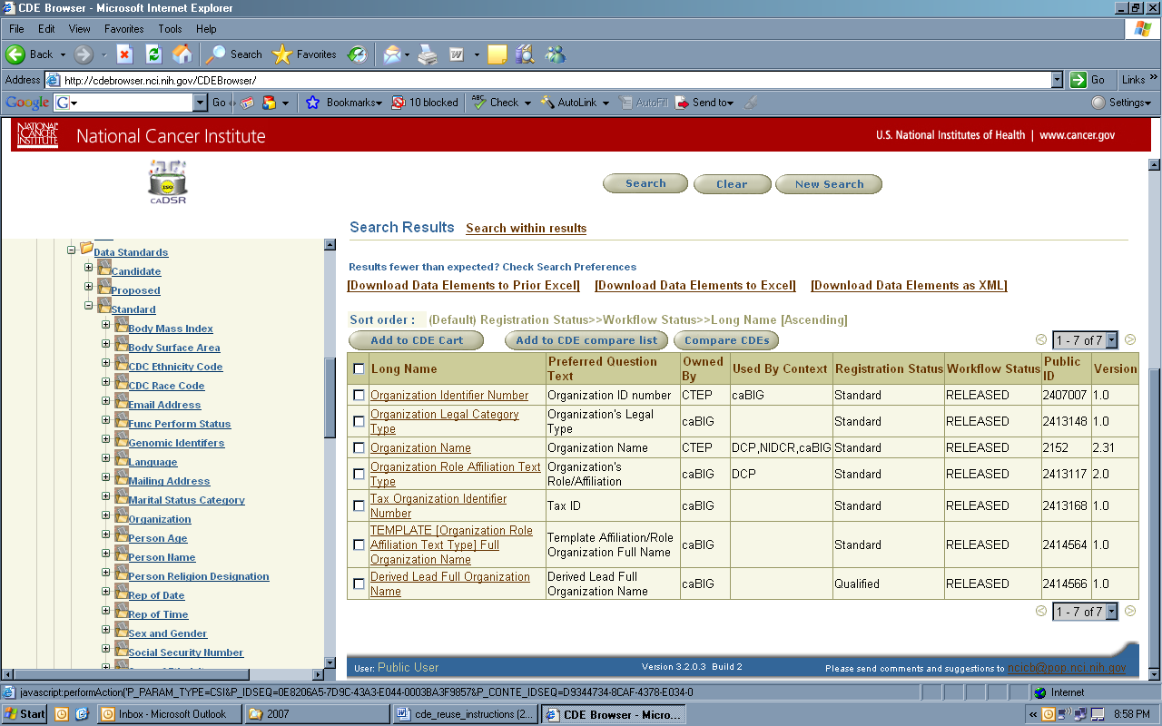
Figure 2 Screenshot of Individual CDE standards in the CDE Browser.

Reusing Standard CDEs
Reusing standard CDEs is accomplished using EA and the SIW.

1. Search for CDE standards using CDE Browser. Download the CDE standards for reuse to an Excel spreadsheet (see Figure 3).
2. Create attributes in EA and export model package to XMI.
3. Open SIW with the XMI exported in step #2. Choose SIW Option 1 (Review Unannotated XMI) or Option 5 (Review Annotated XMI).
4. Click on the attribute and then the Map to DE button (see Figure 4).
5. Click on Search Data Element button (see Figure 5). Enter the Long Name or Public ID of the CDE Standard you wish to reuse.
6. Double click on the CDE. The CDE details will be displayed (see Figure 6 and 7).
7. Click on Apply and continue to the next attribute (see Figure 7).
8. Save XMI with mapped attributes before closing SIW.

The tagged values in EA will be updated automatically when you import your saved XMI back into EA.

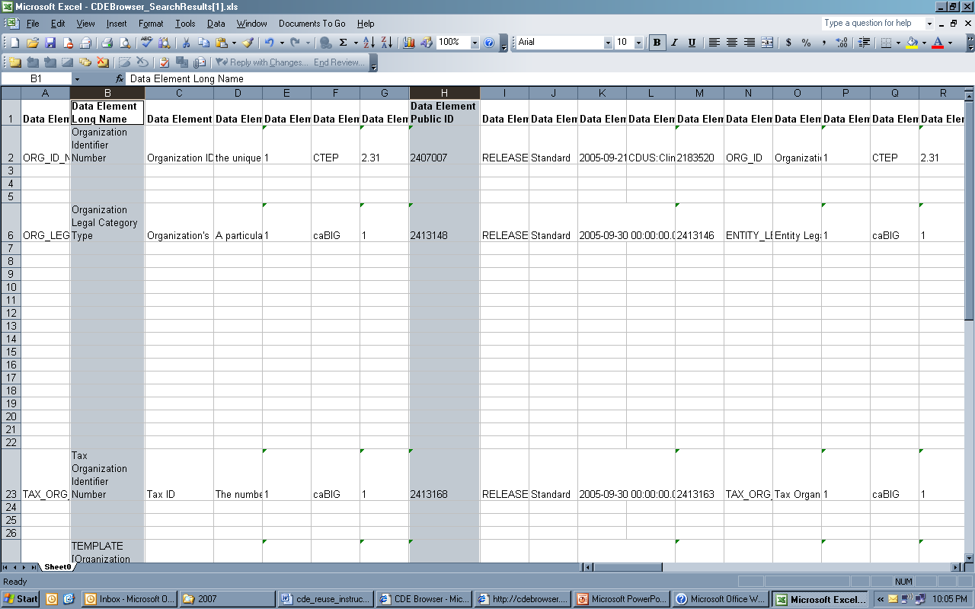

Figure 3 An Excel spreadsheet export of standard CDEs from the CDE Browser highlighting the Data Element Long Name and Public ID column, which can be used to map standard CDEs in the SIW.

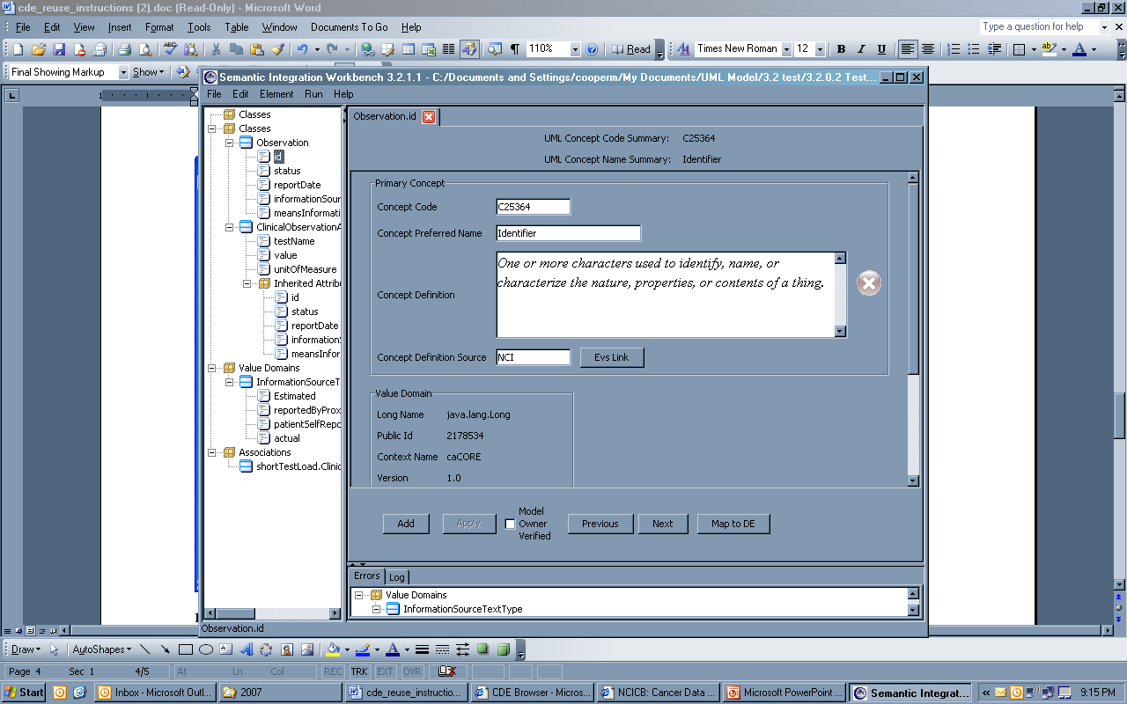
Figure 4 Screenshot of the SIW, showing the Map to DE button used to select standard CDEs for attributes.

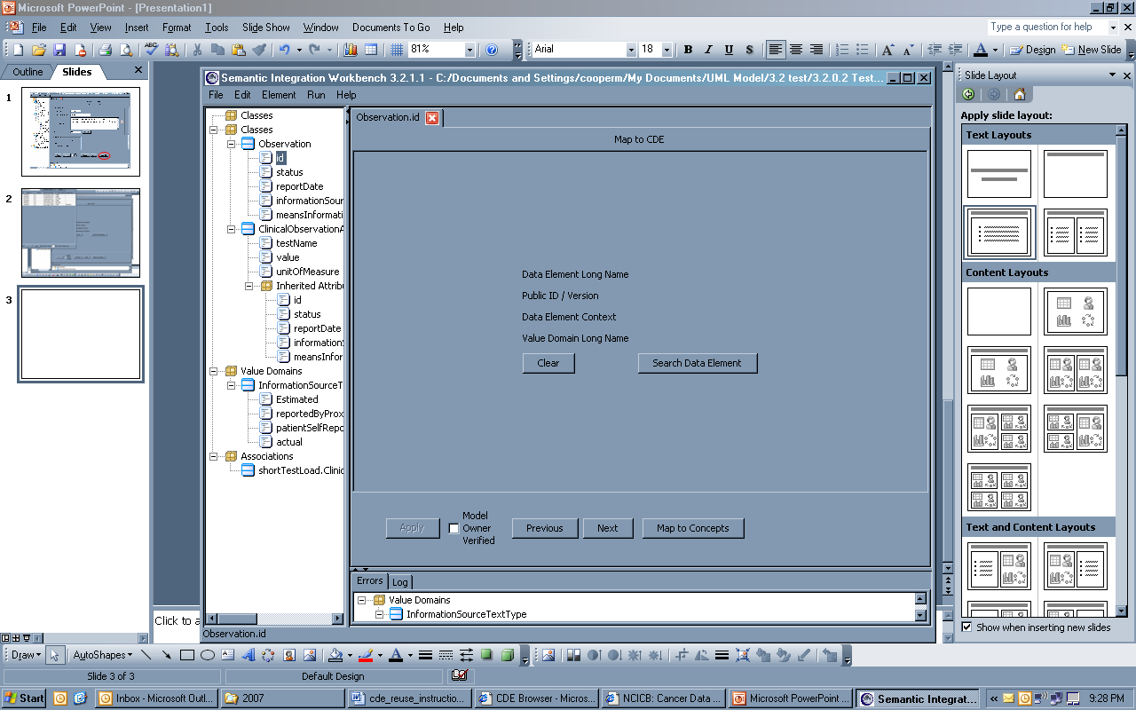
Figure 5 Screenshot of the SIW, showing the Search Data Element button used to select standard CDEs.

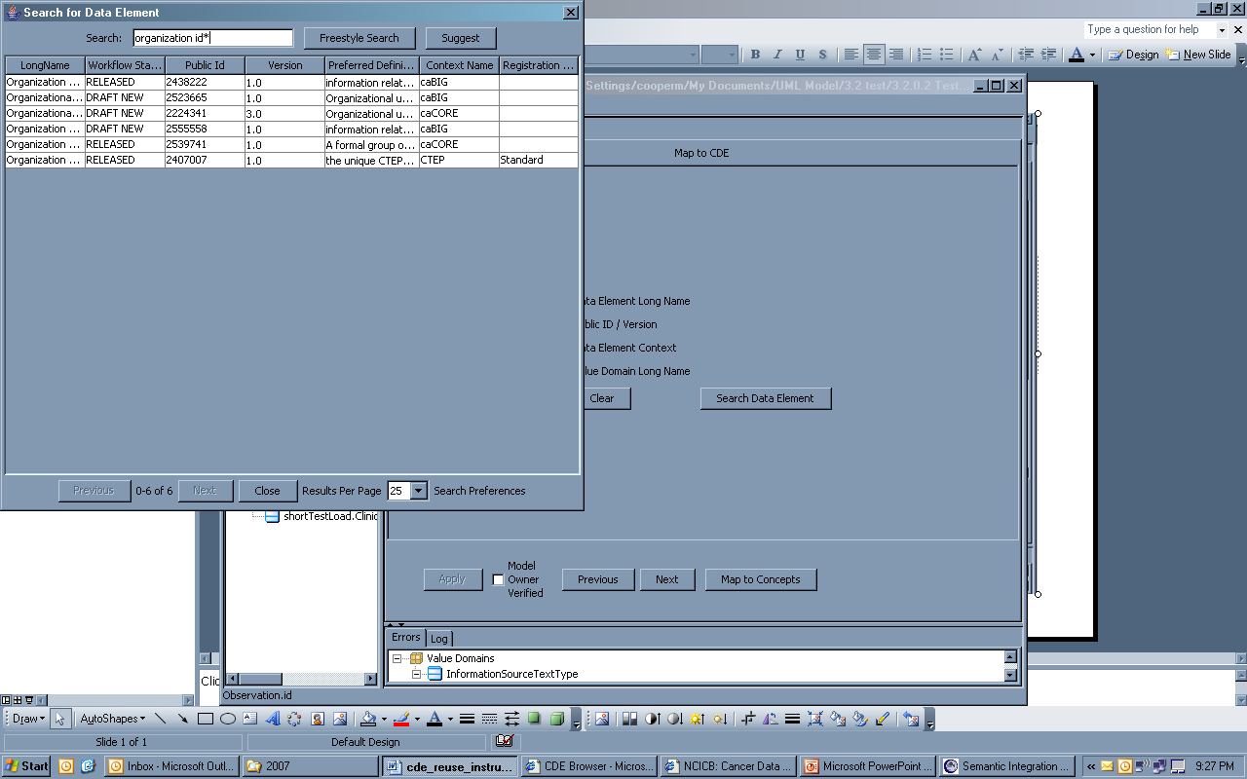
Figure 6 Screenshot of the SIW, showing the search by Long Name results used to select standard CDEs.

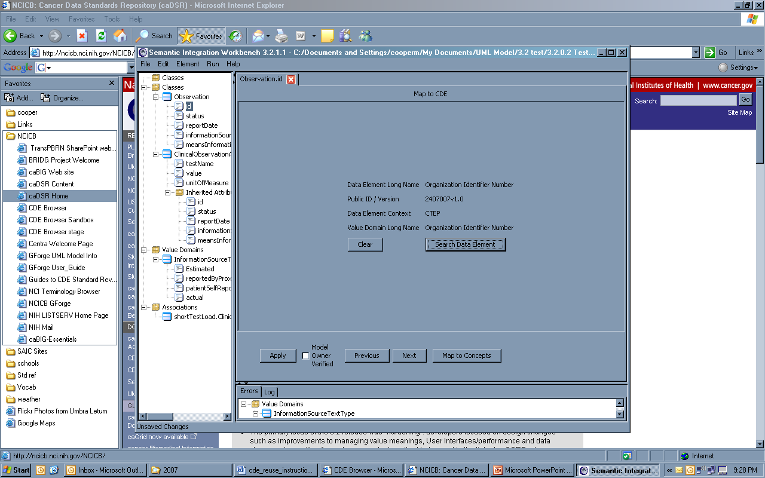
Figure 7 Screenshot of the SIW, showing the standard CDE mapped to UML attribute.

