Conceptual Functional Service Specification

Subject Management

0.0.5

07/21/2010

Architecture Inception Team | Kalpesh Patel, Christo Andonyadis
Editor | Brian McIndoe, Kunal Modi, Santosh Joshi
Authors | Brian McIndoe

Document Version | Date | Author | Changes
0.0.1 | 11/12/2009 | Brian McIndoe | Initial Draft
0.0.2 | 11/15/2009 | Brian McIndoe | Revised for ESST review feedback
0.0.3 | 12/29/2009 | Brian McIndoe | Revised for C3PR team feedback
0.0.4 | 3/11/2010 | Brian McIndoe | Revised after discussion with C3PR team and SMEs. Removed reference to COPPA Person service.
0.0.5 | 07/21/2010 | Denis Krylov | Updated IM and resolved some inconsistencies.

Table of Contents
1 Overview and Business Case 4
1.1 Service Description and Purpose 4
1.2 Scope 4
1.3 Assumptions 5
2 Business Storyboards 6
2.1 Primary Actors 6
2.1.1 People Actors 6
2.2 Story Boards 6
2.2.1 Overview 6
2.2.2 SM-SB1 – Create a Subject 7
2.2.3 SM-SB2 – Query and Retrieve a Subject for Registration 7
2.2.4 SM-SB3 – Update Subject Information 8
2.2.5 SM-SB4 – Update a Subject’s Status 8
2.3 Subject State Transition Diagram 9
3 Detailed Functional Model 10
3.1 Structure of the Service 10
3.2 Detail of the Capabilities 10
4 Profiles 14
4.1 Functional Profiles 14
4.2 Semantic Profiles 14
4.3 Conformance Profiles 15
4.4 Information Model 16
5 System Interaction Details 17
6 Implementation/Deployment Considerations 18
7 Conformance and Compliance 20
7.1 Compliance and Conformance Statements 20
8 Appendix A - Relevant Standards 22
9 Appendix B - References 23
10 Appendix C - Glossary 24
11 Appendix D – Cross Reference Tables 25
11.1 List of Storyboards 25
11.2 Storyboards to Capabilities Mapping 25
11.3 List of Profiles 26
11.4 Actors 26

Overview and Business Case

Service Description and Purpose
The purpose of this service is to provide a set of interfaces to enable the creation, updating, deactivation and querying of a Subject. It is intended to provide authoritative information on a Subject to those applications and services that require it.
A Subject in the context of this service is aligned with the BRIDG model which defines a Subject as “An entity of interest, either biological or otherwise”, with a purpose “to support potential candidates for a study”. In the case of this service we constrain ourselves to Human subjects only. A Subject has identification and contact information and demography data.
The main consumer of this service will be the Subject Registration service which requires that a Subject exist before the registration process can begin. The Subject Registration service will take a snapshot of a Subject’s demography data from the Subject Management service at the point of registration approval for a Subject. Other services that require current information on a Subject may also be consumers of this service.
The development of a common, reusable set of interfaces provided by this service will facilitate standardization, integration and interoperability between various systems that need access to authoritative subject information.
This Service Specification provides a key infrastructure component for NCI to support Subject Management, and integration with other systems. This service serves as a main platform for integrating Subject Management needs among all heterogeneous systems/components independent of platform within the clinical domain.

Scope
The table below provides a list of items that are in scope or out of scope.
Items | Scope / Out of Scope | Source
Provide the ability to Create a Subject and Update Subject’s information. | Scope | Subject Management Service Scope Document
Provide the ability to Query and Retrieve Subject information | Scope | Subject Management Service Scope Document
Provide the ability to change the status of a Subject. | Scope | BRIDG Subject class
Provide the ability to send notifications to interested parties when either a Subject’s Demography data or status changes. | Scope | Discussions with SMEs
This service will support a federated model where providers and consumers may reside in different jurisdictions each with their own policies, procedures and security schemes. | Scope | Multisite Deployment Architecture document
Provide the ability to save historical values of a Subject’s demographic attributes. This will be addressed by the Subject Registration service. | Out of Scope | Discussions with SMEs

Assumptions
Assumption | Affects | Source
This service will not utilize the COPPA Person service for storing a subject’s demographic data. However, it should be designed so that future adoption of the Person service is feasible if NCI decides this is appropriate. | The service will provide its own demographic data structure and supporting operations.
Each site will host its own Subject Management service locally. | See the Multisite Deployment Architecture in section 6.1 of this document.

Business Storyboards

Primary Actors

People Actors
Name | Role | Notes
Sally Smith | Site Registrar | Located at the Georgetown Study Site
David Jones | Study Registrar | Located at the Georgetown Coordinating Center
Lucy Taylor | CRA | Located at Georgetown Study Site
Jerry Carlos | Subject
Dr John Miller | Jerry’s Primary Care Provider

Story Boards

Overview
In order to be registered to a study, a subject must first be created. This requires that information identifying the subject, such as name, address, and contact information be entered into the system. In addition, Demography data about the subject needs to be collected and entered.
These storyboards describe scenarios for the creation, updating, deactivation and querying of a Subject. The subject in these examples is Jerry Carlos, a 48 year old male who has been referred by Dr John Miller, his primary care provider to a Phase III randomized skin cancer study to be held at Georgetown.

SM-SB1 – Create a Subject
Outline | To be registered to a Clinical Trial, a candidate has to first be created as a subject in the system.
Detail | Although he has been to Georgetown hospital many times, this is his first visit to the Georgetown study site. Jerry’s goal is to participate in the skin cancer trial that his physician has recommended to him. In order to do so, he has to first be created as a subject in the system.  Lucy Taylor, the Clinical Research Associate for this study, first obtains Jerry’s informed consent for the trial. She then invokes the Create Subject function and enters Jerry’s name, address and contact information.  Lucy knows that Jerry is a patient at Georgetown and has an electronic Medical Record (EMR) there. She enters Jerry’s EMR number into the system. The screen populates with Jerry’s Demography data from the EMR system.  A subject’s Demography data includes such information as race, ethnicity, gender, date of birth and marital status.  Lucy saves Jerry’s Subject record.  Alternative Scenario  Not every facility has an Electronic Medical Record system from which to extract a subject’s Demography data. In these cases, this data will need to be collected from the subject and entered manually.

SM-SB2 – Query and Retrieve a Subject for Registration
Outline | As part of the subject registration process, a site registrar needs to be able to search for a subject using one or more subject attributes.
Detail | Lucy informs Sally Smith, the Site Registrar at Georgetown that Jerry Carlos is a candidate subject who appears to be eligible, except for the central pathology lab review - who wants to pre-register for the Phase III randomized skin cancer trial.  Sally Smith enters Jerry’s last name and searches for Jerry’s file. The system displays a list of subject’s with the same last name as Jerry. Sally selects Jerry Carlos from the list of Subject’s (no other match has the same first name as Jerry). Note: If there are two or more persons with the same first and last name, the MRN is used to distinguish between them.  The screen is populated with Jerry’s Subject information. Sally reviews the information and then selects the trial to which she wants to submit him for pre-registration. [Note: this action will Initiate the Request for Pre-Registration through the Subject Registration service.]

SM-SB3 – Update Subject Information
Outline | A user needs to be able to update a subject’s information. Updating a subject’s information will cause a notification to be sent to all Study Registrars that have the subject registered to one of their studies.
Detail | Several weeks later, after having completed screening and registration, Jerry makes his next scheduled visit to Georgetown. He informs Lucy that since his last visit, his address has changed, he has gotten married and he has been awarded a Masters degree.  Lucy invokes the Update Subject function and enters his new information into his existing Subject record. When she is satisfied that the changes are correct she submits the update for processing. The system then queries the Registration service to determine which studies Jerry is registered to. It then uses the Notification service to inform the Study Registrar for each of Jerry’s studies that changes have been made to Jerry’s Demographics. It is then up to each Study Registrar to determine whether they need to modify the Demographic data stored with Jerry’s Registration data.

SM-SB4 – Update a Subject’s Status
Outline | A Subject has a status which is set to “Active” when the Subject is created. This is in addition to the status they have as a StudySubject (StudySubject status is addressed in the Subject Registration service specifications). If a Subject becomes “Inactive” then a notification will be sent to all Study Registrars that have the Subject registered to one of their studies.
Detail | Lucy Taylor, the CRA at Georgetown receives a phone call from Dr John Miller regarding Jerry Carlos. Unfortunately Jerry was involved in a car accident and did not survive.  Lucy invokes the Update Subject Status function and retrieves Jerry’s record, sets his Subject status to inactive, and submits for processing.  The system then queries the Registration service to determine which studies Jerry was registered to. It then uses the Notification service to inform the Study Registrar for each study that Jerry was enrolled on that he has become inactive. It is then up to each Study Registrar to determine whether they need to modify Jerry’s Registration status.

Subject State Transition Diagram

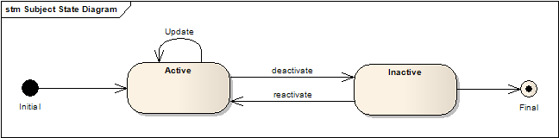

Detailed Functional Model

Structure of the Service
Name | Description
Create Subject | This function is used to create a Subject.
Update Subject | This function is used to update a Subject’s attribute values.
Query Subject | This function is used to query and retrieve matching Subject(s).
Update Subject Status | This function is used to update a Subject’s status.

Detail of the Capabilities
Name [M] | Create Subject
Description [M] | Enables creation of a Subject. Once a Subject has been created they can then be registered to one or more clinical trials via the Subject Registration service.  If an EHR system is available and offers a service that exposes patient data by EHR number, then contact and demography data for the Subject may be populated from this source. Otherwise, it will need to be populated by hand.  If successful, an instance of a Subject and associated Person and BioLogicEntityIdentifier objects are returned. Note that the BioLogicEntityIdentifier.identifier will be the Medical Record number if there is one or an auto generated unique number if there is no Medical Record system in use at the site.
Pre-Conditions [M] | None
Security Pre-Conditions [M] | Access control mechanism needs to be in place to ensure that the user is logged in and has valid privileges of a CRA or Site Registrar to Create Subject.
Inputs [M] | Subject object with status set to ‘Active’  Person object populated with contact and demography data  BioLogicEntityIdentifier populated with Medical Record or Hospital Record number
Outputs [M] | Subject object
Post-Conditions [O] | A Subject and associated Person and BioLogicEntity is created
Exception Conditions [M] | Invalid data type or code value for any attribute  Subject/Person/BioLogicEntity already exists (BioLogicEntity.identifier already in use)  No BioLogicEntity.identifier provided
Aspects left for Technical Bindings [O]
Notes [O] | The Person referred to above is not the COPPA Person service, but a custom structure into which Person attributes defined in the BRIDG model can be captured.

Name [M] | Update Subject
Description [M] | Enables updating a Subject’s associated Person attribute values.  If successful, an instance of the updated Subject object and its associated Person object is returned.
Pre-Conditions [M] | Subject/Person/BioLogicEntity exists
Security Pre-Conditions [M] | Access control mechanism needs to be in place to ensure that the user is logged in and has valid privileges of a Site Registrar to Update a Subject.
Inputs [M] | Subject object  BioLogicEntity object  BioLogicEntityIdentifier object  Person object populated with updated values
Outputs [M] | Subject object
Post-Conditions [O] | Subject/Person/BioLogicEntity data is updated
Exception Conditions [M] | Subject is inactive  invalid  Subject object is incorrectly formed
Aspects left for Technical Bindings [O]
Notes [O] | If a Person attribute is modified then a notification needs to be sent to each Study Registrar that has this Subject enrolled to a study.

Name [M] | Query Subject
Description [M] | Enables queries of Subject information.
Pre-Conditions [M] | None
Security Pre-Conditions [M] | Access control mechanism needs to be in place to ensure that the user is logged in and has valid privileges of a CRA, Site Registrar or Study Registrar to initiate a query.
Inputs [M] | Subject/Person/BioLogicEntity object with search attributes
Outputs [M] | Collection of matching Subject/Person/BioLogicEntity objects
Post-Conditions [O] | None
Exception Conditions [M] | Query Value is incorrect type
Aspects left for Technical Bindings [O]
Notes [O] | Query By Example

Name [M] | Update Subject Status
Description [M] | Enables updating a Subject’s status
Pre-Conditions [M] | The Subject must exist
Security Pre-Conditions [M] | Access control mechanism needs to be in place to ensure that the user is logged in and has valid privileges of a CRA, Site Registrar or Study Registrar to Update Subject Status.
Inputs [M] | BioLogicEntityIdentifier object  New Status value
Outputs [M] | Subject Object with updated status
Post-Conditions [O] | Subject has new status
Exception Conditions [M] | Subject does not exists  Subject already has new status value  New status is not valid
Aspects left for Technical Bindings [O]
Notes [O] | If Subject status is modified then a notification needs to be sent to each Study Registrar that has this Subject enrolled to a study. It is up to the Registrar to determine the appropriate action regarding the Subject’s registration.  Status’ values are ‘active’ and ‘inactive’

Profiles

Functional Profiles
Functional Profile No. | Functional Profile Name | Functional Profile Description | Capability Name
SM-FP1 | SM Query | This Profile is for services/applications that just need to query and retrieve Subject related information | - Query Subject
SM-FP2 | SM Full | This Profile contains all operations. | - Create Subject  - Update Subject  - Query Subject  - Update Subject Status

Semantic Profiles
Semantic Profile No. | Semantic Profile Name | Constrained Information Model | Operations using the Semantic Profile
SM-SP1 | BRIDG V3.0.1 | BRIDG V3.0.1 | - Create Subject  - Update Subject  - Query Subject  - Update Subject Status

Conformance Profiles
Name | SM Query BRIDG V3.0.1
Version | V1.0
Description | This is the minimum conformance profile defined for the Subject Management Service
Usage Context | This profile could have multiple uses where Subject related information needs to be queried and retrieved.
Functional Profile(s) | SM-FP1 : SM Query
Semantic Profile(s) | SM-SP1 : BRIDG V3.0.1
Other….

Name | SM Full Management BRIDG V3.0.1
Version | V1.0
Description | This is the conformance profile required for a study site creating, updating, and querying subjects.
Usage Context | A study site creating a subject as a precursor to making a registration request for the subject.
Functional Profile(s) | SM-FP2 : SM Full
Semantic Profile(s) | SM-SP1 : BRIDG V3.0.1
Other….

Information Model
The following Subject related classes are taken from the BRIDG 3.0.1 analysis model.
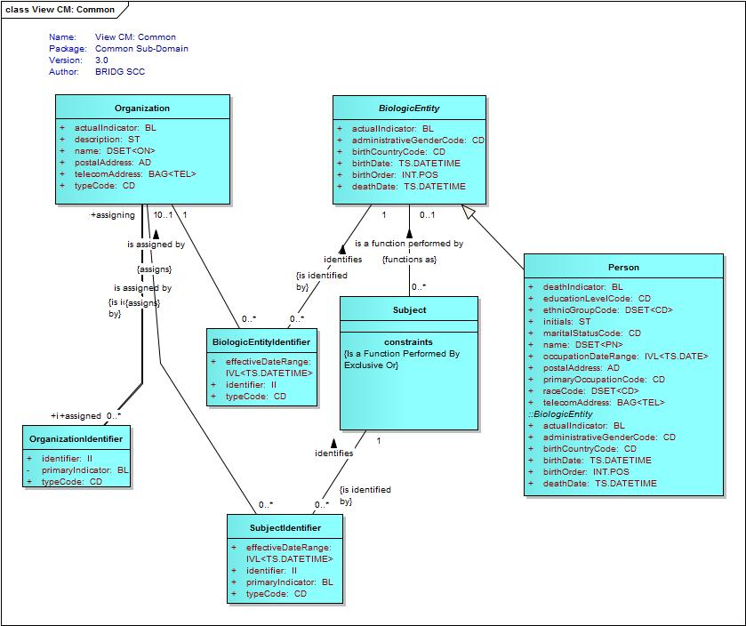

5 System Interaction Details

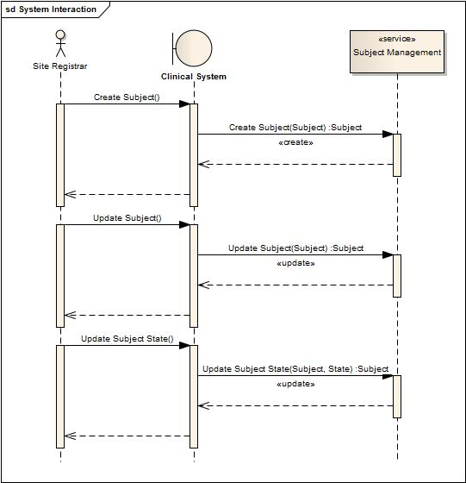

Implementation/Deployment Considerations
Implementation Considerations | Impacts
The deployment of this service may require most capabilities to support federation. It is possible that some profiles may have a mix of locally and remotely provided capabilities. Federation in this context means services that span more than one jurisdiction. | The system may need to be configured such that specific profiles are served by different processes.

The following diagram shows a multisite deployment scenario for the Subject Management service. Each site is responsible for maintaining its Subject related information locally. A Study Registrar at a Study Coordination Center can query and retrieve Subject information across sites but cannot change it.

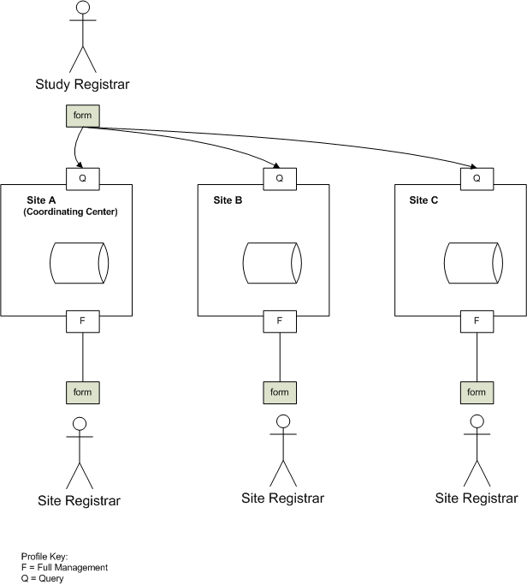

Multisite Deployment Architecture

Conformance and Compliance

Compliance and Conformance Statements
Name | Type | Viewpoint | Description | Test method
Multiple Jurisdictions | Obligation | Enterprise | The Subject Management Service is obligated to be able to support processing across multiple jurisdictional domains. Implementers must provide an implementation that supports multiple jurisdictional domains | Test cases include multiple domain scenarios
Query Performance | Obligation | Enterprise | The query for SM criteria for a subject should return results in 3 seconds | Test cases to include performance testing.
Conformance Profiles | Obligation | Computational / Information | In order to claim a minimal level of conformance to the Subject Management specification, designers/implementers are obligated to support the following mandatory Conformance Profiles (i.e. their contained functional and semantic profiles): SM Query BRIDG V3.0.1, SM Full BRIDG V3.0.1. | Test cases to be defined to test each specified profile
ISO Datatypes | Obligation | Information | Designers/implementers are obliged to support ISO 21090 datatypes in all operations | Test cases to include processing of each relevant data type
Auditing | Obligation | Engineering | Designers/implementers are obligated to decide on and document the approach for logging or auditing of operation calls. | Design Review
Operation Behavior Issues / Assumptions | Obligation | Computational / Information / Engineering | Architects/Designers/Developers are obligated to confirm (or refute) all Assumptions made in the Notes for Service Realization sections of each operation and the overall Assumptions section. | Design Review

Appendix A - Relevant Standards
Name | Description | Location
BRIDG v3.0.1 | BRIDG model used for modeling the SM Service | http://gforge.nci.nih.gov/frs/shownotes.php?release_id=3780
HL7v3 | Health Level 7 version 3 | http://www.hl7.org/implement/standards/v3messages.cfm

Appendix B - References
Name | Description | Location
BRIDG v3.0.1 | BRIDG model used for modeling the SM Service | http://gforge.nci.nih.gov/frs/shownotes.php?release_id=3780
C3PR Use Case Document | Document containing use cases for the C3PR application | https://cabig-kc.nci.nih.gov/CTMS/KC/index.php/C3PR_Use_Cases
BAM v1.1 | Business Architecture Model | https://cabig-kc.nci.nih.gov/CTMS/KC/index.php/Biomedical_Research_Business_Architecture_Modeling

Appendix C - Glossary
Term | Description
BRIDG | The Biomedical Research Integrated Domain Group (BRIDG) has developed a comprehensive domain analysis model representing biomedical/clinical research.
HL7 | Health Level 7

Appendix D – Cross Reference Tables

List of Storyboards
# | Name | Description | Source
SM-SB1 | Create a Subject | In order to be registered to a Clinical Trial, a candidate has to first be created as a Subject in the system. | Storyboard Document
SM-SB2 | Query and Retrieve a Subject for Registration | As part of the subject registration process, a site registrar needs to be able to search for a subject using one or more subject attributes. | Storyboard Document
SM-SB3 | Update Subject Information | A user needs to be able to update a subject’s information. Updating a subject’s information will cause a notification to be sent to all Study Registrars that have the subject registered to one of their studies. | Storyboard Document
SM-SB4 | Update a Subject’s Status | A Subject has a status. This is in addition to the status they may have as a StudySubject (StudySubject status is addressed in the Subject Registration service specifications). | Storyboard Document

Storyboards to Capabilities Mapping
# | Storyboard | Profiles | Actors | Capabilities
SM-SB1 | Create a Subject | SM Full | CRA, Site Registrar | Create Subject
SM-SB2 | Query and Retrieve a Subject | SM Full, SM Query | CRA, Site Registrar, Study Registrar, Other systems requiring Subject Information | Query Subject
SM-SB3 | Update Subject Information | SM Full | CRA, Site Registrar | Update Subject
SM-SB5 | Update a Subject’s Status | SM Full | CRA, Site Registrar | Update Subject Status

List of Profiles
Functional Profile No. | Functional Profile Name | Storyboard No. | Storyboards Supported
SM-FP1 | SM Query | SM-SB2 | Query and Retrieve a Subject
SM-FP2 | SM Full | SM-SB1  SM-SB2  SM-SB3  SM-SB4 | Create a Subject  Query and Retrieve a Subject  Update Subject Information  Update a Subject’s Status

Actors
Actors | Profile | Type | Operations used
CRA | SM Full | Person | Create Subject  Update Subject  Update Subject Status  Query Subject
Site Registrar | SM Full | Person | Create Subject  Update Subject  Update Subject Status  Query Subject
Study Registrar and PI | SM Query | Person | Query Subject
Other Systems | SM Query | Service | Query Subject

