CBIIT Platform Independent Model and Service Specification

Subject Management Service

0.0.9

11/29/2010

Authors | Kunal Modi
Editor | Kunal Modi, Santosh Joshi
Reviewers | Kunal Modi, Kalpesh Patel, Santosh Joshi, Brian McIndoe
Architecture Inception Team | Kalpesh Patel, John Koisch, Paul Boyes
Template Version | 3.0

Version Number | Date | Contributor | Description
0.0.1 | 12/11/2009 | Kunal Modi | Initial Draft
0.0.2 | 12/18/2009 | Kunal Modi | Incorporated ESST Team comments
0.0.3 | 01/20/2010 | Kunal Modi | Incorporated C3PR Team’s feedback
0.0.4 | 04/15/2010 | Kruttik Aggarwal | Updated the information model section, SM-INF2-OP2 section and dynamic model section.
0.0.5 | 04/26/2010 | Kruttik Aggarwal | Updated the information model with C3PR harmonized model.
0.0.6 | 05/04/2010 | Kruttik Aggarwal | Accepted the changes from Kunal Modi. Added comments wherever appropriate.
0.0.7 | 07/21/2010 | Denis Krylov | Updated IM and resolved some inconsistencies.
0.0.8 | 09/15/2010 | Denis Krylov | Added details on Advanced Subject Query operation.
0.0.9 | 11/29/2010 | Denis Krylov | Addressed feedback from ESST.

TABLE OF CONTENTS

1 Overview 4
1.1 Service Description and Purpose 4
1.2 Scope 4
1.3 Referenced Standards 5
1.4 Relation to Subject Management Service Computational Independent Model Service Specification 5
1.4.1 Conformance and Compliance 6
1.4.2 Deviations 6
2 Platform Independent Model 7
2.1 Overview 7
2.2 Information Model 8
2.2.1 Subject Type 8
2.2.2 Subject State Model 10
2.2.3 Subject Management Implementation model 11
2.2.4 Error Implementation Model 11
2.2.5 Advanced Query Parameters 12
2.3 Control Data Type Definitions 13
2.3.1 Status/Return Values/Exceptions 13
2.3.2 Error Codes 13
2.3.3 Query Parameters and Result Sets 14
3 Interfaces 15
3.1 UML Model of Interfaces 15
3.2 Operations (Enumeration) 15
3.3 Operation Behavior Descriptions 16
3.3.1 SM-INF1: SMQuery Interface 16
3.3.2 SM-INF2: SMFullManagement Interface 18
4 Dynamic Model 21
4.1 Relationship with other services 22
5 Non-Functional Requirements 22
5.1 Jurisdictional Domains 22
5.2 Deployment Considerations 22
5.3 Implementation Considerations 22
5.3.1 Assumptions 23
5.4 Privacy 23
6 Profiles 24
6.1 Functional Profiles 24
6.2 Semantic Profiles 26
7 Conformance Statements 27
8 Appendix A - References 28
9 Appendix B - Glossary 29
Appendix C - Cross Reference Tables 30
9.1 Interface to Profile Mapping 30
9.2 Interface Operations to Profile Operations 30

Subject Management Service Platform Independent Model and Service Specification

Overview

Service Description and Purpose

The purpose of this service is to provide a set of interfaces to enable the creation, updating, deactivation and querying of a Subject. It is intended to provide authoritative information on a Subject to those applications and services that require it.

A Subject in the context of this service is a Person who may be either a candidate of interest for a study, or may be an actual registered participant on one or more studies.
The main consumer of this service will be the Subject Registration service which requires that a Subject exist before the registration process can begin. Other services such as the Adverse Event service and the Scheduled Calendar service may also be consumers of Subject information.

This service is part of NCI’s Enterprise Services (NES) and has to adhere to all the service specifications and guidelines set by the NCI’s Enterprise Conformance and Compliance Framework (ECCF). This service also has to adhere to the underlying NCI’s version of BRIDG v3.0.1 and use the NCI’s restricted list of ISO 21090 data types.

The following document provides the Platform Independent Model and Service Specification (PIMSS) for Subject Management Service which is compliant with all the standards and guidelines mentioned above at the same time is compliant with the functionality described by the conformance profiles in the Subject Management Service Conceptual Functional Service Specification (CFSS)

Scope
The table below provides a list of items that are in scope or out of scope.
Items | Scope / Out of Scope | Source
Provide the ability to Create a Subject and Update Subject’s information. | Scope | Subject Management Service Scope Document
Provide the ability to Query and Retrieve Subject information | Scope | Subject Management Service Scope Document
Provide the ability to change the status of a Subject. | Scope | BRIDG Subject class
Provide the ability to send notifications to interested parties when either a Subject’s Demography data or status changes. | Scope | Discussions with SMEs
This service will support a federated model where providers and consumers may reside in different jurisdictions each with their own policies, procedures and security schemes. | Scope | Multisite Deployment Architecture document
Provide the ability to save historical values of a Subject’s demographic attributes. This will be addressed by the Subject Registration service. | Out of Scope | Discussions with SMEs
Provide the ability to remove the entirety of a Subject’s record from the system | Out of Scope | Discussions with SMEs

Referenced Standards

Standards | Description
NCI’s BRIDG v3.0.2 | The Subject Management Service will use NCI’s version of BRIDG Model
NCI’s ISO 21090 | The Subject Management Service will use the NCI’s implementation of ISO 21090

Relation to Subject Management Service Computational Independent Model Service Specification

Conceptual Functional Service Specification Name | Conceptual Functional Service Specification Version | Description & Link to the Conceptual Functional Service Specification
Subject Management Service Computational Indepependent Model Service Specification | 0.0.6 | The Subject Management Service Platform Independent Model and Service Specification follows the Subject Management Service Conceptual Model and Service Specification located at the following location:  https://ncisvn.nci.nih.gov/svn/c3pr/trunk/c3prv2/documentation/design/essn/SubjectManagement/CIM_Subject_Management_Service_CAT_response.doc

Deviation from the Conceptual Functional Service Specification | Reason for Deviation
None | Not Applicable

Conformance and Compliance
This service is conformant and compliant to the following conformance profiles described in the Subject Management Service Computational Independent Service Specification

Conformance Profile No. | SM-CP1
Conformance Profile Name | SM Query BRIDG V3.0.2
Functional Profiles
  Functional Profile No. | Functional Profile Name
  SM-FP1 | SM Query
Semantic Profiles
  Semantic Profile No. | Semantic Profile Name
  SM-SP1 | SM BRIDG V3.0.2

Conformance Profile No. | SM-CP2
Conformance Profile Name | SM Full Management BRIDG V3.0.2
Functional Profiles
  Functional Profile No. | Functional Profile Name
  SM-FP2 | SM Full Management
Semantic Profiles
  Semantic Profile No. | Semantic Profile Name
  SM-SP1 | SM BRIDG V3.0.2

Deviations
None.

Platform Independent Model

Overview
The sections below fully describe the overall architecture of the Subject Management Service Interface. It provides details about the operations and behavior of the interfaces exposed by the service. These interfaces are designed for the end consumer and are designed based on the functionality which is access cohesively by each consumers. Based on these grouping of functionality the overall service is spilt into 2 interfaces.

Subject Management Query: This interface contains operations which are used by the consumers to retrieve an existing subject.

Subject Management Full Management: This interface contains all the operations which are exposed by the Subject Management Service. They include the query operations mentioned above but also other management operations related to a subject life cycle such as create, update etc.

This grouping is done in order to be compliant with the functional profiles described in the CIM. All the operations accept NCI’s BRIDG v3.0.2 based object for input and output and uses the ISO 21090 data types for data transfer. There are certain classes which have been added to facilitate return of report data.

Information Model

Subject Type
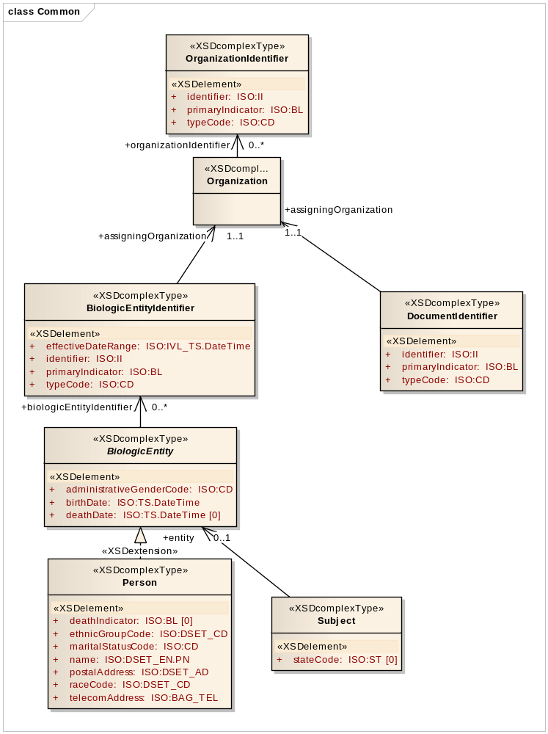

C3PR analysis model harmonized with BRIDG 3.0.2 analysis model

Person
Attribute Name | Type | Attribute Description
administrativeGenderCode | CD | A coded value specifying the physical or societal properties by which male is distinguished from female.  NOTE: For humans, identification of sex is usually based upon self-report and may come from a form, questionnaire, interview, etc.
birthDate | TS.DATETIME | The date (and time) on which the biologic entity is born.
deathDate | TS.DATETIME | The date (and time) on which the biologic entity died.
deathIndicator | BL | Specifies whether the person is dead.
ethnicGroupCode | DSET<CD> | The self-declared ethnic origination, independent of racial origination.
maritalStatusCode | CD | A coded value specifying the domestic partnership status of a person.  For example, Married, Widowed, Single, Separated, etc.
name | PN | A non-unique textual identifier for the person.  For example, proper name, nickname, legal name, etc.
postalAddress | AD | A contact point used to send physical forms of communication to the person.
raceCode | DSET<CD> | A coded value specifying a self-declared racial origination, independent of ethnic origination.
telecomAddress | BAG<TEL> | A sequence of digits or characters used to identify a particular telephone, fax, or email of the person.  For example, the set of digits that serves as the address for a telephone device. Included in the phone number are country, city, and area codes needed to uniquely address the telephone. A URL or e-mail would be similarly described.

BiologicEntityIdentifier
Attribute Name | Type | Attribute Description
effectiveDateRange | IVL<TS.DATETIME> | The date and time span for when the biologic entity identifier is active.
identifier | II | The unique symbol that establishes identity of the biologic entity.
typeCode | CD | A coded value specifying the kind of biologic entity identifier.  For example, hospital record number, medical record number.
primaryIndicator | BL | Specifies whether or not this is the primary identifier.

Subject State Model
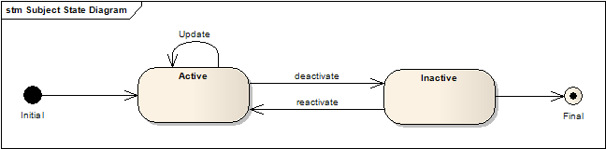
A
C
B
D
E
State Transition Diagram for Subject object during the entire registration process

Operations | Transitions Caused
querySubject | None
createSubject | A
updateSubject | B
updateSubjectState | C, D

Subject Management Implementation model

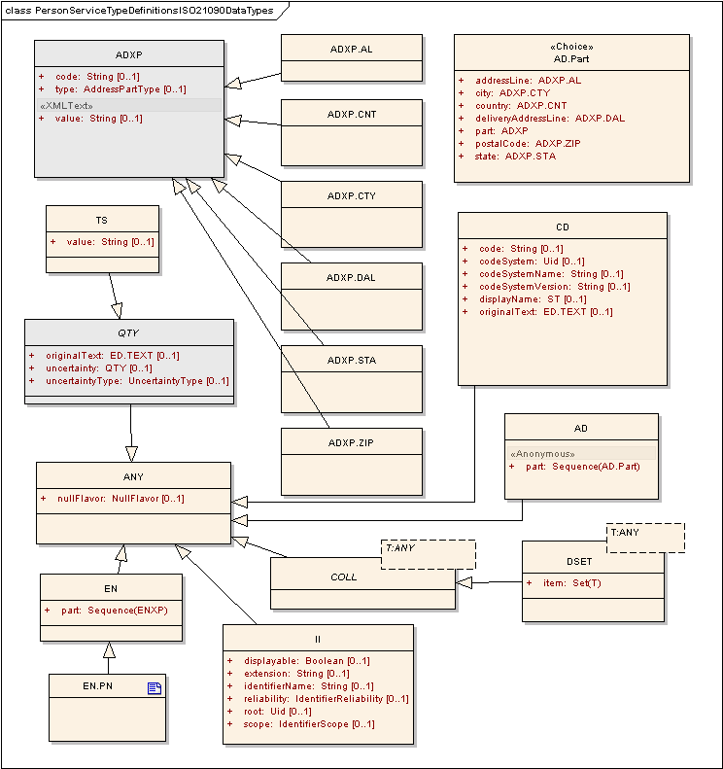
ISO 21090 data types used in the Subject Management Model

Error Implementation Model
This service returns only one exception class named SMException. The structure and details of SMException class are given below

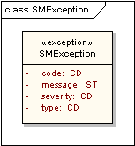

Attribute Name | Type | Attribute Description
code | CD | The actual error code which is Exception class represents
message | ST | The detailed error message
severity | CD | The severity of this error. It can be “FATAL”, “HIGH”, “MEDIUM” or “LOW”
type | CD | Indicates what type of error has occurred. E.g. Business, System etc.

Advanced Query Parameters

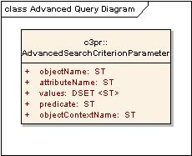

Attribute Name | Type | Attribute Description
attributeName | ST | Name of the dependent object’s attribute to query against.
objectContextName | ST | Context within which to query.
objectName | ST | Name of a Subject’s dependent object, such as Address, to query against.
value | ST | Value to search for.
predicate | ST | Logical predicate to use for query operation.

Control Data Type Definitions

Status/Return Values/Exceptions

Data Type | Type (Status / Return Value / Exception) | Data Type Description
SMException | Exception | The return object in case there is any exception during the execution of any of the operations listed below

Error Codes

Error Code | Error Type | Error Severity | Error/Exception Message
SM1001 | Business | HIGH | Invalid data type or code value for an attribute
SM1002 | Business | HIGH | Invalid Subject class representation
SM2001 | Business | MEDIUM | Invalid State Transition requested
SM2002 | Business | MEDIUM | Subject doesn’t exist for the given identifier
SM2003 | Business | MEDIUM | Subject already exists
SM2004 | Business | MEDIUM | Unable to create the subject - (appropriate details in error message details from the underlying systems if any)
SM2005 | Business | MEDIUM | Unable to update the subject - (appropriate details in error message details from the underlying systems if any)
SM3004 | Business | LOW | No subjects found for the given search criteria
SM5001 | Security | MEDIUM | User doesn’t have permissions to perform the given operation
SM5002 | Security | MEDIUM | User doesn’t have permissions on the given subject

Query Parameters and Result Sets

Data Type | Type (Query Search Criteria / Search Result Limiter / Query Result Set) | Data Type Description
Subject | Query Search Criteria  Query Result Set | Subject object is used to provide the query criteria for searching a subject’s information. The results are all the matching Subject objects for that given search criteria

Interfaces

UML Model of Interfaces
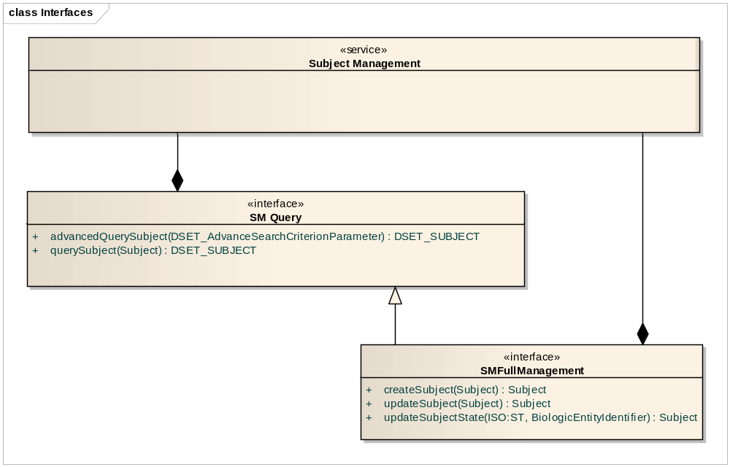
Interface Diagram for Subject Management Service

Interface No | Interface Name | Interface Description
SM-INF1 | SMQuery | Provides the functionality to query subject information
SM-INF2 | SMFullManagement | Provides all the functionality related to querying as well as managing the lifecycle of a Subject.

Operations (Enumeration)

Operation No. | Operation Name | Interface Name | Operation Description
SM-INF1-OP1 | querySubject | SMQuery | Query / Retrieve a Subject’s Information
SM-INF1-OP1 | advancedQuerySubject | SMQuery | Query / Retrieve a Subject’s Information using advanced query mechanism.
SM-INF2-OP1 | createSubject | SMFullManagement | Create a new Subject
SM-INF2-OP2 | updateSubject | SMFullManagement | Update Subject information
SM-INF2-OP3 | updateSubjectState | SMFullManagement | Update the Subject’s Status. A subject can be “ACTIVE” or “INACTIVE”. If INACTIVE then the subject is not available for query as well as for participating in the Study

Operation Behavior Descriptions

SM-INF1: SMQuery Interface

SM-INF1-OP1: querySubject operation

Behavior Description | Query by example model of querying and will retrieve all the Subject objects which match the input search criteria.
Pre-Conditions | None
Security Conditions | The requestor must be a member of Subject Manager group.
Inputs | BRIDG : Subject
Outputs | <DSET> BRIDG : Subject
Post-Conditions | None
Exception Conditions | - Invalid data type or code value for an attribute  - No Subjects found for the given search criteria  - User doesn’t have permissions on the given subject
Additional Implementation Details
Notes | By default, this method will return only the subjects which are in “ACTIVE” state. In order to retrieve “INACTIVE” subjects it must be explicitly specified in the input query criteria

SM-INF1-OP1: advancedQuerySubject operation

Behavior Description | Query by advanced criteria model of querying and will retrieve all the Subject objects which match the input search criteria.
Pre-Conditions | None
Security Conditions | The requestor must be a member of Subject Manager group.
Inputs | DSET <SM: AdvanceSearchCriteriaParameter>
Outputs | <DSET> BRIDG : Subject
Post-Conditions | None
Exception Conditions | - Invalid data type or code value for an attribute  - No Subjects found for the given search criteria  - User doesn’t have permissions on the given subject
Additional Implementation Details
Notes

SM-INF2: SMFullManagement Interface

SM-INF2-OP1: createSubject operation

Behavior Description | Allows creation of a Subject object which can then be registered into a clinical trial.
Pre-Conditions | None
Security Conditions | The requestor must be a member of Subject Manager group.
Inputs | BRIDG : Subject
Outputs | BRIDG : Subject
Post-Conditions | A new Subject object is created with state as “ACTIVE”
Exception Conditions | - Invalid data type or code value for an attribute  - Invalid Subject class representation  - Subject already exists  - Unable to create the subject - (appropriate details in error message details from the underlying systems if any)  - User doesn’t have permissions to perform the given operation
Additional Implementation Details
Notes

SM-INF2-OP2: updateSubject operation

Behavior Description | Allows updating a Subject’s attribute values except the state
Pre-Conditions | The Subject must be created and in “ACTIVE” state
Security Conditions | The requestor must be a member of Subject Manager group.
Inputs | BRIDG : Subject
Outputs | BRIDG : Subject (with the updated values)
Post-Conditions | None
Exception Conditions | - Invalid data type or code value for an attribute  - Invalid Subject class representation  - Subject doesn’t exist for the given identifier  - Unable to update the subject - (appropriate details in error message details from the underlying systems if any)  - User doesn’t have permissions to perform the given operation  - User doesn’t have permissions on the given subject
Additional Implementation Details
Notes | A notification should be sent to registration service.

SM-INF2-OP3: updateSubjectState operation

Behavior Description | Allows the updating of Subject’s State. A subject can be in either of the two states “ACTIVE” or “INACTIVE”. This operation allows toggling between them. Once “INACTIVE” a subject object cannot be assigned to in any studies as well is not available for querying
Pre-Conditions | The Subject must be created and in “ACTIVE” or “INACTIVE” state
Security Conditions | The requestor must be a member of Subject Manager group.
Inputs | BiologicEntityIdentifier  ST : NewState
Outputs | BRIDG : Subject
Post-Conditions | The Subject object is either “ACTIVE” or “INACTIVE” based on the new state passed
Exception Conditions | - Study Subject doesn’t exist for the given identifier  - Invalid State Transition requested  - User doesn’t have permissions to perform the given operation  - User doesn’t have permissions on the given subject
Additional Implementation Details
Notes | A notification should be sent to registration service.

Dynamic Model

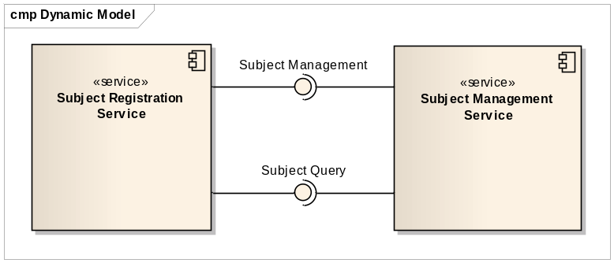
Component View depicting major Interactions of Subject Management Service

Relationship with other services
Service Name | Dependant / Depends | Data | Description
Other CTMS Services | Depends | Subject Demographic Data | Subject Registration Service depends on Subject Management Service for storage and retrieval of Subject’s demographics data. A snapshot of a subject’s demographics will be made by the Subject Registration service.

Non-Functional Requirements

Jurisdictional Domains

Jurisdictional Domains | Boundary
Trial Coordinating Center & Trial Sites | The Subject Management Service will be deployed at various institutions (along with Subject Registration Service) where trials will be conducted. They will be under jurisdiction of these individual centers

Deployment Considerations

Deployment Consideration | Impact
Remote Deployment Mode | Service should run remotely and be able to support remote client
Multiple Jurisdiction | Service should be able to be deployed across various institutions and be compliant with local jurisdictions
External Access | The coordinating center will need to be able to access the SM Query & SM Full Management profiles (via the Subject Registration Service) at each participating sites within the given study

Implementation Considerations

Implementation Consideration | Impact
Service to use the constrained ISO data types | The service developed might not be fully compliant with other ISO 21090 systems
Service to use NCI’s version of BRIDG v3.0.2 | The service developed might not be fully compliant with other BRIDG v3.0.2 systems

Assumptions

Assumptions | Affects
Audit & Logging is assumed to be handled by supporting infrastructure | As a result it is not explicitly referenced in individual operations and assumed to be done automatically
Authorization checks are enforced | Only authorized users will be allowed access
Historical Values are not considered in this specifications | Historical values will be stored as part of the registration record. Subject Registration Service will provide APIs to access the historical values.
Service doesn’t reflect the new demographics CRF requirements | Since they weren’t available at the start of the service, the demographic CRF requirements will be catered in the next revision of the service specifications
Support for single demographics information for a subjects | If multiple demographics need to be supported then demographic information needs to be captured at individual study level

Privacy

Data Element | Privacy Regulation | Access Requirement | Public Information
Subject | HIPAA | User needs to be member of Subject Manager group to have access to the complete subject record. | No public access.

Profiles

Functional Profiles

Profile No. | Profile Name | Profile Description
SM-FP1 | SM Query | This profile provides query functionality
SM-FP2 | SM Full Management | This Profile contains all operations related to subject management service including query.

Interface Operation No. | Interface Operation Name | Profile No. | Profile Name
SM-INF1-OP1 | querySubject | SM–FP1  SM–FP2 | SM Query  SM Full Management
SM-INF1-OP1 | advancedQuerySubject | SM–FP1  SM–FP2 | SM Query  SM Full Management
SM-INF2-OP1 | createSubject | SM–FP2 | SM Full Management
SM-INF2-OP2 | updateSubject | SM–FP2 | SM Full Management
SM-INF2-OP3 | updateSubjectState | SM–FP2 | SM Full Management

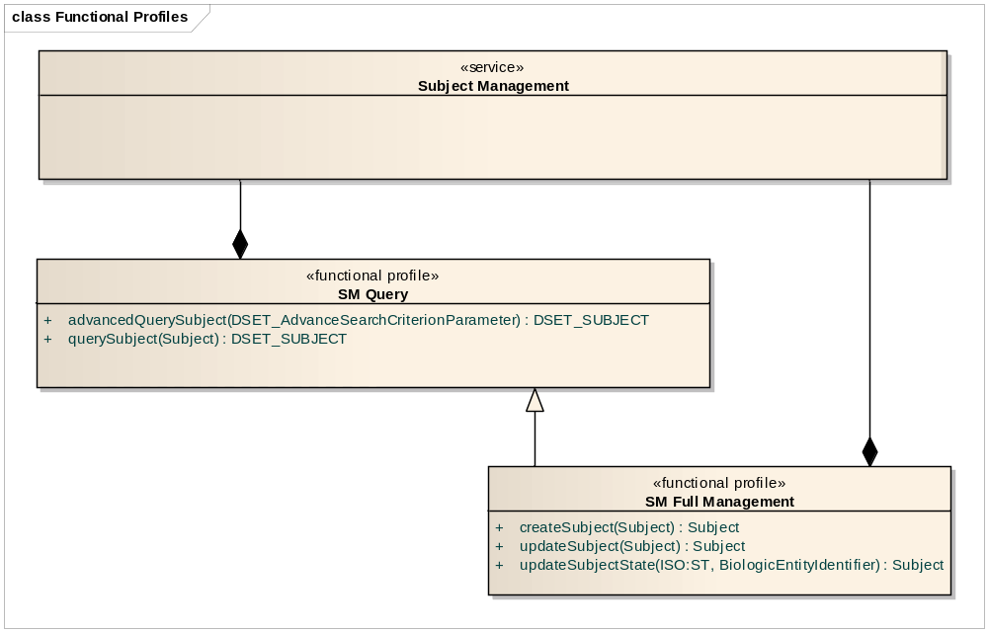
Profile view of the Operations of Subject Management Service

Semantic Profiles

Semantic Profile No. | Semantic Profile Name | Semantic Profile Description
SM-SP1 | BRIDG V3.0.2 Subject Management | BRIDG V3.0.2 based Subject Management Semantic Profile

Conformance Statements

Name | Type | Viewpoint | Description | Test method
Multiple Jurisdictions | Obligation | Enterprise | Implementers must provide an implementation that supports multiple jurisdictional domains to support different Coordinating Center and Sites as well as multi-site trials | Test cases include multiple domain scenarios
Query Performance | Obligation | Enterprise | The performance of the SMQuery interface should be within 0.2 second to return a single record from the underlying database | Test cases to include performance testing.
Conformance Profiles | Obligation | Computational / Information | In order to claim a minimal level of conformance to the Subject Management Service Specification, designers/implementers are obligated to support the following mandatory Conformance Profiles (i.e. their contained functional and semantic profiles): SM Query BRIDG V3.0.2 & SM Full Management BRIDG V3.0.2 | Test cases to be defined to test each specified profile.
Optional Functional Profiles | Permission | Computational | Implementers may implement the additional functional profiles not included in the mandatory conformance profiles. | Test cases to be defined to test each specified profile.
ISO Data types | Obligation | Information | Implementers are obliged to support ISO 21090 data types in all operations | Test cases to include processing of each relevant data type
Auditing | Obligation | Engineering | Designers/implementers are obligated to decide on and document the approach for logging or auditing of operation calls. | Design Review

Appendix A - References

Name | Description | Location
NCI’s BRIDG v3.0.2 | NCI’s BRIDG model used for modeling the SM Service | http://gforge.nci.nih.gov/frs/download.php/8831/BRIDG_Release_3.0.2_Package.zip
Use Case Document | Document containing use cases for the C3PR application | https://cabig-kc.nci.nih.gov/CTMS/KC/index.php/C3PR_Use_Cases
Subject Management Service CIM | Conceptual Functional Service Specification for Subject Management Service | https://ncisvn.nci.nih.gov/svn/c3pr/trunk/c3prv2/documentation/design/essn/SubjectManagement/CIM_Subject_Management_Service_CAT_response.doc

Appendix B - Glossary

Term | Description
BRIDG | The Biomedical Research Integrated Domain Group (BRIDG) has developed a comprehensive domain analysis model representing biomedical/clinical research.
C3PR | Cancer Central Clinical Patient Registry is the existing application developed by CTMS workspace which handles subject registration as well as subject management

Appendix C - Cross Reference Tables

Interface to Profile Mapping

Interface No. | Interface | Profile No. | Profile
SM-INF1 | SMQuery | SM-FP1 | SM Query
SM-INF2 | SMFullManagement | SM-FP2 | SM Full Management

Interface Operations to Profile Operations

Operation No. | Operation Name | Capability No. | Capability Name
SM-INF1-OP1 | querySubject | SM-CPB3 | Query Subject
SM-INF1-OP1 | advancedQuerySubject | SM-CPB3 | Query Subject
SM-INF2-OP1 | createSubject | SM-CPB1 | Create Subject
SM-INF2-OP2 | updateSubject | SM-CPB2 | Update Subject
SM-INF2-OP3 | updateSubjectState | SM-CPB4 | Update Subject Status

