WFU C3PR v2 Install Notes

Construction Iteration 4

07/23/2007

Overview

This document records the install notes of C3PR v2 Construction Iteration 4 at Wake Forest University (WFU). WFU is using the Windows/PostgreSQL configuration. WFU installed the C3PR v2 on a new, out of the box 2.80 GHz Dell GX620 Pentium 4 with 2.00GB of RAM running on a fully patched Windows XP SP2 operating system with WFU. The machine is part of the WFU Baptist Medical Center Domain, and domain security settings are enforced as a group policies. The PC also has Trend Micro antivirus enterprise edition and patch management software (SMS) installed and running. WFU began the installation process on 07/23/07 and finished on 07/24/07.

This is the first time the graphical installer was used to install C3PR v2 automatically. It’s a significant improvement, and it’s much easier for general users to install. Overall the install process documentation was adequate for the current target audience (adopters, who are more familiar with the software and are probably more technically informed than the broader population of potential end users of caTISSUE).

Problems

- Java related issue: compiler error. See error screen shot below.

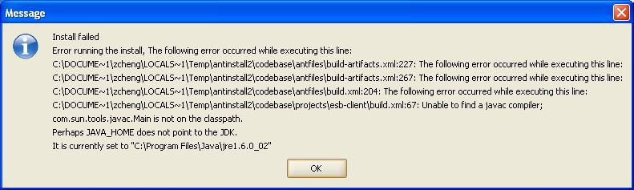

Solution: copy the tools.jar file from $JAVA_HOME/lib/ to C:\Program Files\Java\jre1.6.0_02\lib\ext directory. This is the path the installer uses to search for the javac compiler. The installation guide currently lists an incorrect path.

- PostgreSQL database related issue: authority error
Solution: Start >> All Programs >> PostgreSQL 8.2 >> Configuration Files >> Edit pg_hba.conf, update ‘md5’ in the only line code to ‘trust’

- Database does not exist
Solution: User has to manually create c3pr_dev database by using pgADmin III, then plug in database name, username and password to the configuration in the installer. The installation guide, while explicit that this must be done, should include some instructions on how it is to be done.

- Configuring multiple Tomcat servers
The configuration in our installation is complicated by having more than one caBIG application, requiring multiple TomCat instances. We switched the value for CATALINA_HOME in the system environment for each Tomcat server to start it. We were not sure if this was correct, but received a confirmation from the developers.

