Conceptual Functional Service Specification

Subject Registration

1.0.1

06/30/2010

Architecture Inception Team | Kalpesh Patel, Christo Andonyadis
Editor | Brian McIndoe, Kunal Modi, Santosh Joshi
Authors | Brian McIndoe

Document Version | Date | Author | Changes
0.0.1 | 11/02/2009 | Brian McIndoe | Initial Draft.
0.0.2 | 11/09/2009 | Brian McIndoe | Edits made for ESST review feedback.
0.0.3 | 11/15/2009 | Brian McIndoe | Added StudySubject State Transition Diagram edits.
0.0.4 | 12/11/2009 | Brian McIndoe | Incorporated Kunal Modi’s review feedback.
0.0.5 | 12/14/2009 | Brian McIndoe | Incorporated review feedback from the C3PR team.
0.0.6 | 3/10/2010 | Brian McIndoe | Removed reference to Protocol Management services. Added reference to Protocol Life Cycle service. Clarified federated architecture approach. Modified capabilities to include Person Demography data. Added note that the State Transition diagram is provisional. Added BioLogicEntityIdentifier and StudySubjectIdentifier classes
0.0.7 | 4/19/2010 | Kruttik Aggarwal | Updated the document as per our analysis with C3PR elaborators and adoptors.
0.1.0 | 5/18/2010 | Kruttik Aggarwal | Added the new state flow diagram.
0.1.2 | 5/28/2010 | Kruttik Aggarwal | Added comments from elaborators.
1.0 | 6/24/2010 | Kruttik Aggarwal | Added comments from Topaloglu Umit (UAMS).
1.0.1 | 6/30/2010 | Denis Krylov | Added IM diagrams.

Table of Contents
1 Overview and Business Case 4
1.1 Service Description and Purpose 4
1.2 Scope 5
1.3 Assumptions 7
2 Business Storyboards 9
2.1 Primary Actors 9
2.1.1 People Actors 9
2.2 Story Boards 9
2.2.1 Overview 9
2.2.2 SR-SB1 – Obtain Informed Consent 10
2.2.3 SR-SB2 – Screen for Eligibility 10
2.2.4 SR-SB3 – Capture Demography and Registration Data 10
2.2.5 SR-SB4 – Initiate a Subject Pre-Registration 11
2.2.6 SR-SB5 – Complete Subject Pre-Registration 11
2.2.7 SR-SB6 – Enroll Subject 12
2.2.8 SR-SB7 – Randomize and Assign to an Arm 12
2.2.9 SR-SB8 – Register Subject to Companion Studies 13
2.2.10 SR-SB9 – Re-consent the subject 13
2.2.11 SR-SB10 – Query Registration Data 13
2.2.12 SR-SB11 – Report Accrual Data 14
2.3 Subject Registration Activity Diagram 14
2.4 StudySubject State Transition Diagram 17
3 Detailed Functional Model 19
3.1 Structure of the Service 19
3.2 Detail of the Capabilities 20
4 Profiles 31
4.1 Functional Profiles 31
4.2 Semantic Profiles 32
4.3 Conformance Profiles 32
5 Information Model 35
6 System Interaction Details 36
6.1 Implementation/Deployment Considerations 38
7 Conformance and Compliance 40
7.1 Compliance and Conformance Statements 40
8 Appendix A – Relevant Standards 42
9 Appendix B - References 43
10 Appendix C - Glossary 44
11 Appendix D – Cross Reference Tables 45
11.1 List of Storyboards 45
11.2 Storyboards to Capabilities Mapping 47
11.3 List of Profiles 48
11.4 Actors 48

Overview and Business Case

Service Description and Purpose
The purpose of this service is to provide a set of interfaces to manage the clinical trials registration process, including multi-site studies. In addition, this service is intended to provide authoritative information on a subject’s registration.
This service will provide registrars at study sites with the ability to enroll subjects to clinical trials by making registration requests to the coordinating center. Typically, subjects are required to meet eligibility criteria for the study, which may include satisfactory lab results from a central pathology lab. In addition, the coordinating center needs to verify that sites requesting registration are in compliance with various regulatory requirements. The subject’s informed consent signed date is an important data element since it is used to determine if the subject signed the correct consent version. For e.g. if there was an amendment to the study and the consent form changed, the service needs to ensure that on the date the subject signed the consent, the given form was of correct version. Ensuring the right protocol version for enrollment is a necessity since all the enrollment requirements are scoped by the study protocol version. The service will be able to compute the right protocol version to enroll the subject using the informed consent signed date. Informed consent date is also used to check if the site was active on the specified date. The services will be able to determine the sufficient conditions to approve a registration and hence no manual intervention is required by a StudyRegistrar.
Depending upon the study design, it may be necessary to pre-register a subject to a screening epoch. It would only be on the completion of screening activities that a subject would finally be registered to the trial and move on to a treatment epoch.
For certain types of trials with limited enrollment capacity (e.g., a phase I trial), a study site will want to request a slot reservation prior to making a registration request. Such a requirement can be enforced as part of the study design. Once the design is in place, this service will help facilitate this type of request.
When the treatment is over, the subject can move on to the followup epoch or another treatment epoch as per the study design. Subjects can also go off-study due to various reasons. The ‘Off Study Reason Code (CDE- 2003606)’ will be leveraged to define the possible values. Optionally the service will also use ‘Off Treatment Reason Code (CDE- 2179998)’ in cases where a subject comes off a treatment epoch and moves to another epoch (followup or another treatment epoch). Similarly the service will use a defined set of ‘Off Screening Reason code (CDE not available)’ to move subject from screening epoch to some other epoch. Please refer to the state flow diagrams.
In general, the study design will define the number and kinds of epochs that a subject might or might not go through during its participation in the study. This service will facilitate in tracking a subject through the study.
This service will also help the coordinating center with certain registration update tasks such as facilitating a transfer of a registered subject from one study site to another. A number of reporting needs is also met by this service such as accrual data, screening results and demography data.

When a pre-registration or registration request is made by a Site Registrar, the Subject Registration service will consume the Subject Management service in order to take a snapshot of a subject’s demography data. The captured demography data would then be associated with the subject registration and managed independently of the demography data in the Subject Management service. However, the Subject Management service will send notification messages to Site Registrars notifying them of any changes made to demographic data for a subject. It will be the Registrars responsibility to determine whether this change should be reflected in the subject’s registration record.
The development of a common, reusable set of interfaces provided by this service will facilitate standardization, integration and interoperability between various systems that provide subject registration functionality, or need access to authoritative registration information.
This Service Specification provides a key infrastructure component for NCI to support Subject Registration management, accrual reporting, and integration with other systems. This service serves as a main platform for integrating registration management needs among all heterogeneous systems/components independent of platform within the clinical domain.

Scope
The scope of this service is to provide the ability to register a subject to a clinical trial. This includes reserving a slot for a trial with limited availability (e.g., a phase I trial) and pre-registration where the study protocol requires it. Registration to embedded companion studies is also within scope. The scope also includes the ability to move and track subjects from one epoch to another and provide an easy way to retrieve the state of a subject on a study with proper reason codes as defined in the state flow diagram. The table below provides a list of items that are in scope or out of scope.
This service will support a federated registration model where providers and consumers may reside on different networks within different security domains. This can be leveraged to facilitate multi-site trials
Items | Scope / Out of Scope | Source
Provide the ability to Initiate a Subject Registration, including a pre-registration and a slot reservation | Scope | Subject Registration Service Scope Document
Provide the ability to retrieve and approve a Subject Registration request, including a pre-registration and a slot reservation | Scope | Subject Registration Service Scope Document
Provide Subject Randomization and Arm Assignment | Scope | Subject Registration Service Scope Document
Provide the ability to move subject from one epoch to another | Scope | Discussions with C3PR elaborators
Provide the ability to track a subject through the study | Scope | Discussions with C3PR elaborators
Provide ability to do back dated registration | Scope | Discussions with C3PR elaborators
Provide ability to enroll subject on the correct protocol version (amendment) | Scope | Discussions with C3PR elaborators
Provide ability to retrieve subject’s status on the trail with proper reason codes | Scope | Discussions with C3PR elaborators
Provide the ability to register a subject to mandatory embedded companion studies defined in the main study protocol | Scope | Storyboard discussions with SMEs
Provide the ability to update Subject Registration Information, including the ability to transfer from one study site to another | Scope | Subject Registration Service Scope Document
Provide the ability to query Subject Registration Information including demography data specific to a registration | Scope | Subject Registration Service Scope Document
Provide Accrual, Screening and Demography Reporting | Scope | Subject Registration Service Scope Document
Provide Eligibility waiver | Scope | Discussions with C3PR elaborators

Assumptions
Assumption | Affects | Source
It is assumed that this service will be used for registering subjects to a clinical trial, thus the pre-condition of an approved Study Protocol must be met. | Information about the approved Study protocol must be available at the time of initiation of the registration request. | Subject Registration Storyboard
It is assumed that the Study Protocol Lifecycle service is capable of handing epoch design. | Epochs are the fundamentals of the study design and will be used extensively for registration. | Registration State Flow Diagram
Registration requests from sites will be processed through a central coordinating center. | A coordinating center needs to be established to process all site registration requests. | Subject Registration Storyboard
This service will require the following supporting services to be in place in order to provide all functionality:  - Subject Management  - Protocol Life Cycle  - Eligibility  - Credentialing  - Randomization  - Scheduled Calendar | If one or more of these dependencies is not available then there will be degradation in capabilities provided by this service. | Subject Registration Conceptual Functional Service Specification
Subjects will be registered to embedded mandatory companion studies. Additionally, subjects will be registered to any other companion studies that have all mandatory data entered. |  | Subject Registration Conceptual Functional Service Specification
Study Registrar is located at the Coordinating Center | None | Subject Registration Conceptual Functional Service Specification
Site Registrar and CRA are located at the study site | None | Subject Registration Conceptual Functional Service Specification
Multi-site and Multi-Institutional studies will have one Coordinating Center only. | Multiple Coordinating Centers per study are not supported. | Subject Registration Conceptual Functional Service Specification

Business Storyboards

Primary Actors

People Actors
Name | Role | Notes
Dr David Jones | Study Registrar | Located at the Coordinating Center
Sally Smith | Site Registrar | Located at the Study Site
Lucy Taylor | CRA | Located at the Study Site
Jerry Carlos | Subject
Mary Brown | Subject
Dr John Miller | Jerry’s Primary Care Provider

Story Boards

Overview
Detail | Dr David Jones is the Study Registrar for a Phase III randomized lung cancer study which he is conducting at Georgetown. The study has been approved by the sponsor (NCI in this case) as well as the local IRB (at Georgetown) and is scheduled for trial at the Georgetown site.  The study is open for enrollment and accrual can begin. Subjects are required to be pre-registered for screening prior to completion of full registration. Sally Smith who is the Site Registrar at Georgetown can now start identifying subjects for the trial.  There are four ways by which a subject is identified for the trial.  - Self Referral – where the subject discovers the trial via an advertisement in the print or electronic media and refers him/herself to the trial  - Physician-referral – where a physician encourages the subject to join the trial which he believes could benefit the subject  - Enrolling physician is the primary care doctor – where the doctor who is providing the standard of care to the subject is also a physician on the trial  - caMATCH – where potential candidates are identified by prospective mining of patient databases.  Dr John Miller has referred Jerry Carlos as a subject for the lung cancer study at Georgetown

SR-SB1 – Obtain Informed Consent
Outline | The study protocol calls for a subject to be pre-registered. In order to proceed, the study site must first obtain the subject’s informed consent.
Detail | Prior to being pre-registered, Jerry is required to provide his informed consent to participate on the trial. The Clinical Research Associate provides the current Informed Consent documents to Jerry and reviews the information with him. After reading and comprehending the consent form, it is signed and dated by Lucy as well as Jerry. A copy of the signed consent form must be given to the subject as a reference and reminder of the information conveyed.

SR-SB2 – Screen for Eligibility
Outline | Many studies require that a subject be screened for eligibility. Depending upon the screening requirements. A sample may need to be sent to a lab for analysis.
Detail | Lucy begins to verify Jerry’s eligibility based on the study protocol. Eligibility determination may include a review of Jerry’s medical history including prior relevant tests and procedures. Additionally, specimens may be taken and sent to a central processing laboratory for analysis. Depending upon the study design a final eligibility determination may have to wait for the return of test results. If this is the case, a subject will be pre-registered to a screening epoch in order to obtain a Study Subject ID. A notification will then be sent to caTissue to expect a sample.

SR-SB3 – Capture Demography and Registration Data
Outline | Demography and Registration data needs to be recorded for each subject.
Detail | Lucy documents Jerry’s demography information according to the study protocol using a demography case report form. Demography data for a subject may include the following information items (but not limited to):  - Race, Ethnicity, Gender, Date of Birth, 2000 Census Tract Code, Country of Residence, Zip Code, Method of Payment, CDC Race Code, CDC Ethnicity Code, Education Level, Educational Attainment, Marital Status, Place of Birth  Lucy also documents Jerry’s registration information using a registration case report form. Registration information for a subject may include the following information items (but not limited to):  - Study Identifier, Prior Study Participation, Prior Participant Identifier, Registering Institution Code, Treating Physicians Name, Pre-registration Date, Responsible Clinical Research Associate Name and Contract Information, Projected Start Date of Treatment, Stratification Factors, Local Participant Identifier (Usually the facilities Medical Record Number), Specialist Physician Name

SR-SB4 – Initiate a Subject Pre-Registration
Outline | The Site Registrar initiates a Subject Pre-Registration.
Detail | Lucy collects all the above mentioned information including:  - Jerry’s Demography Data  - Jerry’s Registration Data  - Jerry’s Informed Consent  And submits it to Georgetown’s Site Registrar Sally Smith. Sally reviews all of the information for completeness and then submits it to the Coordinating Center for their review and processing.

SR-SB5 – Complete Subject Pre-Registration
Outline | The Study Registrar reviews and approves the pre-registration request.
Detail | It is only after review and approval from the Coordinating Center that Jerry will be pre-registered to the study. Since this is a single site trial, Georgetown also acts as the Coordinating Center for the study. However, the procedure is the same when registering subjects from multiple sites.  Dr. Jones who is the Study Registrar reviews all the submitted information to ensure:  - That the study is still open for enrollment  - That the site and its staff are in regulatory compliance (Form 1572 has been filed and the local IRB has approved the study)  - That Jerry is eligible for the trial and meets the criteria prescribed by the protocol.  After entering the required data, Jerry is assigned a Study Subject Id by the system and his status is updated to Pending On-Study. A notification is sent to caTissue to expect a sample.

SR-SB6 – Enroll Subject
Outline | When lab results are returned the screening phase is completed and a decision is made as to whether the subject meets Eligibility requirements or is not for the trial.
Detail | Jerry’s lab results are returned to the Coordinating Center from caTissue several days after samples were taken.  Dr. Jones reviews the results to make sure they are within acceptable limits according to the protocol. He also checks to make sure that the study is still open for enrollment and that the site and its staff are still in regulatory compliance. After entering any required data, Jerry’s status is updated in the system to reflect that he is now registered on the Study.

SR-SB7 – Randomize and Assign to an Arm
Outline | Studies often use a randomization service to assign a subject to a trial arm.
Detail | As this is a double blinded randomized trial with multiple treatment Arms, Dr. Jones needs to ensure that Jerry is assigned to a Study Arm in such a way that neither he nor Jerry will know what if any treatment Jerry is receiving. Dr. Jones consults the randomization service and then assigns Jerry to the designated Arm in the system. The details of Jerry’s Arm assignment are returned to Sally by Dr. Jones.  Only after assignment to an Arm is Jerry finally enrolled on the trial.

SR-SB8 – Register Subject to Companion Studies
Outline | Some trials have companion studies that subjects can be registered to. Companion studies may be either embedded in the protocol, or standalone. They may be either mandatory or optional according to the protocol.
Detail | The study to which Jerry has just been registered has an embedded companion study that is mandatory. Dr Jones uses Jerry’s information to register him for the companion study.  [Note: Subject’s will only be registered to embedded mandatory companion studies.]

SR-SB9 – Re-consent the subject
Outline | During the course of a trial, situations may arise that require an amendment to the protocol and consent from subjects that they understand any modifications and risks involved.
Detail | Three weeks after Jerry’s start date, another study subject experiences an unexpected serious adverse event that requires hospitalization. In light of this, Dr Jones after consultation with the local IRB decides to issue an amendment to the protocol to modify the dosage level. The protocol amendment will require that all participants be warned of the potential risk of continuing treatment and be required to sign a new consent form.  After the IRB approval of the amendment, an appointment is scheduled for Jerry to visit the study site. He signs the new consent form and Lucy notifies Dr Jones at the Coordinating Center that Jerry’s re-consent has been obtained.

SR-SB10 – Query Registration Data
Outline | Staffs at both Study Sites and at the Coordinating Center have multiple needs for querying subject registration data.
Detail | Several days after Jerry has registered to the trial a question arises about his registration which will require retrieving and viewing of his information. Lucy, the CRA enters Jerry’s name into a form and issues a query. All of Jerry’s registration related data is returned for her inspection.

SR-SB11 – Report Accrual Data
Outline | Periodic submissions of accrual data are required to be made to various agencies and bodies.
Detail | The Principal Investigator or Study Chair is responsible for reporting accrual data at both the study and site level. The body requesting accrual reports will determine the specific accrual data to be provided, however, it is likely to include the target accrual, and the accruals achieved over several time periods (e.g., last week, last month, last quarter, etc). It is also likely to need counts of subjects who did not complete the registration process for each identified reason.

Subject Registration Activity Diagram
The following diagram shows the registration process workflow.
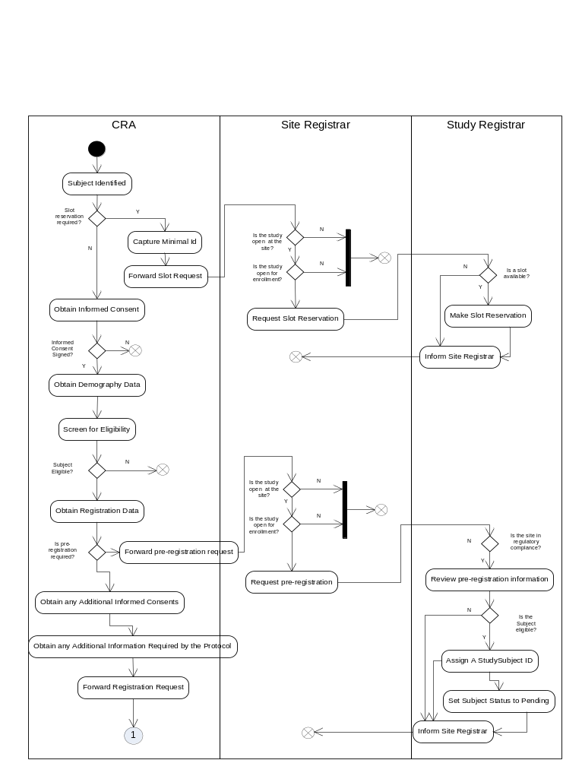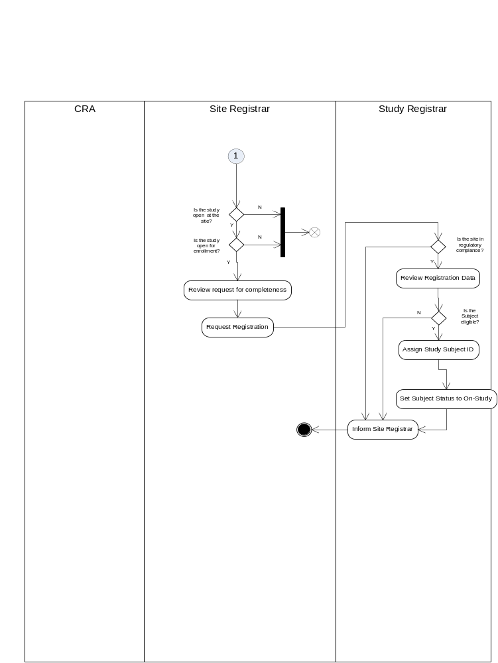

StudySubject State Transition Diagram
Note: The following diagram is prepared by the C3PR and BRIDG team.

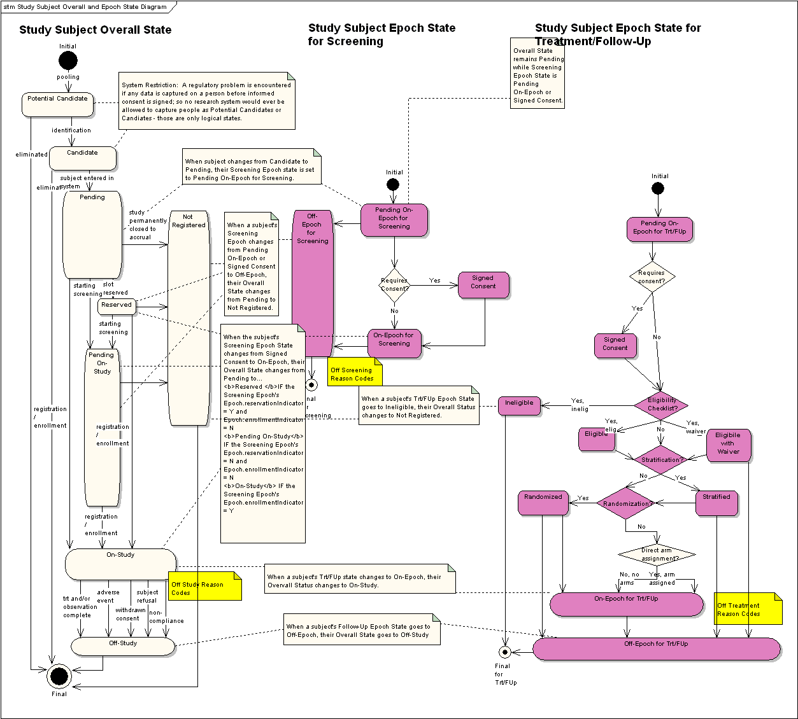

Detailed Functional Model

Structure of the Service
The following list of capabilities was created from an analysis of the storyboards.
Name | Description
Initiate Subject Registration | This capability is used to initiate subject registration on a study. An epoch (screening, reserving or treatment) assignment request is processed and the subject is assigned to the epoch. Note: the epochs are defined as part of the study design.
Change StudySubject Epoch Assignment | This capability is used to change the existing epoch assignment and to assign a subject to a new epoch in the study (from Screening to Treatment, Treatment to Followup etc.
Reconsent Subject | This capability is used to re-consent a subject.
Update Subject Registration | This capability is used to update a limited subset of information associated with a subject registration.
Take Subject Off Study | This capability is used to change the overall registration status of a StudySubject to ‘Off-Study’.
Fail Subject Screening | This capability is used to record screening failure for a subject registration. When a subject is taken off from a screening epoch due to screening failure, it will trigger a change in the overall registration status from ‘Pending On-Study’ to ‘Not Registered’.
Transfer a Registered Subject | This capability is used to transfer a registered subject from one study site to another.
Query Subject Registration Status History | This capability is used to query a StudySubject’s status history with reason codes and status dates.
Query Subject Registration | This capability is used to query and retrieve subject registration data including demography data. This also provides the capability to query epoch specific data, for e.g. it can be used to provide data on how many people were screened and how many failed screening for each possible reason.
Retrieve Accrual Data | This capability is used to provide study accrual data.
Retrieve Subject Demography History | This capability is used to provide an aggregate of subject data by demography, e.g., race, age, gender, ethnicity, marital status, etc.

Detail of the Capabilities
Name [M] | Initiate Subject Registration
Description [M] | Enables initiation of a registration request for a subject. A request may be for assignment on any of the epochs (reserving, screening or treatment) defined by the study. The information required to be submitted is the same in all cases.  Assigns the subject to the epoch in the registration system with all of the required fields populated. The subject registration request will obtain subject identification, contact and demography data from the Subject Management service.  If the epoch is enrolling and the study has mandatory companion studies, then the subject will be registered on the given companions.  If successful, an instance of a StudySubject containing the SubjectIdentifier (in case the epoch is enrolling) and companion StudySubjects is returned.
Pre-Conditions [M] | StudySite should be active.
Security Pre-Conditions [M] | Access control mechanism needs to be in place to ensure that the user is logged in and has valid privileges of a Site Registrar to Initiate Subject Registration.
Inputs [M] | StudySubject object (Populated with Registration Information for parent[M] as well as companion studies[O])  BioLogicEntity.identifier (this is the Hospital or Medical Record Number)  PerformedStudySubjectMilestone.informedConsentDate  Study Identifier  ScheduledEpoch Object (includes epoch name and other optional fields like stratification, eligibility etc.)
Outputs [M] | StudySubject
Post-Conditions [O] | If the registration request meets all the criteria, subject will be assigned to the epoch. The Status of the StudySubject will depend on multiple factors, for e.g. if all the regulatory needs are met by the site and the eligibility requirements are met by the subject and the epoch is enrolling, the status will be ‘On-Study’. Please refer to the state flow diagram for complete list and dependencies of StudySubject statuses.
Exception Conditions [M] | Subject (BioLogicEntity.identifier) is invalid  Subject is already registered  Study is invalid  Study is not approved  Study is not open for enrollment  Study site is out of compliance  Epoch is invalid  Mandatory companion registration missing  Invalid data type or code value for any attribute
Aspects left for Technical Bindings [O]
Notes [O] | The type of identifier generated would depend on the epoch. For e.g a SlotReservation Identifier will be generated if it is a reserving epoch, a StudySubject Identifier will be generated if the epoch is enrolling (Treatment Epoch).

Name [M] | Change StudySubject Epoch Assignment
Description [M] | Enables changing the assignment of a subject to a new epoch in the study, e.g. from screening to treatment, from treatment to Follow-up.  If the new epoch is enrolling and the study has mandatory companion studies, then the subject will be registered on the given companions.  If successful, the subject will be assigned to the new epoch.
Pre-Conditions [M] | Subject should already be assigned to the study.
Security Pre-Conditions [M] | Access control mechanism needs to be in place to ensure that the user is logged in and has valid privileges of a Site Registrar to Change StudySubject Epoch Assignment.
Inputs [M] | SubjectIdentifier.identifier  ScheduledEpoch Object (includes epoch name and other optional fields like stratification, eligibility etc.)  OffPreviousEpochReason Code  Companion StudySubject[O]
Outputs [M] | Updated Study Subject object.
Post-Conditions [O] | If the epoch assignment change request meets all the criteria, subject will be assigned to the epoch.
Exception Conditions [M] | Epoch is invalid  Study is not open for enrollment  Study site is out of compliance  Invalid data type or code value for any attribute  Mandatory companion registration missing
Aspects left for Technical Bindings [O]
Notes [O] | The success would depend on the states defined by the new epoch. For e.g. if the subject was on Screening Epoch and needs to be moved to a Treatment Epoch, and the Treatment Epoch requires stratification, the request must contain the stratification data. Once all the epoch level conditions are met, the request will be considered as eligible. The request will also need to provide OffPreviousEpochReason Code. In the example above, the Treatment Epoch assignment request will need to provide an Off Screening Epoch Reason Code (Type 4).

Name [M] | Take Subject Off Study
Description [M] | Enables changing the status of a StudySubject’s registration from “On-Study” to ‘Off-Study’.
Pre-Conditions [M] | Study Subject status is ’On-Study’.
Security Pre-Conditions [M] | Access control mechanism needs to be in place to ensure that the user is logged in and has valid privileges of a Study Registrar to Initiate Subject Registration Status Change.
Inputs [M] | SubjectIdentifier  OffStudyReasonCode
Outputs [M] | Updated Study Subject object
Post-Conditions [O] | Study Subject changed to ‘Off-Study’
Exception Conditions [M] | Study Subject Identifier is invalid  New Status is invalid  Invalid state transition  Invalid data type or code value for any attribute
Aspects left for Technical Bindings [O]
Notes [O] | OffStudyReasonCode is a CDE.

Name [M] | Fail Subject Screening
Description [M] | Enables screening failure for a subject registration. When a subject is taken off from a screening epoch due to screening failure, it will trigger a change in the overall registration status from ‘Pending On-Study’ to ‘Not Registered’.
Pre-Conditions [M] | Subject is assigned to “Screening” epoch.
Security Pre-Conditions [M] | Access control mechanism needs to be in place to ensure that the user is logged in and has valid privileges of a Study Registrar to Initiate Subject Registration Status Change.
Inputs [M] | SubjectIdentifier  OffEpochReasonCode
Outputs [M] | Updated Study Subject object
Post-Conditions [O] | Study Subject overall status changes to ‘Not Registered’ and epoch status changes to ‘Off-Epoch’.
Exception Conditions [M] | Study Subject Identifier is invalid  New Status is invalid  Invalid state transition  Invalid data type or code value for any attribute
Aspects left for Technical Bindings [O]
Notes [O] | OffScreeningReasonCode (CDE under review)

Name [M] | Reconsent Subject
Description [M] | Enables reconsenting a subject to the amended study version.
Pre-Conditions [M] | Subject has signed an older consent form.
Security Pre-Conditions [M] | Access control mechanism needs to be in place to ensure that the user is logged in and has valid privileges of a Study Registrar to Update Subject Registrations.
Inputs [M] | SubjectIdentifier  PerformedStudySubjectMilestone.informedConsentDate
Outputs [M] | A confirmation that the Update has been successfully performed
Post-Conditions [O] | Study Subject consent information is updated.
Exception Conditions [M] | Study Subject Identifier is invalid  Invalid consent
Aspects left for Technical Bindings [O]
Notes [O]

Name [M] | Update Subject Registration
Description [M] | Enables updates to Subject Registration, including the Subject demography and correction of data entry errors.
Pre-Conditions [M] | Subject is assigned to an epoch (they have a valid SubjectIdentifier.identifier)
Security Pre-Conditions [M] | Access control mechanism needs to be in place to ensure that the user is logged in and has valid privileges of a Study Registrar to Update Subject Registrations.
Inputs [M] | StudySubject object populated with updated values  BioLogicEntity.identifier (this is the Hospital or Medical Record Number) [O]  SubjectIdentifier object
Outputs [M] | A confirmation that the Update has been successfully performed
Post-Conditions [O] | Study Subject and Subject demography data is updated
Exception Conditions [M] | StudySubject object is incorrectly formed  Person object is incorrectly formed  Study Subject Identifier is invalid  Subject (BioLogicEntity.identifier) is invalid  Invalid data type or code value for any attribute
Aspects left for Technical Bindings [O]
Notes [O] | If a Demographic data attribute is changed, then a history of the previous value(s) of that attribute needs to be maintained and be available for query and retrieval.

Name [M] | Transfer Registered Subject
Description [M] | Enables transfer of a registered StudySubject from one study site to another.
Pre-Conditions [M] | Subject is assigned to an epoch.
Security Pre-Conditions [M] | Access control mechanism needs to be in place to ensure that the user is logged in and has valid privileges of a Study Registrar to Transfer Subject Registration.
Inputs [M] | SubjectIdentifier.identifier  New Site Identifier
Outputs [M] | A confirmation message that the subject registration has been updated
Post-Conditions [O] | StudySubject site is updated to new site
Exception Conditions [M] | StudySubject Identifier is invalid  New Site Identifier is invalid
Aspects left for Technical Bindings [O]
Notes [O] | What happens to the enrolling physician assigned to the registration record? Need to discuss this with C3PR elaborators.

Name [M] | Query Subject Status History
Description [M] | Retrieves the history of a StudySubject status and the respective dates. The result also includes the ReasonCodes for each status, if applicable.
Pre-Conditions [M] | Subject is assigned to an epoch.
Security Pre-Conditions [M] | Access control mechanism needs to be in place to ensure that the user is logged in and has valid privileges to Query Subject Registrations.
Inputs [M] | SubjectIdentifier.identifier  IncludeEpochStatuses flag – If set, the result will include the Epoch level status history.
Outputs [M] | StudySubjectStatusHistory (includes dates and ReasonCodes).  StudySubjectEpochStatusHistory[O]
Post-Conditions [O] | None
Exception Conditions [M] | SubjectIdentifier.identifier is invalid
Aspects left for Technical Bindings [O]
Notes [O]

Name [M] | Query Subject Registration
Description [M] | Enables queries of StudySubject registration information including demography data.
Pre-Conditions [M] | None
Security Pre-Conditions [M] | Access control mechanism needs to be in place to ensure that the user is logged in and has valid privileges to Query Subject Registrations.
Inputs [M] | Query Object
Outputs [M] | Collection of matching SubjectIdentifier, StudySubject and Person objects
Post-Conditions [O] | None
Exception Conditions [M] | Query Attribute does not exist  Query Value is incorrect type
Aspects left for Technical Bindings [O]
Notes [O] | Query By Example

Name [M] | Retrieve Accrual Data
Description [M] | Accrual data is required to be reported to a number of agencies and bodies.  Because each agency has its own accrual data reporting requirements and format, it is envisioned that this service will provide raw accrual data to an external reporting service which would then be responsible for selecting and formatting the appropriate values for report presentation.
Pre-Conditions [M] | Study is valid
Security Pre-Conditions [M] | Access control mechanism needs to be in place to ensure that the user is logged in and has valid privileges to execute Retrieve Accrual Data.
Inputs [M] | Study Identifier  Site Identifier [O]
Outputs [M] | Accrual Data Object
Post-Conditions [O] | None
Exception Conditions [M] | Study Identifier is invalid
Aspects left for Technical Bindings [O]
Notes [O]

Name [M] | Retrieve Demography Data
Description [M] | Demography data is required to be reported to a number of agencies and bodies.  A report that describes an aggregate of subject or study subject demographic data, e.g., age, race, ethnicity, gender, marital status)
Pre-Conditions [M] | Study is valid
Security Pre-Conditions [M] | Access control mechanism needs to be in place to ensure that the user is logged in and has valid privileges to execute Retrieve Demography Data.
Inputs [M] | Study Identifier
Outputs [M] | Demography Data Object
Post-Conditions [O] | None
Exception Conditions [M] | Study Identifier is invalid
Aspects left for Technical Bindings [O]
Notes [O]

Profiles

Functional Profiles
Functional Profile No. | Functional Profile Name | Functional Profile Description | Capability Name
SR-FP1 | SR Query | This profile provides query functionality | - Query Subject Registration  - Query Subject Registration Status History
SR-FP2 | SR Site | This profile contains all registration request capabilities used by a study site. | - Initiate Subject Registration  - Change StudySubject Epoch Assignment  - Reconsent Subject  - Update Subject Registration  - Take Subject Off Study  - Fail Screening  - Query Subject Registration  - Query Subject Registration Status History
SR-FP3 | SR CCenter | This profile contains all registration approval capabilities used by a coordinating center. | - Transfer Registered Subject  - Query Subject Registration  - Query Subject Registration Status History  - Retrieve Accrual Data
SR-FP4 | SR Reports | This profile provides the ability to retrieve data for use in submission reports. | - Retrieve Accrual Data  - Retrieve Demography Data  - Query Subject Registration  - Query Subject Registration Status History

Semantic Profiles
Semantic Profile No. | Semantic Profile Name | Constrained Information Model | Operations using the Semantic Profile
SR-SP1 | BRIDG V3.0.1 Subject Registration | BRIDG V3.0.1 | - Initiate Subject Registration  - Change Subject Registration Status Change  - Transfer Registered Subject  - Update Subject Registration

Conformance Profiles

Name | SR Query BRIDG V3.0.1
Version | V1.0
Description | This is the conformance profile required for querying Subject Registration Information.
Usage Context | This profile could have multiple uses where registration information is required.
Functional Profile(s) | SR-FP1 : SR Query
Semantic Profile(s) | SR-SP1 : BRIDG V3.0.1
Security | Yes
Other….

Name | SR Site BRIDG V3.0.1
Version | V1.0
Description | This is the conformance profile required for a study site making registration requests.
Usage Context | A study site making subject registration requests.
Functional Profile(s) | SR-FP2 : SR Site
Semantic Profile(s) | SR-SP1 : BRIDG V3.0.1
Security | Yes
Other….

Name | SR Reports BRIDG V3.0.1
Version | V1.0
Description | This is the conformance profile required for a coordinating center providing study accrual information, screening data and demography data.
Usage Context | Providing accrual, screening and demography information to agencies and regulatory bodies.
Functional Profile(s) | SR-FP4 : SR Reports
Semantic Profile(s) | SR-SP1 : BRIDG V3.0.1
Security | Yes
Other….

Information Model
The following Subject Registration-related classes are mainly taken from the BRIDG 3.0.1 analysis model.

Subject
The following diagram depicts core classes related to Subject:
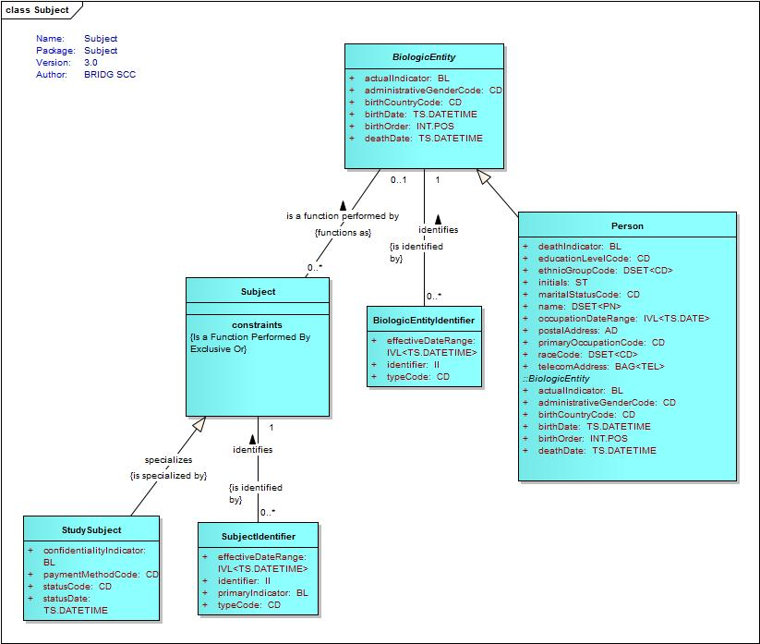

Registration
The following diagram depicts classes related to registration:
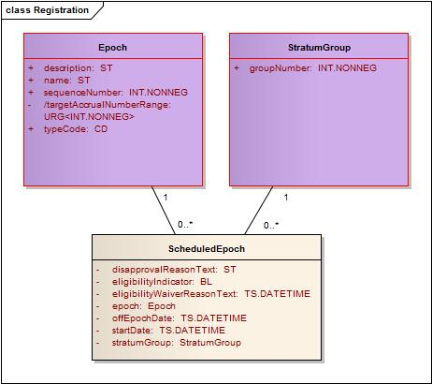

System Interaction Details
The following diagram shows the interaction between the Site Registrar making a request for a subject registration (via the Subject Registration service) and the interaction between the Subject Registration service and the Protocol Life Cycle service to determine whether a study is open for enrollment.
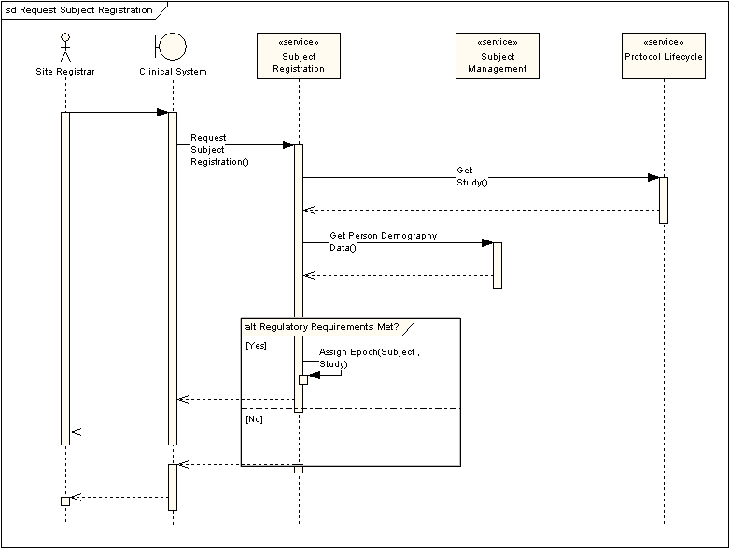

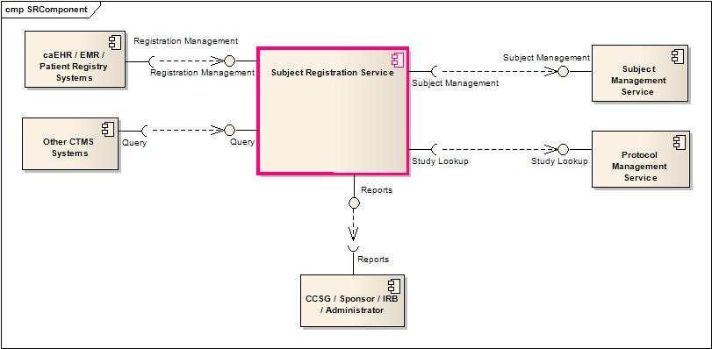
Component view depicting major interactions of the Subject Registration Service

Implementation/Deployment Considerations
Implementation Considerations | Impacts
The deployment of this service may require most capabilities to support federation. It is possible that some profiles may have a mix of locally and remotely provided capabilities. Federation in this context means services that span more than one jurisdiction. | The system may need to be configured such that specific profiles are served by different processes.

The following diagram shows a multisite deployment scenario for the Subject Registration service. Each site is responsible for maintaining its Subject Registration related information locally. A Site Registrar can make a request for registration which will be held in the local service instance. A Study Registrar at a Study Coordination Center can then retrieve the request and process it. All of the data remains at the local site.

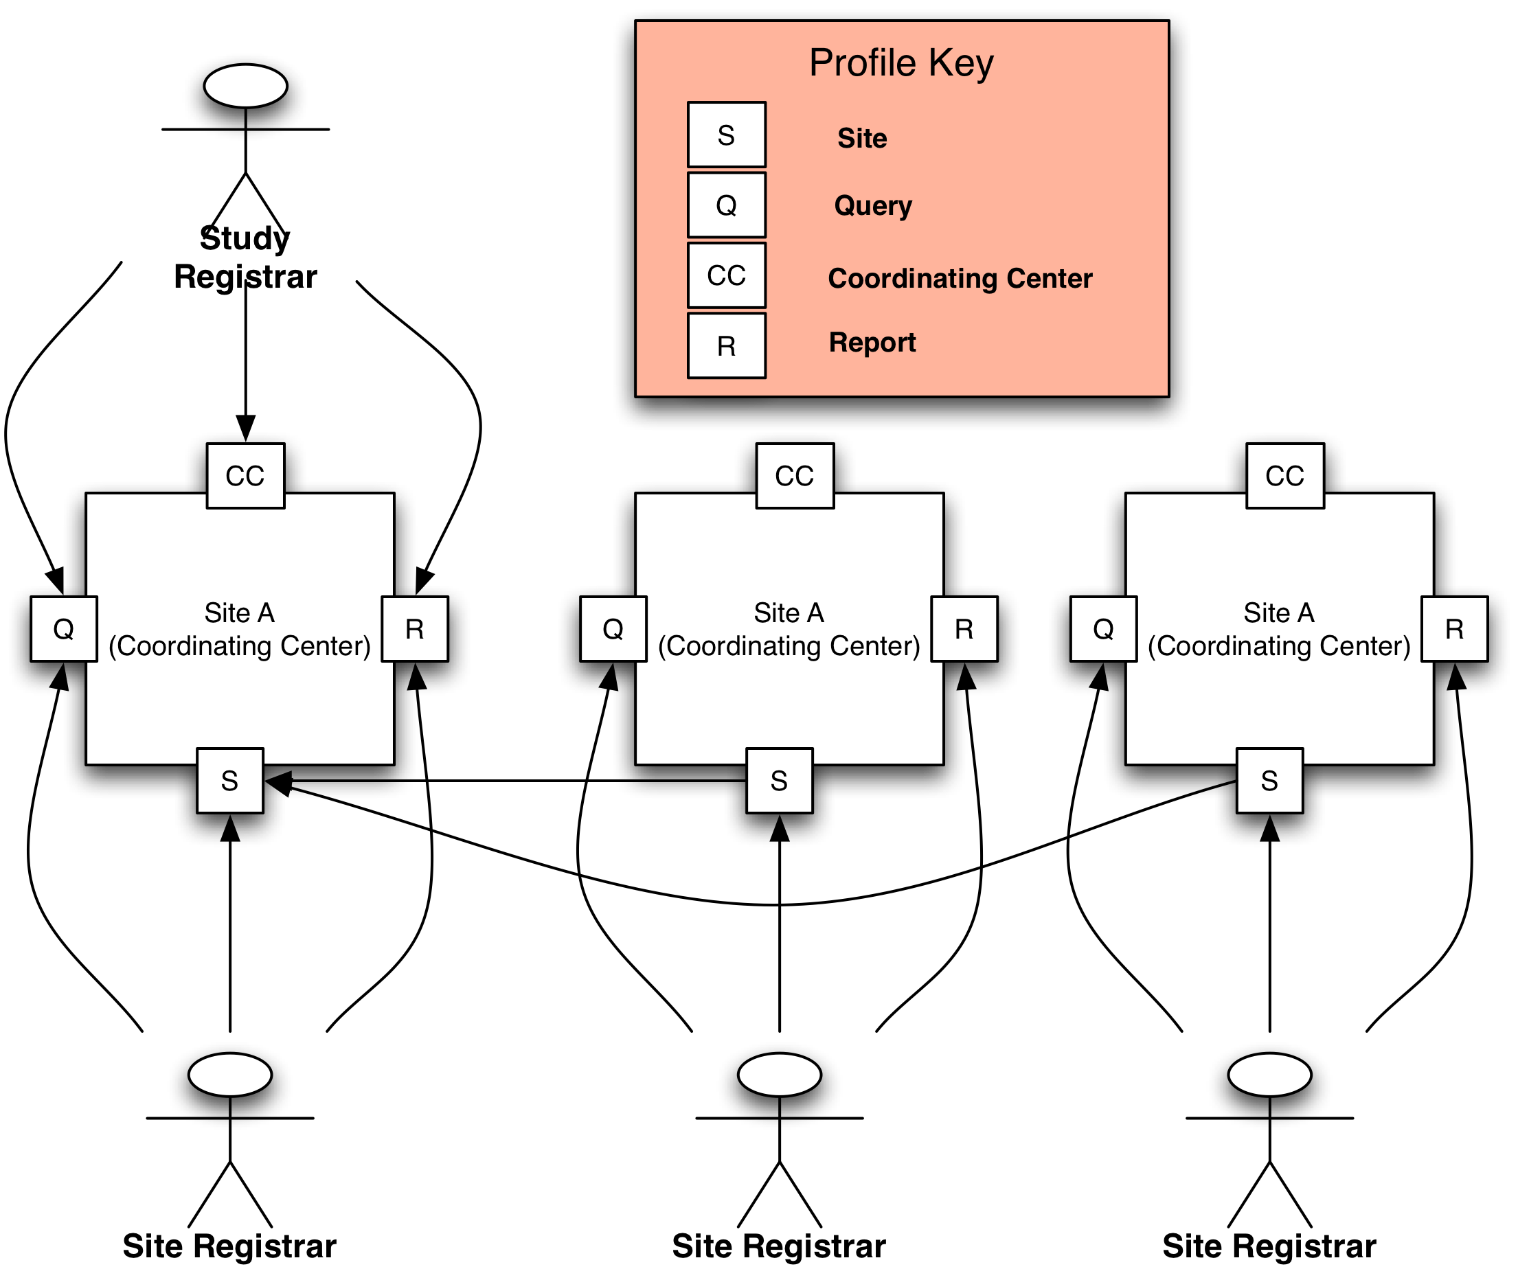

Conformance and Compliance

Compliance and Conformance Statements
Name | Type | Viewpoint | Description | Test method
Multiple Jurisdictions | Obligation | Enterprise | The Subject Registration Service is obligated to be able to support processing across multiple jurisdictional domains. Implementers must provide an implementation that supports multiple jurisdictional domains | Test cases include multiple domain scenarios
Query Performance | Obligation | Enterprise | The query for SR criteria for a subject on a study should return results in 3 seconds | Test cases to include performance testing.
Conformance Profiles | Obligation | Computational / Information | In order to claim a minimal level of conformance to the Subject Registration specification, designers/implementers are obligated to support the following mandatory Conformance Profiles (i.e. their contained functional and semantic profiles): SR Query BRIDG V3.0.1, SR Site BRIDG V3.0.1, SR CCenter BRIDG V3.0.1 | Test cases to be defined to test each specified profile.
Optional Functional Profiles | Permission | Computational | Designers/implementers may implement the additional functional profiles identified in section 4.1 not included in the mandatory conformance profiles. | Test cases to be defined to test each specified profile.
ISO Datatypes | Obligation | Information | Designers/implementers are obliged to support ISO 21090 datatypes in all operations | Test cases to include processing of each relevant data type
Auditing | Obligation | Engineering | Designers/implementers are obligated to decide on and document the approach for logging or auditing of operation calls. | Design Review
Operation Behavior Issues / Assumptions | Obligation | Computational / Information / Engineering | Architects/Designers/Developers are obligated to confirm (or refute) all Assumptions made in the Notes for Service Realization sections of each operation and the overall Assumptions section. | Design Review

Appendix A – Relevant Standards
Name | Description | Location
BRIDG v3.0.1 | BRIDG model | http://gforge.nci.nih.gov/frs/shownotes.php?release_id=3780
HL7v3 | Health Level 7 version 3 | http://www.hl7.org/implement/standards/v3messages.cfm

Appendix B - References
Name | Description | Location
BRIDG v3.0.1 | BRIDG model | http://gforge.nci.nih.gov/frs/shownotes.php?release_id=3780
C3PR Use Case Document | Document containing use cases for the C3PR application | https://cabig-kc.nci.nih.gov/CTMS/KC/index.php/C3PR_Use_Cases
BAM v1.1 | Business Architecture Model | https://cabig-kc.nci.nih.gov/CTMS/KC/index.php/Biomedical_Research_Business_Architecture_Modeling

Appendix C - Glossary
Term | Description
BRIDG | The Biomedical Research Integrated Domain Group (BRIDG) has developed a comprehensive domain analysis model representing biomedical/clinical research.
C3PR | Cancer Central Clinical Patient Repository

Appendix D – Cross Reference Tables

List of Storyboards
# | Name | Description | Source
SR-SB1 | Obtain Informed Consent | The study protocol calls for a subject to be pre-registered. In order to make the request, the study site must first obtain the subject’s informed consent. | Storyboard Document
SR-SB2 | Screen for Eligibility | Many studies require that a subject be screened for eligibility. Depending upon the screening requirements a sample may need to be sent to a lab for analysis. | Storyboard Document
SR-SB3 | Capture Demography and Registration Data | Demography and Registration data needs to be recorded for each subject. | Storyboard Document
SR-SB4 | Initiate a Subject Pre-Registration | The Site Registrar initiates a Subject Pre-Registration | Storyboard Document
SR-SB5 | Complete Subject Pre-Registration | The Study Registrar reviews and approves the pre-registration request | Storyboard Document
SR-SB6 | Update Subject Full Registration | When lab results are returned the screening phase is completed and a decision is made as to whether the subject meets requirements or is not eligible for the trial | Storyboard Document
SR-SB7 | Randomize and Assign to an Arm | Studies often use a randomization service to assign a subject to a trial arm. | Storyboard Document
SR-SB8 | Register Subject to Companion Studies | Some trials have companion studies that subjects can be registered to. These companion studies may be either mandatory or optional according to the protocol. | Storyboard Document
SR-SB9 | Re-consent the subject | During the course of a trial, situations may arise that require an amendment to the protocol and consent from subjects that they understand any modifications and risks involved. | Storyboard Document
SR-SB10 | Query Registration Data | Staffs at both Study Sites and the Coordinating Center have multiple needs for querying subject registration data. | Storyboard Document
SR-SB11 | Report Accrual Data | Periodic submissions of accrual data are required to be made to various agencies and bodies. | Storyboard Document

Storyboards to Capabilities Mapping
# | Storyboard | Profiles | Actors | Capabilities
SR-SB1 | Obtain Informed Consent | SR Site BRIDG V3.0.1 | Patient, Clinical Research Associate (CRA), Site Registrar | Initiate Subject Registration
SR-SB6 | Update Subject Full Registration | SR CCenter BRIDG V3.0.1 | Study Registrar | Initiate Subject Registration
SR-SB2 | Screen For Eligibility | SR CCenter BRIDG V3.0.1 | Study Registrar | Initiate Subject Registration
SR-SB3 | Capture Demography and Registration Data | SR Site BRIDG V3.0.1, SR CCenter BRIDG V3.0.1 | Site Registrar, Study Registrar | Initiate Subject Registration
SR-SB4 | Initiate a Subject Pre-Registration | SR Site BRIDG V3.0.1 | Site Registrar | Initiate Subject Registration
SR-SB5 | Complete Subject Pre-Registration | SR CCenter BRIDG V3.0.1 | Study Registrar | Initiate Subject Registration
SR-SB6 | Randomize and Assign to an Arm | SR CCenter BRIDG V3.0.1 | Study Registrar | Initiate Subject Registration
SR-SB8 | Register Subject to Companion Studies | SR CCenter BRIDG V3.0.1 | Study Registrar | Initiate Subject Registration
SR-SB9 | Re-consent the subject | SR Site BRIDG V3.0.1, SR CCenter BRIDG V3.0.1 | Site Registrar, Study Registrar | Reconsent Subject
SR-SB10 | Query Registration Data | SR Query BRIDG V3.0.1 | Site Registrar, Study Registrar | Query Subject Registration
SR-SB11 | Report Accrual Data | SR Accrual BRIDG V3.0.1 | Study Registrar | Retrieve Accrual Data

List of Profiles
Functional Profile No. | Functional Profile Name | Storyboard No. | Storyboards Supported
SR-FP1 | SR Query | SR-SB10 | Query Registration Data
SR-FP2 | SR Site | SR-SB1  SR-SB2  SR-SB3  SR-SB4 | Obtain Informed Consent  Screen for Eligibility  Capture Demography and Registration Data  Initiate a Subject Pre-Registration
SR-FP3 | SR CCenter | SR-SB5  SR-SB6  SR-SB7  SR-SB8 | Complete Subject Pre-Registration  Update Subject Full Registration  Randomize and Assign to an Arm  Register Subject to Companion Studies
SR-FP4 | SR Reports | SR-SB11 | Report Accrual Data

Actors
Actors | Profile | Type | Operations used
Clinical Research Associate | SR Site | Person | Query Registration Data  Obtain Informed Consent  Screen for Eligibility  Capture Demography and Registration Data  Initiate a Subject Registration
Site Registrar | SR Site | Person | Query Registration Data  Obtain Informed Consent  Screen for Eligibility  Capture Demography and Registration Data  Initiate a Subject Registration
Study Registrar | SR CCenter | Person | Query Registration Data  Retrieve Open Requests  Complete Subject Pre-Registration  Update Subject Full Registration  Randomize and Assign to an Arm  Register Subject to Companion Studies  Transfer Subject Registration

