Software Requirements Specification

Cancer Central Clinical Participant Registry (C3PR)
Version 2
Duke Comprehensive Cancer Center

Background/Summary
This document describes the use cases for the C3PR V2 software. These communicate to developers and end users the requirements of the system at a functional level. Each use case provides one or more scenarios that convey how the system should interact with the users called actors to achieve a specific business goal or function.

Table of Contents

1 Introduction 5
1.1 Overview 5
1.2 Document Conventions 5
1.3 Related Documents 6
2 Actors and Roles 6
2.1 Roles 6
3 Manage Subjects and Study Personnel 8
3.1 Create Subject 8
3.2 Create Study Personnel 9
3.3 Update Subject 9
3.4 Update Study Personnel 10
3.5 Verify Subject 10
3.6 Verify Study Personnel 10
3.7 Delete Subject 10
3.8 Delete Study Personnel 10
3.9 Manage Subject Address 10
3.10 Manage Subject Contact 10
3.11 Manage Study Personnel Contact 10
3.12 Search for a Subject 10
3.13 Search for a Study Personnel 10
3.14 View a Subject 11
3.15 View a Study Personnel 11
3.16 Associate Disease to Patient 11
4 Manage Protocol 11
4.1 High Level Manage Protocol Use Case Diagram 11
4.2 High Level Protocol Data Capture Use Case Diagram 12
4.3 Create Study/Protocol Definition Manually 12
4.4 Load Protocol Definition from a File 16
4.5 Get Protocol/Study Definition via Protocol Message from External Source 17
4.6 Search for Protocols 19
4.7 View Protocol 20
4.8 Update Protocol 22
4.9 Approve Study/Protocol Definition 23
4.10 Amend Study/Protocol Definition 25
4.11 Abstract Protocol Data 26
4.12 Register Patient to a Protocol Arm 26
4.13 Synchronize Creation of Protocol Definition with Study Calendar 26
4.14 Synchronize Registration of a Patient on a Protocol Arm with Study Calendar 28
5 Manage Registration 29
5.1 Register a New Patient to a Study 29
5.2 Register an Existing Unregistered Patient to a Study 31
5.3 Register an Existing Registered Patient to a Study 31
5.4 Register Patient to Local Protocol Study 31
5.5 Register Patient to External Protocol Study 31
5.6 Register Patient to a Reservation-enabled Study 31
5.7 View Subject Registration History 32
5.8 Reserve Registration 32
5.9 Store Patient Screening Data 32
5.10 Submit Pending Registration Information 32
5.11 Confirm Submitted Registration Information 32
5.12 Replicate Registration to Companion Protocol 32
5.13 Replicate Registration to Local Site 32
6 Manage Randomization 33
6.1 Email Notify Registrar 33
6.2 Display Notification 33
6.3 Randomize Using Protocol Block 33
6.4 Randomize Using Call-out 33
7 Manage Eligibility Criteria 33
7.1 Approve Eligibility Criteria 33
7.2 Exempt Eligibility Criteria 33
7.3 Import Eligibility Criteria 33
8 Access Clinical Data 34
9 Manage Stratification 34
10 Manage Relationship 34
10.1 Create Relationship 34
11 Login 34
12 Reporting 34
13 From C3PR Release 1 (Not Yet Analyzed) 35
13.1 Maintain Protocol Strata Randomized List 35
13.2 Synchronize Subject with External Patient Registry 35
13.3 Assign Protocol Part to Subject 35
13.4 Generate Referral Letter 35
14 Integration 35
15 Overall Requirements 35
15.1 Requirements Prioritization 35
16 Sign Off 36
16.1 Approval 36

Introduction

Overview
Researchers, who conduct clinical trials themselves and often require comparative data for dosing, measurable clinical trial end-points, model validation, encounter difficulty accessing aggregate clinical trials data. This, in turn, limits their ability to advance the science. The development and deployment of a central registry, containing requisite information on clinical trials, will provide all groups (patients and their families indirectly, community physicians and cancer researchers directly) to meet their diverse set of informational and data needs.
C3PR Release 1 provides a highly configurable participant registry for managing clinical study registration at a single site. However, it cannot easily manage cross-site studies, and it can be very difficult to install, configure, and manage. The primary goal of C3PR Release 2 is to build upon Release 1 to make it more generally useful to the cancer research community. A scoping goal will be for C3PR to manage participant registration to multi-site studies. This involves the integration of C3PR instances at different centers. Additionally, integration beyond C3PR will be needed to perform institution-level and PI-level eligibility checks. The current registration model is somewhat limited, allowing for simplistic randomization based upon manual assignment of participants to arms. Furthermore, protocol management in C3PR will be greatly enhanced. Though C3PR is not intended as a central protocol repository, protocol information is critical to the registration process. Protocol information will be expanded to meet the use cases of multiple eligibility check-points, multi-institutional studies, and differing randomization schemes. C3PR Release 1 provided registration from a participant-centric standpoint. This workflow will be enhanced to provide registration from a protocol-centric view, and reporting will be extended to provide this information to external systems to generate complex reports.

Document Conventions
The C3PR Release 2 project follows the iterative development of the Unified Framework Process. Thus, each document is a snapshot of a work-in-progress. The following conventions will be used throughout the document:

- Red highlighting will indicate new items that need to be addressed immediately in the next iteration by the developers.
- Green highlighting will indicate new items that need to be addressed in the next iteration by the elaborators.

Related Documents

- Vision and scope document
https://gforge.nci.nih.gov/plugins/scmcvs/cvsweb.php/c3prv2/documentation/communication/c3prv2_vision_scope.doc?cvsroot=c3prv2
- Communication Plan
https://gforge.nci.nih.gov/plugins/scmcvs/cvsweb.php/c3prv2/documentation/communication/c3prv2_communication_plan.doc?cvsroot=c3prv2
- Use case document
https://gforge.nci.nih.gov/plugins/scmcvs/cvsweb.php/c3prv2/documentation/use_cases/c3prv2_use_cases.doc?cvsroot=c3prv2

- Project plan
https://gforge.nci.nih.gov/plugins/scmcvs/cvsweb.php/c3prv2/documentation/planning/c3prv2_project_plan.doc?cvsroot=c3prv2
- Risk matrix
https://gforge.nci.nih.gov/plugins/scmcvs/cvsweb.php/c3prv2/documentation/risks/?cvsroot=c3prv2

Actors and Roles
The actors are the actual users of the system. They can have one or more roles in the system. These roles can be assigned and revoked based upon specific protocols. Roles will define the privileges that an actor has to perform functions within C3PR.

Roles

Subject
A Subject (patient) can be registered to one or more protocols and has no privileges to perform any functions in C3PR.

Principle Investigator
The Principle Investigator has read access to all assigned protocols and all Subjects registered to those protocols.

Treating Physician
The Treating Physician has read access to all assigned protocols and all Subjects registered to those protocols.

Data Manager
The Data Manager has read access to all assigned protocols and all Subjects registered to those protocols.

Protocol Manager
The Protocol Manager has write access to all assigned protocols, has the ability to create new protocols, and has read access to all Subjects on assigned protocols.

Registrar
The Registrar has read access to all protocols, and he has the ability to create new Subjects and register those Patients to a protocol.

IRB Manager
The IRB Manager has write access to IRB items in all assigned protocols.

Site Manager
The Site Manager has write access to all protocols, the ability to create protocols, create new Subjects, and register Subjects to any protocol.

System Administrator
The System Administrator has an intimate understanding of how C3PR is internally functions. This will be the primary user that installs and administrates C3PR.
More roles related to BRIDG may be added in future iterations.
Note that there are differences in terminology regarding roles among the various institutions and organizations, as well as variations in combinations of roles. This document will not attempt to capture all the variations and situation specific differences, but describes roles to a sufficient level of detail needed for system functionality.

Manage Subjects and Study Personnel
To be filled in later.

Create Subject

Use Case Model
Add model here

Brief Description
This use-case deals with the manual creation of a subject by entering each data element of the subject.

Primary Actor
Registrar or any other designated user of C3PR with role authority to create a Subject.

Secondary Actors
None

Preconditions
- The user is logged in to the system with a user account that has role authority to create a Protocol.
- The Subject doesn’t already exist.

Basic Flow of Events
- The user indicates to the system that he/she wants to create a new Subject by clicking the Create Subject link
- The system displays the screen that gives the user option of entering the Subject information manually. The user clicks on the enter Subject manually link.
- The user enters the Subject data elements in the fields.
- The user indicates to the system that the required Subject information has been entered for creation of a new Subject.
- The system displays Subjects with matching fields to ensure that the subject is not a duplicate.

Postconditions
- If the user is logged in to the system with a user account that has role authority to create a Subject (for example, a Registrar), the created Subject is approved.
- If the user was logged in to the system with a role authority to only enter the Subject information, the created Subject awaits for further validation check before it becomes approved.

Data Items
Data Element | Validation/Notes
(1) First name | Required, configurable
(2) Middle initial | Not Required, configurable
(3) Last name | Required, configurable
(4) SSN | Not Required, configurable
(5) First visit date | Not Required, configurable
(6) Race | Required, multi-select
(7) Method of payment | Not Required, configurable (also attached to a protocol, or just to a protocol?)
(8) Annotation | Note: these are questions that must be captured for the subject when the subject is created or registred
8.1 Name | Required (not an input field)
8.2 Value | Required, configurable (input field)
8.3 Allowable values | Not Required (not an input field)
8.4 isOptional | Required (not an input field)
8.4 atSubject | Required (not an input field)
8.5 atProtocol | Required (not an input field)
(9) Participant identifiers | Required
9.1 Value | Required
8.2 Type | Required
8.3 Source | Not Required
8.4 isPrimary | Not Required (defaults to false)
(10) Ethnicity | Required

Special Requirements
None

Create Study Personnel
This use case allows the user to create a Study Personnel in C3PR.

Update Subject
This use case allows the user to update the Subject’s record.

Update Study Personnel
This use case allows the user to update the Study Personnel’s record.

Verify Subject
This use case allows the user to approve a Subject.

Verify Study Personnel
This use case allows the user to approve a Study Personnel.

Delete Subject
This use case provides the sole mechanism for a user to delete a Subject’s record that was erroneously entered in C3PR

Delete Study Personnel
This use case provides the sole mechanism for a user to delete a Study Personnel’s record that was erroneously entered in C3PR

Manage Subject Address
This use case allows the user to add/update Subject’s address information.

Manage Subject Contact
This use case allows the user to add/update Subject’s contact information.

Manage Study Personnel Contact
This use case allows the user to add/update Study Personnel’s contact information.

Search for a Subject
This use case allows the user to search a Subject depending upon the search criteria (FN, LN, D.O.B, PID#, etc).

Search for a Study Personnel
This use case allows the user to search a Study Personnel depending upon the search criteria (FN, LN, D.O.B, PID#, etc).

View a Subject
This use case allows the user to view Subject’s record.

View a Study Personnel
This use case allows the user to view Study Personnel’s record.

Associate Disease to Patient
This use case allows the user to associate a disease/disease site to a patient. This is part of the registration process.

Manage Protocol

High Level Manage Protocol Use Case Diagram
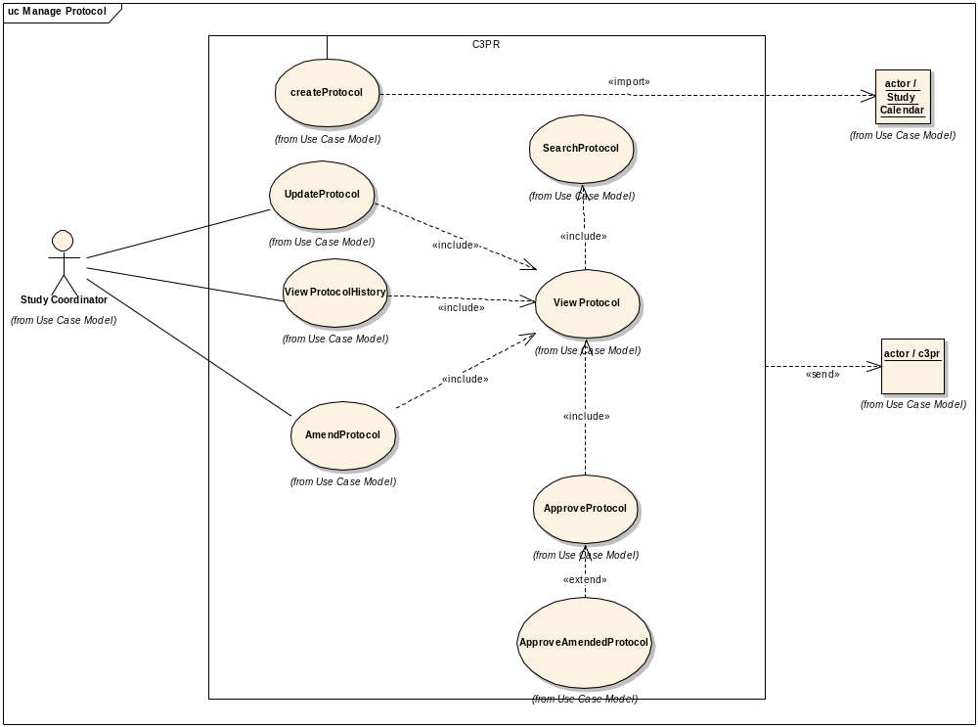

High Level Protocol Data Capture Use Case Diagram
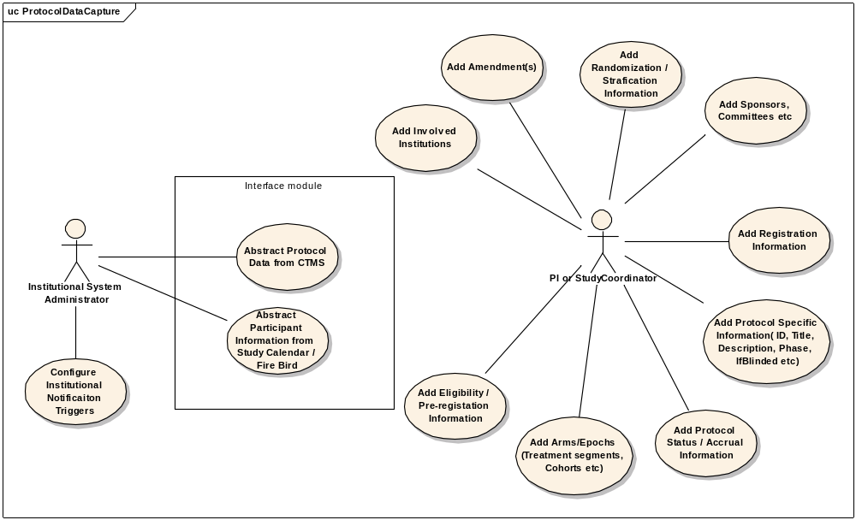

Create Study/Protocol Definition Manually

Use Case Model
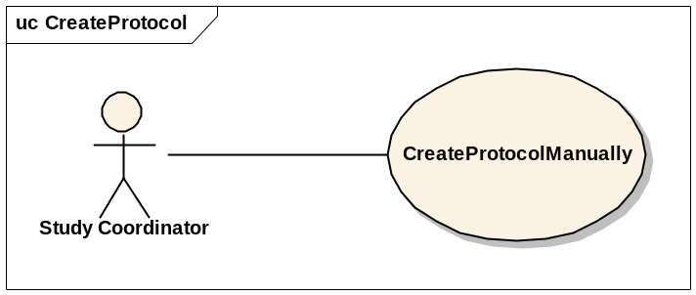

Brief Description
This use-case deals with the manual creation of a protocol by entering each data element of the protocol.

Primary Actor
Study Coordinator or any other designated user of C3PR with role authority to create a Protocol.

Secondary Actors
None

Preconditions
- The user is logged in to the system with a user account that has role authority to create a Protocol.

Basic Flow of Events
- The user indicates to the system that he/she wants to create a new protocol definition by clicking the Create Protocol link
- The system displays the screen that gives the user option of entering the protocol information manually. The user clicks on the enter protocol manually link.
- The user enters the protocol data elements in the fields.
- The user indicates to the system that the required protocol information has been entered for creation of a new protocol.
- The system displays protocols with matching fields to ensure that the protocol is not a duplicate.

Post conditions
- If the user is logged in to the system with a user account that has role authority to create a Protocol (for example, a Protocol Manager), the created protocol is verified.
- If the user was logged in to the system with a role authority to only enter the protocol information, the created protocol awaits for further validation check from a Study Coordinator/Protocol Manager before it becomes approved.

Data Items

Data Element | Validation/Notes
(1) Protocol ID | Required (at least 1)
1.1 Value | Required
1.2 Type | Required
1.1 Source | Not Required
1.1 Is primary | Not Required (defaults to No)
(2) Protocol Amendment | Current
(3) Protocol Amendment Date | Required
(4) Protocol Phase | Required
(5) PI Name | Required (There is only 1 designated PI, the others are AIs)
(6) Branch | Not Required
(7) Protocol Long Title | Required
(8) Protocol Short Title | No/ but would be good
(9) Protocol Description | Required
(10) Precis | Not Required
(11) NCI NCIN Number | Not Required (may not be there)
(12) Registration Tracked | Yes/No (default: Yes)
(13) Multi-Institutional Protocol | Yes/No (default: No)
(14) Involved Institutions
14.1 Name | Required
14.2 Role | One of:  Data Coordinating Center?  Protocol Authority  Funding Sponsor  Participant Site (Health Care Site)  Affiliate Site  Study Site  Registration Center
14.3 Site Investigator | Required (multiple allowed)
14.4. IRB Start Date | Required
14.4. IRB End Date | Required
14.5 IRB approved accrual ceiling | Not Required
14.6 CTEP ID | Not Required
14.7 IRB Name | Not Required
14.8 Site ceiling | Not Required (this is when coordinating=No and is a multisite study)
14.9 Accrual ceiling | Not Required (can have any number)
14.9.1 Name | Required
14.9.2 isHard | Not Required (default: No)
14.9.3 Count | Required
14.9.4 Notification | Not Required (can have any number)
14.9.4.1 Percentage | Required (e.g. 80%)
14.9.4.2 Number | Required (e.g. 13 out of 15)
14.9.4.3 Description | Required
14.9.4.4 Roles | Required (who to notify)
(15) Protocol Accrual Ceiling | Required this ceiling should not be enforcing, or it will cause problems
(16) Protocol Accrual to Date | Default: 0
(17) Sponsor | Organization leading the research (for example, CTEP, NCI, Pfizer)
(18) Sponsor's Protocol ID | Required
(19) Protocol Monitor | For example, CDUS, CTMS, Quintiles
(20) Protocol Monitor's Protocol ID | Not Required
(21) Protocol Type | Not Required
(22) Protocol Design | Not Required
(23) Protocol History | At least 1 required
23.1 Status | Required
23.2 Date of change | Required
(24) Protocol Open Date | For future opening
(25) Protocol Close Date for Accrual | For future closing
(26) Protocol Close Date Final | For future closing
(27) Randomization
27.1 IsRandomized | Required (yes/no) (default: No)
27.2 Method | Method (Required if IsRandomized=Yes) ( a.Book, b. Built-in, c.Call-out)
(28) Arms
28.1 Name | Required
28.2 Description | Required
28.3 Number | Not Required
28.4 Status | Not Required
28.5 Accrual Ceiling | Not Required
28.6 Epoch | Not Required
28.6.1 Name | Not Required
28.6.2 Date | Start/End
28.7 Treatment Segments | Not Required
28.7.1 Name | Not Required
28.7.2 Epoch Name | Not Required
28.7.3 Eligibility at Segment | Not Required
28.8 Eligibility at Arm | Not Required
28.9 Cohort | Required
28.9.1 Yes/No | TBD
28.9.2 Name | TBD
28.9.3 Expiration Time | TBD
(29) Epoch | Not Required
29.1 Name | Not Required
(30) Blinded | Required (yes/no) (default: no)
(31) Blinded Type | Required (If Blinded=Yes)
(32) Eligibility | Not Required
(33) Other Identifiers | Multiple Allowed
33.1 Source | Not Required
33.2 Name | Required
33.3 Value | Required
(34) Pre-Registration
34.1 IfRequired | Yes/No (default: no)
34.2 Eligiblity | Not Required
(35) Disease site
35.1 Name | Not Required
(36) Status | Required: Active, Closed, etc.
(37) Protocol form | Not Required (could have more than one)
37.1 Name | Required
37.2 Description | Required
37.3 Format | Required (pdf, word doc, etc.)
37.4 File | Required (binary file uploaded)
(38) IRB consent date | Not Required (this is the date that the IRB approved the consent)
(39) Allows reservation | Not Required (defaults to No)

Special Requirements
None

Load Protocol Definition from a File

Use Case Model
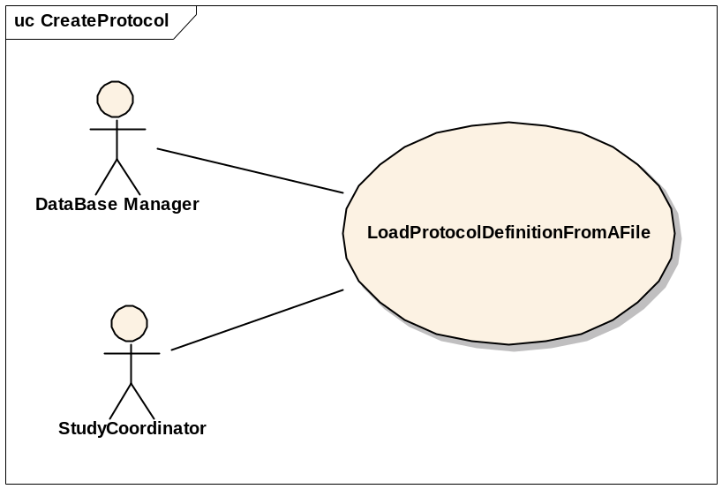

Brief Description
This use-case deals with loading a Protocol from a file that is on the user’s local system.

Primary Actor
Study Administrator or any other designated user of C3PR with role authority to create a Protocol.

Secondary Actors
None

Preconditions
- The user is logged in to the system with a user account that has role authority to create a Protocol.

Basic Flow of Events
- The user indicates to the system that he/she wants to create a new protocol definition from a file by clicking the Import Protocol link
- The system displays a screen that allows the user to browse their local file system.
- The user selects the appropriate file which contains the information about the protocol to be loaded into the system.
- After selecting the file, the user indicates to the system to create a new protocol definition based on the information in the file.
- The system reads the file and validates the file.
- If the file is valid, a new protocol definition entry is created.

Post conditions
- If the user is logged in to the system with a user account that has role authority to create a Protocol (for example, a Protocol manager), the created protocol is approved.
- If the user was logged in to the system with a role authority to only enter the protocol information, the created protocol awaits for further validation check from a study coordinator/protocol manager before it becomes approved.

Special Requirements

Get Protocol/Study Definition via Protocol Message from External Source

Use Case Model
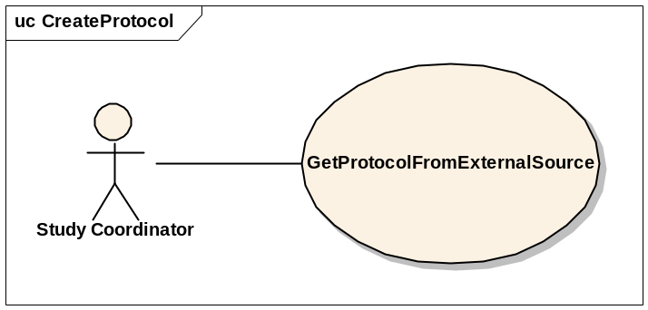

Brief Description
This use-case deals with creation of a Protocol at the local system after getting/importing it from an external source via a Protocol Message.

Primary Actor
Study Administrator, Study Coordinator or any other designated user of C3PR with role authority to create a Protocol.

Secondary Actors
None

Preconditions
- The user is logged in to the system with a user account that has role authority to create a Protocol.
- C3PR is configured to receive messages from the external source.
- The Protocol doesn’t already exist.

Basic Flow of Events
- The user indicates to the system that he/she wants to create a new protocol definition by clicking the Import Protocol link
- The system displays a screen that displays the import methods. This screen allows the user to import a new protocol.
- The user clicks on a link, and the protocol is imported
- If errors occur during the import, they are displayed to the user
- If the protocol is imported successfully, the user views the protocol.
- The user checks the protocol for correctness and updates the protocol entries to correspond to the local site requirements (IRB approval, accrual ceiling, etc).
- After importing the protocol, the user confirms the protocol creation.

Postconditions
The imported protocol waits for further changes/validation with respect to the local site conditions (IRB approval, accrual ceiling, etc) before it is available for use at the local site.

Data Items
See 4.3.8

Special Requirements

Search for Protocols

Use Case Model
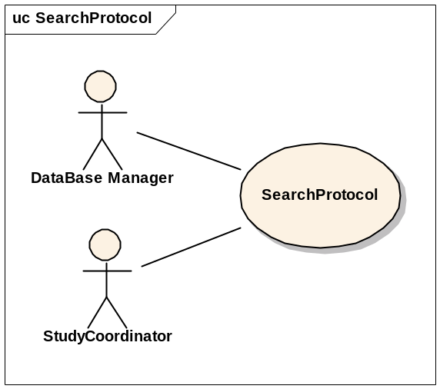

Brief Description
This use-case deals with searching for a protocol. Reasons for searching for a protocol include:
  - Looking for duplicate protocols
  - Begin patient registration
  - Check for eligibility requirements
  - Check protocol status
  - Modify a protocol

Primary Actor
Database Manager, Study Coordinator, Principal Investigator or any other user of C3PR with role authority to search for a protocol.

Secondary Actors
None

Preconditions
The user is logged in to the system with a user account that has role authority to search for a protocol.

Basic Flow of Events
- The user indicates to the system that he/she wants to search for a given protocol definition by clicking the Search Protocol link.
- The user enters the search criteria for the protocol and submits the information to the system.
- The system displays 0, 1 or multiple protocol definitions depending on the search criteria.

Post conditions
The resulting protocol list is in a state that the user can transition to any of the manage protocol or register patient use cases. This means sufficient detail is presented to the user in order to determine which protocol to transition to. These details will be determined in later iterations.

Data Items
Search criteria: keyword, disease site, phase or PI, unique protocol ID.

Special Requirements

View Protocol

Use Case Model
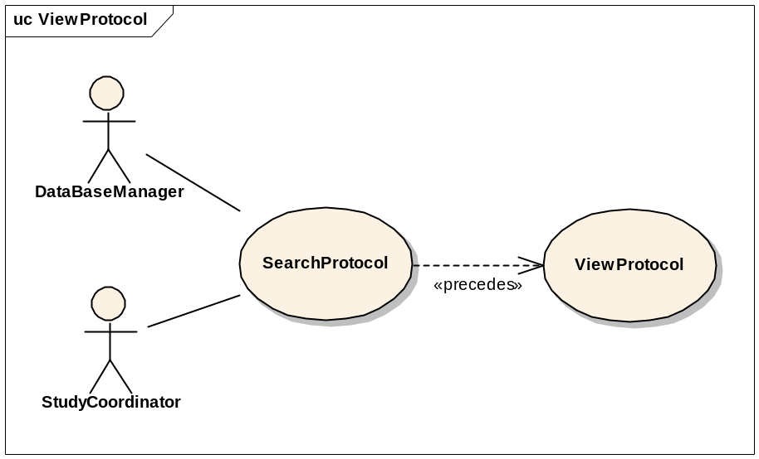

Brief Description
This use-case deals with viewing a protocol.

Primary Actor
Database Manager, Study Coordinator, Principal Investigator or any other user of C3PR with role authority to view a protocol.

Secondary Actors
None

Preconditions
The user is logged in to the system with a user account that has a role authority to view a protocol definition.

Basic Flow of Events
- The user indicates to the system that he/she wants to search for a given protocol definition by clicking the Search Protocol link.
- The user enters the search criteria for the protocol and submits the information to the system.
- The system displays 0, 1 or multiple protocol definitions depending on the search criteria.
- The user selects a protocol and clicks on the link to view that protocol.

Post conditions

Data Items

Special Requirements

Update Protocol

Use Case Model
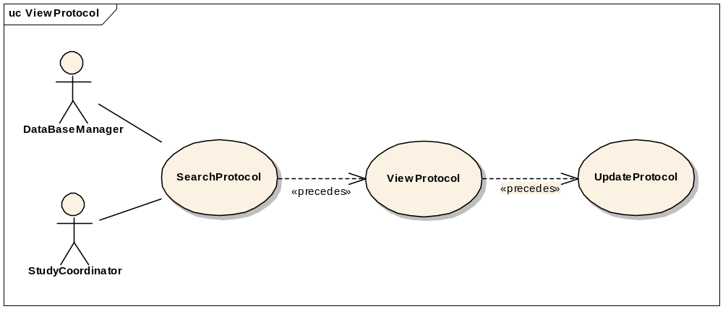

Brief Description
This use-case deals with updating a protocol entry.

Primary Actor
Database Manager, Study Coordinator or any other user of C3PR with role authority to update a protocol definition. This includes changing the status of the protocol (i.e. open versus closed).

Secondary Actors
None

Preconditions
The user is logged in to the system with a user account that has role authority to update a protocol definition.

Basic Flow of Events
- The user indicates to the system that he/she wants to search for a given protocol definition by clicking the Search Protocol link.
- The user enters the search criteria for the protocol and submits the information to the system.
- The system displays 0, 1 or multiple protocol definitions depending on the search criteria.
- The user selects a protocol and clicks on the link to view that protocol.
- The user clicks on the Update Protocol link and updates the necessary fields.
- The user saves the updated protocol information to the system.
- Protocol status and status date fields are updated.

Post conditions
- If the user is logged in to the system with a user account that has role authority to update a protocol, the protocol stands updated
- If the user is logged in to the system with a user account that doesn’t have a role authority to update a protocol, the protocol awaits for further validation check from a protocol manager.

Data Items

Special Requirements

Approve Study/Protocol Definition

Use Case Model
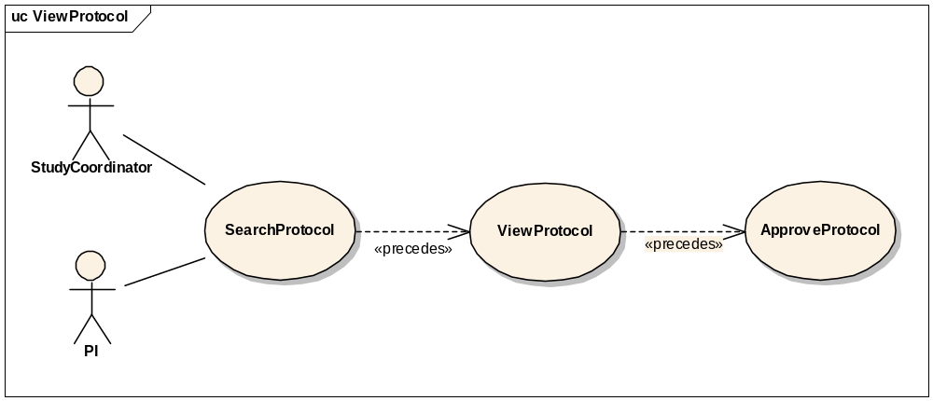

Brief Description
This use-case deals with approval or validation of a protocol definition entry.

Primary Actor
Study Coordinator, PI or any other designated user of C3PR with role authority to approve a Protocol.

Secondary Actors
None

Preconditions
- The user is logged in to the system with a user account that has role authority to approve a Protocol.
- The Protocol definition has already been created but not validated.

Basic Flow of Events
- The user indicates to the system that he/she wants to search for a given protocol definition by clicking the Search Protocol link.
- The user enters the search criteria for the protocol and submits the information to the system.
- The system displays 0, 1 or multiple protocol definitions depending on the search criteria.
- The user indicates to the system that he/she wants to approve a newly created protocol definition by clicking the Approve Protocol link
- The user selects a protocol from a list of newly created protocols.
- The user views the newly created protocol.
- He/She checks for the correctness of the data elements of the protocol against the coordinating site/local site parameters.
- The user approves the newly created protocol by clicking on Approve button or link.

Postconditions

The created protocol has been approved.

Data Items

Special Requirements

Amend Study/Protocol Definition

Use Case Model
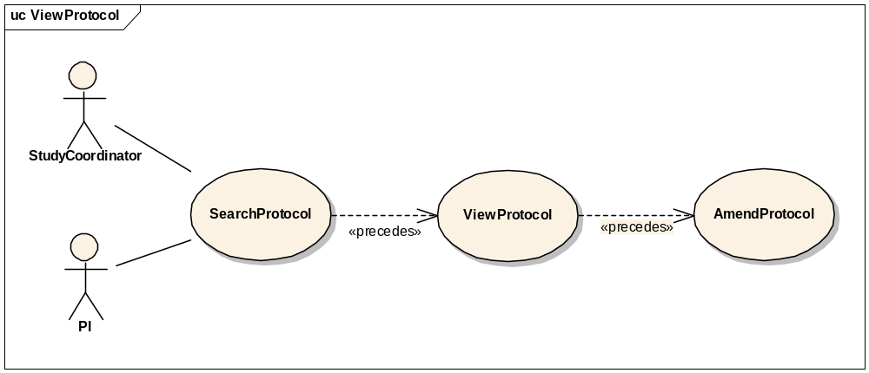

Brief Description
This use-case deals with amending a current protocol definition.

Primary Actor
Study Coordinator, Principal Investigator or any other designated user of C3PR with role authority to amend a protocol definition.

Secondary Actors
None

Preconditions
The user is logged in to the system with a user account that has role authority to amend a protocol definition.

Basic Flow of Events
- The user indicates to the system that he/she wants to search for a given protocol definition by clicking the Search Protocol link.
- The user enters the search criteria for the protocol and submits the information to the system.
- The system displays 0, 1 or multiple protocol definitions depending on the search criteria.
- The user selects the protocol definition for which he/she wants to amend.
- The user indicated to the system that he/she wants to make an amendment by clicking on the Amend Protocol link.
- The user makes the necessary changes to the protocol definition and submits the information to the system by clicking on Amend button or link.

Postconditions
The protocol definition has been amended.

Data Items

Special Requirements

Abstract Protocol Data

Register Patient to a Protocol Arm
This will have a similar flow to edit protocol because a user may want to select a protocol from a search.

Synchronize Creation of Protocol Definition with Study Calendar

Brief Description
This use case propagates the Protocol definition created in the C3PR system to Study Calendar system via CTMS Hub. The use case assumes that C3PR is the authoritative source for protocol information as far as the PSC is concerned.

Primary Actor
Study Administrator or any other designated user of C3PR with role authority to create a Protocol.

Secondary Actors
- CTMS Hub (caExchange or some other messaging infrastructure)
- Patient Study Calendar (PSC)
- Study Coordinator

Preconditions

Successful Creation of Protocol in C3PR system
The Protocol definition has been successfully created in the C3PR system (refer to use cases 3.1 and 3.2) by a user with a user account that has role authority to create a Protocol.

Basic Flow of Events
- The system generates a message in a predetermined format containing the new protocol information.
- The system then submits the new protocol message to the CTMS Hub.
- The CTMS Hub determines where the message needs to be delivered to, which is Study Calendar system in this case.
- The CTMS Hub transforms the new protocol message into a message format that the Study Calendar system can process.
- The Study Calendar system processes the protocol message and creates the Protocol Definition.
- After successfully processing the new protocol definition message, the Study Calendar system sends an acknowledgment to the CTMS Hub indicating the successful creation of a Protocol Definition in the Study Calendar system.
- The CTMS Hub sends an email notification indicating the creation of a new Protocol Definition to relevant actors including the Study Coordinator.

Postconditions

Creation of Protocol Definition in C3PR and PSC
A Protocol Definition created in the C3PR is replicated in the PSC.

Email Notifications
Email notifications are sent to relevant actors indicating the creation of a new protocol.

Data Items

Special Requirements

Synchronize Registration of a Patient on a Protocol Arm with Study Calendar

Brief Description
This use case essentially deals with propagating the registration information of a patient on a Protocol Arm created in the C3PR system to Study Calendar system via CTMS Hub.

Primary Actor
Registrar or any other designated user of C3PR with role authority to register a patient on a Protocol Arm.

Secondary Actors
- CTMS Hub
- Patient Study Calendar (PSC)
- Participant Coordinator

Preconditions

Successful Creation of Protocol in the Study Calendar system
  - The Protocol definition has been successfully created in the Study Calendar system either manually thru the Study Calendar web interface or thru a message from the C3PR system (refer to use case 3.5).

Basic Flow of Events
- The system generates a message in a predetermined format containing the new registration information.
- The system then submits the new registration message to the CTMS Hub.
- The CTMS Hub determines where the message needs to be delivered to, which is Study Calendar system in this case.
- The CTMS Hub transforms the new registration message into a message format that the Study Calendar system can process.
- The Study Calendar system processes the new registration message by creating the Patient record, if the Patient does not already exist in the Study Calendar system, and then creates the calendar for the Arm to which the Patient is being registered to.
- After successfully processing the new patient registration message, the Study Calendar system sends an acknowledgment to the CTMS Hub indicating the successful creation of the calendar corresponding to the Arm that the patient is registered on in the Study Calendar system.
- The CTMS Hub sends an email notification indicating the creation of a new calendar for the Arm that the patient is registered on to relevant actors including the Participant Coordinator.

Post conditions

Creation of Patient record in PSC
A new Patient record is created in the Study Calendar system if the Patient does not already exist in it.

Creation of calendar for the Arm for the Patient
The calendar for the Arm that the Patient is registered on is created in the study calendar system.

Email Notification
Email notifications are sent to relevant actors indicating the creation of the Patient (optional) and calendar.

Exception flow
Errors during the normal flow of events will through the messaging system will trickle back to the user. This could include a misconfigured messaging system or errors generated by the target system.

Data Items
These items will be enumerated in a future iteration.

Special Requirements

Manage Registration

Register a New Patient to a Study

Use Case Model
Add model here

Brief Description
This use case will allow the user to register a patient not currently in the C3PR system to a protocol. The user will be required to enter patient information before completing the registration.

Primary Actor
Registrar or any other designated user of C3PR with role authority to Register a Subject.

Secondary Actors
None

Preconditions
- The user is logged in to the system with a user account that has role authority to create a Protocol.
- The Protocol already exists.
- Any hard accrual limits are not exceeded
- The Protocol has a status of Active

Basic Flow of Events
Add the flow
Include notification of accrual if meets configured percentages
Include check for accrual for all hard limits
Include check for Protocol status

Postconditions
- If the user is logged in to the system with a user account that has role authority to register a Subject (for example, a Registrar), the registration is approved.
- If the user was logged in to the system with a role authority to only enter the registration information, the registration awaits for further validation check before it becomes approved.

Data Items
Data Element | Validation/Notes
(1) Method of Payment | Not Required, configurable
(2) Enrollment date | Required
(3) Study subject identifier | Not Required, configurable (not generated by c3pr)
3.1 Value | Required
3.2 Type | Required
3.3 Source | Not Required
3.4 isPrimary | Not Required (default is false)
(4) Treating MD | Not Required
(5) Diagnosis | Not Required, configurable
5.1 Name | Required
5.2 Date | Required
(6) Adult/Pediatric flag | Not Required, configurable (determining this from the birthday is problematic)
(7) Randomization | Not Required (could have nay number)
7.1 Arm | Required
7.2 Date | Required
(8) Registration status | Required, history tracked
8.1 Date | Required
8.2 Value | Required (Enrolled, Screening, Screening failure, Compassionate care, Ineligible after enrollment, etc.)

Special Requirements
None

Register an Existing Unregistered Patient to a Study
This use case will allow the user to register a patient that is currently in the C3PR system but not registered on a protocol. The user will have to identify an existing patient such that patient information is not duplicated.

Register an Existing Registered Patient to a Study
This use case will allow the user to register a patient that is currently in the C3PR system and registered on a protocol. The user will have to identify a protocol that the patient is not already registered to such that registration information is not duplicated.

Register Patient to Local Protocol Study
This use case allows the user to register a patient to a protocol originated at the local site.

Register Patient to External Protocol Study
This use case allows the user to register a patient to a protocol originated at an external site (coordinating site, CALGB, etc).
Include registration at local site, with propagation to coordinating site, and vice versa.

Register Patient to a Reservation-enabled Study
In some Phase I studies, there are very small number of accrual slots
It is important that someone can be registered to the study, get worked up, and then potentially be removed from the study
This type of “reservation” allows the next candidate to take the originally registered slot
This differs from most protocols, where the de-registered slot is “lost” – the next subject is registered to the next slot

View Subject Registration History
This use case allows the user to view the registration history of a Subject.

Reserve Registration
This use case allows the user to reserve a slot/position for a patient on a protocol so that whenever accrual starts, the patient can be registered.

Store Patient Screening Data
This use case allows the user to store screening data of the patient. This use case is primarily required for reporting purposes; however, this data may be reused during the registration.

Submit Pending Registration Information
This use case allows the user to submit a pending registration.

Confirm Submitted Registration Information
This use case provides for a confirmation message to be sent once a pending registration is submitted. This will be a synchronous message (by email?) such that treatment can immediately begin.

Replicate Registration to Companion Protocol
This use case allows the user to replicate the patient registration information to selected companion protocols.

Replicate Registration to Local Site
This use case allows the user to replicate the patient registration information to the local site.

Manage Randomization

Email Notify Registrar
This use case allows the user to notify the randomization registrar for randomization.

Display Notification
This use provides for a notification to be displayed to the randomization registrar on the website after the user logs in.

Randomize Using Protocol Block
This use case allows the user to fetch randomization from a protocol block stored in C3PR.

Randomize Using Call-out
This use case allows the user to fetch randomization arm via a call-out to an external randomization routine (e.g. the Randomization Hub).

Manage Eligibility Criteria

Approve Eligibility Criteria
This use case allows the user to approve eligibility criteria of a patient.

Exempt Eligibility Criteria
This use case allows the user to exempt the eligibility criteria for a patient (for example, “compassionate treatment exemption”).

Import Eligibility Criteria
This use case allows the user to import eligibility criteria from external sources like caDSR.

Access Clinical Data
This use case allows the user to access clinical data from external systems like C3D.

Manage Stratification
TBD

Manage Relationship

Create Relationship
This use case allows the user to associate a Study Personnel or Subject to other Study Personnel(s) or Subject(s).
More use cases TBD.

Login
This use case allows the user to login into C3PR.

Reporting
TBD

From C3PR Release 1 (Not Yet Analyzed)

Maintain Protocol Strata Randomized List

Synchronize Subject with External Patient Registry

Assign Protocol Part to Subject

Generate Referral Letter

Integration
These use cases will allow user to integrate with external systems like caMATCH, CDW, Study Calendar etc.

Overall Requirements

Requirements Prioritization

Priority | Use Case Name | Supp Requirement Ref #
1 | Manage Protocol

Sign Off

Approval

Workspace General Contractor Rep Print Name Date
Architecture Workspace Rep Print Name Date
VCDE Workspace Rep Print Name Date
Workspace Working Group Rep Print Name Date
NCICB Rep Print Name Date

