1. Project Summary

Project Name: | C3PR Relase 2.0 | Start Date: | 11/1/2006

Cancer Center: | Duke Comprehensive Cancer Center | Date Awarded: | October 2006

Current Stage of Project: | Elaboration

Points of Contact:
Position | Name/Organization | Phone | E-mail
Project Manager | Robert Annechiarico | 919-668-5188 | bob.annechiarico@duke.edu
Software Engineering Manager | Patrick McConnell | 770-414-8143 | patrick.mcconnell@duke.edu
Software Quality Assurance Manager | Patrick McConnell | 770-414-8143 | patrick.mcconnell@duke.edu
Customers: | See vision and scope document | NA | NA
Other Stakeholders (Top 3): | Jamie Cuticchia (Duke PI)  Ram Chilukuri (Semantic Bits)  Bob Morrel (Wake Forest)  (see communication plan for a full list) | 919-681-9646  703-994-7508 | jamie.cuticchia@duke.edu  ram.chilukuri@semanticbits.com  bmorrell@wfubmc.edu

Project vision

Extend the existing cancer Clinical Central Participant Registry (C3PR) system and underlying database to enable additional capability for the capture and management of:
• Patient clinical trials registration
• Protocol information
• Clinical trials information across clinical studies
• Information on referring physicians, research sites, and organizations
• And, to enhance access to information for patients, physicians, and researchers.

The focus of version 2 will be to:
• Integrate with other clinical systems, including C3PR-to-C3PR integration
• Extend registration, including randomization
• Enhance protocol management, including web-based management
• Improve the user interface from the perspective of the registrar
• Extend reporting

Project scope:

Information that is accessible in a timely manner and clearly understandable for cancer clinical research trials is difficult to capture and present to the multitude of stakeholders that require it: cancer patients and their families struggling with treatment options for their disease, physicians seeking information and trials for their patient community, and researchers who seek technical and scientific knowledge on current trials and historical trial outcomes. Patients who have been diagnosed with cancer and want to understand treatment options that are available to them are confused and frustrated with highly scientific and technical information on clinical trials that do not specific address their questions. Physicians, who want to help their patients understand their disease and gain access to current trials and therapy options find it difficult to locate enough information in a user-friendly, timely manner. This prohibits the physician from providing their patients with specific trial options and newly approved therapies. Researchers, who conduct clinical trials themselves and often require comparative data for dosing, measurable clinical trial end-points, model validation, encounter difficulty accessing aggregate clinical trials data. This, in turn, limits their ability to advance the science. The development and deployment of a central registry, containing requisite information on clinical trials, will provide all groups (patients and their families, community physicians, as well as cancer researchers) to meet their diverse set of informational and data needs.

Success Factors:

1. Meet all the use cases laid out in the proposal and the use case document
2. Deliver a system that is deployable and usable by the adopters
3. Meet all deliverables on-time and on-budget.
4. Meet all requirements in the SRS document
http://gforge.nci.nih.gov/plugins/scmcvs/cvsweb.php/c3prv2/documentation/requirements/c3pv2_srs.doc?cvsroot=c3prv2
Project Dependencies/Constraints:
C3PR has key dependencies on existing caBIG projects:
caGrid: C3PR is dependent on the caGrid 1.0 software for it’s basic infrastructure and query language
There will potentially be dependencies on other caBIG CTMS applications (e.g. Patient Study Calendar). However, these specific dependencies will be determined as the use cases are elaborated. See the vision and scope document for a full list of potential integration (dependency) points.

2. Activity List and Schedule
See the C3PR project plan:
http://gforge.nci.nih.gov/plugins/scmcvs/cvsweb.php/c3prv2/documentation/planning/elaboration_project_plan.mpp?cvsroot=c3prv2
3. Work Product Identification
See the C3PR delivery schedule:
http://gforge.nci.nih.gov/plugins/scmcvs/cvsweb.php/c3prv2/documentation/planning/delivery_schedule.doc?cvsroot=c3prv2

4. Estimated Cost at Completion
This is a firm fixed price contract.
5. Resource Profiles – Staffing

Name | Institution | Role | FTEs
Jamie Cuticchia | Duke | Principle Investigator | 0.05
Robert Annechiarico | Duke | Project Manager | 0.20
Emily Allred | Duke | Financial Specialist | 0.10
Patrick McConnell | Duke | Chief Architect | 0.40
Seth Fehrs | Duke | Technical Expert | 0.40
Vijaya Chadaram | Duke | Domain Expert | 0.20
Ram Chilukuri | Semantic Bits | Lead Developer | 0.20
Vinay Kumar | Semantic Bits | Technical Expert | 0.05
Ramakrishna Gundala | Semantic Bits | Developer | 1.00
Kruttik Aggarwal | Semantic Bits | Developer | 1.00
Priyatam Mudivarti | Semantic Bits | Developer | 1.00
Manav Kher | Semantic Bits | Developer | 0.50
Bob Morrel | Wake Forest | Lead Elaborator | 0.25
Xhiquiang Cheng | Wake Forest | Technical Expert | 0.20
Kimberly Hill Livengood | Wake Forest | Domain Expert | 0.35
Sharon Elcombe | Mayo | Lead Elaborator | 0.10
Diane Parkin | Mayo | Domain Expert | 0.10
Rammohan Deeduvanu | Mayo | Technical Expert | 0.05
Kimberly Johnson | CALGB | Lead Elaborator | 0.06
Marin Shanley | CALGB | Domain Expert | 0.10
Josh Yoder | CALGB | Technical Expert | 0.03
Charles Keen | CALGB | Technical Expert | 0.03
Amish Shah | CALGB | Technical Expert | 0.03
Prasid Dasgupta | Coalition Cooperative Groups | Lead Elaborator | 0.20
Steve Riordan | Westat | Lead Elaborator | 0.01
Diana Meyer | Westat | Domain Expert | 0.03
Martha Hering | Westat | Domain Expert | 0.03
Ravi Rajaram | Westat | Domain Expert | 0.04
Total |  |  | 6.71

6. Risk Identification
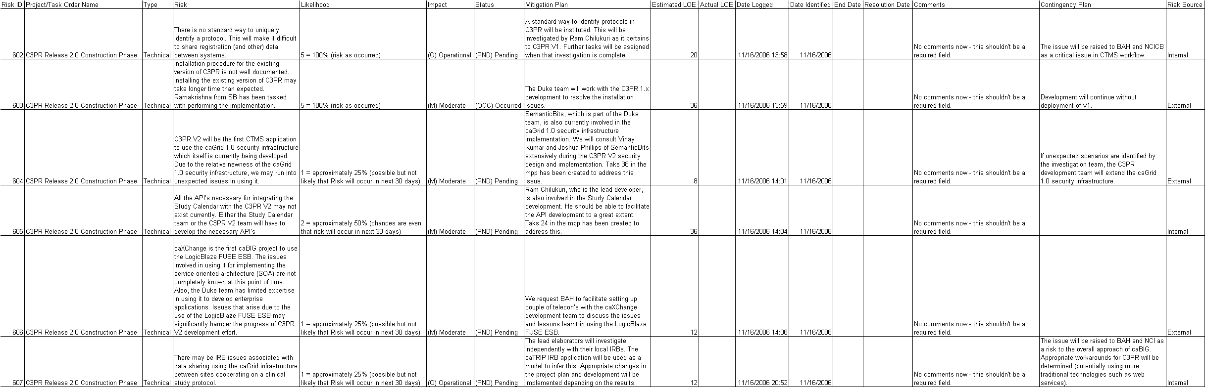
The up to date C3PR risk matrix can be found:
http://gforge.nci.nih.gov/plugins/scmcvs/cvsweb.php/c3prv2/documentation/risks/?cvsroot=c3prv2
7. Configuration/Change Management Plan

Manager: Patrick McConnell
Additional Staff for CM: Ram Chilukuri

Describe the change control process and workflow:

Change requests will be directed to the CM manager. They will be documented in a single Excel file sorted by date and coded/annotated for the type of change requested, the reason for the request, impact of the change requested to current phase of project, original and estimated new timeline, resources and cost and the requester’s name. The outcome of the review of the request will also be documented, including from whom input was sought, if necessary, and the decision to grant the request or make a compromise. The Technical Point of Contact is considered a stakeholder, and so all modifications will be reviewed with him during regularly scheduled C3PR teleconferences. The NCI CCB is not considered a stakeholder. It is expected that changes with high impact will be identified as risks and will be elevated to BAH/NCI by the TPOC as he sees fit.

Change requests and their status can be found at:

http://gforge.nci.nih.gov/plugins/scmcvs/cvsweb.php/c3prv2/documentation/planning/change_requests.xls?cvsroot=c3prv2

Change control workflow:

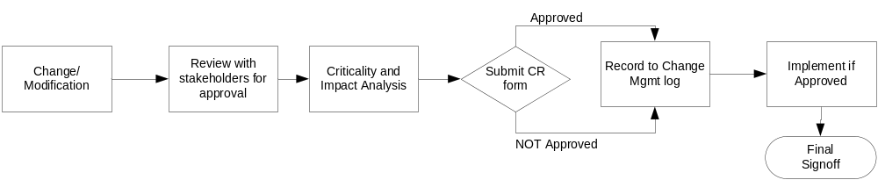

Describe the release management process for each technical environment:

Prior to a release, the CM manager will review the deliverables leading to the release and ensure that issues identified in the testing phase have been addressed. This review will be presented to the project PI and the additional CM staff members, who will suggest potential problem areas to be tested.
8. Quality Assurance Plan

Manager: Patrick McConnell
Additional Staff for QA: Seth Fehrs
While Quality Assurance is not the same as testing, it is highly related. We have documented best practices, such as code review and bug tracking, in the test approach. It can be found at: http://gforge.nci.nih.gov/plugins/scmcvs/cvsweb.php/c3prv2/documentation/testing/c3prv2_test_plan.doc?cvsroot=c3prv2

9. Top Issues

Issue Description | Recommended Solution | Responsible Individual | Status
1. Contract needs to be finalized. | Duke team to work with contracts department to return signed contract to BAH. | Duke | Work In Progress
2. Risk Matrix to be fixed in caMP. | BAH working on this. | Julie Holtzople | Completed
3.
4.
5.

