1. Project Summary

Project Name: | C3PR V2 | Start Date: | 11/1/2006

Cancer Center: | Duke Comprehensive Cancer Center | Date Awarded: | 11/1/2006

Current Stage of Project: | Elaboration

Points of Contact:
Position | Name/Organization | Phone | E-mail
Project Manager | Robert Annechiarico | 919-668-5188 | bob.annechiarico@duke.edu
Software Engineering Manager | Patrick McConnell | 770-414-8143 | patrick.mcconnell@duke.edu
Software Quality Assurance Manager | Patrick McConnell | 770-414-8143 | patrick.mcconnell@duke.edu
Procurement Contact | ? | ? | ?
Customers: | NA | NA | NA
Other Stakeholders (Top 3): | Jamie Cuticchia (Duke PI)  Ram Chilukuri (SemanticBits PM) | 919-681-9646  703-994-7508 | jamie.cuticchia@duke.edu  ram.chilukuri@semanticbits.com

Project vision

Extend the existing cancer Clinical Central Participant Registry (C3PR) system and underlying database to enable additional capability for the capture and management of:
• Patient clinical trials registration
• Protocol information
• Clinical trials information across clinical studies
• Information on referring physicians, research sites, and organizations
• And, to enhance access to information for patients, physicians, and researchers.

The focus of version 2 will be to:
• Integrate with other clinical systems, including C3PR-to-C3PR integration
• Extend registration, including randomization
• Enhance protocol management, including web-based management
• Improve the user interface from the perspective of the registrar
• Extend reporting

Project scope:

Information that is accessible in a timely manner and clearly understandable for cancer clinical research trials is difficult to capture and present to the multitude of stakeholders that require it: cancer patients and their families struggling with treatment options for their disease, physicians seeking information and trials for their patient community, and researchers who seek technical and scientific knowledge on current trials and historical trial outcomes. Patients who have been diagnosed with cancer and want to understand treatment options that are available to them are confused and frustrated with highly scientific and technical information on clinical trials that do not specific address their questions. Physicians, who want to help their patients understand their disease and gain access to current trials and therapy options find it difficult to locate enough information in a user-friendly, timely manner. This prohibits the physician from providing their patients with specific trial options and newly approved therapies. Researchers, who conduct clinical trials themselves and often require comparative data for dosing, measurable clinical trial end-points, model validation, encounter difficulty accessing aggregate clinical trials data. This, in turn, limits their ability to advance the science. The development and deployment of a central registry, containing requisite information on clinical trials, will provide all groups (patients and their families, community physicians, as well as cancer researchers) to meet their diverse set of informational and data needs.

Success Factors:

1. Meet all the use cases laid out in the proposal and the use case document
2. Deliver a system that is deployable and usable by the adopters
3. Meet all deliverables on-time and on-budget.
4. Meet all requirements in the SRS document
add link here
Project Dependencies/Constraints:
C3PR has key dependencies on existing caBIG projects:
caGrid: C3PR is dependent on the caGrid 1.0 software for it’s basic infrastructure and query language

2. Activity List and Schedule
See the C3PR project plan:
Add link here
3. Work Product Identification
See the C3PR delivery schedule:
Add link here

4. Estimated Cost at Completion
See the C3PR V2 Task Order
5. Resource Profiles – Staffing

Name | Institution | Role | FTEs
Jamie Cuticchia | Duke | Principle Investigator | 0.05
Robert Annechiarico | Duke | Project Manager | 0.20
Emily Allred | Duke | Financial Specialist | 0.10
Patrick McConnell | Duke | Chief Architect | 0.40
Seth Fehrs | Duke | Technical Expert | 0.40
Vijaya Chadaram | Duke | Domain Expert | 0.20
Ram Chilukuri | Semantic Bits | Lead Developer | 0.20
Vinay Kumar | Semantic Bits | Technical Expert | 0.05
Ramakrishna Gundala | Semantic Bits | Developer | 1.00
Kruttik Aggarwal | Semantic Bits | Developer | 1.00
Priyatam Mudivarti | Semantic Bits | Developer | 1.00
TBA | Semantic Bits | Developer | 0.50
Bob Morrel | Wake Forest | Lead Elaborator | 0.25
TBA | Wake Forest | Technical Expert | 0.20
TBA | Wake Forest | Domain Expert | 0.35
Sharon Elcombe | Mayo | Lead Elaborator | 0.10
Diane Parkin | Mayo | Domain Expert | 0.10
Rammohan Deeduvanu | Mayo | Technical Expert | 0.05
Kimberly Johnson | CALGB | Lead Elaborator | 0.06
Marin Shanley | CALGB | Domain Expert | 0.10
Josh Yoder | CALGB | Technical Expert | 0.03
Charles Keen | CALGB | Technical Expert | 0.03
Amish Shah | CALGB | Technical Expert | 0.03
Prasid Dasgupta | Coalition Cooperative Groups | Lead Elaborator | 0.20
Steve Riordan | Westat | Lead Elaborator | 0.10
Charles Keen | Westat | Domain Expert | 0.10
Total |  |  | 6.8

6. Risk Identification
See the C3PR risk matrix:
Add link here
7. Configuration/Change Management Plan

Manager: Patrick McConnell
Additional Staff for CM: Ram Chilukuri

Describe the change control process and workflow:

Change requests will be directed to the CM manager. They will be documented in a single Excel file sorted by date and coded/annotated for the type of change requested, the reason for the request, impact of the change requested to current phase of project, original and estimated new timeline, resources and cost and the requester’s name. The outcome of the review of the request will also be documented, including from whom input was sought, if necessary, and the decision to grant the request or make a compromise.

Change requests and their status can be found at:

Add link here

Change control workflow:

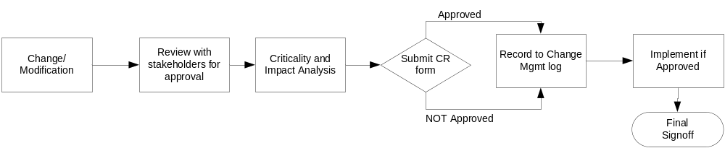

Describe the release management process for each technical environment:

Prior to a release, the CM manager will review the deliverables leading to the release and ensure that issues identified in the testing phase have been addressed. This review will be presented to the project PI and the additional CM staff members, who will suggest potential problem areas to be tested.
8. Quality Assurance Plan

Manager: Patrick McConnell
Additional Staff for QA: Seth Fehrs
See add test plan link here

9. Top Issues
No issues currently identified

Issue Description | Recommended Solution | Responsible Individual | Status
1.
2.
3.
4.
5.

