Cancer Central Clinical Participant Registry (C3PR) v2
End User Manual

Document Change History
Version Number | Date | Contributor | Description
0.1 | 9/20/2007 | Patrick McConnell | Template
0.1.2 | 10/04/2007 | Peter Le | Draft
0.1.3 | 01/24/2008 | Peter Le | Draft
0.1.4 | 03/03/2008 | Peter Le | Draft


Updated March 03, 2008

Copyright and License page

Copyright Notice. Copyright 2007 Duke Comprehensive Cancer Center (“caBIG™ Participant”). C3PR was created with National Cancer Institute (NCI) funding and is part of the caBIG™ initiative. The software subject to this notice and license includes both human readable source code form and machine readable, binary, object code form (the “caBIG™ Software”).
This caBIG™ Software License (the “License”) is between caBIG™ Participant and You. “You (or “Your”) shall mean a person or an entity, and all other entities that control, are controlled by, or are under common control with the entity. “Control” for purposes of this definition means (i) the direct or indirect power to cause the direction or management of such entity, whether by contract or otherwise, or (ii) ownership of fifty percent (50%) or more of the outstanding shares, or (iii) beneficial ownership of such entity.
License. Provided that You agree to the conditions described below, caBIG™ Participant grants You a non-exclusive, worldwide, perpetual, fully-paid-up, no-charge, irrevocable, transferable and royalty-free right and license in its rights in the caBIG™ Software, including any copyright or patent rights therein that may be infringed by the making, using, selling, offering for sale, or importing of caBIG™ Software, to (i) use, install, access, operate, execute, reproduce, copy, modify, translate, market, publicly display, publicly perform, and prepare derivative works of the caBIG™ Software; (ii) make, have made, use, practice, sell, and offer for sale, and/or otherwise dispose of caBIG™ Software (or portions thereof); (iii) distribute and have distributed to and by third parties the caBIG™ Software and any modifications and derivative works thereof; and (iv) sublicense the foregoing rights set out in (i), (ii) and (iii) to third parties, including the right to license such rights to further third parties. For sake of clarity, and not by way of limitation, caBIG™ Participant shall have no right of accounting or right of payment from You or Your sub licensees for the rights granted under this License. This License is granted at no charge to You. Your downloading, copying, modifying, displaying, distributing or use of caBIG™ Software constitutes acceptance of all of the terms and conditions of this Agreement. If You do not agree to such terms and conditions, You have no right to download, copy, modify, display, distribute or use the caBIG™ Software.
- Your redistributions of the source code for the caBIG™ Software must retain the above copyright notice, this list of conditions and the disclaimer and limitation of liability of Article 6 below. Your redistributions in object code form must reproduce the above copyright notice, this list of conditions and the disclaimer of Article 6 in the documentation and/or other materials provided with the distribution, if any.
- Your end-user documentation included with the redistribution, if any, must include the following acknowledgment: “This product includes software developed by Duke Comprehensive Cancer Center.” If You do not include such end-user documentation, You shall include this acknowledgment in the caBIG™ Software itself, wherever such third-party acknowledgments normally appear.
- You may not use the names “Duke Comprehensive Cancer Center”, “The National Cancer Institute”, “NCI”, “Cancer Bioinformatics Grid” or “caBIG™” to endorse or promote products derived from this caBIG™ Software. This License does not authorize You to use any trademarks, service marks, trade names, logos or product names of either caBIG™ Participant, NCI or caBIG™, except as required to comply with the terms of this License.
- For sake of clarity, and not by way of limitation, You may incorporate this caBIG™ Software into Your proprietary programs and into any third party proprietary programs. However, if You incorporate the caBIG™ Software into third party proprietary programs, You agree that You are solely responsible for obtaining any permission from such third parties required to incorporate the caBIG™ Software into such third party proprietary programs and for informing Your sub licensees, including without limitation Your end-users, of their obligation to secure any required permissions from such third parties before incorporating the caBIG™ Software into such third party proprietary software programs. In the event that You fail to obtain such permissions, You agree to indemnify caBIG™ Participant for any claims against caBIG™ Participant by such third parties, except to the extent prohibited by law, resulting from Your failure to obtain such permissions.
- For sake of clarity, and not by way of limitation, You may add Your own copyright statement to Your modifications and to the derivative works, and You may provide additional or different license terms and conditions in Your sublicenses of modifications of the caBIG™ Software, or any derivative works of the caBIG™ Software as a whole, provided Your use, reproduction, and distribution of the Work otherwise complies with the conditions stated in this License.
- THIS caBIG™ SOFTWARE IS PROVIDED "AS IS" AND ANY EXPRESSED OR IMPLIED WARRANTIES (INCLUDING, BUT NOT LIMITED TO, THE IMPLIED WARRANTIES OF MERCHANTABILITY, NON-INFRINGEMENT AND FITNESS FOR A PARTICULAR PURPOSE) ARE DISCLAIMED. IN NO EVENT SHALL THE DUKE COMPREHENSIVE CANCER CENTER OR ITS AFFILIATES BE LIABLE FOR ANY DIRECT, INDIRECT, INCIDENTAL, SPECIAL, EXEMPLARY, OR CONSEQUENTIAL DAMAGES (INCLUDING, BUT NOT LIMITED TO, PROCUREMENT OF SUBSTITUTE GOODS OR SERVICES; LOSS OF USE, DATA, OR PROFITS; OR BUSINESS INTERRUPTION) HOWEVER CAUSED AND ON ANY THEORY OF LIABILITY, WHETHER IN CONTRACT, STRICT LIABILITY, OR TORT (INCLUDING NEGLIGENCE OR OTHERWISE) ARISING IN ANY WAY OUT OF THE USE OF THIS caBIG™ SOFTWARE, EVEN IF ADVISED OF THE POSSIBILITY OF SUCH DAMAGE.

Development Team
Development | End User Guide | Program Management
Patrick McConnell¹ | Patrick McConnell¹ | Jamie Cuticchia¹
Kruttik Aggarwal² | Bob Morrell³ | Bob Annechiarico¹
Manav Kher² | Stephen Cheng³ | Patrick McConnell¹
Ramakrishna Gundala² | William Banks¹ | Ram Chilukuri²
Ram Chilukuri² | Mohammad Farid¹
Vinay Gangoli² | Peter Le¹
 | Seth Fehrs¹
¹Duke Comprehensive Cancer Center
²Semantic Bits
³Wake Forest

Contacts and Support
Training contact | c3prv2-support@gforge.nci.nih.gov

LISTSERV Facilities Pertinent to software teams
LISTSERV | URL | Name
c3prv2-elaborators | c3prv2-elaborators@gforge.nci.nih.gov | C3PR Elaborators Forum
c3prv2-support | c3prv2-support@gforge.nci.nih.gov | C3PR Support Forum

Table of Contents
Chapter 1 - Introduction to the Manual 7
Overview of C3PR Functionality 7
Users of C3PR 8
Organization of the User Guide 8
Document Text Conventions 9
Chapter 2 - Overview of the Software 10
Layout of the User Interface 10
Chapter 3 - Logging In 12
Security 12
Accessing C3PR 12
Logging into C3PR 12
Chapter 4 - Managing Studies 13
Adding Studies 13
Searching for Studies 30
Exporting Studies 30
Editing Studies 31
Amending Studies 31
Printing Studies 32
Chapter 5 - Managing Subjects 33
Adding Subjects 33
Searching for Subjects 34
Chapter 6 - Managing Registrations 36
Creating Registrations 36
Searching for Registrations 40
Chapter 7 - Advanced Querying 42
Querying for Registrations 42
Querying for Studies 42
Chapter 8 - Administration 44
Configure C3PR 44
Adding Investigators 46
Adding Research Staff 48
Adding Organizations 49
Importing Study 50
Importing Registrations 50
References 51
Technical Manuals/Articles 51
caBIG Material 51
caCORE Material 51
Glossary 53
Index 55

Chapter 1 - Introduction to the Manual
This End User Guide was created to provide users of the Cancer Central Clinical Participant Registry (C3PR) with information on how to use the application.
Topics in this chapter include:
Overview of C3PR Functionality
Users of C3PR
Organization of the User Manual
Document Text Conventions

Overview of C3PR Functionality

C3PR is a powerful, highly configurable software tool for managing clinical trials and the registration of subjects on those trials. Users can create detailed abstracts of a clinical trial and manage the Treatment Epochs, IRB approval, sites, and assigned roles for the study. Subject registrations include information about enrollment, eligibility, stratification and randomization. C3PR is useful for National Cancer Institute (NCI) designated Comprehensive and Clinical Cancer Centers as it collects the data necessary for NCI Cancer Center Summary 3 and 4 annual reports in terms of the clinical trial and subject registration details.

Release 2 of C3PR builds on this foundation and provides additional capability for the capture and management of:
- Clinical trials participant registration
- Protocol information
- Clinical trials registration information across multiple studies
- Information on referring physicians, research sites, and organizations
- Timely access to information for clinical research staff and physicians
The focus of version 2 is to:
- Integrate with other clinical systems, including C3PR-to-C3PR integration for multi-site studies
- Extend registration, including randomization
- Enhance protocol management, including web-based management
- Improve the user interface from the perspective of the registrar
- Extend reporting
More information about C3PR can be found at:
- The C3PR GForge site: http://gforge.nci.nih.gov/projects/c3prv2/
- The C3PR Wiki: http://ccis1716.duhs.duke.edu/wiki/index.php?title=C3PR

Users of C3PR
Users of C3PR encompass cancer center staff involved in the registration of subjects onto clinical trials. The range of users includes system administrators (to configure and manage the system), the centralized clinical trial management organization, study coordinators, registrars, data managers, and investigators. This document focuses on those users who are to interact with C3PR through the web interface, which primarily includes the clinical trial management organization, study coordinators, registrars, and data managers.

Organization of the User Manual
Chapter | Chapter Contents
Chapter 1 | Introduction to the User Manual: This chapter orients the first time user to what is contained within the Manual as well as providing a brief background of the software.
Chapter 2 | Overview of the Software: This chapter gives a fairly high level overview of the application. It gives context for the problem that the application has been created to solve, components of the software, and the features and functions of the application itself.
Chapter 3 | Logging In: This chapter gives an explanation of how to access and log into the application.
Chapter 4 | Managing Studies: This chapter gives a detailed description of how to add, search for, and manage studies.
Chapter 5 | Managing Subjects: This chapter gives a detailed description of how to add, search for, and manage subjects.
Chapter 6 | Managing Registrations: This chapter gives a detailed description of how to add, search for, and manage registrations.
Chapter 7 | Advanced Querying: This chapter gives details on more advanced functionality available when searching for studies and registrations.
Chapter 8 | Administration: This chapter describes how to configure C3PR and how to import/export data.
Appendix A | References: This appendix lists documents that were referred to in order to create this manual.
Appendix B | Glossary: This appendix lists terms used in this manual and their definitions.
Index | Full Index

Document Text Conventions
The following table shows various typefaces to differentiate between regular text and menu commands, keyboard keys, and text that you type. This illustrates how conventions are represented in this guide.

Convention | Description | Example
Bold & Capitalized Command  Capitalized command > Capitalized command | Indicates a Menu command  Indicates Sequential Menu commands | Admin > Refresh
text in small caps | Keyboard key that you press | Press enter.
text in small caps + text in small caps | Keyboard keys that you press simultaneously | Press shift + ctrl and then release both.
Boldface type | Options that you select in dialog boxes or drop-down menus. Buttons or icons that you click. | In the Open dialog box, select the file and click the Open button.
Italics | Used to reference other documents, sections, figures, and tables. | caCORE Software Development Kit 1.0 Programmer’s Guide
Italic boldface type | Text that you type | In the New Subset text box, enter Proprietary Proteins.
Courier typestyle | Used for filenames, directory names, commands, file listings, source code examples and anything that would appear in a Java program, such as methods, variables, and classes. | URL_definition ::= url_string
Note: | Highlights a concept of particular interest | Note: This concept is used throughout the installation manual.
Table 1. 1 Document Conventions
Warning! | Highlights information of which you should be particularly aware. | Warning! Deleting an object will permanently delete it from the database.
{} | Curly brackets are used for replaceable items. | Replace {root directory} with its proper value such as c:\cabio

Chapter 2 - Overview of the Software
Topics in this chapter include:
Layout of the User Interface

Layout of the User Interface
C3PR allows tracking of subject registrations to clinical trials including screening, registration, randomization, re-randomization, protocol amendments, re-consent, etc. It ensures that all registration criteria are met. C3PR handles reporting that meets federal regulations, as well as supporting local reporting needs. C3PR supports multi-site integration.

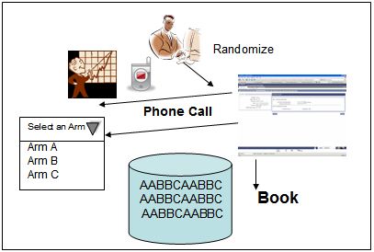
Figure 1: Randomization process

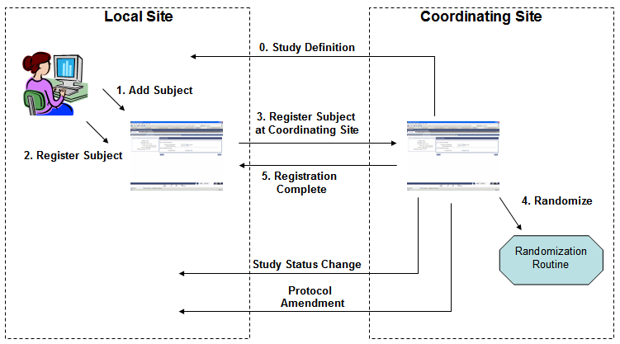
Figure 2: Multi-site integration

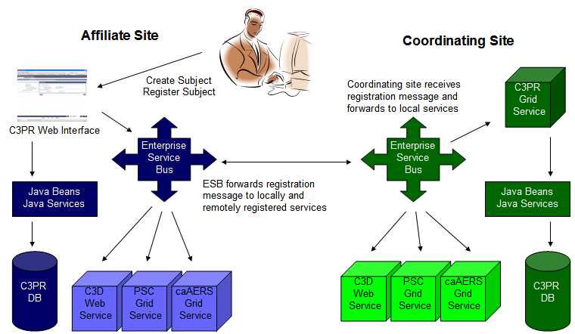

Figure 3: Multi-site trials

Chapter 3 - Logging In
Topics in this chapter include:
Security
Accessing C3PR
Logging into C3PR

Security
Users are added to the system through the administration tab (see chapter 8). At that time, they are provided a user name and password.

Accessing C3PR
Once C3PR is installed, it can be accessed through a standard web browser, such as Firefox 2.0 or Internet Explorer 6.0.

Logging into C3PR
Enter your user name and password into the appropriate fields on the login page, which is the first page you see when accessing C3PR.
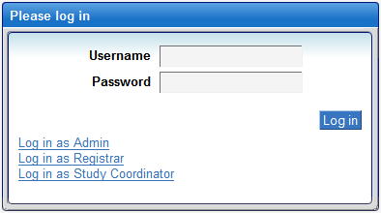

To log in to C3PR:

From the C3PR web page, type in your username and password.
- Click the Log in button.
- Once you have logged in successfully, you can manage a Study (see Chapter 4 -Managing Studies).

Chapter 4 - Managing Studies
Topics in this chapter include:
Adding Studies
Searching for Studies
Exporting Studies
Editing Studies
Amending Studies

Adding Studies
Before adding a new study, pay special attention to the following warning and notes.
Warning! Before adding a new study, confirm with the System Administrator that the Name of the Coordinating Center and the Principal Investigator for the study have been added to C3PR.
In addition, each of the following steps must be performed before a Sub-task that uses the specified list can be defined.
- Every Disease Category to be used by the study must be pre-defined.
- Every Organization to be used by the study must be pre-defined.
- Every Assigning Authority to be used by the study must be pre-defined.
- Every Personnel Research Staff to be used by the study must be pre-defined.
“Pre-defined” means that the information has been entered into C3PR.
If during completion of any Sub-task, a field requires specification of a value from one of the above lists and the desired value is not in the list, all unsaved information entered up to that point during the current session is lost and must be re-entered after the System Administrator has added the desired value.
In addition, if you open a Sub-task for which entry is required in order to activate the study, such as Investigator, you might lose the data entered for the entire session. THEREFORE, it is highly recommended that values to be used by the study be added to ALL of the lists described above before the process of adding the study is begun.
System Administrator: To determine if the above data have been pre-defined, go to the Administration tab. (See Chapter 8 - Administration.)

NOTES:
1. In this manual, bolded words indicate the name of the field.
2. To create a new study, all twelve Sub-tasks must be completed.
3. The twelve Sub-tasks depend on one another. The behavior or action of each Sub-task varies according to answers in the previous Sub-task(s). Please consult the Study Coordinator as to how each of the twelve Sub-tasks relate and interact with one another.
4. In each Sub-task, some fields are required, that is, must have a value entered. A required field has a red asterisk mark (*) in front of the field name. A field without a red asterisk mark (*) is not required to have a value entered. Values can be either (1) typed in by the user or (2) selected from a list.
5. At any time throughout the process, if you click on the Back or the Continue button, or click a Sub-task tab, C3PR validates the field entries. If there are errors, C3PR notifies the user and displays an error message on the screen. All errors must be corrected in order to continue to the next Sub-task. If there are no errors, C3PR saves all entries and proceeds to the next Sub-task.
6. Save: Clicking on the Back or Continue button saves the data only if the fields contain no errors. In order to create a new Study, you must complete and save all of the Sub-tasks and receive a confirmation page that the Study is created successfully.

To add a new Study, complete the following procedures:
- From the main menu, select the Studies tab
- From the Tasks bar, click on Create Study
- Fill out the Create Study: Details page
  - Type in the Short Title for the study. This field is limited to 30 characters in length.
  - Type in the Long Title for the study.
  - Type in the Description for the study.
  - Type in the Precis for the study, a structured summary description of a protocol document.
  - Type in the Target Accrual for the study. This value is the total number of subjects needed for protocol enrollment (accrual) across all study sites.
  - Select a study Type. There are six types from which to select.
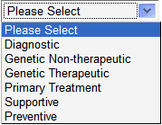
  - Select a study Phase. There are six phases from which to select.
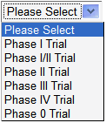
  - Select whether or not the Study is Blinded. (Yes or No).
Note: Selecting Yes for this field impacts the values in the Randomization section; the Randomized field defaults to Yes and the Randomization Type defaults to Phone Call.
  - Select whether or not the Study is Multi-Institutional. (Yes or No)
  - Fill in the Consent Version/Date. Type in a date in mm/dd/yyyy format, or click on the icon, and select a date using the calendar, or enter any free text value.
  - Select whether or not the study is a randomized trial. (Yes or No)
If the selection is Yes, then select the Type of the randomization. The Type can be either a Book or Phone Call. Note: If the type of the randomization is Book, then prepare to locate and upload the Book randomization later on.
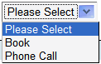
  - Select the Name of the Coordinating Center. Type one or more of the beginning letters of the name. Names in the pre-defined list with names that begin with the typed letters are displayed. If there are more matches than can be displayed completely within the display box, type additional letters to narrow the search or scroll through the list. Select the desired name by clicking on it.
Warning: If the value for which you are searching is not in the list, then it has not been pre-defined. Notify your system administrator of the value for which you are searching. Unless the Coordinating Center is determined to be in the list under a different name, the value must be added to the list. Log out of C3PR. Any unsaved information that you have entered up to this point must be re-entered after the value has been added. Re-read the warning on the first page of the Adding Studies section of this document.
  - Select the Principal Investigator. Type one or more of the beginning letters of the name. Names in the pre-defined list with names that begin with the typed letters are displayed. If there are more matches than can be displayed completely within the display box, type additional letters to narrow the search or scroll through the list. Select the desired name by clicking on it.
Warning: If the value for which you are searching is not in the list, then it has not been pre-defined. Notify your system administrator of the value for which you are searching. Unless the Principal Investigator is determined to be in the list under a different name, the value must be added to the list. Log out of C3PR. Any unsaved information that you have entered up to this point must be re-entered after the value has been added. Re-read the warning on the first page of the Adding Studies section of this document.
  - Type in the Coordinating Center Identifier. This identifier is assigned by the main site hosting the trial, which might differ from the identifier your site is using if your site is not the Coordinating Center. The value is free text.
  - Type in the Funding Sponsor Name, the name of the Organization or Institution conducting the trial. The value is free text.
  - Type in the Funding Sponsor Identifier. The value is free text.

Click the Continue button to proceed to the next task.

- Fill out the Create Study: Epochs & Arms page.
An epoch is a vertical segmentation of one or more arms which are parallel in time. There are two types of Epochs: 1. Treatment Epoch and 2. Non-Treatment Epoch.
If the study is randomized, then at least one Epoch must be added.

  - Click on Add Treatment Epoch to add a Treatment Epoch.
    - Type in the Name. This is a coded value which indicates the general scope of the activities that occur in the various arms of the Epoch. For example, screening, treatment, follow-up, etc.
    - Type in the Description of the epoch.
    - Type in the Order of the epoch within all epochs, both treatment and non-treatment, of the study. The field accepts only integer values.
    - If the study is marked as Randomized on the Create Study: Details page:
Select whether or not the epoch is Randomized. (Yes or No)
    - Click Add Arm to add an Arm to the Treatment Epoch.
A Treatment Epoch can exist without an Arm only if it not randomized. A randomized Study requires two or more Arms for each Treatment Epoch. If only one Arm is specified for a randomized Study, its status is pending.
      - Type in the name of the Arm.
The name of the Arm should be unique across all Treatment Epochs of the study for which Arms are specified. The unique Arm name is used within the randomization procedure.
      - Type in the Description of the arm, fully describing the details of the treatment arm or group.
      - Type in the Accrual Ceiling. This field indicates the total number of subjects targeted for accrual to this arm of the Treatment Epoch.
Repeat the steps of this section to add as many Arms as desired.
To remove an Arm, click on the red ‘X’ mark for the Arm.
Repeat the steps of this section to add as many Treatment Epochs as desired.
To remove a Treatment Epoch, click on the red ‘X’ mark for the Treatment Epoch.
  - After completing entry of all Treatment Epochs, you can continue by clicking on the Continue button, or add Non-treatment Epochs.
  - Click on Add Non-treatment Epoch to add a Non-treatment Epoch.
    - Type in the Name of the Non-treatment Epoch
    - Type in the Description of the epoch.
    - Type in the Order of the epoch within all epochs, both treatment and non-treatment, of the study. The field accepts only integer values.
    - Select the Accrual Indicator. (Yes or No)
Note: This field is required. It indicates whether entry into the epoch counts as an accrual (applies only to pre-Treatment Epochs where participation on the trial is not certain).
      - If Yes is selected:
Type in the Accrual Ceiling, the maximum number of participants allowed or expected to participate in the Non-treatment Epoch.
    - Type in the Enrollment Indicator. (Yes or No)
Note: This field is required. It indicates whether entry into the epoch requires enrollment.
Repeat the steps of this section to add as many Non-treatment Epochs as desired.
To remove a Non-treatment Epoch, click on the red ‘X’ mark for the Non-treatment Epoch.
  - After completing entry of all Non-treatment Epochs, you can continue by clicking on the Continue button, or return to the previous page by clicking the Back button.
- Fill out the Create Study: Eligibility page.
Specify one or more Inclusion Criteria and/or Exclusion Criteria either by uploading the criteria from a file, or by manually entering the criteria.

  - If the Study has a Treatment Epoch, then select the Treatment Epoch.
  - Select the caDSR File to Import by clicking on the Browse… button, and locating the file to upload. After the file has been identified and is ready to upload, click on the Upload button.
Note: The caDSR file (available at the NCI formbuilder website) contains Inclusion/Exclusion criteria.
  - Click on Add Inclusion Criterion to add an Inclusion Criterion.
    - Type in a Question that describes this criterion on the eligibility checklist.
Note: Valid values for Inclusion criteria questions are NA - Allow Not Applicable answers, Yes, and No.
Repeat the steps of this section to add as many Inclusion Criteria as desired.
To remove an Inclusion Criteron, click on the red ‘X’ mark for the Inclusion Criteron.
  - Click on Add Exclusion Criterion to add an Exclusion Criterion.
    - Type in a Question that describes this criterion on the eligibility checklist.
Note: Valid values for Exclusion criteria questions are NA - Allow Not Applicable answers, Yes, and No.
Repeat the steps of this section to add as many Exclusion Criteria as desired.
To remove an Exclusion Criterion, click on the red ‘X’ mark for the Exclusion Criterion.
After completing entry of all Eligibility Criteria, you can continue by clicking on the Continue button, or return to the previous page by clicking the Back button.
- Fill out the Create Study: Stratification page.
  - Click on Add Stratification Factor.
    - Type in the Stratification Question to be answered in order to identify the stratum group. This field is required.
    - Type in Answers to the Stratification Question.
At least 2 Answers are required.
    - To add additional Answers, click on Add Answer.
Repeat this step to add as many Answers as desired.
Repeat the steps of this section to add as many Stratification Factors as desired.
To remove a Stratification Factor, click on the red ‘X’ mark for the Stratification Factor.
  - When all Stratification Factors have been specified:
Click on Generate Stratum Groups to generate the stratum groups. The number of stratum groups is the product of the number of Answers for each Stratification Question. For example, if Question1 has 2 Answers, Question2 has 3 Answers, and Question3 has 4 Answers, the number of Stratum Groups is 2 X 3 X 4 = 24.
  - Continue by clicking on the Continue button, or return to the previous page by clicking the Back button.
- Fill out the Create Study: Randomization page.
Completion of this section depends on the answers given in previous sections.
- In section 3.11 (Create Study: Details: Randomized), the selection for Randomized must be Yes.
- In section 4.1.4 (Create Study: Epochs & Arms: Randomized), the selection for Randomized must be Yes. This section of the Randomization is for the Treatment Epoch.
- In section 6 (Create Study: Stratification), Stratification Factors must have been specified and Generate Stratum Groups must have been performed.
Randomization entries can be entered manually (Randomization Book) or imported from a Randomization File. C3PR accepts .txt, .csv, or .doc files.
Regardless of which method is used, the format of the randomization entries is the same, as described below.
Every Randomization entry is on a separate line.
Randomization entries consist of Stratum Group Number, Position, Arm Name.
Stratum Groups are numbered starting with zero (0). Within each Stratum Group, positions are numbered starting with zero (0). For example, if the Stratum Group Numbers are 0 and 1, and Arms are named A and B, then the randomization entries could look like this:
0,0,A
0,1,A
0,2,A
1,0,B
1,1,B

  - Type in the Randomization Book, the text containing Randomization Entries, in the format specified above, then click on Upload the Randomization Book button.
  - To upload a Randomization File, Select file to Import by clicking on the Browse… button, and locate the file to upload. After the file has been identified and is ready to upload, click on the Upload Randomization File button.
After completing specification of the Randomization entries, you can continue by clicking on the Continue button, or return to the previous page by clicking the Back button.
- Fill out the Create Study: Diseases page.
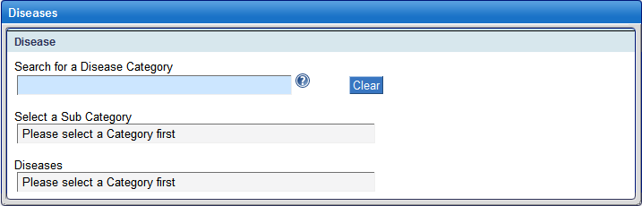
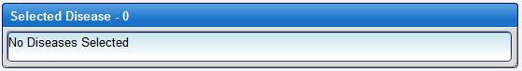
  - Fill out Disease Category. Type one or more of the beginning letters of the name. Names in the pre-defined list with names that begin with the typed letters are displayed. If there are more matches than can be displayed completely within the display box, type additional letters to narrow the search or scroll through the list. Select the desired name by clicking on it.
Warning: If the value for which you are searching is not in the list, then it has not been pre-defined. Notify your system administrator of the value for which you are searching. Unless the Disease Category is determined to be in the list under a different name, the value must be added to the list. Log out of C3PR. Any unsaved information that you have entered up to this point must be re-entered after the value has been added. Re-read the warning on the first page of the Adding Studies section of this document.
  - Select a Sub Category or select All for all Sub-Categories. The specific Sub-Categories that are displayed depend on the Disease Category selected.
  - Select one or more values from the list of Diseases. The specific Diseases that are displayed depend on the Sub-Category selected.
  - Having specified Disease Category, Sub-Category and Disease, click on Add Study Disease.
  - After clicking on Add Study Disease, the selected Disease Term(s) should appear in the “Selected Disease” display. The Selected Disease display also includes a check box for the column: Primary.
Click the check box to indicate primary disease.
Repeat the steps of this section to add as many Diseases as desired.
To remove a Disease, click on the red ‘X’ mark for the Disease.
After completing specification of Diseases, you can continue by clicking on the Continue button, or return to the previous page by clicking the Back button.
- Fill out the Create Study: Sites page.
  - Click on Add Study Site.
    - Fill out Organization. This field is the name of an organization or an institution that is conducting the trial, for example: DCP.
Type one or more of the beginning letters of the name. Names in the pre-defined list with names that begin with the typed letters are displayed. If there are more matches than can be displayed completely within the display box, type additional letters to narrow the search or scroll through the list. Select the desired name by clicking on it.
Warning: If the value for which you are searching is not in the list, then it has not been pre-defined. Notify your system administrator of the value for which you are searching. Unless the Organization is determined to be in the list under a different name, the value must be added to the list. Log out of C3PR. Any unsaved information that you have entered up to this point must be re-entered after the value has been added. Re-read the warning on the first page of the Adding Studies section of this document.
    - Fill out the Activation Date, the date that the site begins participation in the Study. Type in a date in mm/dd/yyyy format, or click on the icon, and select a date using the calendar.
    - Fill out the IRB Approval Date, the date that the Institutional Review Board or research ethics board approved the study for this site. Type in a date in mm/dd/yyyy format, or click on the icon, and select a date using the calendar.
    - Type the Target Accrual Number, the total number of subjects needed for protocol enrollment at this site.
Repeat the steps of this section to add as many Study Sites as desired.
To remove a Study Site, click on the red ‘X’ mark for the Study Site.
  - After completing entry of all Study Sites, you can continue by clicking on the Continue button, or return to the previous page by clicking the Back button.
- Fill out the Create Study: Identifiers page.
  - Organization Assigned Identifiers
The Organization Assigned Identifier for the Coordinating Center appears as specified in the Create Study: Details page, similar to the sample shown above.
To add additional Organization Assigned Identifier(s), click on Add Another Identifier.
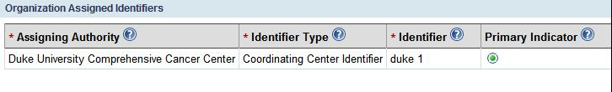
    - Fill out the Assigning Authority. Type one or more of the beginning letters of the name. Names in the pre-defined list with names that begin with the typed letters are displayed. If there are more matches than can be displayed completely within the display box, type additional letters to narrow the search or scroll through the list. Select the desired name by clicking on it.
Warning: If the value for which you are searching is not in the list, then it has not been pre-defined. Notify your system administrator of the value for which you are searching. Unless the Assigning Authority is determined to be in the list under a different name, the value must be added to the list. Log out of C3PR. Any unsaved information that you have entered up to this point must be re-entered after the value has been added. Re-read the warning on the first page of the Adding Studies section of this document.
    - Select Identifier Type.
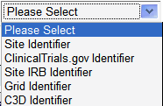
    - Type in the Identifier. This field is the actual identifier number or text.
    - Check whether or not the identifier is a Primary Indicator.
Repeat the steps of this section to add as many Organization Assigned Identifiers as desired.
To remove an Organization Assigned Identifier, click on the red ‘X’ mark for the Organization Assigned Identifier. Note: The Organization Assigned Identifier for the Coordinating Center cannot be removed.
  - System Assigned Identifiers
To add System Assigned Identifier(s), Click on Add Another Identifier.
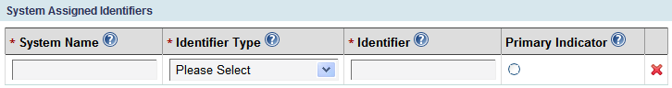
    - Type in the System Name. This field is free-text.
    - Select Identifier Type.
    - Type in the Identifier. This field is the actual identifier number or text.
    - Check whether or not the identifier is a Primary Indicator.
Repeat the steps of this section to add as many System Assigned Identifiers as desired.
To remove a System Assigned Identifier, click on the red ‘X’ mark for the System Assigned Identifier.
  - After completing entry of all Study: Identifiers, you can continue by clicking on the Continue button, or return to the previous page by clicking the Back button.

- Fill out the Create Study: Investigators page.
  - Select Organization. This field is the name of an organization or an institution that is conducting the trial, for example: DCP. Only the Coordinating Center, specified in the Study: Details Sub-task, and the Organizations specified as Study Sites in the Study: Site Sub-task appear in the selection list.
  - Select a Group or select All for all Groups. The specific Group(s) that is displayed depends on the Organization selected and whether or not Investigators for the Organization are assigned to Group(s).
  - Select one or more values from the list of Investigators. The specific Investigators that are displayed depend on the Organization and/or Group selected.
  - Having specified Organization, Group, and Investigator, click on Add Investigators.
  - After clicking on Add Investigators, the selected Investigator(s) should appear in the “Selected Investigator” display.
The Selected Investigator display includes an indication of whether the Investigators are currently participating in this Study.
Select Status.
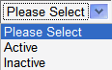
Repeat the steps of this section to add as many Investigators as desired.
To remove an Investigator, click on the red ‘X’ mark for the Investigator.
After completing entry of all Investigators, you can continue by clicking on the Continue button, or return to the previous page by clicking the Back button.

- Fill out the Create Study: Personnel page.
  - Select Organization. This field is the name of an organization or an institution that is conducting the trial, for example: DCP. Only the Coordinating Center, specified in the Study: Details Sub-task, and the Organizations specified as Study Sites in the Study: Site Sub-task appear in the selection list.
  - Click on Add Research Staff Person.
    - Fill out Name from the list. Type one or more letters that appear anywhere within the name. Names in the pre-defined list with names that contain the typed letters are displayed. If there are more matches than can be displayed completely within the display box, type additional letters to narrow the search or scroll through the list. Select the desired name by clicking on it.
The specific Personnel that are displayed depend on the Organization selected.
Warning: If the value for which you are searching is not in the list, then it has not been pre-defined. Notify your system administrator of the value for which you are searching. Unless the Assigning Authority is determined to be in the list under a different name, the value must be added to the list. Log out of C3PR. Any unsaved information that you have entered up to this point must be re-entered after the value has been added. Re-read the warning on the first page of the Adding Studies section of this document.
    - Select the Role of the Research Staff Person on the Study.
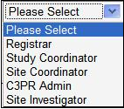
    - Select Status, an indication of whether the Research Staff Person is currently participating in the Study.
Repeat the steps of this section to add as many Research Staff Persons as desired for the selected Organization.
To remove a Research Staff Person, click on the red ‘X’ mark for the Research Staff Person.
  - To add Research Staff Persons to a different Organization, select Organization, then repeat the steps of this section to add as many Research Staff Persons as desired for the selected Organization.
  - Note: The Personnel Summary shows the personnel assigned to each Study Site.
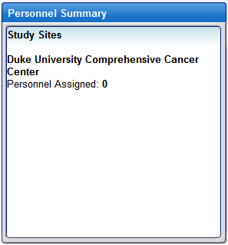
  - After completing entry of all Study Sites, you can continue by clicking on the Continue button, or return to the previous page by clicking the Back button.

- Fill out the Study: Notifications page to specify persons to be sent email when specified accrual landmarks are reached.
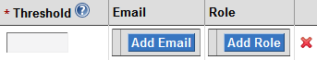
  - Click on Add Notification.
    - Type in Threshold, the portion (percentage) of the Target Accrual specified in Sub-task: Study: Details that, when reached, triggers an Notification email to be sent.
    - To add an Email address to be sent the Notification, click on Add Email and enter an Email address in the field. The Email address can be the address of an individual or of a mailing list.
Add as many Email addresses as desired.
To remove an Email address, click on the red ‘X’ mark for the Email address.
    - To specify that all Research Staff Personnel with a given Role in the study be sent the Notification, click on Add Role and select a Role.
Add as many Roles as desired.
To remove a Role, click on the red ‘X’ mark for the Role.
Repeat the steps of this section to add as many Notifications as desired.
To remove a Notification, click on the red ‘X’ mark on the right hand side of the Notification display.
  - After completing entry of all Notifications, you can continue by clicking on the Continue button, or return to the previous page by clicking the Back button.

- Overview of the study
  - Review the Study Overview.
Note: The information is not displayed in Sub-task order.
    - Review Basic Details.
    - Review Sites.
    - Review Identifiers.
    - Review Investigators.
    - Review Personnel.
    - Review Stratification Factors.
    - Review Stratum Groups.
    - Review Diseases.
    - Review Epochs & Arms.
    - Review the Notifications.
  - If there is an Edit button for the Sub-task, you can click the Edit button to make additional changes to that Sub-task.
  - Click on Print to print the Study Overview.
  - Upon completion of the Study Overview, there are two options.
    - Click on Save to save the Study information. A confirmation page is displayed, stating Study successfully created. Note: C3PR saves the data but the Study status is not changed to “active.”
    - Click on Save and Activate to save and activate the Study. A confirmation page is displayed, stating Study successfully created. Note: A Study can only be made active if all requirements are met.

Searching for Studies
To search for a study:
- From the main menu, select the Studies tab
- From the Tasks bar, click on Search Study
- Select Search By
- 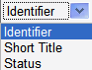
- Type in Search Criteria. You can use a % as a wild card to search on partial text.
- Click Search
- Select the Short Title from the Search Results to view the Study
- Once viewing the Study, the users can Export, Edit, Amend or Print the Study.

Exporting Studies
The following procedures allow the user to export a Study:
From the main menu, select the Studies tab
- From the Tasks bar, click on Search Study
- Select Search By
- Type in Search Criteria. You can use a % as a wild card to search on partial text.
- Click Search
- Select the Short Title from the Search Results to view the Study
- Click on Export Study button
- Select either to Open with or Save to Disk
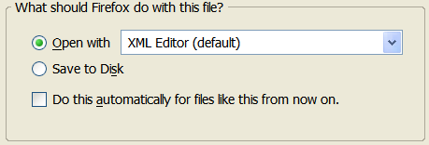

Editing Studies
The following procedures allow the user to edit a Study:
From the main menu, select the Studies tab
- From the Tasks bar, click on Search Study
- Select Search By
- Type in Search Criteria. You can use a % as a wild card to search on partial text.
- Click Search
- Select the Short Title from the Search Results to view the Study
- Click on Edit Study button

Amending Studies
The following procedures allow the user to amend a Study:
From the main menu, select the Studies tab
- From the Tasks bar, click on Search Study
- Select Search By
- Type in Search Criteria. You can use a % as a wild card to search on partial text.
- Click Search
- Select the Short Title from the Search Results to view the Study
- Click on Amend Study button
- Type in Version #
- Type in Amendment Date
- Type in Comments
- Check the Reason for Amendment (minimum of one)
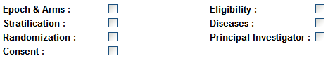
- Click on Save or Save & Continue
- Continue with Amend Study: Details, Epochs & Arms, Eligibility, Stratification, Randomization, Diseases, Sites, Identifiers, Investigators, Personnel, Notifications, and Summary.

Printing Studies
The following procedures allow the user to print a Study:
From the main menu, select the Studies tab
- From the Tasks bar, click on Search Study
- Select Search By
- Type in Search Criteria. You can use a % as a wild card to search on partial text.
- Click Search
- Select the Short Title from the Search Results to view the Study
- Click on Print button

Chapter 5 - Managing Subjects
Topics in this chapter include:
Adding Subjects
Searching for Subjects

Adding Subjects
To add a Subject to a Study, log in to C3PR. See Chapter 3 for the instruction on how to log in to C3PR.
To add a new subject:
1. From the main menu, select the Subjects tab
2. From the Tasks bar, click on Create Subject
To begin to register a new subject, fill out the Create Subject: Details page
2.1 Type in the First Name for the subject
2.2 Type in the Last Name for the subject
2.3 Type in the Middle Name for the subject
2.4 Type in the Maiden Name for the subject
2.5 Select the Gender for the subject
2.6 Type in the Birth Date for the subject
2.7 Select the Ethnicity for the subject
2.8 Select the Race(s) for the subject
2.9 Select the Organization
Warning: if the Organization has not being pre-defined, you must notify your system administrator before you can continue.
2.10 Type in an Identifier
2.11 Click Add Another Identifier for the Organization Assigned Identifiers
2.11.1 Type in the Assigning Authority
2.11.2 Select the Identifier Type
2.11.3 Type in the Identifier
2.11.4 Indicate whether or not if the subject is a Primary Indicator
2.12 Click Add Another Identifier for the System Assigned Identifiers
2.10.1 Type in System Name.
2.10.2 Select the Identifier Type.
2.10.3 Type in the Identifier.
2.10.4 Indicate whether or not if the subject is a Primary Indicator

Upon its completion of the Subject Details, click Continue

3. Fill out the Address & Contact Info
3.1 Type in the Street Address
3.2 Type in the City
3.3 Type in the State
3.3 Type in the Zip
3.3 Type in the Country
3.3 Type in the Email
3.3 Type in the Phone
3.3 Type in the Fax

Click Continue

4. Review and Submit
4.1 Review the Basic Details
4.2 Review the Address
4.3 Review the Contact Information
4.4 Review the Identifier

Click Save. If there is no error, then C3PR displays that the Subject successfully created.

Searching for Subjects
To search for a Subject, log in to C3PR. See Chapter 3 for the instruction on how to log in to C3PR.
To search for a subject:
1. From the main menu, select the Subjects tab
2. From the Tasks bar, click on Search Subject
3. Select Search By
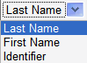
4. Type in Search Criteria. You can use a % as a wild card to search on partial text
5. Click Search

Chapter 6 - Managing Registrations
Topics in this chapter include:
Creating Registrations
Searching for Registrations

Creating Registrations
To create a new registration, log in to C3PR. See Chapter 3 on how to log in to C3PR.
To create a new registration:
1. From the main menu, select the Registration tab
2. From the Tasks bar, click on Create Registration
There are six Sub-tasks for the Registration.
  - Select Subject & Study
  - Enrollment Details
  - Check Eligibility
  - Stratification
  - Select Arm
  - Review & Submit
3. First task: Create Registration: Select Subject & Study
3.1 Select a Subject. There are two ways for a subject to be selected. It can be either (1) select an existing subject using the search subject feature, or (2) simply create a new subject.
3.1.1.0 Select an existing subject, using Search Subject
3.1.1.1 Select one of the options - Search Subject By
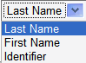
3.1.1.2 Type in Search Criteria. You can use a % as a wild card to search all the available subjects
3.1.1.3 Click on Search
Upon click on Search, C3PR displays the results. Select the subject from the results by moving the cursor to the name and click the mouse. Immediately, the Select a Subject screen gets highlighted and C3PR displays the selected subject. Next, the “Select a Subject” screen gets minimize. To restore to a full screen, click on the icon under the “Select a Subject” screen.
If the result comes back with data, then click on the name of the subject that you want to select.
If the result comes back with no data, and/or you want to create a new subject, then click on Create Subject. (See 3.1.1.0 on how to Create Subject).
3.1.2.0 Create New Subject
3.1.2.1 Click on Create Subject tab
3.1.2.2 Type in the First Name for the subject
3.1.2.3 Type in the Last Name for the subject
3.1.2.4 Type in the Middle Name for the subject
3.1.2.5 Type in the Maiden Name for the subject
3.1.2.6 Select the Gender for the subject
3.1.2.7 Type in the Birth Date for the subject. Date format should be mm/dd/yyyy
3.1.2.8 Select the Ethnicity for the subject. This field indicates the person’s self declared ethnic origination, independent of racial origination.
3.1.2.9 Select the Race(s) for the subject
3.1.2.10 Type in the Organization
3.1.2.11 Type in the Identifier
3.1.2.12 Click add the Organization Assigned Identifiers then click on Add another Identifier
3.1.2.12.1 Type in the Assigning Authority
3.1.2.12.2 Select the Identifier Type
3.1.2.12.3 Type in the Identifier
3.1.2.12.4 Indicate whether or not if the subject is a Primary Indicator
3.1.2.13 Click on Address & Contact Info, to add the Address and Contact information.
3.1.2.13.1 Type in Street Address
3.1.2.13.2 Type in the City
3.1.2.13.3 Type in the State
3.1.2.13.4 Type in the Zip
3.1.2.13.5 Type in the Country
3.1.2.13.6 Type in the Email
3.1.2.13.7 Type in the Phone
3.1.2.13.8 Type in the Fax
3.1.2.14 Click Save
Upon click on Save, C3PR saves the subject and the new subject has been selected. Thus, the Select a Subject screen gets highlighted and C3PR displays the selected subject. The “Select a Subject” screen gets minimize. To restore to a full screen, click on the icon under the “Select a Subject” screen.
3.2 Once the Subject has been selected, the next step is to select a study
3.2.1 Select one of the Search Studies By options:
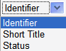
3.2.2 Type in Search Criteria. You can use a % as a wild card to search all the available studies
3.2.3 Click Search
3.2.4 Select the Study from the list. If the Study has more than one site, then select the Site, along with the Study.
Warning: If the study is not on the list, then please contact the system administrator or create the Study (see chapter 4 on how to create a new Study).
3.3 If the selected Study has an epoch treatment, then C3PR displays all the available epoch treatments. Select an epoch treatment from the list.
3.4 Click Continue to proceed to the next task (Enrollment Details)

4. Second task: Create Registration: Enrollment Details
Warning: If the participant is already registered on this epoch. If you want to move this subject to another epoch of this study, please use Manage Registration module. You can navigate to Manage Registration by searching the registration and then clicking on the registration record. See “Search for Registrations” section on how to change its current epoch.
  - Fill out the Enrollment Details
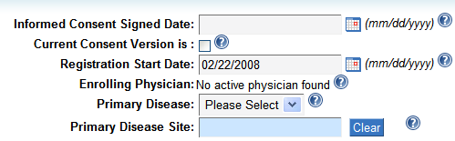
4.1.1 Type in Information Consent Signed Date
4.1.2 Indicate whether if the Current Consent Version is. This is the version of the consent document that the subject signed.
4.1.3 Type in the Registration Start Date
4.1.4 Select the Primary Disease. If the selection is Other, then C3PR provides the user with an addition text field to which it represents a type of disease other than the primary disease for which the patient is being treated could be typed in.
4.1.5 Select the Primary Disease Site
4.1.6 Click Continue to proceed to the next task (Check Eligibility).
5. Third task: Create Registration: Check Eligibility
If the selected epoch does not involved checking eligibility, then click Continue to proceed to the next task (Stratification).
6. Fourth task: Create Registration: Stratify
If the selected epoch does not involved stratification, then click Continue to proceed to the next task (Select Arm).
7. Fifth task: Create Registration: Select Arm
7.1 Select Arm from the list
7.2 Click Continue to proceed to the next task (Review & Submit).
8. Fifth task: Create Registration: Review & Submit
8.1 Review the Registration data
8.2 Click on Save to save the Registration data
8.3 Read the Confirmation Message

Searching for Registrations
To search for a registration, log in to C3PR. See Chapter 3 on how to log in to C3PR.
To search for a registration:
1. From the main menu, select the Registration tab
2. From the Tasks bar, click on Search Registration
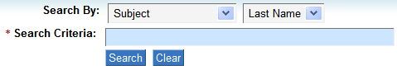
3. Select one of the options for Search By
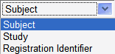
If the above “Search By” option is a Subject, then select one of the below options
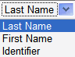
If the above “Search By” option is a Study, then select one of the below options
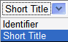
4. Type in Search Criteria (case sensitive & cannot use % as wild card)
5. Click on Search
6. Based on the above search criteria, if C3PR finds its match, then it displays the result for the user to select. Select a Study from the result.
6.1 Once the Study has been selected from the result, the user can (1) view the registration, (2) edit the enrollment details, (3) print the Study, (4) export the Study, or (5) change its current epoch.
6.1.1 To view the registration, simply select a study from the search result. C3PR displays the Overview page for the user to view the registration.
6.1.2 To edit the enrollment details (Only if the registration status is Registered); click on the Edit button under the Enrollment Details section from the Overview page. If the registration status is “Take subject off study”, then edited the registration won’t be able to performed.
6.1.2.1 To “Take subject off study”, click on the button
6.1.2.2 Fill out the Reason
6.1.2.3 Fill out the Date
6.1.2.4 Click OK
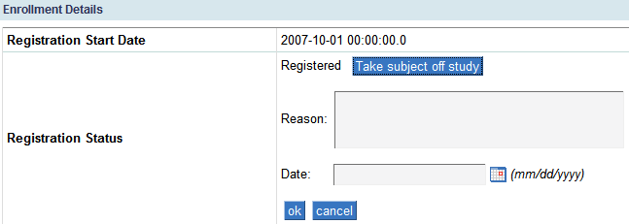
6.1.3 To print the registration, click the Print button from the Overview
6.1.4 To export the registration, click the Export button from the Overview
6.1.5 To change its current epoch, click on Change Current Epoch tab.
6.1.5.1 At this point, C3PR displays all the epoch treatments that related to this registration. To change its current epoch, simply drag and drop the subject to the appropriate epoch.

Chapter 7 - Advanced Querying
Topics in this chapter include:
Querying for Registrations
Querying for Studies

Querying for Registrations
To search for a registration, please complete these following procedures:
From the main menu, select the Administration tab
From the Tasks bar, click on Search Registration
1. To search for a registration, C3PR allows participant to query any of the below four criteria:
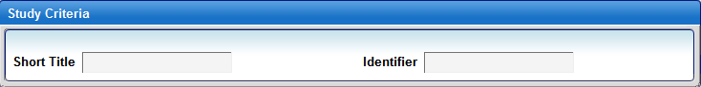
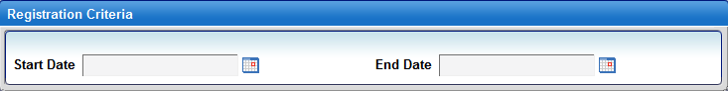
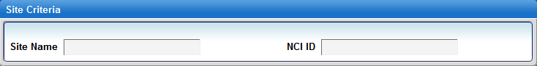
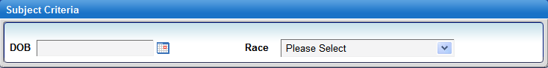
Click on Search to begin to Search for a registration

Querying for Studies
To search for a Study, please complete these following procedures:
From the main menu, select the Administration tab
From the Tasks bar, click on Search Study
2. To search for a Study, C3PR allows participant to query any of the below two criteria:

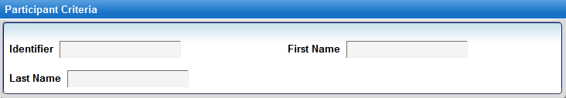
Click on Search to begin to Search for a Study
Chapter 8 - Administration

Topics in this chapter include:
Configure C3PR
Adding Investigators
Adding Research Staff
Adding Organizations
Importing Studies
Importing Registration

Configure C3PR
C3PR has the following configurations that would allow participants to have more control in their research environment.
To begin to configure C3PR, from the main menu, select the Administration tab
Click on Tasks: Configure C3PR

Here are the configurations for C3PR:
Authentication Mode
This defines the strategy C3PR uses to authenticate. Possible values are 'local' and 'webSSO' (Default: local)

Authorization enable switch
Switch to turn on/off authorization. The value may not be applied until the application is restarted (Default: false)

C3D hotlink URL
The base URL for the C3D deployment to which this C3PR instance can link (Default: https://octrials-train.nci.nih.gov/opa45/rdclaunch.htm)

C3PR URL
This is the URL of this C3PR instance.

caAERS hotlink URL. The base URL for the caAERS deployment to which this C3PR instance can link (Default: https://cbvapp-d1017.nci.nih.gov:28443/caaers/pages/ae/list)

WebSSO base URL
(Default: https://cbvapp-d1017.nci.nih.gov:48443/cas)

WebSSO certificate file
WebSSO certificate file path
(Default: /System/Library/Frameworks/JavaVM.framework/Versions/1.5.0/Home/lib/security/cacerts)

ESB enable switch
Switch to turn on/off esb (Default: false)

ESB URL
URL for the enterprise service bus -- the value may not be applied until the application is restarted (Default: https://cbvapp-d1017.nci.nih.gov:28445/wsrf/cagrid/CaXchangeRequestProcessor)

Host certificate file host certificate file path
(Default: /Users/kherm/certs/manav.local-cert.pem)

Host key
Host key path (Default: /Users/kherm/certs/manav.local-key.pem)

Hosted Mode
If the value is false, C3PR will not send a registration request to Co-ordinating center for approval for Multi-Site trials (Default: true)

Local site NCI institute code
The NCI institute code of the site where this C3PR instance is running

SMTP authentication
(Default: true)

From address
The "from" address for all mail sent by C3PR. This address need not be a real e-mail address. The value may not be applied until the application is restarted
(Default: admin@semanticbits.com)

SMTP password
Mail server password (only necessary if the mail server requires authentication). The value may not be applied until the application is restarted (Default: biju1234)

SMTP server
The address of the outgoing mail server (e.g.: smtp.gmail.com). The value may not be applied until the application is restarted (Default: smtp.comcast.net)

SMTP port
The port number of the outgoing mail server. The value may not be applied until the application is restarted (Default: 25)

SMTP user name
Mail server username (only necessary if the mail server requires authentication). The value may not be applied until the application is restarted
(Default: biju.joseph@semanticbits.com)

Study Calendar hotlink URL. The base URL for the Study Calendar deployment to which this C3PR instance can link
(Default: https://cbvapp-d1017.nci.nih.gov:28443/psc/pages/schedule)

Once the participants completed the C3PR configuration, click the Save button to save the configuration.

Adding Investigators
To add a new Investigator, please complete these following procedures:
From the main menu, select the Administration tab
From the Tasks bar, click on Investigator
The Investigator task has three options 1. Search 2. Create and 3. Group
  - To search for an Investigator, enter one or all of the three fields, First Name, Last Name, and NCI Identifier.
Note: Use the NCI Identifier that assigned in the NCI investigator registry to a physician approved for conducting a clinical trial [CTEP].
Also, use % as wildcard for any of the three fields.
8.1.1 Click on Search to search for an Investigator
  - To create a new investigator, click on Create Investigator tab
8.2.1 Select the Organization or the study site at which the investigator exists.
Warning: The name of the Organization must be selected from the list. If the Organization is not on the list, then DO NOT create Investigator. Please create the Organization first, and then a new investigator could be added to the Study. (See Adding Organization section). DO NOT use the Add Organization button while under Create Investigator).
If the investigator has a multiple organization, then click on Add Organization button
    - Select the Investigator Status. Select Active or inactive. This is the code value that represents the activity status of the Study site investigator that will grant that investigator activity capability within that site context.
    - Type in the First Name of the investigator
    - Type in the Last Name of the investigator
    - Type in the Middle Name of the investigator
    - Type in the Maiden Name of the investigator
    - Type in the NCI Identifier of the investigator
    - Type in the Email or Username of the investigator
    - Type in the Phone number of the investigator
    - Type in the Fax number of the investigator
    - Click on Save to create a new investigator
  - Select the Organization
8.3.1 Select a Group. If a group does not exist, and the participants want to add a group for the investigator, then click on Add Group.
8.3.2 To add an investigator group, click on Add Group
8.3.3 Type in the Name of the group
8.3.4 Type in the Start Date
8.3.5 Type in the End Date
8.3.6 Type in the Description of the group investigator
8.3.7 To add a new Investigator to the group investigator, click on Add Investigator
8.3.7.1 Select the Investigator from the list by typing a first or few letter of the investigator first or last name.
8.3.7.2 Type in the Start Date
8.3.7.3 Type in the End Date

8.3.8 Click on Save to create a new Investigator Groups

Adding Research Staff
To add a new Research Staff, please complete these following procedures:
From the main menu, select the Administration tab
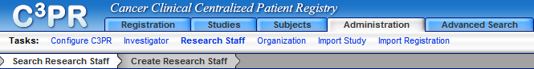
From the Tasks bar, click on Research Staff
The Research Staff task has two options 1. Search 2. Create New
    - To search for a Research Staff, enter one or all of the four fields, First Name, Last Name, NCI Identifier, and Organization
Use the NCI Identifier that the identifier assigned in the NCI research staff registry to a research staff person. The Organization is the site at which the research staff exists. If the Organization does not exit, then DO NOT continues. The Organization needs to be created first before C3PR can create new research staff.
Also, use % as wildcard for any of the fields, except the Organization
8.4.2 Click on Search to search for an Investigator
8.5.1 To create new Research Staff, select the Organization at which the research staff exists.
8.5.2 Type in the First Name of the research staff
8.5.3 Type in the Last Name of the research staff
8.5.4 Type in the Middle Name of the research staff
8.5.5 Type in the Maiden Name of the research staff
8.5.6 Type in the NCI Identifier of the research staff
8.5.7 Type in the Email or Username of the research staff
8.5.8 Type in the Phone number of the research staff
8.5.9 Type in the Fax number of the research staff
8.5.10 Check the user role for the research staff. Check at least one or check all the roles that apply.
◻C3pr admin ◻Study coordinator
◻Registrar ◻Site coordinator

Adding Organizations
To add a new Organization, please complete these following procedures:
From the main menu, select the Administration tab
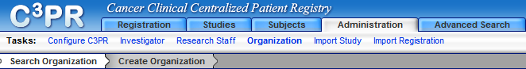
From the Tasks bar, click on Organization
The Organization task has two options; Search and Create New.
8.6.1 To search for an Organization, enter Name and/or NCI Identifier
Note: the NCI Identifier is the assigned code that uniquely identifies an organization. Also, you can use % as a wildcard for any of the fields
    - Click on Search to search for an Organization
    - To create new Organization, enter the following fields:
        - Type in the Name of the organization
        - Type in the Description of the organization
        - Type in the NCI Institute Code of the organization
        - Type in the Street Address of the organization
        - Type in the City of the organization
        - Type in the State of the organization
        - Type in the Zip code of the organization
        - Type in the Country that the organization located
Click on the Save button, to create a new organization

Importing Study
To import a Study, please complete these following procedures:
From the main menu, select the Administration tab
From the Tasks bar, click on Import Study
    - Select XML file to import by clicking on the Browse … button
    - Click on Import to import Study
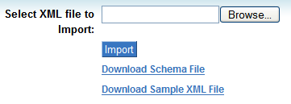
    - Click on the Study that was just imported and change the status of the Study Sites
In order to upload the registration.

Importing Registrations
Warning: The Study site must be activated in order to import registrations.
To import a Registration, please complete these following procedures:
From the main menu, select the Administration tab
From the Tasks bar, click on Import Registration
    - Select XML file to import by clicking on the Browse … button
    - Click on Import to import Registration
References

Technical Manuals/Articles
- National Cancer Institute. "caCORE 2.0 Technical Guide", ftp://ftp1.nci.nih.gov/pub/cacore/caCORE2.0_Tech_Guide.pdf
- Java Bean Specification: http://java.sun.com/products/javabeans/docs/spec.html
- Foundations of Object-Relational Mapping: http://www.chimu.com/publications/objectRelational/
- Object-Relational Mapping articles and products: http://www.service-architecture.com/object-relational-mapping/
- Hibernate Reference Documentation: http://www.hibernate.org/hib_docs/reference/en/html/
- Basic O/R Mapping: http://www.hibernate.org/hib_docs/reference/en/html/mapping.html
- Java Programming: http://java.sun.com/learning/new2java/index.html
- Javadoc tool: http://java.sun.com/j2se/javadoc/
- JUnit: http://junit.sourceforge.net/
- Extensible Markup Language: http://www.w3.org/TR/REC-xml/
- XML Metadata Interchange: http://www.omg.org/technology/documents/formal/xmi.htm

caBIG Material
- caBIG: http://cabig.nci.nih.gov/
- caBIG Compatibility Guidelines: http://cabig.nci.nih.gov/guidelines_documentation

caCORE Material
- caCORE: http://ncicb.nci.nih.gov/core
- caBIO: http://ncicb.nci.nih.gov/core/caBIO
- caDSR: http://ncicb.nci.nih.gov/core/caDSR
- EVS: http://ncicb.nci.nih.gov/core/EVS
- CSM: http://ncicb.nci.nih.gov/core/CSM
Glossary
Term | Definition
API | Application Programming Interface
caArray | cancer Array Informatics
caBIG | cancer Biomedical Informatics Grid
caBIO | Cancer Bioinformatics Infrastructure Objects
caCORE | cancer Common Ontologic Representation Environment
caDSR | Cancer Data Standards Repository
C3PR | Cancer Translational Research Informatics Platform
CDE | Common Data Element
CSM | Common Security Module
CSV | Comma Delimited
DCQL, | Distributed Common Query Language
EA | Enterprise Architect
EVS | Enterprise Vocabulary Services
GUI | Graphical User Interface
HTTP | Hypertext Transfer Protocol
JAR | Java Archive
Javadoc | Tool for generating API documentation in HTML format from doc comments in source code (http://java.sun.com/j2se/javadoc/)
JDBC | Java Database Connectivity
JUnit | A simple framework to write repeatable tests (http://junit.sourceforge.net/)
metadata | Definitional data that provides information about or documentation of other data.
NCI | National Cancer Institute
NCICB | National Cancer Institute Center for Bioinformatics
ORM | Object Relational Mapping
RDBMS | Relational Database Management System
SDK | Software Development Kit
Semantic connector | A development kit to link model elements to NCICB EVS concepts.
SQL | Structured Query Language
UI | User Interface
UML | Unified Modeling Language
URL | Uniform Resource Locators
VD | Value Domain
WAR | Web Application Archive
WSDL | Web Services Description Language
XMI | XML Metadata Interchange (http://www.omg.org/technology/documents/formal/xmi.htm) - The main purpose of XMI is to enable easy interchange of metadata between modeling tools (based on the OMG-UML) and metadata repositories (OMG-MOF) in distributed heterogeneous environments

Index

Adminstration
Configuration, 44
Investigators, 46
Organizations, 48
Research Staffs, 48
C3PR
Definition, 7
Overview & Functionality, 7
Users, 8
Wiki, 8
Common Security Module, 11
Exporting to Excel, 25
Importing Study, 50
Importing Registrations, 50
Login
Accessing , 12
Advanced Query Builder, 42
Basic Query Builder, 30
Organization of the User's Manual, 8
Overview
Architecture, 7
List of Features, 7
Multi-site Intergartion, 11
Randomization Process, 10
User Interface, 10
Query Search
Filters, 42
Finding, 42
References
caBIG materials, 51
caCORE material, 51
Scientific publications, 51
Technical manuals, guides, 51
Registrations
Create, 36
Search, 40
Studies
Amend, 31
Create, 13
Details, 14
Diseases , 22
Edit,31
Eligibility, 19
Epochs and Arms, 17
Export, 30
Identifiers, 24
Non-treatment Epoch, 17
Notifications , 28
Overview, 28
Personnel, 26
Print, 32
Randomization, 20
Requirements, 13
Sites, 23
Search , 30
Stratification, 20
Treatment Epoch, 17
Subjects
Create, 33
Search, 34
Text Conventions
keyboard keys, 9
menu commands, 9
The C3PR GForge site, 8

