Cancer Central Clinical Participant Registry v2

Installation Guide

Updated January 16, 2008
caBIG™ is an initiative of the National Cancer Institute, NIH, DHHS

Copyright and License page

Copyright Notice. Copyright 2006 Duke Comprehensive Cancer Center (“caBIG™ Participant”). C3PR was created with NCI funding and is part of the caBIG™ initiative. The software subject to this notice and license includes both human readable source code form and machine readable, binary, object code form (the “caBIG™ Software”).
This caBIG™ Software License (the “License”) is between caBIG™ Participant and You. “You (or “Your”) shall mean a person or an entity, and all other entities that control, are controlled by, or are under common control with the entity. “Control” for purposes of this definition means (i) the direct or indirect power to cause the direction or management of such entity, whether by contract or otherwise, or (ii) ownership of fifty percent (50%) or more of the outstanding shares, or (iii) beneficial ownership of such entity.
License. Provided that You agree to the conditions described below, caBIG™ Participant grants You a non-exclusive, worldwide, perpetual, fully-paid-up, no-charge, irrevocable, transferable and royalty-free right and license in its rights in the caBIG™ Software, including any copyright or patent rights therein that may be infringed by the making, using, selling, offering for sale, or importing of caBIG™ Software, to (i) use, install, access, operate, execute, reproduce, copy, modify, translate, market, publicly display, publicly perform, and prepare derivative works of the caBIG™ Software; (ii) make, have made, use, practice, sell, and offer for sale, and/or otherwise dispose of caBIG™ Software (or portions thereof); (iii) distribute and have distributed to and by third parties the caBIG™ Software and any modifications and derivative works thereof; and (iv) sublicense the foregoing rights set out in (i), (ii) and (iii) to third parties, including the right to license such rights to further third parties. For sake of clarity, and not by way of limitation, caBIG™ Participant shall have no right of accounting or right of payment from You or Your sublicensees for the rights granted under this License. This License is granted at no charge to You. Your downloading, copying, modifying, displaying, distributing or use of caBIG™ Software constitutes acceptance of all of the terms and conditions of this Agreement. If you do not agree to such terms and conditions, you have no right to download, copy, modify, display, distribute or use the caBIG™ Software.
- Your redistributions of the source code for the caBIG™ Software must retain the above copyright notice, this list of conditions and the disclaimer and limitation of liability of Article 6 below. Your redistributions in object code form must reproduce the above copyright notice, this list of conditions and the disclaimer of Article 6 in the documentation and/or other materials provided with the distribution, if any.
- Your end-user documentation included with the redistribution, if any, must include the following acknowledgment: “This product includes software developed by Duke Comprehensive Cancer Center.” If You do not include such end-user documentation, You shall include this acknowledgment in the caBIG™ Software itself, wherever such third-party acknowledgments normally appear.
- You may not use the names “Duke Comprehensive Cancer Center”, “The National Cancer Institute”, “NCI”, “Cancer Bioinformatics Grid” or “caBIG™” to endorse or promote products derived from this caBIG™ Software. This License does not authorize You to use any trademarks, service marks, trade names, logos or product names of either caBIG™ Participant, NCI or caBIG™, except as required to comply with the terms of this License.
- For sake of clarity, and not by way of limitation, You may incorporate this caBIG™ Software into Your proprietary programs and into any third party proprietary programs. However, if You incorporate the caBIG™ Software into third party proprietary programs, You agree that You are solely responsible for obtaining any permission from such third parties required to incorporate the caBIG™ Software into such third party proprietary programs and for informing Your sublicensees, including without limitation Your end-users, of their obligation to secure any required permissions from such third parties before incorporating the caBIG™ Software into such third party proprietary software programs. In the event that You fail to obtain such permissions, You agree to indemnify caBIG™ Participant for any claims against caBIG™ Participant by such third parties, except to the extent prohibited by law, resulting from Your failure to obtain such permissions.
- For sake of clarity, and not by way of limitation, You may add Your own copyright statement to Your modifications and to the derivative works, and You may provide additional or different license terms and conditions in Your sublicenses of modifications of the caBIG™ Software, or any derivative works of the caBIG™ Software as a whole, provided Your use, reproduction, and distribution of the Work otherwise complies with the conditions stated in this License.
- THIS caBIG™ SOFTWARE IS PROVIDED "AS IS" AND ANY EXPRESSED OR IMPLIED WARRANTIES (INCLUDING, BUT NOT LIMITED TO, THE IMPLIED WARRANTIES OF MERCHANTABILITY, NON-INFRINGEMENT AND FITNESS FOR A PARTICULAR PURPOSE) ARE DISCLAIMED. IN NO EVENT SHALL THE DUKE COMPREHENSIVE CANCER CENTER OR ITS AFFILIATES BE LIABLE FOR ANY DIRECT, INDIRECT, INCIDENTAL, SPECIAL, EXEMPLARY, OR CONSEQUENTIAL DAMAGES (INCLUDING, BUT NOT LIMITED TO, PROCUREMENT OF SUBSTITUTE GOODS OR SERVICES; LOSS OF USE, DATA, OR PROFITS; OR BUSINESS INTERRUPTION) HOWEVER CAUSED AND ON ANY THEORY OF LIABILITY, WHETHER IN CONTRACT, STRICT LIABILITY, OR TORT (INCLUDING NEGLIGENCE OR OTHERWISE) ARISING IN ANY WAY OUT OF THE USE OF THIS caBIG™ SOFTWARE, EVEN IF ADVISED OF THE POSSIBILITY OF SUCH DAMAGE.

Development Team(s)
Development | Installation Documentation | Program Management
Kruttik Aggarwal² | Priyatam Mudivarti² | Bob Annechiarico¹
Manav Kher² | Manav Kher² | Jamie Cuticchia¹
Priyatam Mudivarti² |  | Patrick McConnell¹
Ram Chilukuri² |  | Ram Chilukuri²
Ramakrishna Gundala²
¹Duke Comprehensive Cancer Center | ²SemanticBits

Contacts and Support
Enter training contact | Patrick McConnell  (patrick.mcconnell@duke.edu)
Enter customer support contact | NA

LISTSERV Facilities Pertinent to software teams
LISTSERV | URL | Name
c3prv2-elaborator | c3prv2-elaborators@gforge.nci.nih.gov | C3PR Elaborators Forum
C3prv2-general | c3prv2-general@gforge.nci.nih.gov | C3PR General Forum
Table of Contents

1. Introduction 1
Support for C3PRv1 1
Overview of C3PRv2 1
2. C3PR Software and Technology Requirements 2
Hardware Requirements 2
Software Requirements 3
Required Software 3
Optional Software 5
3. Installing C3PR 6
4. Graphical Installer 7
5. Common Problems with Installer (FAQ) 13
Manual Install 14
Download C3PRV2 codebase 14
C3PR Configuration 15
Setup Database 17
Build / Deploy Code (Ant) 18
Securing Tomcat 18
Running C3PR 19
6. Contacting Technical Support 20
Appendix A – Configuring Multiple Tomcat Servers 21
Appendix B – Setting up CVS clients 22
Setup Tortoise CVS client 22
Setup Eclipse CVS Perspective 28

Introduction
This installation guide outlines the supported configurations and installing, setting up and configuring the application and databases for the Cancer Central Clinical Participant Registry version 2 (C3PRv2). All of the steps and screenshots included in this guide are Windows/Linux specific. If you are using a different platform, then modify the information as appropriate for your system.

Overview of C3PRv2 | The Cancer Central Participant Registry (C3PR) Release 2 is a web-based application used for end-to-end registration of patients to clinical trials. This includes capturing the consent signed date, eligibility criteria, stratification, randomization, and screening. Clinical workflows are enabled by both subject- and study-centric views into the registration process. C3PR can be run in a standalone mode where study definitions, investigators, study personnel, and sites are entered into the system, or C3PR can be run in an integrated mode with the caBIG Clinical Trials Suite (CCTS). C3PR also enables multi-site clinical trials where registration information is entered locally at affiliate sites and the registration is completed by call-out to the coordinating site.

Audience | This document is designed to meet the needs of administrators who will be performing deploying C3PR. To perform the tasks outlined in this document, you should be familiar/knowledgeable with running command-line utilities, running web applications in application containers, and configuring databases. Ideally, the person performing these functions should be someone who is an experienced system administrator.

CCTS | C3PRv2 is a component of the caBIG Clinical Trials Suite (CCTS). Installation instructions and other documentation can be found at:  http://gforge.nci.nih.gov/docman/?group_id=368

Security | Configuring security is not part of the installation guide. See the C3PRv2 administration guide for instructions on this:  http://gforge.nci.nih.gov/plugins/scmcvs/cvsweb.php/c3prv2/documentation/design/c3prv2_administration_guide.doc?cvsroot=c3prv2

Support for C3PRv1 | Although C3PRv2 is based on the underlying functionality of C3PRv1, much of C3PRv2 has been redesigned with more accepted open source technologies to meet the current standards for interoperability and web application development in alignment with caBIG initiative. Hence we are not supporting C3PRv1 as a part of C3PRv2 development. However, critical functionality and use cases would be reused/refactored into C3PRv2, wherever possible.

Relevant Documents:

Document | Type | Link
c3pr_uml.eap | UML Design | gforge.nci.gov
C3PRv2-BRIDG.EAP | Domain Model | gforge.nci.nih.gov
C3prv2_use_cases.doc | Use Cases | gforge.nci.nih.gov
c3prv2_technical_specification_Integration | Architecture | gforge.nci.nih.gov
C3prv2_srs.doc | SRS | gforge.nci.nih.gov
c3prv2_technical_spec_servicemix.doc | design | gforge.nci.nih.gov
C3PRv2 Installation Guide.doc | Installation | gforge.nci.nih.gov

C3PR Software and Technology Requirements

Hardware Requirements
There aren’t any stringent hardware requirements because C3PR is a lightweight web application not intended to have a very large code base. See Table 1 for guidance on hardware requirements.
Processor | Pentium PIII, above 1.5 GHz
RAM | Minimum 512MB. (testing)  2 GB recommended
Operating System | Windows 2000,XP, Linux Mac OS X 10.4.x
Hard Disk Space | Minimum 500MB free space
Table 1 Guidance on hardware requirements

Software Requirements
Required Software | You must download and install the required software that is not included with the C3PRv2 (listed in Table 2 ) The software name, version, description, and URL hyperlinks (for download) are indicated in the table

Software Name | Version | Description | URL
Java Software Development Kit (SDK) | JDK 5.0 Update 11 or higher | The J2SE Software Development Kit (SDK) supports creating J2SE applications | http://java.sun.com/javase/downloads/index_jdk5.jsp
Oracle 9i/10g Database ** | 9i/10g only | Oracle is a commercially-available relational database management system (RDBMS) that can be used on all major operating systems | http://www.oracle.com/technology/software/products/database/oracle10g/index.html
PostGreSQL** | 8.2 only | PostgreSQL is a powerful, open source relational database system. It runs on all major operating systems | http://www.postgresql.org/ftp/source/
Globus Toolkit | 4.0.3 only | Globus toolkit is an open source WSRF-compliant web services java container. Only the Java ws-core source version is needed | http://www.globus.org/toolkit/downloads/4.0.3/#wscore_bin
Tomcat Web Server* | 5.0.28 or later | Open source servlet container | http://archive.apache.org/dist/tomcat/tomcat-5/v5.0.28/bin/jakarta-tomcat-5.0.28.zip
Ant* | 1.6.5 or later | Ant is used for Building the C3PR application | http://archive.apache.org/dist/ant/binaries/
Table 2 Required software and technology for C3PRV2
**Either Oracle OR PostGreSQL (not both) is required as an RDBMS for C3PR application. Note that C3PRv2 doesn’t support SQL Server (which had been supported by C3PRv1)
* Included with the Graphical installer

Optional Software | Optional software to use with the C3PR is listed in Table 3. The included (Incl.) column indicates (with a Yes) if the software is packaged with the SDK. No indicates that you must supply the software. A hyperlink is included for your reference to appropriate sources.

Software Name | Version | Description | URL | Incl.
Eclipse IDE | 3.2 | An open platform for tool integration which provides tool developers with flexibility and control over their software technology. We recommend the use of eclipse for general purpose development, build, test and synchronize with CVS repository | http://www.eclipse.org/downloads/ | No
Tortoise CVS Client |  | An alternate CVS client if Eclipse is not installed (Eclipse has a much simpler, rich CVS synchronization feature) | http://prdownloads.sourceforge.net/tortoisecvs/TortoiseCVS-1.8.30.exe | No
Table 3 Optional software and technology for the C3PR

Note - Drivers for Oracle 9i/10g and PostGreSQL are included with the C3PR. If you are using a different version of Oracle, you must obtain the appropriate drivers. JDBC drivers can be downloaded from the Sun Developer Network at http://developers.sun.com/product/jdbc/drivers/index.html, or from the individual vendors’ sites (for example, the Oracle 9i driver classes12.zip can be downloaded from http://www.oracle.com/technology/software/tech/java/sqlj_jdbc/htdocs/ jdbc817.html). These drivers should be placed in the {project_home}/lib directory and the {CATALINA_HOME}/common/lib directory to enable connection to the appropriate database. In addition, some manual modification of the Hibernate configuration files may be necessary. Hibernate is a set of libraries included with C3PR.

Installing C3PR
C3PRV2 has been tested with the operating systems and hardware specified in Table 2 of this guide. We cannot guarantee C3PRV2 will work if you are using variations of these operating systems and/or hardware.
There are two ways to install C3PRV2.
- Using the graphical installer
- Manual installation
The recommended approach is using the Graphical Installer. Manual installation should only be attempted by those very experienced with CVS, Tomcat, and C3PR.

Graphical Installer
C3PRV2 has a graphical installer to ease the installation process. The following are the steps to install C3PRV2 using the graphical installer.

Note: for CCTS installation, ensure all pre-requisite software has been installed in accordance with the CCTS Installation Guide. As per the CCTS Installation Guide, the following environment variables should already be established on the application server where C3PR will be installed:

- CATALINA_HOME
- ANT_HOME
- JAVA_HOME
- GLOBUS_LOCATION

If the installation is being performed on a Linux server, a GUI Emulator tool must be installed to allow GUI windows to be presented for the Graphical Installer. See the CCTS Installation Guide for instructions on setting up a GUI Emulator.

Step | Action
1 | Download the latest version of the installer from Gforge (located under the heading “Graphical Installer”)  Note: There are two versions of the GUI installer – Online and Offline  The Online version is very compact in size (<2MB) but requires that you be connected to the Internet during the installation. The online installer downloads required software during the install process. The online installer will also download the latest release of C3PRv2  The offline installer packages all the required software and is fairly large download, but can be used in situations where Internet connection is not available or is severely limited (firewall). The offline installer will have to be downloaded for each new release of C3PRv2  The online GUI installer is recommended.  Example download for a Linux system:  %> cd $HOME  %> mkdir C3PRv2  %> cd C3PRv2  %> wget http://gforge.nci.nih.gov/frs/download.php/3096/c3prv2-installer-offline-1.0.jar
2 | OPTIONAL. If a previous version of C3PR was installed, delete your existing c3prv2 web application. This will usually mean deleting $CATALINA_HOME/webapps/c3prv2 directory
3 | Download the Globus (version and download URL provided in Table 2) and do the following  Unzip the downloaded archive into a local folder (henceforth referred to as <globus_root_folder>
- 3  4 | Note for CCTS installation: this step is handled once before any installations are performed and can be skipped.  Verify that the following environment variables are set:  - JAVA_HOME (pointing to the root directory of the Java installation)  - GLOBUS_LOCATION (pointing <globus_root_folder>)  Also, ensure that your PATH statement includes the locations of the Java binaries. Optionally, set CATALINA_HOME if you wish to use an existing tomcat installation. Otherwise, the installer will install one for you.  To set environment variables in Windows:  - Right-click My Computer > Properties (from the shortcut menu) > Advanced tab.  - Click the Environment_Variables button.  - In the New System Variable dialog box, add the Variable and Variable Value.  Examples:  Variable = JAVA_HOME  Value = C:\j2sdk1.5.0_11  Variable=GLOBUS_LOCATION;  Value=C:\ws-core-4.0.3;  To do this in Unix/Mac:  $ export JAVA_HOME=/usr/java..1.5  $ export GLOBUS_LOCATION=/usr/local/ws-core-4.0.3  $ export CATALINA_HOME =/usr/apache-tomcat-5.0.28
5 | Launch the C3PR installer by double clicking on the installer jar file (in windows and Mac) or by running the following command (applies to any OS)  java –jar c3prv2-installer-1.0.jar  This will launch the graphical installation wizard.  Note: Do not launch the jar using Java Jar Launcher tool (double clicking on the file). This does not use the environment variables you set in Step 4 (see FAQ 1 in chapter 5)
6 | Follow the installation wizard to configure and install C3PRV2. Most screens during the installation process are self explanatory, some of the crucial steps are explained below
7 | 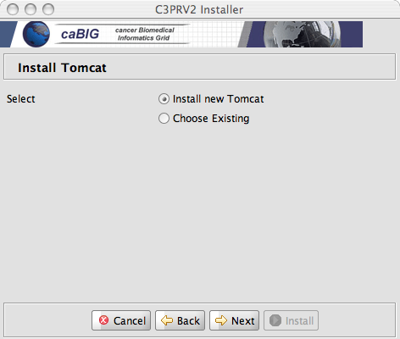  You can let the installer deploy and configure tomcat or chose an existing installation of tomcat on your system. If you choose to use an existing tomcat, see Tomcat SSL How To web page for information on configuring the tomcat server for the HTTPS protocol (C3PRV2 uses SSL to secure client server interaction).  Note for CCTS Installations: select Choose Existing.
8 | The most crucial step is to configure a database to use for C3PRV2. You will need to create an empty database in Oracle/PostgreSQL and the installer will run the database create/update scripts.  Define the database URL username and password using the details provided by your DBA.  The URL details after the :// should contain the server name:port/databasename  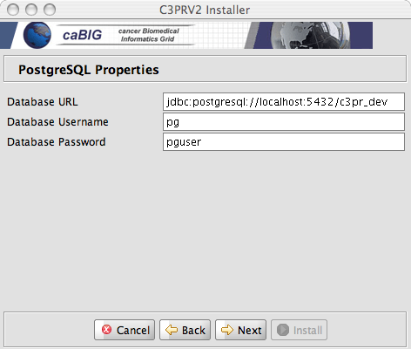  In the above example an empty database c3pr_dev exists in the local PostgreSQL database  Tip: Default values should be acceptable for most steps during the installation.  Example:  - Database URL : "jdbc:postgresql://cbiodb580:5458/ccts_c3pr"  - Database Username : "ccts_admin"  - Database Password : "ccts_admin"  - Here an empty database ‘ccts_c3pr’ exists in PostgreSQL database.
9 | After navigating through the GUI screens, the install process will run through to completion. C3PRv2 install is complete.
10 | If you selected to install a new tomcat then set your CATALINA_HOME environment variable (See Step 7 for details).
12 | Open command prompt, change directory to <CATALINA_HOME>\bin
13 | Run the following command to start tomcat server  startup.bat (windows)  startup.sh (unix)
13 | After your web application server has completely finished starting, open the browser with the following URL  http://localhost:9080/c3pr  NOTE: The installer’s version of tomcat runs on port 9080. Your existing tomcat might be on a different URL/Port. Replace localhost:port with the correct hostname/port assignment. The port assignment will be the Tomcat container that has been configured for the application server.  Example:  - http://cbvapp-q1009.nci.nih.gov:8080/c3pr  - To login, use the default userid: cctsdemo1@nci.nih.gov  - Password: cctsdemo1

At this point your installation should be complete. See the C3PR Administration Guide for configuring C3PR:

http://gforge.nci.nih.gov/docman/view.php/214/10331/c3prv2_administration_guide.doc

Note: for CCTS installation, you will have to configure WebSSO integration. See the administration guide for more details.

See Common Problems during Installation if you encounter problems during installation. You may also send email to c3prv2-support@gforge.nci.nih.gov for support.

Common Problems with Installer (FAQ)

Problem: My installation failed with the message “class sun.tools.javac.Main not on the classpath. Perhaps JAVA_HOME does not point to the JDK. Its currently set to c:/Program Files/Java/jre_1.5.0_11”

Solution: This can happen when installing in the Microsoft Windows Operating system. First, try running the installer from the command prompt (as described in step5).

If the above solution does not work then copy the tools.jar file from $JAVA_HOME/lib/ to c:/Program Files/Java/jre_1.5.0_11/lib/ext directory. If the $JAVA_HOME/jre/lib/ext does not exist then go ahead and create it. Re-run the installer after doing this.

NOTE: c:/Program Files/Java/jre_1.5.0_11 can be different on your system

Problem: My installation failed at the final step with the message “edu.northwestern.bioinformatics.bering.Migration’?

Solution: This means the database create/update scripts did not work. Please check the database URL you entered in the installer. Also, make sure that an empty database is available to the installer. The installer can created the tables etc. but not create a database.

Problem: My installation failed at the final step with the message
“FATAL ERROR: c3pr_dev datbase does no exist”

Solution: This implies that you do not have an empty database created as instructed in Step 8 of the Graphical Installer chapter.

Manual Install
If you wish to manually install C3PRV2, follow the steps outlined in this section.
Note: you should be familiar with CVS, Tomcat, and the C3PR deployment before proceeding with manual installation. The recommended installation procedure is to use the Graphical Installer.

Download C3PRV2 codebase
Complete the following steps to download the C3PR:

Step | Action
1 | Using your CVS Command Line Tool (or tortoise), connect to CVS as ‘anonymous’ (no need of a password) using the following settings:-  Export CVS_RSH=ext  cvs -d:ext:anonymous@cbiocvs2.nci.nih.gov:/cvsshare/content/gforge/c3prv2 "checkout" "-r" "<branch name>" "-P" "c3prv2/codebase"  Note – Replace <branch name> with the current release’s branch. Like construction_iteration9  Separate instructions to download and configure cvs clients for Tortoise and Eclipse are given in the Appendix CVS
- 2  2 | Download the Globus (version and download URL provided in Table 2) and do the following  Unzip the downloaded archive into a local folder (henceforth referred to as <globus_root_folder>
- 3  3 | Verify that the environment variables ANT_HOME and JAVA_HOME, CATALINA_HOME, GLOBUS_LOCATION are set and that your PATH statement includes the locations of the Ant and Java binaries. For example., PATH should include C:\apache-ant-1.6.2\bin; C:\j2sdk1.5.0_11\bin.  To do this in Windows:  - Select My Computer > Properties (from the shortcut menu) > Advanced tab.  - Click the Environment_Variables button.  - In the New User Variable dialog box, add the Variable and Variable Value.  Examples:  Variable = ANT_HOME; Variable Value = C:\apache-ant-1.6.2  Variable = JAVA_HOME; Variable Value = C:\j2sdk1.5.0_11  Variable = CATALINA_HOME; Variable Value = C:\apache-tomcat-5.0.28  Variable = GLOBUS_HOME; Variable Value = C:\ws-core-4.0.3  To do this in Unix/Mac:  $ export ANT_HOME=/usr/ant-1.6.2  $ export JAVA_HOME=/usr/java..1.5  $ export GLOBUS_LOCATION=/usr/local/ws-core-4.0.3  $ export CATALINA_HOME =/usr/apache-tomcat-5.5.20

C3PR Configuration
C3PR consists of multiple sub projects, namely core, web, grid etc. Each Project is configured to have a property file to externalize properties needed for the sub project. These properties are injected to the application via Spring. C3PR works be externalizing these properties from Spring application context to a property file which in turn is build via an ant file.

While installing C3PR, the user needs to set all the properties just in one single place ie, the build.properties file. This file can be located at:

build.properties - codebase/antfiles/build.properties

It can be opened and edited with a simple text editor.
Sample contents of this file:

Entry | Sample Values | Default Values/Ignore?
datasource.url | For Oracle Setup:  jdbc:oracle:thin:@localhost:1521:c3pr  For PostreSQL Setup:  jdbc:postgresql://localhost:5432/c3pr
datasource.username | Enter username
datasource.password | Enter password
datasource.schema | (optional), by default it connects to the schema same as username | (optional)
datasource.dialect | For Oracle Setup:  org.hibernate.dialect.Oracle9Dialect  For PostreSQL Setup:  org.hibernate.dialect.PostgreSQLDialect | org.hibernate.dialect.PostgreSQLDialect
datasource.driver | For Oracle Setup:  oracle.jdbc.OracleDriver  For PostreSQL Setup:  org.postgresql.Driver | org.postgresql.Driver
broadcastEnable | false | false (recommended)
esb.brokerUrl | tcp://cbiovdev5032.nci.nih.gov:61618 | Ignore this value
hotlinks.psc | http:// 74.93.192.33:8041/studycalendar/pages/schedule | Ignore this value
hotlinks.caaers | http:// 74.93.192.33:8030/caaers/pages/ae/list | Ignore this value
hotlinks.c3d | https://octrials-train.nci.nih.gov/opa45/rdclaunch.htm | Ignore this value
grid.idpUrl | https:// 74.93.192.33:8446/wsrf/services/cagrid/AuthenticationService | Ignore this value
grid.ifsUrl | https://localhost:8443/wsrf/services/cagrid/Dorian | Ignore this value
authorizationSwitch | true, false | true (recommended)
log4j.file | /usr/local/apache-tomcat-5.5.23/logs | Change this value as per your CATALINA_HOME installation folder
ctmsi.commons.version | 0.5 | Ignore this value

*Most of the values with the Urls are currently not needed as Security is not enable for this installation. Leave these values with the defaults provided for now.
**Make sure you do not have settings given for both Oracle and PostGreSQL and comment out the unwanted lines preceded by “#”, such as those not applicable to your system/database.
***Also note that all the above values should not have any trailing spaces before and after. For example

datasource.dialect=org.hibernate.dialect.Oracle9Dialect

If you notice the line above, there is an extra space towards the end. This is a casual error that may occur while performing a copy/paste and should be thoroughly checked

Setup Database
Follow the steps in this section to setup/update the c3pr database.

Remember: The ant scripts cannot create a new instance, so an instance of the database (as entered in Section C3PR Configuration) should already exist.

cd codebase\antfiles
ant createOrUpdateDatabase

Build / Deploy Code (Ant)
Perform the following steps to build your system.

Step | Action
1 | Open command prompt, change directory to codebase\antfiles  (Note – You can also use your IDE’s built-in Ant tool and skip the above)
2 | Run the following ant task by executing the following command:  ant build-web  ant deploy-webapp

This deploys the software to the webapp directory of the web application server installation specified in the CATALINA_HOME\webapps\c3pr directory

Securing Tomcat
c3pr requires a secure tomcat container and uses https by default. To secure your Tomcat installation, do the following

Step | Action
1 | Open command prompt, change directory to codebase\antfiles
2 | Run the following command  ant tomcat.security  NOTE:There will be instructions after you run this target on how to edit your tomcat.properties
3 | Follow the online directions on configure SSL for your tomcat (if not done in a previous install)  Tomcat SSL How To

Running C3PR
Perform the following steps to run the system
Step | Action
1 | Open command prompt, change directory to <CATALINA_HOME>\bin
2 | Run the following command to start tomcat server/bin  Startup.bat
3 | After your web application server has completely finished starting, open the browser with the following URL  http://localhost:8080/c3pr  C3PR home page should be displayed  Note: The port (8080) could have a different value on your system

Note - Once the application is running, follow a series of workflows like
- Create a Default Study
- Register a Participant for Study (Create a new Participant)
For a detailed set of Steps to be followed above, refer the end user document or contact support for individual step.

The following figure displays the browser window that opens with a successful system install:
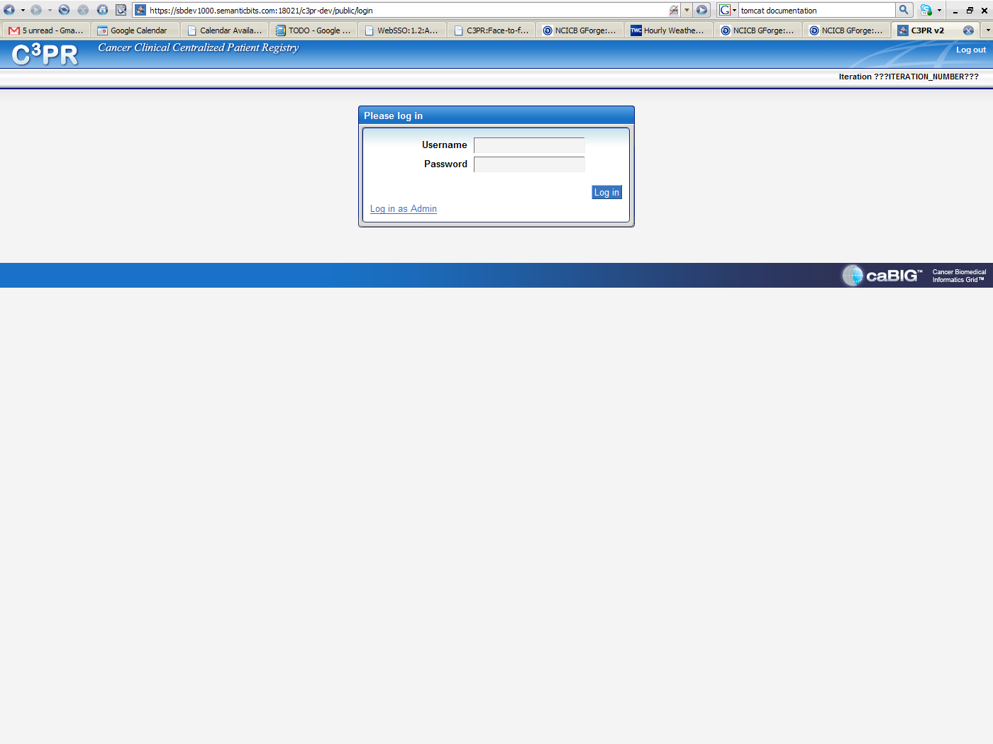

Contacting Technical Support
Please mail c3prv2-support@gforge.nci.nih.gov for support on Installation or general C3PR technical Support queries

Appendix A – Configuring Multiple Tomcat Servers
More often there is a requirement to configure multiple tomcat servers if a tomcat instance is already running another application. A few modifications need to be done to achieve this. It is recommended to install a separate tomcat instance for C3PR. Make a note of the installation directory.

- Setting Tomcat Home:
By default C3PR assumes a single instance of Tomcat installation and looks for a CATALINA_HOME environment variable. If there exists another tomcat instance already, there is a good chance that it is taking up this environment variable. To override this, you need to set your CATALINA_HOME environment variable (see Step 4 of “Installing C3PRv2 using the Graphical Installer” or Step 3 of “Installing C3PRv2 Manually”) to your desired Tomcat installation and run the installation process (Graphical Installer or manual).

Furthermore, you can install a new Tomcat instance with the Graphical Installer. This Tomcat will run on a non default http/https ports – 9080 and 9443. Once your installation is complete reset your CATALINA_HOME to point to the new instance and start/stop the instance.

Appendix B – Setting up CVS clients

Setup Tortoise CVS client
Tortoise CVS can be used to download the latest code from CVS for use in the manual installation procedure. First, download and install using the TortoiseCVS wizard. Second, specify the connection parameters and check out the latest code using windows explorer.

Step 1: Downloading and install TortoiseCVS.

(a) For Windows 95, 98, ME, NT, 2000, XP, and 2003, go to link http://www.tortoisecvs.org/download.shtml and click on the link - TortoiseCVS-1.8.30.exe to download it. The link should take you to the following page:

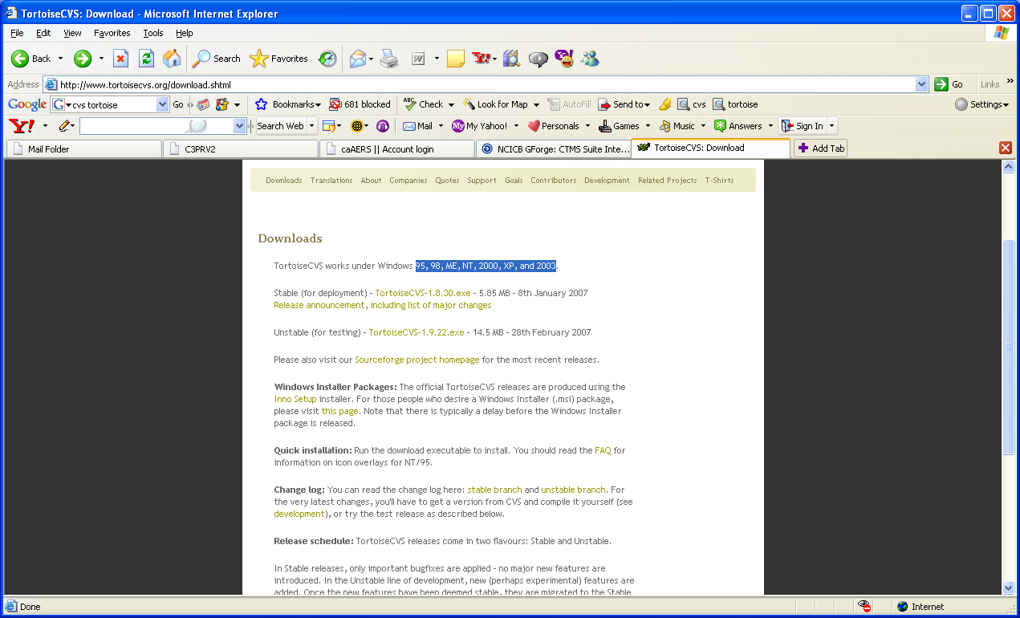

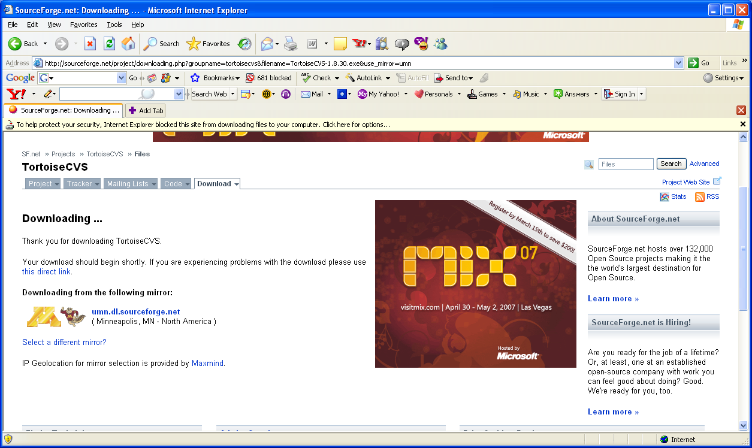

If you have the popup-blocker turned on, you may not be able to see the popup window to download the page. Then right click on the yellow bar, which says that windows blocked the popup as shown in the above image, and select download file. Or if you turn-off the pop-blocker temporarily, it enables you to see the following popup window.

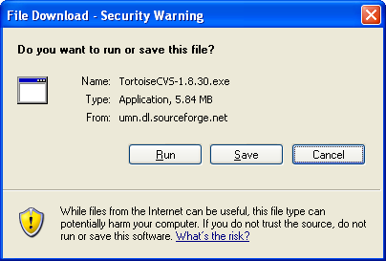

(b) Click-on save and select the destination folder, for example c:\ and save the TortoiseCVS-1.8.30.exe. Now navigate to the folder where you saved TortoiseCVS-1.8.30.exe, double-click on the .exe to run it. Select the language as English, then you should see
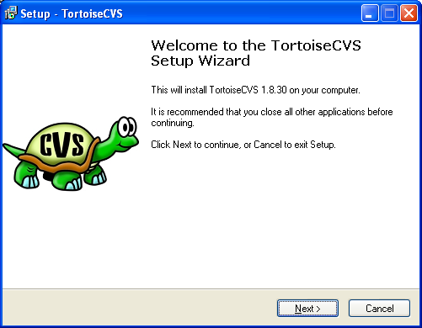

(c) Click on Next, and click on browse to select the destination folder to install TortoiseCVS, for example, c:\. Then the setup wizard would install the TortoiseCVS in C:\TortoiseCVS.

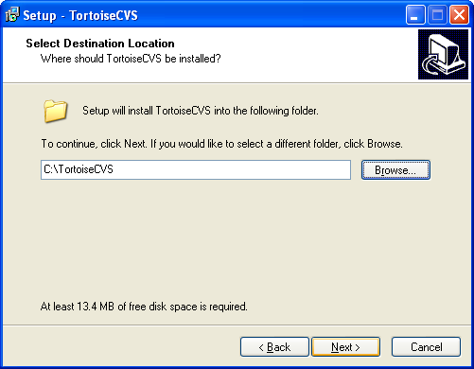

- Click on next. Select Full installation.
- Click on Next, the setup wizard will copy some files and prompt for you to restart the computer to complete the installation. You can select restart computer now or choose to restart it later. Save and close all other applications before restarting your computer. Click on Finish. This will restart your computer if you selected, restart now option.

- Restart your computer.

Step 2: Specify the connection parameters to check out the desired branch into your local folder.
(a) Once you restarted the computer, navigate to the folder, where you want to download the c3prv2 codebase, for example, c:\c3prv2.
(b) Right click on the folder and select CVS Checkout and you should see the following window.

(c) Under module tab type in (or select in case of protocol) the following values in the respective fields:

Select the Protocol as Secure shell(:ext)
Type in the field Server: cbiocvs2.nci.nih.gov
In the Repository folder field, type in: /share/content/gforge/c3prv2
Type in the User name field: anonymous
Type in the Module field: c3prv2

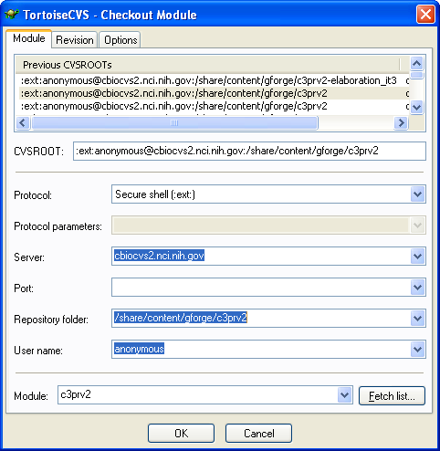

You can see the CVSROOT being automatically built as you enter each field.

Make sure there are no leading, trailing, or empty spaces or any other characters.

(d) Click on the revision tab. Under Revision tab click on the button, Choose branch or tag, and specify the branch or tag name, such as c3prv2_iteration10

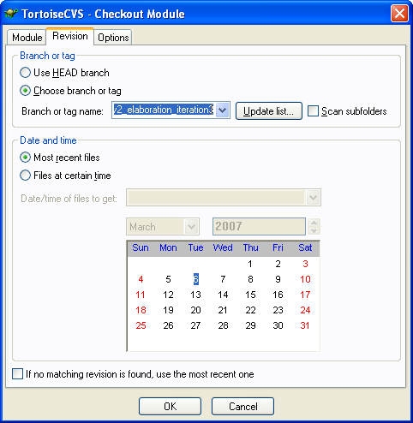

(e) Click on ok.
When it prompts for password, type anonymous

The TortoiseCVS wizard will start checking out the project in the folder you selected. In this case into c:\c3prv2. Wait for it to finish checking out. It may take a few minutes.

If you have successfully checked out c3prv2 , the tortoise will give a message that the download is complete. Click on ok to close the TortoiseCVS project checkout window. If for some reason the check out doesn’t start, or stops in the middle, check the connection parameters, network connection and repeat step 2 again.

You should have successfully checked out c3prv2 from your explorer.

Setup Eclipse CVS Perspective
The following steps assume you are familiar with Eclipse IDE as your development environment and you would like to use it’s CVS perspective to download files from CVS repository. If you don’t have Eclipse IDE installed then it is recommended to use Tortoise CVS client as it is simple to setup and download

Step 1 – Got to Eclipse CVS Perspective by clicking on the menubar Window->Open Perspective-> CVS Perspective (maybe available under “Other…”)

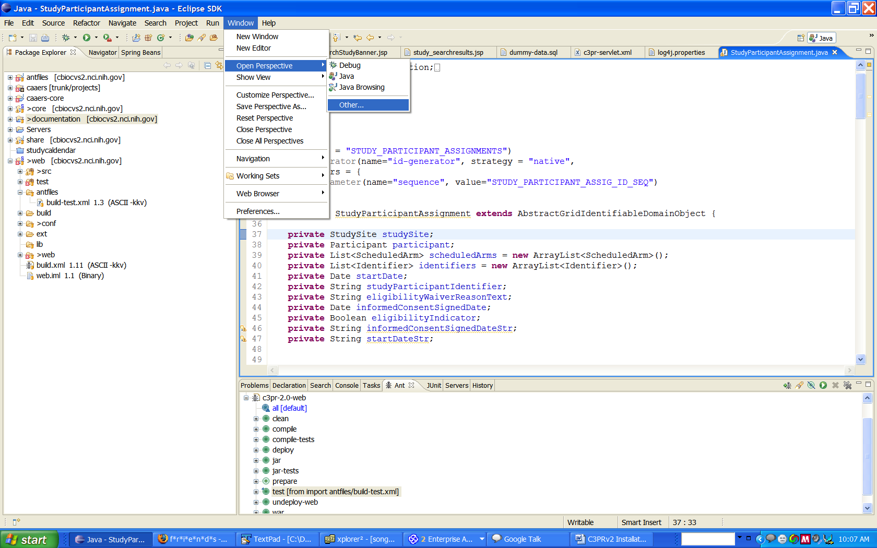
Step 2 – Create a new repository

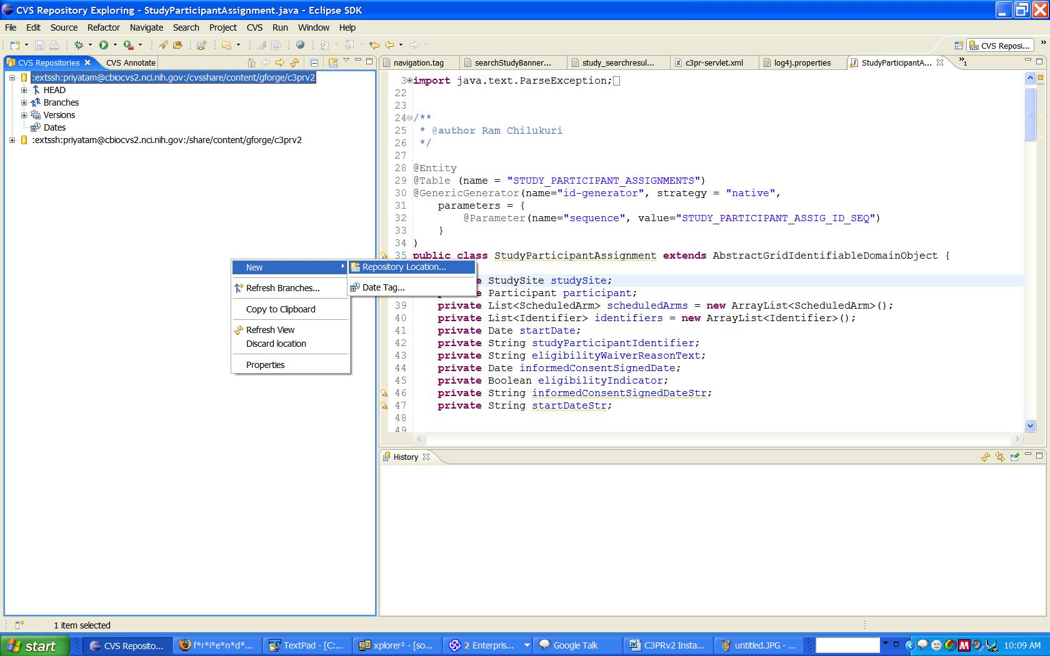
Step 3 – Enter the details for Repository location as follows. Enter Password as “anonymous”

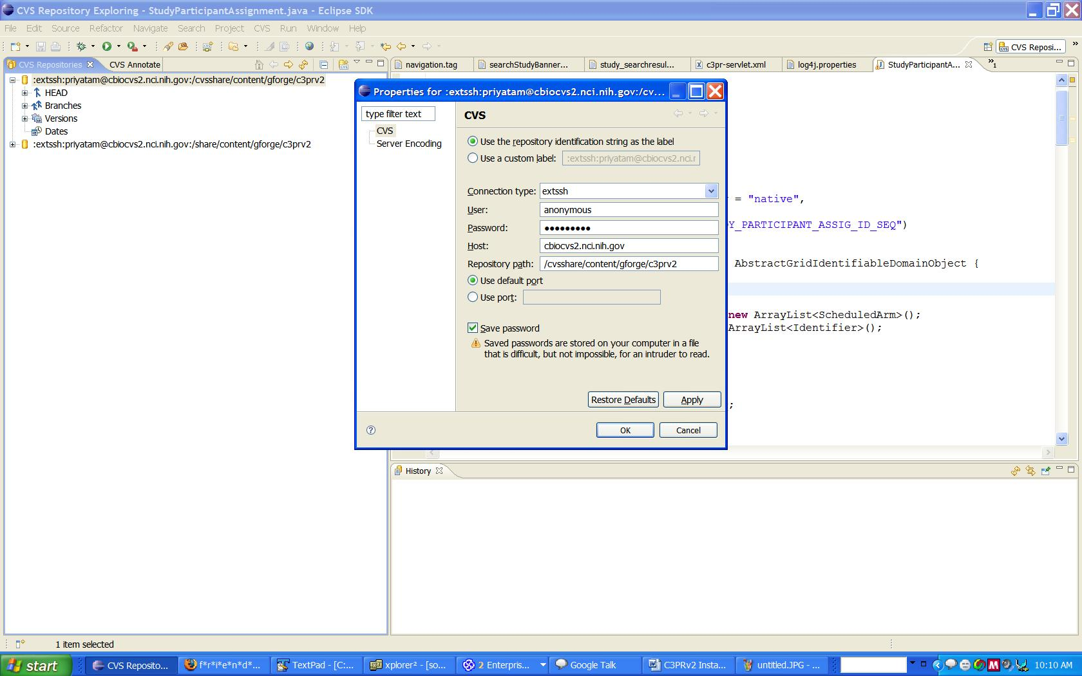

Step 4 – Refresh the Branches Section
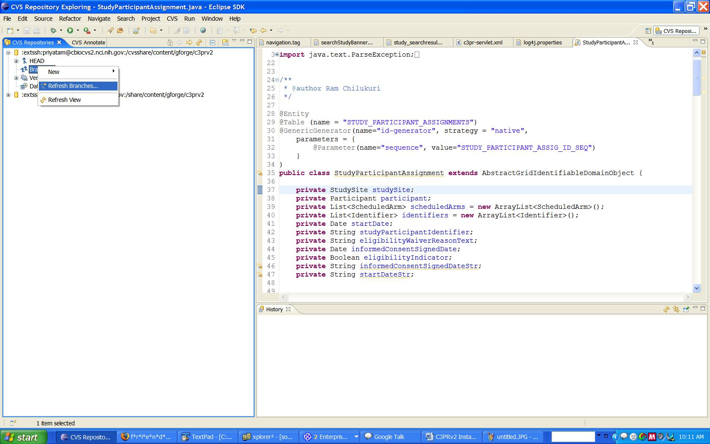

You have now successfully checked out C3PR.
Step 5 – Deep Search for Tags in Branches
Once you click finish, you will get a dialog. Click on ‘deep search’ and wait till the process is completed (This might take some time to finish)
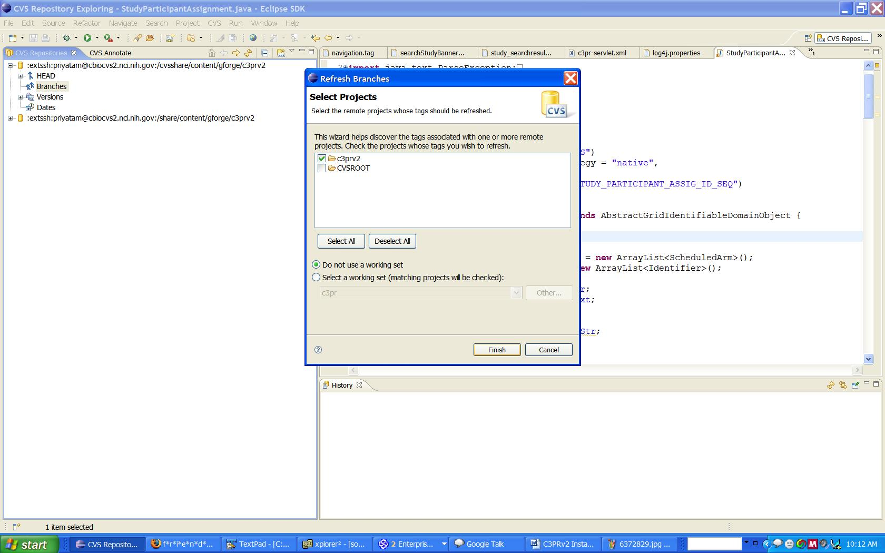

Step 6 – Once done, right click on the desired branch, checkout the entire ‘codebase’ folder

