C3PR –Integration
Technical Specification

Duke Comprehensive Cancer Center


Copyright and License page

Copyright Notice. Copyright 2006 Duke Comprehensive Cancer Center (“caBIG™ Participant”). C3PR was created with NCI funding and is part of the caBIG™ initiative. The software subject to this notice and license includes both human readable source code form and machine readable, binary, object code form (the “caBIG™ Software”).
This caBIG™ Software License (the “License”) is between caBIG™ Participant and You. “You (or “Your”) shall mean a person or an entity, and all other entities that control, are controlled by, or are under common control with the entity. “Control” for purposes of this definition means (i) the direct or indirect power to cause the direction or management of such entity, whether by contract or otherwise, or (ii) ownership of fifty percent (50%) or more of the outstanding shares, or (iii) beneficial ownership of such entity.
License. Provided that You agree to the conditions described below, caBIG™ Participant grants You a non-exclusive, worldwide, perpetual, fully-paid-up, no-charge, irrevocable, transferable and royalty-free right and license in its rights in the caBIG™ Software, including any copyright or patent rights therein that may be infringed by the making, using, selling, offering for sale, or importing of caBIG™ Software, to (i) use, install, access, operate, execute, reproduce, copy, modify, translate, market, publicly display, publicly perform, and prepare derivative works of the caBIG™ Software; (ii) make, have made, use, practice, sell, and offer for sale, and/or otherwise dispose of caBIG™ Software (or portions thereof); (iii) distribute and have distributed to and by third parties the caBIG™ Software and any modifications and derivative works thereof; and (iv) sublicense the foregoing rights set out in (i), (ii) and (iii) to third parties, including the right to license such rights to further third parties. For sake of clarity, and not by way of limitation, caBIG™ Participant shall have no right of accounting or right of payment from You or Your sublicensees for the rights granted under this License. This License is granted at no charge to You. Your downloading, copying, modifying, displaying, distributing or use of caBIG™ Software constitutes acceptance of all of the terms and conditions of this Agreement. If you do not agree to such terms and conditions, you have no right to download, copy, modify, display, distribute or use the caBIG™ Software.
Your redistributions of the source code for the caBIG™ Software must retain the above copyright notice, this list of conditions and the disclaimer and limitation of liability of Article 6 below. Your redistributions in object code form must reproduce the above copyright notice, this list of conditions and the disclaimer of Article 6 in the documentation and/or other materials provided with the distribution, if any.
Your end-user documentation included with the redistribution, if any, must include the following acknowledgment: “This product includes software developed by Duke Comprehensive Cancer Center.” If You do not include such end-user documentation, You shall include this acknowledgment in the caBIG™ Software itself, wherever such third-party acknowledgments normally appear.
You may not use the names “Duke Comprehensive Cancer Center”, “The National Cancer Institute”, “NCI”, “Cancer Bioinformatics Grid” or “caBIG™” to endorse or promote products derived from this caBIG™ Software. This License does not authorize You to use any trademarks, service marks, trade names, logos or product names of either caBIG™ Participant, NCI or caBIG™, except as required to comply with the terms of this License.
For sake of clarity, and not by way of limitation, You may incorporate this caBIG™ Software into Your proprietary programs and into any third party proprietary programs. However, if You incorporate the caBIG™ Software into third party proprietary programs, You agree that You are solely responsible for obtaining any permission from such third parties required to incorporate the caBIG™ Software into such third party proprietary programs and for informing Your sublicensees, including without limitation Your end-users, of their obligation to secure any required permissions from such third parties before incorporating the caBIG™ Software into such third party proprietary software programs. In the event that You fail to obtain such permissions, You agree to indemnify caBIG™ Participant for any claims against caBIG™ Participant by such third parties, except to the extent prohibited by law, resulting from Your failure to obtain such permissions.
For sake of clarity, and not by way of limitation, You may add Your own copyright statement to Your modifications and to the derivative works, and You may provide additional or different license terms and conditions in Your sublicenses of modifications of the caBIG™ Software, or any derivative works of the caBIG™ Software as a whole, provided Your use, reproduction, and distribution of the Work otherwise complies with the conditions stated in this License.
THIS caBIG™ SOFTWARE IS PROVIDED "AS IS" AND ANY EXPRESSED OR IMPLIED WARRANTIES (INCLUDING, BUT NOT LIMITED TO, THE IMPLIED WARRANTIES OF MERCHANTABILITY, NON-INFRINGEMENT AND FITNESS FOR A PARTICULAR PURPOSE) ARE DISCLAIMED. IN NO EVENT SHALL THE DUKE COMPREHENSIVE CANCER CENTER OR ITS AFFILIATES BE LIABLE FOR ANY DIRECT, INDIRECT, INCIDENTAL, SPECIAL, EXEMPLARY, OR CONSEQUENTIAL DAMAGES (INCLUDING, BUT NOT LIMITED TO, PROCUREMENT OF SUBSTITUTE GOODS OR SERVICES; LOSS OF USE, DATA, OR PROFITS; OR BUSINESS INTERRUPTION) HOWEVER CAUSED AND ON ANY THEORY OF LIABILITY, WHETHER IN CONTRACT, STRICT LIABILITY, OR TORT (INCLUDING NEGLIGENCE OR OTHERWISE) ARISING IN ANY WAY OUT OF THE USE OF THIS caBIG™ SOFTWARE, EVEN IF ADVISED OF THE POSSIBILITY OF SUCH DAMAGE.

Development Team(s)
Development | Technical Documentation | Program Management
Kruttik Aggarwal² | Manav Kher² | Bob Annechiarico¹
Manav Kher² | Priyatam Mudivarti² | Jamie Cuticchia¹
Priyatam Mudivarti² |  | Patrick McConnell¹
Ram Chilukuri² |  | Ram Chilukuri²
Ramakrishna Gundala²
¹Duke Comprehensive Cancer Center | ²Semantic Bits

Contacts and Support
Enter training contact | Patrick McConnell  (patrick.mcconnell@duke.edu)
Enter customer support contact | NA

LISTSERV Facilities Pertinent to software teams
LISTSERV | URL | Name
C3PRv2-elaborator | C3PRv2-elaborators@gforge.nci.nih.gov | C3PR Elaborators Forum
C3PRv2-general | C3PRv3-general@gforge.nci.nih.gov | C3PR General Forum
C3PRv2-developers | C3PRv2-developers@gforge.nci.nih.gov | C3PR Developers Forum

Table of Contents

Table of Contents 6
Scope & Purpose 7
Overview 7
1.1 ESB Client Class Diagram 12
1.2 Grid Node class diagram 13
1.3 WSRF Binding Component Class Diagram 15
Use Case Realization 16
1.4 Primary Use cases 16
1.5 Detailed Use Cases 17
1.5.1 Create Study 17
1.5.2 Sequence diagram 18
1.5.3 Request Registration 18
1.5.4 Use Case 19
1.5.5 Sequence diagram 20
Unit Testing 20
1.6 JUnit 20
Integration Testing 21
1.7 Haste 21
Utilities 21
Customized Tools and Features 22
1.8 Documentation /Artifacts 24

Scope & Purpose
The scope of this document is to provide technical design / specification, for the ESB Integration project module within C3PR v2. The specification will include the use case realizations within each iteration with accompanying UML models and documentation wherever appropriate.

Overview
C3PR Integration subproject is aimed at providing a reference implementation, for integrating different clinical systems within the caBIG CTMS workspace. This includes C3PR-to-C3PR integration, as well as integration with other systems (such as PSC, caAERS, CTOM, and C3D). Specifically, the aim of the C3PR Release 2 project is to integrate C3PR-to-C3PR and C3PR-to-C3D. C3PR is also a key component in the CTMS Interoperability project, where C3PR-to-PSC, C3PR-to-caAERS, and C3PR-to-CTOM integration will be developed. While this integration is funded under a different project heading, it will be performed by C3PR developers in the C3PR project space.
Problem Statement - Enterprise networks commonly deploy disparate applications, platforms, and business processes that need to communicate or exchange data with each other. The applications, platforms and processes have non-compatible data formats and non-compatible communications Studys. If an enterprise needs to interface with external systems, the integration problem extends outside of a company, encompassing its business partners' IT systems and processes as well.
The key concepts of this integration effort are outlined below
ESB (Enterprise Service Bus) – is a shared messaging layer for connecting applications and other services throughout an enterprise computing infrastructure . The purpose of an ESB is to facilitate application and process integration by providing distributed processing, intelligent routing, security, and dynamic data transformation. In an ESB these services are infrastructure services so each application does not have to implement these requirements independently and in a proprietary manner.
The caXchange effort leverages an ESB infrastructure much like a web application leverages Tomcat for hosting. Thus, there is no direct overlap between what C3PR is trying to accomplish and what was accomplished under the caXchange/LabHub effort. However, common components (such as a Web Service Binding Component) may be reusable.
The ESB addresses the disadvantages of existing solutions by creating a standard infrastructure for integration. Point-to-point solutions, where each of n components requires n-1 interfaces for full communication, are replaced by a bus solution where each component requires a single interface to the bus for global communication. An ESB provides distributed messaging, routing, business process orchestration, reliability and security. It also provides pluggable services and, because of the standard bus, these pluggable services can be provided by third parties and still interoperate reliably with the bus.
We also encounter this n-1 interface problem in trying to facilitate communication between various Clinical applications in CTMS. What is needed is a shared messaging layer for connecting these applications.
JBI (Java Business Integration) - JBI is J2EE community standard (JSR 208) which outlines the architecture for integration systems specifying plug-in components that interoperate by exchanging messages, rather than by interacting directly. JBI defines the core of a service oriented integration bus and component architecture for SOA. It standardizes the common message routing architecture, plug-in interfaces for service engines and bindings, and a mechanism to combine multiple services into a single executable and auditable unit of work.
JBI defines a plug-in based architecture where services can be plugged into the JBI runtime environment. JBI provides well-defined interfaces for services to interact with the JBI runtime environment. The services need to expose interfaces to the JBI runtime environment for the JBI runtime environment to route messages to the services. The JBI runtime environment acts as a mediator between the services that are deployed in the environment

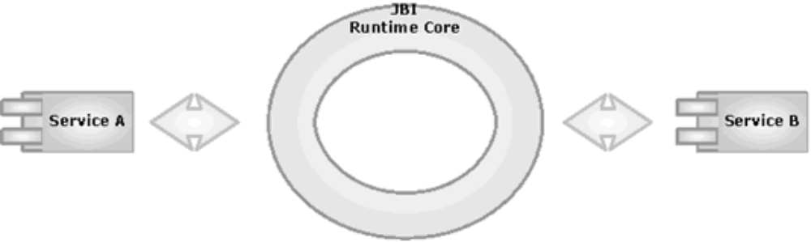

Here's an overview of a typical JBI enabled SOA from Sun
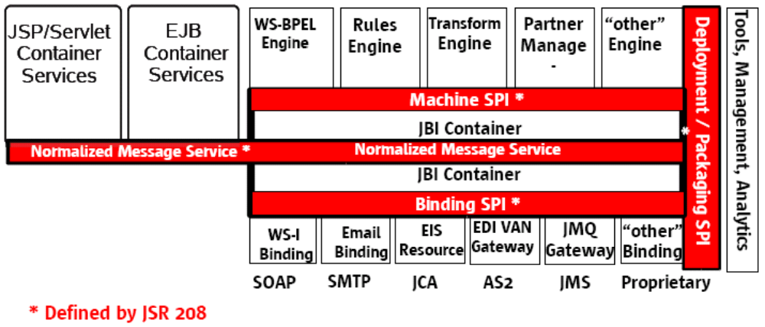

JBI provides a logical XML messaging network which maps well to HTTP, email and JMS/MOM while easily adapting to legacy systems, binary transports and RPC systems like EJB and CORBA.
The binding components deal with all the plumbing and web service protocols, then service engine components work on a logical XML layer, providing content based routing, orchestration, rules, scripting, transformations and custom enrichment etc. For C3PR Integration we will be writing a custom WSRF (Web Service Resource Framework) binding component, to provide connectivity to caGrid 1.1 Services, which includes C3PR, PSC, and caAERS.
ServiceMix – is an open source implementation of the JBI (JSR 208) specification and it provides a standards based ESB. ServiceMix allows plug-in services which can combine to create a service oriented architecture. ServiceMix allows services to operate in an event driven way as well. In other words, the services are decoupled and listen on the bus for service requests. The bus is responsible for quality of service (QoS) features such as message persistence, guaranteed delivery, failure handling, and transaction support.
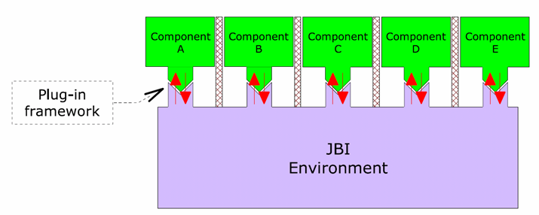

caGrid – is part of the caBIG program which provides an infrastructure of interoperable grid services that provide access to cancer related data and tools. caGrid also provides a development toolkit which is based on the open source Globus Toolkit. The goal of cancer Biomedical Informatics Grid caBIG™ is to develop applications and the underlying systems architecture that connects together data, tools, scientists and organizations in an open federated environment. In meeting this goal, caBIG will necessarily bring together data from many and diverse data sources. The underlying service oriented infrastructure for caBIG is caGrid. C3PR will leverage caGrid for security infrastructure, as well as services for some open APIs.

Domain & Analysis Model
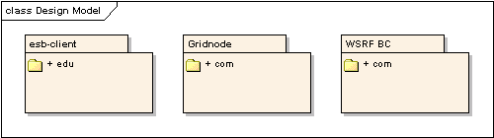

There are three sub modules within the Integration project.
- ESB client
The client that invokes the ESB. This could be a client that is sending a message to C3PR (such as a Study Management software) or it could be C3PR sending a message to the ESB to be propagated to other systems.
- WSRF Binding Component
The component within the ESB that accepts messages and invokes the Grid node. This is a C3PR-developed component that will receive messages inside the ESB and forward them to grid nodes.
- Grid node (consumer)
The grid node that is invoked by the Binding Component. This could be a third-party grid node that is consuming of C3PR-generated messages or it could be a C3PR grid node consuming of a message.

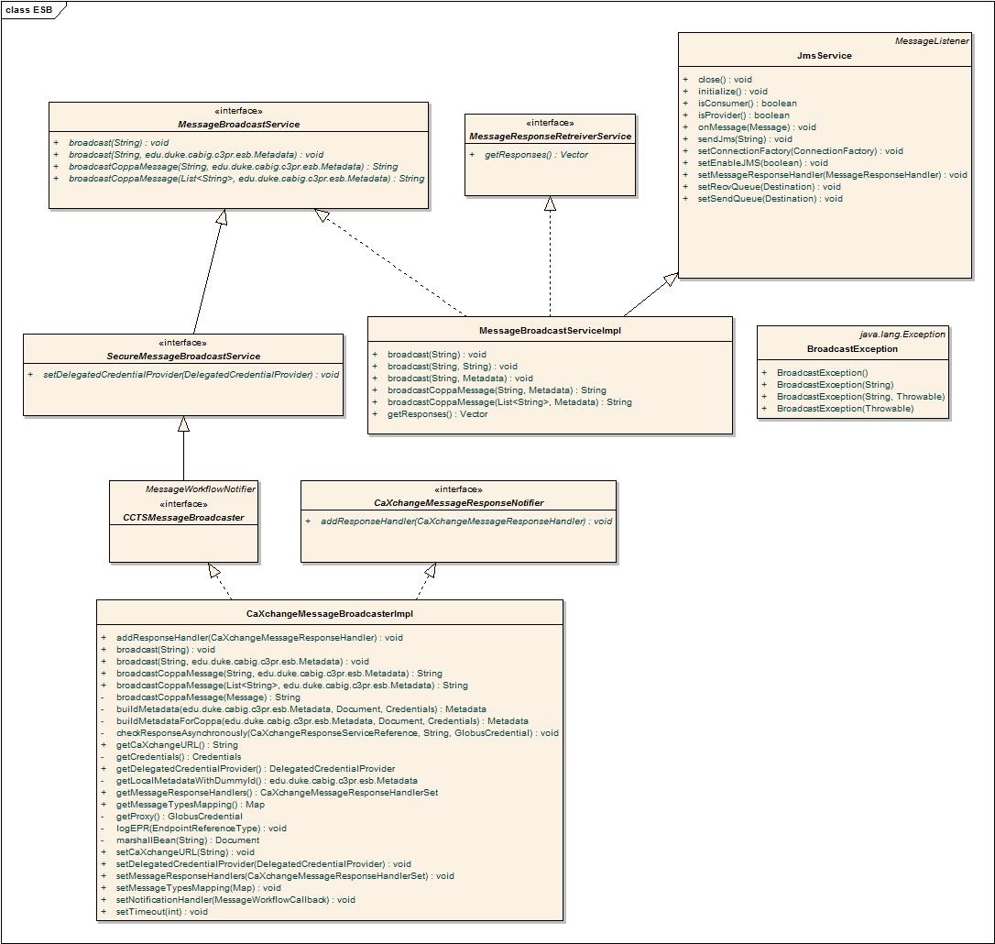

ESB Client Class Diagram

ESB-client provides a service for sending messaging into the ESB. The esb-client service will abstract the runtime messaging implementation from the calling application. Current reference implementation is provided with JMS. But other messaging implementations can be provided by implementing appropriate interfaces. CTMS applications can also extend this esb-client implementation to suit their needs or current infrastructure. The ESB client module is available as independent Spring configurable component.
C3PR, when sending messages using the esb-client, uses the XMLBuilder class to serialize its business (domain) objects into XML. This XML conforms to a CCTS wide XML schema. Below is a snapshot of the XML Schema for both Registration and Study.
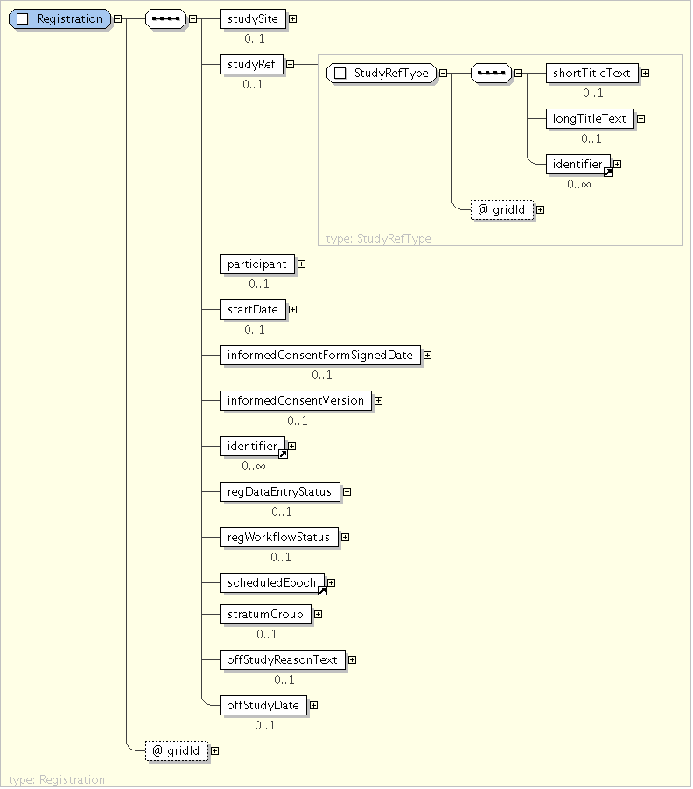

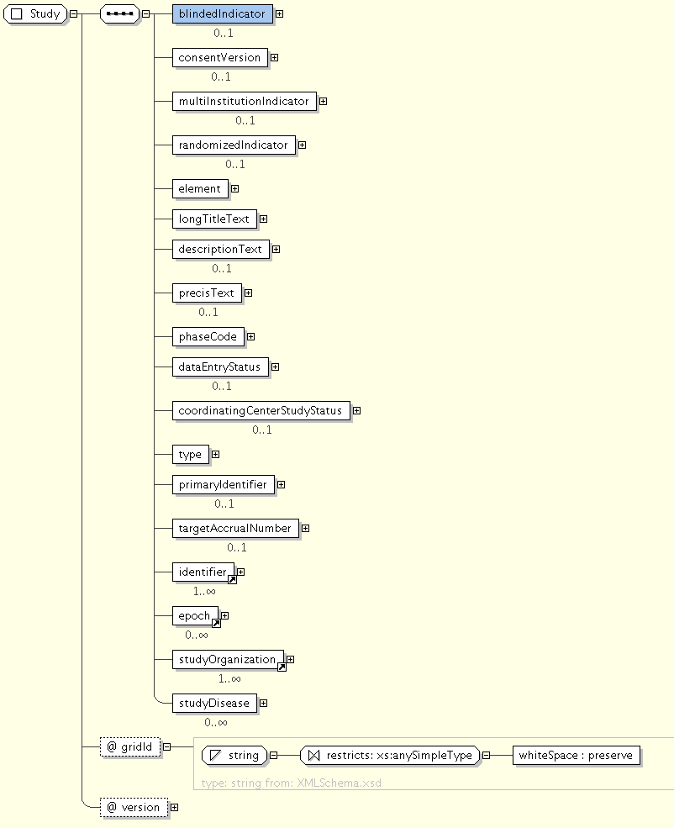

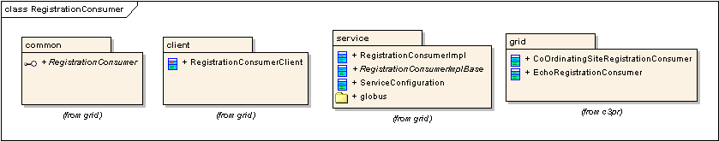

Grid Node

Registration Consumer Class Diagram
Registration Consumer Grid node is a custom caGrid 1.1 service that will act as a consumer to the C3PR ESB and will be able to receive Patient Registration creation messages. The grid service will then use an underlying service layer to create this new Registration in the host system. The Registration service provides an interface that can be implemented by other CCTS applications that wish to consume messages from the ESB and then process the message in some way.
The Registration Consumer service is also implemented in C3PR. This will enable C3PR to receive registration messages from other systems (including other C3PR instances). C3PR manages multi-site studies by sending and consuming messages to/from other C3PR instances. The implementation is outlined below
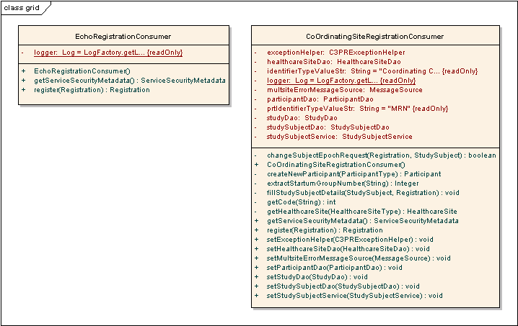

In integrating two instances of C3PR. One C3PR service would act as a provider that would record and send new Study creation messages to the ESB. The ESB will then (according to routing rules) forward the Study message to the consuming C3PR web application, by invoking its Consumer Grid Node. The grid nodes implementation will then (after verifying its local security policy) call the Create Study service (through Spring container invocation). This way, we can keep the two C3PR web applications in sync.

Study Consumer class diagram
Below is the class diagram for the Study Consumer grid service
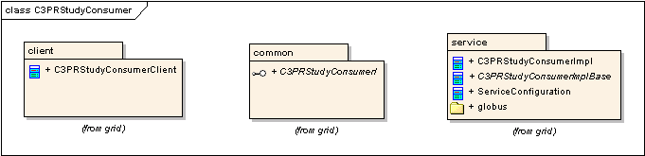

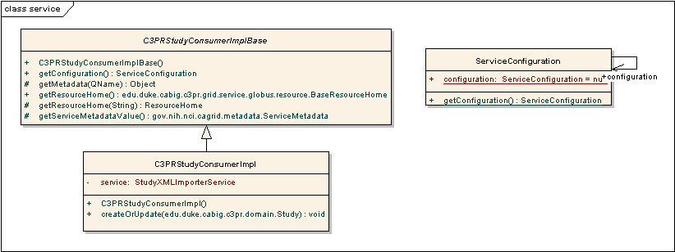

WSRF Binding Component Class Diagram
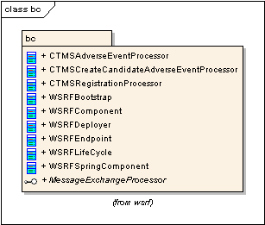

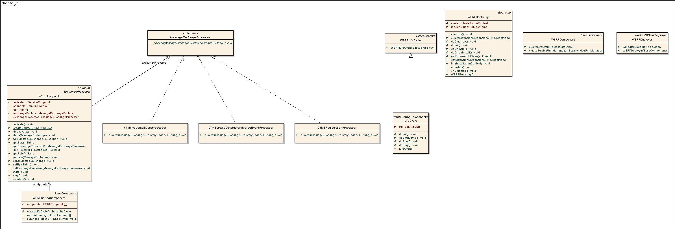

WSRF Binding component is a custom extension to the ServiceMix JBI toolkit. This component communicates with caGrid 1.1 WS-RF (Web service Resource Framework) grid services. Thus, it will be able to pass messages from C3PR to C3PR, PSC, and caAERS.

Use Case Realization
The following are the most basic use cases which relate to a single function in the system. The user must Login, perform and action, and Logout. Here, we use Create Study and Registration as the first user action.

Primary Use Cases

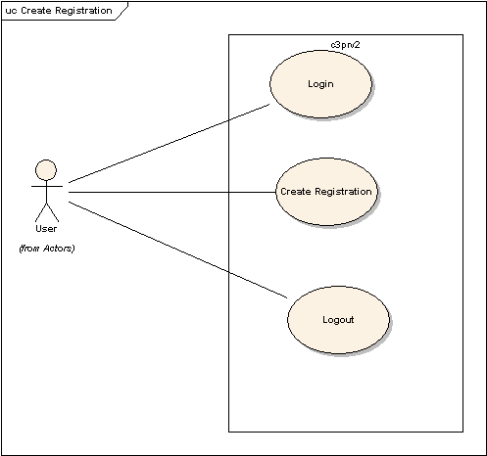
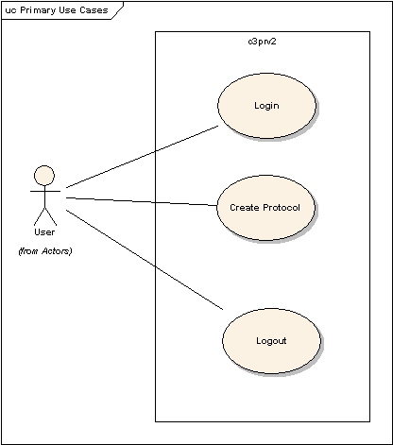

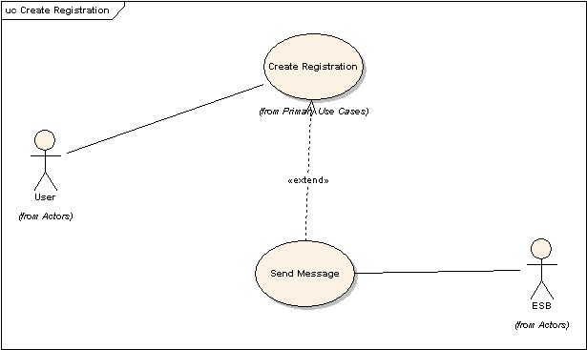

Detailed Use Cases

Create Registration

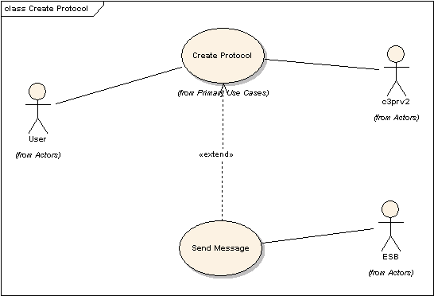

Create Study

Sequence diagram
The following sequence diagram describes a prototype for passing a create study message from C3PR to a Study Consumer grid node.
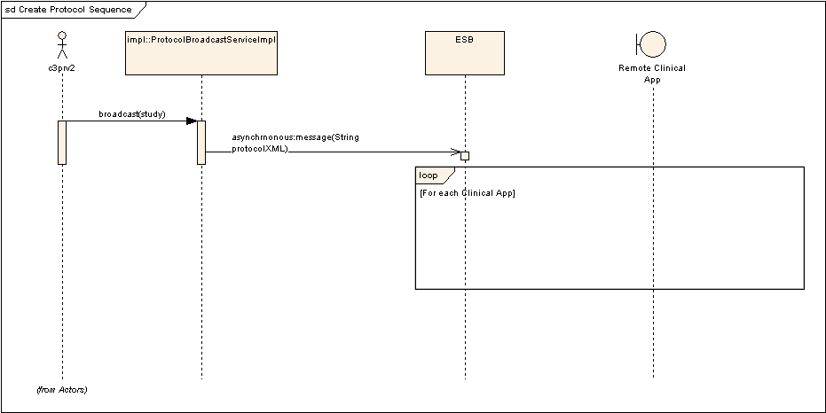

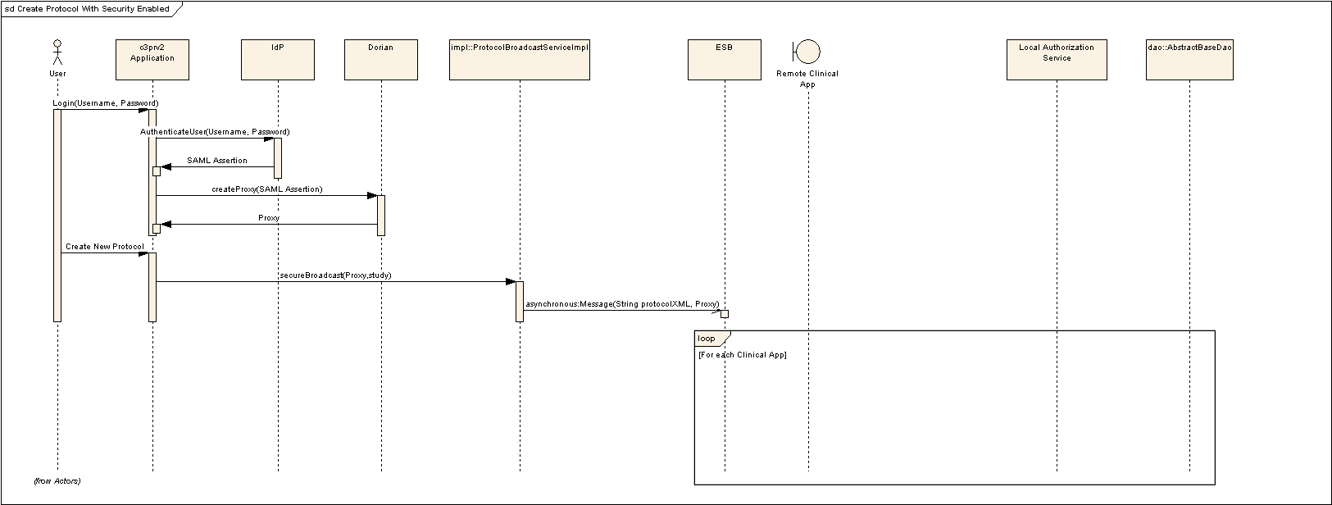

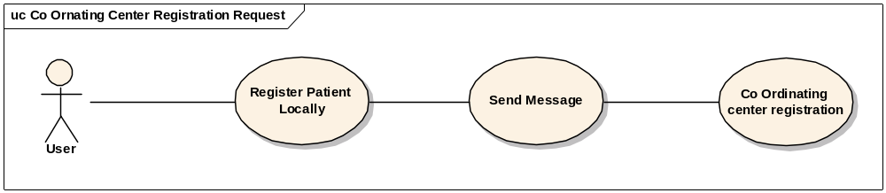

Coordinating Center Request Registration

Sequence diagram
The following sequence diagram describes a prototype for passing a request registration message from C3PR to a Registration Consumer Grid node

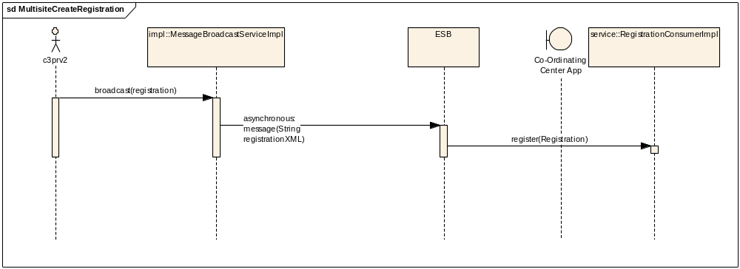

Unit Testing
All the C3PR components –ESB client, Registration Consumer grid service and Study Consumer grid services have JUnit/DBUnit test cases that test the implementation.

JUnit
ServiceMix provides a Spring extension of the JUnit framework to provide a lightweight container to test components. We have leveraged this testing framework to test the custom WSRF binding component project in C3PRV2.

Integration Testing
We are using the Haste - High level Automated System Test Environment for integration testing. Haste allows for orchestration of complex long running test scenarios based on a collection of reusable tests. We have also leveraged some Haste implementation from the caGrid project.

Haste
This integration test is part of the main C3PRV2 build framework (Ant build). This lets us run the integration tests in our continuous build environment.
The integration test currently implemented for this project does the following
- Build the custom WSRF Binding component project in C3PRV2.
- Configure a ServiceMix toolkit with the a workable pipeline for messaging. This pipeline is also known as a Service Assembly. A service assembly is a collection of deployment artifacts and metadata.
- Deploy a Globus toolkit for grid service deployments.
- Build and deploy a dummy WSRF caGrid service into the Globus deployment.
- Send a sample message to ServiceMix.
- Confirm receipt of the message at the grid service endpoint.
- Stop the ServiceMix and Globus toolkits.
- Clean and erase the deployments.

References
JBI - A standard based approach for SOA in Java
Service Oriented Business Integration (Sun)
ServiceMix Toolkit
caGrid Project
Globus Toolkit
Spring Framework
Haste - High level Automated System Test Environment

Documentation /Artifacts
SI No | Artifact | Type | Link
1 | GForge CVS Repository | CVS Repository | gforge.nci.nih.gov
2 | C3PRv2-Bridge.EAPl | Domain Model | gforge.nci.nih.gov
3 | C3PRv2_use_cases.doc | Use Cases | gforge.nci.nih.gov
4 | C3PRv2_technical_architecture.doc | Architecture | gforge.nci.nih.gov
5 | C3PRv2_srs.doc | SRS | gforge.nci.nih.gov
6 | C3PRv2_technical_spec_web.doc | design | gforge.nci.nih.gov
7 | C3PRv2_technical_spec_web.doc | design | gforge.nci.nih.gov

- Glossary
Term | Definition
C3PR | Cancer Central Clinical Participant Registry
API | Application Programming Interface
GUI | Graphical User Interface
UML | Unified Modeling Language
WSRF | Web service resource framework
HASTE | High-level Automated System Test Environment,

