Subject Management Platform Specific Service Specification

Subject Management Service

Version 0.0.2
27 May 2010

Enterprise Service Specification Team | TBD
Editors | TBD
Authors | Denis G. Krylov, SemanticBits LLC
DOCUMENT CHANGE HISTORY

Version Number | Date | Contributor | Description
0.0.1 | 05/19/10 | Denis G Krylov | Initial draft
0.0.2 | 05/27/10 | Denis G Krylov | Removed actualIndicator
Table of Contents
1 Executive Summary 3
1.1 Service Description and Purpose 3
1.2 Scope 3
1.3 Relationship to Standards 3
1.3.1 Domain Standards 3
1.3.2 Technology Standards 4
2 Conformance to Platform Independent Model 4
2.1 Conformance Profile 4
2.2 Functional Profiles 5
2.3 Semantics 5
2.3.1 Biologic Entity Semantics 5
2.3.2 Person Semantics 6
2.3.3 Subject Semantics 7
2.3.4 Subject Identifier Semantics 8
2.3.5 Return Value Semantics 8
2.3.6 Error Handling Semantics 9
3 Platform Specific Model 10
3.1 Overview 10
3.2 Domain Model 10
3.3 Assumptions 11
3.4 Service Interface 11
3.4.1 Interface Model 11
3.4.2 WSDL Messages and Port Types 11
3.4.3 Operations Details 12
3.5 Message Information Model 16
3.5.1 Information Model 16
3.6 Implementation Considerations 18
3.6.1 Security 18
3.6.2 Auditing 19
3.6.3 Privacy 19
3.6.4 Error Handling 19
3.7 Deployment Considerations 19
3.7.1 Deployment Modes 19
3.7.2 Performance 19
3.7.3 Scalability 20
3.7.4 Discovery 20
3.7.5 Uptime 20
3.7.6 Failover 20
3.8 Constraints 20
3.9 Known Issues 20
4 Recommendations for Conformance and Compliance 21
4.1 Conformance Assertions 21
5 Appendix A – References 22
6 Appendix B – Relevant Standards 22
7 Appendix C – Glossary 23
8 Appendix D – WSDL 23

Executive Summary

Service Description and Purpose
The purpose of this service is to provide a set of interfaces to enable the creation, updating, deactivation and querying of a Subject. It is intended to provide authoritative information on a Subject to those applications and services that require it.

A Subject in the context of this service is a person who may be either a candidate of interest for a study or an actual registered participant on one or more studies.

The main consumer of this service will be the Subject Registration service, which requires that a Subject exists before the registration process can begin. Other services, such as the Adverse Event service or the Scheduled Calendar service, may also be consumers of Subject information.

This service is part of NCI’s Enterprise Services (NES) and adheres to all the service specifications and guidelines set by the NCI’s Enterprise Conformance and Compliance Framework (ECCF). This service also adheres to the underlying NCI’s version of BRIDG v3.0.1 and uses the NCI’s restricted list of ISO 21090 data types.

Scope
The scope of this document is limited to the specification of the Subject Management service as a web service using the WSDL 1.1 and XML Schema 1.0 standards. The service will initially focus on the Subject Management Query and Subject Management Full Management functional profiles providing operations to create and update a subject, to update a subject’s state, and to query for subject’s information.

Relationship to Standards

Domain Standards
Standards | Description
NCI’s BRIDG v3.0.1 | The Subject Management Service will use NCI’s version of BRIDG Model
NCI’s ISO 21090 | The Subject Management Service will use the NCI’s implementation of ISO 21090

Technology Standards
Standards | Description
HTTP 1.1 | Hyper Text Transfer Protocol version 1.1 without Extension Framework (RFC2774) will be used as a transport mechanism.
TLS/SSL | Transport Layer Security and Secure Socket Layer are cryptographic protocols that will be used to secure information transmitted to and from the Web service.
SOAP 1.1 | Simple Object Access Protocol version 1.1 will be used to interact with the Web service endpoint.
XML Schema 1.0 | XML Schema version 1.0 will be used to define types used to interact with the Web service.
WSDL 1.1 | Web Services Description Language 1.1 will be used to describe the Web service.
WS-Policy/WS-SecurityPolicy 1.2 | Web Services Policy Framework 1.2 will be used to describe security-related policies of the Web service in the WSDL document.
SAML 2.0 | Security Assertion Markup Language 2.0 will be used to implement authentication and authorization of the Web service’s clients.
WS-I Basic Profile 1.1 | A set of non-proprietary Web services specifications, along with clarifications, refinements, interpretations and amplifications of those specifications. Will be used to promote Web service interoperability.
JAX-WS v2.1 | Java technology for building web services and clients that communicate using XML. Will be used for Web service implementation.

Conformance to Platform Independent Model

Conformance Profile
This service implements the BRIDG 3.0.1 Conformance Profile and the ISO 21090 Data Type Conformance Profile.

Functional Profiles
This service implements both Subject Management Query and Subject Management Full Management profiles described in the platform independent model (PIM).

Semantics
This service implements the BRIDG V3.0-based Subject Management Semantic Profile from the Platform Independent Model (PIM). The referenced “ISO” package contains NCI’s version of ISO 21090 data types. The element and type names in the XML directly correspond to the types in the Platform Independent Model (PIMSS). The complete WSDL can be located in the Appendix D – WSDL.

There are four classes in the independent model. Platform-specific representation of these classes is detailed in the following sections.

Biologic Entity Semantics
This service directly implements the semantics of BiologicEntity via the following XSD fragment. The referenced “ISO” package contains ISO 21090 data types and is omitted for brevity. The element and type names in the XML directly correspond to the types in PIMSS.
<complexType name="BiologicEntity" abstract="true">
<annotation>
<documentation>Any individual living (or previously living) being.

For example, animal, human being.
</documentation>
</annotation>
<sequence>
<element name="administrativeGenderCode" type="ISO:CD">
<annotation>
<documentation>A coded value specifying the physical or societal
properties by which male is distinguished from female.

NOTE: For
humans, identification of sex is usually based upon
self-report and
may come from a form, questionnaire, interview,
etc.
</documentation>
</annotation>
</element>
<element name="birthDate" type="ISO:TS.DateTime">
<annotation>
<documentation>The date (and time) on which the biologic entity
is
born.
</documentation>
</annotation>
</element>
<element name="deathDate" type="ISO:TS.DateTime">
<annotation>
<documentation>The date (and time) on which the biologic entity
died.
</documentation>
</annotation>
</element>
</sequence>
</complexType>

Person Semantics
This service directly implements the semantics of Person via the following XSD fragment. The referenced “ISO” package contains ISO 21090 data types and is omitted for brevity. The element and type names in the XML directly correspond to the types in PIMSS.
<complexType name="Person">
<annotation>
<documentation>A human being.</documentation>
</annotation>
<complexContent>
<extension base="tns:BiologicEntity">
<sequence>
<element name="deathIndicator" type="ISO:BL">
<annotation>
<documentation>Specifies whether the person is dead.
</documentation>
</annotation>
</element>

<element name="ethnicGroupCode" type="ISO:DSET_CD">
<annotation>
<documentation>A coded value specifying the self-declared ethnic
origination, independent of racial origination.

For example, for
the NCI, these ethnic groups are based on OMB
approved
categories.
</documentation>
</annotation>
</element>
<element name="maritalStatusCode" type="ISO:CD">
<annotation>
<documentation>A coded value specifying the domestic partnership
status of a person.

For example, Married, Widowed, Single,
Separated, etc.
</documentation>
</annotation>
</element>
<element name="name" type="ISO:DSET_EN.PN">
<annotation>
<documentation>A non-unique textual identifier for the person.

For example, proper name, nickname, legal name, etc.
</documentation>
</annotation>
</element>

<element name="postalAddress" type="ISO:AD">
<annotation>
<documentation>A contact point used to send physical forms of
communication to the person.
</documentation>
</annotation>
</element>

<element name="raceCode" type="ISO:DSET_CD">
<annotation>
<documentation>A coded value specifying a self-declared racial
origination, independent of ethnic origination.

For example, for
the National Cancer Institute, this code is based
on Office of
Management &amp;amp; Budget (OMB) approved
categories.
</documentation>
</annotation>
</element>
<element name="telecomAddress" type="ISO:BAG_TEL">
<annotation>
<documentation>A sequence of digits or characters used to
identify a particular telephone, fax, or email of the person.

For example, the set of digits that serves as the address for a
telephone device. Included in the phone number are country,
city, and area codes needed to uniquely address the telephone. A
URL or e-mail would be similarly described.
</documentation>
</annotation>
</element>
</sequence>
</extension>
</complexContent>
</complexType>

Subject Semantics
This service directly implements the semantics of Subject via the following XSD fragment. The referenced “ISO” package contains ISO 21090 data types and is omitted for brevity. The element and type names in the XML directly correspond to the types in PIMSS.
<complexType name="Subject">
<annotation>
<documentation>An entity of interest, either biological or otherwise.

For example, a human being who might be of interest because they are
on a study, a sheep who might have experienced an adverse event, or
a pacemaker that failed.
</documentation>
</annotation>
<sequence>
<element name="performing" type="tns:BiologicEntity"
minOccurs="1" maxOccurs="1"/>
<element name="identifying" type="tns:SubjectIdentifier"
minOccurs="0" maxOccurs="unbounded"></element>

</sequence>
</complexType>

Subject Identifier Semantics
This service directly implements the semantics of Subject Identifier via the following XSD fragment. The referenced “ISO” package contains ISO 21090 data types and is omitted for brevity. The element and type names in the XML directly correspond to the types in PIMSS.
<complexType name="SubjectIdentifier">
<annotation>
<documentation>The unique identification of a study subject in a
specified context.
</documentation>
</annotation>
<sequence>
<element name="identifier" type="ISO:II">
<annotation>
<documentation>A unique symbol that establishes identity of the
study subject.

For example, study subject number 7 on a specific
study.
</documentation>
</annotation>
</element>
<element name="primaryIndicator" type="ISO:BL">
<annotation>
<documentation>An indicator of whether or not this identifier is a
primary one.
</documentation>
</annotation>
</element>
<element name="typeCode" type="ISO:CD">
<annotation>
<documentation>A coded value specifying the kind of study
subject
identifier.

For example, study level subject identifier, study site
level subject
identifier, cross study identifier.
</documentation>
</annotation>
</element>
</sequence>
</complexType>

Return Value Semantics
Any SOAP reply that does not contain a fault and contains HTTP 200 OK code is to be considered a successful acknowledgement of the service operation. Any service operation that does not return a SOAP reply is to be considered successfully executed if it returns HTTP 200 OK or 202 Accepted status code.

Error Handling Semantics
At the logical level described in PIMSS, the Subject Management Service throws a single exception with attributes for severity, type, and code. In this platform-specific model, each exception is typed independently as shown on the diagram below. Error code, severity, and type attributes thus are eliminated, and service clients are encouraged to rely on exception type hierarchy to derive this information.
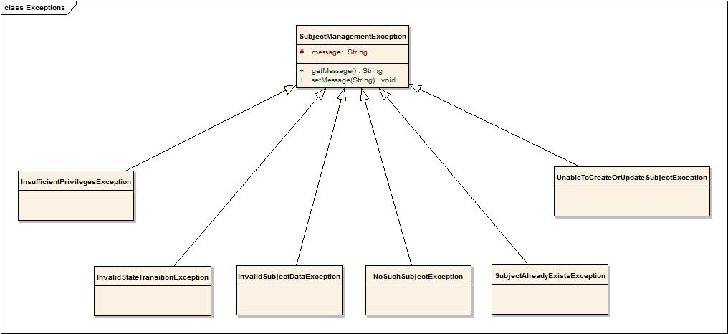

InvalidSubjectDataException
This exception is thrown when an XML message contains invalid or malformed data for a subject.

InvalidStateTransitionException
This exception is thrown when an invalid state transition is requested for a subject. The following diagram depicts allowable state transitions for a subject:
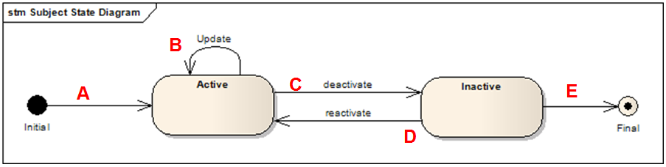

NoSuchSubjectException
This exception is thrown when an update or a state transition is attempted on an inexistent subject.

SubjectAlreadyExistsException
This exception is thrown when a subject being created already exists in the system.

UnableToCreateOrUpdateSubjectException
This exception is thrown when updating or creating a subject fails for a reason that is not covered by other exception types.

InsufficientPrivilegesException
This exception is thrown when a caller of the service does not have sufficient privileges to perform the requested operation.

Platform Specific Model

Overview
This section describes the service payload model and the service interface contract in detail. Links to the schemas for the service message payloads are included. The service interface is described using WSDL snippets and the complete WSDL is in the Appendix D – WSDL. This section also provides guidelines for implementing this service.

Domain Model

Standards | Description
NCI’s BRIDG v3.0.1 | The service specifications will be based on NCI’s version of BRIDG Model.
NCI’s Implementation of ISO 21090 Data types | The service specifications will be based on NCI’s restricted implementation of ISO 21090 data types.

Assumptions

Assumption | Affects
HTTP is the only transport protocol choice used to transmit SOAP messages to and from the service. | Clients of the service will not be able to use other protocols to consume the service.

Service Interface

Interface Model
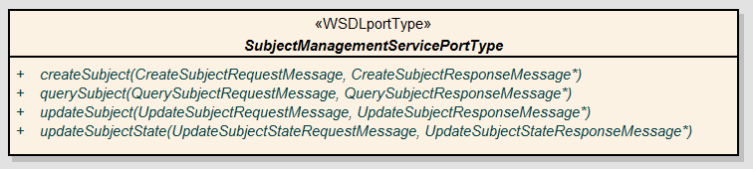
This service interface consists of four operations, and corresponds to both Subject Management Query and Subject Management Full Management profiles. The service interface details are provided in the following sections.

WSDL Messages and Port Types
The service shall conform to the messages and port types defined in the WSDL located at the following URL:
Description | URL
Subject Management WSDL | https://ncisvn.nci.nih.gov/svn/c3pr/trunk/c3prv2/documentation/design/essn/SubjectManagement/SubjectManagement.wsdl
Subject Management XML Schema | https://ncisvn.nci.nih.gov/svn/c3pr/trunk/c3prv2/documentation/design/essn/SubjectManagement/SubjectManagement.xsd
Business exception types thrown by interface methods. | https://ncisvn.nci.nih.gov/svn/c3pr/trunk/c3prv2/documentation/design/essn/SubjectManagement/SubjectManagement.xsd
ISO 21090 Healthcare Datatypes. | https://ncisvn.nci.nih.gov/svn/c3pr/trunk/c3prv2/documentation/design/essn/SubjectManagement/ISO_datatypes_Narrative.xsd

Operations Details
The following sections describe service operations in detail.

Query Subject
Behavior Description | Query by example model of querying and will retrieve all the Subject objects that match the input search criteria.
Pre-Conditions | None
Security Conditions | The requestor must be  - Must be a member of Study Registrar group for the given study  OR  - Must be a member of Site Registrar group at the given site  - Must be a member of Site Registrar group for the given study
Inputs | BRIDG : Subject. Partially or fully populated instance of subject.
Outputs | <DSET> BRIDG : Subject. A collection of subjects, which match the specified criteria and are registered to the site.
Post-Conditions | None
Exception Conditions | - Invalid data type or code value for an attribute.  - Invalid Subject class representation.  - User doesn’t have permissions to perform the requested operation.
Additional Implementation Details | If there are no subjects found, which match the specified criteria, an empty collection is returned.
Notes | By default, this method will return only the subjects which are in “ACTIVE” state. In order to retrieve “INACTIVE” subjects it must be explicitly specified in the input query criteria

Create Subject
Behavior Description | Allows creation of a Subject object, which can then be registered into a clinical trial.
Pre-Conditions | None
Security Conditions | The requestors  - Must be a member of Study Registrar group for the given study  OR  - Must be a member of Site Registrar group at the given site  - Must be a member of Site Registrar group for the given study
Inputs | BRIDG : Subject (with unset identifier field)
Outputs | BRIDG : Subject (with the identifier field populated)
Post-Conditions | A new Subject object is created with state as “ACTIVE”
Exception Conditions | - Invalid data type or code value for an attribute  - Invalid Subject class representation  - Subject already exists  - Unable to create the subject - (appropriate details in error message details from the underlying systems if any)  - User doesn’t have permissions to perform the given operation
Additional Implementation Details
Notes

Update Subject
Behavior Description | Allows updating a Subject’s attribute values except the state
Pre-Conditions | The Subject must be already created and is in “ACTIVE” state
Security Conditions | The requestors  - Must be a member of Study Registrar group for the given study  OR  - Must be a member of Site Registrar group at the given site  - Must be a member of Site Registrar group for the given study  - Subject is registered to that particular site
Inputs | BRIDG : Subject
Outputs | BRIDG : Subject (with the updated values)
Post-Conditions | None
Exception Conditions | - Invalid data type or code value for an attribute  - Invalid Subject class representation  - Subject doesn’t exist for the given identifier  - Unable to update the subject - (appropriate details in error message details from the underlying systems if any)  - User doesn’t have permissions to perform the given operation  - User doesn’t have permissions on the given subject
Additional Implementation Details
Notes | A notification should be sent to registration service.

Update Subject State
Behavior Description | Allows the updating of Subject’s State. A subject can be in either of the two states “ACTIVE” or “INACTIVE”. This operation allows toggling between them. Once it has become “INACTIVE”, a subject object cannot be assigned to a study and is not available for querying.
Pre-Conditions | The Subject must be already created and is in either “ACTIVE” or “INACTIVE” state.
Security Conditions | The requestors  - Must be a member of Study Registrar group for the given study  OR  - Must be a member of Site Registrar group at the given site  - Must be a member of Site Registrar group for the given study  - Subject is registered to that particular site
Inputs | II : SubjectIdentifier  ST : NewState
Outputs | BRIDG : Subject
Post-Conditions | The Subject object is either “ACTIVE” or “INACTIVE” based on the new state passed
Exception Conditions | - Study Subject doesn’t exist for the given identifier  - Invalid State Transition requested  - User doesn’t have permissions to perform the given operation  - User doesn’t have permissions on the given subject
Additional Implementation Details
Notes | A notification should be sent to registration service.

Message Information Model
Communication protocol of the Referral Service is chosen to be SOAP 1.1, so all messages of the service will contain appropriate SOAP envelope and will conform to this protocol standard.

Information Model
The platform for this PSM is chosen to be Java, thus Platform Independent Model presented in the PIMSS specification document is transformed into Java Platform Specific Model. The Java PSM class diagram is shown in the following diagram.

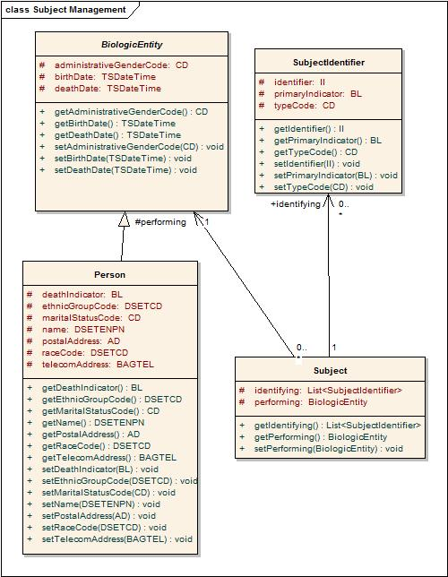

Java Information Model shown above uses ISO 21090 datatypes, in accordance with the PIMSS specification. Java PSM for the given ISO datatypes is provided below.
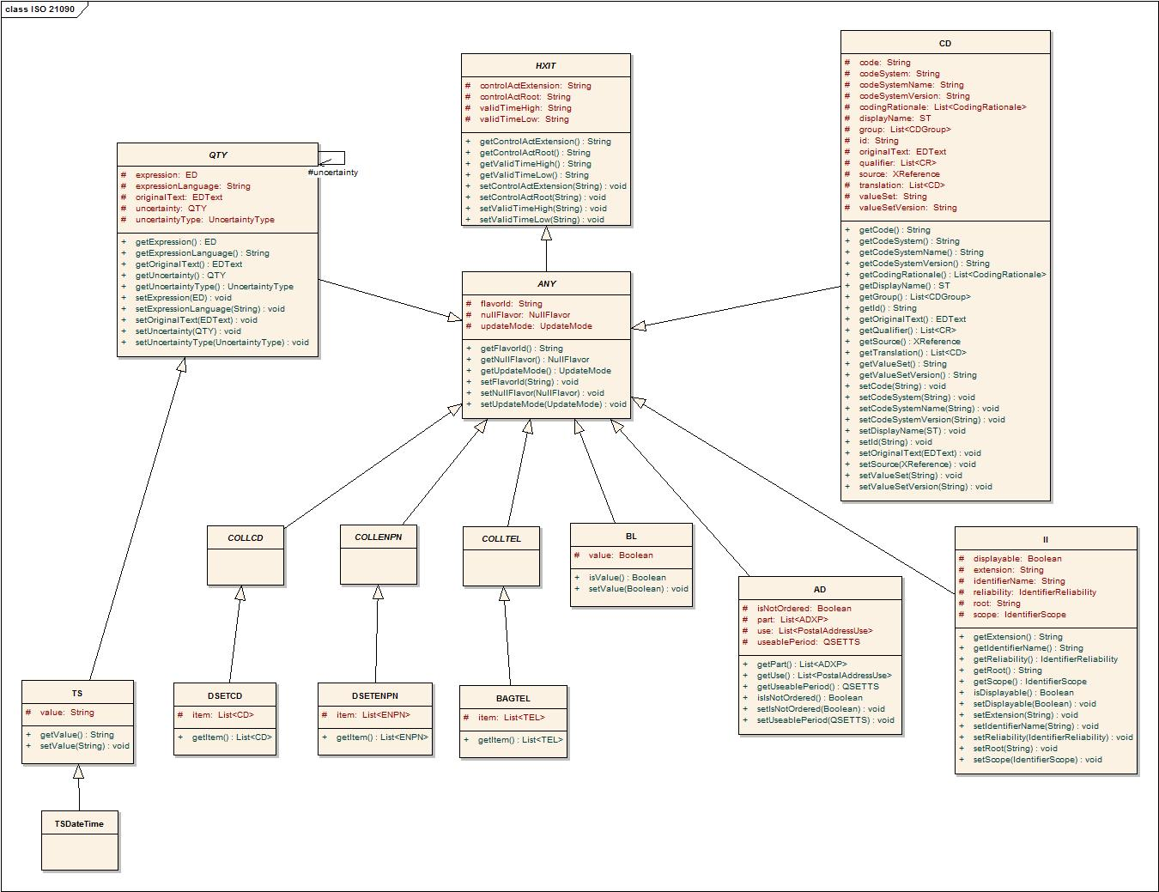

Implementation Considerations

Security

Encryption
The service will utilize transport-level security using HTTPS/SSL that will ensure confidentiality and integrity of the data being transmitted. Security policy specified in the WSDL file will require clients of the service to support secured connections.

Authentication
- Authentication Required: Yes
- Anonymous Access Allowed: No
- Type of Credential: SAML v2.0 Token obtained from an Identity Provider

Authorization
- Authorization Required: Yes
- Authorization Type: Local policy enforcement
- Authorization Product: Local CSM Based
- Authorization Policy: Provisioning required

Auditing
The service implementation will record details of all invocations in the database. Records will include identity of the caller, timestamp, subject’s data, and other invocation parameters.

Privacy
No privacy requirements are specified for this service.

Error Handling
Subclasses of SubjectManagementException are instantiated and thrown in case of errors along with user-friendly error messages. Java exceptions are translated into SOAP faults correspondingly by the JAX-WS runtime, which are used at a later point to re-create exceptions on the client’s side. Since an exception hierarchy is used, thrown exceptions will not contain a code, severity, or type indicator specified in PIMSS.

Deployment Considerations

Deployment Modes
The service will be deployed as a JAX-WS 2.1 Java Web service using SOAP 1.1 binding over HTTPS in a WS-I Basic Profile v1.1-compliant container.

Performance
The table below lists, per operation, the maximum average performance conformant implementations must meet, under the load given in the next section. Times are expressed in seconds, and should be measured using clients on networks local to the deployed services. Roundtrip times are for full message delivery, but do not include network latency or client serialization/de-serialization overhead.

Operation | Maximum Average Roundtrip
createSubject | < 2.0s
updateSubject | < 2.0s
updateSubjectState | < 2.0s
querySubject | < 5s

Scalability
Conformant services will support the performance metrics described in the previous section under a sustained maximum load of 2 requests per second. The requests should be a random mix of the available operations.

Discovery
The service posts all specifications in a WSDL and is accessible via web service endpoints. The specification does not cover how interested parties discover available web service endpoints. It is conceivable that there will be global and local registries, such as UDDI, that list available service providers in the context of further metadata aiding the discovery of relevant services. Clients can invoke the web service via any SOAP-based service client applications.

Uptime
The expected uptime for this service is to be 99.9% during business hours.

Failover
Failover should be provided for endpoints in the case of failing server software (servlet container, database) or hardware. Recommended is a second server (hardware) that can either be switched in when the primary hardware fails or concurrently deployed in a load balancing setup.

Constraints
No known constraints at this time.

Known Issues
No known issues at this time.

Recommendations for Conformance and Compliance

Conformance Assertions
Name | Type | Viewpoint | Description | Test method
NCI’s version of BRIDG 3.0.1 conformant | Obligation | Informational | The semantics of the Subject representation are directly conformant to BRIDG 3.0.1. | 1. Design Review  2. Inspection of WSDL and XSD
ISO 21090 Data Type conformant | Obligation | Informational | The attributes of the Subject class use ISO 21090 data types as defined in the referenced PIM_21090 document, as represented by the ISO 21090 XSD. | 1. Design Review  2. Inspection of WSDL and XSD
Observable behavior | Prohibition | Computational | Service clients are prohibited from making any assumptions based on the internal implementation details of the Service. As a corollary, all observable behavior must be made explicit in the Service specification. | 1. Design Review  2. Change of implementation not affect clients
Functional Profile | Obligation | Computational | All functional profiles must be implemented. | 1. Design review  2. Inspection of WSDL and XSD
Operations required | Obligation | Computational | Designers/implementers are obligated to implement all of the operations of both identified functional profiles. | 1. Test cases include all identified operations
Information Model Conformance | Obligation | Information | The Information Model representation will conform to the Information model provided in Section 3.5.1. | 1. Design Review  2. Test cases to be defined to test specified information model conformance
Multiple Jurisdictions | Obligation | Enterprise | Implementers will provide an implementation that supports multiple jurisdictional domains to support different Coordinating Center and Sites as well as multi-site trials | 1. Test cases include multiple domain scenarios
Query Performance | Obligation | Enterprise | The performance of the “querySubject” operation should be within 0.2 second to return a single record from the underlying database | 1. Test cases to include performance testing.
Auditing | Obligation | Engineering | Designers/implementers are obligated to decide on and document the approach for logging or auditing of operation calls | 1. Design Review

Appendix A – References
Name | Description | Location
NCI’s BRIDG v3.0.1 | NCI’s BRIDG model used for modeling the SM Service | https://gforge.nci.nih.gov/frs/download.php/8131/BRIDG_Release_3.0.1_Package.zip
Use Case Document | Document containing use cases for the C3PR application | https://cabig-kc.nci.nih.gov/CTMS/KC/index.php/C3PR_Use_Cases
Subject Management Service PIMSS | Platform Independent Model and Service Specification for Subject Management Service | http://gforge.nci.nih.gov/svnroot/ent-services/trunk/specifications/PIMSS_Subject_Management_Service.doc
PIM_21090.doc | ISO 21090 data types | https://gforge.nci.nih.gov/svnroot/coppa/trunk/documents/analysis_and_design/PIM_21090.doc

Appendix B – Relevant Standards
Please refer to the Section 1.3 of this document.

Appendix C – Glossary
Please refer to the caBIG shared glossary located at https://wiki.nci.nih.gov/display/Suite/10+-+Glossary+v2.2.

Appendix D – WSDL
<?xml version="1.0" encoding="UTF-8" standalone="no"?>
<wsdl:definitions xmlns:soap="http://schemas.xmlsoap.org/wsdl/soap/"
xmlns:tns="http://enterpriseservices.nci.nih.gov/SubjectManagementService"
xmlns:xsi="http://www.w3.org/2001/XMLSchema-instance" xmlns:sm="http://enterpriseservices.nci.nih.gov"
xmlns:ISO="uri:iso.org:21090" xmlns:wsdl="http://schemas.xmlsoap.org/wsdl/"
xmlns:xsd="http://www.w3.org/2001/XMLSchema" name="SubjectManagementService"
xsi:schemaLocation="uri:iso.org:21090 ISO_datatypes_Narrative.xsd http://enterpriseservices.nci.nih.gov SubjectManagement.xsd http://schemas.xmlsoap.org/ws/2005/07/securitypolicy http://schemas.xmlsoap.org/ws/2005/07/securitypolicy/ws-securitypolicy.xsd"
targetNamespace="http://enterpriseservices.nci.nih.gov/SubjectManagementService">
<wsdl:types>
<xsd:schema
targetNamespace="http://enterpriseservices.nci.nih.gov/SubjectManagementService">
<xsd:import namespace="http://enterpriseservices.nci.nih.gov"
schemaLocation="SubjectManagement.xsd"/>
<xsd:import namespace="uri:iso.org:21090" schemaLocation="ISO_datatypes_Narrative.xsd"/>
<xsd:element name="CreateSubjectRequest">
<xsd:complexType>
<xsd:sequence>
<xsd:element name="subject" type="sm:Subject"
minOccurs="1" maxOccurs="1"></xsd:element>
</xsd:sequence>
</xsd:complexType>
</xsd:element>
<xsd:element name="CreateSubjectResponse">
<xsd:complexType>
<xsd:sequence>
<xsd:element name="subject" type="sm:Subject"
minOccurs="1" maxOccurs="1"></xsd:element>
</xsd:sequence>
</xsd:complexType>
</xsd:element>
<xsd:element name="QuerySubjectRequest">
<xsd:complexType>
<xsd:sequence>
<xsd:element name="subject" type="sm:Subject"
minOccurs="1" maxOccurs="1"></xsd:element>
</xsd:sequence>
</xsd:complexType>
</xsd:element>
<xsd:element name="QuerySubjectResponse">
<xsd:complexType>
<xsd:sequence>
<xsd:element name="subjects" type="sm:DSET_SUBJECT"
minOccurs="1" maxOccurs="1"></xsd:element>
</xsd:sequence>
</xsd:complexType>
</xsd:element>
<xsd:element name="UpdateSubjectRequest">
<xsd:complexType>
<xsd:sequence>
<xsd:element name="subject" type="sm:Subject"
minOccurs="1" maxOccurs="1"></xsd:element>
</xsd:sequence>
</xsd:complexType>
</xsd:element>
<xsd:element name="UpdateSubjectResponse">
<xsd:complexType>
<xsd:sequence>
<xsd:element name="subject" type="sm:Subject"
minOccurs="1" maxOccurs="1"></xsd:element>
</xsd:sequence>
</xsd:complexType>
</xsd:element>
<xsd:element name="UpdateSubjectStateRequest">
<xsd:complexType>
<xsd:sequence>
<xsd:element name="subjectIdentifier" type="ISO:II"
maxOccurs="1" minOccurs="1"></xsd:element>
<xsd:element name="newState" type="ISO:ST" maxOccurs="1"
minOccurs="1"></xsd:element>
</xsd:sequence>
</xsd:complexType>
</xsd:element>
<xsd:element name="UpdateSubjectStateResponse">
<xsd:complexType>
<xsd:sequence>
<xsd:element name="subject" type="sm:Subject"
minOccurs="1" maxOccurs="1"></xsd:element>
</xsd:sequence>
</xsd:complexType>
</xsd:element>
<xsd:element name="SubjectManagementException" type="sm:SubjectManagementException"></xsd:element>
</xsd:schema>
</wsdl:types>

<wsdl:message name="CreateSubjectRequestMessage">
<wsdl:part name="parameters" element="tns:CreateSubjectRequest"/>
</wsdl:message>
<wsdl:message name="CreateSubjectResponseMessage">
<wsdl:part name="parameters" element="tns:CreateSubjectResponse"/>
</wsdl:message>
<wsdl:message name="QuerySubjectRequestMessage">
<wsdl:part name="parameters" element="tns:QuerySubjectRequest"/>
</wsdl:message>
<wsdl:message name="QuerySubjectResponseMessage">
<wsdl:part name="parameters" element="tns:QuerySubjectResponse"/>
</wsdl:message>
<wsdl:message name="UpdateSubjectRequestMessage">
<wsdl:part name="parameters" element="tns:UpdateSubjectRequest"/>
</wsdl:message>
<wsdl:message name="UpdateSubjectResponseMessage">
<wsdl:part name="parameters" element="tns:UpdateSubjectResponse"/>
</wsdl:message>
<wsdl:message name="UpdateSubjectStateRequestMessage">
<wsdl:part name="parameters" element="tns:UpdateSubjectStateRequest"/>
</wsdl:message>
<wsdl:message name="UpdateSubjectStateResponseMessage">
<wsdl:part name="parameters" element="tns:UpdateSubjectStateResponse"/>
</wsdl:message>
<wsdl:message name="SubjectManagementExceptionFaultMessage">
<wsdl:part name="fault" element="tns:SubjectManagementException"></wsdl:part>
</wsdl:message>

<wsdl:portType name="SubjectManagement">
<wsdl:operation name="createSubject">
<wsdl:input message="tns:CreateSubjectRequestMessage"/>
<wsdl:output message="tns:CreateSubjectResponseMessage"/>
<wsdl:fault message="tns:SubjectManagementExceptionFaultMessage"
name="SubjectManagementExceptionFault"/>
</wsdl:operation>
<wsdl:operation name="querySubject">
<wsdl:input message="tns:QuerySubjectRequestMessage"/>
<wsdl:output message="tns:QuerySubjectResponseMessage"/>
<wsdl:fault message="tns:SubjectManagementExceptionFaultMessage"
name="SubjectManagementExceptionFault"/>
</wsdl:operation>
<wsdl:operation name="updateSubject">
<wsdl:input message="tns:UpdateSubjectRequestMessage"/>
<wsdl:output message="tns:UpdateSubjectResponseMessage"/>
<wsdl:fault message="tns:SubjectManagementExceptionFaultMessage"
name="SubjectManagementExceptionFault"/>
</wsdl:operation>
<wsdl:operation name="updateSubjectState">
<wsdl:input message="tns:UpdateSubjectStateRequestMessage"/>
<wsdl:output message="tns:UpdateSubjectStateResponseMessage"/>
<wsdl:fault message="tns:SubjectManagementExceptionFaultMessage"
name="SubjectManagementExceptionFault"/>
</wsdl:operation>

</wsdl:portType>

<wsdl:binding name="SubjectManagementSOAP" type="tns:SubjectManagement">
<wsp:Policy xmlns:sp="http://schemas.xmlsoap.org/ws/2005/07/securitypolicy"
xmlns:wsp="http://schemas.xmlsoap.org/ws/2004/09/policy">
<wsp:ExactlyOne>
<wsp:All>
<sp:TransportBinding>
<wsp:Policy>
<sp:TransportToken>
<wsp:Policy>
<sp:HttpsToken RequireClientCertificate="false"/>
</wsp:Policy>
</sp:TransportToken>
<sp:AlgorithmSuite>
<wsp:Policy>
<sp:Basic256Rsa15/>
</wsp:Policy>
</sp:AlgorithmSuite>
</wsp:Policy>
</sp:TransportBinding>
<sp:SignedSupportingTokens>
<wsp:Policy>
<sp:SamlToken
sp:IncludeToken="http://docs.oasis-open.org/ws-sx/ws-securitypolicy/200702/IncludeToken/AlwaysToRecipient">
<wsp:Policy>
<sp:WssSamlV20Token11/>
</wsp:Policy>
</sp:SamlToken>
</wsp:Policy>
</sp:SignedSupportingTokens>
</wsp:All>
</wsp:ExactlyOne>
</wsp:Policy>
<soap:binding style="document"
transport="http://schemas.xmlsoap.org/soap/http"/>
<wsdl:operation name="createSubject">
<soap:operation style="document"/>
<wsdl:input>
<soap:body use="literal"/>
</wsdl:input>
<wsdl:output>
<soap:body use="literal"/>
</wsdl:output>
<wsdl:fault name="SubjectManagementExceptionFault">
<soap:fault name="SubjectManagementExceptionFault"/>
</wsdl:fault>
</wsdl:operation>
<wsdl:operation name="querySubject">
<soap:operation style="document"/>
<wsdl:input>
<soap:body use="literal"/>
</wsdl:input>
<wsdl:output>
<soap:body use="literal"/>
</wsdl:output>
<wsdl:fault name="SubjectManagementExceptionFault">
<soap:fault name="SubjectManagementExceptionFault"/>
</wsdl:fault>
</wsdl:operation>
<wsdl:operation name="updateSubject">
<soap:operation style="document"/>
<wsdl:input>
<soap:body use="literal"/>
</wsdl:input>
<wsdl:output>
<soap:body use="literal"/>
</wsdl:output>
<wsdl:fault name="SubjectManagementExceptionFault">
<soap:fault name="SubjectManagementExceptionFault"/>
</wsdl:fault>
</wsdl:operation>
<wsdl:operation name="updateSubjectState">
<soap:operation style="document"/>
<wsdl:input>
<soap:body use="literal"/>
</wsdl:input>
<wsdl:output>
<soap:body use="literal"/>
</wsdl:output>
<wsdl:fault name="SubjectManagementExceptionFault">
<soap:fault name="SubjectManagementExceptionFault"/>
</wsdl:fault>
</wsdl:operation>
</wsdl:binding>
</wsdl:definitions>

