Test Script Number: | create_new_participant |  |  |  | Module: |  |  | Tester Name: |  | Steven Cheng | Pass/Fail:  pass
Use Case #: |  |  |  |  | Username: |  |  | Test Date: |  | 05/04/2007 | Pass/Fail:  pass
Estimated Execution Time: |  |  |  |  |  |  | Actual Execution Time: |  | 40 min
Test Objective: create a new participant.

Test Setup:

Related Requirements
or Configuration Change Requests (Number/Description):

 | Test Action | Expected Results | Pass / Fail | Actual Results/Comments | gForge Tracker Bug ID
 | Click Subjects tab, and click Create Subject link, fill the required information for new participant, then click Save &Continue button. See figure 1. |  | Pass | Address tab is active.  Comments:  1) Future date should not be accepted as a birth date.  2) Type, Value and Source are ALL required? Otherwise remove red * at front of each.  3) Add ‘-- Please Select –‘ to dropdown lists in this page, don’t select first item in the list at default, force users to choose the right one.  4) Add ‘add/remove button’ to control Assigning Authority, not always come with 5 at default.  5) Radio button for Primary Indicator can not be unchecked. | 4433  4435  6311  6312  6313
 | Fill the required information in Address page, then click Save & Continue button. See figure 2 |  | Pass | Review and Submit tab is active.  Comments: Once click Previous button to modify the details page, ALL inputs in Address page are automatically cleared out when switch back | 6310
 | Review Participant Details, click Submit button. See figure 3 |  | pass | Comments:  1) A confirmation message should be displayed when successfully added a participant to the system.  2) 3 Edit buttons do NOT work.  3) The system does not check duplicates for participants at all. | 4440  4441

Tester Signature: Steven Cheng
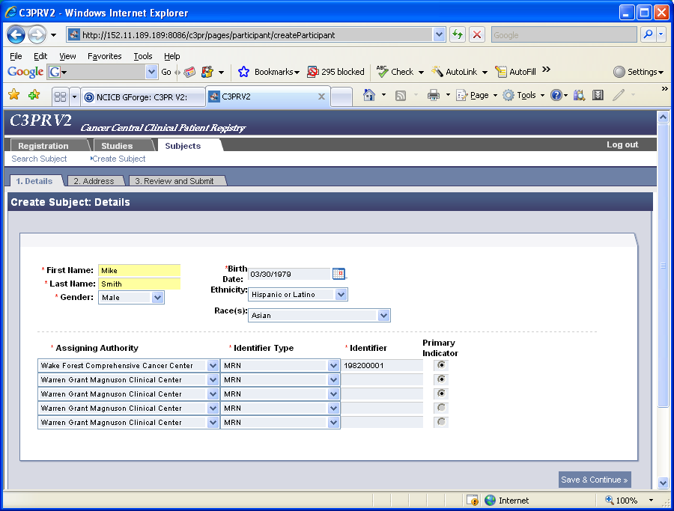
Figure 1
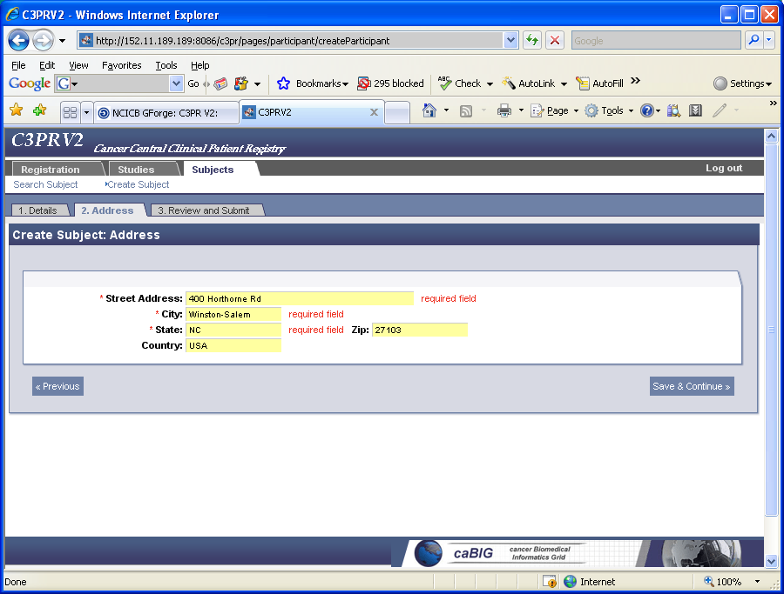
Figure 2
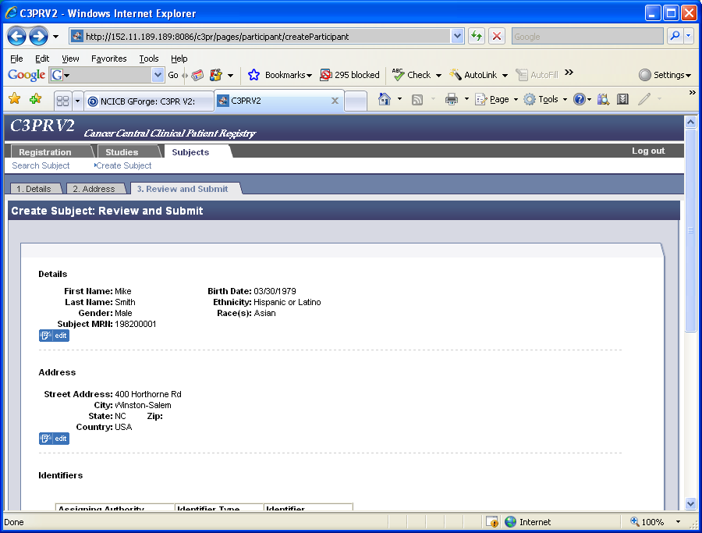
Figure 3

