Test Script Number: | create_new_study |  |  |  | Module: |  |  | Tester Name: |  | Steven Cheng | Pass/Fail:  Pass
Use Case #: |  |  |  |  | Username: |  |  | Test Date: |  | 04/24/2007 | Pass/Fail:  Pass
Estimated Execution Time: |  |  |  |  |  |  | Actual Execution Time: |  | 60 min
Test Objective: create a new study.

Test Setup:

Related Requirements
or Configuration Change Requests (Number/Description):

 | Test Action | Expected Results | Pass / Fail | Actual Results/Comments | gForge Tracker Bug ID
 | Click Studies tab, click Create Study link, fill the required information for Details, then click Save &Continue button. See figure 1. |  | Pass | Identifiers tab is active.  Required field validation works correctly.  Comments: Randomized and Multi Institution fields in Details page do NOT save the values users selected. | 6303
 | Fill the required information for Identifiers, then click Save & Continue button. See figure 2 |  | Pass | Sites tab is active.  Comments: Identifier is optional, remove red *  Add/Remove identifier function work correctly, but need to put description text next to icons.  Required field validation does NOT work on this page.  Radio button can’t be unchecked.
 | Fill the required information for Sites, then click Save & Continue button. See figure 3 |  | pass | Investigators tab is active  Comments: Activation date and IRB Approval Date are optional? The system still take without any input. | 4227
 | Fill the required information for Investigators, then click Save & Continue button. See figure 4 |  | pass | Personnel tab is active  Comments: when input investigator’s name, error message really bother users. After click Save & Continue button, the system automatically clears the investigator’s name and stop going to next step.  Currently the system will only accept built-in investigator ‘Bill Gates’ related to ‘Duck University Comprehensive Cancer Center’.  By delete the investigator, can go through next step. | 6112
 | Fill the required information for Personnel, then click Save & Continue button. See figure 5 |  | pass | Eligibility Checklist tab is active.  Comments: the same error as in step 4
 | Fill the required information for Eligibility Checklist, then click Save & Continue button. See figure 6 |  | pass | Epochs & Arms tab is active.  Comments: Two image icons next to ‘Inclusion/Exclusion Criteria’ are not shown up when first switch to the page. Once click the error icon, shown up, but when click ‘X’ to delete one question, it refreshes back to error icon.  Display arrangement is wrong for ‘Inclusion Criteria’, it should be similar to one for ‘Exclusion Criteria’. | 6304  6305
 | Fill the required information for Epochs & Arms, then click Save & Continue button. See figure 7 |  | pass | Overview tab is active.
 | Review the study’s information, then click Save & Continue button. See figure 8 |  | pass | The study successfully created  Comment: print link does not work on the page. Save button on the page for what?

Tester Signature: Steven Cheng
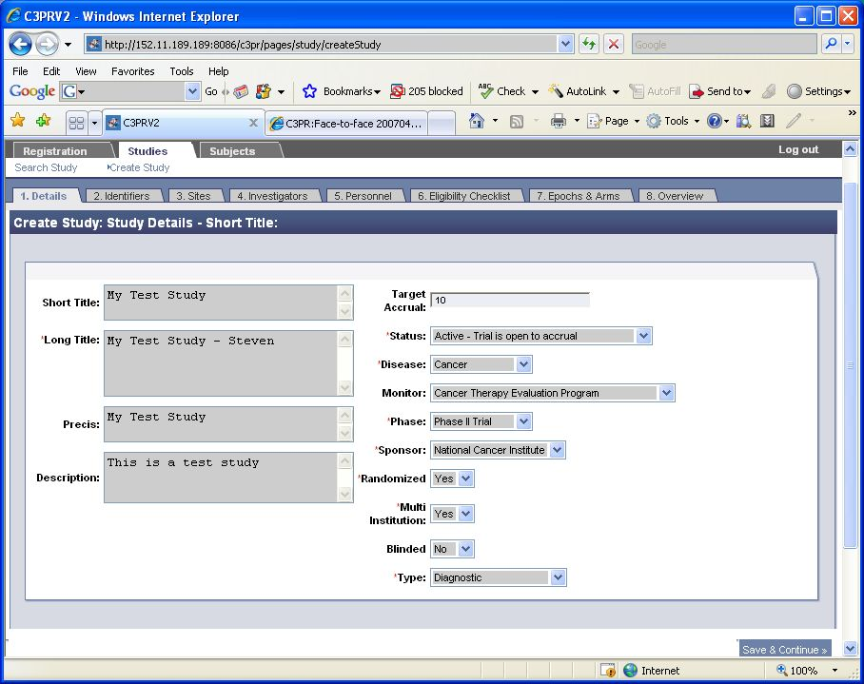
Figure 1
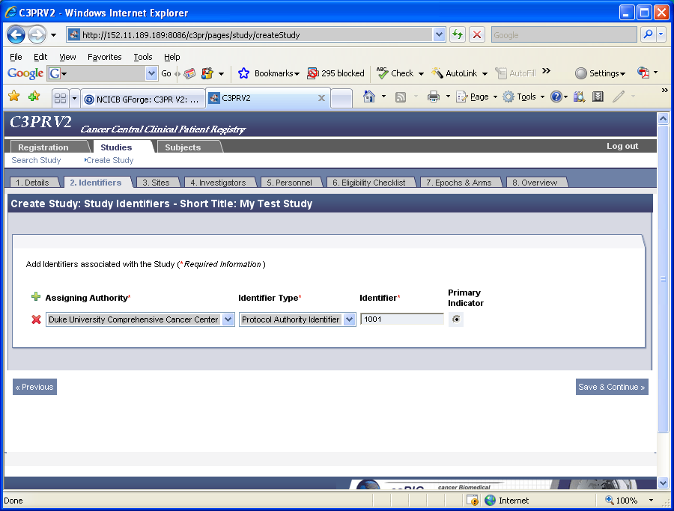
Figure 2
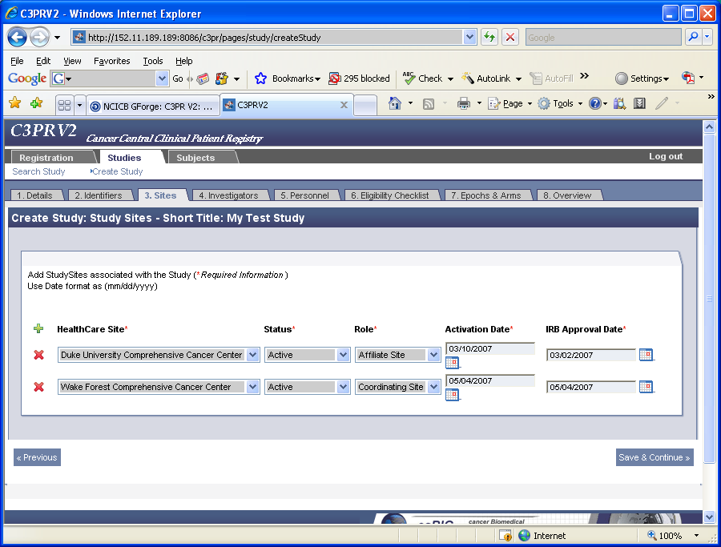
Figure 3
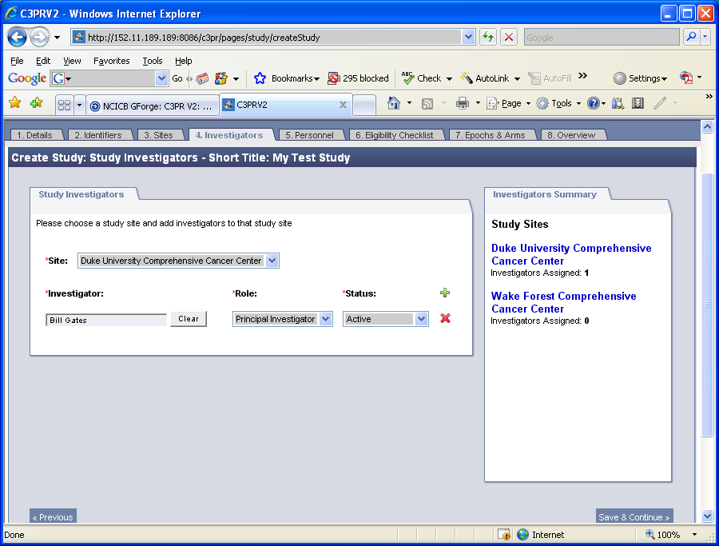
Figure 4
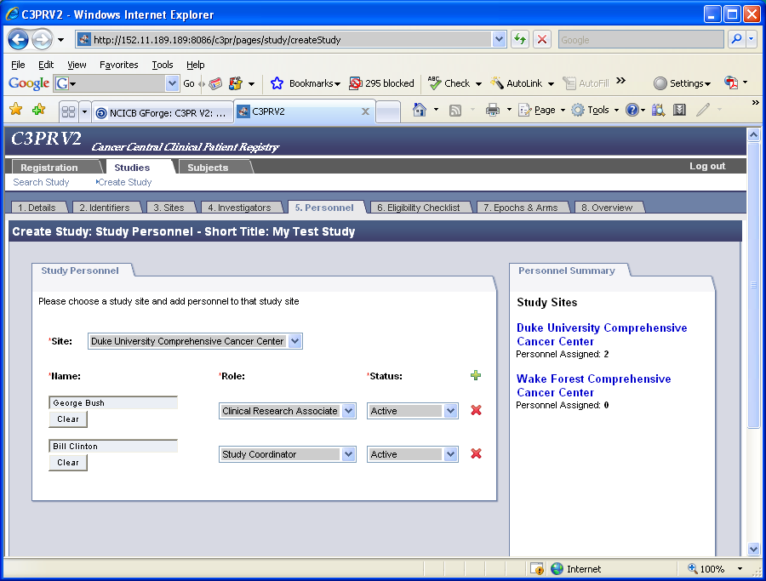
Figure 5
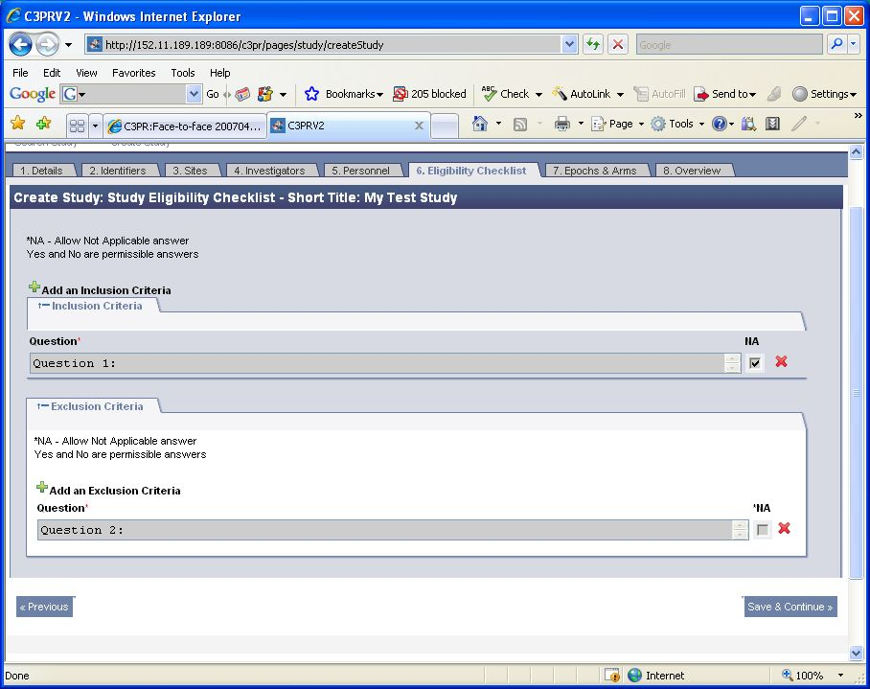
Figure 6
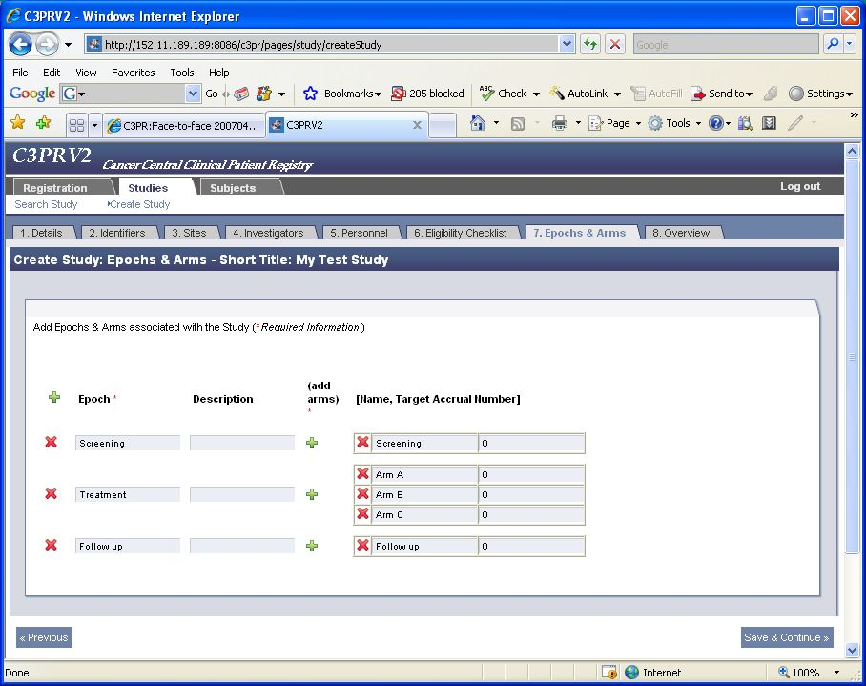
Figure 7
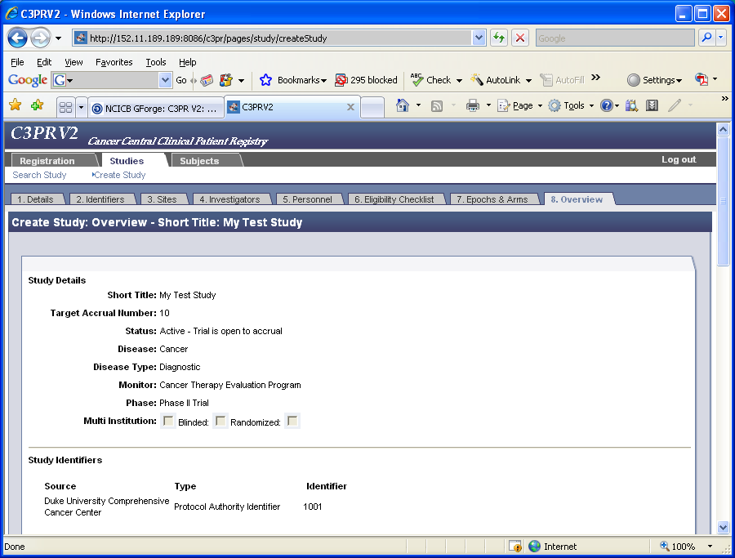
Figure 8
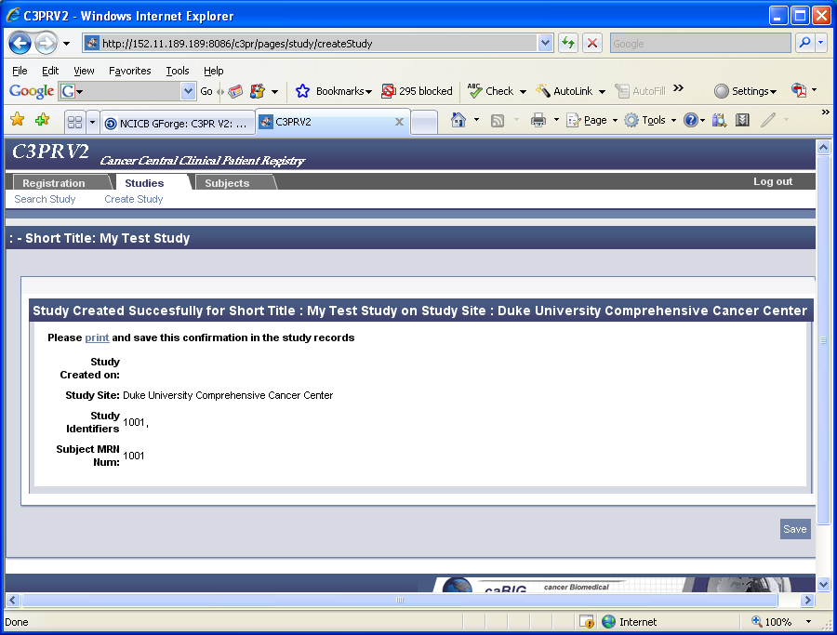
Figure 9

