Test Script Number: | create_new_participant |  |  |  | Module: |  |  | Tester Name: |  | Steven Cheng | Pass/Fail:  pass
Use Case #: |  |  |  |  | Username: |  |  | Test Date: |  | 03/02/2007 | Pass/Fail:  pass
Estimated Execution Time: |  |  |  |  |  |  | Actual Execution Time: |  | 40 min
Test Objective: create a new participant.

Test Setup:

Related Requirements
or Configuration Change Requests (Number/Description):

 | Test Action | Expected Results | Pass / Fail | Actual Results/Comments | gForge Tracker Bug ID
 | Click Subject tab, and click Add Subject link, fill the required information for new participant, then click Continue button. See figure 1. |  | Pass | Address Information tab is active.  Comments: future date should not be accepted as a birth date.  Type, Value and Source are ALL required? Otherwise remove red * at front of each | 4433  4435
 | Fill the required information in Address Information page, then click Continue button. See figure 2 |  | Pass | Review and Submit tab is active.  Comments: Zip is not a required, so remove red * at front.  State is a required field, but no error messaged displayed when nothing is entered.  Search Zip link does not work. | 4436  4437  4438
 | Review Participant Details, click Submit button. See figure 3 |  | pass | Comments: A confirmation message should be displayed when successfully added a participant to the system.  Both Edit buttons do NOT work.  The system does not check duplicates for participants at all. | 4440  4441

Tester Signature: Steven Cheng

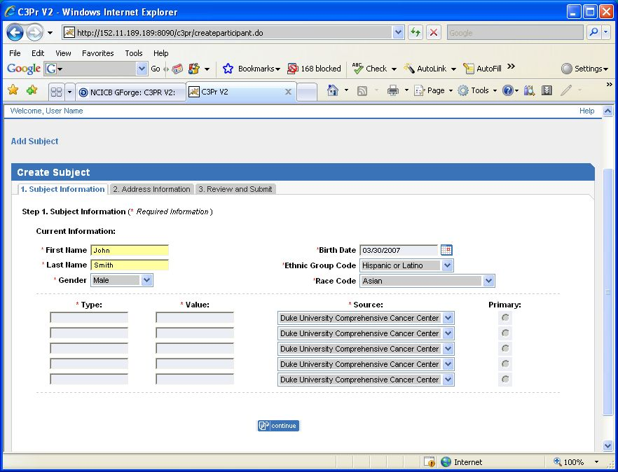

Figure 1

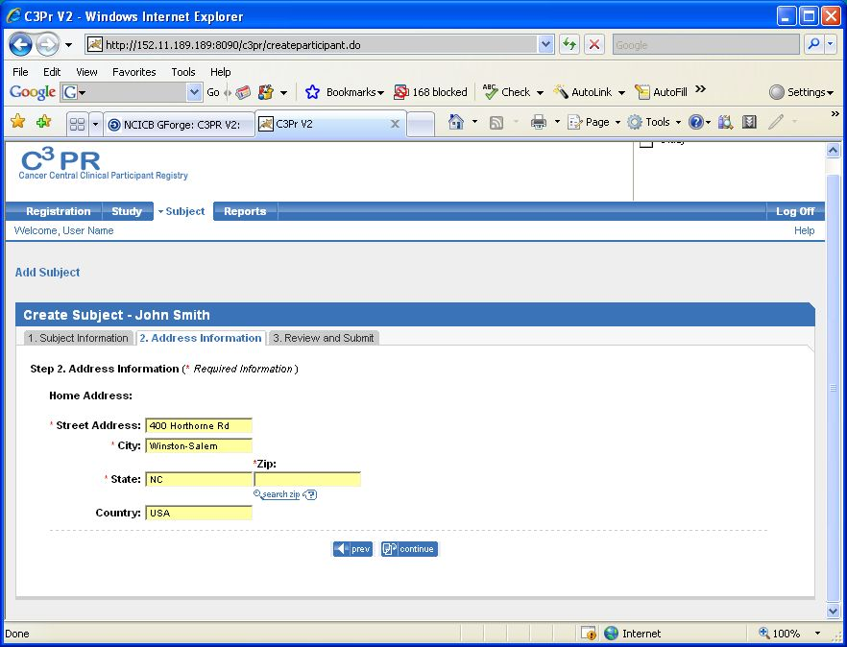

Figure 2
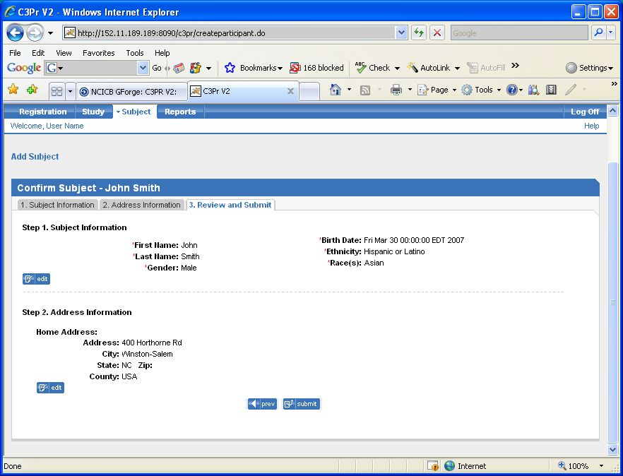
Figure 3

