Test Script Number: | create_new_study |  |  |  | Module: |  |  | Tester Name: |  | Steven Cheng | Pass/Fail:  pass
Use Case #: |  |  |  |  | Username: |  |  | Test Date: |  | 03/01/2007 | Pass/Fail:  pass
Estimated Execution Time: |  |  |  |  |  |  | Actual Execution Time: |  | 40 min
Test Objective: create a new study.

Test Setup:

Related Requirements
or Configuration Change Requests (Number/Description):

 | Test Action | Expected Results | Pass / Fail | Actual Results/Comments | gForge Tracker Bug ID
 | Click Study tab, click Add Study link, fill the required information for study details, then click Continue button. See figure 1. |  | Pass | Identifiers tab is active.  Comments: Multi Institution is optional, remove red *  Required field error message should be displayed next to the specific field or in a separate window, otherwise users may not find it. | 4226
 | Fill the required information for Study Identifiers, then click Continue button. See figure 2 |  | Pass | Study Site tab is active.  Comments: Identifier is optional, remove red *
 | Fill the required information for Study Site, then click Continue button. See figure 3 |  | pass | Study Design tab is active  Comments: Start Date, End date and IRB Approval Date are optional? The system still take without any input.  End date should NOT be earlier than start date | 4227  4225
 | Fill the required information for Study Design, then click Continue button. See figure 4 |  | pass | Review and Submit tab is active  Comments: remove (* next to add arms column, remove [ ] from Name and Target Accrual Number fields and separate them | 4229  4230
 | Review Study information, then click Submit button. See figure 5, 6, 7 |  | pass | You have successfully created Study  Comments: print link does not work | 4228

Tester Signature: Steven Cheng

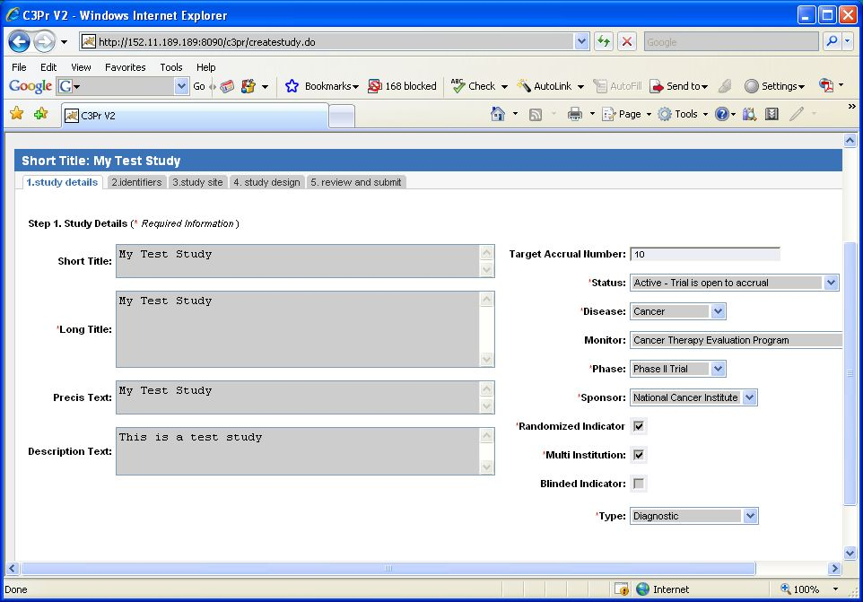

Figure 1

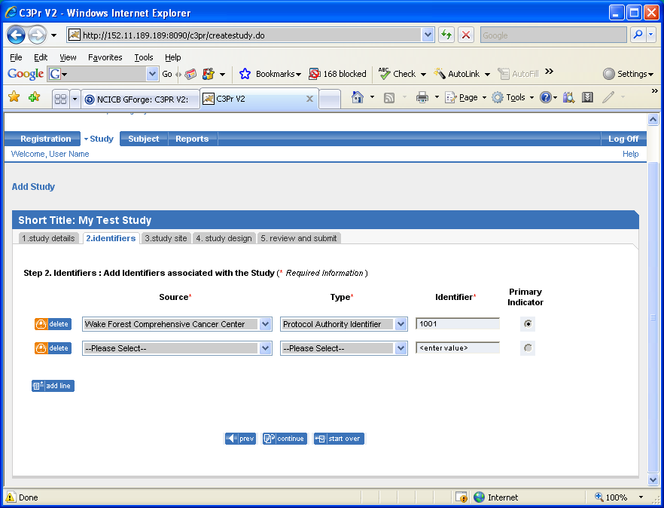

Figure 2
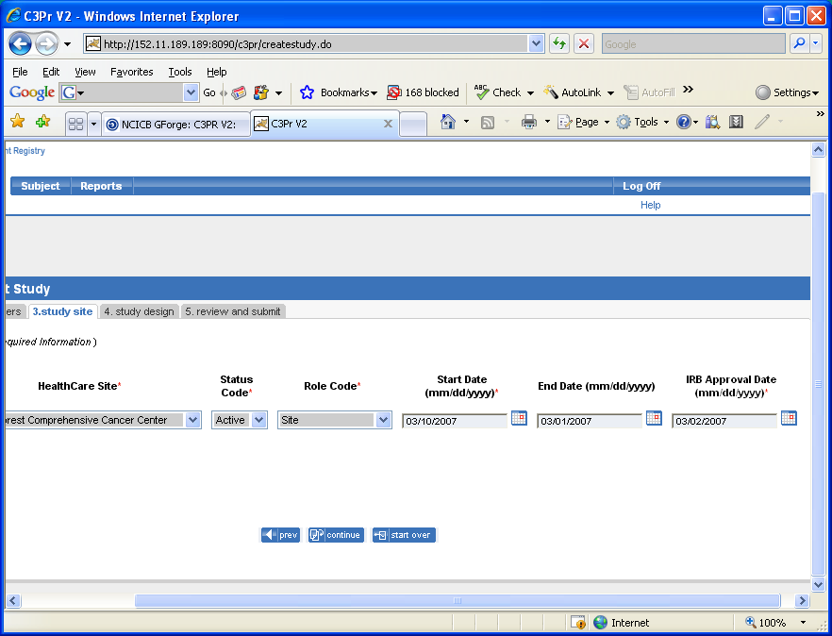
Figure 3
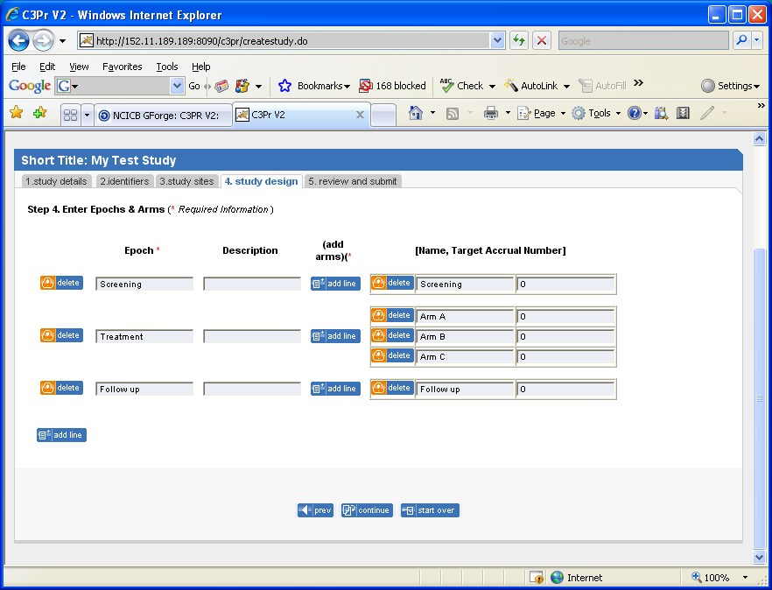
Figure 4
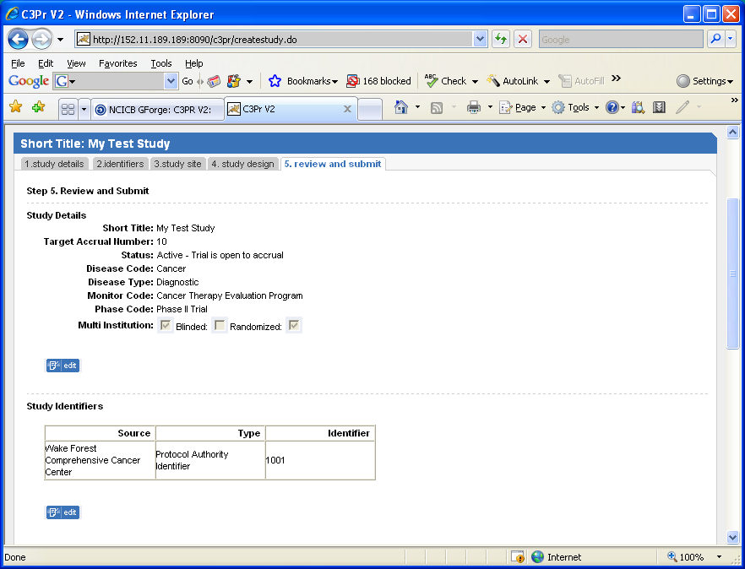
Figure 5
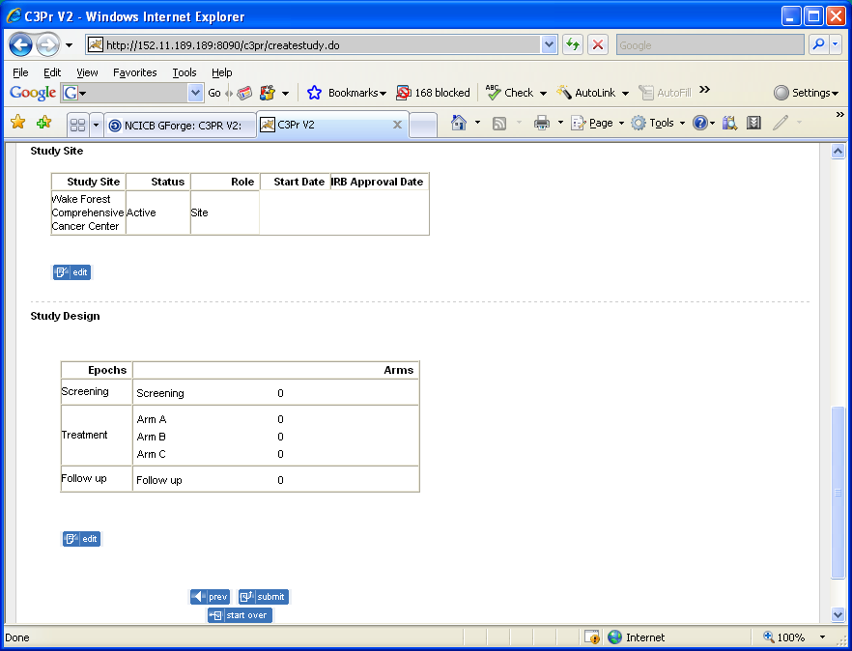
Figure 6
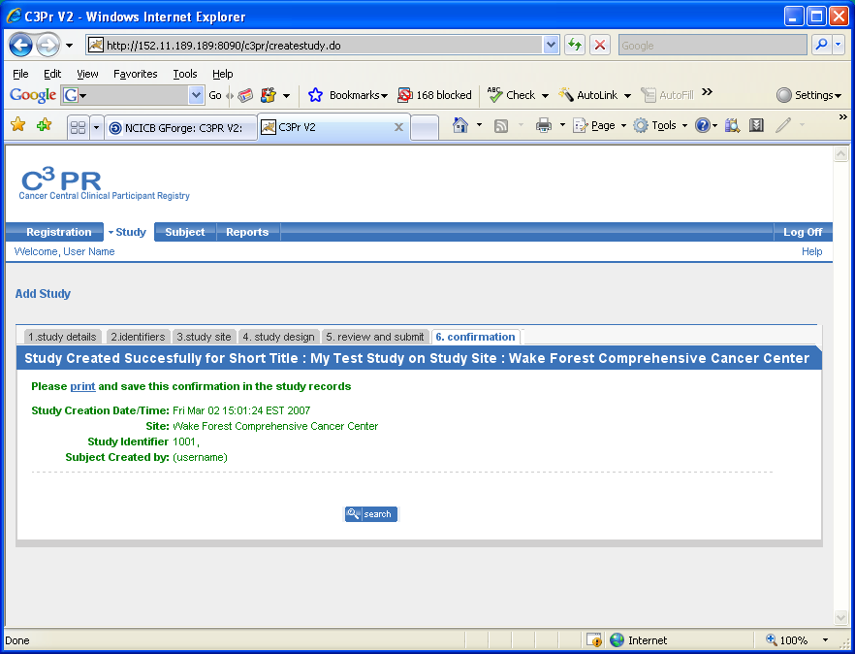
Figure 7

