C3PR V2.8
Use Case Document

Duke Comprehensive Cancer Center


Updated Novemebr 16, 2009

Copyright and License page

Copyright Notice. Copyright 2009 Duke Comprehensive Cancer Center (“caBIG™ Participant”). C3PR was created with NCI funding and is part of the caBIG™ initiative. The software subject to this notice and license includes both human readable source code form and machine readable, binary, object code form (the “caBIG™ Software”).
This caBIG™ Software License (the “License”) is between caBIG™ Participant and You. “You (or “Your”) shall mean a person or an entity, and all other entities that control, are controlled by, or are under common control with the entity. “Control” for purposes of this definition means (i) the direct or indirect power to cause the direction or management of such entity, whether by contract or otherwise, or (ii) ownership of fifty percent (50%) or more of the outstanding shares, or (iii) beneficial ownership of such entity.
License. Provided that You agree to the conditions described below, caBIG™ Participant grants You a non-exclusive, worldwide, perpetual, fully-paid-up, no-charge, irrevocable, transferable and royalty-free right and license in its rights in the caBIG™ Software, including any copyright or patent rights therein that may be infringed by the making, using, selling, offering for sale, or importing of caBIG™ Software, to (i) use, install, access, operate, execute, reproduce, copy, modify, translate, market, publicly display, publicly perform, and prepare derivative works of the caBIG™ Software; (ii) make, have made, use, practice, sell, and offer for sale, and/or otherwise dispose of caBIG™ Software (or portions thereof); (iii) distribute and have distributed to and by third parties the caBIG™ Software and any modifications and derivative works thereof; and (iv) sublicense the foregoing rights set out in (i), (ii) and (iii) to third parties, including the right to license such rights to further third parties. For sake of clarity, and not by way of limitation, caBIG™ Participant shall have no right of accounting or right of payment from You or Your sublicensees for the rights granted under this License. This License is granted at no charge to You. Your downloading, copying, modifying, displaying, distributing or use of caBIG™ Software constitutes acceptance of all of the terms and conditions of this Agreement. If you do not agree to such terms and conditions, you have no right to download, copy, modify, display, distribute or use the caBIG™ Software.
- Your redistributions of the source code for the caBIG™ Software must retain the above copyright notice, this list of conditions and the disclaimer and limitation of liability of Article 6 below. Your redistributions in object code form must reproduce the above copyright notice, this list of conditions and the disclaimer of Article 6 in the documentation and/or other materials provided with the distribution, if any.
- Your end-user documentation included with the redistribution, if any, must include the following acknowledgment: “This product includes software developed by Duke Comprehensive Cancer Center.” If You do not include such end-user documentation, You shall include this acknowledgment in the caBIG™ Software itself, wherever such third-party acknowledgments normally appear.
- You may not use the names “Duke Comprehensive Cancer Center”, “The National Cancer Institute”, “NCI”, “Cancer Bioinformatics Grid” or “caBIG™” to endorse or promote products derived from this caBIG™ Software. This License does not authorize You to use any trademarks, service marks, trade names, logos or product names of either caBIG™ Participant, NCI or caBIG™, except as required to comply with the terms of this License.
- For sake of clarity, and not by way of limitation, You may incorporate this caBIG™ Software into Your proprietary programs and into any third party proprietary programs. However, if You incorporate the caBIG™ Software into third party proprietary programs, You agree that You are solely responsible for obtaining any permission from such third parties required to incorporate the caBIG™ Software into such third party proprietary programs and for informing Your sublicensees, including without limitation Your end-users, of their obligation to secure any required permissions from such third parties before incorporating the caBIG™ Software into such third party proprietary software programs. In the event that You fail to obtain such permissions, You agree to indemnify caBIG™ Participant for any claims against caBIG™ Participant by such third parties, except to the extent prohibited by law, resulting from Your failure to obtain such permissions.
- For sake of clarity, and not by way of limitation, You may add Your own copyright statement to Your modifications and to the derivative works, and You may provide additional or different license terms and conditions in Your sublicenses of modifications of the caBIG™ Software, or any derivative works of the caBIG™ Software as a whole, provided Your use, reproduction, and distribution of the Work otherwise complies with the conditions stated in this License.
- THIS caBIG™ SOFTWARE IS PROVIDED "AS IS" AND ANY EXPRESSED OR IMPLIED WARRANTIES (INCLUDING, BUT NOT LIMITED TO, THE IMPLIED WARRANTIES OF MERCHANTABILITY, NON-INFRINGEMENT AND FITNESS FOR A PARTICULAR PURPOSE) ARE DISCLAIMED. IN NO EVENT SHALL THE DUKE COMPREHENSIVE CANCER CENTER OR ITS AFFILIATES BE LIABLE FOR ANY DIRECT, INDIRECT, INCIDENTAL, SPECIAL, EXEMPLARY, OR CONSEQUENTIAL DAMAGES (INCLUDING, BUT NOT LIMITED TO, PROCUREMENT OF SUBSTITUTE GOODS OR SERVICES; LOSS OF USE, DATA, OR PROFITS; OR BUSINESS INTERRUPTION) HOWEVER CAUSED AND ON ANY THEORY OF LIABILITY, WHETHER IN CONTRACT, STRICT LIABILITY, OR TORT (INCLUDING NEGLIGENCE OR OTHERWISE) ARISING IN ANY WAY OUT OF THE USE OF THIS caBIG™ SOFTWARE, EVEN IF ADVISED OF THE POSSIBILITY OF SUCH DAMAGE.

Table of Contents

C3PR Introduction 3
Background 3
Document Conventions 3
Actors and Roles 4
Manage Subjects 4
Create Subject 4
Search for a Subject 7
View a Subject 8
Update Subject Details 10
Manage Study 11
High Level Study Diagram 11
Data Capture Diagram 13
Create Study Definition Manually 15
Search for Studies 16
View Study 18
Update Study 19
Associate Study Personnel Study 21
Add Notifications to Study 22
Add Stratification 23
Disable a Stratum Group 25
Add Eligibility Criteria 28
Add Diseases 30
Change Status from Pending to Open 32
Change Status from Amendment Pending to Open 34
Update Study Definition 35
Update Study Protocol Version 37
Manage Registration 38
Register a New Subject 38
Register Subject to Multi-site Study 40
Enroll Subject to a Study Site 42
Transfer Epoch to Study Site of Multi-site Study 44
Assign Subject to New Epoch in Study Site 46
Register Existing Subject to a Study 47
Assign Kit Number for Blinded Study 49
Save a Registration in Incomplete Status 50
Register Subject to Reservation Study 52
Search for Registrations 54
View Subject Registration History 57
Update Eligibility Status for Registration 58
Randomize Subject 60
Take Subject Off Study 61
Unblind Registered Subject 62
Reporting 64
Advanced Registration Search 64
Study Search and Export 65
Administration 67
Create Investigator 67
Add Investigator Group 69
Add Investigator To A Group 70
Create Research Staff 72
Create Organization 74
Associate Investigator to Study Organization 76
Associate Investigator Group to Study Organization 78
Search for a Study Personnel 79
View and Update Research Staff Details 81
Search for an Investigator 83
List Investigators In A Group 84
View or Update Investigator Details 86
Disassociate Study Person from Study Site 87
Change the Study Site Investigator status 89
Export Study Definition to a File 90
Export Registration Definition to a File 92
Import Study Definition from a File 93
Get Study Definition via Study Message from External Source 95
Integration 97
Synchronize Registration of a Subject on a Study Arm with Study Calendar 97
Overall Requirements 99
Requirements Prioritization 99
Sign Off 100
Approval 100
NCICB Rep Print Name 100

C3PR Introduction

Background
The Cancer Center Participant Registry (C3PR) is a web-based application used for end-to-end registration of patients to clinical trials. This includes capturing the consent signed date, eligibility criteria, stratification, randomization, and screening. Clinical workflows are enabled by both subject- and study-centric views into the registration process. C3PR can be run in a standalone mode where study definitions, investigators, study personnel, and sites are entered into the system, or C3PR can be run in an integrated mode with the caBIG Clinical Trials Suite (CCTS). C3PR also enables multi-site clinical trials where registration information is entered locally at affiliate sites and the registration is completed by call-out to the coordinating site.
Throughout the development of C3PR, a number of elaborator and adopter sites are actively being engaged to help define requirements and test the application. Our primary elaborators include Duke, Wake Forest, Mayo, Westat, CALGB, CCR, and the Coalition of Cooperative Groups. Our primary adopters include Duke and Wake Forest with engagement of Georgetown and CCR.
C3PR release 1 was developed by Nortel Solutions and released in 2006. Release 2 was developed by Duke Cancer Center in collaboration with SemanticBits, LLC and was released in March, 2008. We are currently in the next phase of development with the release of C3PR 2.8 slated for early December 2009.

Document Conventions
The C3PR Release 2 project follows the iterative development of the Unified Framework Process. Thus, each document is a snapshot of a work-in-progress. The following conventions will be used throughout the document:
- will indicate new items that need to be addressed immediately in the next iteration by the developers.
- will indicate new items that need to be addressed in the next iteration by the elaborators.

Actors and Roles
The likely users of C3PR are people with the job responsibilities listed below. The role(s) granted to each user in the application will depend on the specific responsibilities of the person's job and other institutional rules under which they execute their responsibilities.
- Registrar
- Study Coordinator
- Site Coordinator
- System Administrator
The following table contains the different kinds of user groups:
System Administrator | - Is a "super-user" who manages the application  - Approves and manages user registration process  - Grants users to a role within the application
Study Administrator | - Reviews completed Study definitions to determine if they are complete and correct  - Determines which studies can be viewed and edited by each Clinical Research Coordinator and viewable for each Research Associate
Study Coordinator | - Creates new Study definitions in the system
Registrar

Manage Subjects

Create Subject

Use Case Model
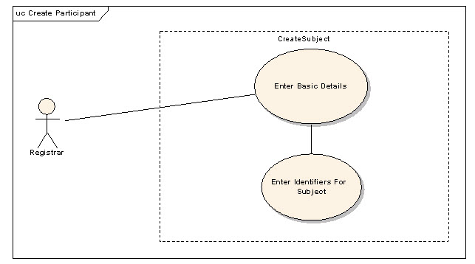

Brief Description
Existence of the subjects within the C3PR system is required for several use cases. In this use case a subject is created in the C3PR system.

Primary Actor(s)

Registrar

Secondary Actor(s)

Admin

Preconditions
- The user is logged into the system with a user account that has role authority to create a Subject.
- The Subject doesn't already exist.

Basic Flow of Events
- The user selects Create Subject
- The user is presented with a screen where details about the Subject are entered.
- The user enters the Subject data elements in the fields.
- The user submits the data
- If a subject with duplicate information is found in the system an alternate flow is introduced.
- The system displays the result page confirming the successful creation of a Subject.

Post Conditions
- Subject data is stored in the system.
- The user is presented with a conformation of Subject creation.

Alternate Flow
- The system shows an error for Subjects with a duplicate identifier.
- The user cancels the creation of the subject.
- The user changes the identifier value for a given system and creates the subject.
- The system displays the result page confirming the successful creation of the subject.
Special Requirements
Data Item | Notes/Validation Rule
Subject Identfier | At least one is required. The system will allow for any number of these to be specified and will capture the type of the identifier, the issuer of the identifier, and its value. This ID is uniquie to the Subject independent of the Subject's participation in a clinical trial.
First Name | Required
Middle Name | Not Required
Maiden Name | Not Required
Last Name | Required
Date of Birth | mm/dd/yyyy, forced format, Required
Gender | Coded, Required (Valid values include "unknown" and "not reported")
Race | Coded, Required (Valid values include "unknown" and "not reported")
Ethnicity | Coded, Required (Valid values include "unknown" and "not reported")

Search for a Subject

Use Case Model
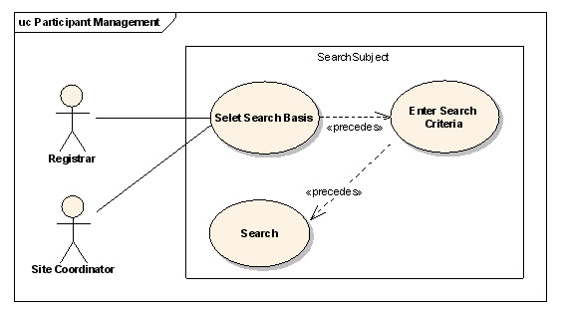

Brief Description
This use-case deals with searching for a subject. Reasons for searching for a subject include:
- Looking for duplicate subjects
- Begin subject registration in create registration workflow
- View registration details
- Update subject information
- Update registration

Primary Actor(s)

Registrar

Secondary Actor(s)

Admin

Preconditions
The user is logged in to the system with a user account that has role authority to search for a subject.

Basic Flow of Events
- The user indicates to the system that he/she wants to search for a subject.
- The user selects the search basis on which he/she wants to perform the search.
- The user enters the search criteria for the subject and submits the information to the system.
- The system displays search results for subjects depending on the search criteria.
- If no result is displayed use the alternate flow.

Post Conditions
The resulting subject is in a state that the user can use to perform registration in create registration flow or simply to view subject details or to update subject details.

Alternate Flow
#The use changes the search criteria.
- The user submits the search criteria.

View a Subject
Use Case Model 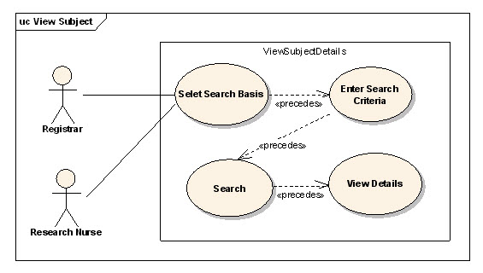

Brief Description
This use case allows the user to view Subject's record.

Primary Actor(s)

Registrar

Secondary Actor(s)

Admin

Preconditions
The subject already exists.

Basic Flow of Events
- The user indicates to the system that he/she wants to search for a subject.
- The user enters the search criteria for the subject and submits the information to the system.
- The system displays 0, 1 or multiple subjects depending on the search criteria.
- The user selects a subject.
- The user views the subject details

Post Conditions
- The subject details are displayed.
- The user can transition to Edit Use Case.

Update Subject Details

Use Case Model
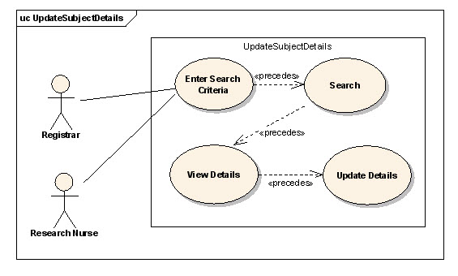

Brief Description
This use case allows the user to update Subject's record.

Primary Actor(s)

Registrar

Secondary Actor(s)

Admin

Preconditions
The subject record already exists.

Basic Flow of Events
- The user indicates to the system that he/she wants to search for a subject.
- The user enters the search criteria for the subject and submits the information to the system.
- The system displays 0, 1 or multiple subjects depending on the search criteria.
- The user selects a subject.
- The user views the subject details.
- The user selects the edit option for the displayed subject details.
- The user updates the subject detais.

Post Conditions
- The subject record is updated.

Special Requirements
None.

Manage Study

High Level Study Diagram

Use Case Model
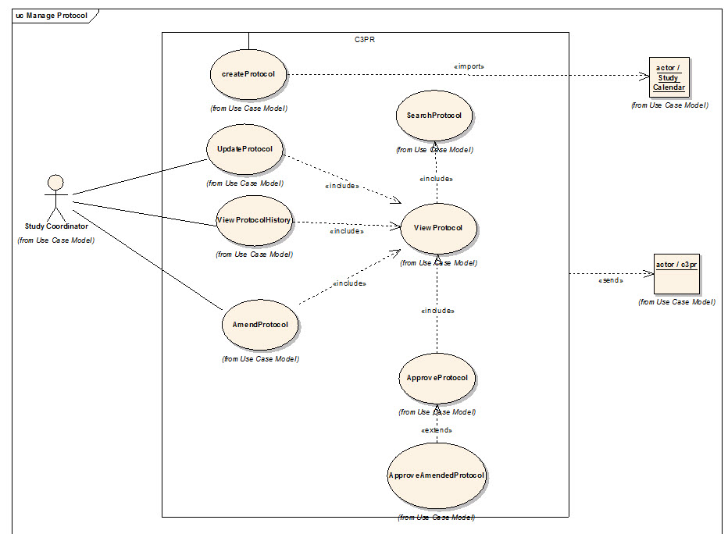

Brief Description
Study Management is not the primary function of C3PR. However, Study Management is critical for the independent functioning of C3PR because registration is driven by the structure of the study. Therefore, it is included as a primary use case.

Primary Actor(s)

TBD

Secondary Actor(s)

TBD

Preconditions

TBD

Basic Flow of Events

TBD

Post Conditions

TBD

Alternate Flow

TBD

Data Capture Diagram

Use Case Model
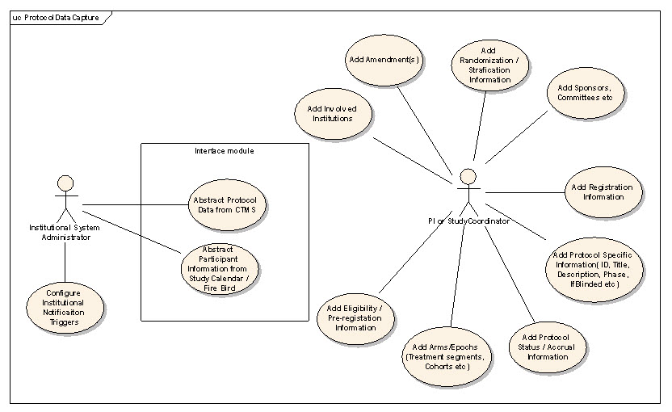

Brief Description

TBD

Primary Actor(s)

TBD

Secondary Actor(s)

TBD

Preconditions

TBD

Basic Flow of Events

TBD

Post Conditions

TBD

Alternate Flow

TBD

Create Study Definition Manually

Use Case Model
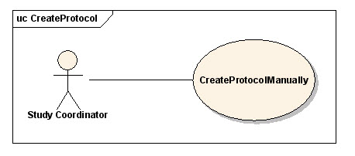

Brief Description
This use-case deals with the manual creation of a study by entering each data element of the study.

Primary Actor(s)

Site Coordinator

Secondary Actor(s)

Admin

Preconditions
- The user is logged in to the system with a user account that has role authority to create a study.
- The study has not already been entered.

Basic Flow of Events
- The user indicates to the system that he/she wants to create a new study definition.
- The system displays the screen that gives the user the option of entering the study information manually.
- The user enters the study data elements in the fields.
- The user indicates to the system that the required study information has been entered for creation of a new study through a confirmation window with all of the study data items.

Extension
- If this is a multi-site study that is shared across more than one organization, the user indicates to the system that the information must be broadcast to all participating organization sites.

Post Conditions
- The study is created in the system.
- The study is created and defined as being in either "Pending" or "Active" status.

Alternate Flow
- If a duplicate study is found then the user has to fix the details before it can be saved in C3PR.

Special Requirements
None.

Search for Studies

Use Case Model
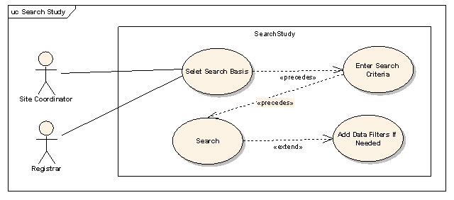

Brief Description
This use-case deals with searching for a study. Reasons for searching for a study include:
- Looking for duplicate studies
- Begin subject registration
- Check for eligibility requirements
- Check study status
- Modify a study

Primary Actor(s)
Database Manager, Site Coordinator, Registrar or any other user of C3PR with role authority to search for a study.

Secondary Actor(s)

None

Preconditions
The user is logged in to the system with a user account that has role authority to search for a study.

Basic Flow of Events
- The user indicates to the system that he/she wants to search for a given study definition.
- The user enters the search criteria for the study and submits the information to the system.
- The system displays 0, 1 or multiple study definitions depending on the search criteria.

Post Conditions
The resulting study list is in a state that the user can transition to any of the manage study or register subject use cases. This means sufficient detail is presented to the user in order to determine which study to transition to. These details will be determined in later iterations.

View Study

Use Case Model
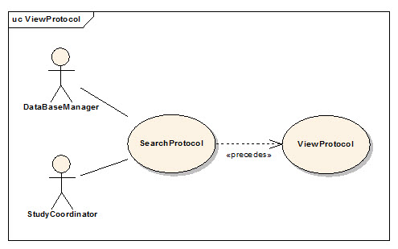

Brief Description
This use-case deals with viewing a study.

Primary Actor(s)

Study Coordinator, Site Coordinator and Registrar

Secondary Actor(s)

Admin

Preconditions
- The user is logged in to the system with a user account that has a role authority to view a study definition.

Basic Flow of Events
- The user indicates to the system that he/she wants to search for a given study definition.
- The user enters the search criteria for the study and submits the information to the system.
- The system displays 0, 1 or multiple study definitions depending on the search criteria.
- The user selects a study.
- All data items from the study are displayed

Post Conditions
The user can transition either to edit the use case or export the study use case.

Special Requirements

None

Update Study

Use Case Model
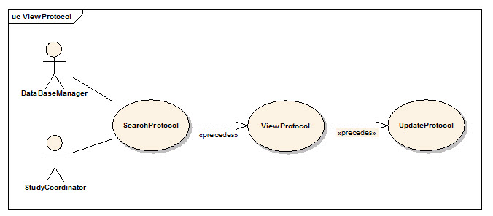

Brief Description
This use-case deals with updating a study entry through the user interface. Note that this is different from a study amendment, which is a metadata item about an official change to a study.

Primary Actor(s)

Study Coordinator

Secondary Actor(s)

Admin

Preconditions
- The user is logged in to the system with a user account that has role authority to update a study definition.

Basic Flow of Events
- The user indicates to the system that he/she wants to search for a given study definition.
- The user enters the search criteria for the study and submits the information to the system.
- The system displays 0, 1 or multiple study definitions depending on the search criteria.
- The user selects a study and views that study.
- The user updates the necessary fields.
- The user saves the updated study information to the system.

Post Conditions
- If the user is logged in to the system with a user account that has role authority to update a study, the study stands updated.

Special Requirements
The "Blinded" and "Multi-Institutional" data fields cannot be updated.

Associate Study Personnel Study

Use Case Model
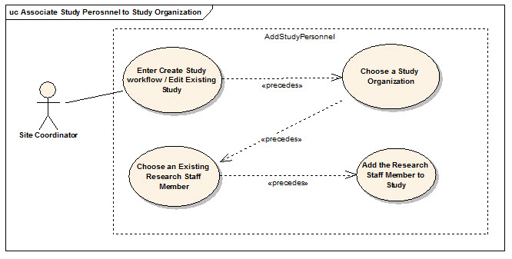

Brief Description
A study, depending on whether it is multi-site study or not can have multiple sites associated with it. Each site can have one or more personnel (Research Staff) involved in conducting the study. This use case deals with associating such staff with a Study. Site Coordinator, during the creation of a study definition, will be able to add one or many of the study personnel for the study.

Primary Actor(s)

Site Coordinator

Secondary Actor(s)

Admin

Preconditions
- The user is logged in to the system with an administrative account that has role authority to add study personnel to the study organization.
- The organization already exists.
- The study exists.
- The intended research staff member already exists at that organization and has an "Active" status for that organization.

Basic Flow of Events
- The user locates the study of interest
- The user indicates that he/she wants to associate study personnel.
- The user selects the desired organization for which the association should take place.
- The user chooses from the list of research staff existing at this organization to be assigned as study personnel
- The user chooses other relevant info for the association
- The user may select more research staff repeating the steps 1-4

Post Conditions
None.

Special Requirements
None.

Add Notifications to Study

Brief Description
A study can have multiple notifications associated with it. Every notification has a Threshold value associated with it. A notification email is sent when the number of registered participants reaches the threshold value. These notifications can be either Email based or Role based. Email based notifications take an email address as input and Role based notifications send emails to all the email addresses in that role for that study.

Primary Actor(s)

Site Coordinator

Secondary Actor(s)

Admin

Preconditions
- The user is logged in to the system with an administrative account that has role authority to add study personnel to the study organization.
- The study already exists.
- The intended roles and e-mail addresses for those roles that already exist in the C3PR system.

Basic Flow of Events
- The user locates the study of interest
- The user indicates that he/she wants to add notifications.
- The user clicks on Add Notifications.
- The user enters a threshold value for which he wants the notification to be sent.
- The user enters an email address by clicking the Add email or selects a role by clicking on AddRole.
- The user may repeat the steps 1-5 as many times as desired.

Post Conditions
The notifications are set up such that when the registered participants reach the threshold value the corresponding email addresses/roles are notified.

Special Requirements
None.

Add Stratification

Use Case Model
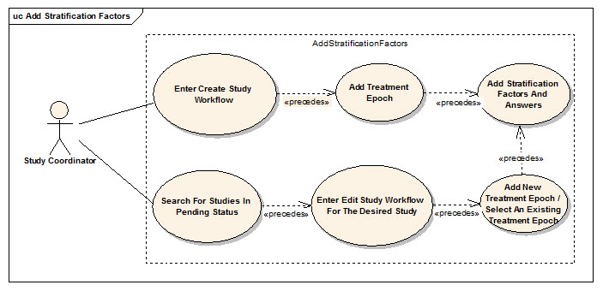

Brief Description
Studies can have one or more stratification factors. Each stratification factor consists of a question and two or more discreet answers. The answers for a particular Subject on a Study determine the stratum group for the Study Subject. The stratum group can be used to help determine the arm during randomization.

Primary Actor(s)
Study Coordinator: defines the stratification when defining the study.

Secondary Actor(s)

Admin

Preconditions
- The user is in the study creation or update workflow

Basic Flow of Events: Study Definition
- The user enters the stratification portion of the study definition workflow
- The user adds zero or more stratification factors
- The user defines the question text for each stratification factor
- The user defines one or more discreet answers for each stratification factor
- The system saves the stratification factors

Basic Flow of Events: Subject Registration
- The user enters the registration workflow
- The user navigates to the stratification tab
- The user answers each stratification factor question via drop-down menus
- The stratum group is displayed when then final stratification factor is answered
- The system saves the stratum group

Post Conditions
The system is ready to create a stratum group now.

Special Requirements
None.

Disable a Stratum Group

Use Case Model
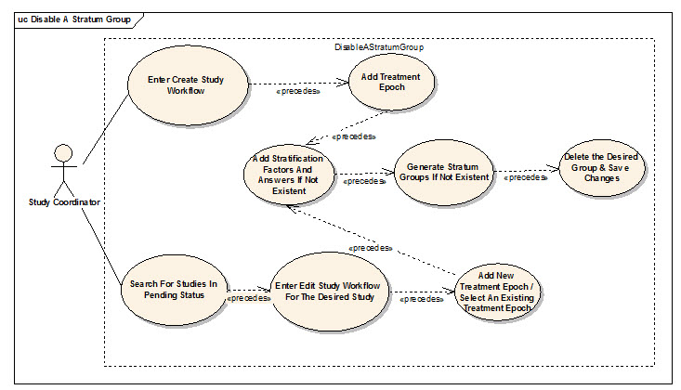

Brief Description
Studies can have one or more stratification factors. Each stratification factor consists of a question and two or more discreet answers. The different combinations of all the questions along with the possible answers constitute the stratum groups. All stratum groups may not be important or valid for the study. This use case deals with disabling an invalid group.

Primary Actor(s)

Study Coordinator and Site Coordinator

Secondary Actor(s)

Admin

Preconditions
- The user is in the study creation or update workflow.
- The study is either newly created or is in pending status.

Basic Flow of Events: Study Definition
- The user enters the stratification portion of the study definition workflow
- The user adds one or more stratification factors if they do not already exist.
- The user defines the question text for each stratification factor.
- The user defines one or more discreet answers for each stratification factor
- The user indicates to the system to generate the stratum groups if they do not already exist or if he/she updates any stratification questions and/or answers.
- The user deletes the desired stratum group.
- The user indicates to the system to update/save the study.

Post Conditions
- The stratum group will be deleted.
- If the study has book randomization, the book randomization entries have to be updated to remove the entries for the deleted stratum group.

Special Requirements
None.

Add Eligibility Criteria

Use Case Model
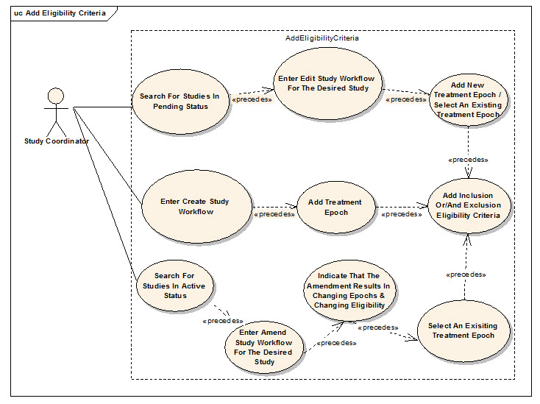

Brief Description
Studies can have one or more Eligibility Criterion. These are further classified as Inclusion and Exclusion Eligibility criteria. The user can add new eligibility criteria to any treatment epoch. This use case helps add new eligibility criteria in 3 different ways depending on the business requirement.

Primary Actor(s)

Study Coordinator and Site Coordinator

Secondary Actor(s)

Admin

Preconditions
- The user is in the study creation or update workflow

Basic Flow of Events: Create Study
- The user enters the eligibility portion of the study definition workflow.
- The user identifies the treatment epoch for which eligibility criteria needs be added.
- The user adds one or more inclusion or/and exclusion criterion.
- The user updates the study to save the newly added eligibility questions.

Alternate Flow (Load caDSR):
- The user enters the eligibility portion of the study definition workflow.
- The user selects the treatment epoch for which eligibility criteria needs be added from a dropdown.
- The user adds clicks on the browse button and selects the file to be uploaded.
- The user clicks the upload button.
- The user can now add to or modify the uploaded contents.

Basic Flow of Events: Edit Study
- If the desired study is saved in a pending status, the user enters the search criteria and searches for the desired study.
- The user selects the desired study and enters the edit workflow.
- The user enters the eligibility portion of the study.
- The user identifies the treatment epoch for which eligibility criteria needs to be added.
- The user adds one or more inclusion/exclusion eligibility criterion.
- The user updates the study to saves the newly added eligibility questions.

Basic Flow of Events: Amend Study
- If the desired study is saved in an active status, the user enters the search criteria and searches for the desired study.
- The user selects the desired study and enters the amend study workflow.
- The user indicates that treatment epoch and eligibility change as a result of the amendment.
- The user enters the eligibility portion of the study.
- The user identifies the treatment epoch for which eligibility criteria needs to be added.
- The user adds one or more inclusion/exclusion eligibility criterion.
- The user updates the study to saves the newly added eligibility questions.

Post Conditions
The new eligibility criteria is added to the study.

Special Requirements
None.

Add Diseases

Use Case Model
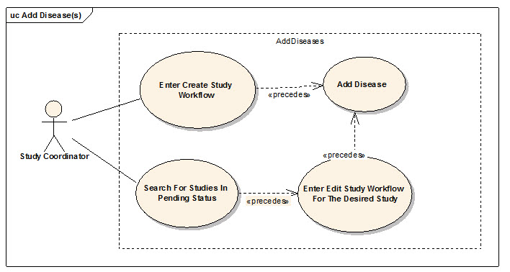
Registration Flow
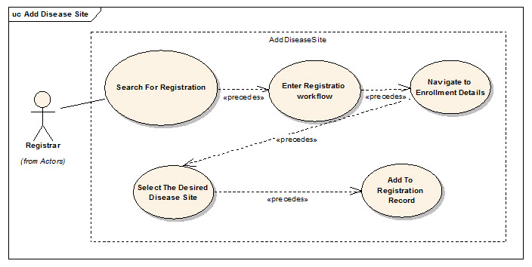

Brief Description
Studies can have one or more diseases associated with them. These diseases are used during Registration to allow the user to select a disease for a Study Subject. The user will also be able to select a primary disease site for the Study Subject. There are a number of different disease and disease site nomenclatures used in the community. C3PR will initally provide the CTEP diseases and disease sites.

Primary Actor(s)

Study Coordinator: defines the disease sites when defining the study
Registrar: registers a subject to a study and, in doing so, defines the disease and disease site for the subject.

Secondary Actor(s)

None

Preconditions

None

Basic Flow of Events
- The user enters the disease portion of the study definition workflow.
- The user adds one or more diseases.

Basic Flow of Events: Subject Registration
- The user enters the registration workflow.
- The user navigates to the disease tab.
- The user selects a disease or enters a free-text disease.
- The user selects a disease site or enters a free-text disease site.

Post Conditions
- A new disease and disease site are associated with the study.

Alternate Flow

None

Special Requirements

None

Change Status from Pending to Open

Use Case Model
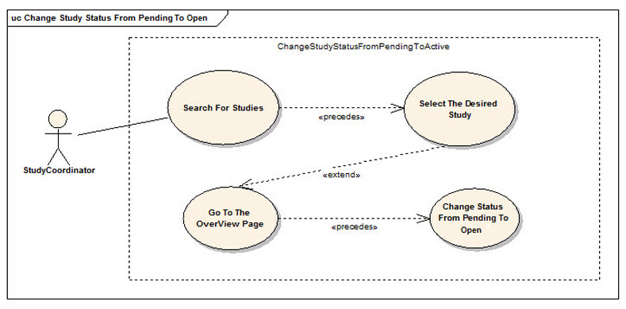

Brief Description
A new study entered into c3pr using the User Interface can be saved in a pending status. All the studies need at least one study site and one enrolling epoch and other basic data to be considered as data entry complete (which is system derived). The study has to go through a curation phase or a quality analysis check before the study coordinator or site coordinator reviews and can set the study status to open. This use case deals with this scenario.

Primary Actor(s)

Study Coordinator

Secondary Actor(s)

Admin

Preconditions
- The user is logged in to the system with a user account that has role authority to update study status from Pending to Open.
- The study is in a Pending status.

Basic Flow of Events
- The user indicates to the system that he/she wants to search for a given study definition.
- The user enters the search criteria for the study and submits the information to the system.
- The system displays 0, 1 or multiple study definitions depending on the search criteria.
- The user selects a study and views its summary.
- The user updates the study definition or any part of the study in the edit flow if required.
- The user updates the study status from Pending to Open.

Post Conditions
- If the user is logged in to the system with a user account that has role authority to update study status, the study status is updated from Pending to Open.

Special Requirements
- The system requires at least one study site.
- The system requires at least one enrolling epoch.

Change Status from Amendment Pending to Open

Use Case Model
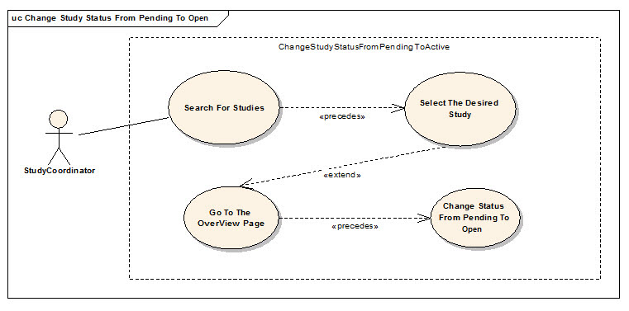

Brief Description
A study in an open status can be modified through an amendment. Once an amendment is anticipated or initiated, the user captures the study amendment information. However, at this stage the user may not have sufficient information to completely capture all the required information or the amendment may not have IRB approval yet. At this stage the system automatically puts the study in an Amendment Pending status. The study has to go through a quality analysis check before the study coordinator or site coordinator reviews and can update the study status from Amendment Pending to Open. This use case deals with this scenario.

Primary Actor(s)
Study Coordinator, Site coordinator or any other user of C3PR with role authority to update the status of a study to Open.

Secondary Actor(s)
None.

Preconditions
- The user is logged in to the system with a user account that has role authority to update study status from Amendment Pending to Open.
- The study is in an Amendment Pending status.

Basic Flow of Events
- The user indicates to the system that he/she wants to search for a given study definition.
- The user enters the search criteria for the study and submits the information to the system.
- The system displays 0, 1 or multiple study definitions depending on the search criteria.
- The user selects a study and views its summary.
- The user goes through the amendment workflow and updates any information if required.
- The user updates the study status from Amending Pending to Active

Post Conditions
- If the user is logged in to the system with a user account that has role authority to update study status, the study status is updated to Open.

Extension
- If this is a multi-site study that is shared across more than one organization, the user indicates to the system that the modified information must be broadcast to all participating organization sites.

Special Requirements

None

Update Study Definition

Use Case Model
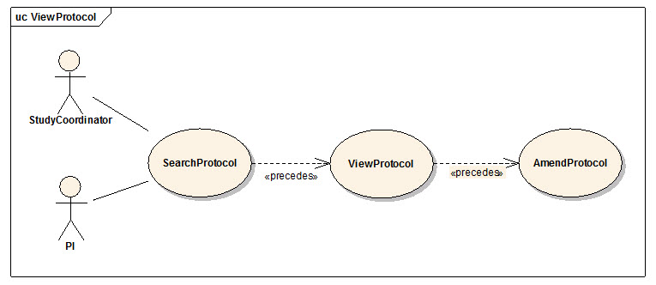

Brief Description
This use-case deals with amending a current study definition.

Primary Actor(s)

Study Coordinator

Secondary Actor(s)
None.

Preconditions
- The user is logged into the system with a user account that has role authority to amend a study definition.
- The study is in an active status.

Basic Flow of Events
- The user indicates to the system that he/she wants to search for a given study definition.
- The user enters the search criteria for the study and submits the information to the system.
- The system displays 0, 1 or multiple study definitions depending on the search criteria.
- The user selects the study definition for which he/she wants to amend.
- The user indicates to the system that he/she wants to make an amendment.
- The user enters the amendment data items

Post Conditions
The study definition has been amended.

Alternate Flow
None.

Special Requirements
None.

Update Study Protocol Version

Use Case Model

Brief Description
The study protocol version can be updated by amending a study with an open status. Once an update to the study site protocol version is anticipated or initiated, the user captures the information needed to update the protocol version. However, at this stage the user may not have completely captured all the required information or the update to the protocol version may not have IRB approval yet. At this stage the system automatically puts the update to the study in an Amendment Pending status. The update to the protocol version has to go through a quality analysis check before the study coordinator or site coordinator can update the study protocol version. This use case deals with this scenario.

Primary Actor(s)
Study Coordinator, Site coordinator or any other user of C3PR with role authority to update the status of a study.

Secondary Actor(s)
None.

Preconditions
- The user is logged in to the system with a user account that has role authority to update study status from Amendment Pending to Open.

Basic Flow of Events
- The user indicates to the system that he/she wants to search for a given study definition.
- The user enters the search criteria for the study and submits the information to the system.
- The system displays 0, 1 or multiple study definitions depending on the search criteria.
- The user selects a study and views its summary.
- The user goes through the amendment workflow and updates information for the protocol version update.
- After a quality analysis check of the protocol version update has been performed and IRB approval has been received, the user updates the study status from Amending Pending to Open.

Post Conditions
- If the user is logged in to the system with a user account that has role authority to update study status, the study protocol version is updated.

Extension
- If this is a multi-site study that is shared across more than one organization, the user indicates to the system that the modified information must be broadcast to all participating organization sites.

Manage Registration

Register a New Subject

Use Case Model
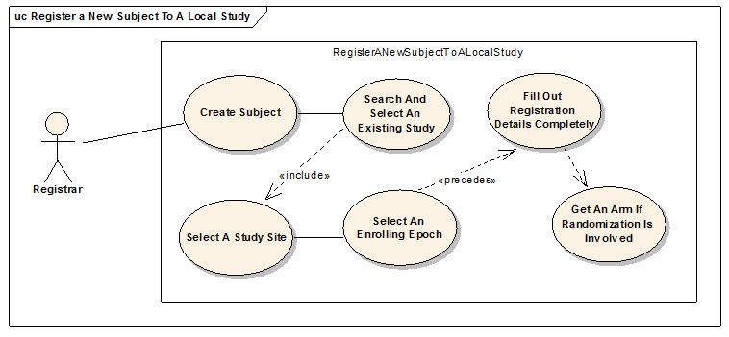

Brief Description
This use case will allow the user to register a subject not currently in the C3PR system to a study. The user will be required to enter subject information before completing the registration.

Primary Actor(s)
Registrar or any other designated user of C3PR with role authority to register a Subject.

Secondary Actor(s)
None.

Preconditions
- The Study already exists.
- Any hard accrual limits are not exceeded.
- The Study is in Active status.
- The study has an enrolling epoch.
- The subject does not already exist in the system.
- The subject meets the eligibility criteria for the enrolling epoch.

Basic Flow of Events
- The user enters create registration workflow
- The user creates a new subject.
- The user searches and selects the desired study
- The user selects a study site
- The user selects an enrolling epoch from the selected study.
- The system alerts the user of any soft accrual limits.
- The system alerts the user if the subject is already registered to the same study.
- The user fills out the enrollment details completely.
- If the study involves Randomization, the user indicates to the system that he/she wants to randomize

Post Conditions
- If the enrolling epoch involves randomization, an arm is successfully obtained.
- If the user was logged in to the system with a role authority to register a subject, the subject is registered to the study.

Alternate Flow
None.

Special Requirements
None.

Register Subject to Multi-site Study

Use Case Model
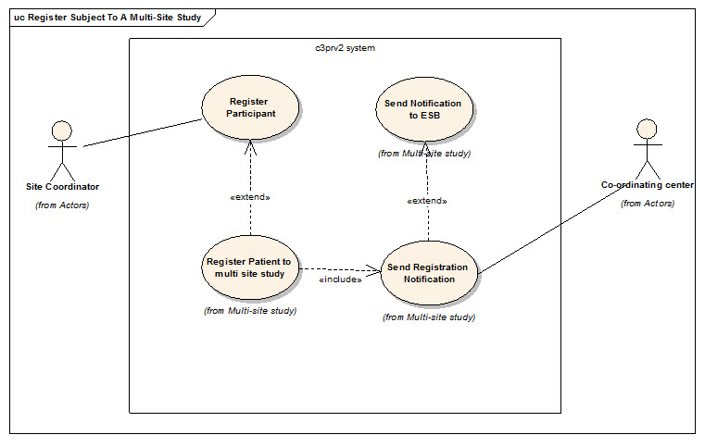

Brief Description
The user must first create a registration in the appropriate study site before they can enroll a subject. This use case will explain how the user can create a registration in a study site in a multi-site study. In order to register a subject to a study site of a multi-site study the study must already exist the system and have an Open status. Once the registration has been created go to the Enroll Subject to Study Site use case and follow the steps to complete the registration of a subject.

Primary Actor(s)

Registrar

Secondary Actor(s)

Admin

Preconditions
- The user is logged in to the system with a user account that has role authority to register a Subject.
- The Study already exists.
- Any hard accrual limits are not exceeded.
- The Study is in Active status.
- The study has an enrolling epoch.
- The subject meets the eligibility criteria for the enrolling epoch.

Basic Flow of Events
- The user enters create registration workflow
- The user searches and selects the desired multi-site study
- The user selects the desired study site
- The user selects an enrolling epoch from the selected study.
- The system alerts the user of any soft accrual limits.
- The system alerts the user if the subject is already registered to the same study.
- The user fills out the enrollment details completely.
- The system sends the registration notification fo the ESB.
- The ESB sends the registration notification to the coordinating center for approval.
- The system gets back either an approval or a disapproved message back from the coordinating center.

Post Conditions
- If the subject meets eligibility criteria, he/she is successfully registered.
- If the enrolling epoch involves randomization, an arm is obtained.

Alternate Flow
None.

Special Requirements
None.

Enroll Subject to a Study Site

Use Case Model

Brief Description
This use case will explain how the user can enroll a subject to a study site in a multi-site study after they have created the registration. The user must first create a registration in the appropriate study site before they can enroll a subject. Once the steps in the Register Subject to Multi-site Study use case have been completed the user can follow the steps in this use case to enroll a subject in the registration of a study site.

Primary Actor(s)
Registrar or any other designated user of C3PR with role authority to register a Subject.

Secondary Actor(s)

None

Preconditions
- Registration is pending
- Randomization of study subjects is complete

Basic Flow of Events
- The user searches and selects the desired study
- The user enters create registration workflow and broadcasts the registration
- The user changes the status of an existing subject.
- The user selects an enrolling epoch from the selected study.
- The system alerts the user of any soft accrual limits.
- The system alerts the user if the subject is already registered to the same study.
- The user fills out the enrollment details completely.

Post Conditions
- If the user was logged in to the system with a role authority to register a subject, the subject is registered to the study.

Alternate Flow
None.

Special Requirements
None.

Transfer Epoch to Study Site of Multi-site Study

Use Case Model

Brief Description
Before you can transfer subjects from one epoch to another you must first transfer the epoch to the appropriate study site in the multi-site study. In this use case an epoch is changed in the system to be stored in a study site.

Primary Actor(s)

Study Coordinator

Secondary Actor(s)

Admin

Preconditions
- The user is logged in to the system with a user account that has role authority to register a Subject.

Basic Flow of Events
- The user searches for the appropriate study
- The user selects the study to edit it
- The user selects or adds the appropriate epoch
- The user broadcasts the epoch to study sites

Post Conditions
- The epoch is now stored in the appropriate study site of the multi-site study.

Alternate Flow
None.

Special Requirements
None.

Assign Subject to New Epoch in Study Site

Use Case Model

Brief Description
Subjects can be assigned to an epoch in a study site after the epoch has been transferred to the study site of a multi-site study. You will need to change the registration status of the subject and broadcast the information to the study sites associated with the multi-site study. In this use case a subject is assigned to an epoch in a study site of a multi-site study.

Primary Actor(s)

Study Coordinator

Secondary Actor(s)

Admin

Preconditions
- The user is logged in to the system with a user account that has role authority to register a Subject.
- If randomization is selected for the study then randomization of the subjects must be complete

Basic Flow of Events
- The user searches for the appropriate study
- The user selects the study to edit it
- The user selects or adds the appropriate subject
- The user broadcasts to study sites

Post Conditions
- The subject is now assigned to the appropriate epoch of the multi-site study.

Alternate Flow
None.

Special Requirements
None.

Register Existing Subject to a Study

Use Case Model
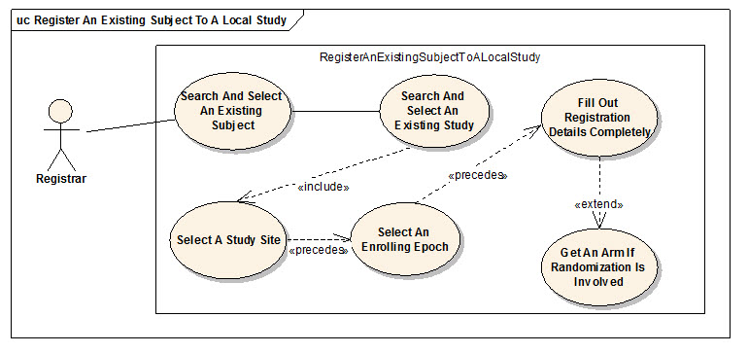

Brief Description
This use case will allow the user to register a subject not currently in the C3PR system to a study. The user will be required to enter subject information before completing the registration.

Primary Actor(s)

Registrar

Secondary Actor(s)

Admin

Preconditions
- The user is logged in to the system with a user account that has role authority to register a Subject.
- The Study already exists.
- Any hard accrual limits are not exceeded
- The Study is in Active status.
- The study has an enrolling epoch.
- The subject already exists and meets the eligibility criteria required by the enrolling epoch.

Basic Flow of Events
- The user enters create registration workflow
- The user searches and selects the desired subject.
- The user searches and selects the desired study
- The user selects a study site
- The user selects an enrolling epoch from the selected study.
- The system alerts the user of any soft accrual limits.
- The system alerts the user if the subject is already registered to the same study.
- The user fills out the enrollment details completely.
- If the study involves Randomization, the user indicates to the system that he/she wants to randomize

Post Conditions
- The randomization process successfully returns an arm.
- If the user was logged in to the system with a role authority to register a subject, the subject is registered to the study.

Alternate Flow
None.

Special Requirements
None.

Assign Kit Number for Blinded Study

Use Case Model
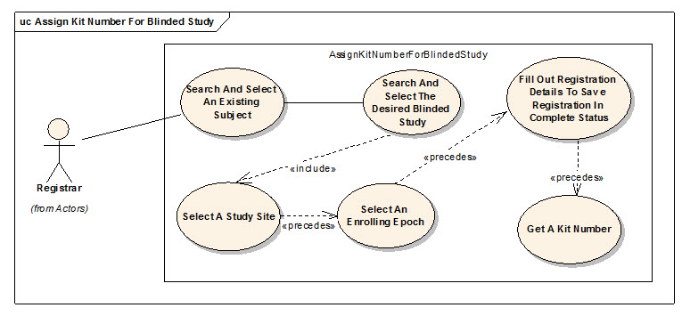

Brief Description
This use case will allow the user to register a subject to a blinded study and obtain a kit number.

Primary Actor(s)

Registrar

Secondary Actor(s)

Admin

Preconditions
- The user is logged in to the system with a user account that has role authority to register a subject.
- The blinded Study already exists.
- Any hard accrual limits are not exceeded
- The Study is in Active status.
- The study has an enrolling epoch.
- The subject already exists and meets the eligibility criteria required by the enrolling epoch.

Basic Flow of Events
- The user enters create registration workflow
- The user searches and selects the desired subject.
- The user searches and selects the desired blinded study
- The user selects a study site
- The user selects an enrolling epoch from the selected study.
- The system alerts the user of any soft accrual limits.
- The system alerts the user if the subject is already registered to the same study.
- The user fills out the enrollment details completely.
- The user indicates to the system that he/she wants to obtain a kit number.

Post Conditions
#If the subject is eligible and no hard accrual limits are exceeded, a kit number is obtained.

Alternate Flow
None.

Special Requirements
None.

Save a Registration in Incomplete Status

Use Case Model
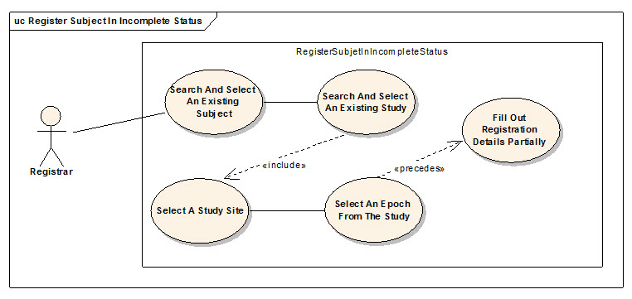

Brief Description
This use case allows the user to select a study and select a subject and without entering other details, save the information in an incomplete status. Users can then search for the registration and complete the information and the registration will either go on pending status if it requires some approval, if it's a multi site study or it can be accepted as a complete registration.

Primary Actor(s)

Registrar

Secondary Actor(s)

Admin

Preconditions
- The user is logged in to the system with a user account that has role authority to register a Subject.
- The Study already exists.
- Any hard accrual limits are not exceeded
- The Study has an Active status.
- The Subject is not already registered to the same Study.

Basic Flow of Events
- The user enters create registration workflow
- The user searches and selects the desires subject.
- The user searches and selects the desired study
- The user selects a study site
- The user selects an epoch from the selected study.
- The system alerts the user of any soft accrual limits.
- The system alerts the user if the subject is already registered to the same study.
- The user fills out the enrollment details incompletely i.e. either the treating physician is not entered or eligibility is not met or Informed Consent Version or Date is not valid.

Post Conditions
- The registration is saved in an incomplete status if no hard accrual limits are exceeded or the subject is not already registered to the same study site.

Alternate Flow
None.

Special Requirements

None.

Register Subject to Reservation Study

Use Case Model
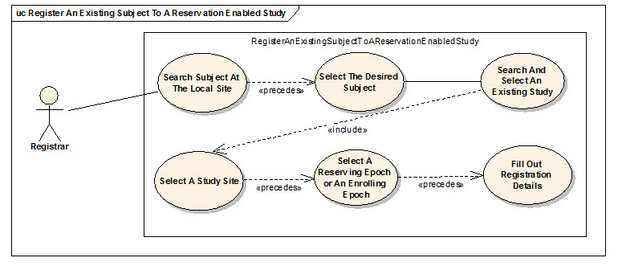

Brief Description
- In some Phase I studies, there are very small number of accrual slots.
- It is important that someone can be registered to the study, get worked up, and then potentially be removed from the study.
- This type of "reservation" allows the next candidate to take the originally registered slot.
- This differs from most studies, where the de-registered slot is "lost" - the next subject is registered to the next slot.

Primary Actor(s)

Registrar

Secondary Actor(s)

Admin

Preconditions
- The user is logged in to the system with a user account that has role authority to reserve a spot on the study.
- The Study already exists.
- Any hard accrual limits are not exceeded
- The Study is in Active status.
- The study has a reserving or enrolling epoch.
- The subject already exists.

Basic Flow of Events
- The user enters create registration workflow
- The user searches and selects the desired subject.
- The user searches and selects the desired study.
- The user selects a study site.
- The user selects a reserving or an enrolling epoch from the selected study.
- The system alerts the user of any soft accrual limits.
- The system alerts the user if the subject is already registered to the same study.
- The user fills out the enrollment details.

Post Conditions
- The subject is reserved a spot on the study.

Alternate Flow
None.

Special Requirements
None.

Search for Registrations

Use Case Model
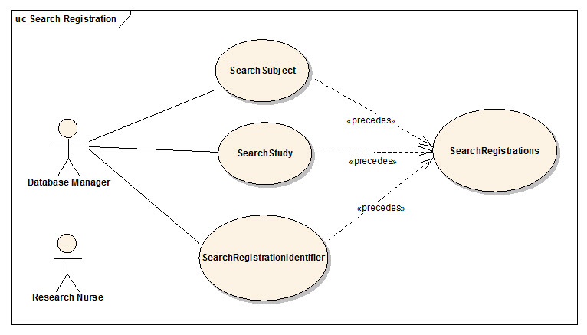

Brief Description
This use-case deals with searching for registrations. Reasons for searching for registrations include:
- Looking for duplicate registrations
- View registration history
- Check for eligibility requirements
- Check registration status
- Modify a registration
- To assign a subject to a randomized arm

Primary Actor(s)

Study Coordinator, Site Coordinator and Registrar

Secondary Actor(s)

Registrar

Preconditions
- The user is logged in to the system with a user account that has role authority to search for a registration.

Basic Flow of Events
- The user indicates to the system that he/she wants to search for registrations.
- The system displays a 2-step search process. The user first searches for a subject, study or a registration identifier based on subject search criteria, study search criteria or the registration identifier value respectively.
- The user then searches for the registrations based on the selected subject, study or registration identifier
- The system displays 0, 1 or multiple registrations depending on the search criteria.

Post Conditions
- The resulting registration list is in a state that the user can transition to any of the manage registration use cases like completing, updating eligibility, assigning to a randomized arm, updating registration status etc. This means sufficient detail is presented to the user in order to determine which registration to transition to.

Alternate Flow
None.

Special Requirements

None.

View Subject Registration History

Use Case Model
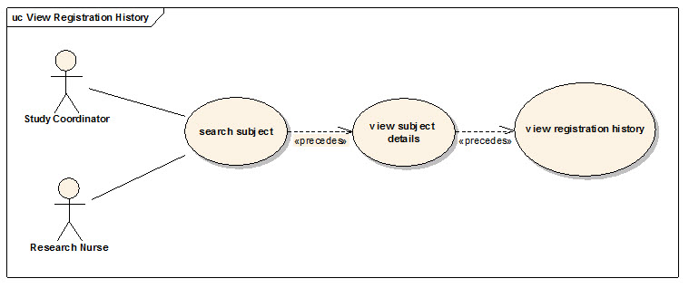

Brief Description
This use case allows the user to view registration details of a subject.

Primary Actor(s)
Registrar, Site Coordinator, CRA or any other designated user of C3PR with role authority to view a registration.

Secondary Actor(s)

Registrar

Preconditions
- The subject is already registered to a study at a particular healthcare site.
- The user is logged into the system with a user account that has role authority to view registration details.

Basic Flow of Events
- The user searches for a given subject.
- The user selects desired subject to view the subject details.
- The user indicates that he/she wants to view the desired registration from a list of registrations the subject is on.
- The user can choose to view registration details, eligibility status, registration status, stratification factors, randomization arm, and registration identifiers.

Post Conditions
#The registration details have been viewed by the user.

Alternate Flow
None.

Special Requirements
None.

Update Eligibility Status for Registration

Use Case Model
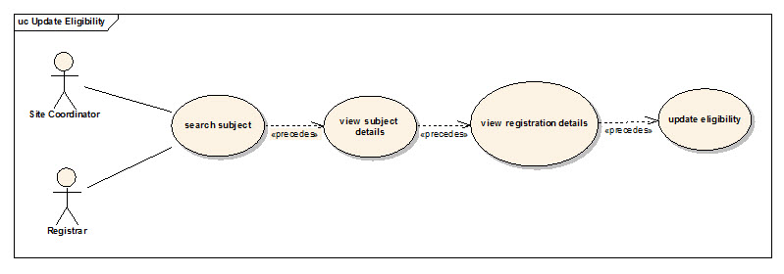

Brief Description
This use case allows the user to update eligibility status of a subject on a given registration.

Primary Actor(s)

Registrar

Secondary Actor(s)

Admin

Preconditions
- The subject is already pre-registered to a study at a particular healthcare site.
- The user is logged into the system with a user account that has role authority to update eligibility status of a subject on a given study.

Basic Flow of Events
- The user searches for a given subject.
- The user selects desired subject to view the subject details.
- The user indicates that he/she wants to view the desired registration details from a list of registrations the subject is on.
- The user indicates that he/she wants to view the eligibility of the subject on the given study by selecting the eligibility tab.
- The user can change the eligibility of the subject and indicates to the system that he/she wants to save the new eligibility status.

Post Conditions
- If the user had the role authority to update eligibility of the subject on the given study, the registration status is updated if eligibility is met.

Alternate Flow
None.

Special Requirements

None.

Randomize Subject

Use Case Model
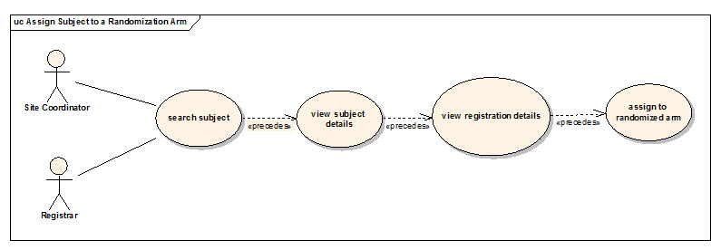

Brief Description
This use case allows the user to assign a subject to an arm.

Primary Actor(s)

Registrar

Secondary Actor(s)

Admin

Preconditions
- The subject is already registered to a study at a particular healthcare site.
- The user is logged into the system with a user account that has role authority to assign a subject to a randomized arm on a given study.

Basic Flow of Events
- The user searches for a given subject.
- The user selects desired subject to view the subject details.
- The user indicates that he/she wants to view the desired registration details from a list of registrations the subject is on.
- The user indicates that he/she wants to view the randomization information of the subject on the given study by selecting the randomization tab.
- The user selects the desired arm to which the subject is to be assigned indicates to the system that he/she wants to save the arm.

Post Conditions
- If the user has the role authority to assign the subject to a randomized arm on the given study, the subject is assigned to a randomized arm.

Alternate Flow
None.

Special Requirements
None.

Take Subject Off Study

Use Case Model

Brief Description
This use case allows the user to update the registration status of a subject on a given study.

Primary Actor(s)
Site Coordinator, CRA, or any other designated user of C3PR with role authority to update the registration status on a given study.

Secondary Actor(s)

Registrar

Preconditions
- The subject is pre-registered to a study at a particular healthcare site.
- The user is logged into the system with a user account that has role authority to update registration status for a subject on a given study.

Basic Flow of Events
- The user searches for a given subject.
- The user selects desired subject to view the subject details.
- The user indicates that he/she wants to view the desired registration details from a list of registrations the subject is on.
- The user indicates that he/she wants to view the registration status of the subject on the given study by selecting the registration tab.
- The user selects the desired registration status and indicates to the system that he/she wants to save the status.

Post Conditions
- If the user has the role authority to change registration status of the subject on the given study, the registration status of the subject stands changed.

Alternate Flow
None.

Special Requirements

None.

Unblind Registered Subject

Use Case Model 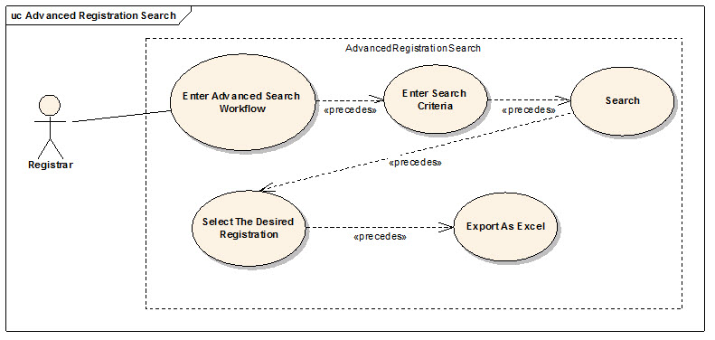Brief Description
This use case allows the user to update the registration status of a subject on a given study.

Primary Actor(s)

Site Coordinator, Study Coordinator and Registrar

Secondary Actor(s)

Admin

Preconditions
1. The user is logged in to the system with an account that has permission to search registrations.

Basic Flow of Events

The user enters the desired search criteria. The four criteria are: Study, Site, Registration and Subject

The user retrieves the corresponding registrations.

The user downloads the table in the .xls format. The user searches for a given subject.

Post Conditions
- If the user has the role authority to change registration status of the subject on the given study, the registration status of the subject stands changed.
- This table provides a export as excel button which lets the user download the table contents in excel format.

Alternate Flow
None.

Special Requirements

None.

Reporting

Advanced Registration Search

Use Case Model
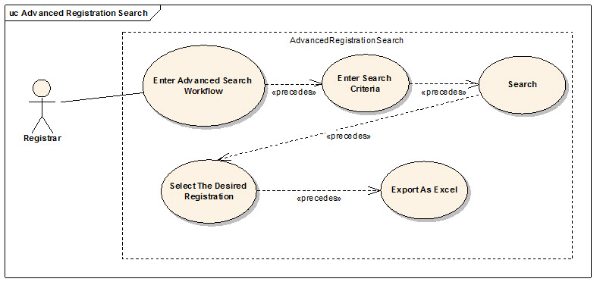

Brief Description
This use case allows the user to enter information in 4 different kinds of criteria and run a registrations search. The search results table also allows the user to download the results in .xls format.

Primary Actor(s)

Site Coordinator, Study Coordinator and Registrar

Secondary Actor(s)

Admin

Preconditions
- The user is logged in to the system with an account that has permission to search registrations.

Basic Flow of Events
- The user enters the desired search criteria. The four criteria are: Study, Site, Registration and Subject.
- The user retrieves the corresponding registrations.
- The user downloads the table in the .xls format.

Post Conditions
- The search results are displayed in a table on the same page.
- This table provides a export as excel button which lets the user download the table contents in excel format.

Alternate Flow
None.

Special Requirements
None.

Study Search and Export

Use Case Model
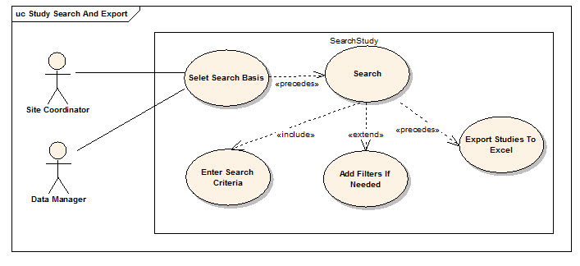

Brief Description
This use case allows the user to search for studies and export the search result as an excel file.

Primary Actor(s)

Site Coordinator, Study Coordinator and Registrar

Secondary Actor(s)

Admin

Preconditions
- The user is logged in to the system with appropriate privileges
- One or more studies must exist in the C3PR database

Basic Flow of Events
- The user enters the desired search criteria. The user can search on 3 criteria's: Study # # Identifiers, Study Short Title and Study Status
- The system retrieves the corresponding studies
- The user downloads the table in the .xls format.

Post Conditions
- The search results are displayed in a table on the same page.
- This table provides a export as excel button which lets the user download the table contents in excel format.

Alternate Flow
None.

Special Requirements

None.

Administration

Create Investigator

Use Case Model
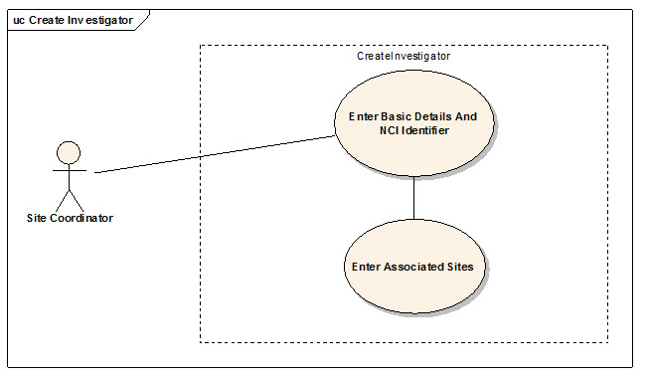

Brief Description
This use-case deals with the manual creation of an Investigator at the specified healthcare sites by entering each data element of the investigator.

Primary Actor(s)

Site Coordinator

Secondary Actor(s)

Admin

Preconditions
- The user is logged in to the system with an administrative account that has role authority to create an investigator.
- The investigator doesn't already exist.

Basic Flow of Events
- The user indicates to the system that he/she wants to perform an administrative task
- The user indicates to the system that he/she wants to create an investigator.
- The system displays the screen that gives the user option of entering the investigator information manually.
- The user enters the Investigator data elements in the fields.
- The user indicates to the system that the required investigator information has been entered for creation of a new investigator.

Post Conditions
- If the user is logged in to the system with a user account that has administrative privileges to create an Investigator (for example, a System Administrator), the created Investigator is approved.

Alternate Flow
None.

Special Requirements

None.

Add Investigator Group

Use Case Model
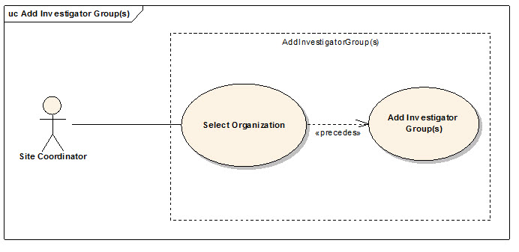

Brief Description
This use-case deals with the manual creation of Investigator Groups at a healthcare site.

Primary Actor(s)

Site Coordinator

Secondary Actor(s)

Admin

Preconditions
- The user is logged in to the system with an administrative account that has role authority to create an investigator group.
- The investigator group doesn't already exist.

Basic Flow of Events
- The user indicates to the system that he/she wants to perform an administrative task
- The user indicates to the system that he/she wants to create an investigator group.
- The system displays the screen that gives the user option of selecting an organization and entering the investigator group information manually.
- The user enters the group's data elements in the fields.
- The user indicates to the system that the required investigator group information has been entered for creation of a new investigator group.

Post Conditions
- If the user is logged in to the system with a user account that has administrative privileges to create an Investigator group, the Investigator group is created.

Alternate Flow
None.

Special Requirements
None.

Add Investigator To A Group

Use Case Model
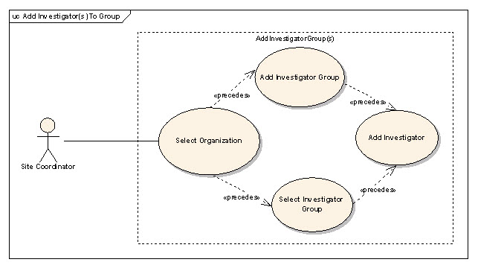

Brief Description
This use-case deals with the manual addition of Investigators to a group at a healthcare site.

Primary Actor(s)

Site Coordinator

Secondary Actor(s)

Admin

Preconditions
- The user is logged in to the system with an administrative account that has role authority to create an investigator group.
- The desired investigator(s) do not already belong to the group.

Basic Flow of Events
- The user indicates to the system that he/she wants to perform an administrative task
- The user indicates to the system that he/she wants to add investigators to a group.
- The system displays the screen that gives the user option of selecting an organization and the desired investigator group.
- The user selects from the list of existing investigators at the organization, those that he/she intends to be add to the group.
- The user indicates to the system to save the new information.

Post Conditions
- If the user is logged in to the system with a user account that has administrative privileges to add Investigators to a group, the Investigators would be added to the group.

Alternate Flow
None.

Special Requirements
None.

Create Research Staff

Use Case Model
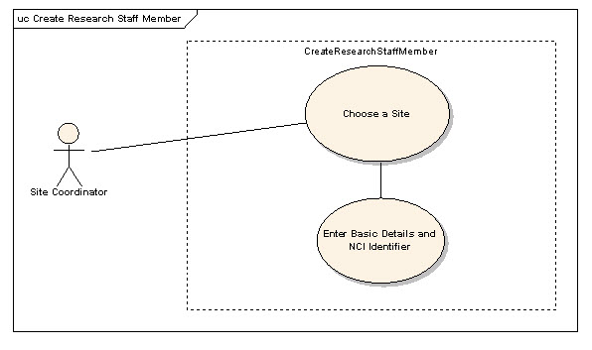

Brief Description
This use-case deals with the manual creation of research staff by entering each data element of the research staff.

Primary Actor(s)

Site Coordinator

Secondary Actor(s)

Admin

Preconditions
- The user is logged in to the system with an administrative account that has role authority to create research staff.
- The research staff member doesn't already exist.

Basic Flow of Events
- The user indicates to the system that he/she wants to do an administrative task
- The user indicates to the system that he/she wants to create a research staff member
- The system displays the screen that gives the user option of entering the research staff member information manually.
- The user enters the research staff member's data elements in the fields.
- The user indicates to the system that the required research staff member information has been entered for creation of a new research staff member.

Post Conditions
#If the user is logged in to the system with a user account that has administrative privileges to create a research staff (for example, a System Administrator), the created research staff member is approved.

Alternate Flow
None.

Special Requirements
None.

Create Organization

Use Case Model
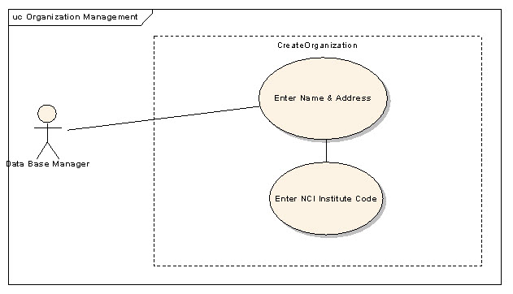

Brief Description
This use-case deals with the manual creation of an Organization by entering organization related data. The user can enter information and select save or select reset tab to clear the entered data.

Primary Actor(s)

Site Coordinator

Secondary Actor(s)

Admin

Preconditions
- The user is logged in to the system with an administrative account that has role authority to create Organization.
- The Organization doesn't already exist.

Basic Flow of Events
- The user indicates to the system that he/she wants to do administrative tasks
- The user indicates to the system that he/she wants to create an Organization.
- The system displays the screen that lets the user enter the Organization information manually.
- The user enters Organization's data elements in the fields.
- The user indicates to the system that the required Organization information has been entered for creation of a new Organization.

Post Conditions
- If the user is logged in to the system with a user account that has administrative privileges to create a research staff (for example, a System Administrator), the created research staff member is approved.

Alternate Flow
None.

Special Requirements
None.

Associate Investigator to Study Organization

Use Case Model
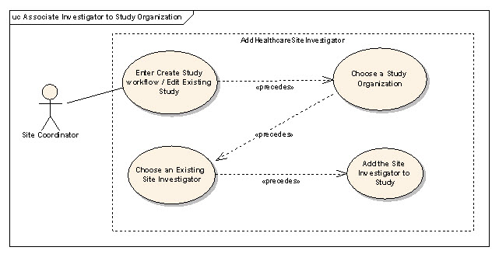

Brief Description
This use case allows the user to associate an investigator to a study organization.

Primary Actor(s)

Site Coordinator

Secondary Actor(s)
None.

Preconditions
- The user is logged in to the system with an administrative account that has role authority to add investigator to a study organization.
- The site already exists.
- The intended investigator already exists at the organization
- The intended investigator does not already exist at that study organization

Basic Flow of Events
- The user enters the create study work flow for a new study or edit study flow for an existing study.
- The user selects the desired site for which the association should take place.
- The user chooses the list of investigators associated for this site to be assigned as study investigator, which is commonly referred to as the enrolling physician.
- The user adds other relevant information for the association.
- The user may select more site investigators repeating the steps 1-4

Post Conditions
None.

Alternate Flow
#Instead of selecting a single Study Investigator, the user selects a group of Investigators.

Special Requirements
None.

Associate Investigator Group to Study Organization

Use Case Model
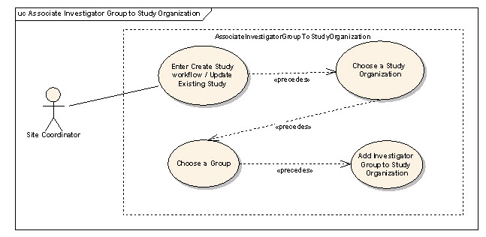

Brief Description
This use case allows the user to associate an investigator group to a study organization

Primary Actor(s)

Site Coordinator and Study Coordinator

Secondary Actor(s)
None.

Preconditions
- The user is logged in to the system with an administrative account that has role authority to add an investigator group to a study organization.
- The study organization already exists.
- The intended group already exists at the organization.
- The study organization does not already have the intended group.

Basic Flow of Events
- The user enters the create study work flow for a new study or update study flow for an existing study.
- The user selects the desired site for which the association should take place.
- The user chooses the investigator group that is intended to be associated to the study organization.
- The user chooses other relevant information for the association.
- The user may select more groups repeating the steps 1-4

Post Conditions
None.

Alternate Flow
- Instead of selecting an investigator group, the user selects a single investigator.

Special Requirements
None.

Search for a Study Personnel

Use Case Model
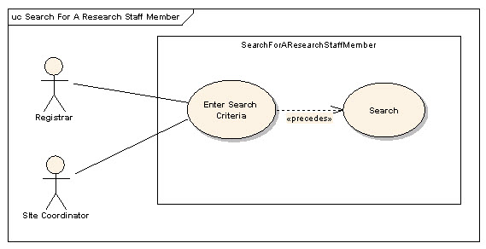

Brief Description
This use case allows the user to search a Study Person (Research Staff Member) depending upon the search criteria. Reasons for searching for a study person include:
- Looking for a duplicate research staff member.
- View research staff member details.
- Update research staff member details.

Primary Actor(s)

Site Coordinator

Secondary Actor(s)

Admin

Preconditions
- The user is logged in to the system with a user account that has role authority to search for a research staff member at the given site.

Basic Flow of Events
- The user indicates to the system that he/she wants to search for a research staff member.
- The user either enters the first name and/or last name and/or the NCI Identifier.
- The user searches for the research staff member by clicking on search.
- The system displays 0, 1 or multiple research staff members matching the search criteria.

Post Conditions
- The resulting research staff member in a state where his/her details can be viewed and updated if the user has the necessary privileges to do so.

Alternate Flow
None.

Special Requirements
None.

View and Update Research Staff Details

Use Case Model
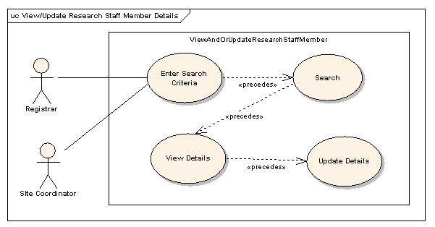

Brief Description
This use case allows the user to view or/and update a Study Person (Research Staff Member) depending upon the search criteria (FN, LN, NCI Identifier). Reasons for this include:
- Looking for a duplicate Research Staff member.
- View Research Staff member details.
- Update Research Staff member details.

Primary Actor(s)

Site Coordinator

Secondary Actor(s)
None.

Preconditions
#The user is logged in to the system with a user account that has role authority to view or/and update details of a Research Staff member at the given site.

Basic Flow of Events
- The user indicates to the system that he/she wants to search for a Research Staff member.
- The user either enters the first name and/or last name and/or the NCI Identifier.
- The user searches for the Research Staff member by clicking on search.
- The system displays 0, 1 or multiple Research Staff members matching the search criteria.
- The user selects the desired Research Staff member whose details he/she wants to see.
- The user views or/and updates the details of that member.

Post Conditions
- The resulting research staff member in a state where his/her details can be viewed and updated if the user has the necessary privileges to do so.

Alternate Flow
None.

Special Requirements
None.

Search for an Investigator

Use Case Model
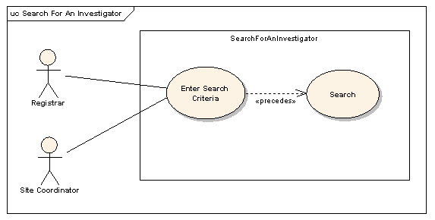

Brief Description
This use case allows the user to search an Investigator. Reasons for searching for an Investigator include:
- Looking for a duplicate Investigator.
- View Investigator details.
- Update Investigator details.

Primary Actor(s)

Site Coordinator

Secondary Actor(s)

Admin

Preconditions
- The user is logged in to the system with a user account that has role authority to search for a Investigator at the given site.

Basic Flow of Events
- The user indicates to the system that he/she wants to search for an Investigator.
- The user either enters the first name and/or last name and/or the NCI Identifier.
- The user searches for the Investigator by clicking on search.
- The system displays 0, 1 or multiple Investigators matching the search criteria.

Post Conditions
- The resulting Investigator in a state where his/her details can be viewed and updated if the user has the necessary privileges to do so.

Alternate Flow
None.

Special Requirements
None.

List Investigators In A Group

Use Case Model
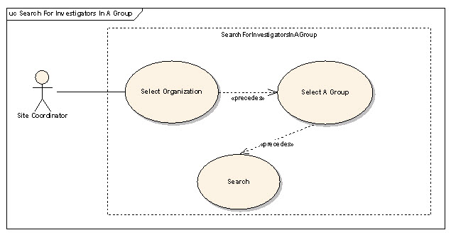

Brief Description
This use-case deals with the search for Investigators in a group at a healthcare site.

Primary Actor(s)
Site coordinator or any other designated user of C3PR with administrative privilege to search for investigators at a given site.

Secondary Actor(s)
None.

Preconditions
- The user is logged in to the system with an administrative account that has role authority to search for investigators.
- The desired group and the healthcare site already exist.

Basic Flow of Events
- The user indicates to the system that he/she wants to perform an administrative task
- The user indicates to the system that he/she wants to search for investigators belonging to a group.
- The system displays the screen that gives the user option of selecting an organization and the desired investigator group at that organization.
- The user indicates to the system that he/she want to search for investigators.
- The system displays all the investigators belonging to the group.

Post Conditions
- If the user is logged in to the system with a user account that has administrative privileges to search for the Investigators, the system displays the information of the investigators belonging to that group

Alternate Flow
None.

Special Requirements
None.

View or Update Investigator Details

Use Case Model
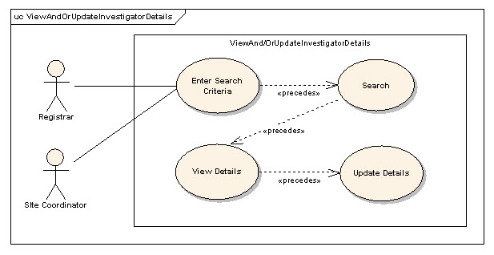

Brief Description
This use case allows the user to view or/and update an Investigator depending upon the search criteria (FN, LN, NCI Identifier). Reasons for this include:
- Looking for a duplicate Investigator member.
- View Investigator member details.
- Update Investigator member details.

Primary Actor(s)

Site Coordinator

Secondary Actor(s)
None.

Preconditions
- The user is logged in to the system with a user account that has role authority to view or/and update details of an Investigator member at the given site.

Basic Flow of Events
- The user indicates to the system that he/she wants to search for a Investigator member.
- The user either enters the first name and/or last name and/or the NCI Identifier.
- The user searches for the Investigator member by clicking on search.
- The system displays 0, 1 or multiple Investigator members matching the search criteria.
- The user selects the desired Investigator member whose details he/she wants to see.
- The user views or/and updates the details of that member.

Post Conditions
- The resulting Investigator member in a state where his/her details can be viewed and updated if the user has the necessary privileges to do so.

Alternate Flow
None.

Special Requirements
None.

Disassociate Study Person from Study Site

Use Case Model
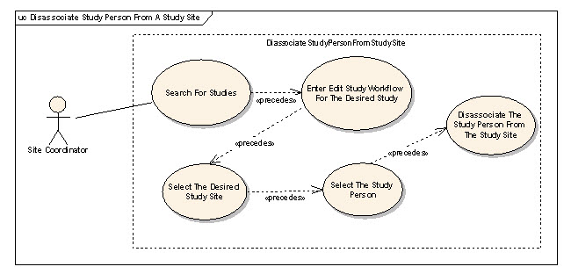

Brief Description
Each study site can have one or more research staff members associated with them. The associated research staff members are called study personnel. These study personnel can be disassociated from the study site. This use case deals with this scenario.

Primary Actor(s)

Site Coordinator and Study Coordinator

Secondary Actor(s)

Admin

Preconditions
- The study person already exists.

Basic Flow of Events
- The user searches for the desired study.
- He/she enters the edit flow of the desired study.
- The user selects a study site at which he/she wishes to disassociate the study person.
- The user indicates to the system that he/she wants to remove the study person.

Post Conditions
- The study person will be successfully disassociated from the study site if the user had privilege to do so.

Alternate Flow
None.

Special Requirements
None.

Change the Study Site Investigator status

Use Case Model
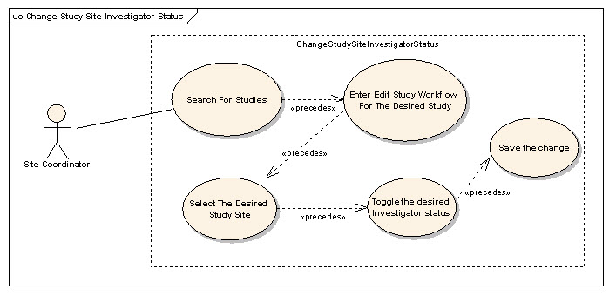

Brief Description
Each study site can have one or more investigators associated with them. The associated investigators' status can be set from Active to Inactive and vice-versa.. This use case deals with this scenario.

Primary Actor(s)

Site Coordinator and Study Coordinator

Secondary Actor(s)

Admin

Preconditions
- The investigator already exists and is associated with the study.

Basic Flow of Events
- The user searches for the desired study.
- He/she enters the edit flow of the desired study.
- The user selects a study site at which he/she wishes to update the investigator status.
- The user toggles the investigator status by selecting the new status.
- The user indicates to the system that he/she wants to save the changes.

Post Conditions
- The status of the study site investigator will be updated if the user had privilege to do so.

Alternate Flow
None.

Special Requirements
None.

Export Study Definition to a File

Use Case Model
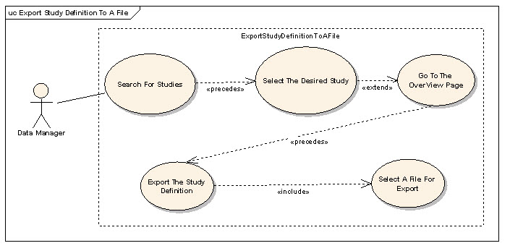

Brief Description
This use-case deals with exporting a Study to a File that can be saved on the users local file system.

Primary Actor(s)

Study Coordinator, Site Coordinator and Registrar

Secondary Actor(s)

Admin

Preconditions
- The user is logged in to the system with a user account that has role authority to view a Study.
- The Study exists in the C3PR database

Basic Flow of Events
- The user searches for a Study
- The user is taken to the Study details page where there is an "Export Study" link.
- The system generates a XML export of the Study definition and the user is asked to save the study on their local system

Post Conditions
None.

Alternate Flow
None.

Special Requirements
User may need special software to view the exported Study XML.

Export Registration Definition to a File

Use Case Model
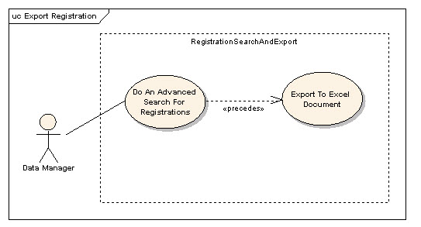

Brief Description
This use-case deals with exporting a Registration to a File that can be saved on the users local file system.

Primary Actor(s)

Registrar, Site Coordinator and Study Coordinator

Secondary Actor(s)
None.

Preconditions
- The user is logged in to the system with a user account that has role authority to view a Registration.
- The Registration exists in the C3PR database

Basic Flow of Events
- The user searches for Registration(s) from the Advanced Search section.
- The user indicates to the system that he/she wants to export the registration to an excel file.
- The system generates a XML export of Registration and the user is asked to save the registration on their local system

Post Conditions
None.

Alternate Flow
None.

Special Requirements
User may need special software to view the exported Registration XML.

Import Study Definition from a File

Use Case Model
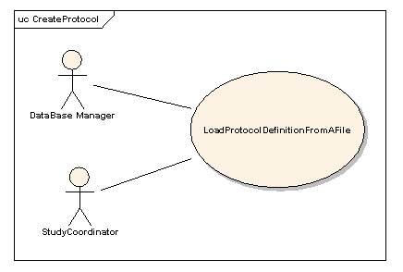

Brief Description
This use-case deals with importing one or more Studies from a file that is on the user's local system.

Primary Actor(s)

Site Coordinator and Admin

Secondary Actor(s)

Admin

Preconditions
- The user is logged in to the system with a user account that has role authority to create a Study.
- The Study definition is in XML format
- The Study definition XML conforms to the C3PR Study XML schema
- The Study Sites that is participating in the Study already exist in C3PR

Basic Flow of Events
- The user indicates to the system that he/she wants to create a new study definition from a file
- The system displays a screen that allows the user to browse their local file system.
- The user selects the appropriate file which contains the information about the study(s) to be loaded into the system.
- After selecting the file, the user indicates to the system to import the study definitions based on the information in the file.
- The system reads the file and validates the file.
- If the file is valid, new study definitions are created.
- The system indicates to the user the status of the import by displaying a list of the newly created Study definitions.

Post Conditions
- The Study definitions that have been imported can be (depending on the users privileges) viewed and edited by the user.

Alternate Flow
None.

Special Requirements
None.

Get Study Definition via Study Message from External Source

Use Case Model
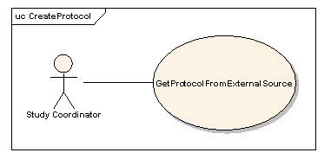

Brief Description
This use-case deals with creation of a Study at the local system after getting/importing it from an external source via a Study Message.

Primary Actor(s)
Study Administrator, Study Coordinator or any other designated user of C3PR with role authority to create a Study.

Secondary Actor(s)
None.

Preconditions
- The user is logged in to the system with a user account that has role authority to create a Study.
- C3PR is configured to receive messages from the external source.

Basic Flow of Events
- The user indicates to the system that he/she wants to create a new study definition
- The system displays a screen that displays the import methods. This screen allows the user to import a new study.
- The study is imported
- If errors occur during the import, they are displayed to the user
- If the study is imported successfully, the user views the study.
- The user checks the study for correctness and updates the study entries to correspond to the local site requirements (IRB approval, accrual ceiling, etc).
- After importing the study, the user confirms the study creation.

Post Conditions
- The imported study waits for further changes/validation with respect to the local site conditions (IRB approval, accrual ceiling, etc) before it is available for use at the local site.

Alternate Flow
- If the study already exists, an error is returned

Alternate Flow
None.

Integration

Synchronize Registration of a Subject on a Study Arm with Study Calendar

Brief Description
This use case essentially deals with propagating the registration information of a subject on a Study Arm created in the C3PR system to Study Calendar system via CTMS Hub.

Primary Actor(s)
Registrar or any other designated user of C3PR with role authority to register a subject on a Study Arm.

Secondary Actor(s)
- CTMS Hub
- Subject Study Calendar (PSC)
- Participant Coordinator

Preconditions

Successful Creation of Study in the Study Calendar system
- The Study definition has been successfully created in the Study Calendar system either manually through the Study Calendar web interface or through a message from the C3PR system (refer to use case 3.5).

Basic Flow of Events
- The system generates a message in a predetermined format containing the new registration information.
- The system then submits the new registration message to the CTMS Hub.
- The CTMS Hub determines where the message needs to be delivered to, which is Study Calendar system in this case.
- The CTMS Hub transforms the new registration message into a message format that the Study Calendar system can process.
- The Study Calendar system processes the new registration message by creating the Subject record, if the Subject does not already exist in the Study Calendar system, and then creates the calendar for the Arm to which the Subject is being registered to.
- After successfully processing the new subject registration message, the Study Calendar system sends an acknowledgment to the CTMS Hub indicating the successful creation of the calendar corresponding to the Arm that the subject is registered on in the Study Calendar system.
- The CTMS Hub sends an email notification indicating the creation of a new calendar for the Arm that the subject is registered on to relevant actors including the Participant Coordinator.

Creation of Subject record in PSC
A new Subject record is created in the Study Calendar system if the Subject does not already exist in it.

Creation of Calendar for the Arm related to the Subject
The calendar for the Arm that the Subject is registered on is created in the study calendar system.

Email Notification
Email notifications are sent to relevant actors indicating the creation of the Subject (optional) and calendar.

Exception Flow
Errors during the normal flow of events in messaging system will trickle back to the user. This could include improperly configured messaging system or errors generated by the target system.

Special Requirements

None

Overall Requirements

Requirements Prioritization

Priority | Use Case Name | Supp Requirement Ref #
1 | Manage Study

Sign Off

Approval

Workspace General Contractor Rep Print Name Date
Architecture Workspace Rep Print Name Date
VCDE Workspace Rep Print Name Date
Workspace Working Group Rep Print Name Date

NCICB Rep Print Name

