C3PR Web Services
Integration Guide

Client : Nation Cancer Institute - Center for Bioinformatics,
National Institutes of Health,
US Department of Health and Human Services

Document History

Document Location
Ensure that this document is current. Printed documents and locally copied files may become obsolete due to changes to the master document. The source of the document is located in NCI CVS at the following path c3pr/docs.

Revision History
Version Number | Revision Date | Author | Summary of Changes
0.1 | 10-25-05 | Charles Griffin | Initial version
0.2 | 10-27-05 | Charles Griffin | Changes after reviews
0.3 | 12-15-05 | Charles Griffin | Add additional descriptions for clarification
1.0 | 12-22-05 | Stephen Reckford | Minor Editorial Changes

Reviews
Name | Team/Role | Version and  Date Reviewed | Reviewer Comments
C3PR Team | Project Team | 10/26/2005 | Suggest changes to format and content.
Christo Andonyadis | NCI, Program Manager | 12-15-2005 | Suggested changes, pointed out areas that needed additional explanations

Reference Documents
Document Name | Version
C3PR Installation Guide
C3PR Use Case Documents
C3PR Web Services Software Architecture Document
C3PR Web Services Security Configuration Document

Table of Contents
1. Introduction 4
1.1. Objective 4
1.2. Technical Summary 4
1.3. Audience 4
1.4. Related Documents 4
1.5. Assumptions 4
2. Getting Started 5
2.1. Step 1: Evaluation and Planning 5
2.2. Step 2: Understand the Interface 5
2.3. Step 3: Data mapping 5
2.4. Step 4: Review Business Process 5
3. Architecture and Planning Guide 6
3.1. Client Side Requirements 6
3.2. Supported Platforms 6
4. Web Services Interface 7
4.1. What It Provides 7
4.2. What It Does Not Provide 7
4.3. C3PR Web Service XML Schema 7
4.3.1. C3PR Schema 7
4.3.2. Change Management 7
4.4. Adding Protocols to C3PR 7
4.5. Amending Protocols in C3PR 10
4.6. Adding Patient Participants to C3PR 12
4.7. Registering Patient Participants to Protocols in C3PR 14
C3PR Web Service Interface “Conversations” 16
5. Web Services Security 17
5.1. Mutual Authentication and SSL 17
5.2. WS-Security and Common Security Module Authorization 17
Appendix A 19
C3PR Contacts 19
FAQ’s 19
Acronyms and Definitions 19
Web Resources on SOAP, WSDL and Other Tools and Technologies 20
Appendix B 21
Static Binding to the C3PR WSDL 21

Introduction

Objective

The objective of this document is to provide C3PR adopters with information on C3PR Web Services. After reading this document, the reader should understand what operations a client application can perform via C3PR Web Services as well as how to utilize and communicate with the C3PR Web Service.

Technical Summary
- Operating System and Software Language Agnostic
- Open-specifications Driven
- W3C standards for Web Services
  - Extensible Markup Language (XML) http://www.w3.org/XML
  - Simple Object Access Protocol (SOAP) http://www.w3.org/TR/soap
  - Hyper Text Transfer Protocol (HTTP) http://www.w3.org/Protocols/
  - Web Services Description Language (WSDL) http://www.w3.org/TR/wsdl
  - WS Security http://www.oasis-open.org/specs/index.php#wssv1.0
- SSL and Mutual Certificate Based Authentication for security

Audience

The audience for this specification includes:
- Project managers
- Software Engineers
- Software Testers
- Other Interested Groups

Related Documents

- C3PR Deployment Guide
- C3PR Use Case Documents
  - C3PR_WebService_AmendProtocols.doc
  - C3PR_WebService_CreatePatients.doc
  - C3PR_WebService_CreateProtocols.doc
  - C3PR_WebService_RegisterPatients.doc
- C3PR Software Architecture Document

Assumptions
- The information exchange is based on web services.
- The communication exchange is based on an agreed upon standard protocol and standard transaction definition.
- Authentication is performed using mutual certificate based authentication.

Getting Started
This document is intended to be the first information you read about C3PR Web Services. This guide will help you determine a strategy on how to integrate C3PR Web Services within your technical environment.

Step 1: Evaluation and Planning
The first step in integrating with C3PR Web Services is determining the deployment location of the C3PR installation.
If you are a C3PR adopter intending to utilize a dedicated instance of C3PR hosted by NCI (behind the NCI firewall) you will need to contact NCICB C3PR program management to discuss:
- Timeframes for deploying a new C3PR instance in the NCICB production environment.
- Setting up mutual certificate based authentication with the systems operations team.
- Configuring the C3PR user authorization policy for the web service client user.
If you are a planning to host a C3PR instance in your local environment, you will need to address the following:
- Contact NCICB program management to arrange support for downloading and installing a version of the C3PR system.
- Determine your security strategy for securing C3PR Web Service messages at the transport level. It is recommended that mutual certificate based authentication be configured at the application or web service layer for point to point system communication.
- Work with NCICB program management to obtain a public/private key pair in order for your local instance of C3PR to communicate with the C3D Web Service hosted at NCICB (assuming you are utilizing the NCICB hosted version of C3D).

Step 2: Understand the Interface

After reading this document, obtain a copy of the C3PR Web Service WSDL document. The WSDL document will inform you what operations can be performed via C3PR Web Services along with describing the format of the content of each message. The C3PR Web Service schema is located in it’s entirety in the WSDL document.

Step 3: Data mapping

The staff of the client application interfacing with the C3PR Web Service will need to perform an exercise to map fields from the application’s data model to the data elements in C3PRs XML schema. The purpose of this exercise is to ensure that the C3PR XML schema is interpreted correctly and the proper data is being sent in the message to the C3PR Web Service.

Step 4: Review Business Process

Understanding when a client application should utilize C3PR Web Service operations is important and should be thoroughly thought through. In many cases, C3PR Web Service operations will be used as part of a data migration from a legacy participant registration system to C3PR with only the CreateProtocol and AmendProtocol operations being utilized after data migration is complete.

Architecture and Planning Guide

Client Side Requirements

This system-to-system interface requires adopter organizations to develop a W3C compliant SOAP client to interact with the C3PR web service interface. Integrators shall comply with the W3C Web Services standards (HTTP, SOAP v1.1, WS-Security BP1, and WSDL). In addition, the client system must support certificate based mutual authentication over 128-bit SSL (mandatory for NCICB hosted C3PR deployment). Table 3.1 lists the specifications required of client systems and their purpose:
Table 3-1 Client Side Specifications
Specification | Purpose/Description | Comments
HTTPS | HTTPS (Hypertext Transfer Protocol over Secure Socket Layer or HTTP over SSL) is a Web protocol that encrypts and decrypts user page requests as well as the pages that are returned by the Web server. HTTPS is the use of SSL (Secure Socket Layer) as a sub-layer under its regular HTTP application layering. | The system-to-system message exchange will occur over HTTPS and will use mutual certificate based authentication.
SOAP | SOAP (Simple Object Access Protocol) defines a standard data communications protocol for Web Services. SOAP provides a simple and consistent mechanism that allows one application to send an XML message to another application. SOAP specifies the structure of a message rather than how it is transported. | C3PR uses SOAP as the messaging protocol for any system-to-system message exchanges.
WSDL | WSDL (Web Services Description Language) defines a standard mechanism to describe a Web Service. A WSDL document describes what functionality a Web Service offers, how it communicates, and where it is accessible. | C3PR will provide a WSDL file as a means of concisely describing its Web Service interfaces. An organization may optionally choose to use this file.
XML | XML (eXtensible Markup Language) is a meta-markup language that can be used to define data formats. XML data formats can be interpreted by any application, written in any language, running on any platform. XML data formats can also be transformed on the fly to adapt to the needs of a specific application. | C3PR uses XML in all system-to-system message exchanges, as XML is the technology of choice in the present architecture of the Federal government for information exchange between systems.
XML Schema | XML Schemas express shared vocabularies and allow machines to carry out rules made by people. They provide a means for defining the structure, content and semantics of XML documents. | C3PR will use XML Schemas to define the structure and content of the messages received.
WS-SECURITY | This WS-Security specification proposes a standard set of Simple Object Access Protocol (SOAP) extensions that can be used when building secure Web services to implement message content integrity and confidentiality. The specified mechanisms can be used to accommodate a variety of security models and encryption technologies, according to a description of the specification. | C3PR utilizes the UsernameToken Profile 1.0 specification within the WS-Security specification to receive a username in each request. C3PR utilizes the WSS4J implementation of WS-Security.

Supported Platforms
Due to the use of standards-based communications methods, web services can be developed in various programming languages, including Java, .NET, C++, VBScript, JavaScript, PHP, or PERL. More importantly, web services are “platform-independent”; i.e., web services can execute on virtually all platforms, including Linux, NT/2000/XP, HP-UX, and Solaris.

Web Services Interface

What It Provides
The Web Service interface provides a platform independent messaging service that follows the SOAP specification. Below is a brief overview of the Web Service operations that are currently available:
- CreateProtocol – Web service operation to load one or more protocols into the C3PR system.
- AmendProtocol – Web service operation to load an amendment to a protocol that exists within the C3PR system.
- CreatePatient – Web service operation to load and create patient participants in the C3PR system.
- RegisterPatient – Web Service operation to register an existing patient participant to an existing protocol within C3PR. It is important to note that during this request, C3PR will attempt to obtain an available patient position on the study from the source protocol system (currently only the C3D source system is supported). If the protocol is not a C3D protocol and the accrual positions are handled by C3PR, the system will give the patient the next available patient position on the study based on the accrual count for the study and the accrual ceiling.
- CreateReferringPhysician – Not Implemented

What It Does Not Provide
- The C3PR web service does not provide an operation to load reference table data that is used to populate drop down boxes and/or valid values in the C3PR system. A C3PR installation must execute the appropriate data load scripts as described in the C3PR Deployment Guide.
- The C3PR web service does not provide external systems with the ability to notify C3PR of any updates to patient involvement/positions on protocols. When a patient is registered to a protocol within C3PR, C3PR interfaces with C3D to obtain an available patient position for the protocol. If a C3D user utilizes the C3D system to take the patient off study/treatment, there is no mechanism in place to then notify C3PR of the update to the patient/protocol. This is a data integrity issue that must be solved via business processes in the short term. This problem may be addressed technically in future iterations of C3PR and C3D.

C3PR Web Service XML Schema

C3PR Schema

The C3PR Web Service schema can be found in the c3pr.wsdl document.

Change Management
To assist client and adopter organizations in the change management process of the C3PR XML schema NCICB will:
- Develop and enforce a change management policy on the schema so that adequate lead-time is provided for adopter systems to comply.
- Provide a test environment for introducing new versions of existing schemas.

Adding Protocols to C3PR

A new deployment of the C3PR system will not contain any protocol data. The preferred process of loading protocol data into C3PR is via the CreateProtocol C3PR web service operation. The CreateProtocol operation takes a CreateProtocolRequestMessage, containing data for one or more protocols, as input. Each protocol contained in the message is identifiable by a subjected. The SubjectId element is an id generated by the webservice client to uniquely identify each protocol record sent in the request. Each protocol record is processed sequentially until all of the protocols in the message have been processed. Processing a protocol includes ensuring that the protocol does not already exist in the C3PR database and persisting the protocol data to the appropriate tables in the C3PR database.

The response message returned by the operation contains an acknowledgement indicating the status of the operation. If all of the protocols within the request were processed successfully, the status would be set to “Processed”. If there were problems processing one or more of the protocols in the request, the status would be set to “Processed with Errors” and a detailed error message will be placed in the response containing an identifier (SubjectId) to allow the client system to programmatically determine which of the protocols sent in the request did not get loaded into C3PR.

If system errors or exceptions occur that prevent all of the protocols from being processed, a fault is returned to the client system.

Examples of the request xml, along with the various responses are provided in Appendix C.

An excerpt of the C3PR schema showing the structure of a protocol is provided Figure 4-1.

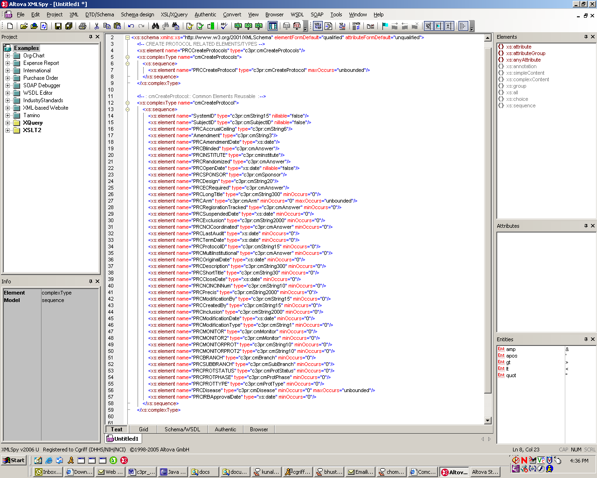
Figure 4-1 Primary Elements representing Protocol data

Amending Protocols in C3PR

The ability to send amendments to a protocol within the C3PR system is provided by the AmendProtocol C3PR web service operation. The AmendProtocol message takes the AmendProtocolRequestMessage, which contains one or more protocol amendments, as input. Each protocol amendment is processed sequentially until all of the protocol amendments have been processed. It is important to note that a protocol must have already have been created in C3PR in order for a protocol amendment to a protocol to be processed.

The response message returned by the operation contains an acknowledgement indicating the status of the operation. If all of the protocol amendments within the request were processed successfully, the status would be set to “Processed”. If there were problems processing one or more of the protocol amendments in the request, the status would be set to “Processed with Errors” and a detailed error message will be placed in the response containing an identifier to allow the client system to programmatically determine which of the protocol amendments sent in the request did not get loaded into C3PR.

If system errors or exceptions occur that prevent all of the protocol amendments from being processed occur, a fault is returned to the client system.

An excerpt of the C3PR schema showing the structure of the primary elements contained in an AmendProtocol request shown in Figure 4-2.

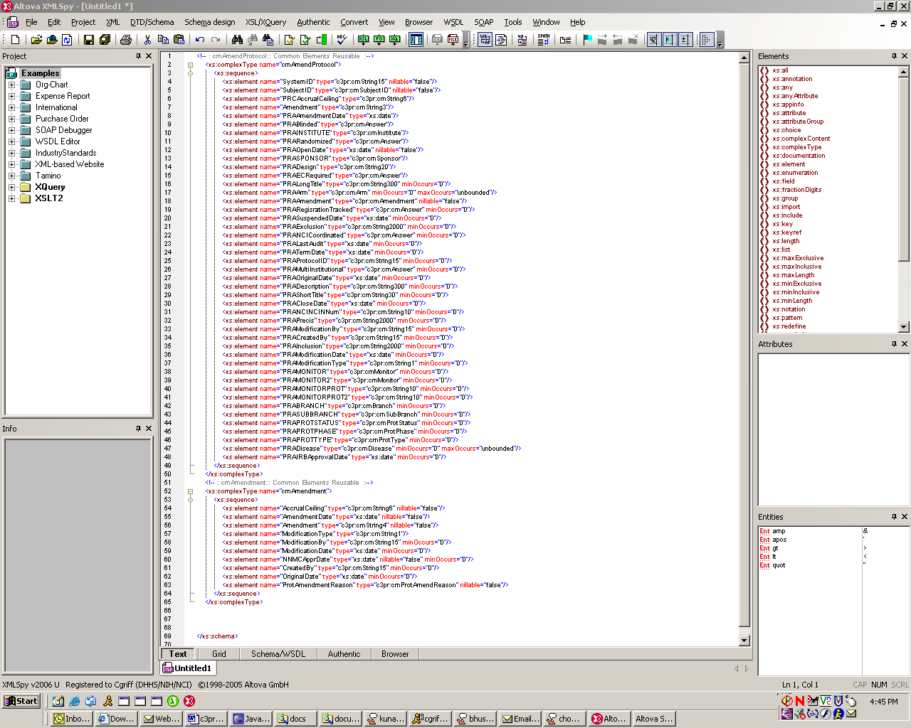
Figure 4-2

Adding Patient Participants to C3PR

The ability to programmatically add one or more patient participants to the C3PR is provided by the CreatePatient C3PR Web Service operations. The CreatePatient message takes the CreatePatientRequestMessage, which contains one or more patients as input. Each patient is processed sequentially until all of the patients have been processed.

The process of adding a patient via the C3PR web service involves:

- Validating the patient data to ensure all of the required fields are present.
- Performing a duplicate participant check to ensure that there are no patient participants within C3PR with the same last name, first name, date of birth, and person identifier.
- Persisting the patient data to the appropriate tables within C3PR.

The response message returned by the operation contains an acknowledgement indicating the status of the operation. If all of the patients within the request were processed successfully, the status would be set to “Processed”. If there were problems processing one or more of the patients in the request (i.e. a duplicate required was found or required data was not provided for the patient), the status would be set to “Processed with Errors” and a detailed error message will be placed in the response containing an identifier to allow the client system to programmatically determine which of the patients sent in the request did not get loaded into C3PR.

If system errors or exceptions occur that prevent all of the patients from being processed occur, a fault is returned to the client system.

An excerpt of the C3PR schema showing the structure of the primary elements contained in a CreatePatient request shown in Figure 4-3.

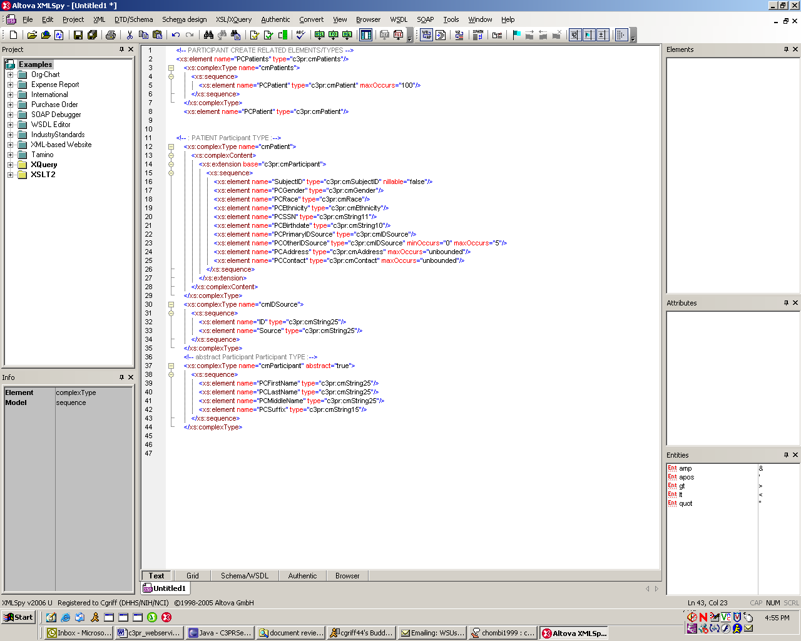
Figure 4-3

Registering Patient Participants to Protocols in C3PR

The ability to programmatically register an existing C3PR patient participant and to an existing C3PR protocol is provided by the RegisterPatient C3PR Web Service operation. The RegisterPatient message takes the RegisterPatientRequestMessage as input.

C3PR takes the following steps to process a RegisterPatientRequestMessage:

- Validating the patient and protocol data to ensure all of the required fields are present in the request and the protocol and participant exist within C3PR. The participant last name, first name, and birth date are used to determine if the patient exists within C3PR.
- C3PR makes a call to the IsValidProtocol C3D Web Service operation to check to see if the protocol is a C3D protocol. If it is a C3D protocol, a patient position is obtained from C3D via a subsequent call to the GetPatientStudyPosition C3D Web Service. If the protocol is not a C3D protocol, a patient position is obtained from within C3PR following the non-C3D protocol registration workflow. A description of the two C3D web service operations is provided below:
  - IsValidProtocol – C3PR consumes this web service operation to check whether or not a protocol is a valid protocol within C3D.
  - GetPatientStudyPosition – C3PR consumes this web service operation to obtain an available study position on the protocol to which the patient will be assigned. This method is only called by C3PR if the IsValidProtocol web service operation reply indicates that the protocol that the patient is being registered to is a valid protocol within C3D.
- Assign a position to the patient.
- Register patient.

Note that this process assumes that a patient has passed the eligibility criteria for the protocol and consented to the protocol. An eligibility checklist within C3PR will not have to be filled out for patients that were registered to a protocol via the RegisterPatient web service operation.

The response message returned by the operation contains an acknowledgement indicating the status of the operation.

An excerpt of the C3PR schema showing the structure of the primary elements contained in a RegisterPatient request shown in Figure 4-4.

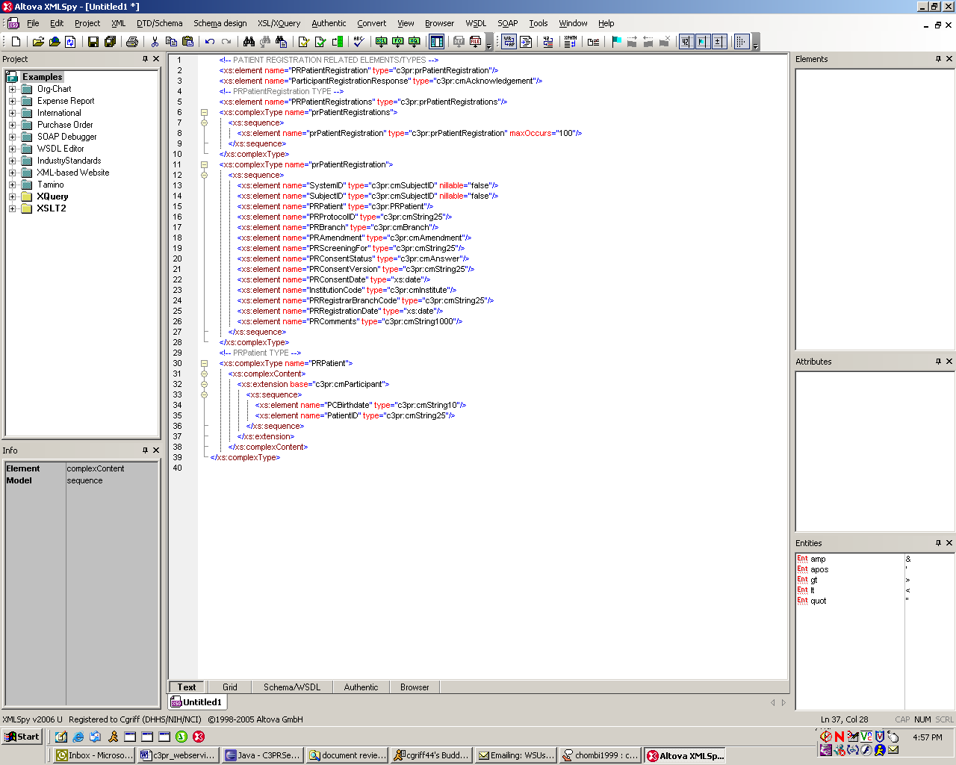
Figure 4-4
* Note: Only the patient first name, last name, and birth date are used to match the patient to a participant within C3PR. The protocol and the participant must be created within C3PR before the RegisterPatient web service operation can be used to register a patient to a protocol.

C3PR Web Service Interface “Conversations”

Figure 4-5 depicts typical request/response “conversations” between a client system and C3PR.
EMBED Visio.Drawing.6 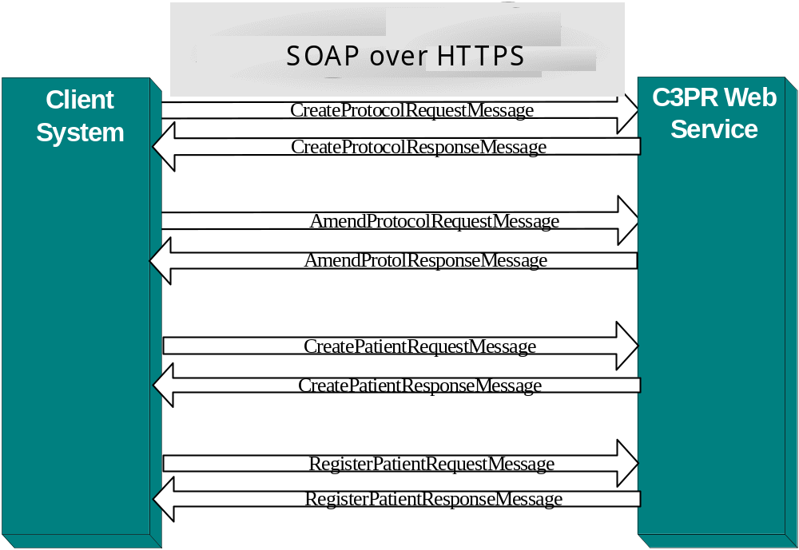
Figure 4-5 Typical Request/Response “Conversations”

Web Services Security

Mutual Authentication and SSL

Please refer to the C3PR Web Services Security document for in-depth information on security. It is recommended that C3PR adopters deploying C3PR in their local environments utilize Secure Socket Layer (SSL) and mutual authentication for managing the security of a message transmission over the Internet. The NCICB hosted deployments of C3PR require both server-side and client-side authentication. Web Services need to be implemented securely; i.e., the data transferred over the Web Service needs to be safe from interception tampering, and unauthorized access. Some of the most common security threats to a distributed information system include:
- An authorized user of the system gaining access to information that should be hidden from him/her.
- A user masquerading as someone else, and obtaining access to whatever that second user is authorized to do. Actions will be attributed to the wrong person.
- Eavesdropping on a communication line, gaining access to confidential data.
- Tampering with communication between objects: modifying, inserting, and deleting items.
- Lack of accountability, due, for example, to inadequate identification of users. The most important problem is repudiation, meaning denial of responsibility for an action.

WS-Security and Common Security Module Authorization

In additional to mutual authentication, C3PR Web Services requires that the web service client send over the WS-Security UserNameToken in the SOAP header of the request. The C3PR Web Service utilizes the username within the UserNameToken in the request to perform authorization on each web service operation. A sample of the WS-Security UsernameToken is shown in Figure 5-1.

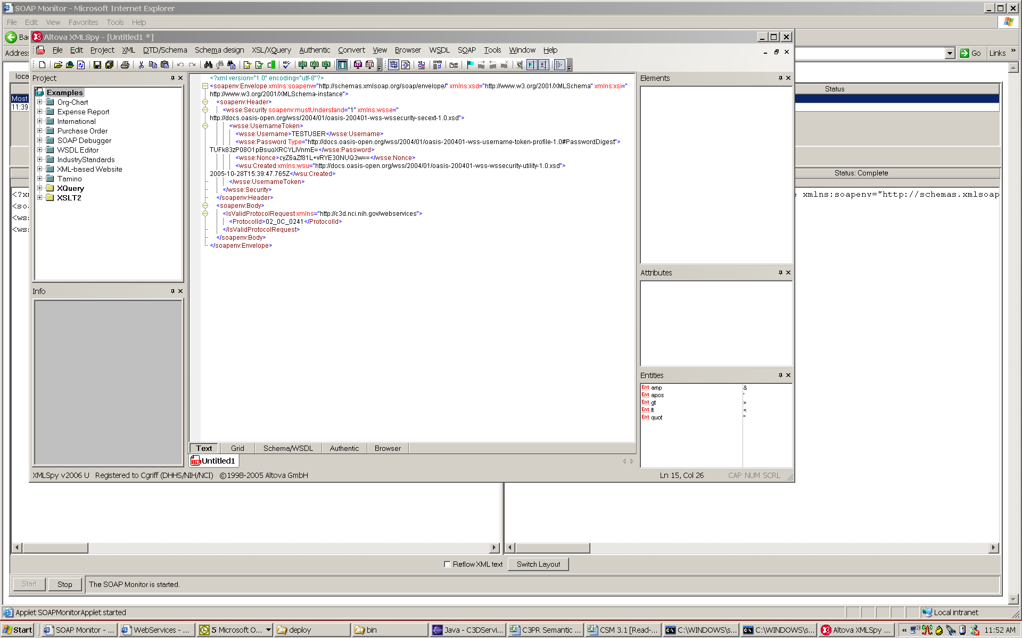
Figure 5-6 Sample Username Token in the SOAP Header of a Request

Generating the UsernameToken in the web service request can be done in any number of ways. One open source tool that can be utilized is WSS4J, http://ws.apache.org/wss4j/, which is an open source implementation of the Oasis Web Services Security specification that provides a Java library to sign and verify SOAP with WS-Security. The soap header in Figure 5-1 was generated using WSS4J.

The AuthorizationManager supplied by the CSM APIs is utilized to perform all authorization within C3PR Web Service operations. The password in the UsernameToken should be set to the value “default” by the client as it is not used for authentication (see section 5.1 for authentication) but is required to be sent by the client to C3PR Web Service.

To authorize a username to consume a C3PR Web Services hosted by NCICB, the client should contact the NCICB C3PR support team to create a valid username and configure the proper authorization to C3PR Web Service operations for that user.

For a C3PR instance deployed in an adopter’s local environment, the technical support team must provide usernames to the C3PR client and configure authorization to C3PR Web Service operations for that username via the CSM User Provision Tool (UPT) through which all of the C3PR authorization strategy is configured. There is a protection element created for each web service operation that the user will need to be given “EXECUTE” privilege to. The protection elements are listed in the Table 2 below.

Table 2
Web Service Operation | Protection Element
CreateProtocol | gov.nih.nci.c3pr.webservices.CmCreateProtocols
AmendProtocol | gov.nih.nci.c3pr.webservices.CmAmendProtocols
CreatePatient | gov.nih.nci.c3pr.webservices.CmPatients
RegisterPatient | gov.nih.nci.c3pr.webservices.PrPatientRegistrations

Appendix A

C3PR Contacts
Program Manager - Christo Andonyadis, andonyac@mail.nih.gov
Project Manager – Stephen Reckford, reckfordsj@mail.nih.gov

FAQ’s
Table A-3 Frequently Asked Questions
Question Description | Answer
Where do we obtain the Digital Certificate for authenticating the client system with C3PR Web Services? | Digital certificates can be obtained from CA's such as Verisign or Entrust. Certs will be required for integration testing (in staging) and for production with a NCICB hosted deployment of C3PR.
Date when the changes to schema definitions will freeze for the upcoming release. | The schema for the release 1.0 is currently frozen. C3PR adopters will be notified if there is a change in the schema for the up coming release.
How will client applications be notified if a request cannot be processed due to a system error? | An error response is returned as the response to the web service request with detailed information on what the problem was and what elements of the request did not get processed.

Acronyms and Definitions

Table A-4 Acronyms and Definitions
Acronym | Description
CSM | NCICB Common Security Module – Common infrastructure provided by NCICB that is used to provide programmatic security to C3PR.
COTS | Commercial Off-the-Shelf
UPT | User Provisioning Tool - Tool provided by the CSM project to configure authorization for users or user roles of the application.
HTTP | Hyper Text Transfer Protocol
HTTPS | Hyper Text Transfer Protocol Secure Sockets
J2EE | Java 2 platform, Enterprise Edition. A Java platform designed for the intensive computing needs in large enterprises.
JAVA | A general purpose, high-level, object-oriented, cross-platform programming language.
SHA | Secure Hash Algorithm
S2S | System to System
SOAP | Simple Object Access Protocol
SSL | Secure Socket Layer
URI | Uniform Resource Identifiers
W3C | World Wide Web Consortium
WSDL | Web Services Description Language
XML | eXtensible Markup Language
XSL | eXtensible Stylesheet Language

Web Resources on SOAP, WSDL and Other Tools and Technologies
- [SOAP] SOAP (Simple Object Access Protocol) Version 1.1 (http://www.w3.org/TR/SOAP/)
- [XML] Extensible Markup Language (XML) 1.0 (http://www.w3.org/TR/1998/REC-xml-19980210)
- [URI] Uniform Resource Identifiers (URI): Generic Syntax (http://www.ietf.org/rfc/rfc2396.txt)
- [XMLBASE] XML Base http://www.w3.org/TR/xmlbase
- [Hypertext Transfer Protocol -- HTTP/1.1 (http://www.ietf.org/rfc/rfc2616.txt) Application Server Comparison Matrix
- [WSDL] Web Services Description Language -- http://www.w3.org/TR/wsdl
- [WS-Security UsernameToken] http://docs.oasis-open.org/wss/2004/01/oasis-200401-wss-username-token-profile-1.0.pdf

Appendix b

Static Binding to the C3PR WSDL
Client systems can utilize static WSDL binding in to build a java client to the C3D Web Service. WSDL2Java is an Apache tool that can be used for building Java proxies and skeletons from the C3PR WSDL. This tool can be downloaded at http://ws.apache.org/axis/.

