Test Script Number: | create_new_organization |  |  |  | Module: |  |  | Tester Name: |  | Steven Cheng | Pass/Fail:  fail
Use Case #: |  |  |  |  | Username: | c3pr_admin |  | Test Date: |  | 09/24/2007 | Pass/Fail:  fail
Estimated Execution Time: |  |  |  |  |  |  | Actual Execution Time: |  | 10 min
Test Objective: create a new organization.

Test Setup:

Related Requirements
or Configuration Change Requests (Number/Description):

 | Test Action | Expected Results | Pass / Fail | Actual Results/Comments | gForge Tracker Bug ID
 | Click Administration tab, then click Create Organization link, fill the required information, then click Save button. See figure 1. |  | Pass | Tested features:  1) Required field validation is active.  2) Save button works  3) Reset tab works  Comments:  - Required field validation for NCI Institute Code is inactive. | 9112
 | Confirmation message displayed. See figure 2, 3 |  | fail | Failed.  Comments:  - Creating Organization is failed with error message or no name displayed in confirmation page | 9114

Tester Signature: Steven Cheng
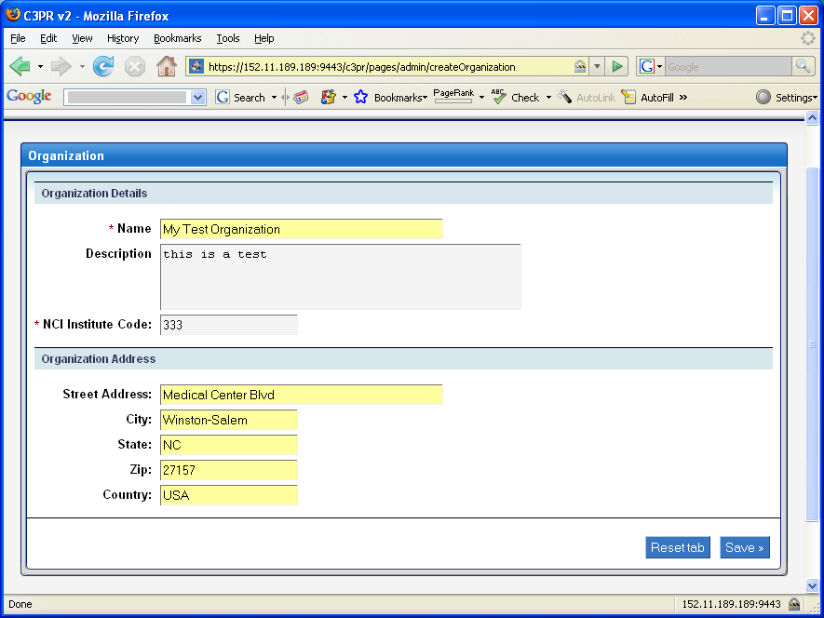
Figure 1
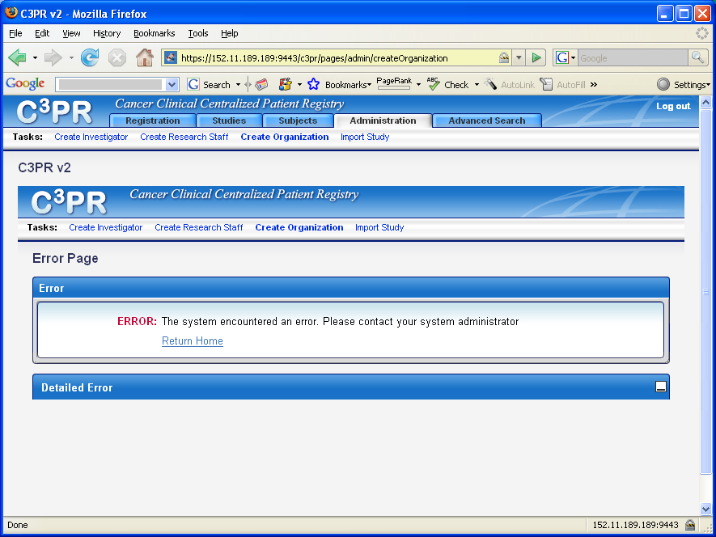
Figure 2
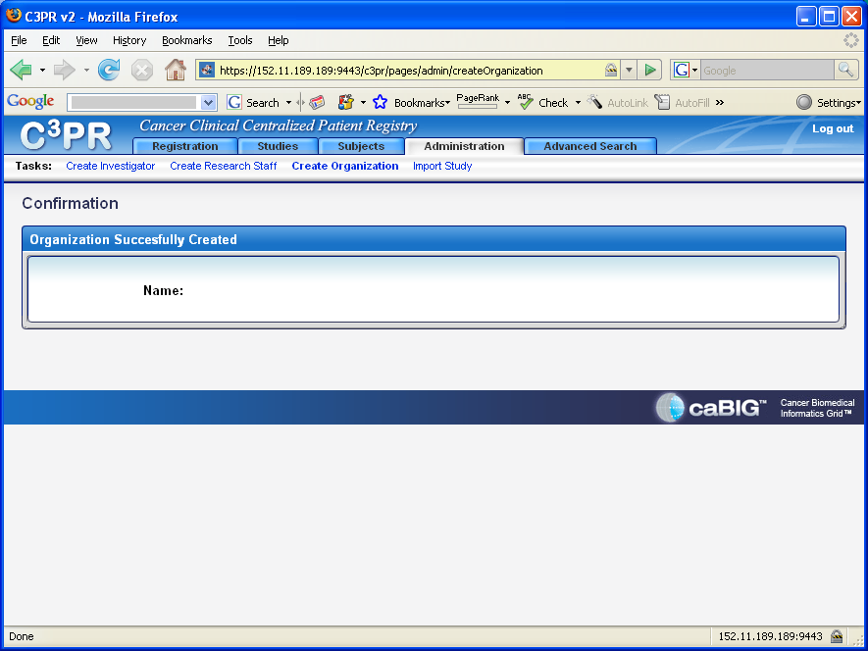
Figure 3

