C3PR –Integration
Technical Specification
Duke Comprehensive Cancer Center

Duke Comprehensive Cancer Center

Duke Comprehensive Cancer Center

Duke Comprehensive Cancer Center

C3PR – Core & Web
Technical Specification

Copyright Notice. Copyright 2006 Duke Comprehensive Cancer Center (“caBIG™ Participant”). caTRIP was created with NCI funding and is part of the caBIG™ initiative. The software subject to this notice and license includes both human readable source code form and machine readable, binary, object code form (the “caBIG™ Software”).
This caBIG™ Software License (the “License”) is between caBIG™ Participant and You. “You (or “Your”) shall mean a person or an entity, and all other entities that control, are controlled by, or are under common control with the entity. “Control” for purposes of this definition means (i) the direct or indirect power to cause the direction or management of such entity, whether by contract or otherwise, or (ii) ownership of fifty percent (50%) or more of the outstanding shares, or (iii) beneficial ownership of such entity.
License. Provided that You agree to the conditions described below, caBIG™ Participant grants You a non-exclusive, worldwide, perpetual, fully-paid-up, no-charge, irrevocable, transferable and royalty-free right and license in its rights in the caBIG™ Software, including any copyright or patent rights therein that may be infringed by the making, using, selling, offering for sale, or importing of caBIG™ Software, to (i) use, install, access, operate, execute, reproduce, copy, modify, translate, market, publicly display, publicly perform, and prepare derivative works of the caBIG™ Software; (ii) make, have made, use, practice, sell, and offer for sale, and/or otherwise dispose of caBIG™ Software (or portions thereof); (iii) distribute and have distributed to and by third parties the caBIG™ Software and any modifications and derivative works thereof; and (iv) sublicense the foregoing rights set out in (i), (ii) and (iii) to third parties, including the right to license such rights to further third parties. For sake of clarity, and not by way of limitation, caBIG™ Participant shall have no right of accounting or right of payment from You or Your sublicensees for the rights granted under this License. This License is granted at no charge to You. Your downloading, copying, modifying, displaying, distributing or use of caBIG™ Software constitutes acceptance of all of the terms and conditions of this Agreement. If you do not agree to such terms and conditions, you have no right to download, copy, modify, display, distribute or use the caBIG™ Software.
Your redistributions of the source code for the caBIG™ Software must retain the above copyright notice, this list of conditions and the disclaimer and limitation of liability of Article 6 below. Your redistributions in object code form must reproduce the above copyright notice, this list of conditions and the disclaimer of Article 6 in the documentation and/or other materials provided with the distribution, if any.
Your end-user documentation included with the redistribution, if any, must include the following acknowledgment: “This product includes software developed by Duke Comprehensive Cancer Center.” If You do not include such end-user documentation, You shall include this acknowledgment in the caBIG™ Software itself, wherever such third-party acknowledgments normally appear.
You may not use the names “Duke Comprehensive Cancer Center”, “The National Cancer Institute”, “NCI”, “Cancer Bioinformatics Grid” or “caBIG™” to endorse or promote products derived from this caBIG™ Software. This License does not authorize You to use any trademarks, service marks, trade names, logos or product names of either caBIG™ Participant, NCI or caBIG™, except as required to comply with the terms of this License.
For sake of clarity, and not by way of limitation, You may incorporate this caBIG™ Software into Your proprietary programs and into any third party proprietary programs. However, if You incorporate the caBIG™ Software into third party proprietary programs, You agree that You are solely responsible for obtaining any permission from such third parties required to incorporate the caBIG™ Software into such third party proprietary programs and for informing Your sublicenses, including without limitation Your end-users, of their obligation to secure any required permissions from such third parties before incorporating the caBIG™ Software into such third party proprietary software programs. In the event that You fail to obtain such permissions, You agree to indemnify caBIG™ Participant for any claims against caBIG™ Participant by such third parties, except to the extent prohibited by law, resulting from Your failure to obtain such permissions.
For sake of clarity, and not by way of limitation, You may add Your own copyright statement to Your modifications and to the derivative works, and You may provide additional or different license terms and conditions in Your sublicenses of modifications of the caBIG™ Software, or any derivative works of the caBIG™ Software as a whole, provided Your use, reproduction, and distribution of the Work otherwise complies with the conditions stated in this License.
THIS caBIG™ SOFTWARE IS PROVIDED "AS IS" AND ANY EXPRESSED OR IMPLIED WARRANTIES (INCLUDING, BUT NOT LIMITED TO, THE IMPLIED WARRANTIES OF MERCHANTABILITY, NON-INFRINGEMENT AND FITNESS FOR A PARTICULAR PURPOSE) ARE DISCLAIMED. IN NO EVENT SHALL THE DUKE COMPREHENSIVE CANCER CENTER OR ITS AFFILIATES BE LIABLE FOR ANY DIRECT, INDIRECT, INCIDENTAL, SPECIAL, EXEMPLARY, OR CONSEQUENTIAL DAMAGES (INCLUDING, BUT NOT LIMITED TO, PROCUREMENT OF SUBSTITUTE GOODS OR SERVICES; LOSS OF USE, DATA, OR PROFITS; OR BUSINESS INTERRUPTION) HOWEVER CAUSED AND ON ANY THEORY OF LIABILITY, WHETHER IN CONTRACT, STRICT LIABILITY, OR TORT (INCLUDING NEGLIGENCE OR OTHERWISE) ARISING IN ANY WAY OUT OF THE USE OF THIS caBIG™ SOFTWARE, EVEN IF ADVISED OF THE POSSIBILITY OF SUCH DAMAGE.

Development Team(s)
Development | Technical Documentation | Program Management
Kruttik Aggarwal² | Priyatam Mudivarti² | Bob Annechiarico¹
Manav Kher² | Manav Kher² | Jamie Cuticchia¹
Priyatam Mudivarti² | Patrick McConnell¹ | Patrick McConnell¹
Ram Chilukuri² |  | Ram Chilukuri²
Ramakrishna Gundala²
¹Duke Comprehensive Cancer Center | ²SemanticBits

Contacts and Support
Enter training contact | Patrick McConnell (patrick.mcconnell@duke.edu)
Enter customer support contact | NA

LISTSERV Facilities Pertinent to software teams
LISTSERV | URL | Name
c3prv2-elaborator | c3prv2-elaborators@gforge.nci.nih.gov | C3PR Elaborators Forum
C3prv2-general | c3prv3-general@gforge.nci.nih.gov | C3PR General Forum
C3prv2-developers | c3prv2-developers@gforge.nci.nih.gov | C3PR Developers Forum
Table of Contents

1. Scope and Purpose 7
2. Overview 7
2.1. Technology Stack 7
2.2. Architectural Layers 8
2.2.1. Domain Objects / Persistence 8
2.2.2. Views 9
2.2.3. Controllers 9
2.2.4. Commands 9
2.2.5. Service Layer 9
2.2.6. Dao Layer 10
2.3. Core Modules 10
2.3.1. Dependency injection (Architectural Pattern) 10
2.3.2. Open Session In View filter 11
2.3.3. Grid Identifiers 11
2.3.4. Security 12
2.3.4.1. TLS 13
2.3.4.2. Authentication 13
2.3.4.3. Dorian 13
2.3.4.4. Authorization 14
2.3.5. Single Sign On (Web SSO) 14
2.3.5.1. GridProxyFilter 15
2.3.5.2. DefaultGridProxyRetrievalStrategy 15
2.3.5.3. GridBasicAuthenticationClient 15
2.3.5.4. GridProxyValidator 15
2.3.5.5. SyncGTS 16
2.3.5.6. Integration Steps 16
2.3.6. Login Interceptors (Spring) 16
2.3.7. Decorators (Sitemesh) 17
2.3.8. Tag Libraries 17
2.3.9. Dynamic Navigation Framework 17
2.3.10. Ajax (DWR) & Scriptaculous 17
3. Domain Analysis Model 18
4. Implementation Model 19
5. Data Model 20
6. Use Case Realization 21
6.1. Create Study 21
6.1.1. Domain Objects Used 21
6.1.2. Activity Diagram 21
6.1.3. Sequence Diagram 22
6.2. Search Study 23
6.2.1. Domain Objects Used 23
6.2.2. Activity Diagram 23
6.2.3. Sequence Diagram 24
6.3. Edit Study 24
6.3.1. Domain Objects 25
6.3.2. Activity Diagram 25
6.3.3. Sequence Diagram 25
6.4. Create Subject 26
6.4.1. Domain Objects 26
6.4.2. Activity Diagram 26
6.4.3. Sequence Diagram 27
6.5. Search Subject 28
6.5.1. Domain Objects 28
6.5.2. Activity Diagram 28
6.5.3. Sequence Diagram 29
6.6. Edit Subject 30
6.6.1. Domain Objects 30
6.6.2. Activity Diagram 30
6.6.3. Sequence Diagram 31
6.7. Register Subject to Multi-Site Study 32
6.7.1. Domain Objects 32
6.7.2. Activity Diagram 32
6.7.3. Sequence Diagram 33
6.8. Register Subject to a Study 34
6.8.1. Domain Objects 34
6.8.2. Activity Diagram 34
6.9. View/Update Registration Details 34
6.9.1. Domain Objects 34
6.9.2. Activity Diagram 34
6.9.3. Sequence Diagram 35
7. Integration with External Systems 36
7.1. ESB Client 36
8. Unit Testing 36
8.1. JUnit 36
8.2. Mock Objects 37
9. Integration Testing 37
10. Configuration/Build/Deployment 37

Scope and Purpose
The scope of this document is to provide technical design / specification, for the Core & Web project modules within C3PR v2. The specification will include the use case realizations within each iteration with accompanying UML models and documentation wherever appropriate.
The purpose of this document is to facilitate development with an initial phase of analysis and design and support as a documentation of the overall design in the Core project for other developers.

Overview
C3PR Core project consists of the core modules for overall project like domain objects, service layer classes, Data Access Objects (DAOs), db scripts, utility classes and shared libraries servicing the entire project. The sub-project is built independently from the others and is included as a dependency for other projects. Although the Core project cannot be deployed as an application itself, it can packaged in a separate jar to include in your project’s classpath.

Technology Stack

Operating System | Windows XP/Linux
Java Version | JDK 1.5.2
MVC framework | Spring MVC 2.0
View Technology | JSP, JSP Tag libraries, AJAX
AJAX Framework | Direct Web Remoting (DWR), Scriptaculous
ORM | Hibernate 3.2.1
Transactions, IOC, dependency injection | Spring 2.0
Web Server | Tomcat 5.5.20
Database | Oracle 10x / PostgreSQL 8x
Development Tools | Eclipse 3.2, Enterprise Architect 4.5
Build | Ant
Source Control | CVS (gForge)

Architectural Layers

Figure: C3PR Architectural Layers
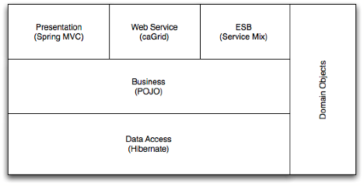

Domain Objects / Persistence
C3PR is purely domain driven, test driven development. There is no need for separate concerns on view layer, for instance, there is no need for separate view objects or separate persistence objects and mapping between all the objects. All of C3PR domain objects reside in the package edu.duke.cabig.c3pr.domain; the Design & Analysis starting from a BRIDG (Biomedical Research Integrated Domain Group) Harmonized model

A Base Domain object interface is needed as a placeholder for all domain objects in the system, along with commonly needed attributes (id, version, name). An AbstractDomainObject extends domainObject and forms a representation of a persistent base domain object. In case of a domain object which includes a grid id, a separate GridIdentifiableDomainObject.
The Domain objects not only encapsulate the state but have basic behavior (like adding/removing collections) incorporated. Each domain object knows how to persist itself via Hibernate annotations. (Instead of separate hbm files to map persistent objects to database)

Lastly, to facilitate convention over configuration, an improvedNamingStrategy is used in hibernate’s session factory (configured in spring). This enables lesser mapping annotations in domain objects for simple attributes which follow conventions of Database pluralization

</property>
<property name="namingStrategy">
<bean class="org.hibernate.cfg.ImprovedNamingStrategy" />
</property>

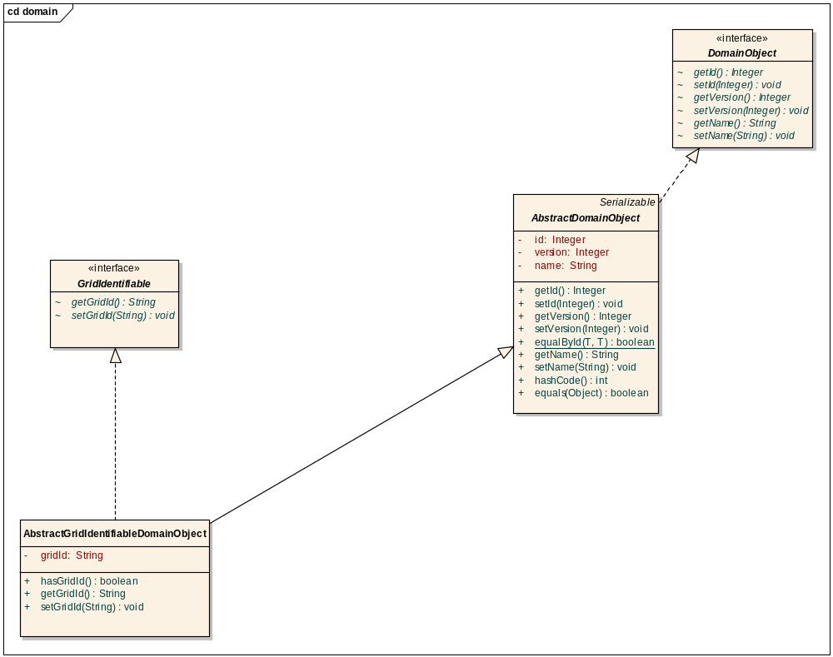

Views
The view technology consists of JSP pages with standard stylesheets (css), JSP Tag libraries including Spring tag libraries, AJAX, DWR and Scriptaculous.

Controllers
Spring’s MVC is being used as the defacto MVC architecture for C3PRv2. All the Controller classes for the respective use case will be located in the package edu.duke.cabig.c3pr.web

Commands
A set of command objects (Form objects) as per the Spring MVC which acts as a command for each controller. It is recommended to use domain objects as command wherever applicable to reduce the unnecessary creation of extra value objects.

Service Layer
The service layer will expose a set of interfaces for the client to call in (currently the interface decided is a Web Interface). The Controller classes typically delegate the functionality to Service classes. Spring adds the dependency injection for the implemented classes as Controller need not be coupled with the Service implementations.

Dao Layer
Hibernate is chosen for the persistence layer and all DAO implementations will specific to the domain objects being persisted. Leveraging Java 5.0 generics, each dao class specifically caters to a domain object’s persistence by accepting a domain object type in the class definition. All Services/Controllers should be able to access the database only via a DAO object. Each implementation extends the
org.Springframework.orm.hibernate3.support.HibernateDaoSupport class that provides a good template for quickly building data access methods without the risk of database leaks and poor error handling.

A BaseDao interface as a place holder for generic operations. AbstractBaseDao implements BaseDao implementing specific methods, leaving template methods for all subclasses

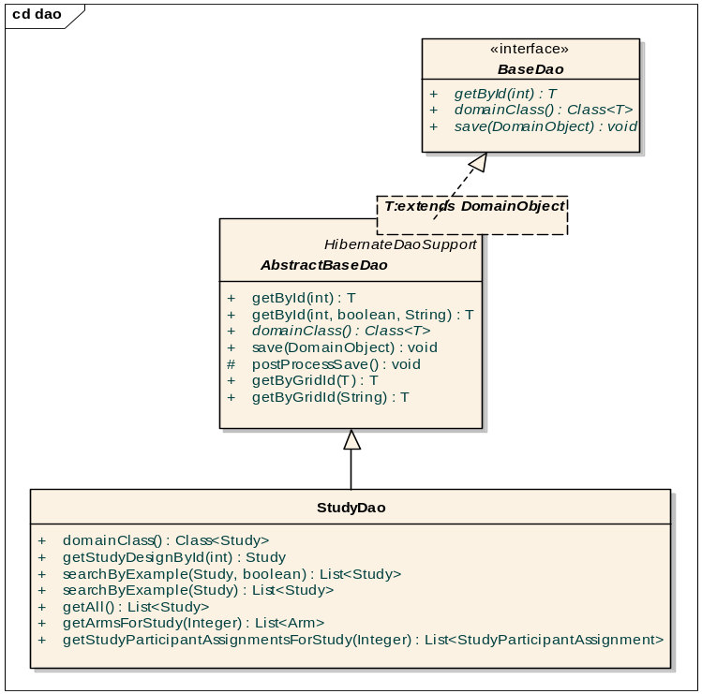

Core Modules

Dependency injection (Architectural Pattern)

The objects in different layers are connected or wired together using an architectural pattern called dependency injection/inversion of control. This means that, instead of a DAO object acquiring a data source from JNDI, or a controller finding a DAO using some sort of service locator, each object declares the objects (commonly referred to as collaborators) it depends on based on its own requirements. All the collaborators are instantiated by an external configuration tool; all their dependencies are satisfied by that tool when they are created.

Inter-layer dependencies are oriented such that higher levels depend on lower levels, but never vice versa. For instance, a service may depend on a DAO, but a DAO will never depend on a service.

C3PR uses the Spring Framework (version 2.0), specifically Spring IOC container for dependency injection, with the dependencies declared in a series of XML files included alongside the deployed classes. For more information about the Spring Framework, please see http://www.springframework.org/documentation.
The following diagram illustrates the wiring of various objects that belong to different layers in C3PRV2:

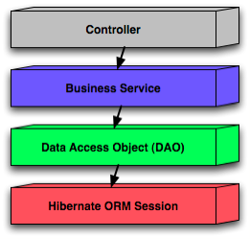
Figure: Spring wiring of C3PRV2 web app components

Open Session In View filter

A filter which implements the Open Session In View pattern. Different from the one built into Spring because this one delegates to an instance of OpenSessionInViewInterceptor configured in the application context. This permits the use of the same interceptor for deployed code & unit tests.

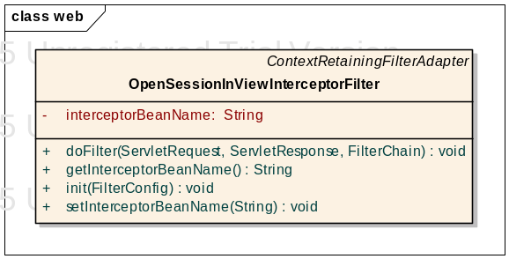

Grid Identifiers

Grid Identifier servers as a unique identifier for persistent entities across different C3PR instances. For example, to be able to uniquely identify a Study object in C3PR instance A in Duke and another Study object (with the same semantics) in C3PR instance B at Mayo, the only way to uniquely identify is via a Grid Identifier.

In c3PR an interface is included to achieve this functionality – GridIndentifierCreator. Two different implementations exist for generating Grid Ids, one based on UUID (LocalGridIdentifier) and another based on caBig’s handler based grid ids.
Currently we are using LocalGridIdentifiers

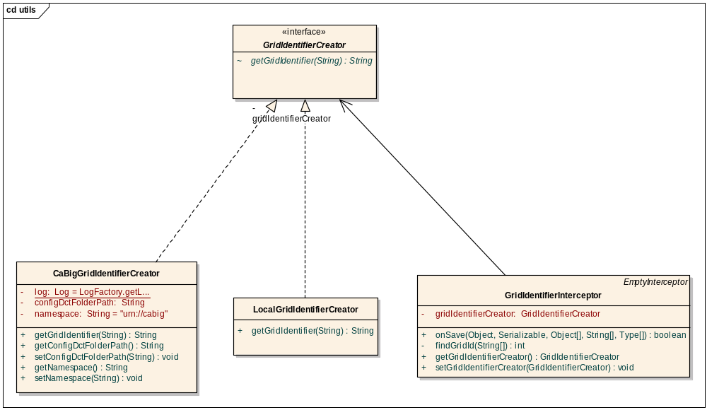

Security
The requirements of the C3PR security architecture are to ensure the privacy and integrity of all network communication, and to enforce authentication and authorization before granting access to operations and data. This architecture is also required to enforce authentication and authorization of users and services that may be outside of the security authority of the host organization.

Privacy and integrity of data in transit through the network are ensured by using Transport Level Security (TLS). Access to data at rest in a database is protected using basic (username/password) authentication mechanisms. Authentication is enforce using a combination of Public Key Infrastructure (PKI) and basic authentication. Authorization policy is constructed and maintained using NCICB’s Common Security Module (CSM). Authorization policy is enforced using custom components in the web application layer and the caGrid Authz module, which enables local and external (grid-wide) policy to be enforced in parallel.

PKI-based authentication works as follows. Users and services are provisioned with X509v3 certificates that have been signed by widely-trusted certificate authorities. During negotiation of security communication between parties, party A authenticates party B by verifying that the certificate of party B has been signed by a certificate authority that party A trusts. Both uni- and bi-directional (mutual) authentication can be required.

Basic authentication involves looking up the requesting parties credentials (username and password) in some credential provider. CSM supports LDAP and RDBMS credential providers. Local users have a username and password that have been provisioned by the hosting organization and are authenticated using basic authentication. Grid users have a proxy certificate (short-lived X509 certificate) and are authenticated using PKI authentication.

The following sections describe how security issues are addressed at each layer of the C3PR architecture.(Web Application)

TLS

The C3PR web application runs in a servlet container. Web browser clients make requests to the container, and code running in the container sends and receives messages from a JMS broker. To secure communication between the web browser and the web application, the servlet container is configured to accept connections over HTTPS, and the web application is configured to require that pages containing sensitive data can only be accessed over HTTPS. In this way, all data communicated between the browser and the application are encrypted. To secure communication between the web application and the JMS broker, the broker is configured to accept SSL connections and the client is configured to use a SSL connection to the broker.

Authentication

X509 certificates are used to authenticate the servlet container to the web browser client using PKI. Similarly, the JMS brokers certificate is used to authenticate the broker to the C3PR JMS client. Local users must provide username and password credentials which are validated by CSM against the credential provider (LDAP or RDBMS). Authentication of local users is enforced in the web application as follows.

All HTTP requests in the Spring MVC framework go through the DipatcherServlet, which serves as a front controller. It uses a HandlerMapping object to figure out the Controller class that should be used to handle the request. The mapping between the URL and the controller class is configured in the spring-servlet.xml file. The DispatcherServlet also retrieves all the interceptors that are configured for the controller before delegating the request to the controller class. A LoginCheckInterceptor is used to check if the user is logged in and has a valid active session. If the login check fails, the user is redirected to the login page.

Grid users must provide a proxy certificate which is validated using PKI. Authentication of grid users is enforced by the WEBSSO module. See the WEBSSO section for details.

Dorian
Dorian is the Grid User Account Management system provided by caGrid 1.0 . Dorian acts is a bridge between external security domains and the grid. Dorian allows users to use their existing credentials (external to the grid) to authenticate to the grid.
Dorian comes with a default identity provider. This allows users to register for an account and obtain grid credentials through Dorian. We leverage the Dorian default IdP for requesting grid credentials for users in c3pr v2. This grid credentials can then be used to authenticate to other CTMS systems, thus providing a Single Sign On (SSO) between these systems.

- Proxy Creation Workflow
- Client authenticates with Local IdP
- Client creates public/private key pair to use for grid proxy.
- Client requests Dorian to create a grid proxy.
- Dorian verifies that the SAML assertion provided by the user is signed by a Trusted IdP and that the user has a valid account.
- Dorian locates the user’s grid credentials, private key and certificate
- Dorian uses the public key provided to create a proxy certificate and signs it with the user’s private key
- Dorian returns the proxy certificate to the user.
- The user may now use the proxy to authenticate to grid services
(Diagram for this Flow is in the Integration EA document). See Appendix A (item# 6)

Authorization

Both role-based and identity-based authorization. Role-based authorization policy applies in two ways. First is access to URLs – roles are assigned access permissions to the pages they need to function. Second is attribute-based – some pages mutate based on the roles granted to the logged-in user. Certain links or forms will only appear if a user has a role that grants him or her access to the target page.

C3PR also uses identity-based authorization for specific resources. For example, it is possible to limit access an individual item to one or more users.Authorization is enforced through a combination of a Spring interceptor, custom JSP tags, and the caGrid Authz component.

As described previously, the Spring DispatcherServlet passes an incoming request to the chain of interceptors before delegating to the Controller. One of these interceptors is the URLAccessCheckInterceptor, which verifies if the logged in user is authorized to access the page that he is requesting, based on his role. If the user does not have privileges to access a page then the access denied page is displayed. The URLAccessCheckInterceptor uses the CSM API to determine the roles of the logged in user.

Similarly, custom JSP tags control the rendering of a page based on the user’s role, so that only sections which expose functionality and data to which the user is authorized are displayed. This works fine for local users because they can be provisioned with roles using the organization’s CSM. However, it is impractical to provision all possible grid users. Instead, the Authz component is plugged into CSM to enable grid-based authorization policy to be enforced in parallel with local policy. See the caGrid User’s Guide for more information about the Authz component.

Single Sign On (Web SSO)

The websso component of C3PR is used by web applications in the CTMS suite to implement SSO at the web application layer. It is designed to be easily integrated into an existing web application. The following describes how this component works.

First, some background. In caGrid, authentication is achieved through the use of X.509 certificates. Therefore, each user needs a certificate in order to access a secure resource on the grid. The caGrid components that enable each user to obtain a certificate are the Dorian service and the AuthenticationService service. AuthenticationService plays the role of an Identity Provider (IdP). Dorian plays the role of an Identity Federation Service (IFS).

A user obtains a certificate by following these steps:
- User provides IdP username and password
- IdP returns a singed SAML assertion attesting to the user's identity
- User provides SAML assertion to IFS
- IFS returns a certificate

The certificate returned by the IFS is a proxy certificate, which we commonly refer to as a grid proxy. It is basically just a short-lived certificate (usually valid for only 12 hours).

The websso component implements SSO across web applications using these grid proxies. There are four components involved in this implementation:
- gov.nih.nci.cabig.ctms.web.sso.GridProxyFilter
- gov.nih.nci.cabig.ctms.web.sso.GrixProxyRetrievalStrategy
- gov.nih.nci.cabig.ctms.web.sso.GridBasicAuthenticationClient
- gov.nih.nci.cabig.ctms.web.sso.GridProxyValidator

GridProxyFilter

This is a servlet filter which will use an instance of GridProxyRetrievalStrategy to check for the presence of a grid proxy in the request or session scopes. If not found, it will redirect to a configured page. If found, it will continue chain processing. This filter can operate in "strict" or "non-strict" modes. In non-strict mode, the filter will continue chain processing even if a proxy is not found. This permits use of the application by users that do not have grid identities.

This filter uses Spring to instantiate the desired implementation of GridProxyRetrievalStrategy.

DefaultGridProxyRetrievalStrategy

This implementation of GridProxyRetrievalStrategy looks for a proxy first in the request and then the session under a configured parameter/attribute name. If a proxy is found, it delegates to an instance of GridProxyValidator to validate the proxy. It can also me configured to check for username/password credentials under configurable parameter/attribute names. If these credentials are found, this class will delegate to an instance of GridBasicAuthenticationClient to obtain a grid proxy.

If a grid proxy is located (or newly obtained) and successfully validated, it is placed under a configurable attribute name in the session.

DefaultGridProxyRetrievalStrategy is the class that should be extended to work with a local authentication mechanism. In C3PR, it is gov.nih.nci.cabig.ctms.web.sso.DefaultGridProxyRetrievalStrategy (see ctms commons) that interacts with this systems ApplicationSecurityManager to set the current user to the grid identity obtained from the proxy.

GridBasicAuthenticationClient

This is simple API that handles interaction with the IdP and IFS. The single method looks like this:

/**
*
* @param username
* @param password
* @return String representation of grid proxy
* @throws AuthenticationErrorException if an error is encountered during authentication
*/
String authenticate(String username, String password) throws AuthenticationErrorException;

GridProxyValidator

This class the JGlobus ProxyPathValidator to verify that the proxy is valid and check that it has been signed by one of the "trusted" certificates and has not been revoked. The convention used by Globus is to store trusted certificates under $HOME/.globus/certificates. So, this class checks the proxy against certificates in that directory by default. But custom directories for trusted certificates and certificate revocation lists (CRLs) can be provided.

SyncGTS

SyncGTS is the caGrid component that automates the process of keeping a node (machine) synchronized with the grid trust fabric. That means, keeping the adding/remove trusted certificates and CRLs from the local file system. In order for the websso component to work properly, syncGTS must be installed on the machine that hosts the web application.

Integration Steps

Three steps are required to integrate this approach into a web application. First, GridProxyFilter must be configured in web.xml. Second, the existing authentication mechanism must ensure that grid proxy ends up in the session under a pre-defined attribute name. Third, "hot links" between applications must include the grid proxy as a pre-defined parameter in the request.

The websso component has been integrated into C3PR by extending DefaultGridProxyRetrievalStrategy to interact with the ApplicationSecurityManager. Essentially, it uses ApplicationSecurityManager to put the grid identity of the caller into the session. Also, the LoginController first checks if the caller already exists in the session before attempting to authenticate to the local credential provider.

Finally, “hot links” to other CTMS suite applications are implemented by intercepting JavaScript click events on anchor tags that have a CSS class “sso”, and submitting a form (implemented as a custom JSP tag) that contains a hidden field whose value is the string representation of the grid proxy. In this way, the grid proxy is included as a parameter of an HTTP POST to the target application.

Acegi Filter (Spring)

To achieve Authentication and Authorization in C3PR, Acegi Security is used in conjunction with caCORE Common Security Module. C3PRV2 uses the csm-acegi module from the CTMS Commons application.

Acegi provides a Filter called FilterToBeanProxy which just delegates to another Filter that has been declared in the web applications ApplicationContext. The point here is to allow the Filter to be managed by Spring. The FilterToBeanProxy filter is declared in the application's web.xml. Acegi provides another Filter called FilterChainProxy which delegates a Filter request through a chain of Filters. FilterChainProxy is configured to map URLs to Filter chains.

In C3PRV2, the FilterToBeanProxy Filter is declared in web.xml. It is declared after the Sitemesh Filter so that page decoration can occur even for access denied and error pages. It matches all request URLs and it points to a FilterChainProxy bean that is defined in WEB-INF/applicationContext-acegi-security.xml and has a bean ID of "filterChainProxy".

<filter>
<filter-name>Acegi Filter Chain Proxy</filter-name>
<filter-class>
org.acegisecurity.util.FilterToBeanProxy
</filter-class>
<init-param>
<param-name>targetClass</param-name>
<param-value>
org.acegisecurity.util.FilterChainProxy
</param-value>
</init-param>
</filter>

<filter-mapping>
<filter-name>Acegi Filter Chain Proxy</filter-name>
<url-pattern>/*</url-pattern>
</filter-mapping>

Acegi Servelet will internally call a chain of Spring based interceptors that perform authentication and authorization decisions. This is to decouple the existing business logic from knowing the security mechanism. Every URL request from the client (webapp) is intercepted and the Acegi interceptor chain is invoked by Spring to see if the authentication has been done on the current request.

.

Decorators (Sitemesh)
C3PR uses Sitemesh for rendering multiple layouts for various Screens. The advantage of Sitemesh is the flexibility of standardizing layouts across all workflows and ‘decorating’ pages with subflows on demand. For instance,
Create Study and Edit Study can both reuse the same jsps for rendering the pages. As Edit Study Workflow has futher more panels (like Study Summary and Registrations), these panels will be rendered by the decorator without the knowledge of the corresponding Controller

Tag Libraries
Several Tag Libraries have been incorporated to generalize UI rendering, encouraging code reuse. This includes tag libraries for pages like Study Summary, Registration History, Search (Subject & Study) etc. Also generic tags for the following are incorporated
- Standard Header
- Standard Footer
- Standard Navigation

Dynamic Navigation Framework
A tag library for navigation across all UI pages has been incorporated. The Use of Spring Interceptors to intercept each http request and render the Dynamic Menu is the key. Each Menu on the navigation is regarded as “Section” and MenuItem as “Task”. For more details refer the UML diagram

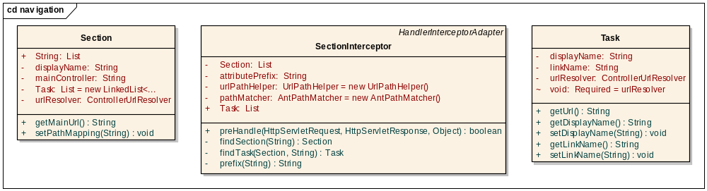

Ajax (DWR) & Scriptaculous
Wherever possible, Ajax is being used to provide dynamic interface to the users. DWR Engine helps to serialize/deserialize Ajax requests back & forth to the Server. For javascript, Scriptaculous library is being used.

Domain Analysis Model
The domain analysis model for C3PR is based on a BRIDG.

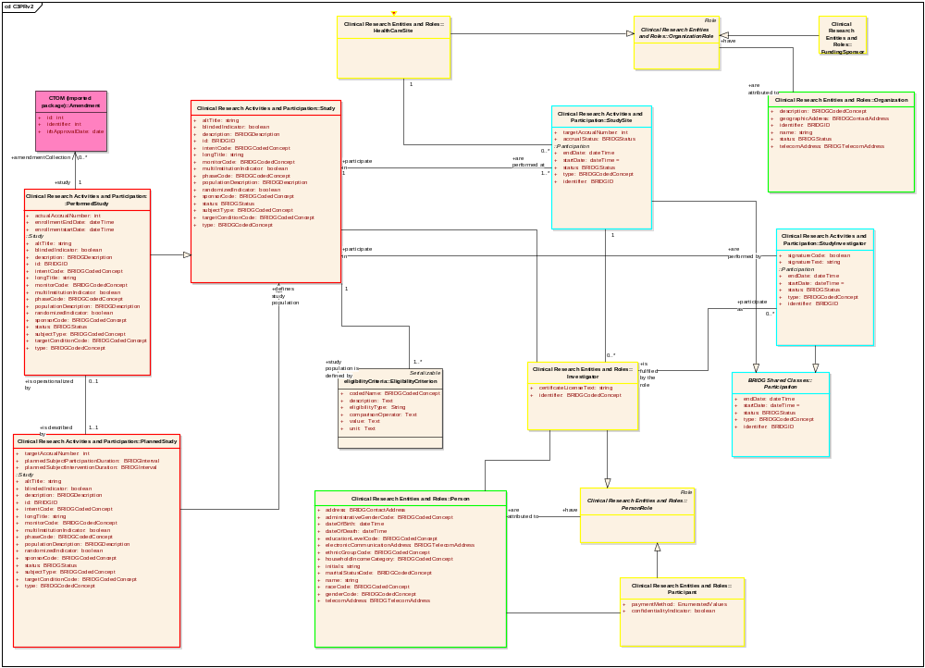

Implementation Model
Derived from Domain Analysis model, the implementation model is a model realized for a Java implementation with classes, associations. For a complete UML model, refer the Domain model section in c3pr-uml design in appendix

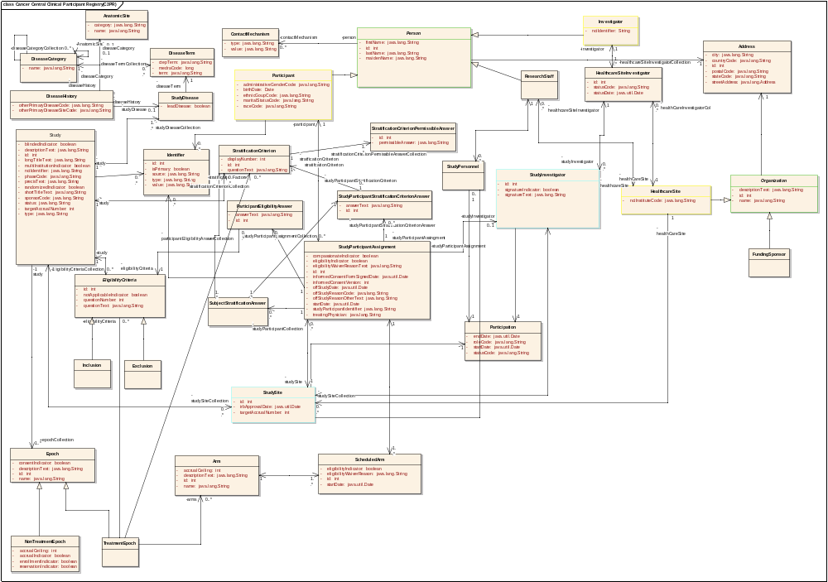

Data Model
C3PR is currently tested for Oracle 10x/Postgres 8x databases

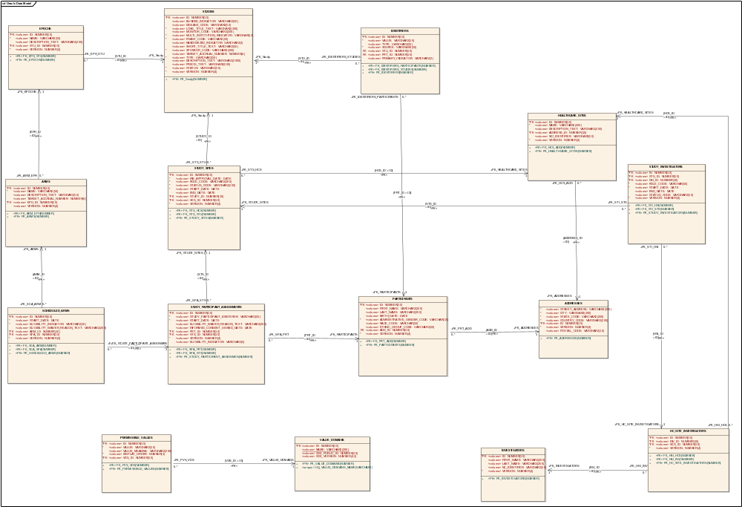

Use Case Realization

Create Study
This use-case deals with the manual creation of a study by entering each data element of the study.

Domain Objects Used

- Study
- Epoch
- Arm
- StudySite
- Identifier
- Healthcare

Activity Diagram
The workflow is split into multiple pages in a Wizard style for capturing individual pieces of information for simplifying the workflow of Study creation

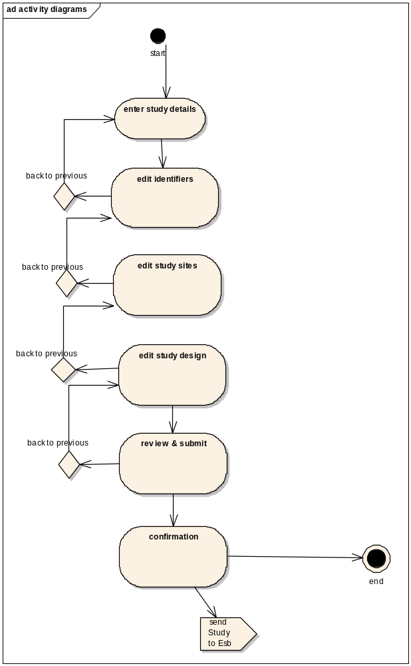

Sequence Diagram
Core controller of Create Study is based on Spring’s AbstractWizardFormController. This eliminates the session/form handling by the developer and provides fine extension points for generating a workflow between a well defined set of pages with the notion of back/next buttons. The validations used on the page are two level – client side javascript and server side Spring validations (to be done only on the last page).

The command object used for the controller is the domain object itself. The advantages of this design is that there are no unnecessary value objects/DTOs used in the whole process and the emphasis is on reusing rich domain objects across all layers in the appropriate context. The View saves individual elements of Study object within each page of the workflow (wizard) dynamically and on the last page the entire graph of Study object along with it’s associations of StudySite, Identifiers, Epochs, Arms are saved. Spring’s HibernateTemplate is used to saveOrUpdate the populated domain object

Spring Validators are used for simple business validations on the server side. The Controller’s validate() method takes the central place to delegate validations to individual validation of domain objects (Study, Epochs, Arms etc)

This also involves in integration with ESB client interface to add an asynchronous message. ServiceMix and GridServices are used to propagate the newly created Study.

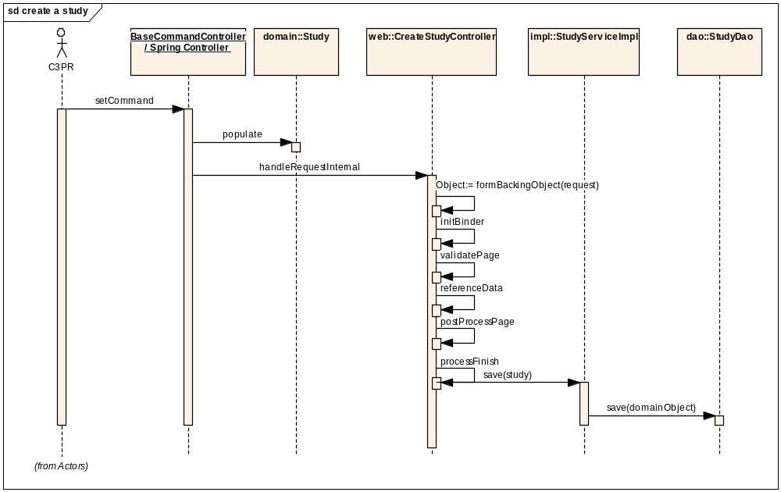

Search Study
This use-case deals with searching an existing Study either by status, long title or by one of the Identifiers

Domain Objects Used

- Study

Activity Diagram
User is provided a simple Form where search criteria can be entered (includes wildcards), search results are displayed in separate search results page with an option of searching from the same page via an intuitive search bar on the top of search results page

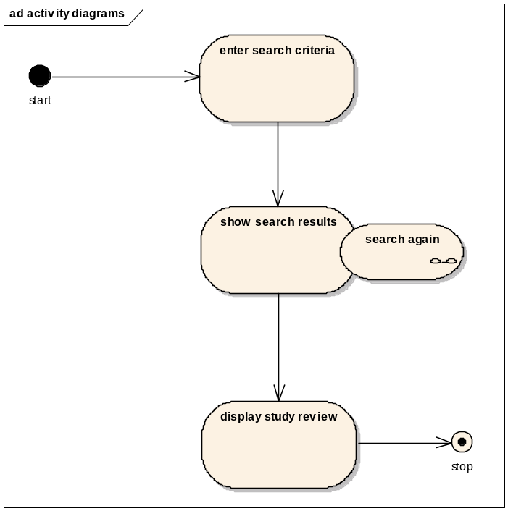

Sequence Diagram
As it’s a simple search, a SimpleFormController is being used for implementing the behavior of
Search->SearchResults page. Hibernate’s SearchByExample is being used to search using an example object populated with the user’s dynamic criteria.

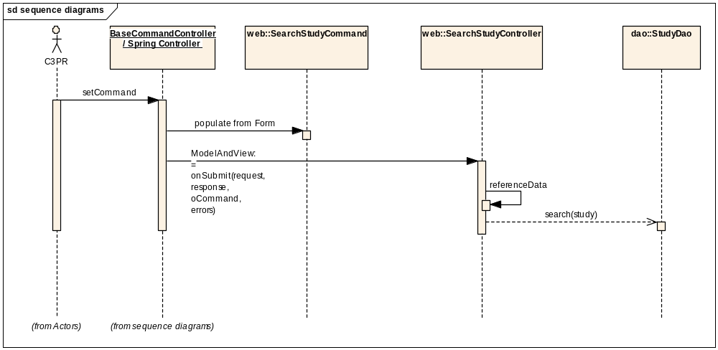

Edit Study
This use case deals with updating the existing Study once the user searches for a study. The user can view the complete details of Study as well as update individual identifiers, study sites, design etc …

Domain Objects

- Study
- Epoch
- Arm
- StudySite
- Identifier
- Healthcare

Activity Diagram
The user is provided with a three sections of Study View. The left most section is a read only pane with a Study Summary Page. The middle section consists of a tabbed view with all existing details of Study including identifiers, design and study sites. The right most section consists of a read only pane with Study Participant Assignments

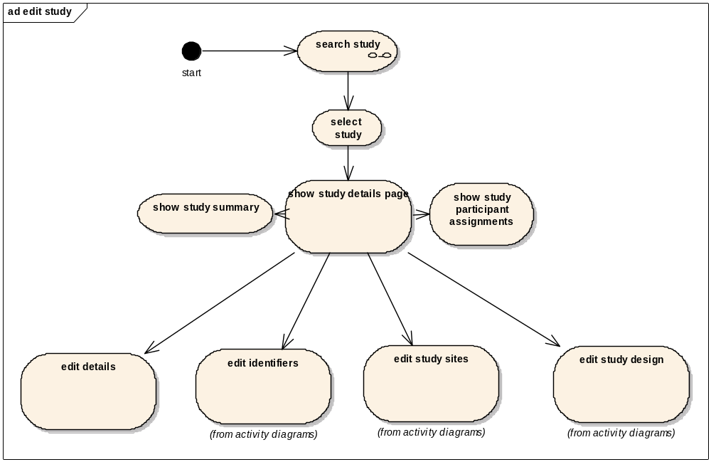

Sequence Diagram

Core controller of Edit Study is based on Spring’s AbstractWizardFormController. This eliminates the session/form handling by the developer and provides fine extension points for generating a workflow between a well defined set of pages with the notion of back/next buttons. The validations and other functionality works similar to that of Create Study Controller. The command object used for the controller is the domain object itself.

The main difference of Edit Study wrt to Create Study is the loading of entire Study object in the formBackingObject. Once the user has selected a study in the previous screen, the edit screen should be loaded with Study details in the Web Session. It is to be noted that Lazy loading of collections is not recommended as Hibernate objects need to be detached and reattached in case of updation in the Web layer. By loading the entire graph before the page is called simplifies the design for simultaneous view/update as Study objects are not intensive in data (still fine with performance). Spring’s HibernateTemplate is used to saveOrUpdate the populated domain object

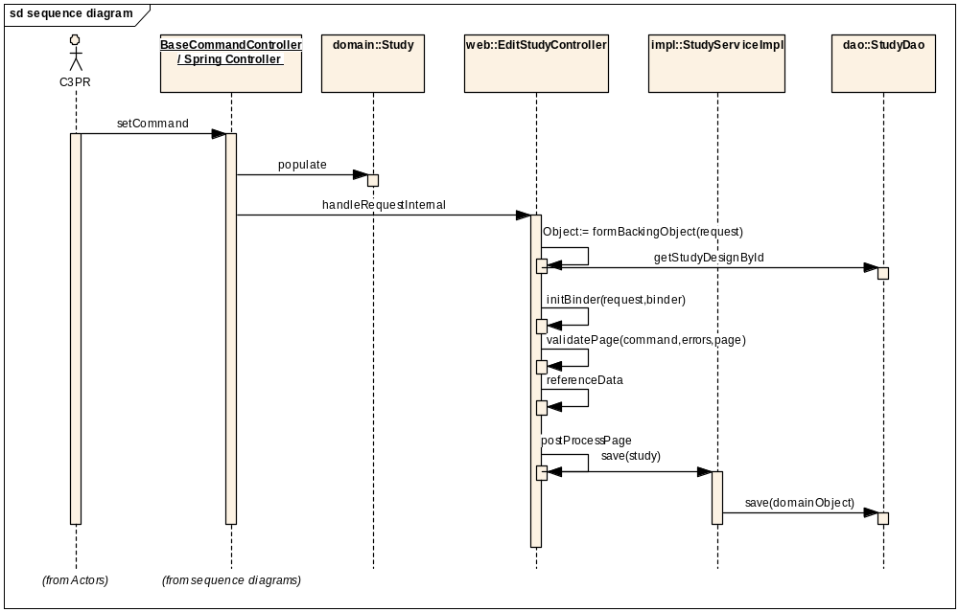

Create Subject
This use-case deals with the manual creation of a subject by entering each data element of the subject

Domain Objects

- Participant
- Person
- Address
- Identifier
- StudyParticipantAssignment

Activity Diagram
The workflow is split into 3 tabs using a Wizard form controller for capturing individual pieces of information about the subject. In the first tab, the basic subject details and the subject’s identifiers are entered. In the 2nd tab, the subject’s addresses are entered. The third tab is for reviewing and submitting all the information.

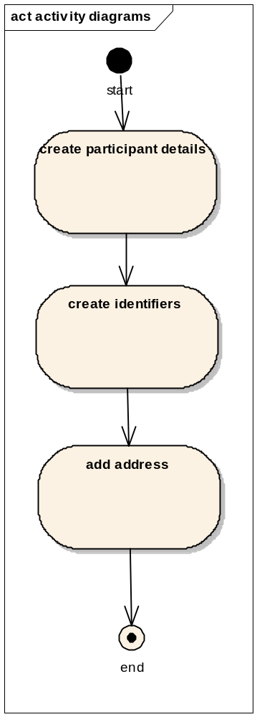

Sequence Diagram
Core controller of Create Subject is based on Spring’s AbstractWizardFormController. This eliminates the session/form handling by the developer and provides fine extension points for generating a workflow between a well defined set of pages with the notion of back/next buttons. The domain object acts as the command Object. The CreateParticipantController invokes the services of ParticipantServiceImpl. The ParticipantServiceImpl uses the ParticipantDao class for persisting the participant Object.

Spring Validators are used for simple business validations on the server side. The Controller’s validate() method takes the central place to delegate validations to individual validation of domain objects (Participant)

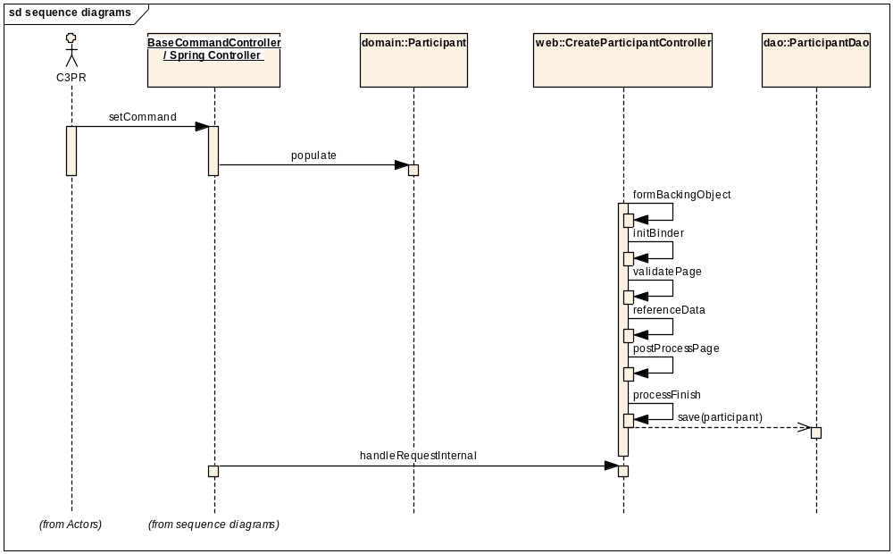

Search Subject
This use-case deals with searching an existing Subject either by last name or by one of the Identifiers.

Domain Objects

- Participant

Activity Diagram
User is provided a simple Form where search criteria can be entered (includes wildcards), search results are displayed in separate search results page with an option of searching from the same page via an intuitive search bar on the top of search results page

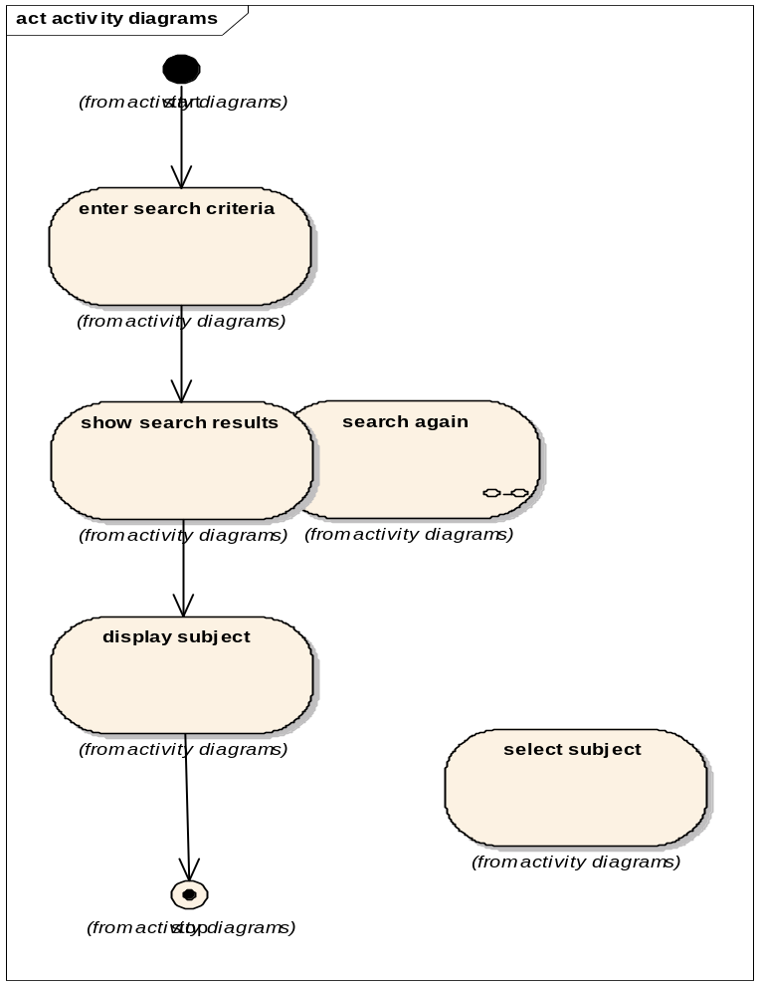

Sequence Diagram
A SimpleFormController is being used for implementing the behavior of Search->SearchResults page. Hibernate’s SearchByExample is being used to search using an example Subject object populated with the user’s dynamic criteria.

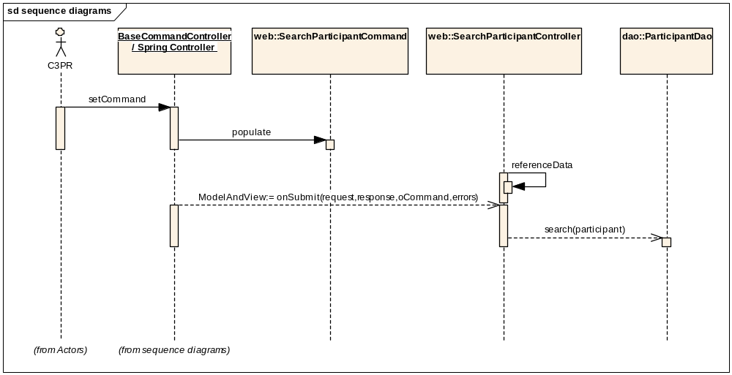

Edit Subject
This use case deals with updating the existing Participant once the user searches for a participant. The user can view the complete details of Participant as well as update individual identifiers, addresses, contact info

Domain Objects
- Participant
- Person
- Address
- Identifier
- StudyParticipantAssignment

Activity Diagram
The user is provided with a three sections of Participant View. The left most section is a read only pane with a Participant Summary Page with only the basic details. The middle section consists of a tabbed view with all existing details of Participant including identifiers, addresses, contact info. The right most section consists of a read only pane with Participant Registration Info

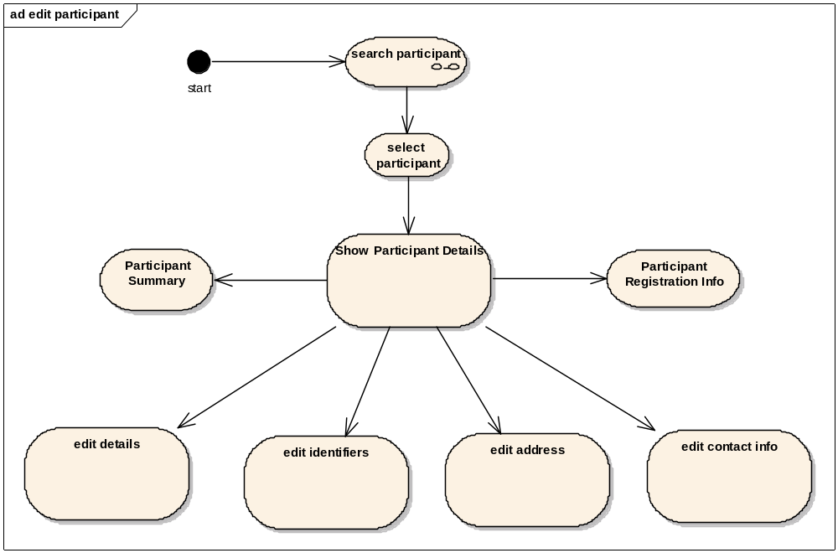

Sequence Diagram
Core controller of Edit Participant is based on Spring’s AbstractWizardFormController. This eliminates the session/form handling by the developer and provides fine extension points for generating a workflow between a well defined set of pages with the notion of back/next buttons. The validations and other functionality works similar to that of Create Participant Controller. The command object used for the controller is the domain object itself.

The main difference of Edit Participant wrt to Create Participant is the loading of entire Participant object in the formBackingObject. Once the user has selected a study in the previous screen, the edit screen should be loaded with Participant details in the Web Session. It is to be noted that Lazy loading of collections is not recommended as Hibernate objects need to be detached and reattached in case of updation in the Web layer. By loading the entire graph before the page is called simplifies the design for simultaneous view/update as Particpant objects are not intensive in data (still fine with performance). Spring’s HibernateTemplate is used to saveOrUpdate the populated domain object

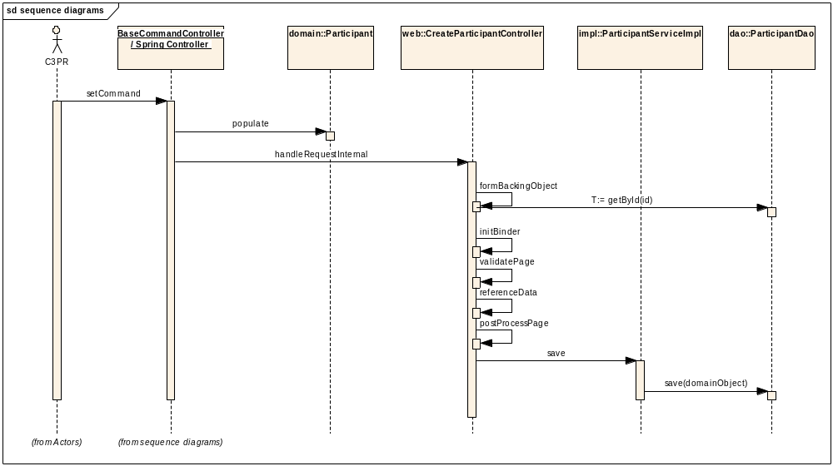

Register Subject to Multi-Site Study
This use case deals with registering a patient to a study being conducted at multiple sites. This use case from the perspective of the C3PRV2 system involves the following

Notifying the coordinating Site- The C3PRV2 system at the local site will notify the coordinating center of the multi-site study, of a new patient registration. It is assumed that the registration flows from the local site to the coordinating site. In this case the C3PRV2 system at the local site sends a notification of the new registration

Consuming the notification - The C3PRV2 system at the co-ordinating site will then receive and process this notification . Notification denotes a message that describes the patient registration that has taken place at a local site

Domain Objects

- StudyParticipantAssignment

Activity Diagram

This following activity diagram captures the sequence of events happening at the local site during the registration of a patient to a multi-site study.
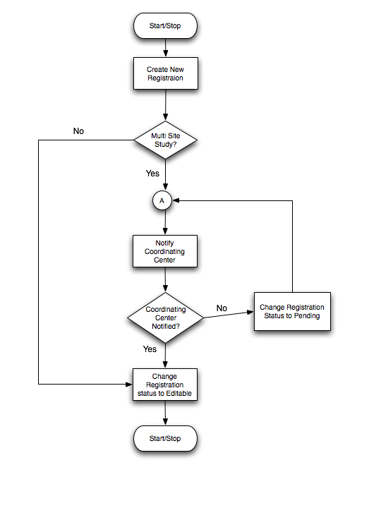

Sequence Diagram

The following sequence diagram captures the sequence of events at the coordinating center C3PRV2 that receives a notification of a new registration at the local site. The notification triggers the creating of a new Registration in the coordinating center C3PRV2 system

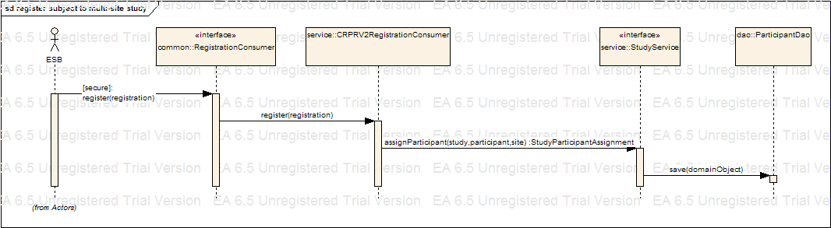

Register Subject to a Study
This use case deals with registering a participant with a study at a study site. The following are the various scenarios possible:
Patient not currently in C3PR.
Patient already existing in C3PR but not registered to any protocol.

Domain Objects

- StudyParticipantAssignment

Activity Diagram
The workflow is split into multiple pages in a Wizard style for capturing individual pieces of information for simplifying the workflow of Registration.

View/Update Registration Details
This use case deals with viewing a subject’s registration details, updating registration identifiers, changing the eligibility status, viewing stratification information, getting an arm from randomization and updating registration status. This use case from the perspective of the C3PRV2 system involves the following

Domain Objects

- StudyParticipantAssignment

Activity Diagram

This following activity diagram captures the sequence of events that happen in update registration details process.
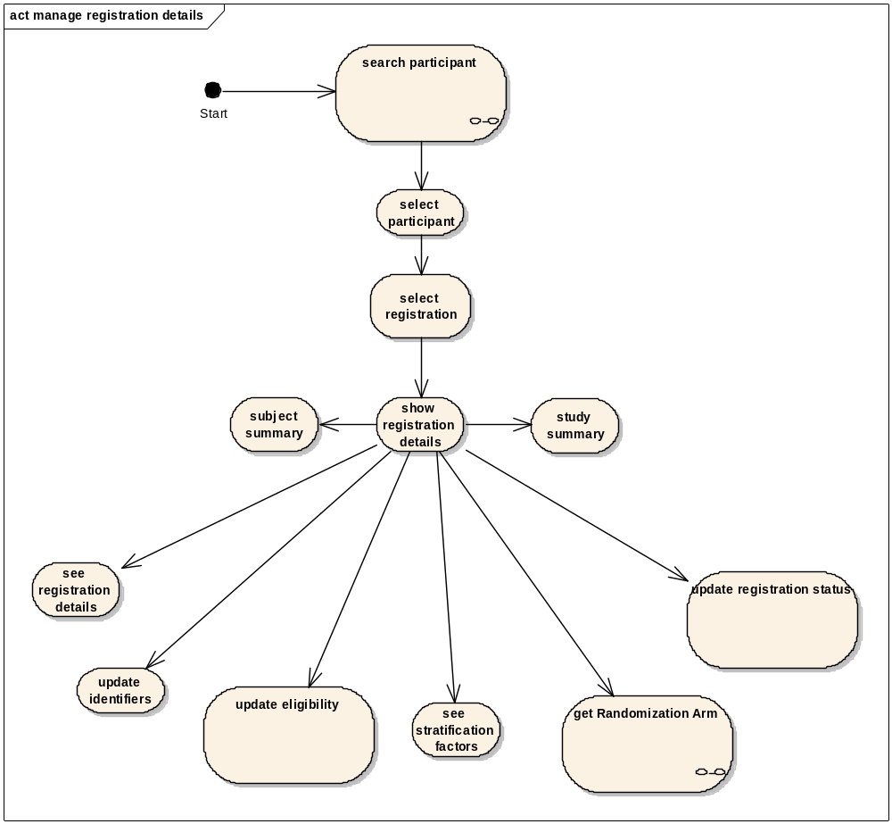

Sequence Diagram

Core controller of manage registration details is RegistrationDetailsController which extends RegistrationController, which in turn is derived from AbstractTabbedFlowFormController. Edit Registration Flow is initialized and tabs are added to the flow. Tabbed Flow Controller automatically manages the tab numbering and the page flow. The domain object, StudyParticipantAssignment is used as the command object.

The main difference of Edit Registration with respect to Create Registration is the loading of entire StudyParticipantAssignment object in the formBackingObject. Once the user has selected a registration from a set of registrations, the edit screen is loaded with Subject summary, registration details and study summary in the Web Session. It is to be noted that Lazy loading of collections is not recommended as Hibernate objects need to be detached and reattached in case of updation in the Web layer. By loading the entire graph before the page is called simplifies the design for simultaneous view/update. Spring’s HibernateTemplate is used to saveOrUpdate the populated domain object

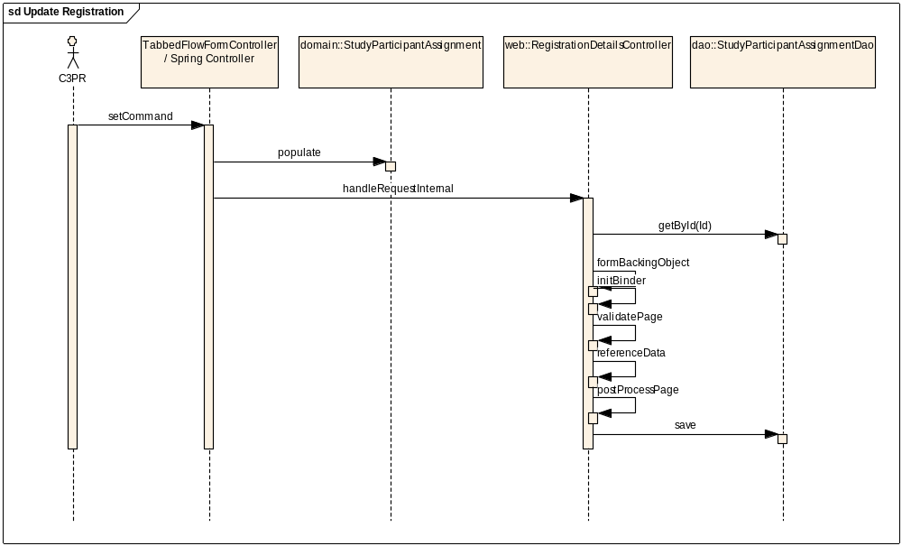

Integration with External Systems

ESB Client
C3PR Service interacts with an ESB client for messaging in order to pass on the data created (new Study, registration etc) to other instances of C3PR, as well as other external applications. More information about the design of ESB can be found in the technical design of ESB

Unit Testing

JUnit
JUnit framework will be used for unit testing. DbUnit forms the core part of the unit testing framework to setup/delete test data xmls before running each test case. C3PR uses custom classes written over DbUnit test package providing more utility methods for unit testing in each layer (Controller, Dao etc). Currently, C3PR has test cases at 2 levels, the Dao layer and the Web layer. Each DaoTest extends DaoTestCase, which extends DbTestCase, which in turn extends DatabaseTestCase. Before each test case is run, the DbUnit cleans up the database so that each test starts on a clean slate to make sure there are no errors introduced due to bad data or due to dependencies. All the test data xmls can be found in the package edu.duke.cabig.c3pr.dao.testdata. The database settings are externalized and specified in the file database.properties, which is to be found in core/conf. Other utility classes like ContextDaoTestCase, DaoTestCase, and ApplicationTestCase can be found in the package edu.duke.cabig.c3pr.utils.
Similarly at the web layer, each controllerTest extends ControllerTestCase, which inherits from WebTestCase, which in turn extends ApplicationTestCase. Mocks are registered for the HttpServletRequest, HttpServletResponse, ServletContext, Session, the Dao layer etc using springframework’s support for creating mocks. The controllers are tested for the correctness of the reference data, for handling the HttpServletRequest, HttpServletResponse, and for generating correct view. The test cases for the controllers and the command classes can be found in the package edu.duke.cabig.c3pr.web. The beans in the ApplicationContext*.xml are loaded using edu.duke.cabig.c3pr.utils.ContextTools.

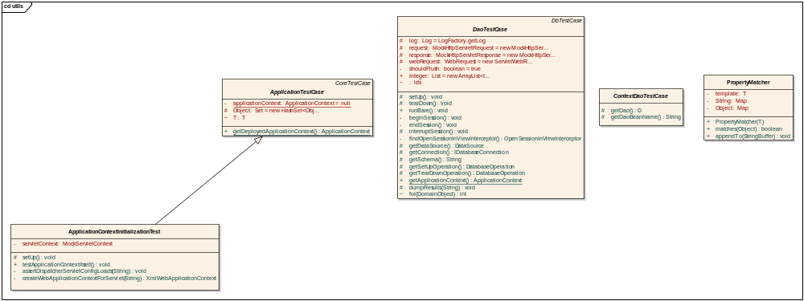

Mock Objects
Use of Spring mock objects for mocking the dependent layers like Controller, Dao, Services

Integration Testing
Integration Testing will be achieved via JUnit/Haste frameworks. This is integrated with the main build file.

Configuration/Build/Deployment
The files in the Core/Web projects will be build through the main build file (build-core & build-web individually). For all other builds like build-tests, the individual build files of these projects have corresponding ant tasks
- References
No | Artifact | Type | Link
1 | GForge CVS Repository | CVS Repository | gforge.nci.nih.gov
2 | c3pr_uml.eap | UML Design | gforge.nci.gov
3 | C3PRv2-BRIDG.EAP | Domain Model | gforge.nci.nih.gov
4 | C3prv2_use_cases.doc | Use Cases | gforge.nci.nih.gov
5 | c3prv2_technical_architecture.doc | Architecture | gforge.nci.nih.gov
6 | c3prv2_technical_specification_Integration | Architecture | gforge.nci.nih.gov
7 | C3prv2_srs.doc | SRS | gforge.nci.nih.gov
8 | c3prv2_technical_spec_servicemix.doc | design | gforge.nci.nih.gov

- Glossary
Term | Definition
CSM | Common Security Module
IdP | Identity Provider
API | Application Programming Interface
CDE | Common Data Element
GUI | Graphical User Interface
UML | Unified Modeling Language
JMS | Java Message Service
API | Application Programming Interface
caBIG | cancer Biomedical Informatics Grid
DAO | Data Access Objects
HTTP | Hypertext Transfer Protocol
JDBC | Java Database Connectivity
JSP | JavaServer Pages
ORM | Object Relational Mapping
RDBMS | Relational Database Management System
SDK | Software Development Kit
HASTE | High-level Automated System Test Environment
WSRF | Web service resource framework
ESB | Enterprise Service Bus
AJAX | Asynchronous JavaScript a
BC | Binding Component
SE | Service Engine
NMR | Normalized Message Router
JAAS | Java Authentication and Authorization Service
GAARDS | Grid authentication and authorization with Reliably Distributed Services
DWR | Direct Web Remoting

