Use Case Document

Cancer Central Clinical Participant Registry (C3PR)
Version 2
Duke Comprehensive Cancer Center

Table of Contents

1 Introduction 5
1.1 Overview 5
1.2 Document Conventions 5
1.3 Related Documents 6
2 Actors and Roles 6
2.1 Roles 6
3 Manage Subjects 8
3.1 Create Subject 8
3.2 Search for a Subject 10
3.3 View a Subject 11
3.4 Update Subject Details 12
4 Manage Study 13
4.1 High Level Manage Study Use Case Diagram 14
4.2 High Level Study Data Capture Use Case Diagram 15
4.3 Create Study Definition Manually 15
4.4 Search for Studies 17
4.5 View Study 18
4.6 Update Study 19
4.7 Associate Study Personnel to Study 21
4.8 Add Notifications to Study 22
4.9 Add Stratification 24
4.10 Disable a Stratum Group 26
4.11 Add Eligibility Criteria 28
4.12 Add Diseases 30
4.13 Change Study Status from Pending to Active 32
4.14 Change Study Status from Amendment Pending to Active 34
4.15 Approve Study Definition 35
4.16 Update Study Definition 37
5 Manage Registration 38
5.1 Register a New Subject to a Study 38
5.2 Register a Subject to a Multi-site Study 40
5.3 Register an Existing Subject to a Study 42
5.4 Assign Kit Number for Blinded Study 43
5.5 Save a Registration in Incomplete Status 45
5.6 Register Subject to a Reservation-enabled Study 46
5.7 Search for Registrations 48
5.8 View Subject Registration History 50
5.9 Update Eligibility Status on a Pre-Registration/Registration 51
5.10 Randomize Subject 52
5.11 Update Registration Status of a Subject on a given Study 54
6 Reporting 55
6.1 Advanced Registration Search 55
6.2 Study Search and export 56
7 Administration 58
7.1 Create Investigator 58
7.2 Add Investigator Group(s) 59
7.3 Add Investigator(s) to a Group 61
7.4 Search for Investigators In a Group 62
7.5 Create Research Staff 64
7.6 Create Organization 65
7.7 Associate Investigator to Study Organization 67
7.8 Associate Investigator Group to Study Organization 68
7.9 Search for a Study Personnel 70
7.10 View or / and Update Research Staff Member Details 71
7.11 Search for an Investigator 73
7.12 View or / and Update Investigator Details 74
7.13 Disassociate Study Person from a Study Site 76
7.14 Change the Study Site Investigator status 77
7.15 Export Study definition to a File 78
7.16 Export Registration definition to a File 80
7.17 Load (Import) Study Definition from a File 81
7.18 Get Study Definition via Study Message from External Source 83
8 Integration 84
8.1 Synchronize Registration of a Subject on a Study Arm with Study Calendar 84
9 Overall Requirements 86
9.1 Requirements Prioritization 86
10 Sign Off 87
10.1 Approval 87

Introduction

Overview
Researchers, who conduct clinical trials themselves and often require comparative data for dosing, measurable clinical trial end-points, model validation, encounter difficulty accessing aggregate clinical trials data. This, in turn, limits their ability to advance the science. The development and deployment of a central registry, containing requisite information on clinical trials, will provide all groups (subjects and their families indirectly, community physicians and cancer researchers directly) to meet their diverse set of informational and data needs.
C3PR Release 1 provides a highly configurable participant registry for managing clinical study registration at a single site. However, it cannot easily manage cross-site studies, and it can be very difficult to install, configure, and manage. The primary goal of C3PR Release 2 is to build upon Release 1 to make it more generally useful to the cancer research community. A scoping goal will be for C3PR to manage participant registration to multi-site studies. This involves the integration of C3PR instances at different centers. Additionally, integration beyond C3PR will be needed to perform institution-level and PI-level eligibility checks. The current registration model is somewhat limited, allowing for simplistic randomization based upon manual assignment of participants to arms. Furthermore, study management in C3PR will be greatly enhanced. Though C3PR is not intended as a central study repository, study information is critical to the registration process. Study information will be expanded to meet the use cases of multiple eligibility check-points, multi-institutional studies, and differing randomization schemes. C3PR Release 1 provided registration from a participant-centric standpoint. This workflow will be enhanced to provide registration from a study-centric view, and reporting will be extended to provide this information to external systems to generate complex reports.

Document Conventions
The C3PR Release 2 project follows the iterative development of the Unified Framework Process. Thus, each document is a snapshot of a work-in-progress. The following conventions will be used throughout the document:

- Red highlighting will indicate new items that need to be addressed immediately in the next iteration by the developers.
- Green highlighting will indicate new items that need to be addressed in the next iteration by the elaborators.

Related Documents

- Vision and scope document
https://gforge.nci.nih.gov/plugins/scmcvs/cvsweb.php/c3prv2/documentation/communication/c3prv2_vision_scope.doc?cvsroot=c3prv2
- Communication Plan
https://gforge.nci.nih.gov/plugins/scmcvs/cvsweb.php/c3prv2/documentation/communication/c3prv2_communication_plan.doc?cvsroot=c3prv2
- Use case document
https://gforge.nci.nih.gov/plugins/scmcvs/cvsweb.php/c3prv2/documentation/use_cases/c3prv2_use_cases.doc?cvsroot=c3prv2

- Project plan
https://gforge.nci.nih.gov/plugins/scmcvs/cvsweb.php/c3prv2/documentation/planning/c3prv2_project_plan.doc?cvsroot=c3prv2
- Risk matrix
https://gforge.nci.nih.gov/plugins/scmcvs/cvsweb.php/c3prv2/documentation/risks/?cvsroot=c3prv2

Actors and Roles
The actors are the actual users of the system. They can have one or more roles in the system. These roles can be assigned and revoked based upon specific studies. Roles will define the privileges that an actor has to perform functions within C3PR.

Roles
C3PR Role | C3PR Version | C3PR Definition | caDSR Role | caDSR Concepts | caDSR Definition | BRIDG Role
Subject | 2 | Does not participate in C3PR | Participant | C29867 | Someone who takes part in an activity. | Participant
Study Chair | >2 | Has overall responsibility for scientific conduct of study. Has read permission for all aspects of his studies. | Study Chair | C51878 | A person who is responsible for providing overall management for the operation of the study, and for reporting to the Data and Safety Monitoring Board. The continual review of the data by an independent individual or DSMB assures the investigator(s) that the trial can continue without jeopardizing patient safety. | MISSING
Site Principle Investigator | 2 | Conducts studies at a single institution. Has read permission for all aspects of his studies. | Principal Investigator | MISSING | An investigator who is responsible for all aspects of the conduct of a study. | Investigator
Enrolling Physician | 2 | Performs treatment and follow-up for subjects. Has read permissions to study reports. | Physician | C25741 | Physician; a licensed medical practitioner. | MISSING
Data Manager | >2 | Collects and reviews data. Has read permissions to study reports. | Data Manager | C51820 | A person primarily responsible for database creation, data collection, validation, integration, coding, review, quality evaluation, and archiving, as well as for preparation of reports and data displays. | Clinical Data Management
Study Coordinator | 2 | Defines and conducts the study at a particular site. Has create, read, and update of study definitions. Can stop enrollment on a study. Has read permissions for aggregate reports. | Study Coordinator | C51880 | A person who handles most of the administrative responsibilities of a clinical study, acts as liaison between investigative site and sponsor, and reviews all data and records before a monitor's visit. | Study Designer
Registrar | 2 | Enrolls subjects on studies. Has create, read, and update permissions on subjects, enrollments, and treatment assignments. Has read permission on the study and reports. | Registrar | C25357 | Registrar; someone responsible for keeping records. | MISSING
IRB Manager for C3PR | >2 | Manages the IRB aspects of a study. Has update permission on the study record. | Protocol Chair at an Organization | C51855 | A person at a business or administrative group that retains the responsibility for regulation compliance and ensures the proper administration of the objectives, study design, and methodology of study. | MISSING
Site Coordinator | 2 | Manages administrative aspects of study conduct. Has delete and read permissions across all aspects of C3PR. Has update permission on the study record. | Site Coordinator | C51872 | The staff member at the organization who is responsible for program management of the study and functions as the primary contact at the organization. | Site Coordinator
Security Manager | >2 | Assigns access privileges to C3PR system. Has permissions to assign roles. | MISSING | MISSING | MISSING | MISSING
Technical System Administrator | 2 | Administers C3PR from a technical standpoint. Has permissions to create new roles. | MISSING | MISSING | MISSING | MISSING
Site Software Developer | >2 | Writes modules to interact with C3PR, such as new reports. Has permissions to create and update reports. | Software Developer | C67226 | A person or organization that designs software and writes the programs. Software development includes the design of the user interface and the program architecture as well as programming the source code. A somewhat broader scope of computer programming or a specialty of project managing. | Programmer
Data Analyst | >2 | Analyzes data (generally for reporting and operational purposes). Has permissions to read all data in C3PR. | Statistician | C51877 | A person responsible for the compilation, organization, and analysis of mathematical data. | Statistician
More roles related to BRIDG may be added in future iterations. The roles with C3PR Version 2 are implemented in version 2. Those with C3PR Version >2 will be implemented in a future release but are still documented here.
Note that there are differences in terminology regarding roles among the various institutions and organizations, as well as variations in combinations of roles. This document will not attempt to capture all the variations and situation specific differences, but describes roles to a sufficient level of detail needed for system functionality.

Manage Subjects

Create Subject

Use Case Model
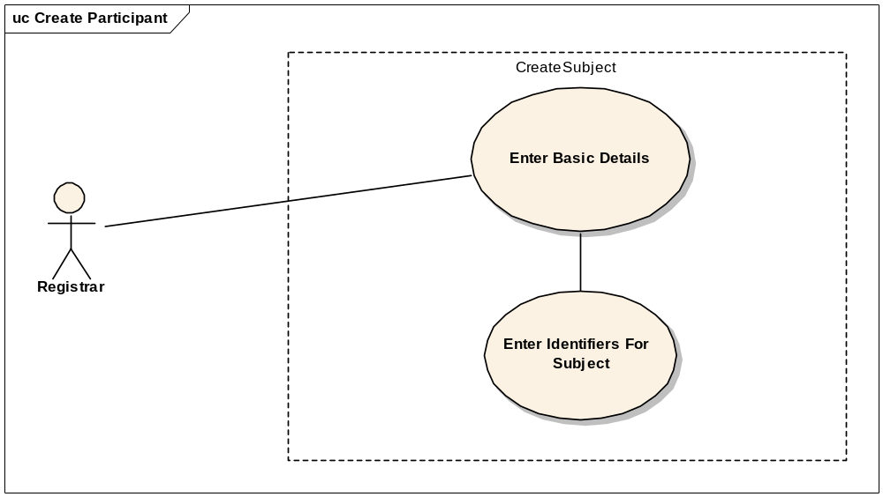

Brief Description
This use-case deals with the manual creation of a subject by entering each data element of the subject.

Primary Actor
Registrar or any other designated user of C3PR with role authority to create a Subject.

Secondary Actors
Registrar

Preconditions
- The user is logged in to the system with a user account that has role authority to create a Subject.
- The Subject doesn’t already exist.

Basic Flow of Events
- The user indicates to the system that he/she wants to create a new Subject
- The system displays the screen that gives the user option of entering the Subject information manually.
- The user enters the Subject data elements in the fields.
- The user indicates to the system that the required Subject information has been entered for creation of a new Subject.
- The system displays Subjects with matching fields to ensure that the subject is not a duplicate.

Postconditions
- If the user is logged in to the system with a user account that has role authority to create a Subject (for example, a Registrar), the created Subject is approved.
- If the user was logged in to the system with a role authority to only enter the Subject information, the created Subject awaits for further validation check before it becomes approved.

Alternate flow
1. The system shows an error for Subjects with a duplicate identifier.

Alternate flow
1. The system displays Subjects with matching fields to ensure that the subject is not a duplicate.

Special Requirements
1. Entering Subjects in C3PR that are not registered may represent a patient data risk to some cancer centers.

Search for a Subject

Use Case Model
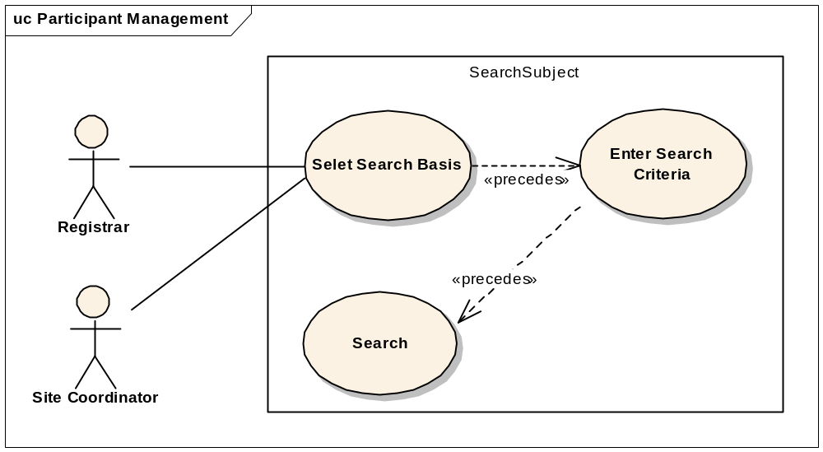

Brief Description
This use-case deals with searching for a subject. Reasons for searching for a subject include:
  - Looking for duplicate subjects
  - Begin subject registration in create registration workflow
  - View registration details
  - Update subject information
  - Update registration

Primary Actor
Registrar, Site Coordinator, Principal Investigator or any other user of C3PR with role authority to search for a subject.

Secondary Actors
Registrar

Preconditions
The user is logged in to the system with a user account that has role authority to search for a subject.

Basic Flow of Events
- The user indicates to the system that he/she wants to search for a subject.
- The user selects the search basis on which he/she wants to perform the search.
- The user enters the search criteria for the subject and submits the information to the system.
- The system displays 0, 1 or multiple subjects depending on the search criteria.

Post conditions
The resulting subject is in a state that the user can use to perform registration in create registration flow or simply to view subject details or to update subject details.

Special Requirements

View a Subject

Use Case Model
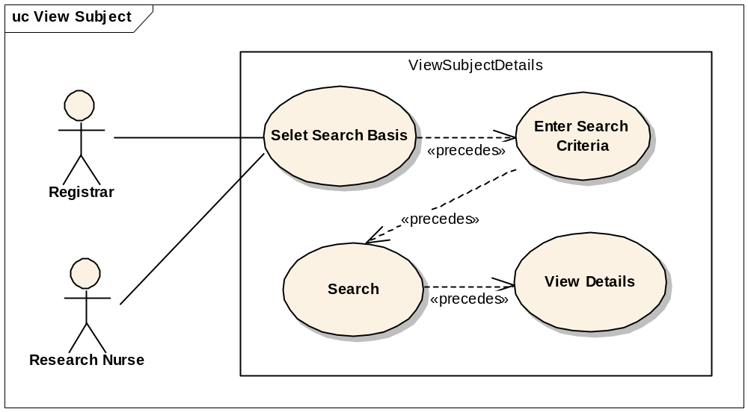

Brief Description
This use case allows the user to view Subject’s record.

Primary Actor
Registrar, Principal Investigator or any other user of C3PR with role authority to view subject details.

Secondary Actors
Registrar

Preconditions
The subject already exists.

Basic Flow of Events
- The user indicates to the system that he/she wants to search for a subject.
- The user enters the search criteria for the subject and submits the information to the system.
- The system displays 0, 1 or multiple subjects depending on the search criteria.
- The user selects a subject.
- The user views the subject details

Post conditions

Special Requirements

Update Subject Details

Use Case Model
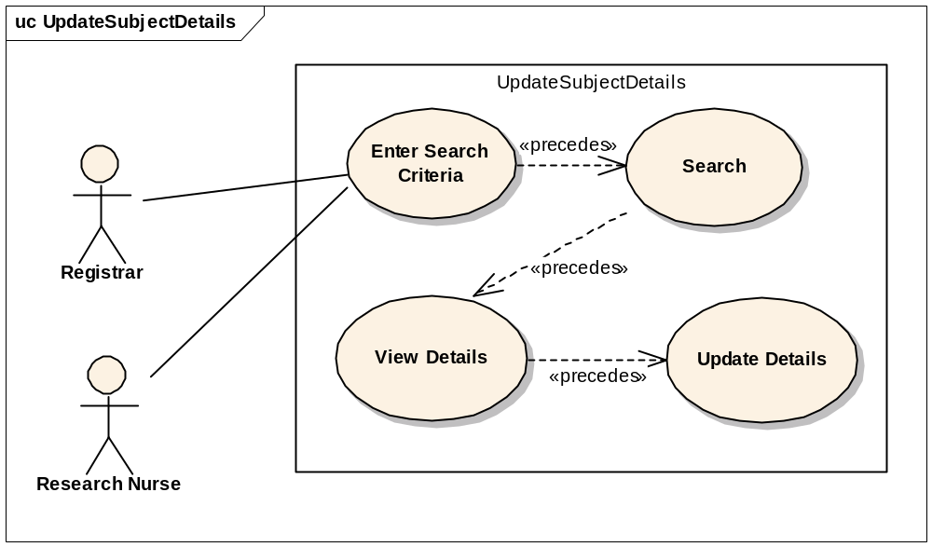

Brief Description
This use case allows the user to update Subject’s record.

Primary Actor
Registrar, Principal Investigator or any other user of C3PR with role authority to update subject’s details.

Secondary Actors
Registrar

Preconditions
The subject record already exists.

Basic Flow of Events
- The user indicates to the system that he/she wants to search for a subject.
- The user enters the search criteria for the subject and submits the information to the system.
- The system displays 0, 1 or multiple subjects depending on the search criteria.
- The user selects a subject.
- The user views the subject details.
- The user updates the subject details.

Post conditions
1. The subject record is updated

Special Requirements
None.

Manage Study
Study Management is not the primary function of C3PR. However, Study Management is critical for the independent functioning of C3PR because registration is driven by the structure of the study. Therefore, it is included as a primary use case.

High Level Manage Study Use Case Diagram
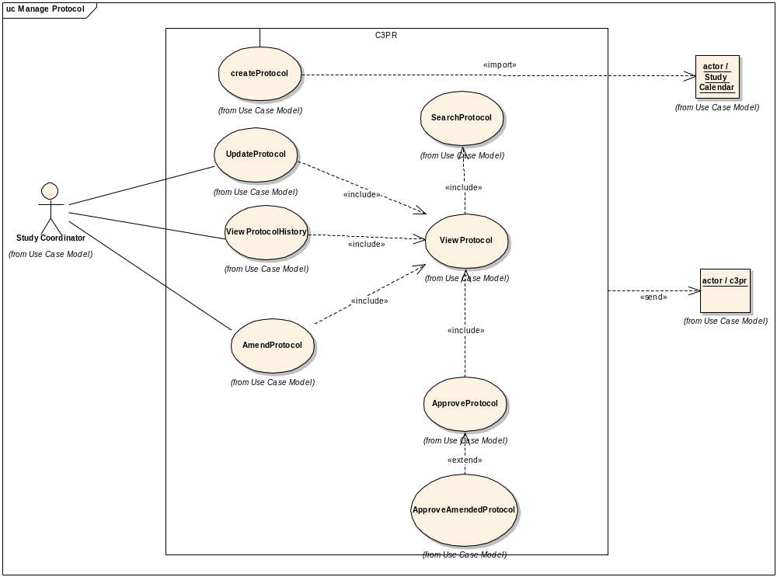

High Level Study Data Capture Use Case Diagram
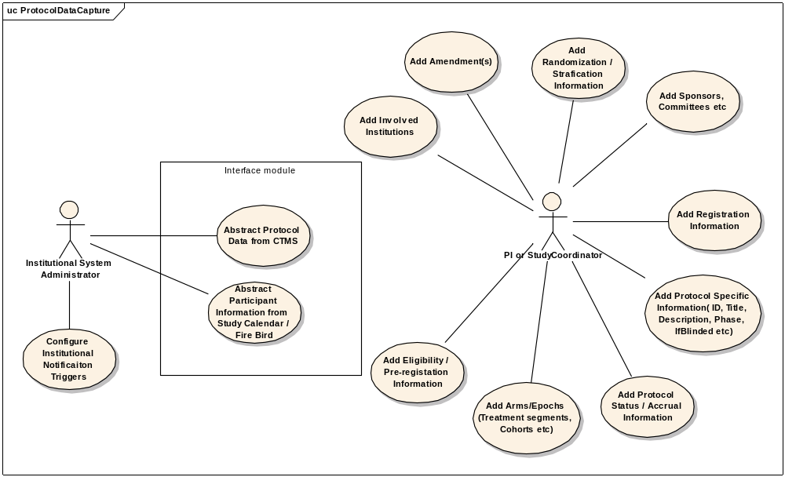

Create Study Definition Manually

Use Case Model
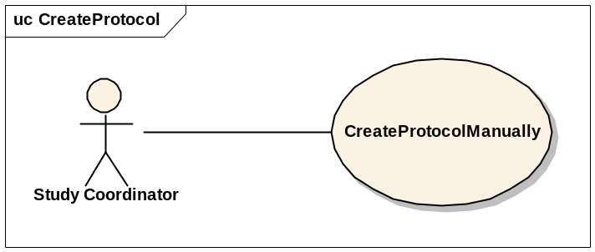

Brief Description
This use-case deals with the manual creation of a study by entering each data element of the study.

Primary Actor
Study Coordinator or any other designated user of C3PR with role authority to create a study.

Secondary Actors
Study Coordinator or any other designated user of C3PR with role authority to approve a study.

Preconditions
- The user is logged in to the system with a user account that has role authority to create a study.
- The study has not already been entered

Basic Flow of Events
- The user indicates to the system that he/she wants to create a new study definition
- The system displays the screen that gives the user option of entering the study information manually.
- The user enters the study data elements in the fields.
- The user indicates to the system that the required study information has been entered for creation of a new study through a confirmation window with all of the study data items.

Post conditions
- If the user is logged in to the system with a user account that has role authority to create a Study (for example, a Study Manager), the created study is verified.
- If the user was logged in to the system with a role authority to only enter the study information, the created study awaits for further validation check from a Study Coordinator/Study Manager before it becomes approved.

Alternate flow
- The system displays studies with matching fields to ensure that the study is not a duplicate.

Special Requirements
None

Search for Studies

Use Case Model
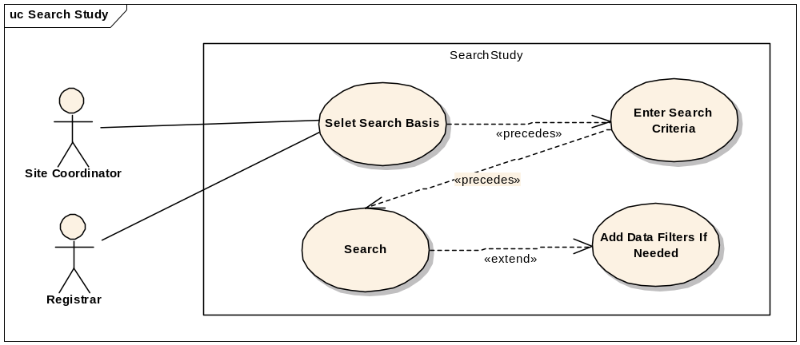

Brief Description
This use-case deals with searching for a study. Reasons for searching for a study include:
  - Looking for duplicate studies
  - Begin subject registration
  - Check for eligibility requirements
  - Check study status
  - Modify a study

Primary Actor
Database Manager, Site Coordinator, Registrar or any other user of C3PR with role authority to search for a study.

Secondary Actors
None

Preconditions
The user is logged in to the system with a user account that has role authority to search for a study.

Basic Flow of Events
- The user indicates to the system that he/she wants to search for a given study definition.
- The user enters the search criteria for the study and submits the information to the system.
- The system displays 0, 1 or multiple study definitions depending on the search criteria.

Post conditions
The resulting study list is in a state that the user can transition to any of the manage study or register subject use cases. This means sufficient detail is presented to the user in order to determine which study to transition to. These details will be determined in later iterations.

Special Requirements

View Study

Use Case Model
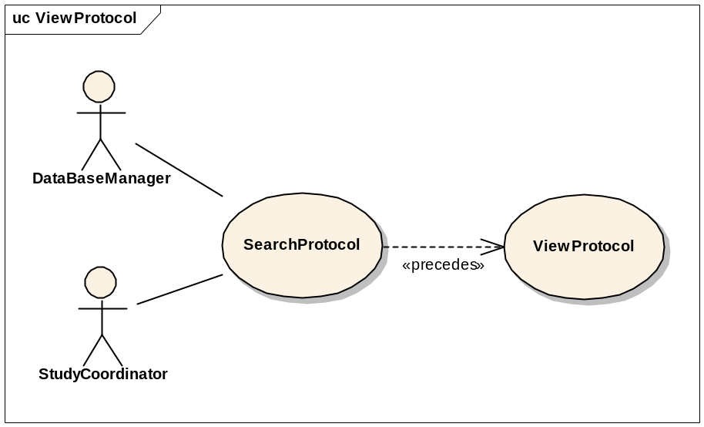

Brief Description
This use-case deals with viewing a study.

Primary Actor
Database Manager, Study Coordinator, Principal Investigator or any other user of C3PR with role authority to view a study.

Secondary Actors
None

Preconditions
The user is logged in to the system with a user account that has a role authority to view a study definition.

Basic Flow of Events
- The user indicates to the system that he/she wants to search for a given study definition.
- The user enters the search criteria for the study and submits the information to the system.
- The system displays 0, 1 or multiple study definitions depending on the search criteria.
- The user selects a study.
- All data items from the study are displayed

Post conditions

Special Requirements

Update Study

Use Case Model
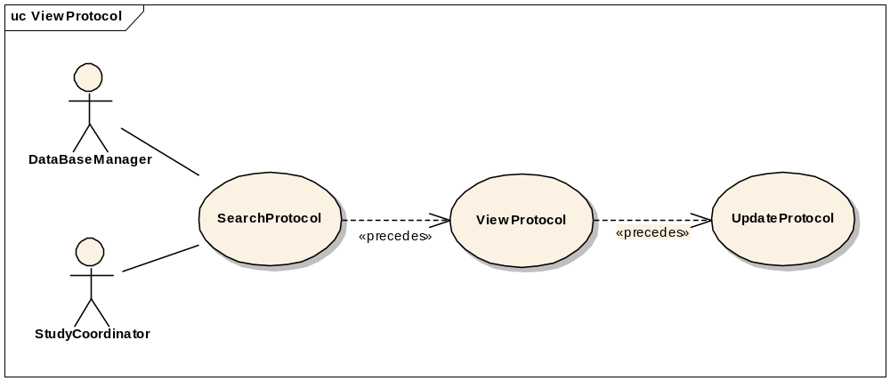

Brief Description
This use-case deals with updating a study entry through the user interface. Note that this is different from a study amendment, which is a metadata item about an official change to a study.

Primary Actor
Database Manager, Study Coordinator or any other user of C3PR with role authority to update a study definition. This includes changing the status of the study (i.e. open versus closed).

Secondary Actors
None

Preconditions
The user is logged in to the system with a user account that has role authority to update a study definition.

Basic Flow of Events
- The user indicates to the system that he/she wants to search for a given study definition.
- The user enters the search criteria for the study and submits the information to the system.
- The system displays 0, 1 or multiple study definitions depending on the search criteria.
- The user selects a study and views that study.
- The user updates the necessary fields.
- The user saves the updated study information to the system.

Post conditions
- If the user is logged in to the system with a user account that has role authority to update a study, the study stands updated
- If the user is logged in to the system with a user account that doesn’t have a role authority to update a study, the study awaits for further validation check from a study manager.

Special Requirements

Associate Study Personnel to Study

Use Case Model
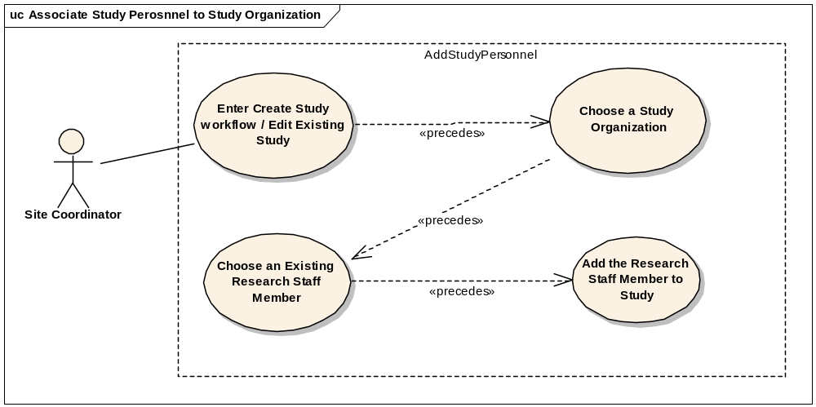

Brief Description
A study, depending on whether it is multi-site study or not can have multiple sites associated with it. Each site can have one or more personnel (Research Staff) involved in conducting the study. This use case deals with associating such staff with a Study. Site Coordinator, during the creation of a study definition, will be able to add one or many of the study personnel for the study.

Primary Actor
Site Coordinator

Secondary Actors
None.

Preconditions
- The user is logged in to the system with an administrative account that has role authority to add study personnel to the study organization.
- The organization already exists.
- The study exists.
- The intended research staff member already exists at that organization.

Basic Flow of Events
1. The user locates the study of interest
2. The user indicates that he/she wants to associate study personnel.
3. The user selects the desired organization for which the association should take place.
4. The user chooses from the list of research staff existing at this organization to be assigned as study personnel
5. The user chooses other relevant info for the association
6. The user may select more research staff repeating the steps 1-4

Post Conditions
None.

Special Requirements
None.

Add Notifications to Study

Use Case Model

Brief Description
A study can have multiple notifications associated with it. Every notification has a Threshold value associated with it. A notification email is sent when the number of registered participants reach the threshold value. These notifications can be either Email based or Role based. Email based notifications take an email address as input and Role based notificatinos send emails to all the email addresses in that role for that study.

Primary Actor
Site Coordinator

Secondary Actors
None.

Preconditions
- The user is logged in to the system with an administrative account that has role authority to add study personnel to the study organization.
- The study already exists.
- The intended roles and email addresses already exist.

Basic Flow of Events
1. The user locates the study of interest
2. The user indicates that he/she wants to add notifications.
3. The user clicks on Add Notifications.
4. The user enters a threshold value for which he wants the notification to be sent.
5. The user enters an email address by clicking the Add email or selects a role by clicking on Add Role.
6. The user may repeat the steps 1-5 as many times as desired.

Post Conditions
The notifications are set up such that when the registered participants reach the threshold value the corresponding email addresses/roles are notified..

Special Requirements
None.

Add Stratification

Use Case Model
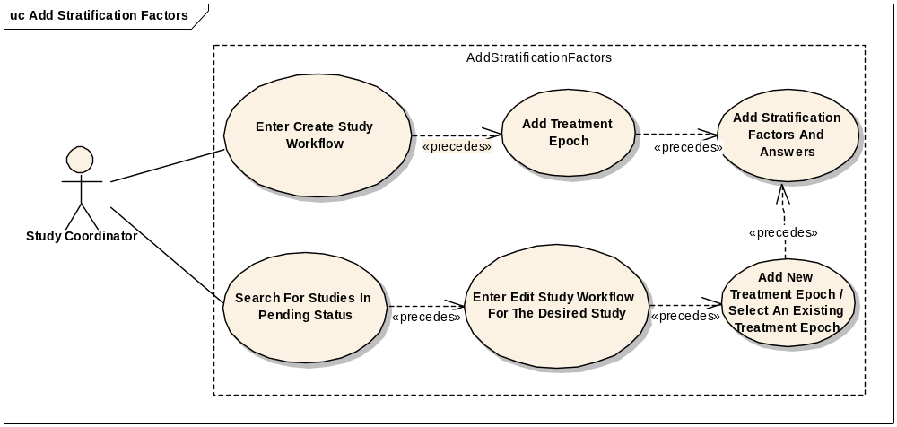

Brief Description
Studies can have one or more stratification factors. Each stratification factor consists of a question and two or more discreet answers. The answers for a particular Subject on a Study determine the stratum group for the Study Subject. The stratum group can be used to help determine the arm during randomization.

Primary Actor
Study Coordinator: defines the stratification when defining the study

Secondary Actors
None

Preconditions
1. The user is in the study creation or update workflow

Basic Flow of Events: Study Definition
1. The user enters the stratification portion of the study definition workflow
2. The user adds zero or more stratification factors
3. The user defines the question text for each stratification factor
4. The user defines one or more discreet answers for each stratification factor
5. The system saves the stratification factors

Basic Flow of Events: Subject Registration
1. The user enters the registration workflow
2. The user navigates to the stratification tab
3. The user answers each stratification factor question via drop-down menus
4. The stratum group is displayed when then final stratification factor is answered
5. The system saves the stratum group

Post Conditions
None

Special Requirements
None.

Disable a Stratum Group

Use Case Model
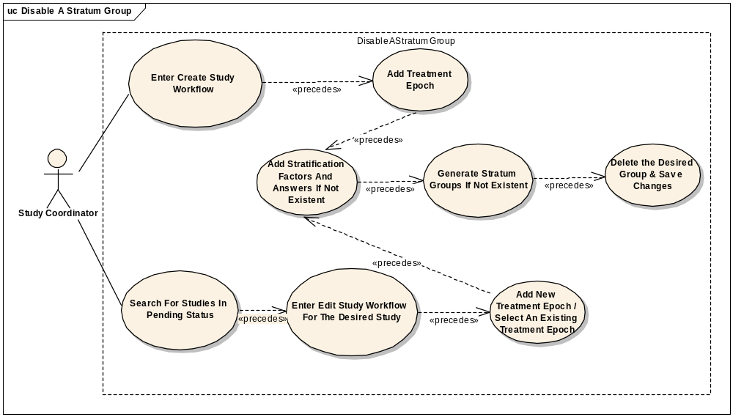

Brief Description
Studies can have one or more stratification factors. Each stratification factor consists of a question and two or more discreet answers. The different combinations of all the questions along with the possible answers constitute the stratum groups. All stratum groups may not be important or valid for the study. This use case deals with disabling an invalid group.

Primary Actor
Study Coordinator: defines the stratification and stratum groups when defining the study

Secondary Actors
None

Preconditions
      - The user is in the study creation or update workflow.
      - The study is either newly created or is in pending status.

Basic Flow of Events: Study Definition
1. The user enters the stratification portion of the study definition workflow
2. The user adds one or more stratification factors if they do not already exist.
3. The user defines the question text for each stratification factor.
4. The user defines one or more discreet answers for each stratification factor
5. The user indicates to the system to generate the stratum groups if they do not already exist or if he/she updates any stratification questions and/or answers.
6. The user deletes the desired stratum group.
7. The user indicates to the system to update/save the study.

Post Conditions
- The stratum group will be deleted.
- If the study has book randomization, the book randomization entries have to be updated to remove the entries for the deleted stratum group.

Special Requirements
None.

Add Eligibility Criteria

Use Case Model
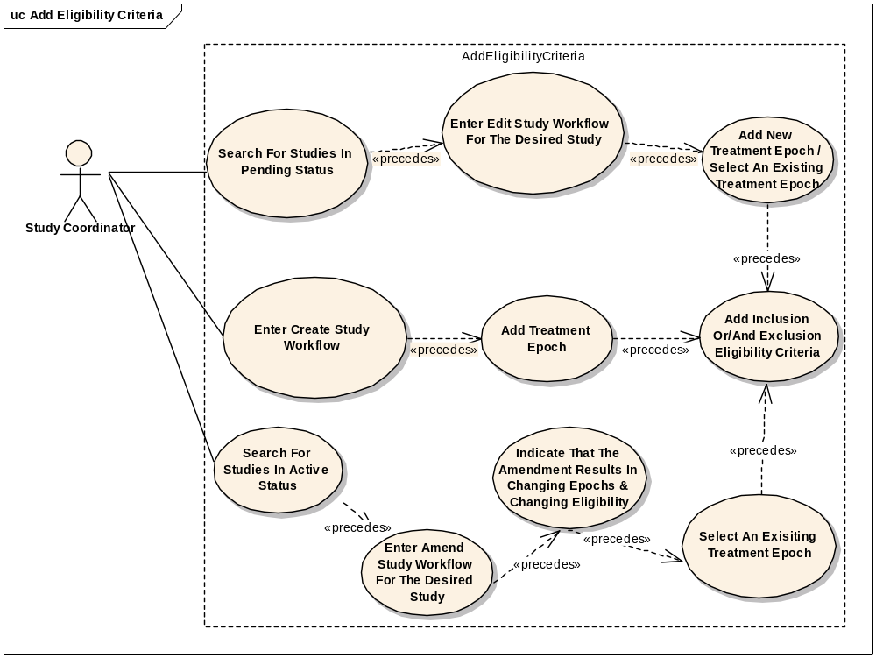

Brief Description
Studies can have one or more Eligibility Criterion. These are further classified as Inclusion and Exclusion Eligibility criteria. The user can add new eligibility criteria to any treatment epoch. This use case helps add new eligibility criteria in 3 different ways depending on the business requirement.

Primary Actor
Study Coordinator: defines the eligibility criteria when defining the study.

Secondary Actors
None

Preconditions
1. The user is in the study creation or update workflow

Basic Flow of Events: Create Study
      - The user enters the eligibility portion of the study definition workflow.
      - The user identifies the treatment epoch for which eligibility criteria needs be added.
      - The user adds one or more inclusion or/and exclusion criterion.
      - The user updates the study to save the newly added eligibility questions.
ALTERNATE FLOW (Load caDSR):
- The user enters the eligibility portion of the study definition workflow.
- The user selects the treatment epoch for which eligibility criteria needs be added from a dropdown.
- The user adds clicks on the browse button and selects the file to be uploaded.
- The user clicks the upload button.
- The user can now add to or modify the uploaded contents.

Basic Flow of Events: Edit Study
1. If the desired study is saved in a pending status, the user enters the search criteria and searches for the desired study.
2. The user selects the desired study and enters the edit workflow.
3. The user enters the eligibility portion of the study.
4. The user identifies the treatment epoch for which eligibility criteria needs to be added.
5. The user adds one or more inclusion/exclusion eligibility criterion.
6. The user updates the study to saves the newly added eligibility questions.

Basic Flow of Events: Amend Study
1. If the desired study is saved in an active status, the user enters the search criteria and searches for the desired study.
2. The user selects the desired study and enters the amend study workflow.
3. The user indicates that treatment epoch and eligibility change as a result of the amendment.
4. The user enters the eligibility portion of the study.
5. The user identifies the treatment epoch for which eligibility criteria needs to be added.
6. The user adds one or more inclusion/exclusion eligibility criterion.
7. The user updates the study to saves the newly added eligibility questions.

Post Conditions
New eligibility criteria is added to the study.

Special Requirements
None.

Add Diseases

Use Case Model

Create Study
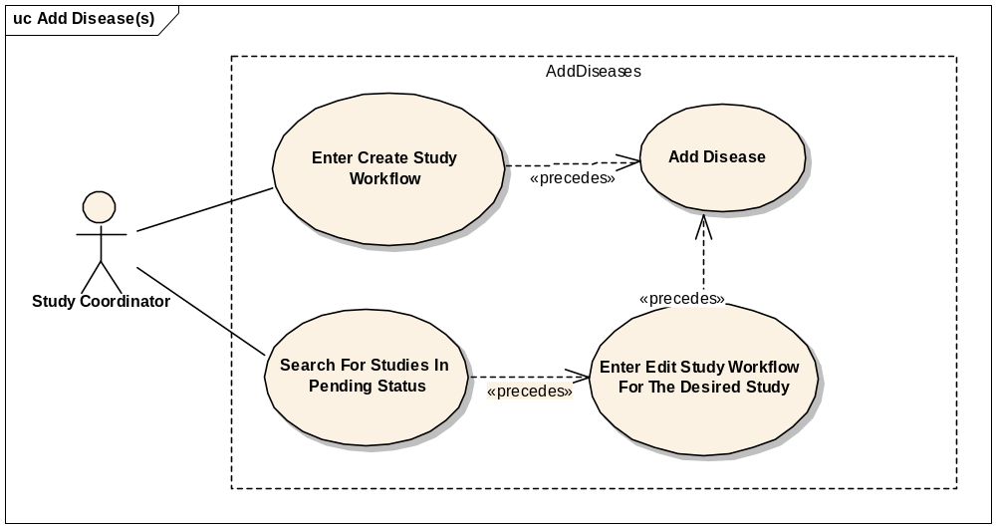
Registration Flow
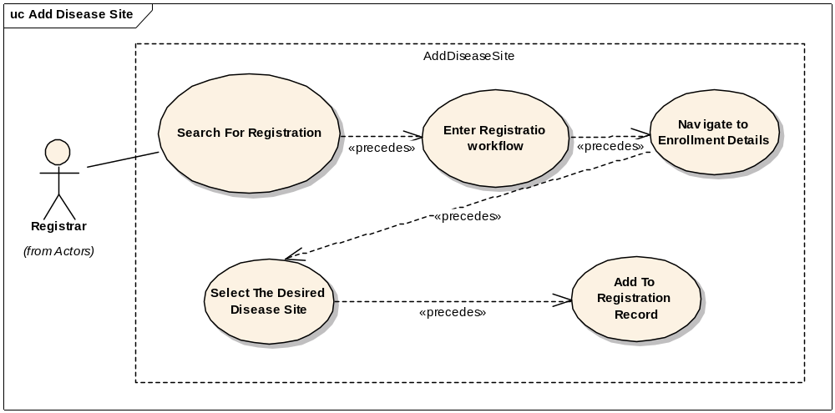

Brief Description
Studies can have one or more diseases associated with them. These diseases are used during Registration to allow the user to select a disease for a Study Subject. The user will also be able to select a primary disease site for the Study Subject. There are a number of different disease and disease site nomenclatures used in the community. C3PR will initially provide the CTEP diseases and disease sites.

Primary Actor
Study Coordinator: defines the disease sites when defining the study
Registrar: registers a subject to a study and, in doing so, defines the disease and disease site for the subject.

Secondary Actors
None

Preconditions
None

Basic Flow of Events: Study Definition
1. The user enters the disease portion of the study definition workflow
2. The user adds one or more diseases

Basic Flow of Events: Subject Registration
1. The user enters the registration workflow
2. The user navigates to the disease tab
3. The user selects a disease or enters a free-text disease
4. The user selects a disease site or enters a free-text disease site

Post Conditions
- A new disease and disease site are associated with the study.

Special Requirements
None.

Change Study Status from Pending to Active

Use Case Model
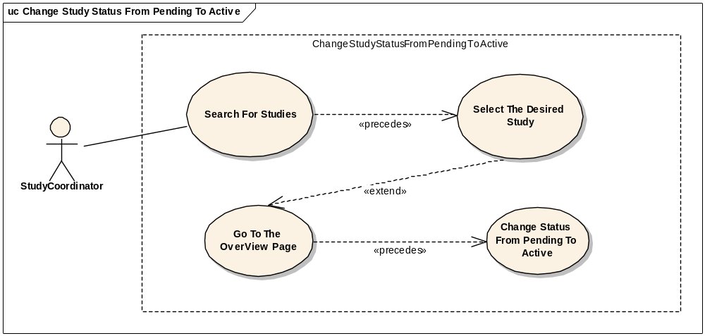

Brief Description
A new study entered into c3pr using the User Interface is always saved in a pending status. All the studies need at least one study site and one enrolling epoch and other basic data to be considered as data entry complete (which is system derived). The study has to go through a curation phase or a quality analysis check before the study coordinator or site coordinator reviews and can set the study status to active. This use case deals with this scenario.

Primary Actor
Study Coordinator, Site coordinator or any other user of C3PR with role authority to update the status of a study to Active.

Secondary Actors
None

Preconditions
The user is logged in to the system with a user account that has role authority to update study status from Pending to Active.
The study is in a Pending status.

Basic Flow of Events
- The user indicates to the system that he/she wants to search for a given study definition.
- The user enters the search criteria for the study and submits the information to the system.
- The system displays 0, 1 or multiple study definitions depending on the search criteria.
- The user selects a study and views its summary.
- The user updates the study definition or any part of the study in the edit flow if required.
- The user updates the study status from Pending to Active

Post conditions
- If the user is logged in to the system with a user account that has role authority to update study status, the study status is updated from Pending to Active.

Special Requirements
- The system requires at least one study site.
- The system requires at least one enrolling epoch.

Change Study Status from Amendment Pending to Active

Use Case Model

Brief Description
A study in an active status can be modified through an amendment. Once an amendment is anticipated or initiated, the user captures the study amendment information. However, at this stage the user may not have sufficient information to completely capture all the required information or the amendment may not be having IRB approval. At this stage the system automatically puts the study in an Amendment Pending status. The study has to go through a quality analysis check before the study coordinator or site coordinator reviews and can update the study status from Amendment Pending to Active. This use case deals with this scenario.

Primary Actor
Study Coordinator, Site coordinator or any other user of C3PR with role authority to update the status of a study to Active.

Secondary Actors
None

Preconditions
- The user is logged in to the system with a user account that has role authority to update study status from Amendment Pending to Active.
- The study is in an Amendment Pending status.

Basic Flow of Events
- The user indicates to the system that he/she wants to search for a given study definition.
- The user enters the search criteria for the study and submits the information to the system.
- The system displays 0, 1 or multiple study definitions depending on the search criteria.
- The user selects a study and views its summary.
- The user goes through the amendment workflow and updates any information if required.
- The user updates the study status from Amending Pending to Active

Post conditions
- If the user is logged in to the system with a user account that has role authority to update study status, the study status is updated to Active.

Special Requirements

Approve Study Definition

Use Case Model
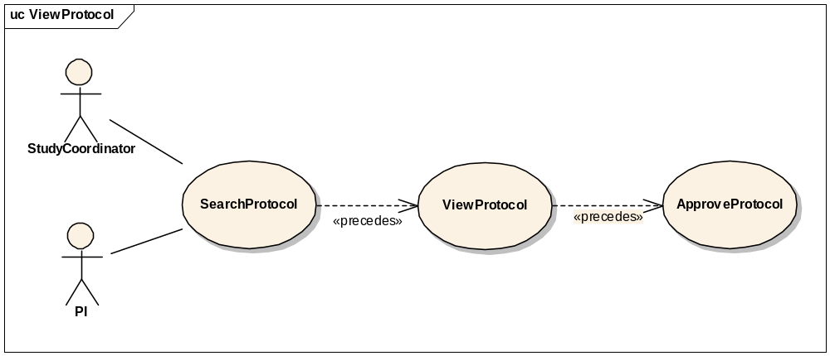

Brief Description
This use-case deals with approval or validation of a study definition entry.

Primary Actor
Study Coordinator, PI or any other designated user of C3PR with role authority to approve a Study.

Secondary Actors
None

Preconditions
- The user is logged in to the system with a user account that has role authority to approve a Study.
- The Study definition has already been created but not validated.

Basic Flow of Events
- The user indicates to the system that he/she wants to search for a given study definition.
- The user enters the search criteria for the study and submits the information to the system.
- The system displays 0, 1 or multiple study definitions depending on the search criteria.
- The user indicates to the system that he/she wants to approve a newly created study definition
- The user selects a study from a list of newly created studies.
- The user views the newly created study.
- He/She checks for the correctness of the data elements of the study against the coordinating site/local site parameters.
- The user approves the newly created study.

Postconditions

The created study has been approved and the study status is now effective (e.g. open, closed, etc.)

Special Requirements

Update Study Definition

Use Case Model
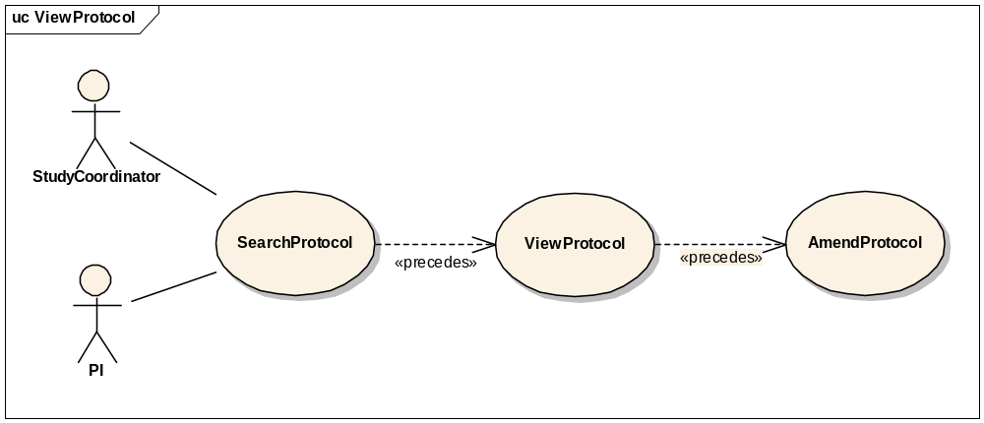

Brief Description
This use-case deals with amending a current study definition.

Primary Actor
Study Coordinator, Principal Investigator or any other designated user of C3PR with role authority to amend a study definition.

Secondary Actors
None

Preconditions
- The user is logged into the system with a user account that has role authority to amend a study definition.
- The study is in an active status.

Basic Flow of Events
- The user indicates to the system that he/she wants to search for a given study definition.
- The user enters the search criteria for the study and submits the information to the system.
- The system displays 0, 1 or multiple study definitions depending on the search criteria.
- The user selects the study definition for which he/she wants to amend.
- The user indicates to the system that he/she wants to make an amendment.
- The user enters the amendment data items

Postconditions
The study definition has been amended.

Special Requirements

Manage Registration
The following use cases describe the management of subject registration in C3PR. Different registration scenarios are captured as distinct use cases because they follow different flows and potentially have different actors and pre-requisites.

Register a New Subject to a Study

Use Case Model
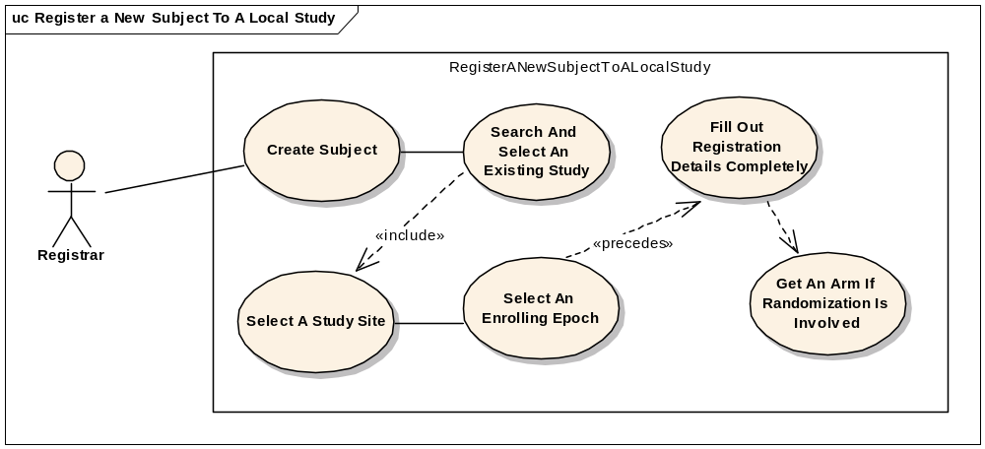

Brief Description
This use case will allow the user to register a subject not currently in the C3PR system to a study. The user will be required to enter subject information before completing the registration.

Primary Actor
Registrar or any other designated user of C3PR with role authority to register a Subject.

Secondary Actors
None

Preconditions
- The Study already exists.
- Any hard accrual limits are not exceeded.
- The Study is in Active status.
- The study has an enrolling epoch.
- The subject does not already exist in the system.
- The subject meets the eligibility criteria for the enrolling epoch.

Basic Flow of Events
- The user enters create registration workflow
- The user creates a new subject.
- The user searches and selects the desired study
- The user selects a study site
- The user selects an enrolling epoch from the selected study.
- The system alerts the user of any soft accrual limits.
- The system alerts the user if the subject is already registered to the same study.
- The user fills out the enrollment details completely.
- If the study involves Randomization, the user indicates to the system that he/she wants to randomize

Postconditions
- If the enrolling epoch involves randomization, an arm is successfully obtained.
- If the user was logged in to the system with a role authority to register a subject, the subject is registered to the study.

Special Requirements
None

Register a Subject to a Multi-site Study

Use Case Model
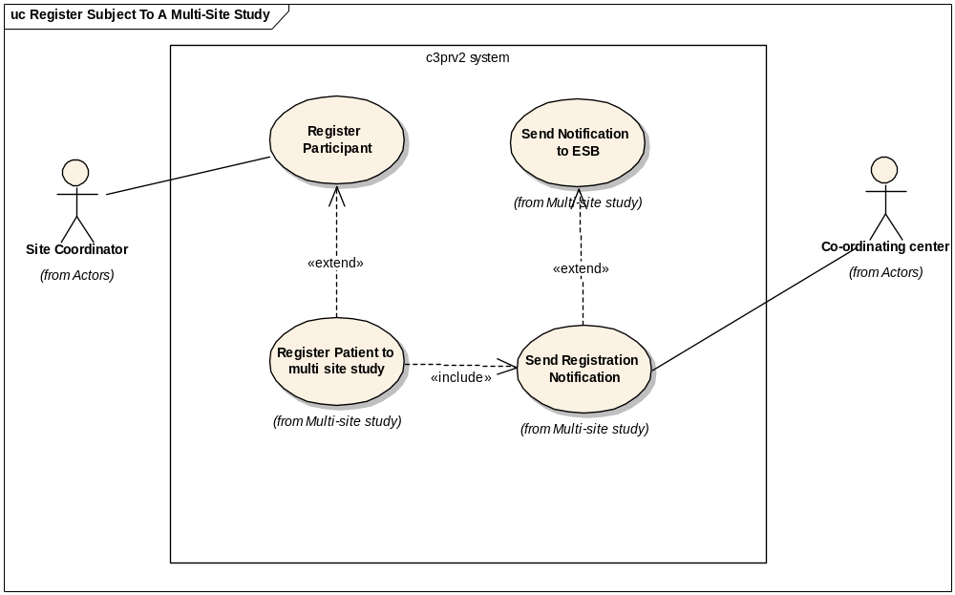

Brief Description
This use case will allow the user to register a subject to a multi-site study.

Primary Actor
Registrar or any other designated user of C3PR with role authority to register a Subject for multi-site studies.

Secondary Actors
None

Preconditions
- The user is logged in to the system with a user account that has role authority to register a Subject.
- The Study already exists.
- Any hard accrual limits are not exceeded.
- The Study is in Active status.
- The study has an enrolling epoch.
- The subject meets the eligibility criteria for the enrolling epoch.

Basic Flow of Events
- The user enters create registration workflow
- The user searches and selects the desired multi-site study
- The user selects the desired study site
- The user selects an enrolling epoch from the selected study.
- The system alerts the user of any soft accrual limits.
- The system alerts the user if the subject is already registered to the same study.
- The user fills out the enrollment details completely.
- The system send the registration notification fo the ESB.
- The ESB sends the registration notification to the coordinating center for approval.
- The system gets back approval or disapproved message back from the coordinating center.

Postconditions
- If the subject meets eligibility criteria, he/she is successfully registered.
- If the enrolling epoch involves randomization, an arm is obtained.

Special Requirements
None

Register an Existing Subject to a Study

Use Case Model
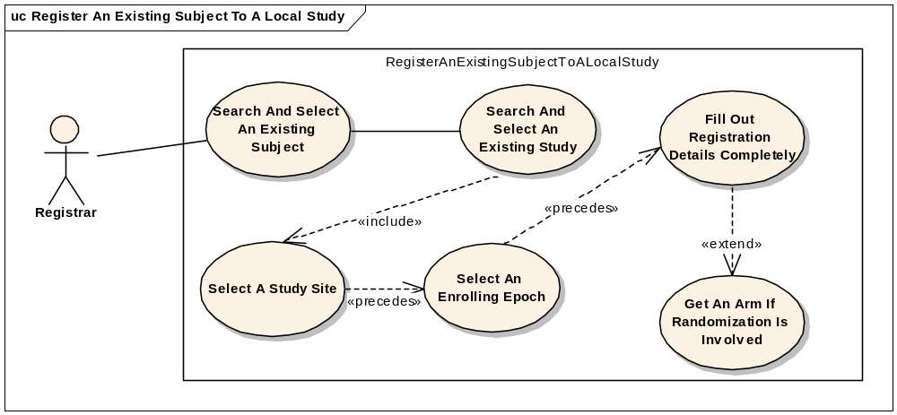

Brief Description
This use case will allow the user to register a subject not currently in the C3PR system to a study. The user will be required to enter subject information before completing the registration.

Primary Actor
Registrar or any other designated user of C3PR with role authority to register a Subject.

Secondary Actors
None

Preconditions
- The user is logged in to the system with a user account that has role authority to register a Subject.
- The Study already exists.
- Any hard accrual limits are not exceeded
- The Study is in Active status.
- The study has an enrolling epoch.
- The subject already exists and meets the eligibility criteria required by the enrolling epoch.

Basic Flow of Events
- The user enters create registration workflow
- The user searches and selects the desired subject.
- The user searches and selects the desired study
- The user selects a study site
- The user selects an enrolling epoch from the selected study.
- The system alerts the user of any soft accrual limits.
- The system alerts the user if the subject is already registered to the same study.
- The user fills out the enrollment details completely.
- If the study involves Randomization, the user indicates to the system that he/she wants to randomize

Postconditions
- The randomization process successfully returns an arm.
- If the user was logged in to the system with a role authority to register a subject, the subject is registered to the study.

Assign Kit Number for Blinded Study

Use Case Model
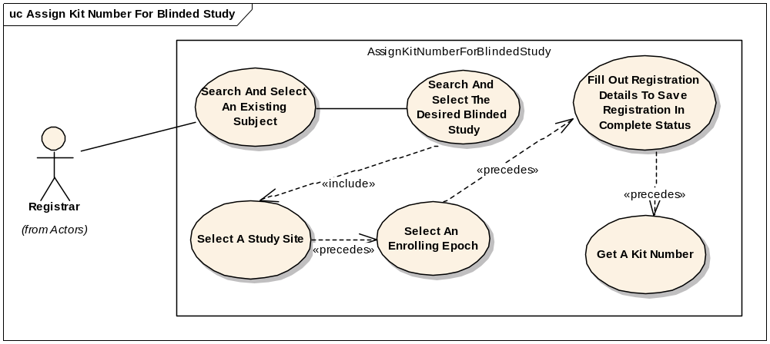

Brief Description
This use case will allow the user to register a subject to a blinded study and obtain a kit number.

Primary Actor
Registrar or any other designated user of C3PR with role authority to register a Subject to a blinded study.

Secondary Actors
None

Preconditions
- The user is logged in to the system with a user account that has role authority to register a subject.
- The blinded Study already exists.
- Any hard accrual limits are not exceeded
- The Study is in Active status.
- The study has an enrolling epoch.
- The subject already exists and meets the eligibility criteria required by the enrolling epoch.

Basic Flow of Events
- The user enters create registration workflow
- The user searches and selects the desired subject.
- The user searches and selects the desired blinded study
- The user selects a study site
- The user selects an enrolling epoch from the selected study.
- The system alerts the user of any soft accrual limits.
- The system alerts the user if the subject is already registered to the same study.
- The user fills out the enrollment details completely.
- The user indicates to the system that he/she wants to obtain a kit number.

Postconditions
- If the subject is eligible and no hard accrual limits are exceeded, a kit number is obtained.

Save a Registration in Incomplete Status

Use Case Model
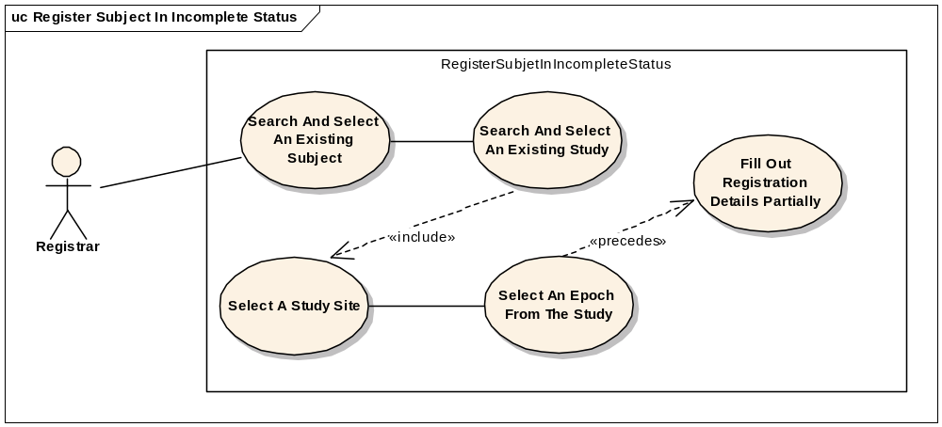

Brief Description
This use case allows the user to select a study and select a subject and without entering other details, save the information in an incomplete status. Users can then search for the registration and complete the information and the registration will either go on pending status if it requires some approval, if it’s a multi site study or it can be accepted as a complete registration

Primary Actor
Registrar or any other designated user of C3PR with role authority to register a Subject.

Secondary Actors
Registrar

Preconditions
- The user is logged in to the system with a user account that has role authority to register a Subject.
- The Study already exists.
- Any hard accrual limits are not exceeded
- The Study has an Active status.
- The Subject is not already registered to the same Study.

Basic Flow of Events
- The user enters create registration workflow
- The user searches and selects the desires subject.
- The user searches and selects the desired study
- The user selects a study site
- The user selects an epoch from the selected study.
- The system alerts the user of any soft accrual limits.
- The system alerts the user if the subject is already registered to the same study.
- The user fills out the enrollment details incompletely i.e. either the treating physician is not entered or eligibility is not met or Informed Consent Version or Date is not valid.

Postconditions
- The registration is saved in an incomplete status if no hard accrual limits are exceeded or the subject is not already registered to the same study site.

Register Subject to a Reservation-enabled Study

Use Case Model
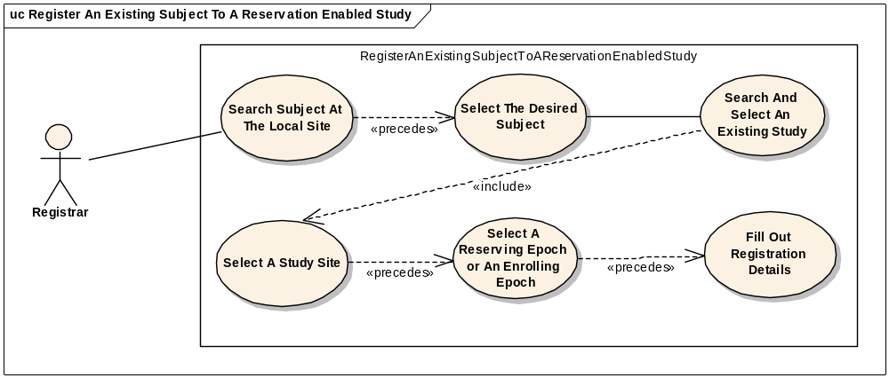

Brief Description
In some Phase I studies, there are very small number of accrual slots
It is important that someone can be registered to the study, get worked up, and then potentially be removed from the study
This type of “reservation” allows the next candidate to take the originally registered slot
This differs from most studies, where the de-registered slot is “lost” – the next subject is registered to the next slot.

Primary Actor
Registrar or any other designated user of C3PR with role authority to reserve a spot on the study.

Secondary Actors
None

Preconditions
- The user is logged in to the system with a user account that has role authority to reserve a spot on the study.
- The Study already exists.
- Any hard accrual limits are not exceeded
- The Study is in Active status.
- The study has a reserving or enrolling epoch.
- The subject already exists.

Basic Flow of Events
- The user enters create registration workflow
- The user searches and selects the desired subject.
- The user searches and selects the desired study.
- The user selects a study site.
- The user selects a reserving or an enrolling epoch from the selected study.
- The system alerts the user of any soft accrual limits.
- The system alerts the user if the subject is already registered to the same study.
- The user fills out the enrollment details.

Postconditions
- The subject is reserved a spot on the study.

Search for Registrations

Use Case Model
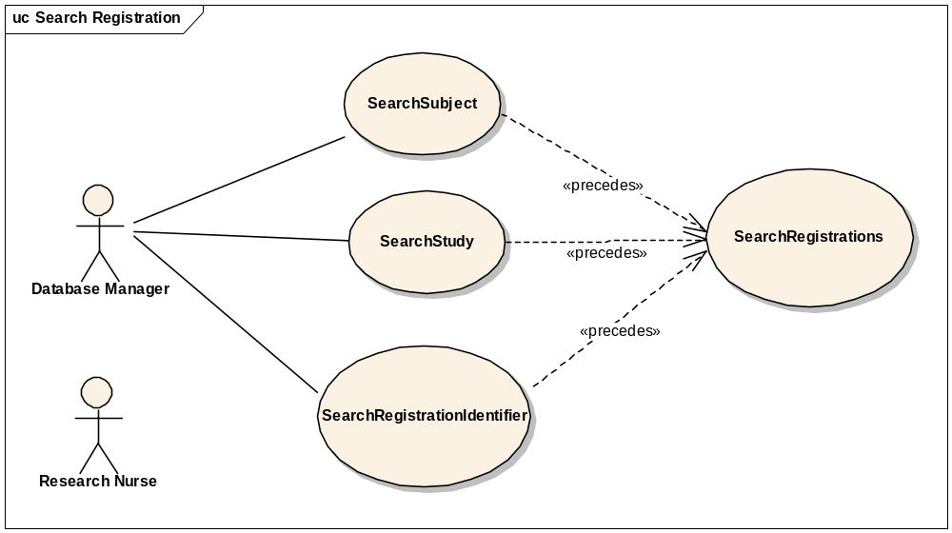

Brief Description
This use-case deals with searching for registrations. Reasons for searching for registrations include:
  - Looking for duplicate registrations
  - View registration history
  - Check for eligibility requirements
  - Check registration status
  - Modify a registration
  - To assign a subject to a randomized arm

Primary Actor
Database Manager, Study Coordinator, Principal Investigator or any other user of C3PR with role authority to search for a registration.

Secondary Actors
Registrar

Preconditions
The user is logged in to the system with a user account that has role authority to search for a registration.

Basic Flow of Events
- The user indicates to the system that he/she wants to search for registrations.
- The system displays a 2-step search process. The user first searches for a subject, study or a registration identifier based on subject search criteria, study search criteria or the registration identifier value respectively.
- The user then searches for the registrations based on the selected subject, study or registration identifier
- The system displays 0, 1 or multiple registrations depending on the search criteria.

Post conditions
The resulting registration list is in a state that the user can transition to any of the manage registration use cases like completing, updating eligibility, assigning to a randomized arm, updating registration status etc. This means sufficient detail is presented to the user in order to determine which registration to transition to.

Special Requirements

View Subject Registration History

Use Case Model
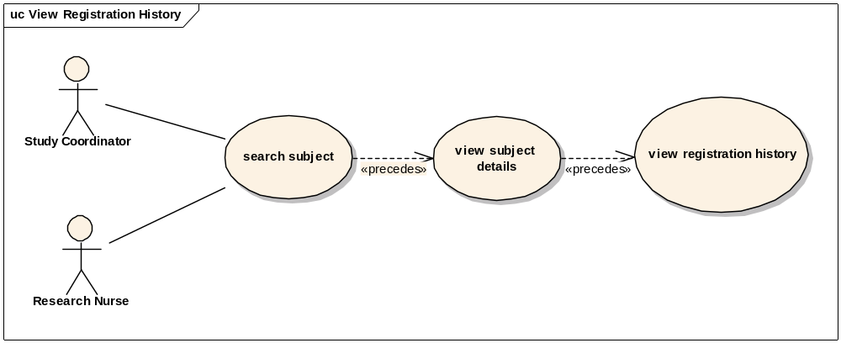

Brief Description
This use case allows the user to view registration details of a subject.

Primary Actor
Registrar, Site Coordinator, CRA or any other designated user of C3PR with role authority to view a registration.

Secondary Actors
Registrar

Preconditions
1 The subject is already registered to a study at a particular healthcare site.
2 The user is logged into the system with a user account that has role authority to view registration details.

Basic Flow of Events
1 The user searches for a given subject.
2 The user selects desired subject to view the subject details.
3 The user indicates that he/she wants to view the desired registration from a list of registrations the subject is on.
4 The user can choose to view registration details, eligibility status, registration status, stratification factors, randomization arm, and registration identifiers.

Alternate Flow(s)
1 The user for a given subject.
2 The user selects desired subject and searches for the registrations on that subject.
3 The user searches for a study.
4. The user searches for the registrations on the study.

Postconditions
1 The registration details have been viewed by the user.

Data Elements

Update Eligibility Status on a Pre-Registration/Registration

Use Case Model
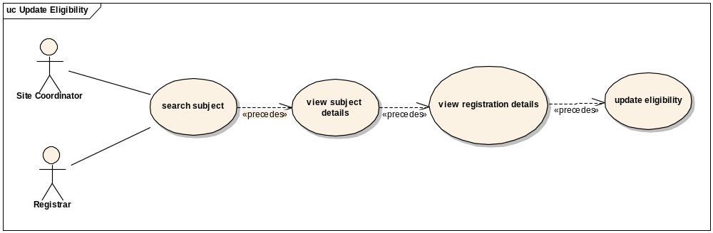

Brief Description
This use case allows the user to update eligibility status of a subject on a given registration.

Primary Actor
Site Coordinator, CRA or any other designated user of C3PR with role authority to update eligibility on a given registration.

Secondary Actors
Registrar

Preconditions
1 The subject is already pre-registered to a study at a particular healthcare site.
2 The user is logged into the system with a user account that has role authority to update eligibility status of a subject on a given study.

Basic Flow of Events
1 The user searches for a given subject.
2 The user selects desired subject to view the subject details.
3 The user indicates that he/she wants to view the desired registration details from a list of registrations the subject is on.
4 The user indicates that he/she wants to view the eligibility of the subject on the given study by selecting the eligibility tab.
5 The user can change the eligibility of the subject and indicates to the system that he/she wants to save the new eligibility status.

Postconditions
- If the user had the role authority to update eligibility of the subject on the given study, the eligibility status would be updated.
- If the user didn’t have the role authority to update eligibility of the subject, the status would await for further approval.

Randomize Subject

Use Case Model
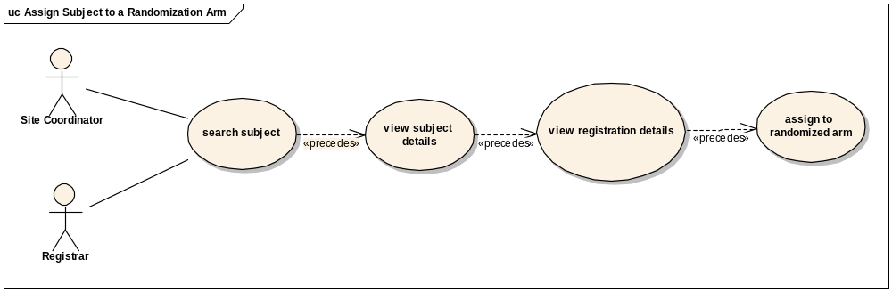

Brief Description
This use case allows the user to assign a subject to an arm.

Primary Actor
Site Coordinator, CRA, designated Statistician or any other user of C3PR with role authority to assign a subject to a randomized arm on a given registration.

Secondary Actors
Registrar

Preconditions
1 The subject is already registered to a study at a particular healthcare site.
2 The user is logged into the system with a user account that has role authority to assign a subject to a randomized arm on a given study.

Basic Flow of Events
1 The user searches for a given subject.
2 The user selects desired subject to view the subject details.
3 The user indicates that he/she wants to view the desired registration details from a list of registrations the subject is on.
4 The user indicates that he/she wants to view the randomization information of the subject on the given study by selecting the randomization tab.
5 The user selects the desired arm to which the subject is to be assigned indicates to the system that he/she wants to save the arm.

Postconditions
- If the user has the role authority to assign the subject to a randomized arm on the given study, the subject is assigned to a randomized arm.

Update Registration Status of a Subject on a given Study

Use Case Model
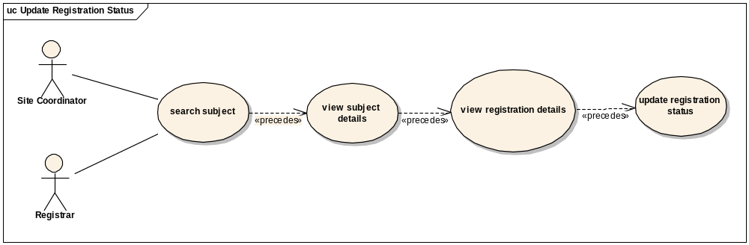

Brief Description
This use case allows the user to update the registration status of a subject on a given study.

Primary Actor
Site Coordinator, CRA, or any other designated user of C3PR with role authority to update the registration status on a given study.

Secondary Actors
Registrar

Preconditions
1 The subject is pre-registered to a study at a particular healthcare site.
2 The user is logged into the system with a user account that has role authority to update registration status for a subject on a given study.

Basic Flow of Events
1 The user searches for a given subject.
2 The user selects desired subject to view the subject details.
3 The user indicates that he/she wants to view the desired registration details from a list of registrations the subject is on.
4 The user indicates that he/she wants to view the registration status of the subject on the given study by selecting the registration tab.
5 The user selects the desired registration status and indicates to the system that he/she wants to save the status.

Postconditions
1 If the user has the role authority to change registration status of the subject on the given study, the registration status of the subject stands changed.

Reporting

Advanced Registration Search

Use Case Model
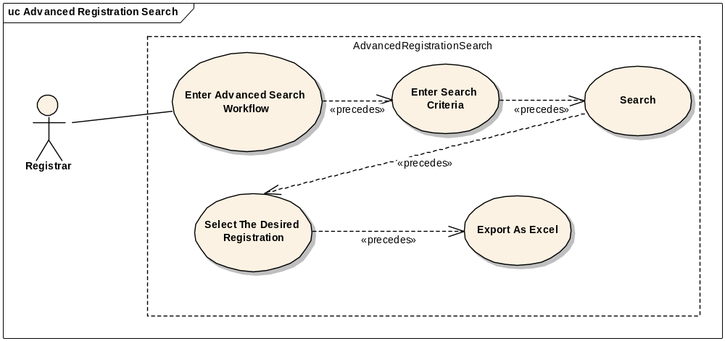

Brief Description
This use case allows the user to enter information in 4 different kinds of criteria and run a registrations search. The search results table also allows the user to download the results in .xls format.

Primary Actor
Administrator or any other designated user of C3PR with role authority to generate reports.

Secondary Actors
None

Preconditions
1 The user is logged in to the system with an account that has permission to search registrations.

Basic Flow of Events
1 The user enters the desired search criteria. The four criteria are: Study, Site, Registration and Subject.
2 The user retrieves the corresponding registrations.
3 The user downloads the table in the .xls format.

Postconditions
- The search results are displayed in a table on the same page.
- This table provides a export as excel button which lets the user download the table contents in excel format.

Study Search and export

Use Case Model
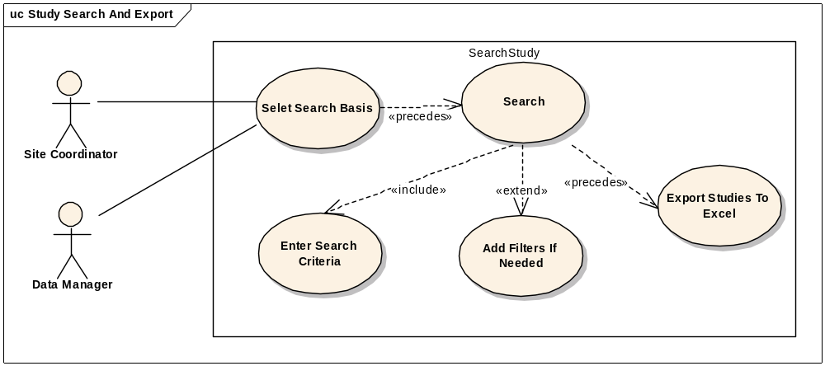

Brief Description
This use case allows the user to search for studies and export the search result as an excel file.
Primary Actor
Administrator or any other designated user of C3PR with role authority to view studies.

Secondary Actors
None

Preconditions
- The user is logged in to the system with appropriate privileges
- One or more studies must exist in the C3PR database

Basic Flow of Events
1 The user enters the desired search criteria. The user can search on 3 criteria’s: Study Identifiers, Study Short Title and Study Status
2 The system retrieves the corresponding studies
3 The user downloads the table in the .xls format.

Postconditions
- The search results are displayed in a table on the same page.
- This table provides a export as excel button which lets the user download the table contents in excel format.

Administration

Create Investigator

Use Case Model
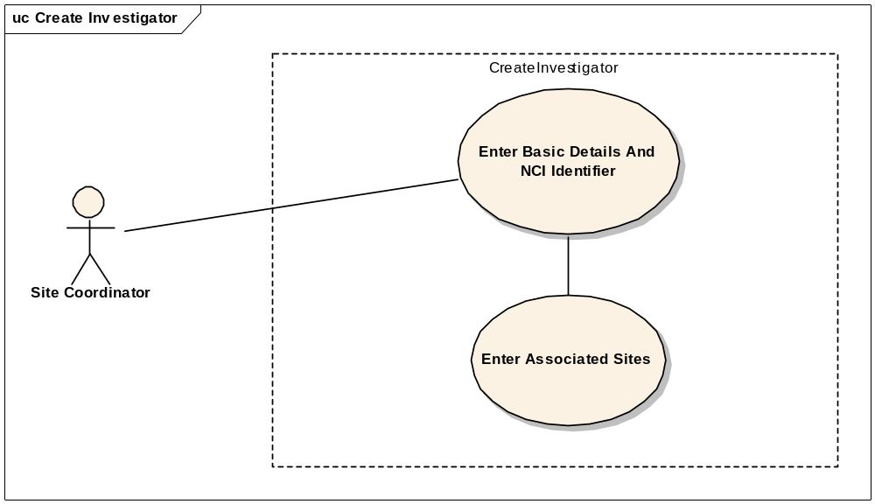

Brief Description
This use-case deals with the manual creation of an Investigator at the specified healthcare sites by entering each data element of the investigator.

Primary Actor
System administrator or any other designated user of C3PR with administrative privilege to create an investigator.

Secondary Actors
Site Coordinator

Preconditions
- The user is logged in to the system with an administrative account that has role authority to create an investigator.
- The investigator doesn’t already exist.

Basic Flow of Events
- The user indicates to the system that he/she wants to perform an administrative task
- The user indicates to the system that he/she wants to create an investigator.
- The system displays the screen that gives the user option of entering the investigator information manually.
- The user enters the Investigator data elements in the fields.
- The user indicates to the system that the required investigator information has been entered for creation of a new investigator.

Postconditions
- If the user is logged in to the system with a user account that has administrative privileges to create an Investigator (for example, a System Administrator), the created Investigator is approved.

Special Requirements
None.

Add Investigator Group(s)

Use Case Model
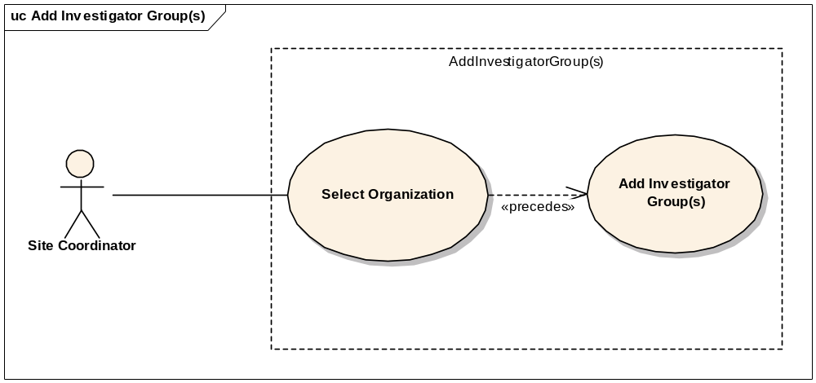

Brief Description
This use-case deals with the manual creation of Investigator Groups at a healthcare site.

Primary Actor
Site coordinator or any other designated user of C3PR with administrative privilege to create an investigator group.

Secondary Actors
None.

Preconditions
- The user is logged in to the system with an administrative account that has role authority to create an investigator group.
- The investigator group doesn’t already exist.

Basic Flow of Events
- The user indicates to the system that he/she wants to perform an administrative task
- The user indicates to the system that he/she wants to create an investigator group.
- The system displays the screen that gives the user option of selecting an organization and entering the investigator group information manually.
- The user enters the group’s data elements in the fields.
- The user indicates to the system that the required investigator group information has been entered for creation of a new investigator group.

Postconditions
- If the user is logged in to the system with a user account that has administrative privileges to create an Investigator group, the Investigator group is created.

Special Requirements
None.

Add Investigator(s) to a Group

Use Case Model
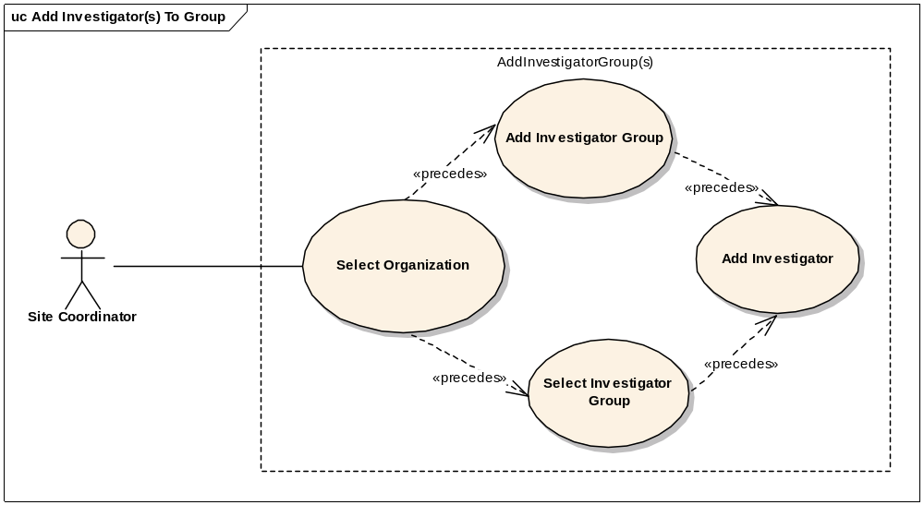

Brief Description
This use-case deals with the manual addition of Investigators to a group at a healthcare site.

Primary Actor
Site coordinator or any other designated user of C3PR with administrative privilege to add investigators to group.

Secondary Actors
None.

Preconditions
- The user is logged in to the system with an administrative account that has role authority to create an investigator group.
- The desired investigator(s) do not already belong to the group.

Basic Flow of Events
- The user indicates to the system that he/she wants to perform an administrative task
- The user indicates to the system that he/she wants to add investigators to a group.
- The system displays the screen that gives the user option of selecting an organization and the desired investigator group.
- The user selects from the list of existing investigators at the organization, those that he/she intends to be add to the group.
- The user indicates to the system to save the new information.

Postconditions
- If the user is logged in to the system with a user account that has administrative privileges to add Investigators to a group, the Investigators would be added to the group.

Special Requirements
None.

Search for Investigators In a Group

Use Case Model
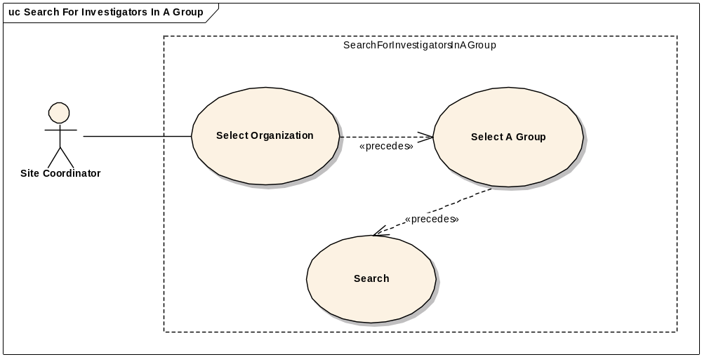

Brief Description
This use-case deals with the search for Investigators in a group at a healthcare site.

Primary Actor
Site coordinator or any other designated user of C3PR with administrative privilege to search for investigators at a given site.

Secondary Actors
None.

Preconditions
- The user is logged in to the system with an administrative account that has role authority to search for investigators.
- The desired group and the healthcare site already exist.

Basic Flow of Events
- The user indicates to the system that he/she wants to perform an administrative task
- The user indicates to the system that he/she wants to search for investigators belonging to a group.
- The system displays the screen that gives the user option of selecting an organization and the desired investigator group at that organization.
- The user indicates to the system that he/she want to search for investigators.
- The system displays all the investigators belonging to the group.

Postconditions
- If the user is logged in to the system with a user account that has administrative privileges to search for the Investigators, the system displays the information of the investigators belonging to that group.

Special Requirements
None.

Create Research Staff

Use Case Model
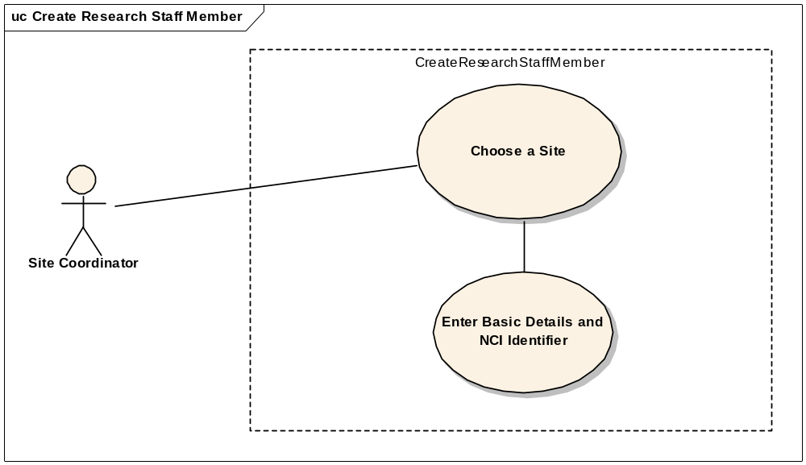

Brief Description
This use-case deals with the manual creation of research staff by entering each data element of the research staff.

Primary Actor
Site Coordinator or any other designated user of C3PR with administrative privilege to create research staff.

Secondary Actors
None

Preconditions
- The user is logged in to the system with an administrative account that has role authority to create research staff.
- The research staff member doesn’t already exist.

Basic Flow of Events
- The user indicates to the system that he/she wants to do an administrative task
- The user indicates to the system that he/she wants to create a research staff member
- The system displays the screen that gives the user option of entering the research staff member information manually.
- The user enters the research staff member’s data elements in the fields.
- The user indicates to the system that the required research staff member information has been entered for creation of a new research staff member.

Postconditions
- If the user is logged in to the system with a user account that has administrative privileges to create a research staff (for example, a System Administrator), the created research staff member is approved.

Special Requirements
None

Create Organization

Use Case Model
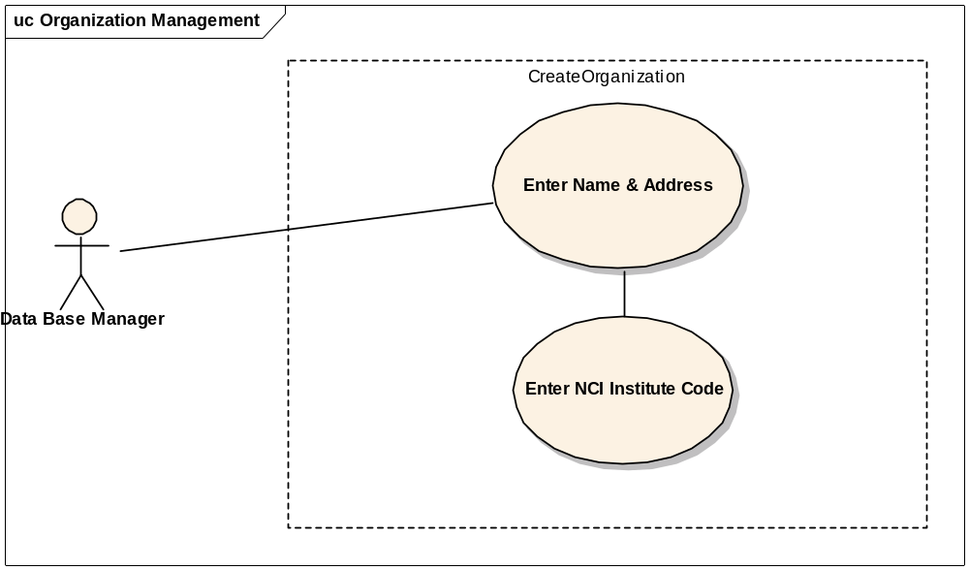

Brief Description
This use-case deals with the manual creation of an Organization by entering organization related data. The user can enter information and select save or select reset tab to clear the entered data.

Primary Actor
System administrator or any other designated user of C3PR with administrative privilege to create Organization.

Secondary Actors
None

Preconditions
- The user is logged in to the system with an administrative account that has role authority to create Organization.
- The Organization doesn’t already exist.

Basic Flow of Events
- The user indicates to the system that he/she wants to do administrative tasks
- The user indicates to the system that he/she wants to create an Organization.
- The system displays the screen that lets the user enter the Organization information manually.
- The user enters Organization’s data elements in the fields.
- The user indicates to the system that the required Organization information has been entered for creation of a new Organization.

Postconditions
- If the user is logged in to the system with a user account that has administrative privileges to create a research staff (for example, a System Administrator), the created research staff member is approved.

Special Requirements
None

Associate Investigator to Study Organization

Use Case Model
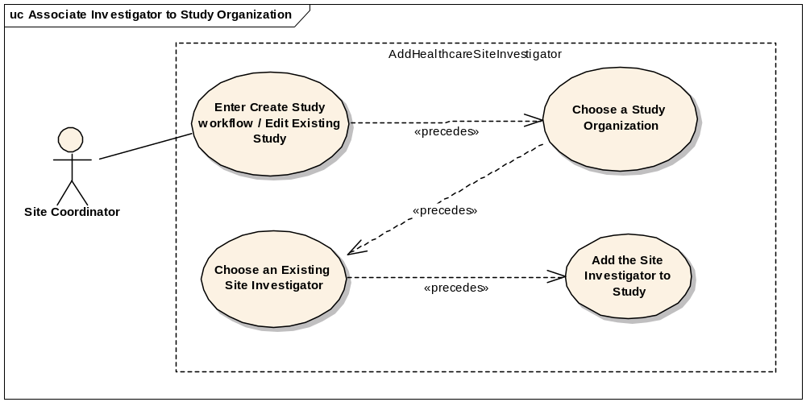

Brief Description
This use case allows the user to associate an investigator to a study organization.

Primary Actor
Site Coordinator

Secondary Actors
None

Preconditions
- The user is logged in to the system with an administrative account that has role authority to add investigator to a study organization.
- The site already exists.
- The intended investigator already exists at the organization
- The intended investigator does not already exist at that study organization

Basic Flow of Events
1. The user enters the create study work flow for a new study or edit study flow for an existing study.
2. The user selects the desired site for which the association should take place.
3. The user chooses the list of investigators associated for this site to be assigned as study investigator, which is commonly referred to as the enrolling physician.
4. The user adds other relevant information for the association.
5. The user may select more site investigators repeating the steps 1-4

Post Conditions
None.

Alternate Flow
      - Instead of selecting a single Study Investigator, the user selects a group of Investigators.

Associate Investigator Group to Study Organization

Use Case Model
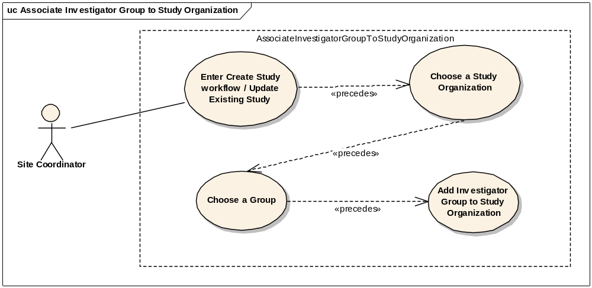

Brief Description
This use case allows the user to associate an investigator group to a study organization.

Primary Actor
Site Coordinator

Secondary Actors
None

Preconditions
- The user is logged in to the system with an administrative account that has role authority to add an investigator group to a study organization.
- The study organization already exists.
- The intended group already exists at the organization.
- The study organization does not already have the intended group.

Basic Flow of Events
1. The user enters the create study work flow for a new study or update study flow for an existing study.
2. The user selects the desired site for which the association should take place.
3. The user chooses the investigator group that is intended to be associated to the study organization.
4. The user chooses other relevant information for the association.
5. The user may select more groups repeating the steps 1-4

Post Conditions
None

Alternate Flow
1. Instead of selecting an investigator group, the user selects a single investigator.

Search for a Study Personnel

Use Case Model
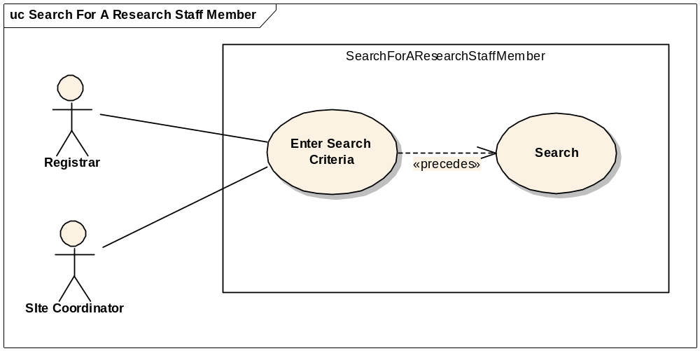

Brief Description
This use case allows the user to search a Study Person (Research Staff Member) depending upon the search criteria. Reasons for searching for a study person include:
  - Looking for a duplicate research staff member.
  - View research staff member details.
  - Update research staff member details.

Primary Actor
Registrar, Site Coordinator, Data Base Manager or any other user of C3PR with role authority to search for a research staff member.

Secondary Actors
None

Preconditions
The user is logged in to the system with a user account that has role authority to search for a research staff member at the given site.

Basic Flow of Events
- The user indicates to the system that he/she wants to search for a research staff member.
- The user either enters the first name and/or last name and/or the NCI Identifier.
- The user searches for the research staff member by clicking on search.
- The system displays 0, 1 or multiple research staff members matching the search criteria.

Post conditions
The resulting research staff member in a state where his/her details can be viewed and updated if the user has the necessary privileges to do so.

Special Requirements

View or / and Update Research Staff Member Details

Use Case Model
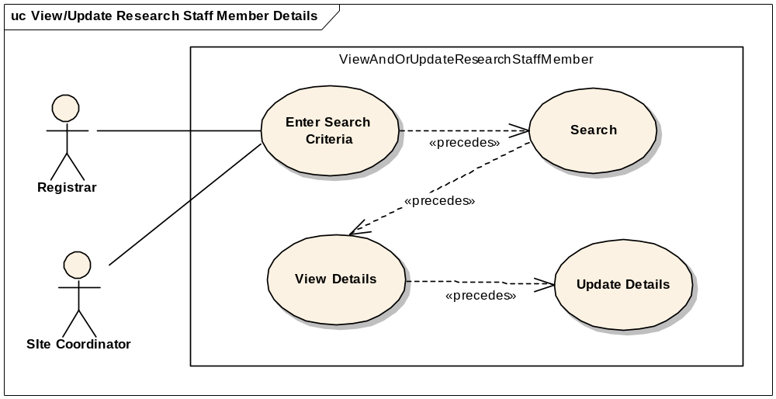

Brief Description
This use case allows the user to view or/and update a Study Person (Research Staff Member) depending upon the search criteria (FN, LN, NCI Identifier). Reasons for this include:
  - Looking for a duplicate Research Staff member.
  - View Research Staff member details.
  - Update Research Staff member details.

Primary Actor
Registrar, Site Coordinator, Data Base Manager or any other user of C3PR with role authority to search for a research Staff member.

Secondary Actors
None

Preconditions
The user is logged in to the system with a user account that has role authority to view or/and update details of a Research Staff member at the given site.

Basic Flow of Events
- The user indicates to the system that he/she wants to search for a Research Staff member.
- The user either enters the first name and/or last name and/or the NCI Identifier.
- The user searches for the Research Staff member by clicking on search.
- The system displays 0, 1 or multiple Research Staff members matching the search criteria.
- The user selects the desired Research Staff member whose details he/she wants to see.
- The user views or/and updates the details of that member.

Post conditions
The resulting research staff member in a state where his/her details can be viewed and updated if the user has the necessary privileges to do so.

Special Requirements

Search for an Investigator

Use Case Model
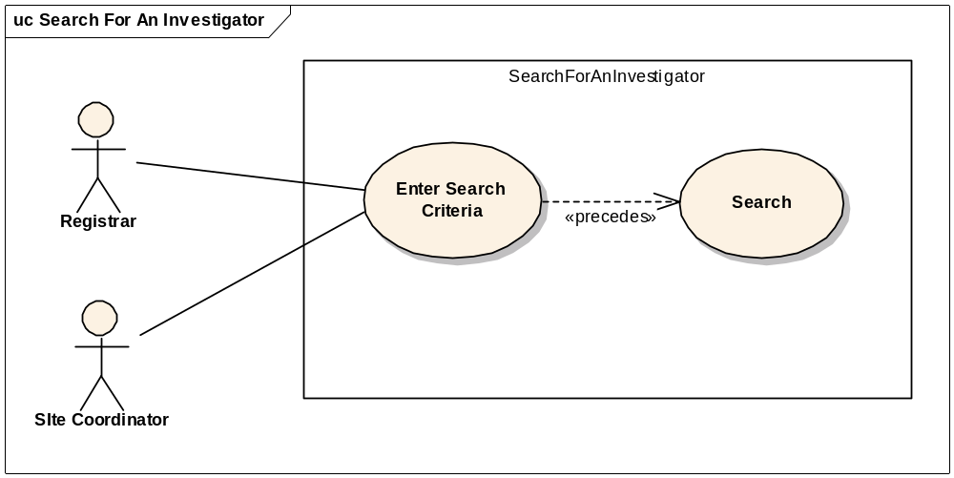

Brief Description
This use case allows the user to search an Investigator. Reasons for searching for an Investigator include:
  - Looking for a duplicate Investigator.
  - View Investigator details.
  - Update Investigator details.

Primary Actor
Registrar, Site Coordinator, Data Base Manager or any other user of C3PR with role authority to search for an Investigator.

Secondary Actors
None

Preconditions
The user is logged in to the system with a user account that has role authority to search for a Investigator at the given site.

Basic Flow of Events
- The user indicates to the system that he/she wants to search for an Investigator.
- The user either enters the first name and/or last name and/or the NCI Identifier.
- The user searches for the Investigator by clicking on search.
- The system displays 0, 1 or multiple Investigators matching the search criteria.

Post conditions
The resulting Investigator in a state where his/her details can be viewed and updated if the user has the necessary privileges to do so.

Special Requirements

View or / and Update Investigator Details

Use Case Model
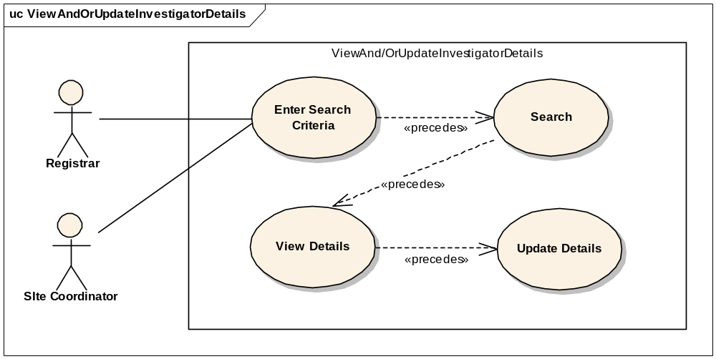

Brief Description
This use case allows the user to view or/and update an Investigator depending upon the search criteria (FN, LN, NCI Identifier). Reasons for this include:
  - Looking for a duplicate Investigator member.
  - View Investigator member details.
  - Update Investigator member details.

Primary Actor
Registrar, Site Coordinator, Data Base Manager or any other user of C3PR with role authority to search for an Investigator.

Secondary Actors
None

Preconditions
The user is logged in to the system with a user account that has role authority to view or/and update details of an Investigator member at the given site.

Basic Flow of Events
- The user indicates to the system that he/she wants to search for a Investigator member.
- The user either enters the first name and/or last name and/or the NCI Identifier.
- The user searches for the Investigator member by clicking on search.
- The system displays 0, 1 or multiple Investigator members matching the search criteria.
- The user selects the desired Investigator member whose details he/she wants to see.
- The user views or/and updates the details of that member.

Post conditions
The resulting Investigator member in a state where his/her details can be viewed and updated if the user has the necessary privileges to do so.

Special Requirements

Disassociate Study Person from a Study Site

Use Case Model
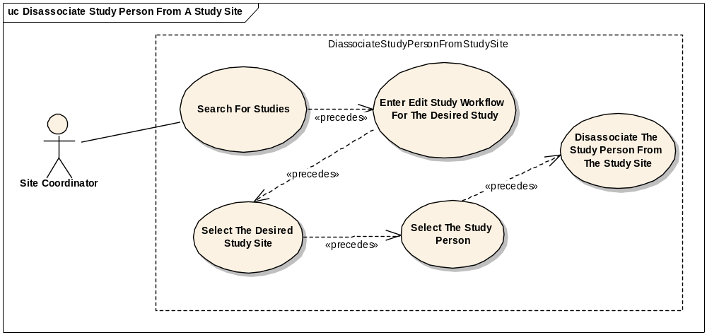

Brief Description
Each study site can have one or more research staff members associated with them. The associated research staff members are called study personnel. These study personnel can be disassociated from the study site. This use case deals with this scenario.

Primary Actor
Site Coordinator.

Secondary Actors
None

Preconditions
The study person already exists.

Basic Flow of Events
1. The user searches for the desired study.
2. He/she enters the edit flow of the desired study.
3. The user selects a study site at which he/she wishes to disassociate the study person.
4. The user indicates to the system that he/she wants to remove the study person.

Post Conditions
- The study person will be successfully disassociated from the study site if the user had privilege to do so.

Special Requirements
None.

Change the Study Site Investigator status

Use Case Model
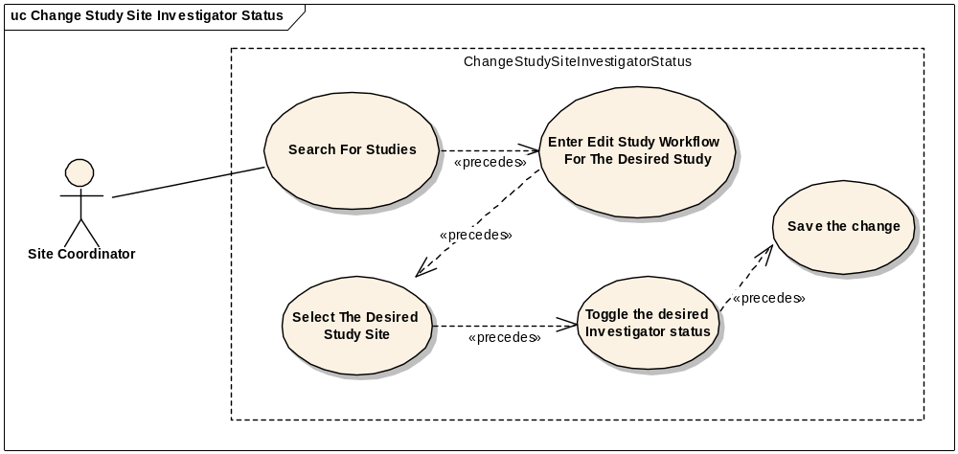

Brief Description
Each study site can have one or more investigators associated with them. The associated investigators’ status can be set from Active to Inactive and vice-versa.. This use case deals with this scenario.

Primary Actor
Site Coordinator.

Secondary Actors
None

Preconditions
The investigator already exists.

Basic Flow of Events:
1. The user searches for the desired study.
2. He/she enters the edit flow of the desired study.
3. The user selects a study site at which he/she wishes to update the investigator status.
4. The user toggles the investigator status by selecting the new status.
5. The user indicates to the system that he/she wants to save the changes.

Post Conditions
- The status of the study site investigator will be updated if the user had privilege to do so.

Special Requirements
None.

Export Study definition to a File

Use Case Model
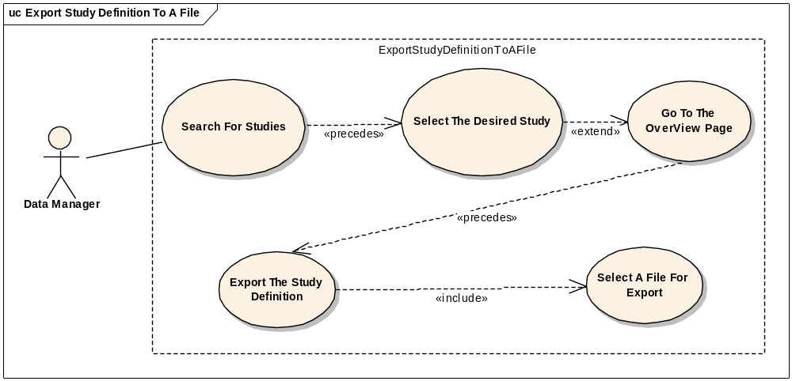

Brief Description
This use-case deals with exporting a Study to a File that can be saved on the users local file system.

Primary Actor
Study Administrator or any other designated user of C3PR with role authority to view a Study.

Secondary Actors
None

Preconditions
- The user is logged in to the system with a user account that has role authority to view a Study.
- The Study exists in the C3PR database

Basic Flow of Events
- The user searches for a Study
- The user is taken to the Study details page where there is an “Export Study” link.
- The system generates a XML export of the Study definition and the user is asked to save the study on their local system

Post conditions

Special Requirements
User may need special software to view the exported Study XML

Export Registration definition to a File

Use Case Model
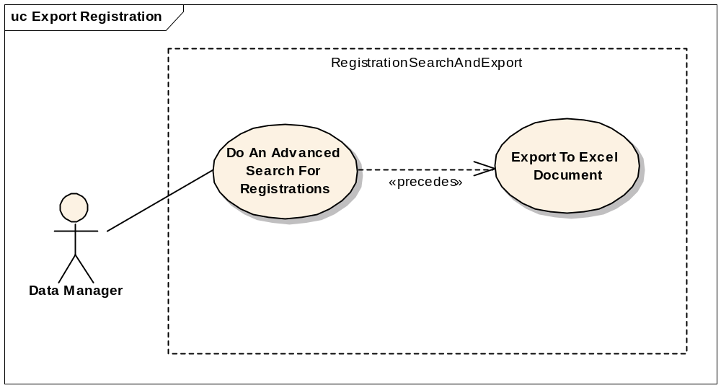

Brief Description
This use-case deals with exporting a Registration to a File that can be saved on the users local file system.

Primary Actor
Registrar, Data Manager or any other designated user of C3PR with role authority to view a registration.

Secondary Actors
None

Preconditions
- The user is logged in to the system with a user account that has role authority to view a Registration.
- The Registration exists in the C3PR database

Basic Flow of Events
- The user searches for Registration(s) from the Advanced Search section.
- The user indicates to the system that he/she wants to export the registration to an excel file.
- The system generates a XML export of Registration and the user is asked to save the registration on their local system

Post conditions

Special Requirements
User may need special software to view the exported Registration XML

Load (Import) Study Definition from a File

Use Case Model
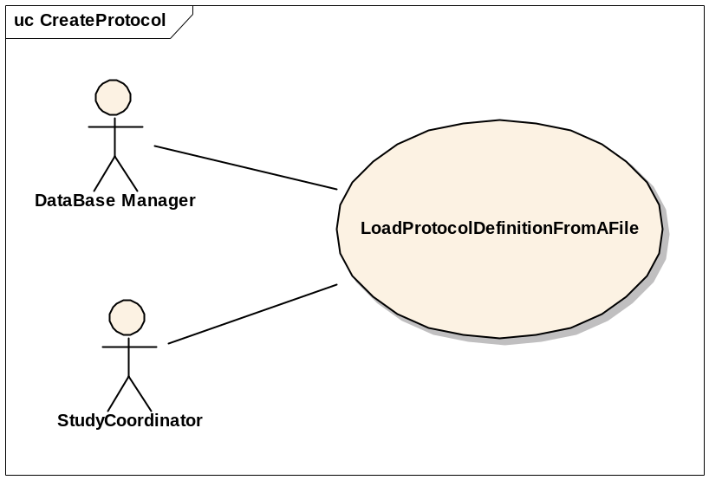

Brief Description
This use-case deals with importing one or more Studies from a file that is on the user’s local system.

Primary Actor
Study Administrator or any other designated user of C3PR with role authority to create a Study.

Secondary Actors
None

Preconditions
- The user is logged in to the system with a user account that has role authority to create a Study.
- The Study definition is in XML format
- The Study definition XML conforms to the C3PR Study XML schema
- The Study Sites that is participating in the Study already exist in C3PR

Basic Flow of Events
- The user indicates to the system that he/she wants to create a new study definition from a file
- The system displays a screen that allows the user to browse their local file system.
- The user selects the appropriate file which contains the information about the study(s) to be loaded into the system.
- After selecting the file, the user indicates to the system to import the study definitions based on the information in the file.
- The system reads the file and validates the file.
- If the file is valid, new study definitions are created.
- The system indicates to the user the status of the import by displaying a list of the newly created Study definitions.

Post conditions
- If the user is logged in to the system with a user account that has role authority to create a Study (for example, a Study manager), the created study is approved.
- If the user was logged in to the system with a role authority to only enter the study information, the created study awaits for further validation check from a study coordinator/study manager before it becomes approved.
- The Study definitions that have been imported can be (depending on the users privileges) viewed and edited by the user.

Special Requirements

Get Study Definition via Study Message from External Source

Use Case Model
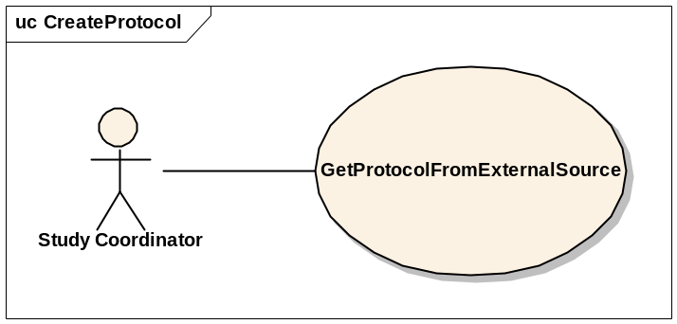

Brief Description
This use-case deals with creation of a Study at the local system after getting/importing it from an external source via a Study Message.

Primary Actor
Study Administrator, Study Coordinator or any other designated user of C3PR with role authority to create a Study.

Secondary Actors
None

Preconditions
- The user is logged in to the system with a user account that has role authority to create a Study.
- C3PR is configured to receive messages from the external source.

Basic Flow of Events
- The user indicates to the system that he/she wants to create a new study definition
- The system displays a screen that displays the import methods. This screen allows the user to import a new study.
- The study is imported
- If errors occur during the import, they are displayed to the user
- If the study is imported successfully, the user views the study.
- The user checks the study for correctness and updates the study entries to correspond to the local site requirements (IRB approval, accrual ceiling, etc).
- After importing the study, the user confirms the study creation.

Postconditions
The imported study waits for further changes/validation with respect to the local site conditions (IRB approval, accrual ceiling, etc) before it is available for use at the local site.

Alternate path
- If the study already exists, an error is returned

Special Requirements

Integration
These use cases will allow user to integrate with external systems like the Patient Study Calendar, etc.

Synchronize Registration of a Subject on a Study Arm with Study Calendar

Brief Description
This use case essentially deals with propagating the registration information of a subject on a Study Arm created in the C3PR system to Study Calendar system via CTMS Hub.

Primary Actor
Registrar or any other designated user of C3PR with role authority to register a subject on a Study Arm.

Secondary Actors
- CTMS Hub
- Subject Study Calendar (PSC)
- Participant Coordinator

Preconditions

Successful Creation of Study in the Study Calendar system
  - The Study definition has been successfully created in the Study Calendar system either manually through the Study Calendar web interface or through a message from the C3PR system (refer to use case 3.5).

Basic Flow of Events
- The system generates a message in a predetermined format containing the new registration information.
- The system then submits the new registration message to the CTMS Hub.
- The CTMS Hub determines where the message needs to be delivered to, which is Study Calendar system in this case.
- The CTMS Hub transforms the new registration message into a message format that the Study Calendar system can process.
- The Study Calendar system processes the new registration message by creating the Subject record, if the Subject does not already exist in the Study Calendar system, and then creates the calendar for the Arm to which the Subject is being registered to.
- After successfully processing the new subject registration message, the Study Calendar system sends an acknowledgment to the CTMS Hub indicating the successful creation of the calendar corresponding to the Arm that the subject is registered on in the Study Calendar system.
- The CTMS Hub sends an email notification indicating the creation of a new calendar for the Arm that the subject is registered on to relevant actors including the Participant Coordinator.

Post conditions

Creation of Subject record in PSC
A new Subject record is created in the Study Calendar system if the Subject does not already exist in it.

Creation of Calendar for the Arm related to the Subject
The calendar for the Arm that the Subject is registered on is created in the study calendar system.

Email Notification
Email notifications are sent to relevant actors indicating the creation of the Subject (optional) and calendar.

Exception flow
Errors during the normal flow of events in messaging system will trickle back to the user. This could include improperly configured messaging system or errors generated by the target system.

Special Requirements

Overall Requirements

Requirements Prioritization

Priority | Use Case Name | Supp Requirement Ref #
1 | Manage Study

Sign Off

Approval

Workspace General Contractor Rep Print Name Date
Architecture Workspace Rep Print Name Date
VCDE Workspace Rep Print Name Date
Workspace Working Group Rep Print Name Date
NCICB Rep Print Name Date

