Test Script Number: | register_participant |  |  |  | Module: |  |  | Tester Name: |  | Steven Cheng | Pass/Fail:  pass
Use Case #: |  |  |  |  | Username: | c3pr_admin |  | Test Date: |  | 06/22/2007 | Pass/Fail:  pass
Estimated Execution Time: |  |  |  |  |  |  | Actual Execution Time: |  | 1 hr
Test Objective: register a participant.

Test Setup: log in as an administrator.

Related Requirements
or Configuration Change Requests (Number/Description):

 | Test Action | Expected Results | Pass / Fail | Actual Results/Comments |  |  | gForge Tracker Bug ID
 | Click Registration tab, click Create Registration link, run Study Search to find the study, then click Search button. See figure 1. |  | Pass | Study Search results displayed.  Tested features:  - Search study by Identifier, Short Title and Status works fine. In addition, input one blank space and run search, get all studies displayed except by Identifier.  - Search subject by Last Name and Identifier works fine. Blank space search not work on the subject search.
 | Click the right one to select it. See figure 2 |  | Pass | The study is selected, go to next step to select subject.  Comments:  - Hyperlinks on Select Study tab and Select Subject tab do nothing. It’s better remove the hyperlinks on them. |  |  | 6892
 | Run Search Subject to find the participant, then click Search button. See figure 3 |  | pass | Subject Search results displayed.
 | Click the right one to select it. |  | pass | The subject is selected, go to next step to enter Enrollment Details.
 | Fill the date by using calendar function, then click Continue button. See figure 4 |  | pass | Go to next step to Check Eligibility  Tested features:  - No fields required?  - Data format for consent signed date checked. In iteration 4, this not work.  - Date calendar works fine.  - Enrolling Physician list auto populated from the study’s investigators.  Comments:  - Previous button does not work on this page, it will clear out the selected date once click.  - Red * is put in the front of Informed Consent Signed Date, but the system check the required field for Informed Consent Version. Which one is right?  - The system automatically ignores date with invalid format or an invalid date without any error displayed when pass the required field validation. In iteration 4, the system accepts invalid format or an invalid date, but displays as wired date instead of user’s input.  - Previous button breaks the system.  - Automatically close the calendar once select one |  |  | 6322  6893 - fixed  6895  7500  7501
 | Select Disease and Disease Site, then click Continue button. See figure 5. |  | pass | Go to next step to Stratify  Tested features:  - Primary Disease list auto populated from the study disease list  Comments:  - Clear button does nothing.  - One text box on there without anything displayed, remove that.  - Tab ‘5. Check Eligibility’ should NOT be highlighted in this page.  - User’s input not saved between sessions. |  |  | 6897 - fixed  6898 - fixed  6896 - fixed  7505
 | In Check Eligibility tab, answer the questions, Click Continue button. See figure 6. |  | pass | Tested features:  - Required field validation is active for all related answer fields. failed in Iteration 4?  - Answer lists auto populated from the study  Comments:  - Tab ‘4. Disease’ should NOT be highlighted in this page.  - Once click Previous button twice, got error message. See figure 7  - Required field validation failed. |  |  | 6896 - fixed  6891 – fixed  7506
 | In Stratify tab, answer the questions, click Continue button. See figure 7. |  | pass | Test features:  - No required validation check
 | In Randomize tab, select an arm, click Continue button. See figure 8. |  | pass
 | In Review & Submit tab, review the result, click Save button. See figure 9, 10 |  | pass | Registration successfully saved.  Test features:  - All Edit buttons work fine.

Tester Signature: Steven Cheng

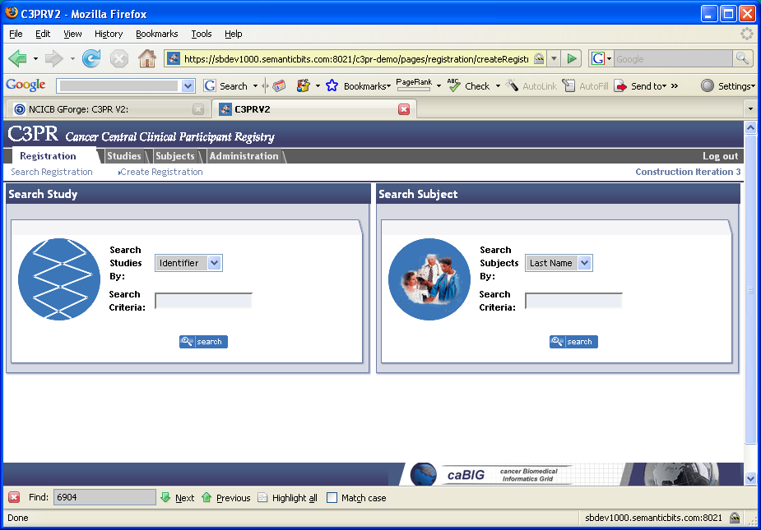

Figure 1

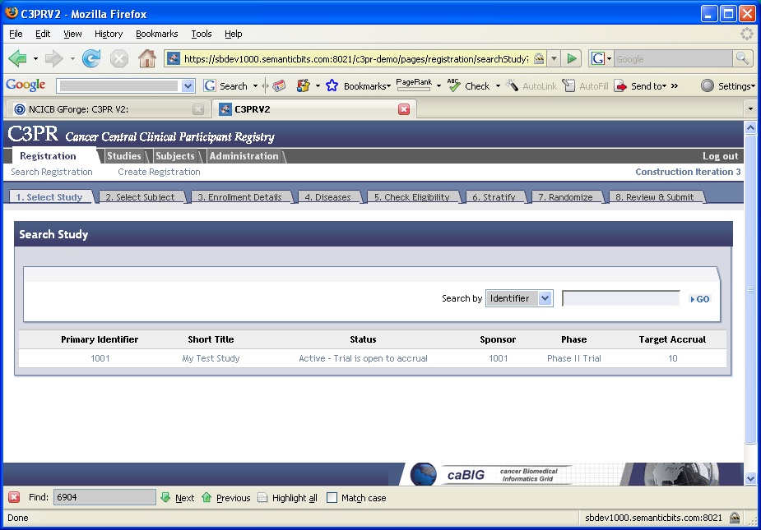

Figure 2
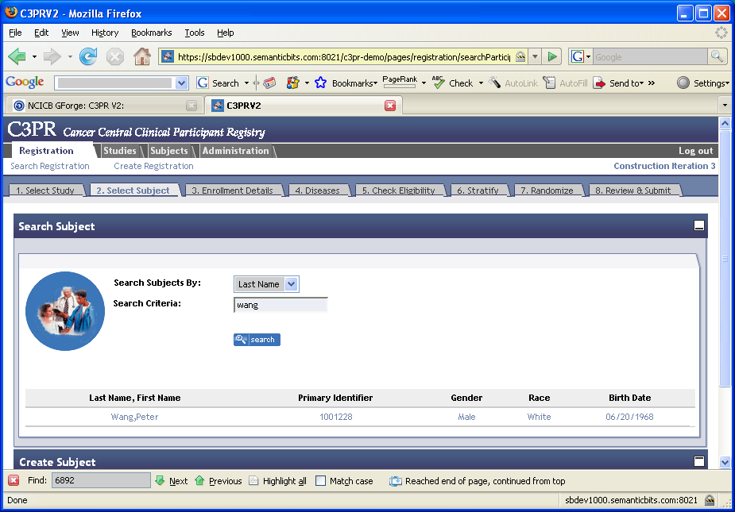
Figure 3
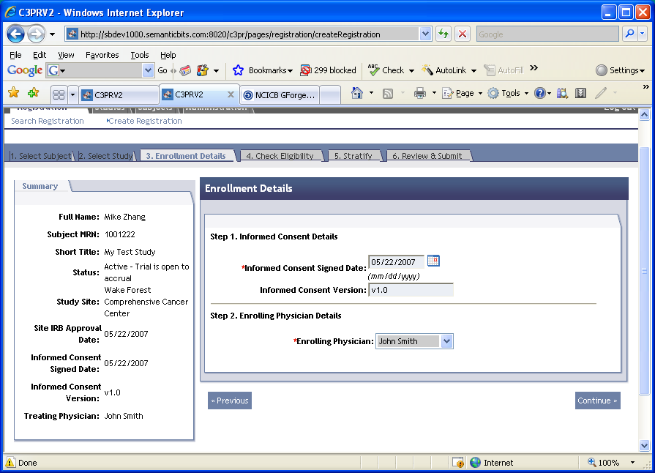
Figure 4
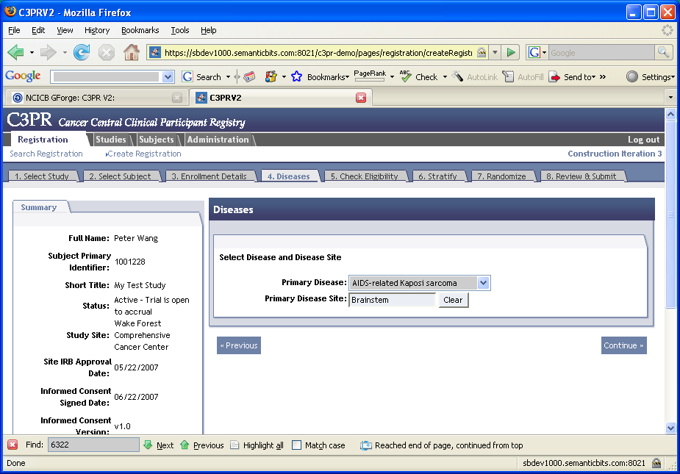
Figure 5
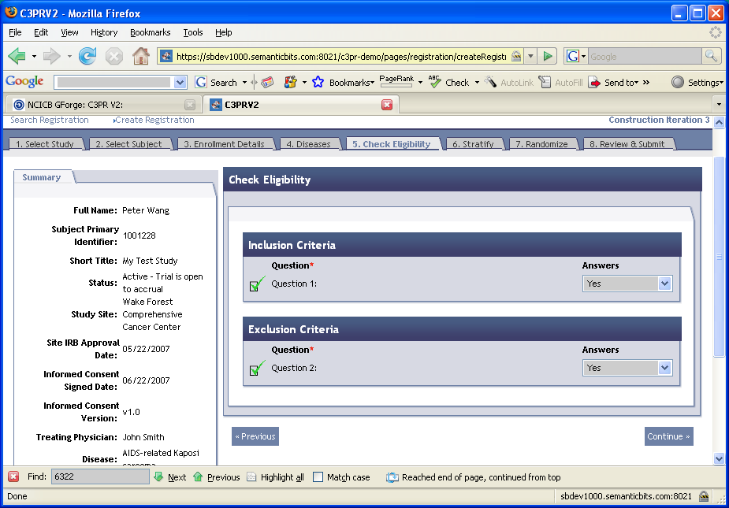
Figure 6
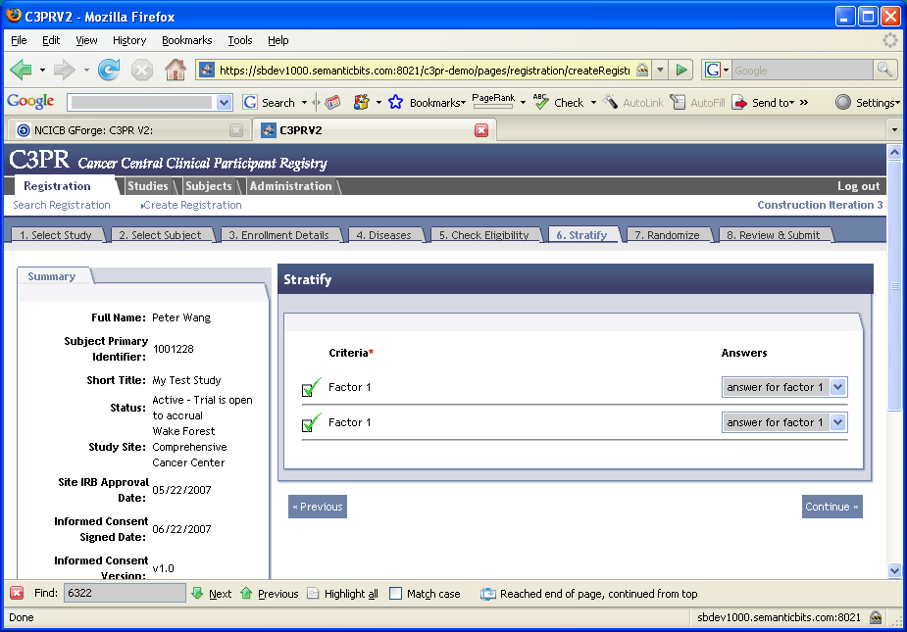
Figure 7
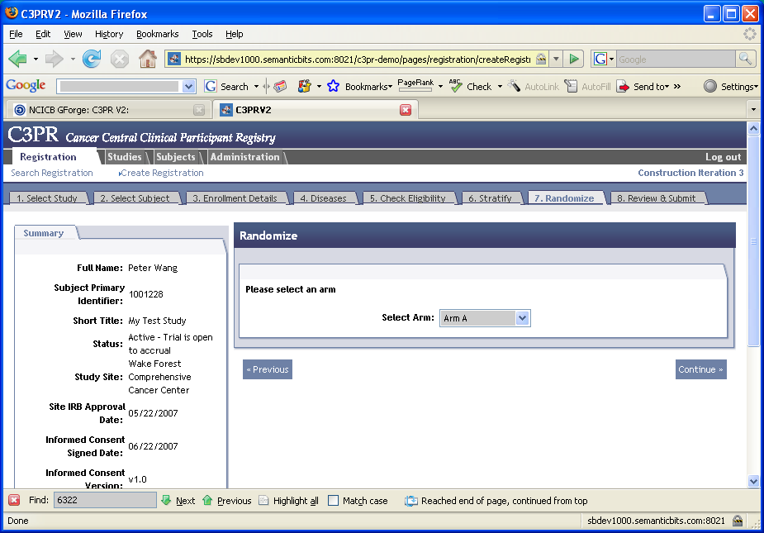
Figure 8
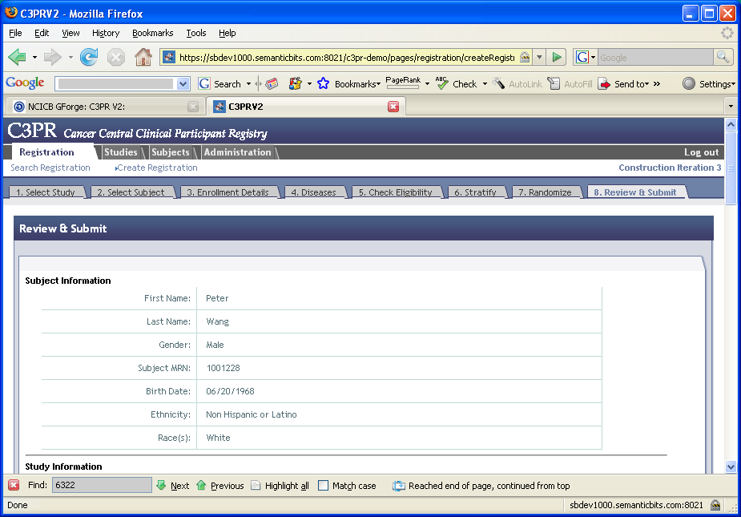
Figure 9
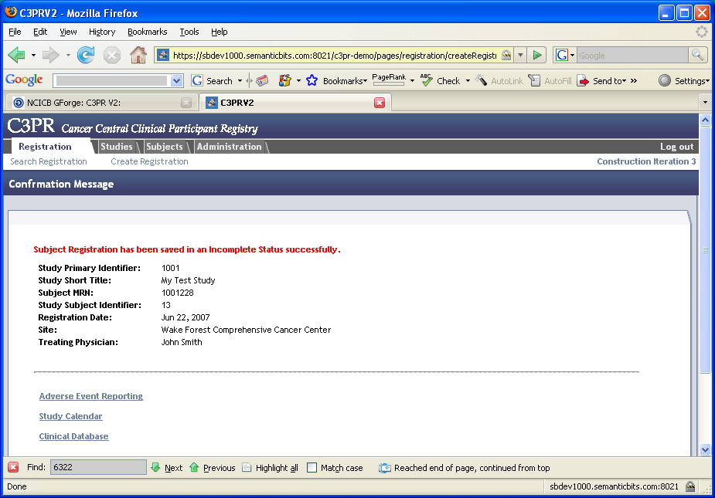
Figure 10

