Test Script Number: | create_new_study |  |  |  | Module: |  |  | Tester Name: |  | Steven Cheng | Pass/Fail:  Pass
Use Case #: |  |  |  |  | Username: | site_coordinator@wfubmc.edu |  | Test Date: |  | 01/29/2008 | Pass/Fail:  Pass
Estimated Execution Time: |  |  |  |  |  |  | Actual Execution Time: |  | 60 min
Test Objective: create a new study.

Test Setup:

Related Requirements
or Configuration Change Requests (Number/Description):

 | Test Action | Expected Results | Pass / Fail | Actual Results/Comments | gForge Tracker Bug ID
 | Click Studies tab, click Create Study link, fill the required information for Details, then click Continue button. See figure 1. |  | Pass | Tested features:  - Required field validation is active for all related fields except Type field.  Comments:  - Required field validation for Type field is inactive.  - Change default selection to ‘Please Select’ instead of ‘No’ for Multi-Institutional field. | 6930 – fixed  11982
 | Fill the required information for Epochs & Arms, then click Continue button. See figure 2 |  | Pass | Tested features:  - +/X buttons work fine
 | Fill the required information for Eligibility, then click Continue button. See figure 3 |  | pass | Tested features:  - Required field validation is active  Comments:  - Wrong label for Exclusion Criteria, replace Inclusion with Exclusion  - Required validation for Select Treatment Epoch is inactive. | 6935 - fixed  11986
 | Fill the required information for Stratification, then click Continue button. See figure 4 |  | pass | Tested features:  - Required field validation is active  Comments:  - +/X buttons don’t work  - Clicking X button next to Stratum Groups cause all entered information lost in first 3 steps. | 6940 – fixed  11989
 | Fill the required information for Randomization, then click Continue button. See figure 5 |  | pass
 | Fill the required information for Diseases, then click Continue button. See figure 6 |  | pass | Tested features:  - Clear button works  - Sub Category/Diseases list auto populated.  - +/X buttons work fine.  - Selected Disease count works fine
 | Fill the required information for Sites, then click Continue button. See figure 7 |  | pass | Tested features:  - Required field validation is active even when ‘--Please Select--‘ is selected by default.  Comments:  - Activation date and IRB Approval Date are optional? The system still takes without any input.  - +/X buttons don’t work in IE7  - Once click X button to delete the only existing one, + button will not work | 4227 - fixed  6932 - fixed
 | Fill the required information for Identifiers, then click Continue button. See figure 8 |  | Pass
 | Fill the required information for Investigators, then click Continue button. See figure 9 |  | pass
 | Fill the required information for Personnel, then click Continue button. See figure 10 |  | pass
 | Fill the required information for Notifications, then click Continue button. See figure 11 |  | pass
 | Review the study’s information in Overview, then click Save and Active button. See figure 12, 13, 14, 15 |  | pass | The study successfully created  Comment:  - Save button on figure 11 for what? Should be removed?  - Confirmation message should be displayed once the study successfully created. | 6944 - fixed  6945 - fixed

Tester Signature: Steven Cheng

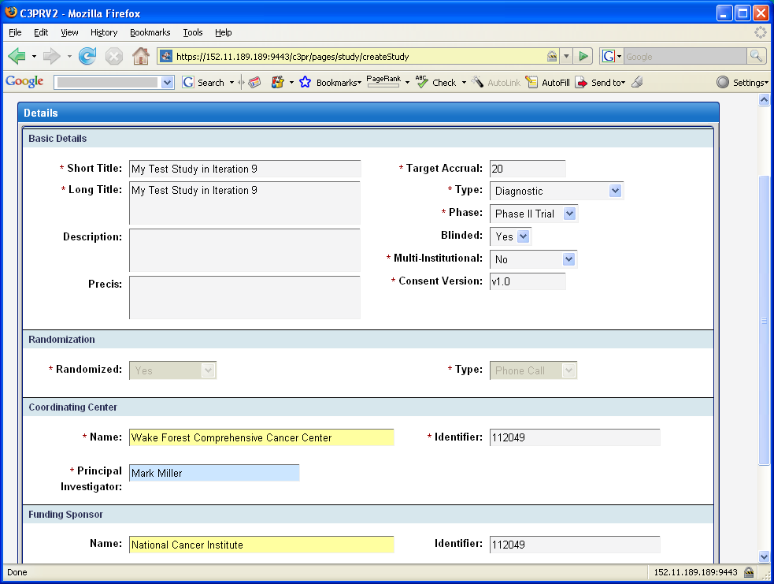
Figure 1
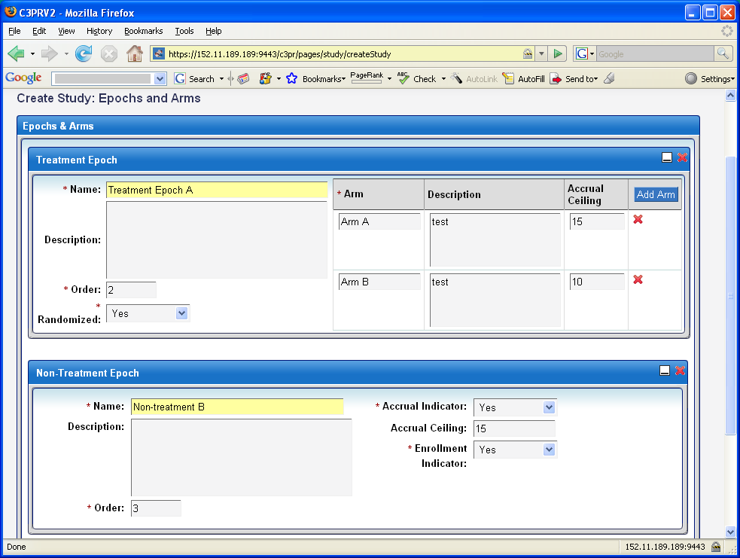
Figure 2
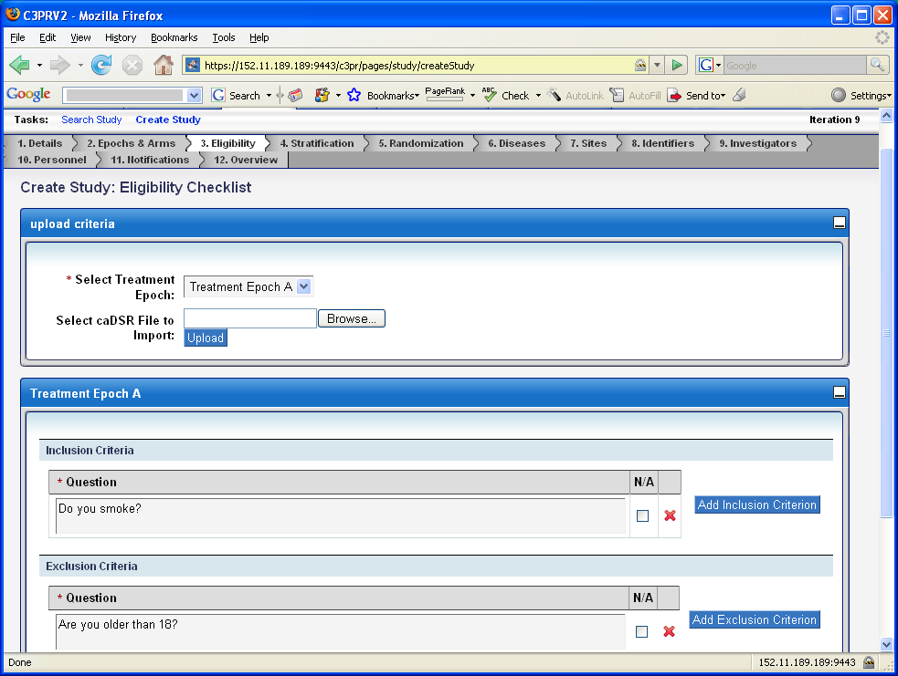
Figure 3
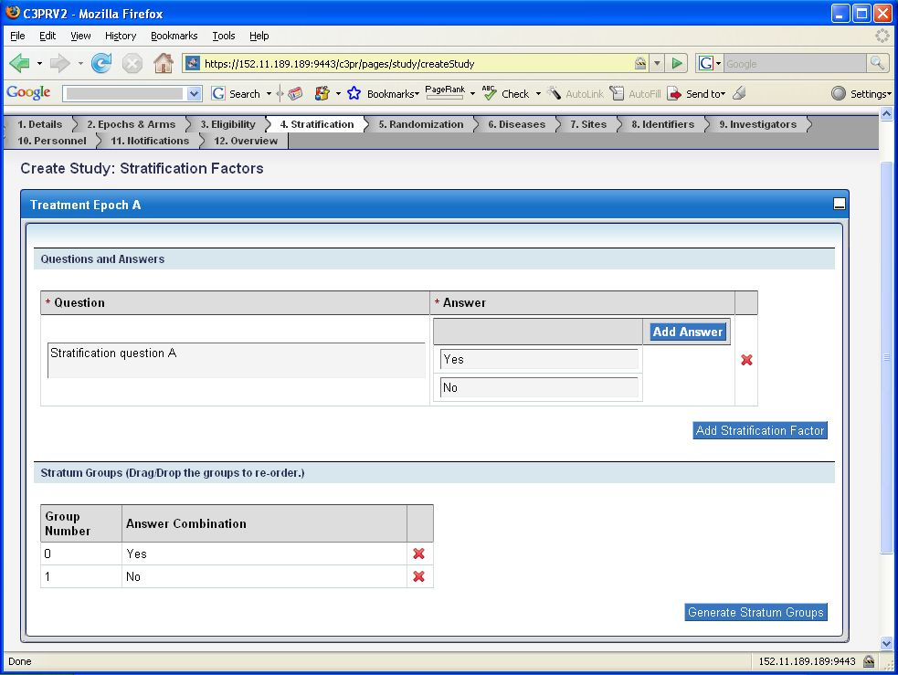
Figure 4
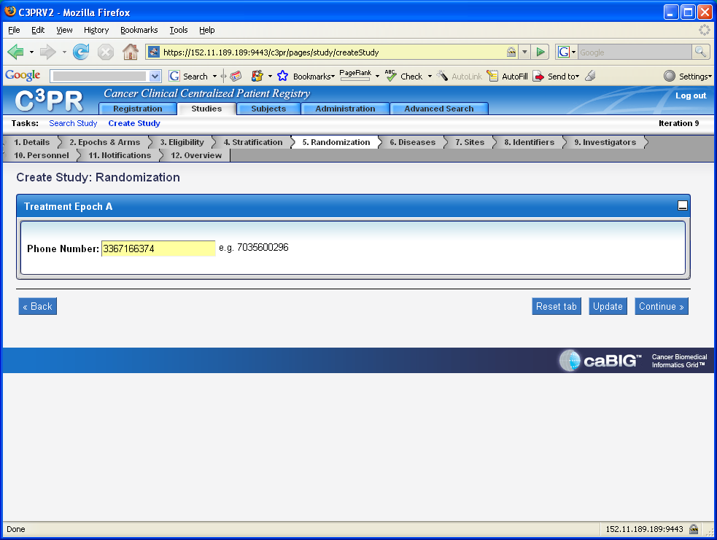
Figure 5
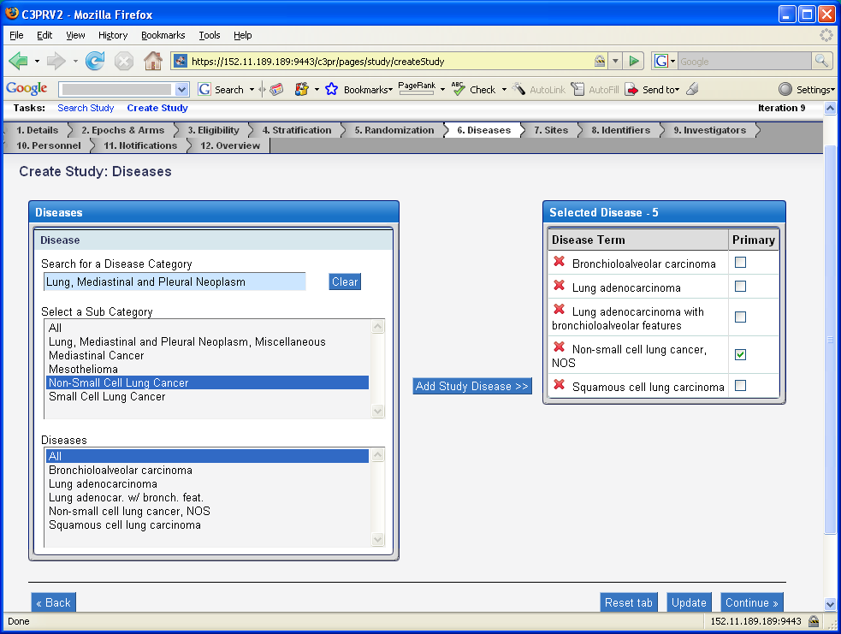
Figure 6
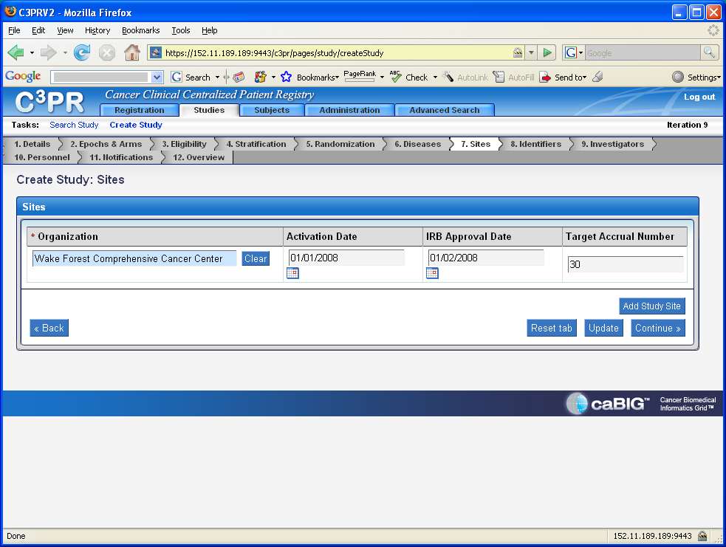
Figure 7
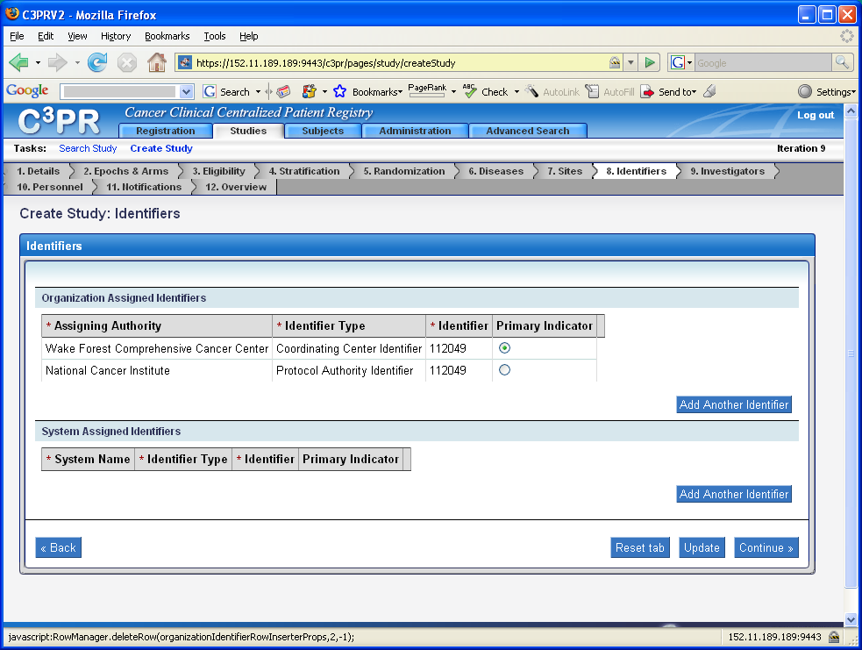
Figure 8
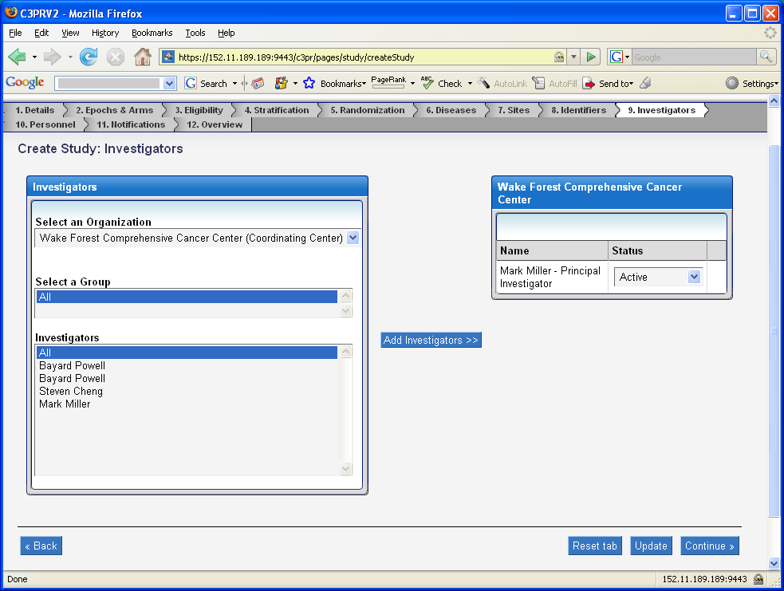
Figure 9
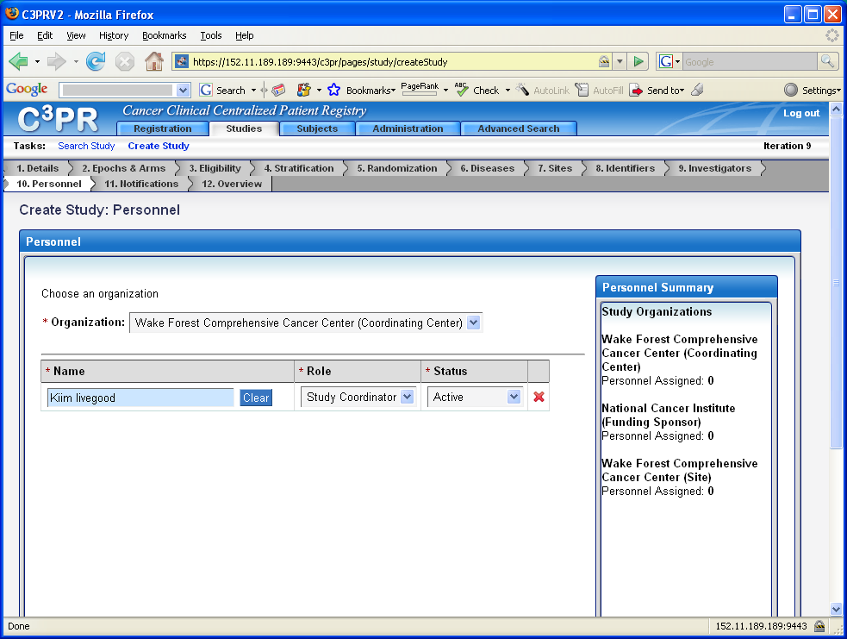
Figure 10
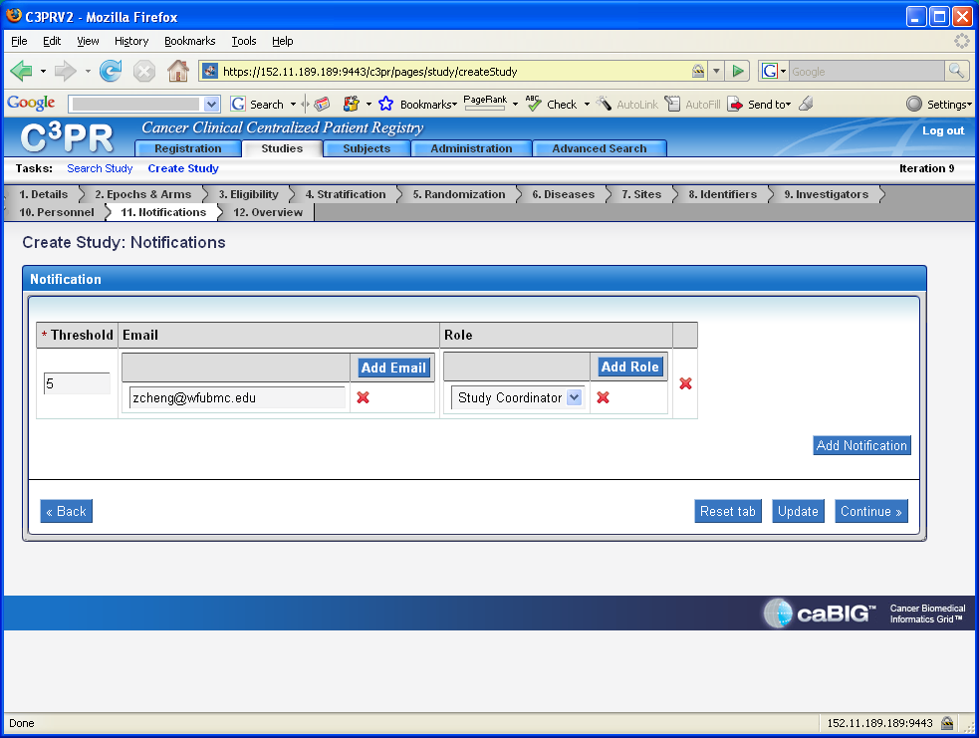
Figure 11
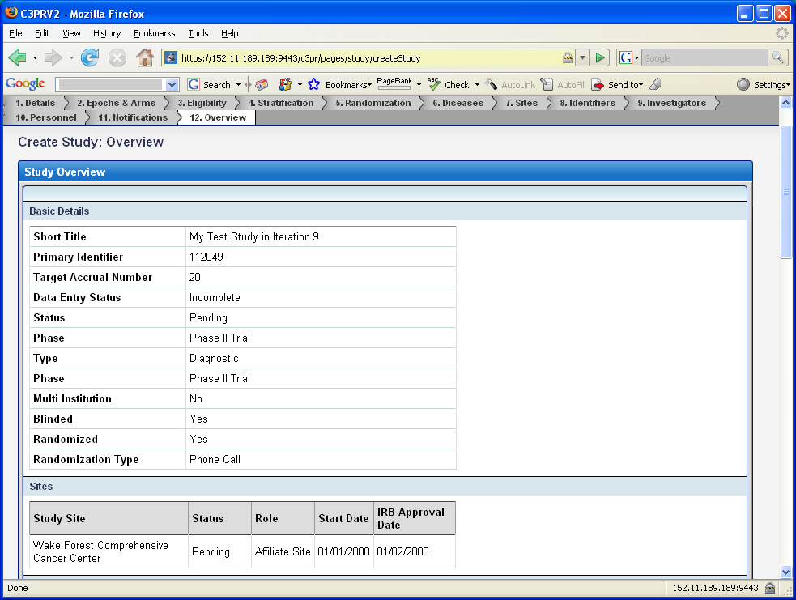
Figure 12
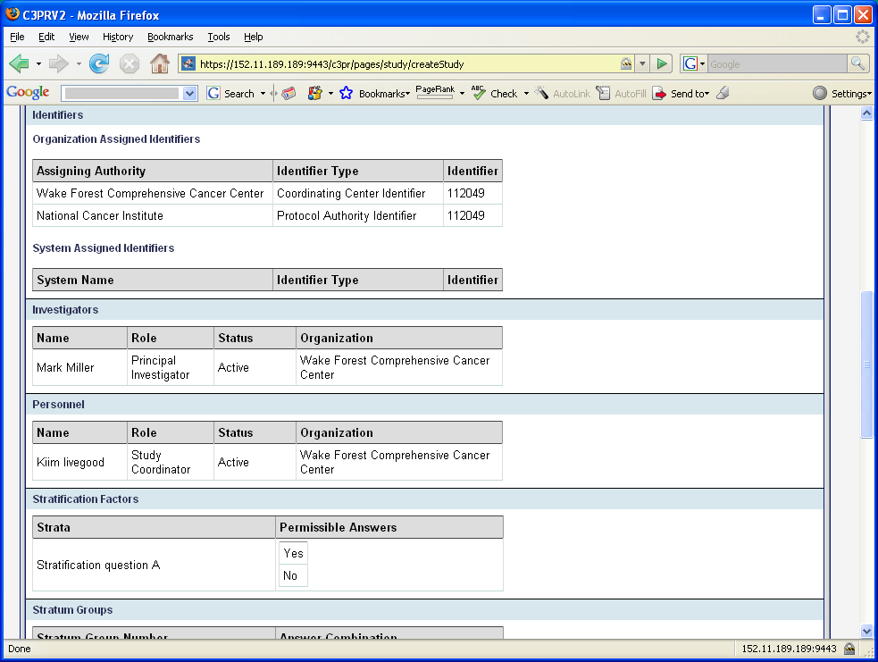
Figure 13
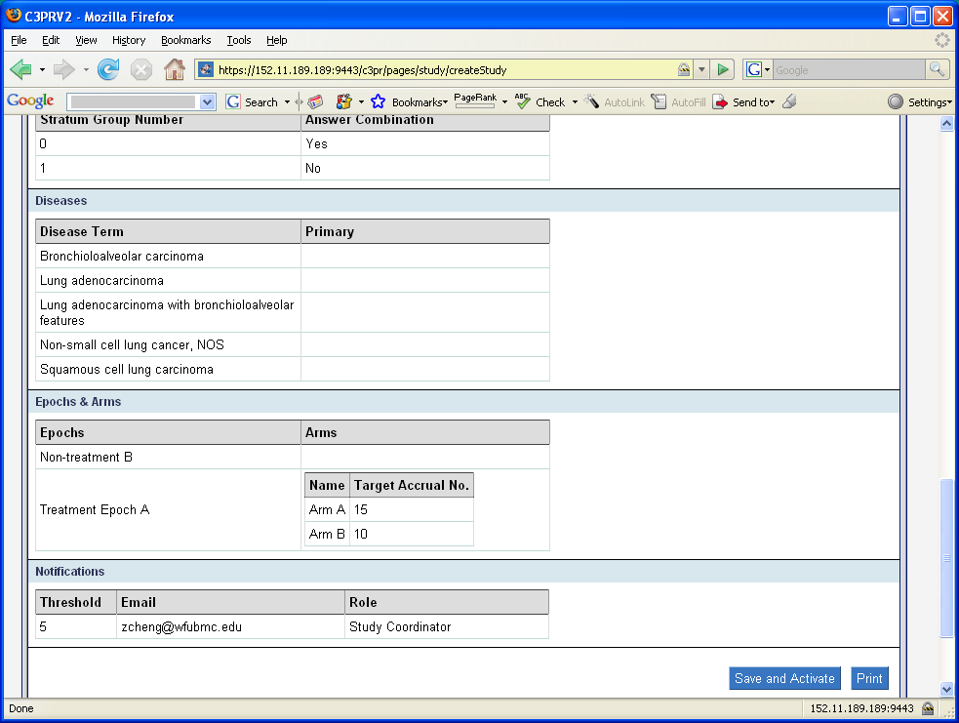
Figure 14
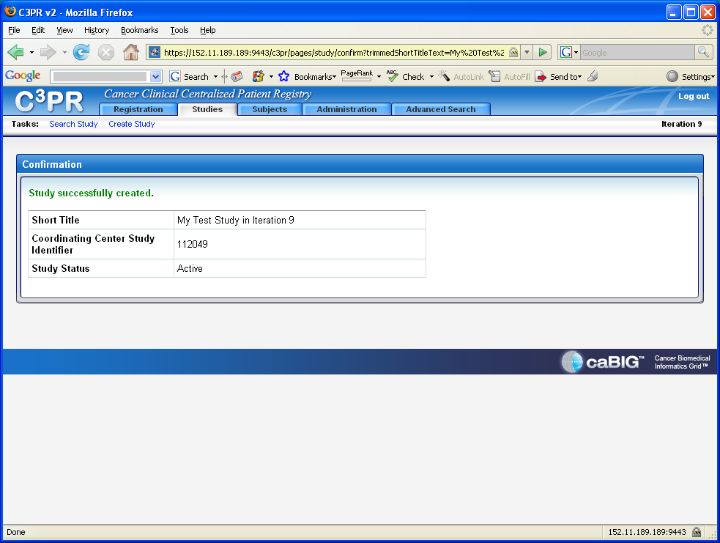
Figure 15

